UNITED STATES
SECURITIES AND EXCHANGE COMMISSION
Washington, D.C. 20549

FORM 8-K

CURRENT REPORT

Pursuant to Section 13 or 15(d)
of the Securities Exchange Act of 1934

May 9, 2024
Date of Report (Date of earliest event reported)

Essential Properties Realty Trust, Inc.
(Exact name of registrant as specified in its charter)

Maryland |  |  |  |  |  | 001-38530 |  |  |  |  |  | 82-4005693
(State or other jurisdiction of incorporation) |  |  |  |  |  | (Commission File Number) |  |  |  |  |  | (IRS Employer Identification No.)
902 Carnegie Center Blvd., Suite 520
Princeton, New Jersey |  |  |  |  |  |  |  |  |  |  |  | 08540
(Address of principal executive offices) |  |  |  |  |  |  |  |  |  |  |  | (Zip Code)
Registrant’s telephone number, including area code: |  |  |  |  |  |  |  |  |  |  |  | (609) 436-0619

Check the appropriate box below if the Form 8-K filing is intended to simultaneously satisfy the filing obligations of the registrant under any of the following provisions:
☐ |  |  | Written communications pursuant to Rule 425 under the Securities Act 17 CFR 230.425)
☐ |  |  | Soliciting material pursuant to Rule 14a-12 under the Exchange Act (17 CFR 240.14a-12)
☐ |  |  | Pre-commencement communications pursuant to Rule 14d-2(b) under the Exchange Act (17 CFR 240.14d-2(b))
☐ |  |  | Pre-commencement communications pursuant to Rule 13e-4(c) under the Exchange Act (17 CFR 240.13e-4(c))

Securities registered pursuant to Section 12(b) of the Act:
Title of Each Class |  |  |  |  |  | Trading Symbol(s) |  |  |  |  |  | Name of Each Exchange on Which Registered
Common stock, $0.01 par value |  |  |  |  |  | EPRT |  |  |  |  |  | New York Stock Exchange

Indicate by check mark whether the registrant is an emerging growth company as defined in Rule 405 of the Securities Act of 1933 (§230.405 of this chapter) or Rule 12b-2 of the Securities Exchange Act of 1934 (§240.12b-2 of this chapter).

Emerging growth company ☐

If an emerging growth company, indicate by check mark if the registrant has elected not to use the extended transition period for complying with any new or revised financial accounting standards provided pursuant to Section 13(a) of the Exchange Act ☐

Item 7.01 — Regulation FD Disclosure.

Investor Presentation

On May 9, 2024, Essential Properties Realty Trust, Inc. released a presentation that it intends to use from time to time in meetings with investors. A copy of the presentation is attached hereto as Exhibit 99.1.

The information set forth in this item 7.01 and in the attached Exhibit 99.1 is being "furnished" and shall not be deemed "filed" for the purposes of Section 18 of the Securities Exchange Act of 1934, as amended (the "Exchange Act"), or otherwise subject to the liabilities of Section 18, nor shall it be deemed incorporated by reference into any filing of the company under the Securities Act of 1933, as amended, or the Exchange Act, whether made before or after the date hereof, regardless of any general incorporation language in any such filing.

Item 9.01 — Financial Statements and Exhibits.
(d) Exhibits. The following exhibit is being filed herewith:

Exhibit No. |  |  |  |  |  | Description
99.1 |  |  |  |  |  | May 2024 Investor Presentation
104 |  |  |  |  |  | Cover Page Interactive Data File (embedded within the Inline XBRL document).

SIGNATURES

Pursuant to the requirements of the Securities Exchange Act of 1934, the registrant has duly caused this report to be signed on its behalf by the undersigned hereunto duly authorized.

Date: May 9, 2024 |  |  | ESSENTIAL PROPERTIES REALTY TRUST, INC.
 |  |  | By: |  |  | /s/ Mark E. Patten
 |  |  |  |  |  | Mark E. Patten
 |  |  |  |  |  | Executive Vice President, Chief Financial Officer, Treasurer and Secretary

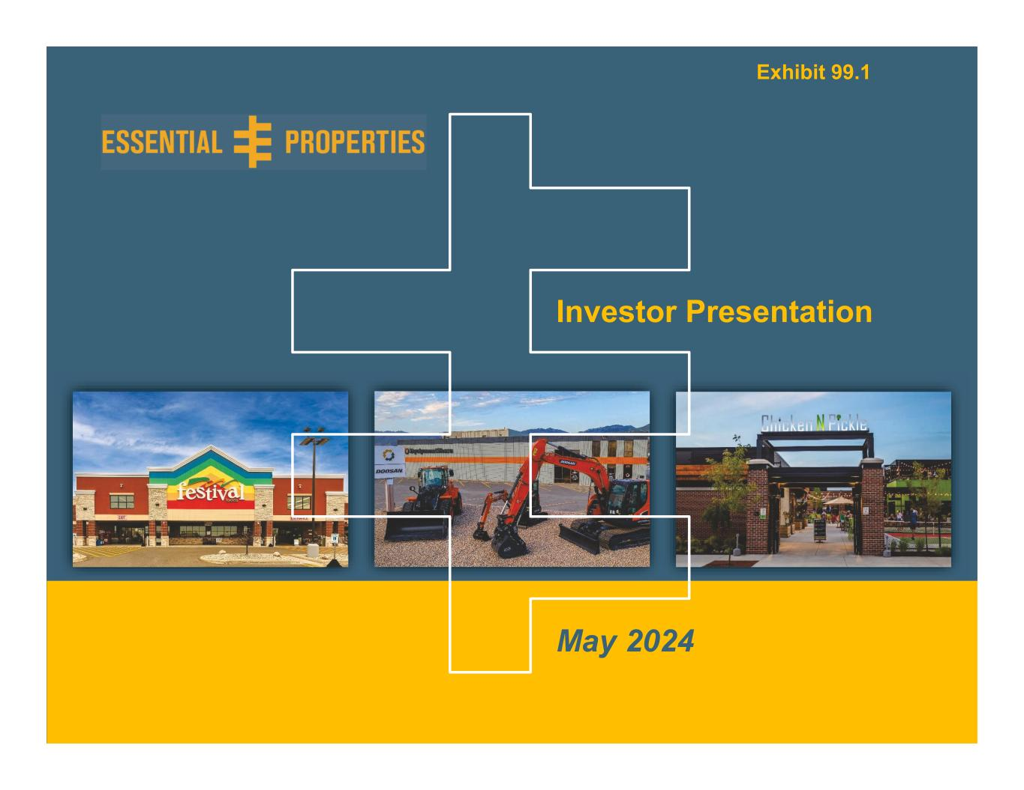
Investor Presentation – May 20240 Investor Presentation May 2024 Exhibit 99.1

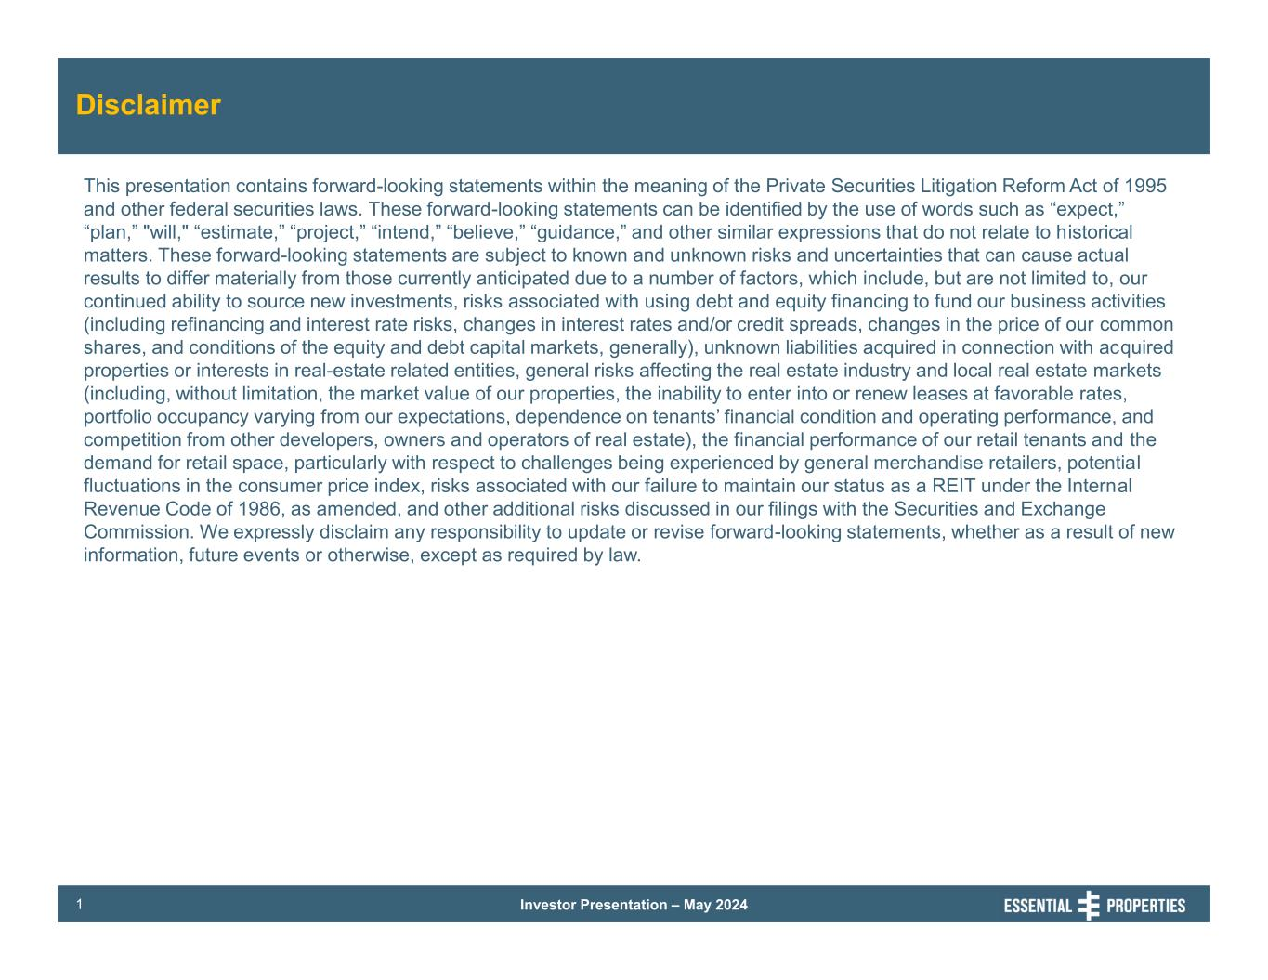
Investor Presentation – May 20241 Disclaimer This presentation contains forward-looking statements within the meaning of the Private Securities Litigation Reform Act of 1995 and other federal securities laws. These forward-looking statements can be identified by the use of words such as “expect,” “plan,” "will," “estimate,” “project,” “intend,” “believe,” “guidance,” and other similar expressions that do not relate to historical matters. These forward-looking statements are subject to known and unknown risks and uncertainties that can cause actual results to differ materially from those currently anticipated due to a number of factors, which include, but are not limited to, our continued ability to source new investments, risks associated with using debt and equity financing to fund our business activities (including refinancing and interest rate risks, changes in interest rates and/or credit spreads, changes in the price of our common shares, and conditions of the equity and debt capital markets, generally), unknown liabilities acquired in connection with acquired properties or interests in real-estate related entities, general risks affecting the real estate industry and local real estate markets (including, without limitation, the market value of our properties, the inability to enter into or renew leases at favorable rates, portfolio occupancy varying from our expectations, dependence on tenants’ financial condition and operating performance, and competition from other developers, owners and operators of real estate), the financial performance of our retail tenants and the demand for retail space, particularly with respect to challenges being experienced by general merchandise retailers, potential fluctuations in the consumer price index, risks associated with our failure to maintain our status as a REIT under the Internal Revenue Code of 1986, as amended, and other additional risks discussed in our filings with the Securities and Exchange Commission. We expressly disclaim any responsibility to update or revise forward-looking statements, whether as a result of new information, future events or otherwise, except as required by law.

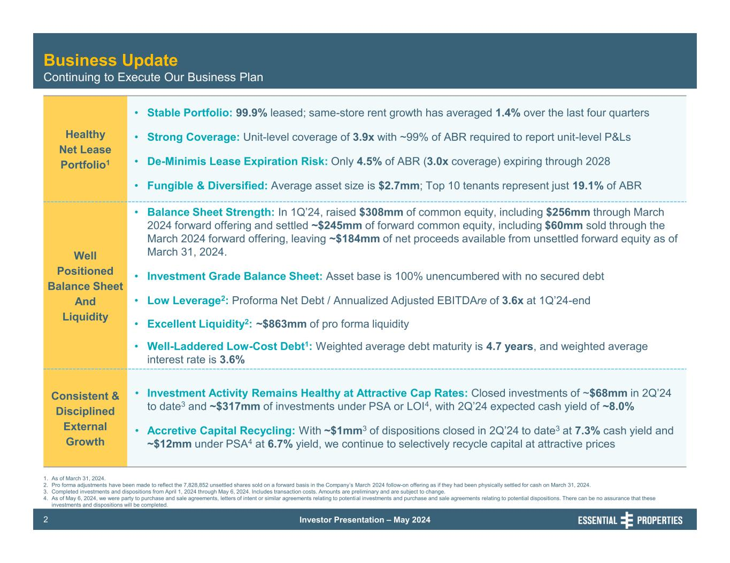
Investor Presentation – May 20242 Healthy Net Lease Portfolio1 • Stable Portfolio: 99.9% leased; same-store rent growth has averaged 1.4% over the last four quarters • Strong Coverage: Unit-level coverage of 3.9x with ~99% of ABR required to report unit-level P&Ls • De-Minimis Lease Expiration Risk: Only 4.5% of ABR (3.0x coverage) expiring through 2028 • Fungible & Diversified: Average asset size is $2.7mm; Top 10 tenants represent just 19.1% of ABR Well Positioned Balance Sheet And Liquidity • Balance Sheet Strength: In 1Q’24, raised $308mm of common equity, including $256mm through March 2024 forward offering and settled ~$245mm of forward common equity, including $60mm sold through the March 2024 forward offering, leaving ~$184mm of net proceeds available from unsettled forward equity as of March 31, 2024. • Investment Grade Balance Sheet: Asset base is 100% unencumbered with no secured debt • Low Leverage2: Proforma Net Debt / Annualized Adjusted EBITDAre of 3.6x at 1Q’24-end • Excellent Liquidity2: ~$863mm of pro forma liquidity • Well-Laddered Low-Cost Debt1: Weighted average debt maturity is 4.7 years, and weighted average interest rate is 3.6% Consistent & Disciplined External Growth • Investment Activity Remains Healthy at Attractive Cap Rates: Closed investments of ~$68mm in 2Q’24 to date3 and ~$317mm of investments under PSA or LOI4, with 2Q’24 expected cash yield of ~8.0% • Accretive Capital Recycling: With ~$1mm3 of dispositions closed in 2Q’24 to date3 at 7.3% cash yield and ~$12mm under PSA4 at 6.7% yield, we continue to selectively recycle capital at attractive prices 1. As of March 31, 2024. 2. Pro forma adjustments have been made to reflect the 7,828,852 unsettled shares sold on a forward basis in the Company’s March 2024 follow-on offering as if they had been physically settled for cash on March 31, 2024. 3. Completed investments and dispositions from April 1, 2024 through May 6, 2024. Includes transaction costs. Amounts are preliminary and are subject to change. 4. As of May 6, 2024, we were party to purchase and sale agreements, letters of intent or similar agreements relating to potential investments and purchase and sale agreements relating to potential dispositions. There can be no assurance that these investments and dispositions will be completed. Business Update Continuing to Execute Our Business Plan

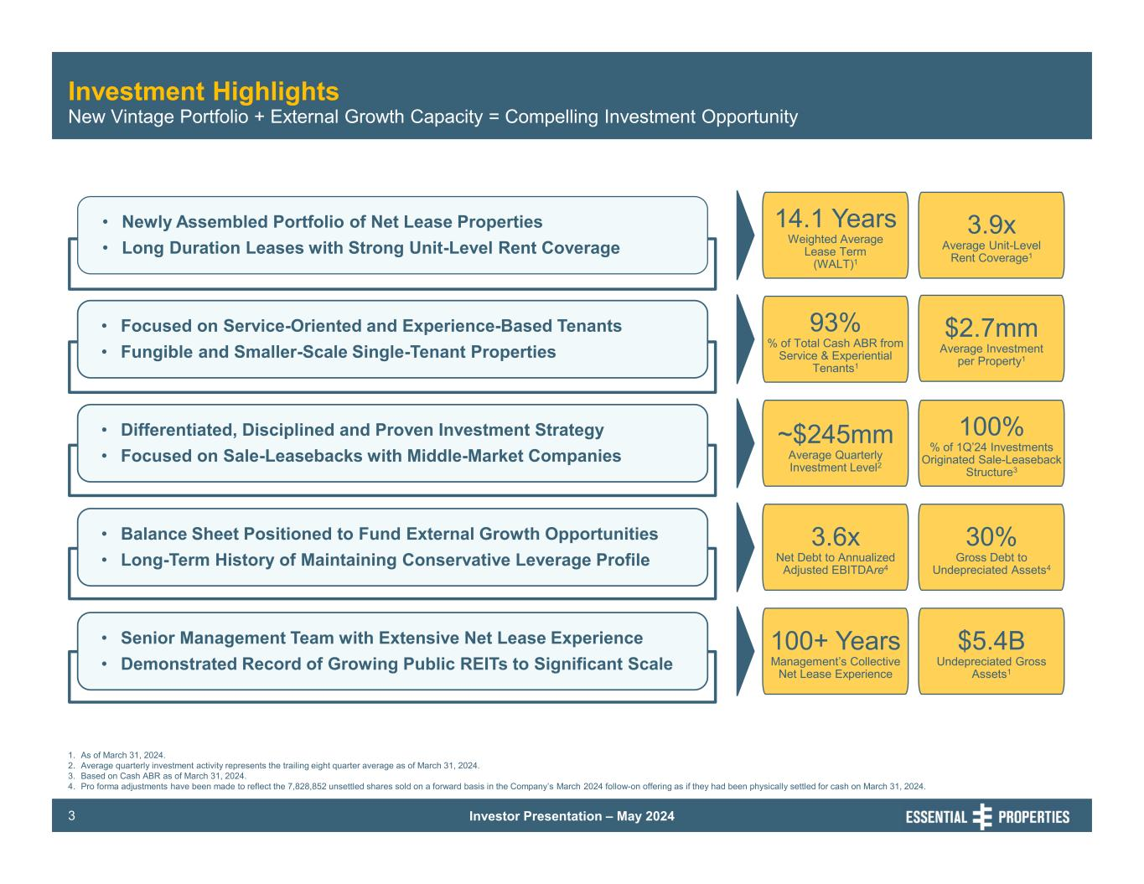
Investor Presentation – May 20243 Investment Highlights • Newly Assembled Portfolio of Net Lease Properties • Long Duration Leases with Strong Unit-Level Rent Coverage • Focused on Service-Oriented and Experience-Based Tenants • Fungible and Smaller-Scale Single-Tenant Properties • Differentiated, Disciplined and Proven Investment Strategy • Focused on Sale-Leasebacks with Middle-Market Companies • Balance Sheet Positioned to Fund External Growth Opportunities • Long-Term History of Maintaining Conservative Leverage Profile • Senior Management Team with Extensive Net Lease Experience • Demonstrated Record of Growing Public REITs to Significant Scale 1. As of March 31, 2024. 2. Average quarterly investment activity represents the trailing eight quarter average as of March 31, 2024. 3. Based on Cash ABR as of March 31, 2024. 4. Pro forma adjustments have been made to reflect the 7,828,852 unsettled shares sold on a forward basis in the Company’s March 2024 follow-on offering as if they had been physically settled for cash on March 31, 2024. New Vintage Portfolio + External Growth Capacity = Compelling Investment Opportunity 14.1 Years Weighted Average Lease Term (WALT)1 3.9x Average Unit-Level Rent Coverage1 93% % of Total Cash ABR from Service & Experiential Tenants1 $2.7mm Average Investment per Property1 ~$245mm Average Quarterly Investment Level2 100% % of 1Q’24 Investments Originated Sale-Leaseback Structure3 3.6x Net Debt to Annualized Adjusted EBITDAre4 30% Gross Debt to Undepreciated Assets4 100+ Years Management’s Collective Net Lease Experience $5.4B Undepreciated Gross Assets1

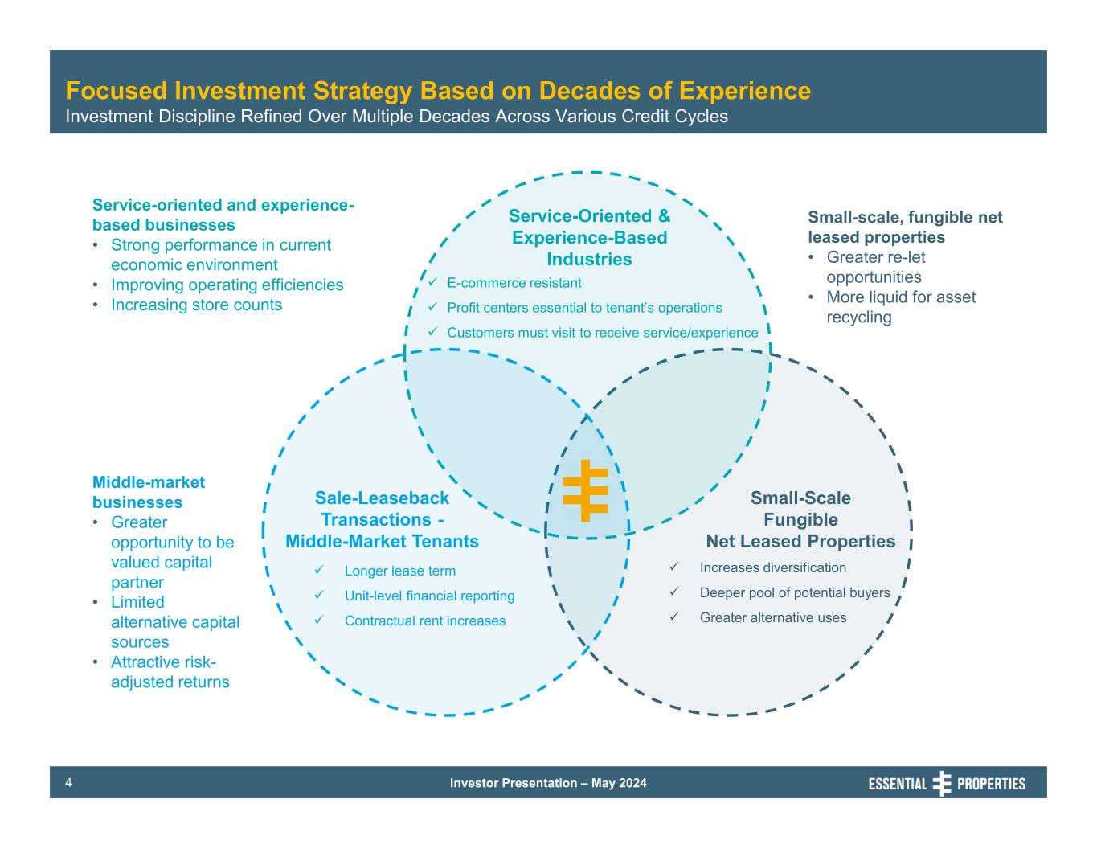
Investor Presentation – May 20244 Focused Investment Strategy Based on Decades of Experience Investment Discipline Refined Over Multiple Decades Across Various Credit Cycles Service-Oriented & Experience-Based Industries Sale-Leaseback Transactions - Middle-Market Tenants Small-Scale Fungible Net Leased Properties E-commerce resistant Profit centers essential to tenant’s operations Customers must visit to receive service/experience Longer lease term Unit-level financial reporting Contractual rent increases Increases diversification Deeper pool of potential buyers Greater alternative uses Small-scale, fungible net leased properties • Greater re-let opportunities • More liquid for asset recycling Service-oriented and experience- based businesses • Strong performance in current economic environment • Improving operating efficiencies • Increasing store counts Middle-market businesses • Greater opportunity to be valued capital partner • Limited alternative capital sources • Attractive risk- adjusted returns

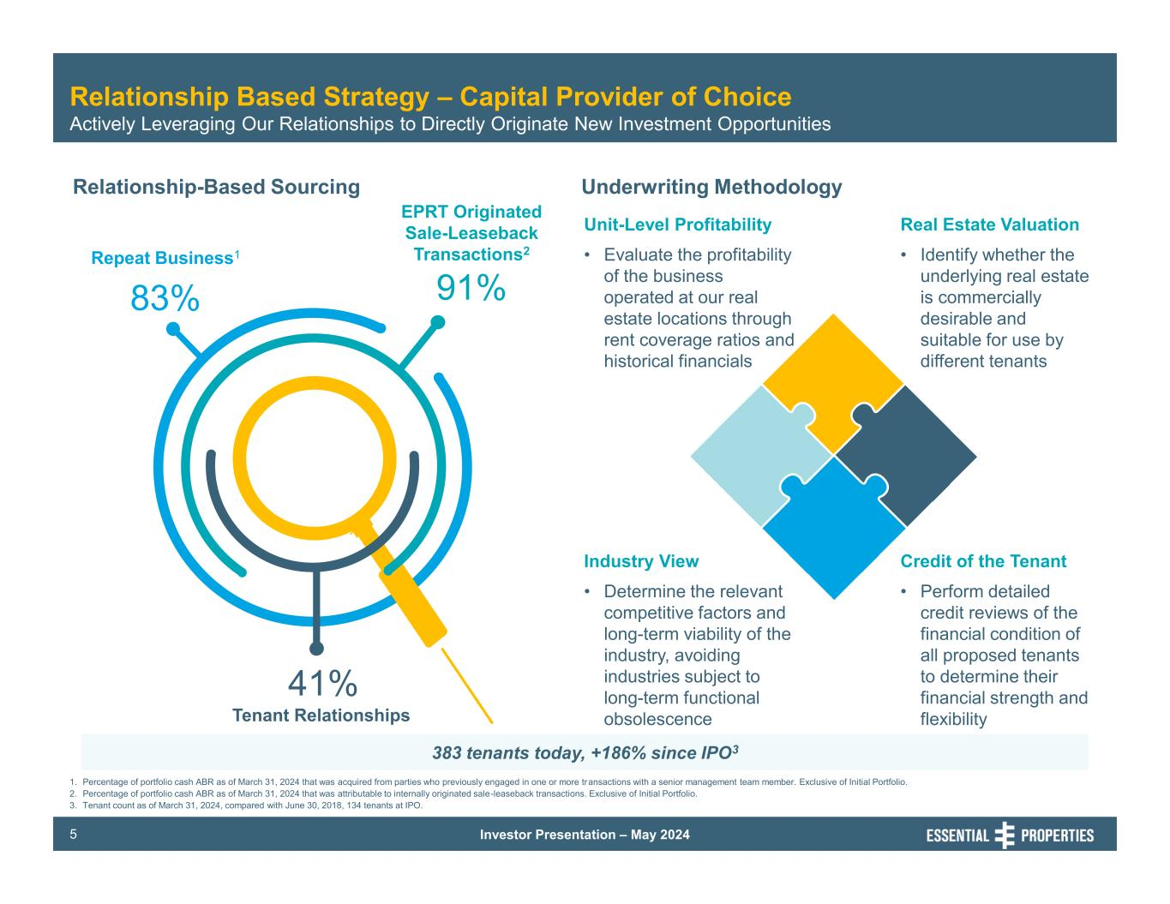
Investor Presentation – May 20245 Relationship Based Strategy – Capital Provider of Choice Actively Leveraging Our Relationships to Directly Originate New Investment Opportunities Relationship-Based Sourcing 1. Percentage of portfolio cash ABR as of March 31, 2024 that was acquired from parties who previously engaged in one or more transactions with a senior management team member. Exclusive of Initial Portfolio. 2. Percentage of portfolio cash ABR as of March 31, 2024 that was attributable to internally originated sale-leaseback transactions. Exclusive of Initial Portfolio. 3. Tenant count as of March 31, 2024, compared with June 30, 2018, 134 tenants at IPO. Repeat Business1 83% EPRT Originated Sale-Leaseback Transactions2 91% Tenant Relationships 41% Underwriting Methodology Industry View • Determine the relevant competitive factors and long-term viability of the industry, avoiding industries subject to long-term functional obsolescence Credit of the Tenant • Perform detailed credit reviews of the financial condition of all proposed tenants to determine their financial strength and flexibility Unit-Level Profitability • Evaluate the profitability of the business operated at our real estate locations through rent coverage ratios and historical financials Real Estate Valuation • Identify whether the underlying real estate is commercially desirable and suitable for use by different tenants 383 tenants today, +186% since IPO3

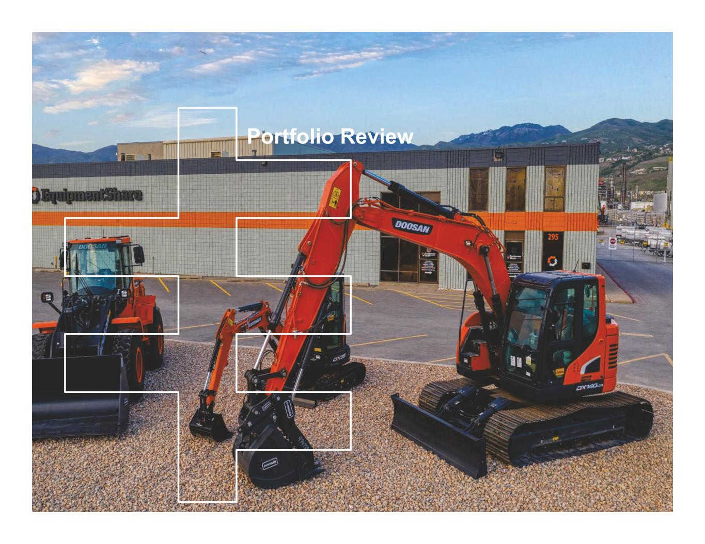
Portfolio Review

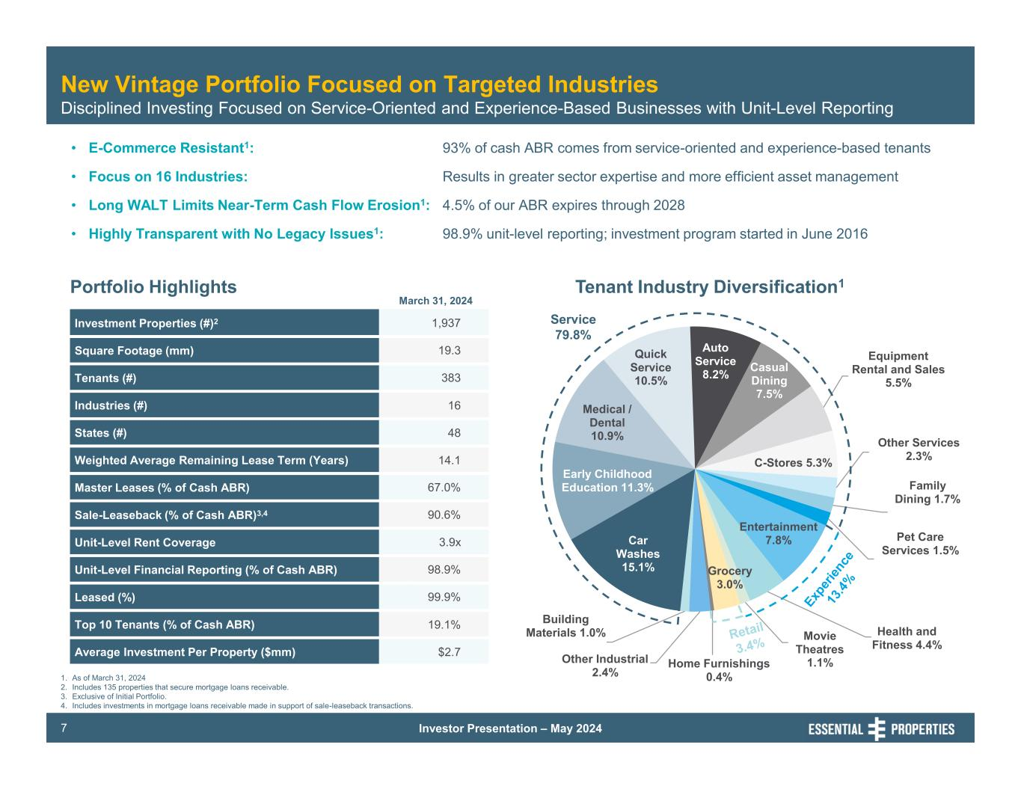
Investor Presentation – May 20247 New Vintage Portfolio Focused on Targeted Industries Disciplined Investing Focused on Service-Oriented and Experience-Based Businesses with Unit-Level Reporting 1. As of March 31, 2024 2. Includes 135 properties that secure mortgage loans receivable. 3. Exclusive of Initial Portfolio. 4. Includes investments in mortgage loans receivable made in support of sale-leaseback transactions. Portfolio Highlights March 31, 2024 Tenant Industry Diversification1 • E-Commerce Resistant1: • Focus on 16 Industries: • Long WALT Limits Near-Term Cash Flow Erosion1: • Highly Transparent with No Legacy Issues1: Investment Properties (#)2 1,937 Square Footage (mm) 19.3 Tenants (#) 383 Industries (#) 16 States (#) 48 Weighted Average Remaining Lease Term (Years) 14.1 Master Leases (% of Cash ABR) 67.0% Sale-Leaseback (% of Cash ABR)3,4 90.6% Unit-Level Rent Coverage 3.9x Unit-Level Financial Reporting (% of Cash ABR) 98.9% Leased (%) 99.9% Top 10 Tenants (% of Cash ABR) 19.1% Average Investment Per Property ($mm) $2.7 93% of cash ABR comes from service-oriented and experience-based tenants Results in greater sector expertise and more efficient asset management 4.5% of our ABR expires through 2028 98.9% unit-level reporting; investment program started in June 2016 Car Washes 15.1% Early Childhood Education 11.3% Medical / Dental 10.9% Quick Service 10.5% Auto Service 8.2% Casual Dining 7.5% Equipment Rental and Sales 5.5% C-Stores 5.3% Other Services 2.3% Family Dining 1.7% Pet Care Services 1.5% Entertainment 7.8% Health and Fitness 4.4% Movie Theatres 1.1% Grocery 3.0% Home Furnishings 0.4% Other Industrial 2.4% Building Materials 1.0% Service 79.8%

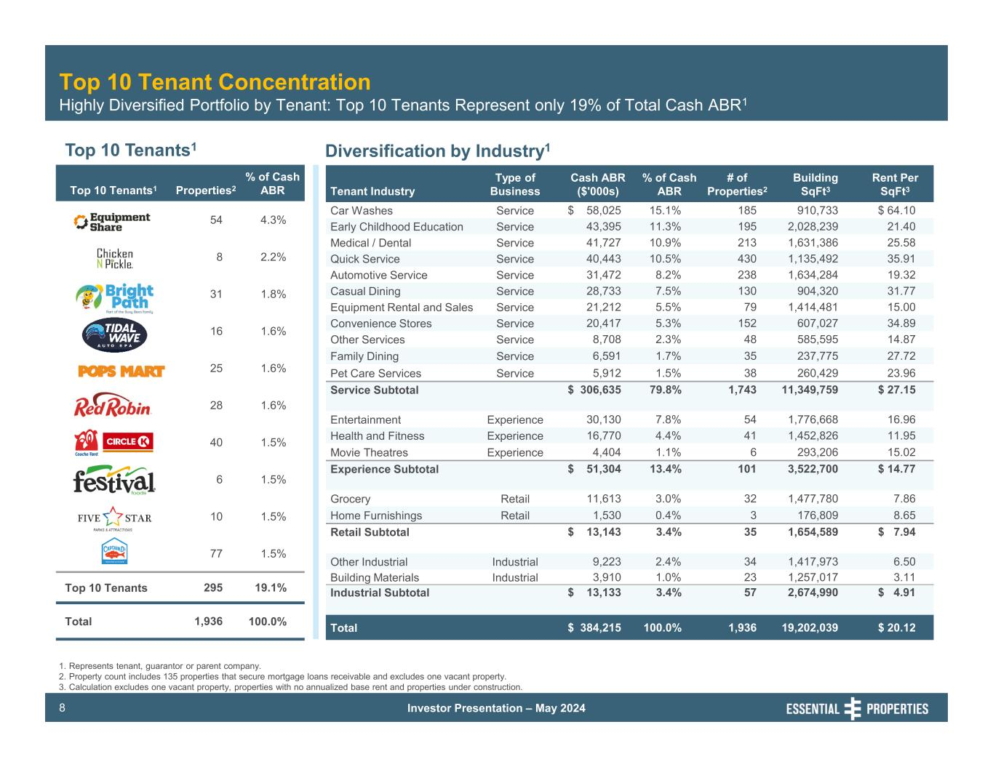
Investor Presentation – May 20248 Top 10 Tenant Concentration Highly Diversified Portfolio by Tenant: Top 10 Tenants Represent only 19% of Total Cash ABR1 Top 10 Tenants1 Diversification by Industry1 Top 10 Tenants1 Properties2 % of Cash ABR 54 4.3% 8 2.2% 31 1.8% 16 1.6% 25 1.6% 28 1.6% 40 1.5% 6 1.5% 10 1.5% 77 1.5% Top 10 Tenants 295 19.1% Total 1,936 100.0% Tenant Industry Type of Business Cash ABR ($'000s) % of Cash ABR # of Properties2 Building SqFt3 Rent Per SqFt3 Car Washes Service $ 58,025 15.1% 185 910,733 $ 64.10 Early Childhood Education Service 43,395 11.3% 195 2,028,239 21.40 Medical / Dental Service 41,727 10.9% 213 1,631,386 25.58 Quick Service Service 40,443 10.5% 430 1,135,492 35.91 Automotive Service Service 31,472 8.2% 238 1,634,284 19.32 Casual Dining Service 28,733 7.5% 130 904,320 31.77 Equipment Rental and Sales Service 21,212 5.5% 79 1,414,481 15.00 Convenience Stores Service 20,417 5.3% 152 607,027 34.89 Other Services Service 8,708 2.3% 48 585,595 14.87 Family Dining Service 6,591 1.7% 35 237,775 27.72 Pet Care Services Service 5,912 1.5% 38 260,429 23.96 Service Subtotal $ 306,635 79.8% 1,743 11,349,759 $ 27.15 Entertainment Experience 30,130 7.8% 54 1,776,668 16.96 Health and Fitness Experience 16,770 4.4% 41 1,452,826 11.95 Movie Theatres Experience 4,404 1.1% 6 293,206 15.02 Experience Subtotal $ 51,304 13.4% 101 3,522,700 $ 14.77 Grocery Retail 11,613 3.0% 32 1,477,780 7.86 Home Furnishings Retail 1,530 0.4% 3 176,809 8.65 Retail Subtotal $ 13,143 3.4% 35 1,654,589 $ 7.94 Other Industrial Industrial 9,223 2.4% 34 1,417,973 6.50 Building Materials Industrial 3,910 1.0% 23 1,257,017 3.11 Industrial Subtotal $ 13,133 3.4% 57 2,674,990 $ 4.91 Total $ 384,215 100.0% 1,936 19,202,039 $ 20.12 1. Represents tenant, guarantor or parent company. 2. Property count includes 135 properties that secure mortgage loans receivable and excludes one vacant property. 3. Calculation excludes one vacant property, properties with no annualized base rent and properties under construction.

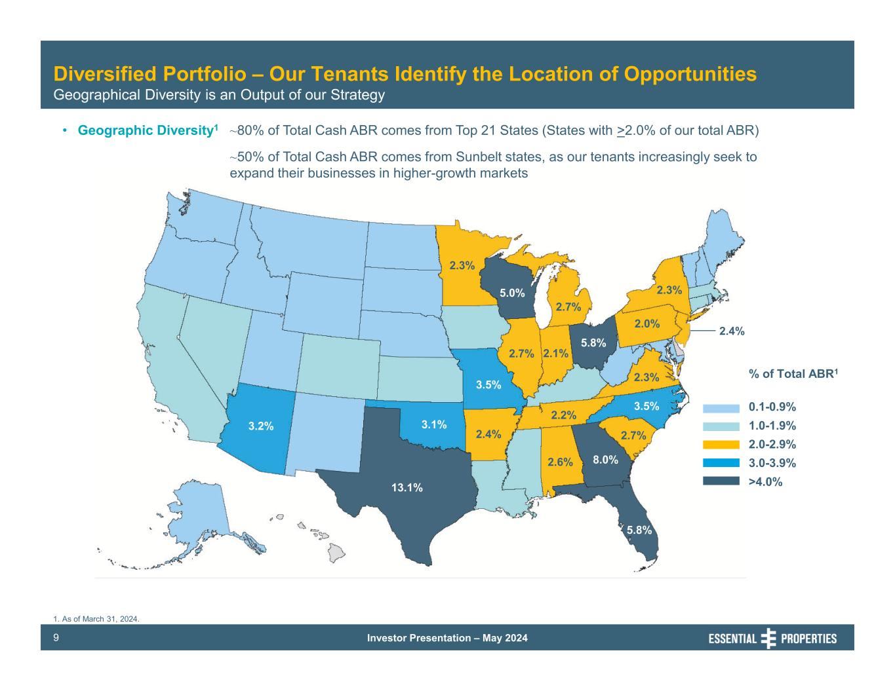
Investor Presentation – May 20249 Diversified Portfolio – Our Tenants Identify the Location of Opportunities Geographical Diversity is an Output of our Strategy • Geographic Diversity1 ~80% of Total Cash ABR comes from Top 21 States (States with >2.0% of our total ABR) ~50% of Total Cash ABR comes from Sunbelt states, as our tenants increasingly seek to expand their businesses in higher-growth markets % of Total ABR1 0.1-0.9% 1.0-1.9% 2.0-2.9% 3.0-3.9% >4.0% 2.3% 2.4% 13.1% 3.2% 3.5% 2.3% 5.0% 2.7% 2.7% 3.1% 2.4% 5.8% 2.3% 3.5% 8.0%2.6% 5.8% 2.2% 2.1% 2.0% 2.7% 1. As of March 31, 2024.

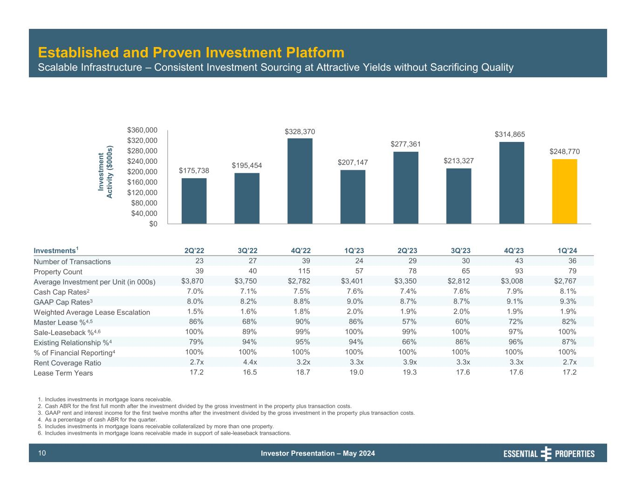
Investor Presentation – May 202410 Established and Proven Investment Platform Scalable Infrastructure – Consistent Investment Sourcing at Attractive Yields without Sacrificing Quality $175,738 $195,454 $328,370 $207,147 $277,361 $213,327 $314,865 $248,770 $0 $40,000 $80,000 $120,000 $160,000 $200,000 $240,000 $280,000 $320,000 $360,000 In ve st m en t Ac tiv ity ($ 00 0s ) Investments1 2Q’22 3Q’22 4Q’22 1Q’23 2Q’23 3Q’23 4Q’23 1Q’24 Number of Transactions 23 27 39 24 29 30 43 36 Property Count 39 40 115 57 78 65 93 79 Average Investment per Unit (in 000s) $3,870 $3,750 $2,782 $3,401 $3,350 $2,812 $3,008 $2,767 Cash Cap Rates2 7.0% 7.1% 7.5% 7.6% 7.4% 7.6% 7.9% 8.1% GAAP Cap Rates3 8.0% 8.2% 8.8% 9.0% 8.7% 8.7% 9.1% 9.3% Weighted Average Lease Escalation 1.5% 1.6% 1.8% 2.0% 1.9% 2.0% 1.9% 1.9% Master Lease %4,5 86% 68% 90% 86% 57% 60% 72% 82% Sale-Leaseback %4,6 100% 89% 99% 100% 99% 100% 97% 100% Existing Relationship %4 79% 94% 95% 94% 66% 86% 96% 87% % of Financial Reporting4 100% 100% 100% 100% 100% 100% 100% 100% Rent Coverage Ratio 2.7x 4.4x 3.2x 3.3x 3.9x 3.3x 3.3x 2.7x Lease Term Years 17.2 16.5 18.7 19.0 19.3 17.6 17.6 17.2 1. Includes investments in mortgage loans receivable. 2. Cash ABR for the first full month after the investment divided by the gross investment in the property plus transaction costs. 3. GAAP rent and interest income for the first twelve months after the investment divided by the gross investment in the property plus transaction costs. 4. As a percentage of cash ABR for the quarter. 5. Includes investments in mortgage loans receivable collateralized by more than one property. 6. Includes investments in mortgage loans receivable made in support of sale-leaseback transactions.

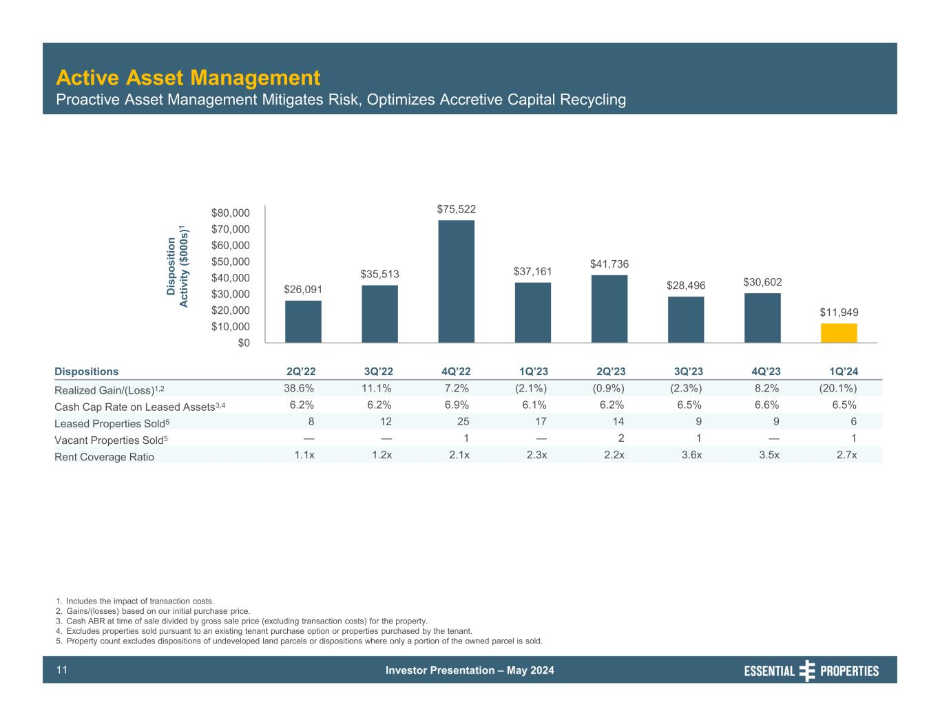
Investor Presentation – May 202411 Active Asset Management Proactive Asset Management Mitigates Risk, Optimizes Accretive Capital Recycling 1. Includes the impact of transaction costs. 2. Gains/(losses) based on our initial purchase price. 3. Cash ABR at time of sale divided by gross sale price (excluding transaction costs) for the property. 4. Excludes properties sold pursuant to an existing tenant purchase option or properties purchased by the tenant. 5. Property count excludes dispositions of undeveloped land parcels or dispositions where only a portion of the owned parcel is sold. Dispositions 2Q’22 3Q’22 4Q’22 1Q’23 2Q’23 3Q’23 4Q’23 1Q’24 Realized Gain/(Loss)1,2 38.6% 11.1% 7.2% (2.1%) (0.9%) (2.3%) 8.2% (20.1%) Cash Cap Rate on Leased Assets3,4 6.2% 6.2% 6.9% 6.1% 6.2% 6.5% 6.6% 6.5% Leased Properties Sold5 8 12 25 17 14 9 9 6 Vacant Properties Sold5 — — 1 — 2 1 — 1 Rent Coverage Ratio 1.1x 1.2x 2.1x 2.3x 2.2x 3.6x 3.5x 2.7x $26,091 $35,513 $75,522 $37,161 $41,736 $28,496 $30,602 $11,949 $0 $10,000 $20,000 $30,000 $40,000 $50,000 $60,000 $70,000 $80,000 D is po si tio n Ac tiv ity ($ 00 0s )1

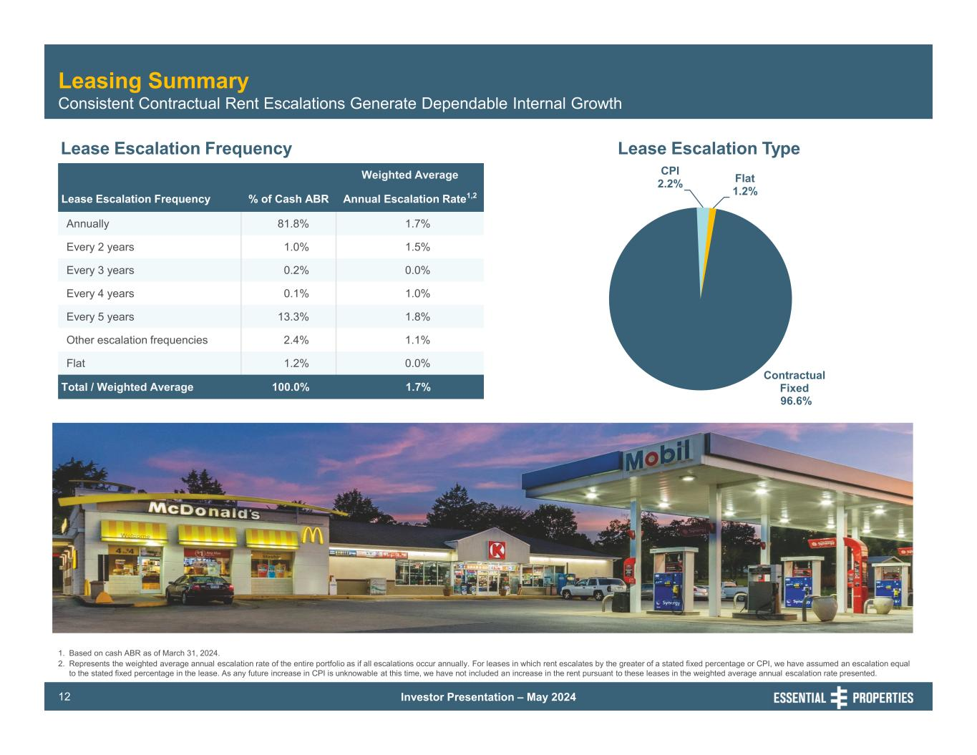
Investor Presentation – May 202412 Leasing Summary Consistent Contractual Rent Escalations Generate Dependable Internal Growth Lease Escalation Frequency Lease Escalation Type 1. Based on cash ABR as of March 31, 2024. 2. Represents the weighted average annual escalation rate of the entire portfolio as if all escalations occur annually. For leases in which rent escalates by the greater of a stated fixed percentage or CPI, we have assumed an escalation equal to the stated fixed percentage in the lease. As any future increase in CPI is unknowable at this time, we have not included an increase in the rent pursuant to these leases in the weighted average annual escalation rate presented. Contractual Fixed 96.6% CPI 2.2% Flat 1.2% Weighted Average Lease Escalation Frequency % of Cash ABR Annual Escalation Rate1,2 Annually 81.8% 1.7% Every 2 years 1.0% 1.5% Every 3 years 0.2% 0.0% Every 4 years 0.1% 1.0% Every 5 years 13.3% 1.8% Other escalation frequencies 2.4% 1.1% Flat 1.2% 0.0% Total / Weighted Average 100.0% 1.7%

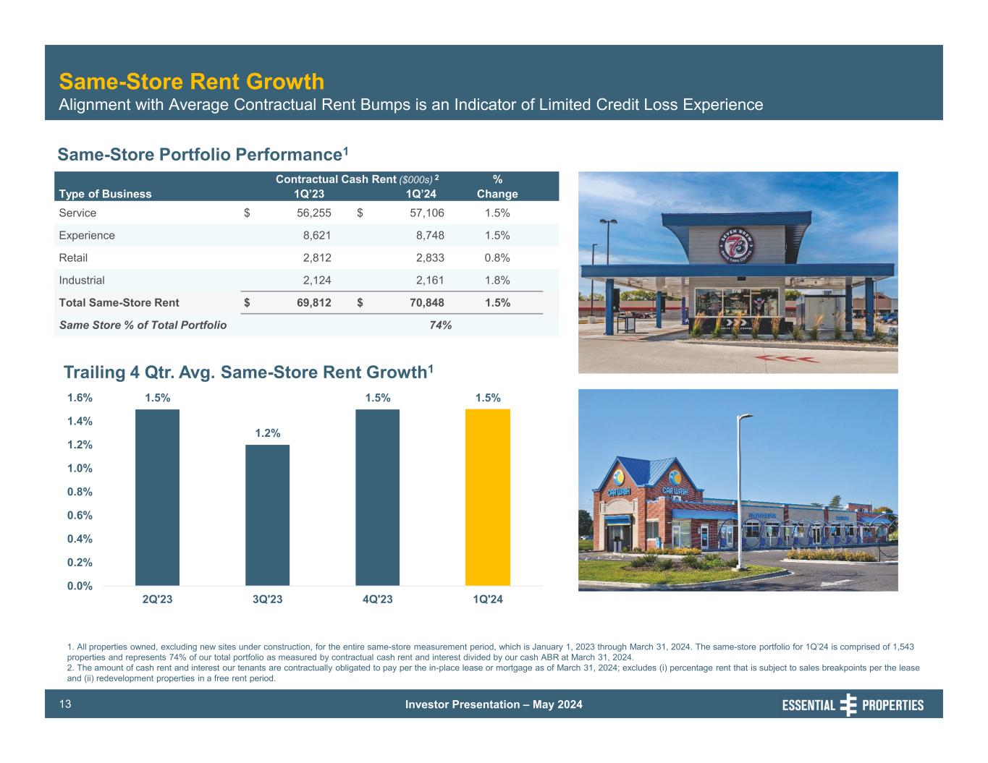
Investor Presentation – May 202413 Same-Store Rent Growth Alignment with Average Contractual Rent Bumps is an Indicator of Limited Credit Loss Experience Same-Store Portfolio Performance1 Trailing 4 Qtr. Avg. Same-Store Rent Growth1 Contractual Cash Rent ($000s) 2 % Type of Business 1Q’23 1Q’24 Change Service $ 56,255 $ 57,106 1.5% Experience 8,621 8,748 1.5% Retail 2,812 2,833 0.8% Industrial 2,124 2,161 1.8% Total Same-Store Rent $ 69,812 $ 70,848 1.5% Same Store % of Total Portfolio 74% 1.5% 1.2% 1.5% 1.5% 0.0% 0.2% 0.4% 0.6% 0.8% 1.0% 1.2% 1.4% 1.6% 2Q'23 3Q'23 4Q'23 1Q'24 1. All properties owned, excluding new sites under construction, for the entire same-store measurement period, which is January 1, 2023 through March 31, 2024. The same-store portfolio for 1Q’24 is comprised of 1,543 properties and represents 74% of our total portfolio as measured by contractual cash rent and interest divided by our cash ABR at March 31, 2024. 2. The amount of cash rent and interest our tenants are contractually obligated to pay per the in-place lease or mortgage as of March 31, 2024; excludes (i) percentage rent that is subject to sales breakpoints per the lease and (ii) redevelopment properties in a free rent period.

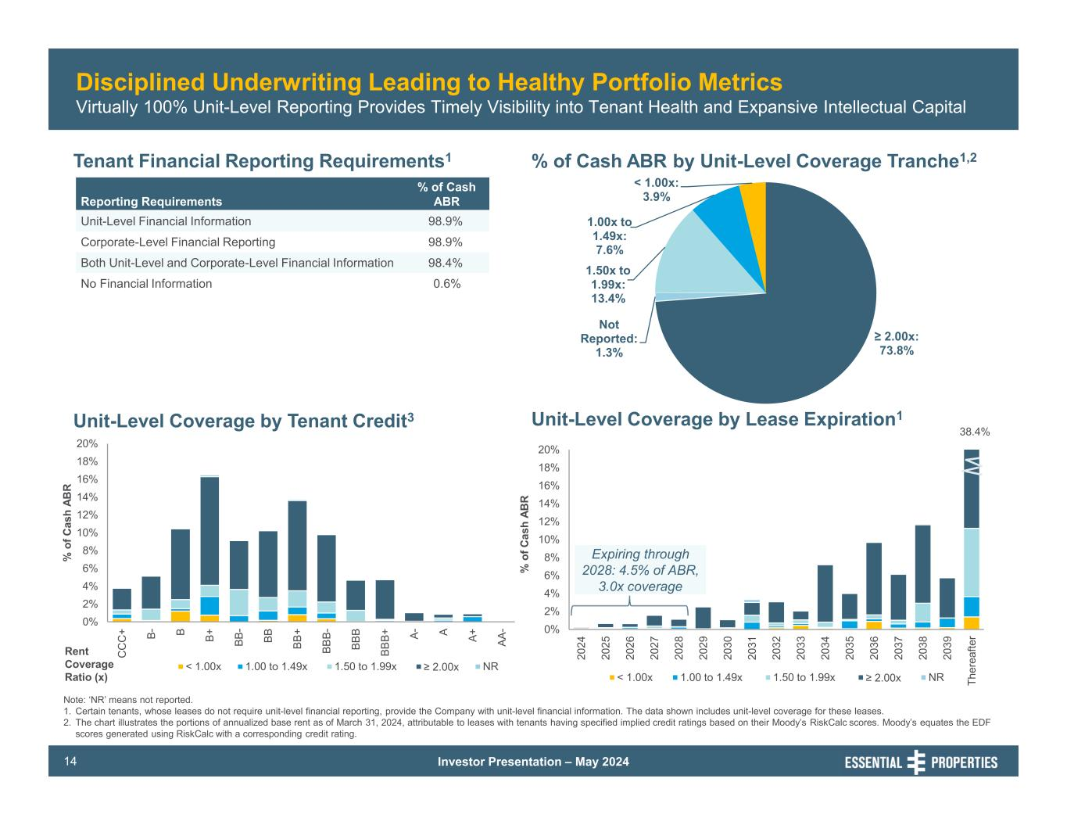
Investor Presentation – May 202414 Tenant Financial Reporting Requirements1 % of Cash ABR by Unit-Level Coverage Tranche1,2 Unit-Level Coverage by Lease Expiration1Unit-Level Coverage by Tenant Credit3 Reporting Requirements % of Cash ABR Unit-Level Financial Information 98.9% Corporate-Level Financial Reporting 98.9% Both Unit-Level and Corporate-Level Financial Information 98.4% No Financial Information 0.6% 38.4% Disciplined Underwriting Leading to Healthy Portfolio Metrics Virtually 100% Unit-Level Reporting Provides Timely Visibility into Tenant Health and Expansive Intellectual Capital ≥ 2.00x: 73.8% Not Reported: 1.3% 1.50x to 1.99x: 13.4% 1.00x to 1.49x: 7.6% < 1.00x: 3.9% 0% 2% 4% 6% 8% 10% 12% 14% 16% 18% 20% C C C + B- B B+ BB - BB BB + BB B- BB B BB B+ A- A A+ AA - % o f C as h AB R < 1.00x 1.00 to 1.49x 1.50 to 1.99x ≥ 2.00x NR Rent Coverage Ratio (x) Note: ‘NR’ means not reported. 1. Certain tenants, whose leases do not require unit-level financial reporting, provide the Company with unit-level financial information. The data shown includes unit-level coverage for these leases. 2. The chart illustrates the portions of annualized base rent as of March 31, 2024, attributable to leases with tenants having specified implied credit ratings based on their Moody’s RiskCalc scores. Moody’s equates the EDF scores generated using RiskCalc with a corresponding credit rating. 0% 2% 4% 6% 8% 10% 12% 14% 16% 18% 20% 20 24 20 25 20 26 20 27 20 28 20 29 20 30 20 31 20 32 20 33 20 34 20 35 20 36 20 37 20 38 20 39 Th er ea fte r % o f C as h AB R < 1.00x 1.00 to 1.49x 1.50 to 1.99x ≥ 2.00x NR Expiring through 2028: 4.5% of ABR, 3.0x coverage

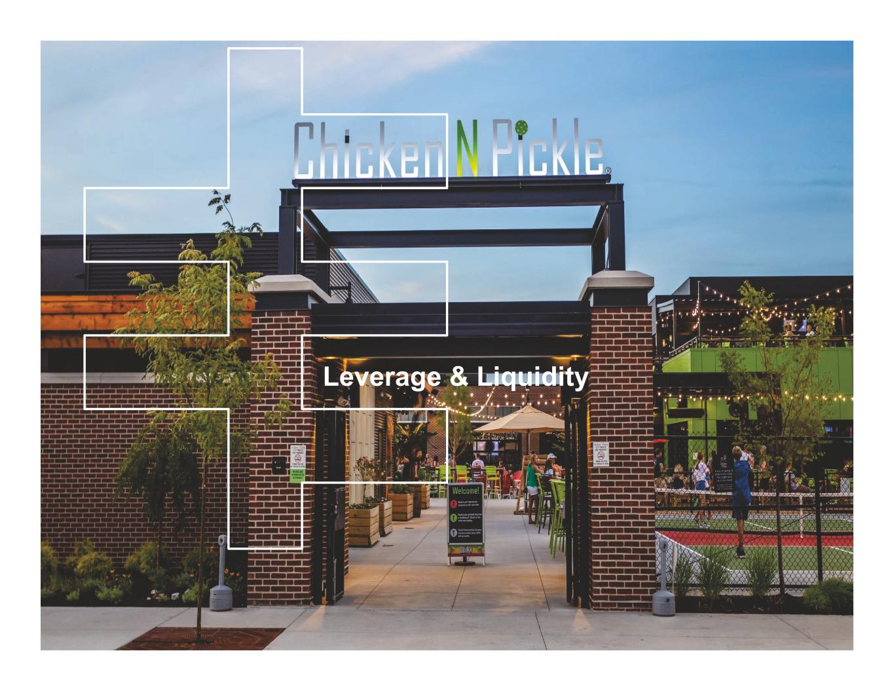
EPRT Board Meeting Management Presentation First Quarter Ended March 31, 2023 Leverage & Liquidity

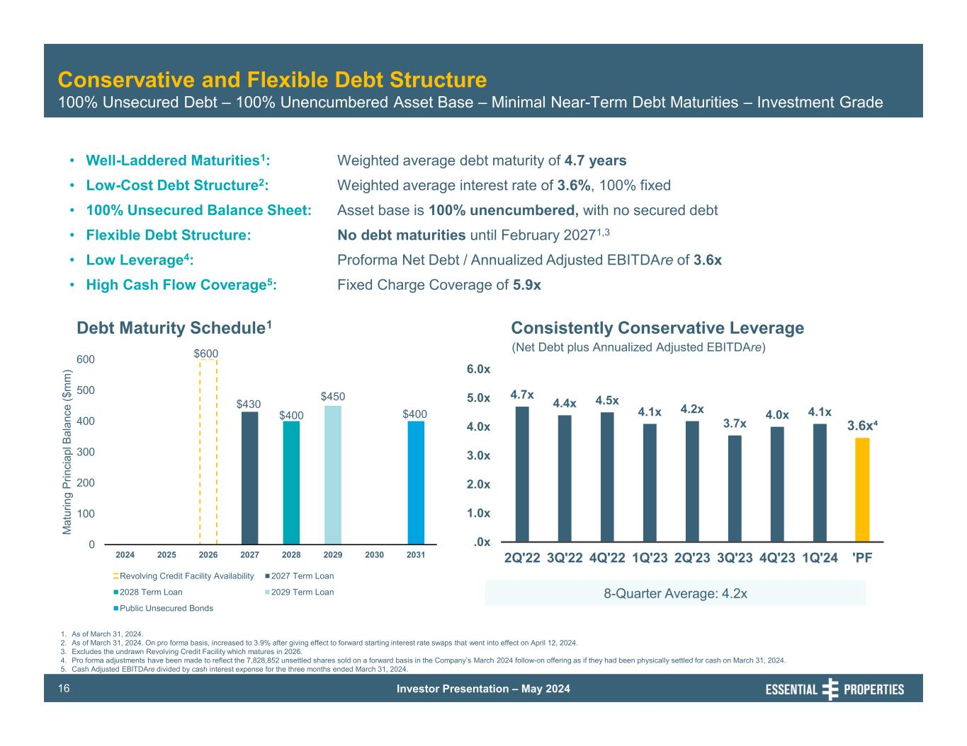
Investor Presentation – May 202416 Conservative and Flexible Debt Structure 100% Unsecured Debt – 100% Unencumbered Asset Base – Minimal Near-Term Debt Maturities – Investment Grade Debt Maturity Schedule1 • Well-Laddered Maturities1: • Low-Cost Debt Structure2: • 100% Unsecured Balance Sheet: • Flexible Debt Structure: • Low Leverage4: • High Cash Flow Coverage5: Weighted average debt maturity of 4.7 years Weighted average interest rate of 3.6%, 100% fixed Asset base is 100% unencumbered, with no secured debt No debt maturities until February 20271,3 Proforma Net Debt / Annualized Adjusted EBITDAre of 3.6x Fixed Charge Coverage of 5.9x 1. As of March 31, 2024. 2. As of March 31, 2024. On pro forma basis, increased to 3.9% after giving effect to forward starting interest rate swaps that went into effect on April 12, 2024. 3. Excludes the undrawn Revolving Credit Facility which matures in 2026. 4. Pro forma adjustments have been made to reflect the 7,828,852 unsettled shares sold on a forward basis in the Company’s March 2024 follow-on offering as if they had been physically settled for cash on March 31, 2024. 5. Cash Adjusted EBITDAre divided by cash interest expense for the three months ended March 31, 2024. (Net Debt plus Annualized Adjusted EBITDAre) Consistently Conservative Leverage 8-Quarter Average: 4.2x $600 $430 $400 $450 $400 0 100 200 300 400 500 600 2024 2025 2026 2027 2028 2029 2030 2031 M at ur in g Pr in ci ap l B al an ce ($ m m ) Revolving Credit Facility Availability 2027 Term Loan 2028 Term Loan 2029 Term Loan Public Unsecured Bonds 4.7x 4.4x 4.5x 4.1x 4.2x 3.7x 4.0x 4.1x 3.6x⁴ .0x 1.0x 2.0x 3.0x 4.0x 5.0x 6.0x 2Q'22 3Q'22 4Q'22 1Q'23 2Q'23 3Q'23 4Q'23 1Q'24 'PF

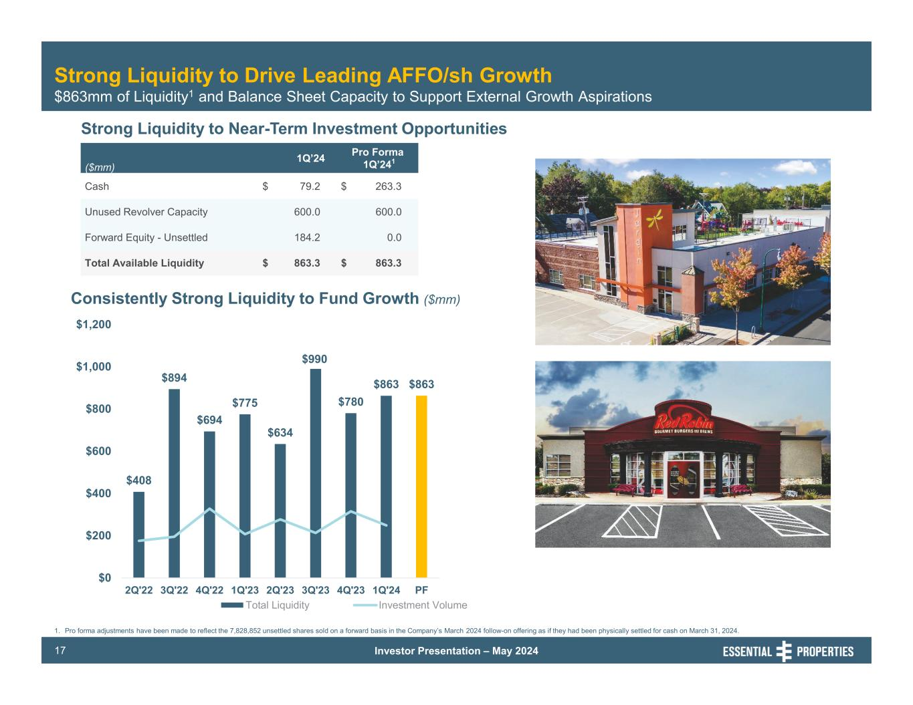
Investor Presentation – May 202417 Consistently Strong Liquidity to Fund Growth ($mm) Strong Liquidity to Drive Leading AFFO/sh Growth $863mm of Liquidity1 and Balance Sheet Capacity to Support External Growth Aspirations ($mm) 1Q’24 Pro Forma 1Q’241 Cash $ 79.2 $ 263.3 Unused Revolver Capacity 600.0 600.0 Forward Equity - Unsettled 184.2 0.0 Total Available Liquidity $ 863.3 $ 863.3 1. Pro forma adjustments have been made to reflect the 7,828,852 unsettled shares sold on a forward basis in the Company’s March 2024 follow-on offering as if they had been physically settled for cash on March 31, 2024. Strong Liquidity to Near-Term Investment Opportunities $408 $894 $694 $775 $634 $990 $780 $863 $863 $0 $200 $400 $600 $800 $1,000 $1,200 2Q'22 3Q'22 4Q'22 1Q'23 2Q'23 3Q'23 4Q'23 1Q'24 PF Total Liquidity Investment Volume

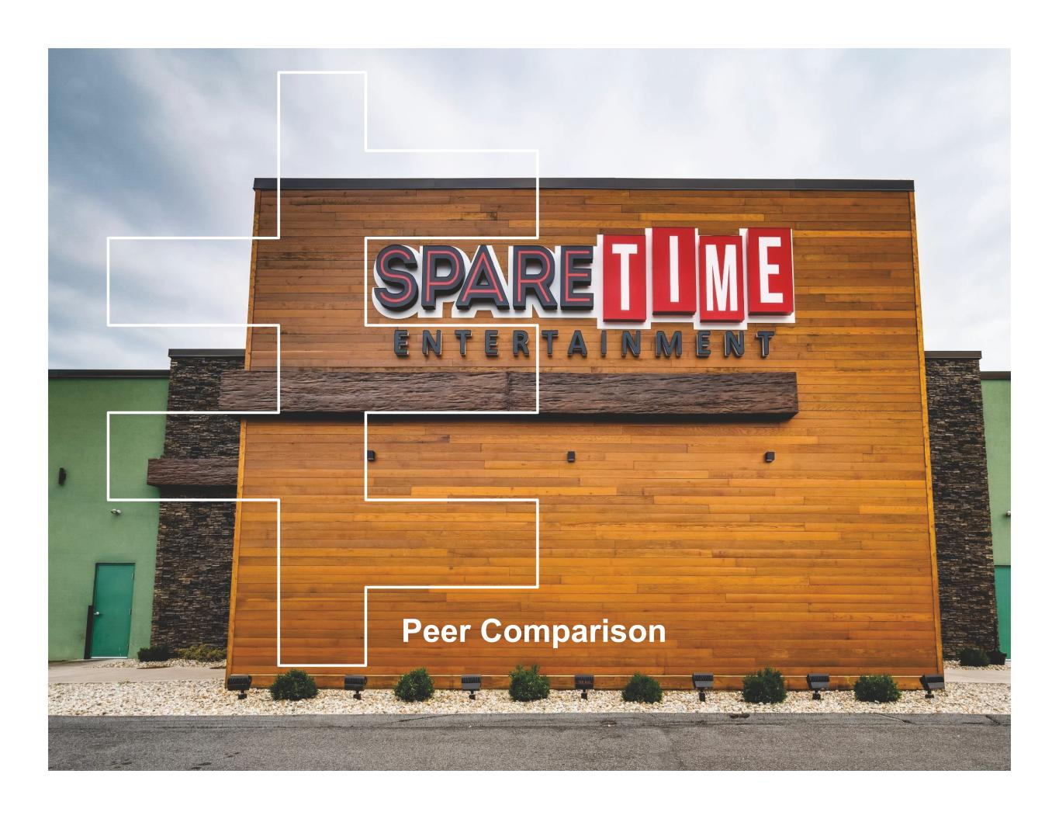
Peer Comparison

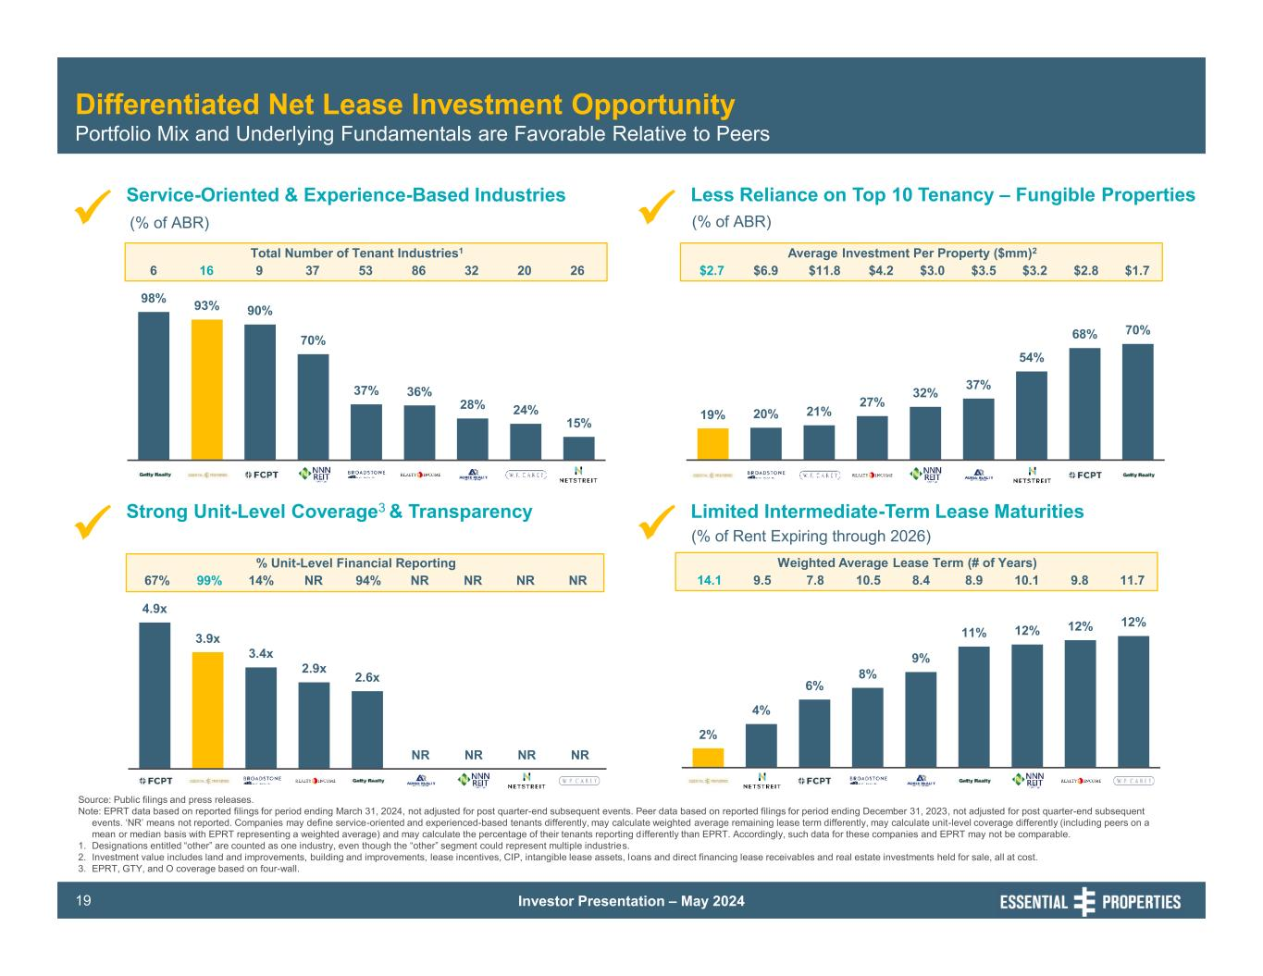
Investor Presentation – May 202419 4.9x 3.9x 3.4x 2.9x 2.6x NR NR NR NR 70% 68% 54% 37% 32% 27% 21% 20% 19% 2% 4% 6% 8% 9% 11% 12% 12% 12% 98% 93% 90% 70% 37% 36% 28% 24% 15% Differentiated Net Lease Investment Opportunity Portfolio Mix and Underlying Fundamentals are Favorable Relative to Peers Strong Unit-Level Coverage3 & Transparency Service-Oriented & Experience-Based Industries Limited Intermediate-Term Lease Maturities Source: Public filings and press releases. Note: EPRT data based on reported filings for period ending March 31, 2024, not adjusted for post quarter-end subsequent events. Peer data based on reported filings for period ending December 31, 2023, not adjusted for post quarter-end subsequent events. ‘NR’ means not reported. Companies may define service-oriented and experienced-based tenants differently, may calculate weighted average remaining lease term differently, may calculate unit-level coverage differently (including peers on a mean or median basis with EPRT representing a weighted average) and may calculate the percentage of their tenants reporting differently than EPRT. Accordingly, such data for these companies and EPRT may not be comparable. 1. Designations entitled “other” are counted as one industry, even though the “other” segment could represent multiple industries. 2. Investment value includes land and improvements, building and improvements, lease incentives, CIP, intangible lease assets, loans and direct financing lease receivables and real estate investments held for sale, all at cost. 3. EPRT, GTY, and O coverage based on four-wall. (% of ABR) (% of Rent Expiring through 2026) Less Reliance on Top 10 Tenancy – Fungible Properties (% of ABR) 6 Total Number of Tenant Industries1 16 9 37 53 86 32 20 26 67% % Unit-Level Financial Reporting 14% NR 94% NR NR99% NR NR $2.7 Average Investment Per Property ($mm)2 $6.9 $11.8 $4.2 $3.0 $3.5 $3.2 $2.8 $1.7 14.1 Weighted Average Lease Term (# of Years) 9.5 7.8 10.5 8.4 8.9 10.1 9.8 11.7

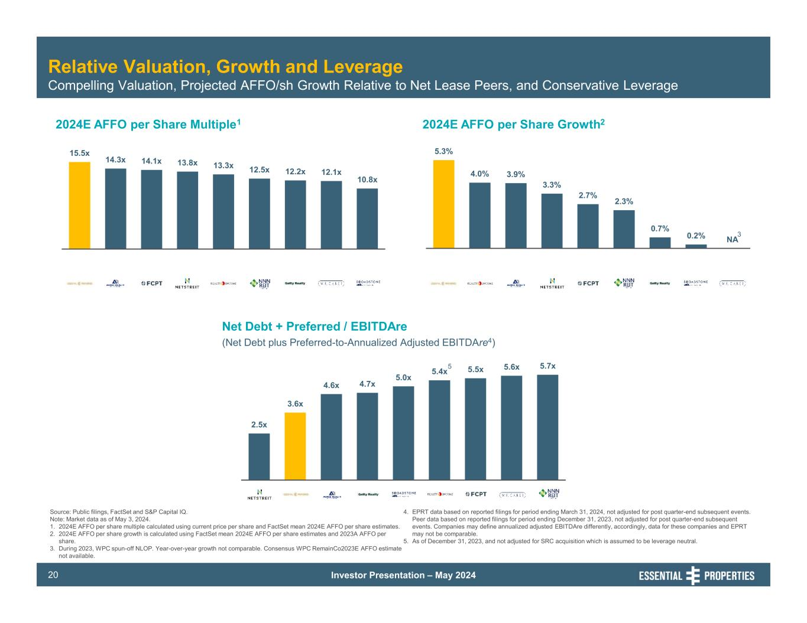
Investor Presentation – May 202420 2.5x 3.6x 4.6x 4.7x 5.0x 5.4x 5.5x 5.6x 5.7x 15.5x 14.3x 14.1x 13.8x 13.3x 12.5x 12.2x 12.1x 10.8x 5.3% 4.0% 3.9% 3.3% 2.7% 2.3% 0.7% 0.2% NA Source: Public filings, FactSet and S&P Capital IQ. Note: Market data as of May 3, 2024. 1. 2024E AFFO per share multiple calculated using current price per share and FactSet mean 2024E AFFO per share estimates. 2. 2024E AFFO per share growth is calculated using FactSet mean 2024E AFFO per share estimates and 2023A AFFO per share. 3. During 2023, WPC spun-off NLOP. Year-over-year growth not comparable. Consensus WPC RemainCo2023E AFFO estimate not available. 4. EPRT data based on reported filings for period ending March 31, 2024, not adjusted for post quarter-end subsequent events. Peer data based on reported filings for period ending December 31, 2023, not adjusted for post quarter-end subsequent events. Companies may define annualized adjusted EBITDAre differently, accordingly, data for these companies and EPRT may not be comparable. 5. As of December 31, 2023, and not adjusted for SRC acquisition which is assumed to be leverage neutral. 2024E AFFO per Share Multiple1 2024E AFFO per Share Growth2 Relative Valuation, Growth and Leverage Compelling Valuation, Projected AFFO/sh Growth Relative to Net Lease Peers, and Conservative Leverage Net Debt + Preferred / EBITDAre (Net Debt plus Preferred-to-Annualized Adjusted EBITDAre4) 3 5

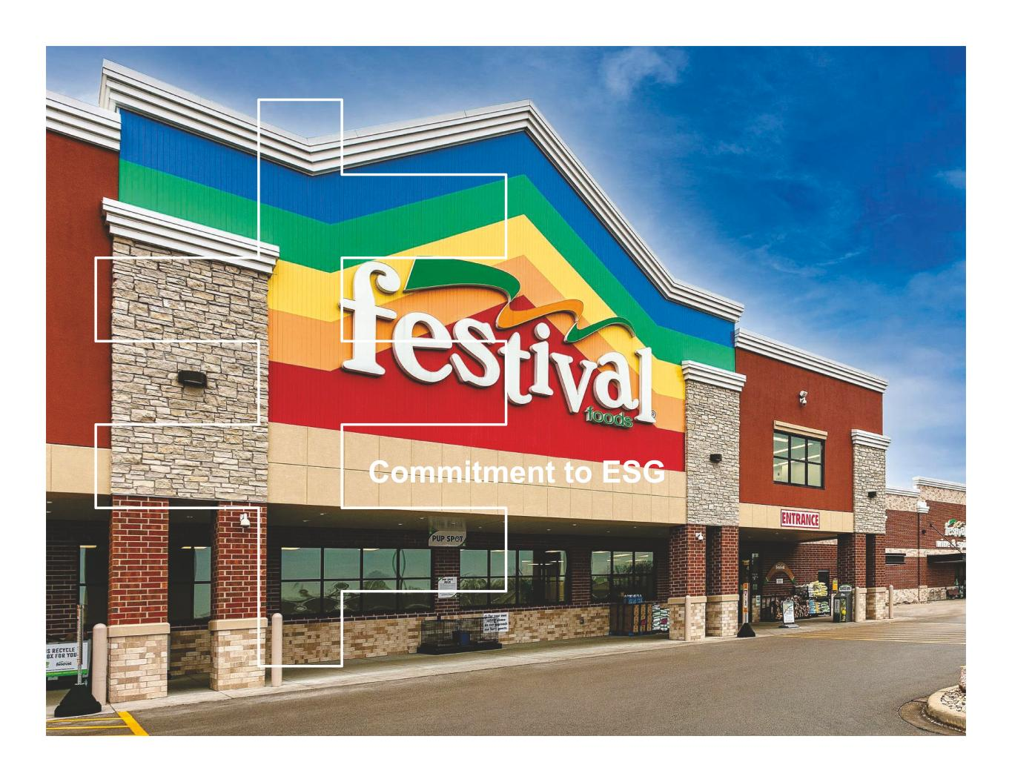
Commitment to ESG

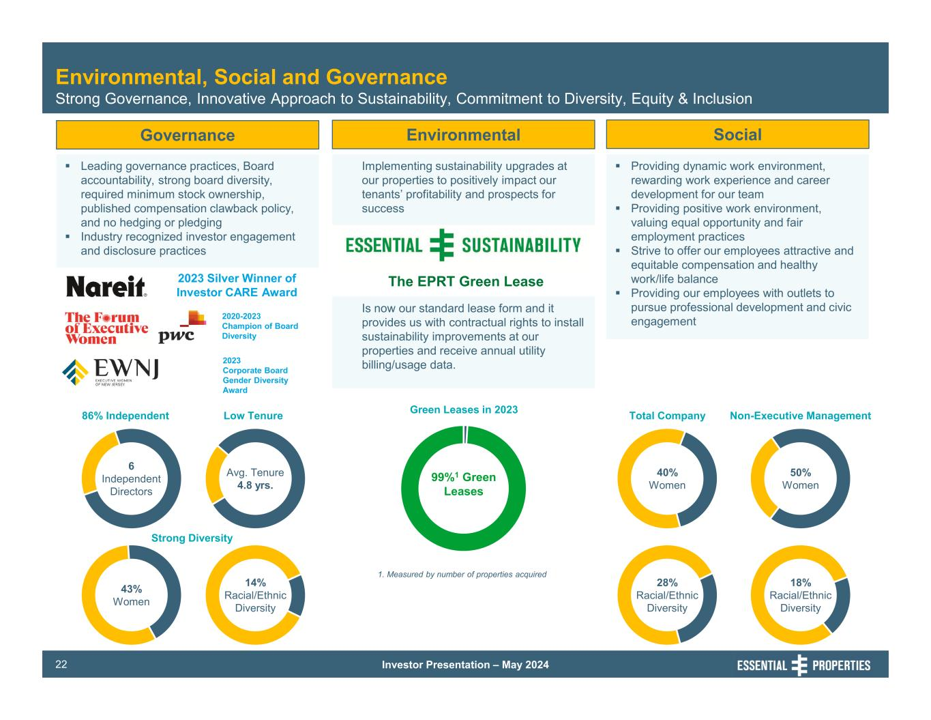
Investor Presentation – May 202422 Governance Leading governance practices, Board accountability, strong board diversity, required minimum stock ownership, published compensation clawback policy, and no hedging or pledging Industry recognized investor engagement and disclosure practices Environmental, Social and Governance Strong Governance, Innovative Approach to Sustainability, Commitment to Diversity, Equity & Inclusion Environmental Social Implementing sustainability upgrades at our properties to positively impact our tenants’ profitability and prospects for success Providing dynamic work environment, rewarding work experience and career development for our team Providing positive work environment, valuing equal opportunity and fair employment practices Strive to offer our employees attractive and equitable compensation and healthy work/life balance Providing our employees with outlets to pursue professional development and civic engagement 28% Racial/Ethnic Diversity 40% Women 50% Women 18% Racial/Ethnic Diversity Total Company Non-Executive Management 99%1 Green Leases 1. Measured by number of properties acquired 2020-2023 Champion of Board Diversity Avg. Tenure 4.8 yrs. 6 Independent Directors 43% Women 14% Racial/Ethnic Diversity Green Leases in 202386% Independent Low Tenure Strong Diversity 2023 Silver Winner of Investor CARE Award Is now our standard lease form and it provides us with contractual rights to install sustainability improvements at our properties and receive annual utility billing/usage data. The EPRT Green Lease 2023 Corporate Board Gender Diversity Award

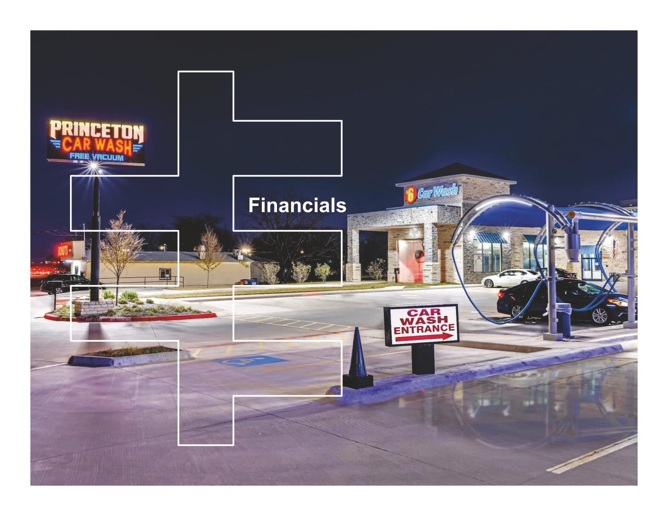
Financials

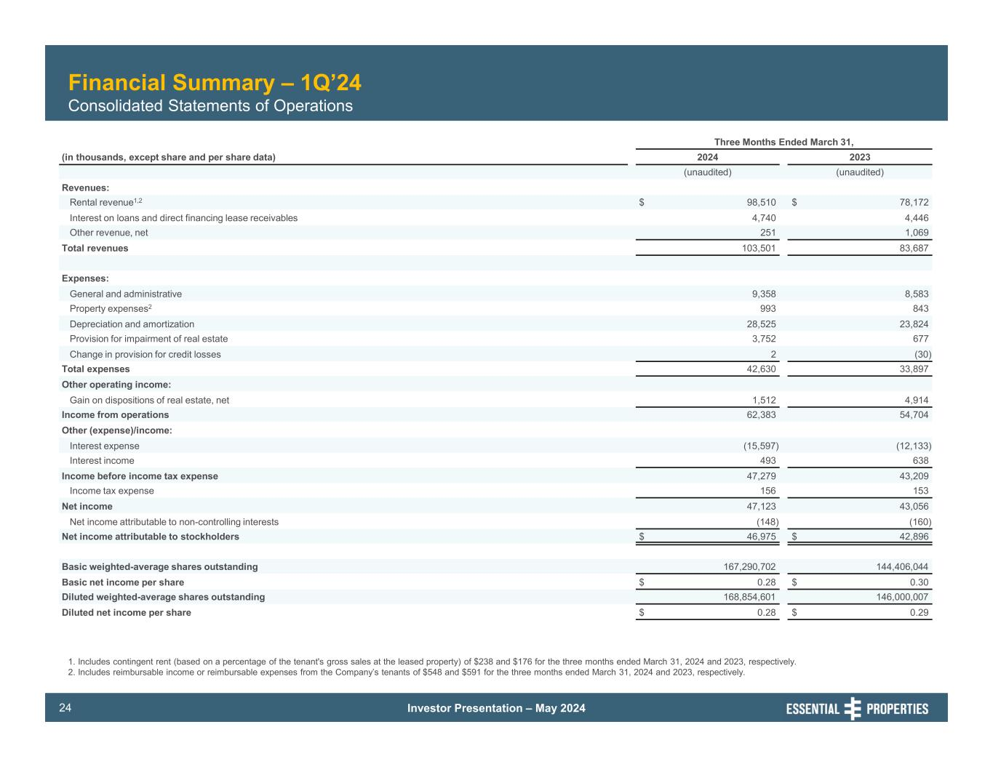
Investor Presentation – May 202424 Financial Summary – 1Q’24 Consolidated Statements of Operations Three Months Ended March 31, (in thousands, except share and per share data) 2024 2023 (unaudited) (unaudited) Revenues: Rental revenue1,2 $ 98,510 $ 78,172 Interest on loans and direct financing lease receivables 4,740 4,446 Other revenue, net 251 1,069 Total revenues 103,501 83,687 Expenses: General and administrative 9,358 8,583 Property expenses2 993 843 Depreciation and amortization 28,525 23,824 Provision for impairment of real estate 3,752 677 Change in provision for credit losses 2 (30) Total expenses 42,630 33,897 Other operating income: Gain on dispositions of real estate, net 1,512 4,914 Income from operations 62,383 54,704 Other (expense)/income: Interest expense (15,597) (12,133) Interest income 493 638 Income before income tax expense 47,279 43,209 Income tax expense 156 153 Net income 47,123 43,056 Net income attributable to non-controlling interests (148) (160) Net income attributable to stockholders $ 46,975 $ 42,896 Basic weighted-average shares outstanding 167,290,702 144,406,044 Basic net income per share $ 0.28 $ 0.30 Diluted weighted-average shares outstanding 168,854,601 146,000,007 Diluted net income per share $ 0.28 $ 0.29 1. Includes contingent rent (based on a percentage of the tenant's gross sales at the leased property) of $238 and $176 for the three months ended March 31, 2024 and 2023, respectively. 2. Includes reimbursable income or reimbursable expenses from the Company’s tenants of $548 and $591 for the three months ended March 31, 2024 and 2023, respectively.

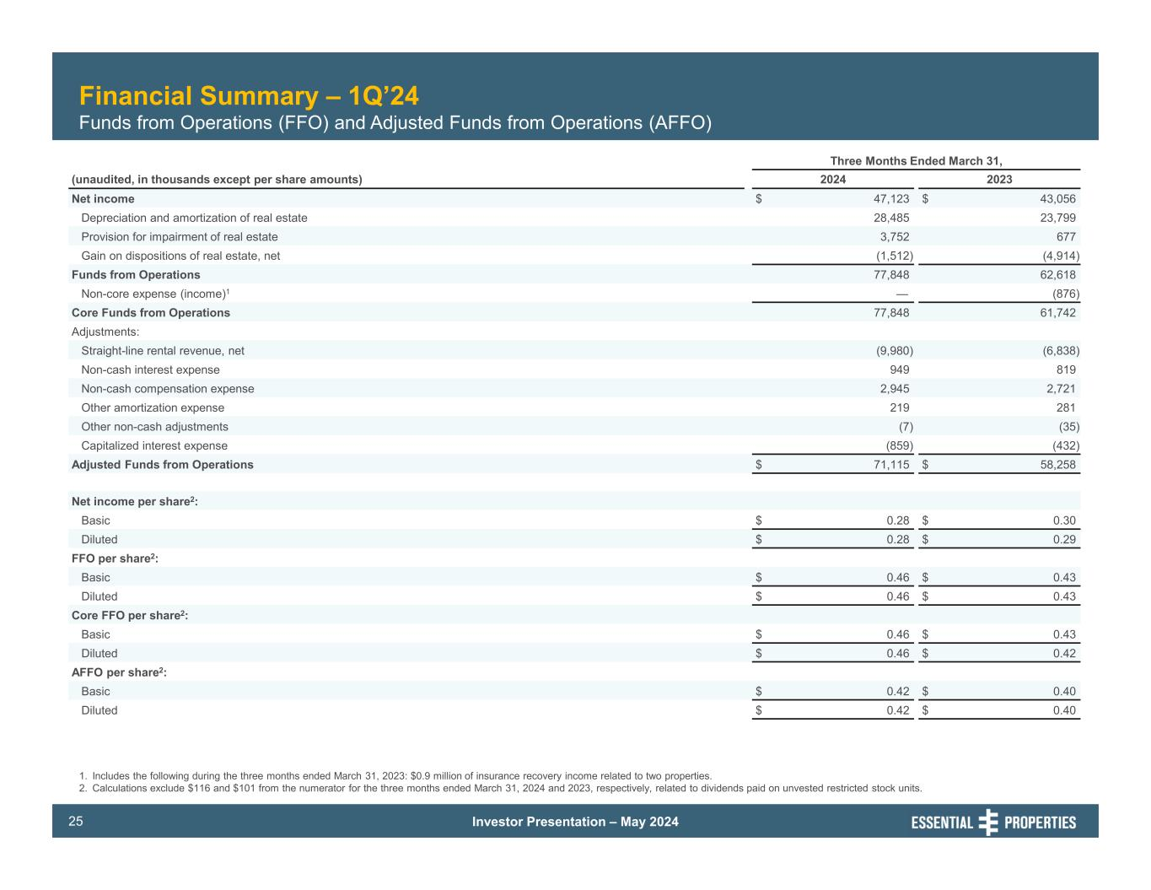
Investor Presentation – May 202425 Financial Summary – 1Q’24 Funds from Operations (FFO) and Adjusted Funds from Operations (AFFO) Three Months Ended March 31, (unaudited, in thousands except per share amounts) 2024 2023 Net income $ 47,123 $ 43,056 Depreciation and amortization of real estate 28,485 23,799 Provision for impairment of real estate 3,752 677 Gain on dispositions of real estate, net (1,512) (4,914) Funds from Operations 77,848 62,618 Non-core expense (income)1 — (876) Core Funds from Operations 77,848 61,742 Adjustments: Straight-line rental revenue, net (9,980) (6,838) Non-cash interest expense 949 819 Non-cash compensation expense 2,945 2,721 Other amortization expense 219 281 Other non-cash adjustments (7) (35) Capitalized interest expense (859) (432) Adjusted Funds from Operations $ 71,115 $ 58,258 Net income per share2: Basic $ 0.28 $ 0.30 Diluted $ 0.28 $ 0.29 FFO per share2: Basic $ 0.46 $ 0.43 Diluted $ 0.46 $ 0.43 Core FFO per share2: Basic $ 0.46 $ 0.43 Diluted $ 0.46 $ 0.42 AFFO per share2: Basic $ 0.42 $ 0.40 Diluted $ 0.42 $ 0.40 1. Includes the following during the three months ended March 31, 2023: $0.9 million of insurance recovery income related to two properties. 2. Calculations exclude $116 and $101 from the numerator for the three months ended March 31, 2024 and 2023, respectively, related to dividends paid on unvested restricted stock units.

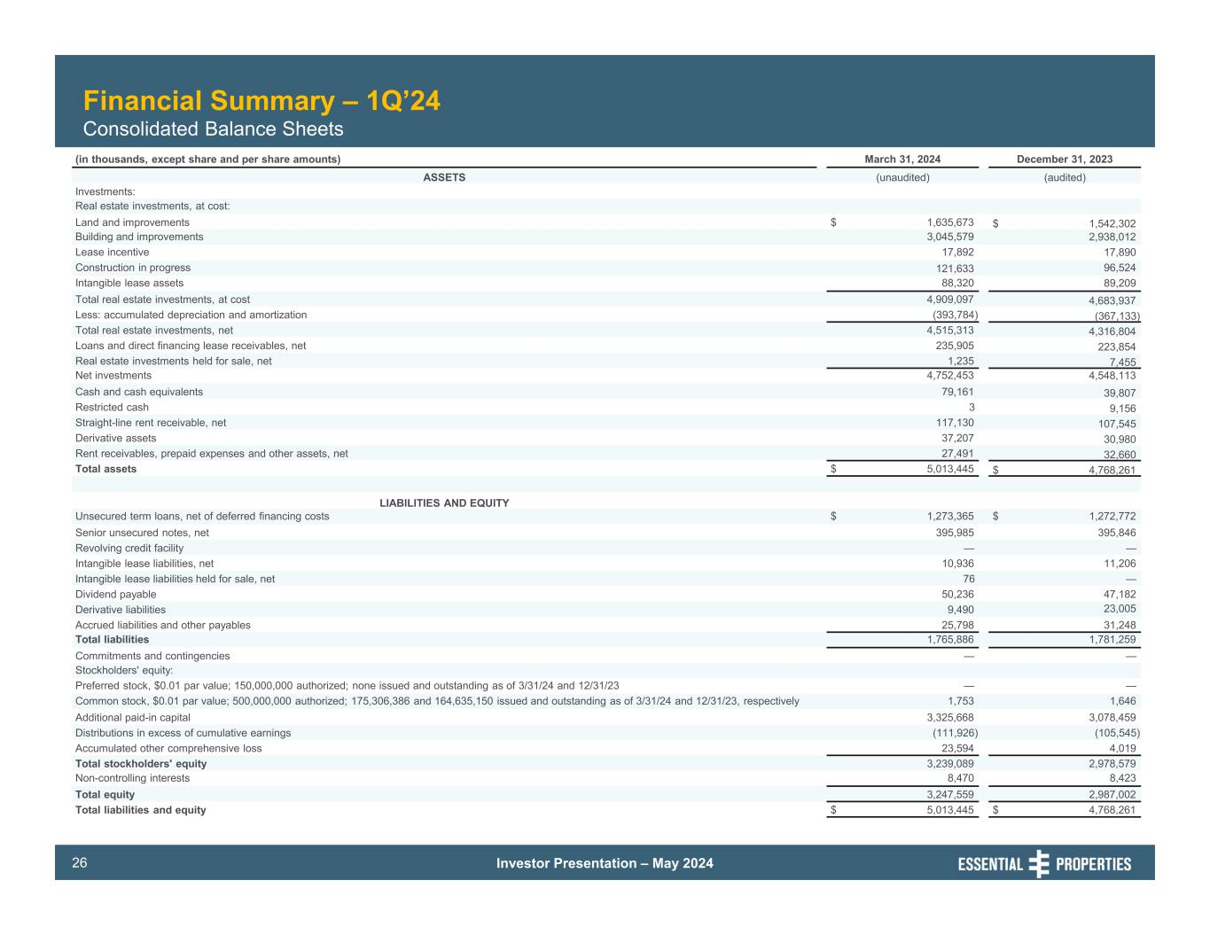
Investor Presentation – May 202426 Financial Summary – 1Q’24 Consolidated Balance Sheets (in thousands, except share and per share amounts) March 31, 2024 December 31, 2023 ASSETS (unaudited) (audited) Investments: Real estate investments, at cost: Land and improvements $ 1,635,673 $ 1,542,302 Building and improvements 3,045,579 2,938,012 Lease incentive 17,892 17,890 Construction in progress 121,633 96,524 Intangible lease assets 88,320 89,209 Total real estate investments, at cost 4,909,097 4,683,937 Less: accumulated depreciation and amortization (393,784) (367,133) Total real estate investments, net 4,515,313 4,316,804 Loans and direct financing lease receivables, net 235,905 223,854 Real estate investments held for sale, net 1,235 7,455 Net investments 4,752,453 4,548,113 Cash and cash equivalents 79,161 39,807 Restricted cash 3 9,156 Straight-line rent receivable, net 117,130 107,545 Derivative assets 37,207 30,980 Rent receivables, prepaid expenses and other assets, net 27,491 32,660 Total assets $ 5,013,445 $ 4,768,261 LIABILITIES AND EQUITY Unsecured term loans, net of deferred financing costs $ 1,273,365 $ 1,272,772 Senior unsecured notes, net 395,985 395,846 Revolving credit facility — — Intangible lease liabilities, net 10,936 11,206 Intangible lease liabilities held for sale, net 76 — Dividend payable 50,236 47,182 Derivative liabilities 9,490 23,005 Accrued liabilities and other payables 25,798 31,248 Total liabilities 1,765,886 1,781,259 Commitments and contingencies — — Stockholders' equity: Preferred stock, $0.01 par value; 150,000,000 authorized; none issued and outstanding as of 3/31/24 and 12/31/23 — — Common stock, $0.01 par value; 500,000,000 authorized; 175,306,386 and 164,635,150 issued and outstanding as of 3/31/24 and 12/31/23, respectively 1,753 1,646 Additional paid-in capital 3,325,668 3,078,459 Distributions in excess of cumulative earnings (111,926) (105,545) Accumulated other comprehensive loss 23,594 4,019 Total stockholders' equity 3,239,089 2,978,579 Non-controlling interests 8,470 8,423 Total equity 3,247,559 2,987,002 Total liabilities and equity $ 5,013,445 $ 4,768,261

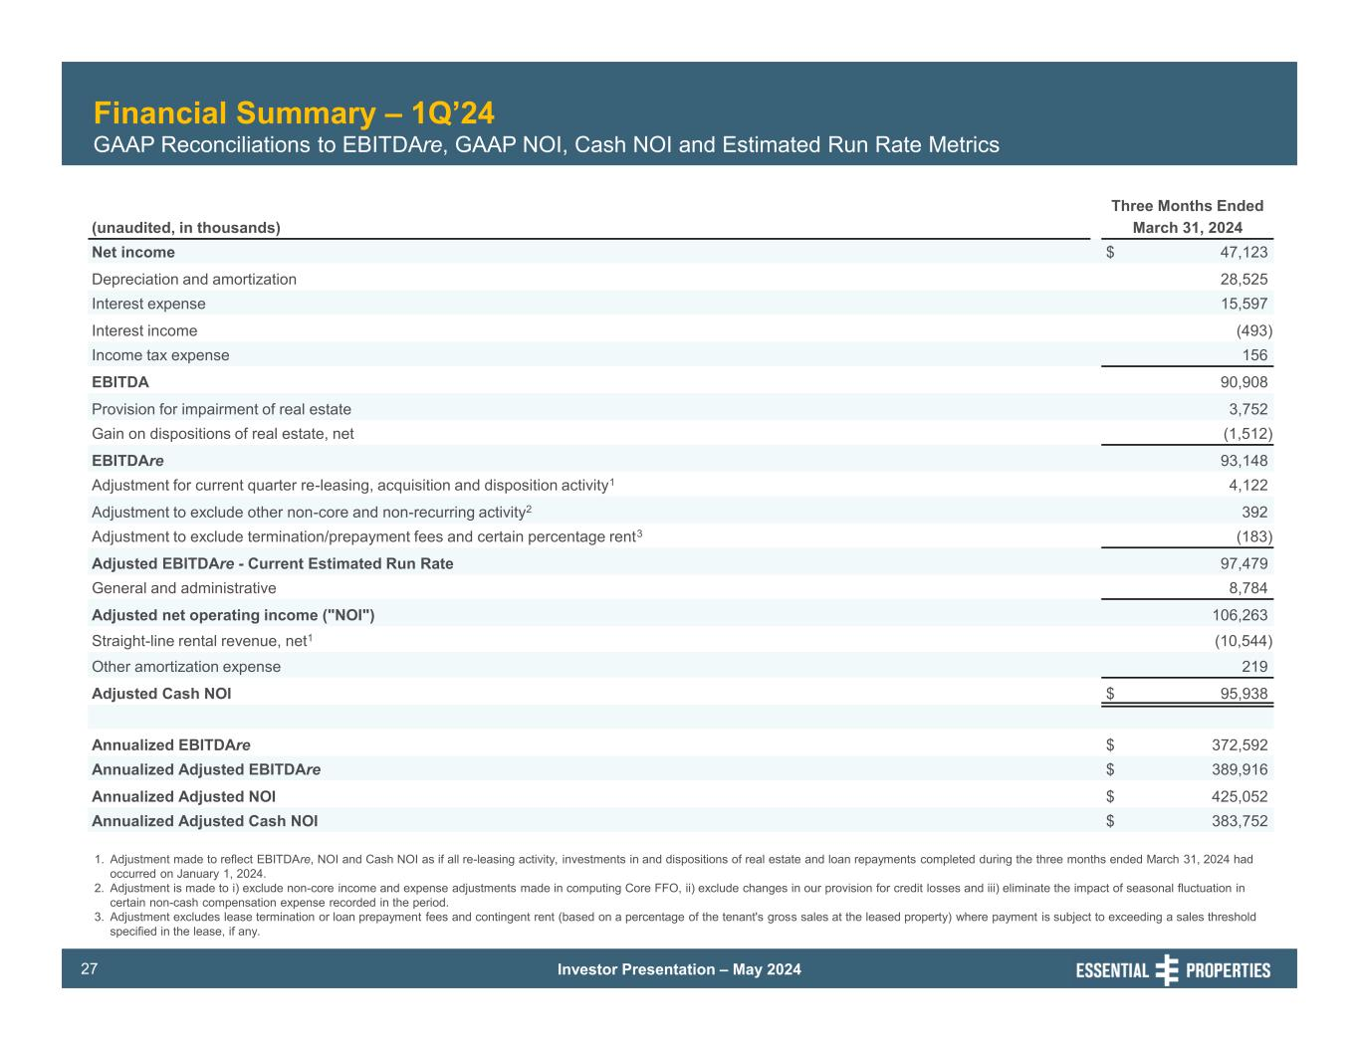
Investor Presentation – May 202427 Financial Summary – 1Q’24 GAAP Reconciliations to EBITDAre, GAAP NOI, Cash NOI and Estimated Run Rate Metrics Three Months Ended (unaudited, in thousands) March 31, 2024 Net income $ 47,123 Depreciation and amortization 28,525 Interest expense 15,597 Interest income (493) Income tax expense 156 EBITDA 90,908 Provision for impairment of real estate 3,752 Gain on dispositions of real estate, net (1,512) EBITDAre 93,148 Adjustment for current quarter re-leasing, acquisition and disposition activity1 4,122 Adjustment to exclude other non-core and non-recurring activity2 392 Adjustment to exclude termination/prepayment fees and certain percentage rent3 (183) Adjusted EBITDAre - Current Estimated Run Rate 97,479 General and administrative 8,784 Adjusted net operating income ("NOI") 106,263 Straight-line rental revenue, net1 (10,544) Other amortization expense 219 Adjusted Cash NOI $ 95,938 Annualized EBITDAre $ 372,592 Annualized Adjusted EBITDAre $ 389,916 Annualized Adjusted NOI $ 425,052 Annualized Adjusted Cash NOI $ 383,752 1. Adjustment made to reflect EBITDAre, NOI and Cash NOI as if all re-leasing activity, investments in and dispositions of real estate and loan repayments completed during the three months ended March 31, 2024 had occurred on January 1, 2024. 2. Adjustment is made to i) exclude non-core income and expense adjustments made in computing Core FFO, ii) exclude changes in our provision for credit losses and iii) eliminate the impact of seasonal fluctuation in certain non-cash compensation expense recorded in the period. 3. Adjustment excludes lease termination or loan prepayment fees and contingent rent (based on a percentage of the tenant's gross sales at the leased property) where payment is subject to exceeding a sales threshold specified in the lease, if any.

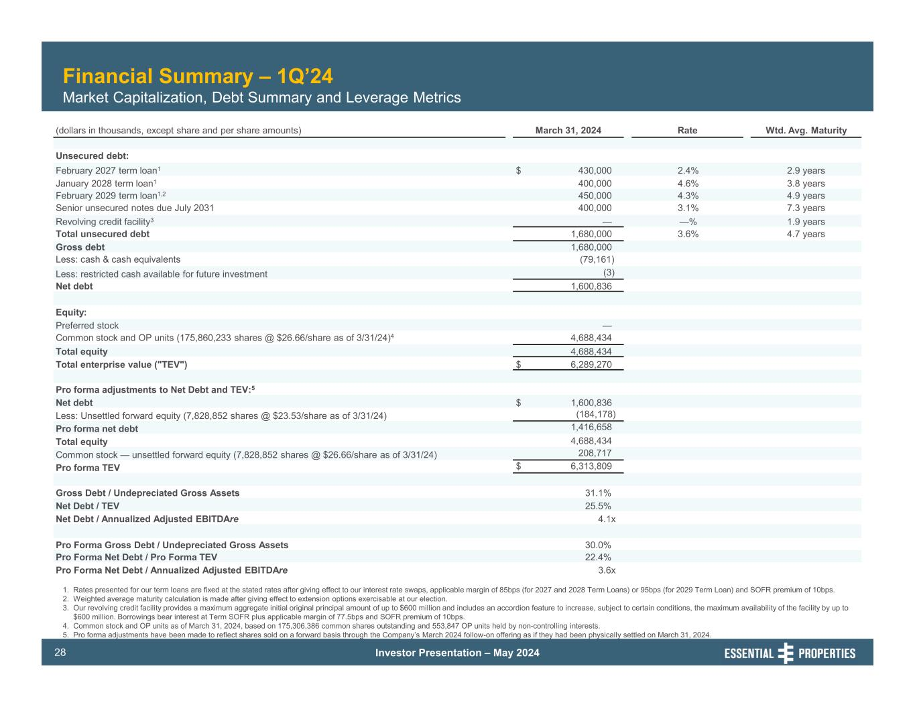
Investor Presentation – May 202428 Financial Summary – 1Q’24 Market Capitalization, Debt Summary and Leverage Metrics (dollars in thousands, except share and per share amounts) March 31, 2024 Rate Wtd. Avg. Maturity Unsecured debt: February 2027 term loan1 $ 430,000 2.4% 2.9 years January 2028 term loan1 400,000 4.6% 3.8 years February 2029 term loan1,2 450,000 4.3% 4.9 years Senior unsecured notes due July 2031 400,000 3.1% 7.3 years Revolving credit facility3 — —% 1.9 years Total unsecured debt 1,680,000 3.6% 4.7 years Gross debt 1,680,000 Less: cash & cash equivalents (79,161) Less: restricted cash available for future investment (3) Net debt 1,600,836 Equity: Preferred stock — Common stock and OP units (175,860,233 shares @ $26.66/share as of 3/31/24)4 4,688,434 Total equity 4,688,434 Total enterprise value ("TEV") $ 6,289,270 Pro forma adjustments to Net Debt and TEV:5 Net debt $ 1,600,836 Less: Unsettled forward equity (7,828,852 shares @ $23.53/share as of 3/31/24) (184,178) Pro forma net debt 1,416,658 Total equity 4,688,434 Common stock — unsettled forward equity (7,828,852 shares @ $26.66/share as of 3/31/24) 208,717 Pro forma TEV $ 6,313,809 Gross Debt / Undepreciated Gross Assets 31.1% Net Debt / TEV 25.5% Net Debt / Annualized Adjusted EBITDAre 4.1x Pro Forma Gross Debt / Undepreciated Gross Assets 30.0% Pro Forma Net Debt / Pro Forma TEV 22.4% Pro Forma Net Debt / Annualized Adjusted EBITDAre 3.6x 1. Rates presented for our term loans are fixed at the stated rates after giving effect to our interest rate swaps, applicable margin of 85bps (for 2027 and 2028 Term Loans) or 95bps (for 2029 Term Loan) and SOFR premium of 10bps. 2. Weighted average maturity calculation is made after giving effect to extension options exercisable at our election. 3. Our revolving credit facility provides a maximum aggregate initial original principal amount of up to $600 million and includes an accordion feature to increase, subject to certain conditions, the maximum availability of the facility by up to $600 million. Borrowings bear interest at Term SOFR plus applicable margin of 77.5bps and SOFR premium of 10bps. 4. Common stock and OP units as of March 31, 2024, based on 175,306,386 common shares outstanding and 553,847 OP units held by non-controlling interests. 5. Pro forma adjustments have been made to reflect shares sold on a forward basis through the Company’s March 2024 follow-on offering as if they had been physically settled on March 31, 2024.

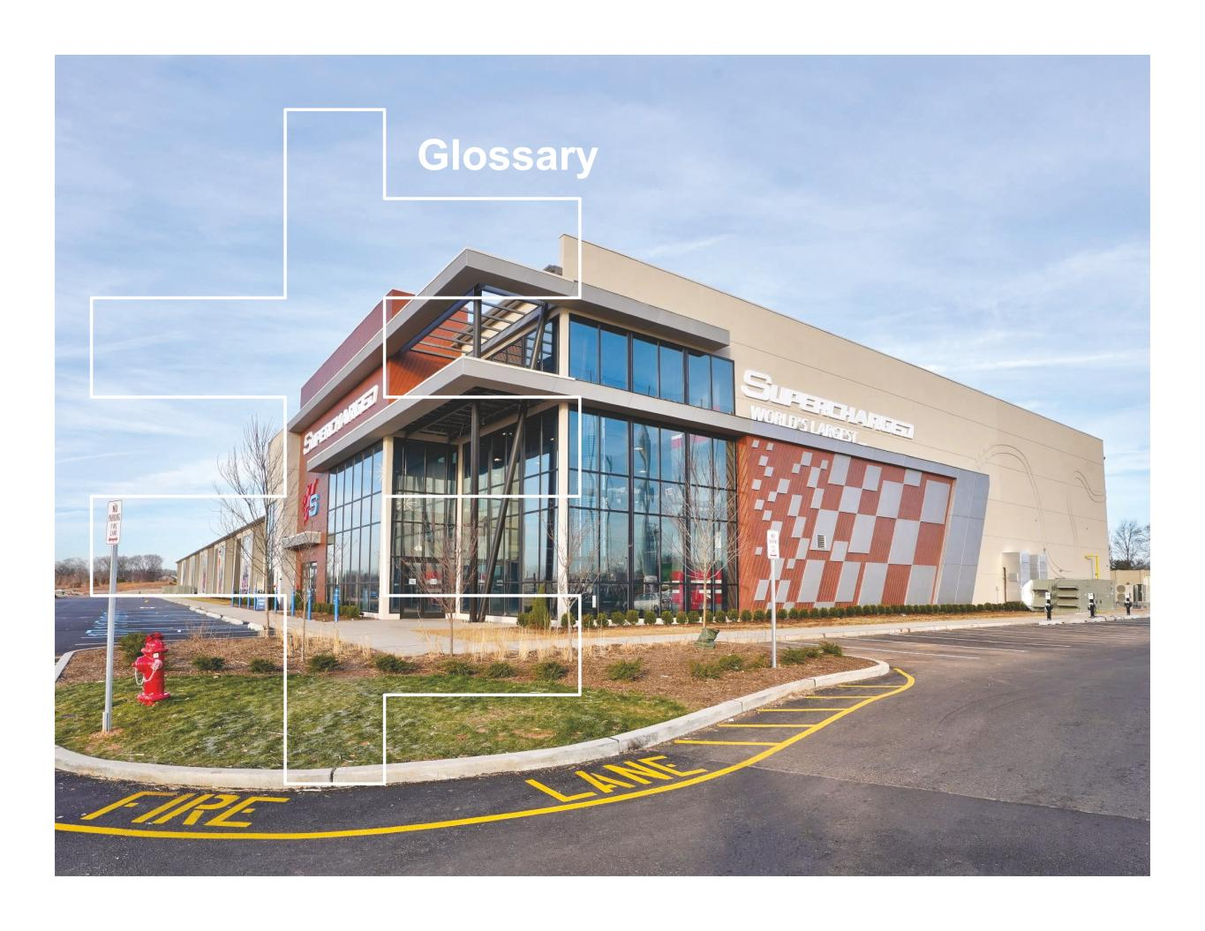
Glossary

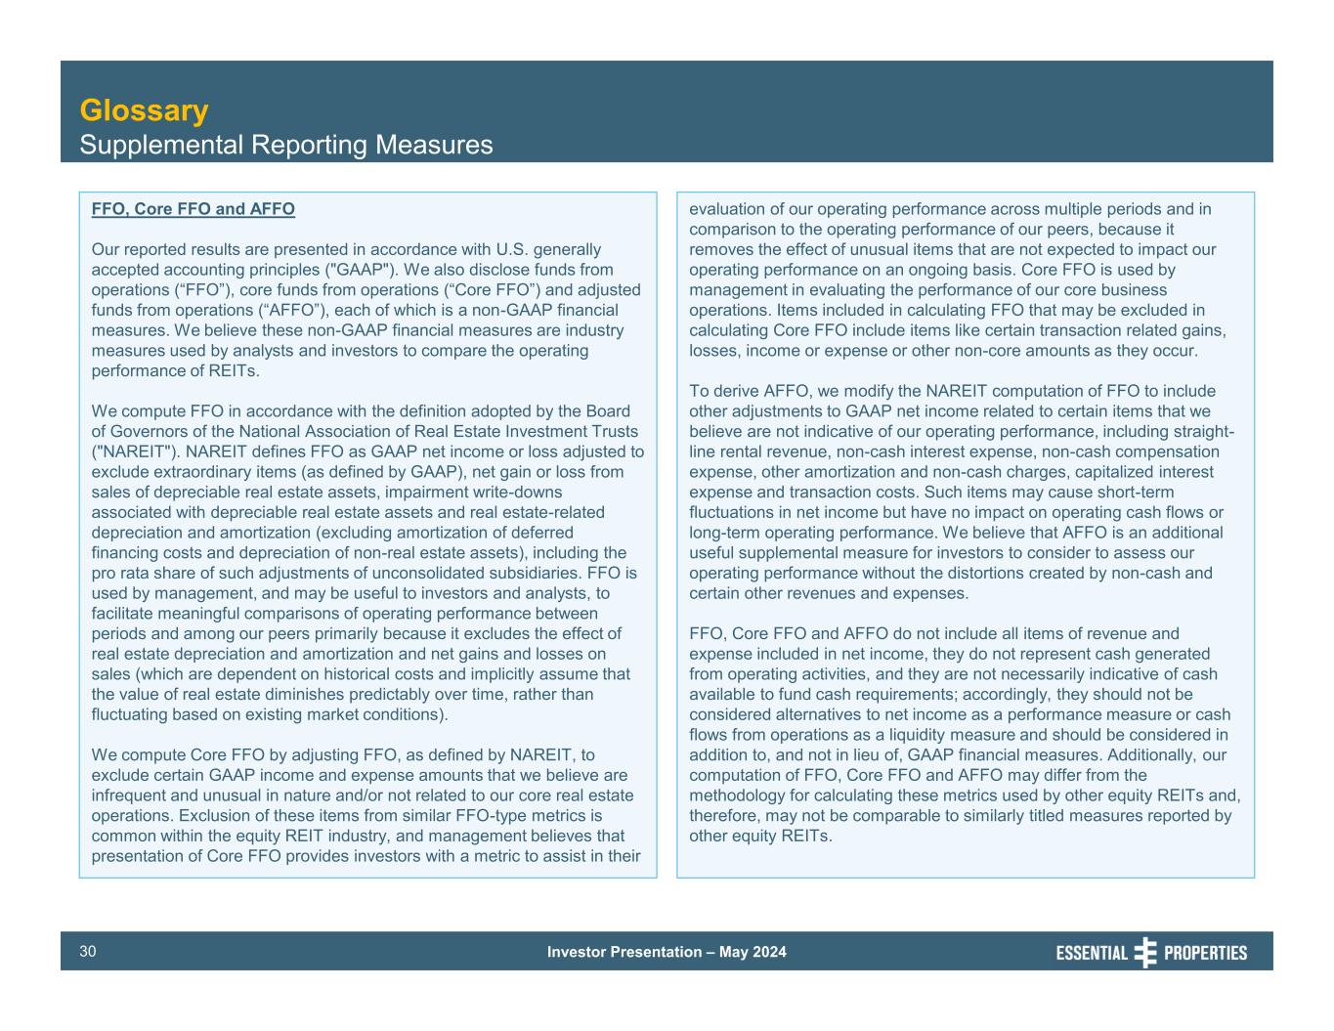
Investor Presentation – May 202430 Glossary Supplemental Reporting Measures FFO, Core FFO and AFFO Our reported results are presented in accordance with U.S. generally accepted accounting principles ("GAAP"). We also disclose funds from operations (“FFO”), core funds from operations (“Core FFO”) and adjusted funds from operations (“AFFO”), each of which is a non-GAAP financial measures. We believe these non-GAAP financial measures are industry measures used by analysts and investors to compare the operating performance of REITs. We compute FFO in accordance with the definition adopted by the Board of Governors of the National Association of Real Estate Investment Trusts ("NAREIT"). NAREIT defines FFO as GAAP net income or loss adjusted to exclude extraordinary items (as defined by GAAP), net gain or loss from sales of depreciable real estate assets, impairment write-downs associated with depreciable real estate assets and real estate-related depreciation and amortization (excluding amortization of deferred financing costs and depreciation of non-real estate assets), including the pro rata share of such adjustments of unconsolidated subsidiaries. FFO is used by management, and may be useful to investors and analysts, to facilitate meaningful comparisons of operating performance between periods and among our peers primarily because it excludes the effect of real estate depreciation and amortization and net gains and losses on sales (which are dependent on historical costs and implicitly assume that the value of real estate diminishes predictably over time, rather than fluctuating based on existing market conditions). We compute Core FFO by adjusting FFO, as defined by NAREIT, to exclude certain GAAP income and expense amounts that we believe are infrequent and unusual in nature and/or not related to our core real estate operations. Exclusion of these items from similar FFO-type metrics is common within the equity REIT industry, and management believes that presentation of Core FFO provides investors with a metric to assist in their evaluation of our operating performance across multiple periods and in comparison to the operating performance of our peers, because it removes the effect of unusual items that are not expected to impact our operating performance on an ongoing basis. Core FFO is used by management in evaluating the performance of our core business operations. Items included in calculating FFO that may be excluded in calculating Core FFO include items like certain transaction related gains, losses, income or expense or other non-core amounts as they occur. To derive AFFO, we modify the NAREIT computation of FFO to include other adjustments to GAAP net income related to certain items that we believe are not indicative of our operating performance, including straight- line rental revenue, non-cash interest expense, non-cash compensation expense, other amortization and non-cash charges, capitalized interest expense and transaction costs. Such items may cause short-term fluctuations in net income but have no impact on operating cash flows or long-term operating performance. We believe that AFFO is an additional useful supplemental measure for investors to consider to assess our operating performance without the distortions created by non-cash and certain other revenues and expenses. FFO, Core FFO and AFFO do not include all items of revenue and expense included in net income, they do not represent cash generated from operating activities, and they are not necessarily indicative of cash available to fund cash requirements; accordingly, they should not be considered alternatives to net income as a performance measure or cash flows from operations as a liquidity measure and should be considered in addition to, and not in lieu of, GAAP financial measures. Additionally, our computation of FFO, Core FFO and AFFO may differ from the methodology for calculating these metrics used by other equity REITs and, therefore, may not be comparable to similarly titled measures reported by other equity REITs.

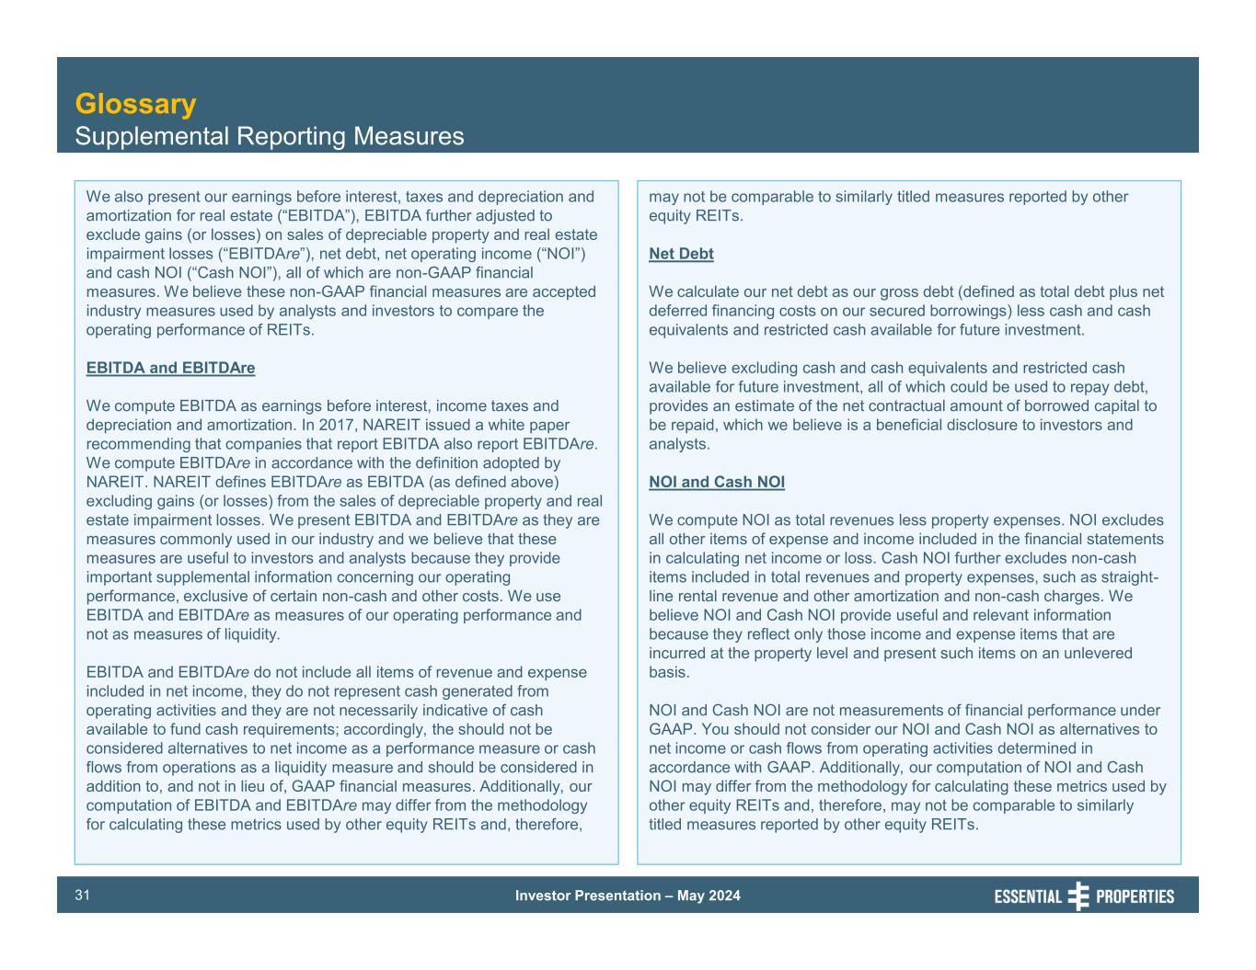
Investor Presentation – May 202431 Glossary Supplemental Reporting Measures We also present our earnings before interest, taxes and depreciation and amortization for real estate (“EBITDA”), EBITDA further adjusted to exclude gains (or losses) on sales of depreciable property and real estate impairment losses (“EBITDAre”), net debt, net operating income (“NOI”) and cash NOI (“Cash NOI”), all of which are non-GAAP financial measures. We believe these non-GAAP financial measures are accepted industry measures used by analysts and investors to compare the operating performance of REITs. EBITDA and EBITDAre We compute EBITDA as earnings before interest, income taxes and depreciation and amortization. In 2017, NAREIT issued a white paper recommending that companies that report EBITDA also report EBITDAre. We compute EBITDAre in accordance with the definition adopted by NAREIT. NAREIT defines EBITDAre as EBITDA (as defined above) excluding gains (or losses) from the sales of depreciable property and real estate impairment losses. We present EBITDA and EBITDAre as they are measures commonly used in our industry and we believe that these measures are useful to investors and analysts because they provide important supplemental information concerning our operating performance, exclusive of certain non-cash and other costs. We use EBITDA and EBITDAre as measures of our operating performance and not as measures of liquidity. EBITDA and EBITDAre do not include all items of revenue and expense included in net income, they do not represent cash generated from operating activities and they are not necessarily indicative of cash available to fund cash requirements; accordingly, the should not be considered alternatives to net income as a performance measure or cash flows from operations as a liquidity measure and should be considered in addition to, and not in lieu of, GAAP financial measures. Additionally, our computation of EBITDA and EBITDAre may differ from the methodology for calculating these metrics used by other equity REITs and, therefore, may not be comparable to similarly titled measures reported by other equity REITs. Net Debt We calculate our net debt as our gross debt (defined as total debt plus net deferred financing costs on our secured borrowings) less cash and cash equivalents and restricted cash available for future investment. We believe excluding cash and cash equivalents and restricted cash available for future investment, all of which could be used to repay debt, provides an estimate of the net contractual amount of borrowed capital to be repaid, which we believe is a beneficial disclosure to investors and analysts. NOI and Cash NOI We compute NOI as total revenues less property expenses. NOI excludes all other items of expense and income included in the financial statements in calculating net income or loss. Cash NOI further excludes non-cash items included in total revenues and property expenses, such as straight- line rental revenue and other amortization and non-cash charges. We believe NOI and Cash NOI provide useful and relevant information because they reflect only those income and expense items that are incurred at the property level and present such items on an unlevered basis. NOI and Cash NOI are not measurements of financial performance under GAAP. You should not consider our NOI and Cash NOI as alternatives to net income or cash flows from operating activities determined in accordance with GAAP. Additionally, our computation of NOI and Cash NOI may differ from the methodology for calculating these metrics used by other equity REITs and, therefore, may not be comparable to similarly titled measures reported by other equity REITs.

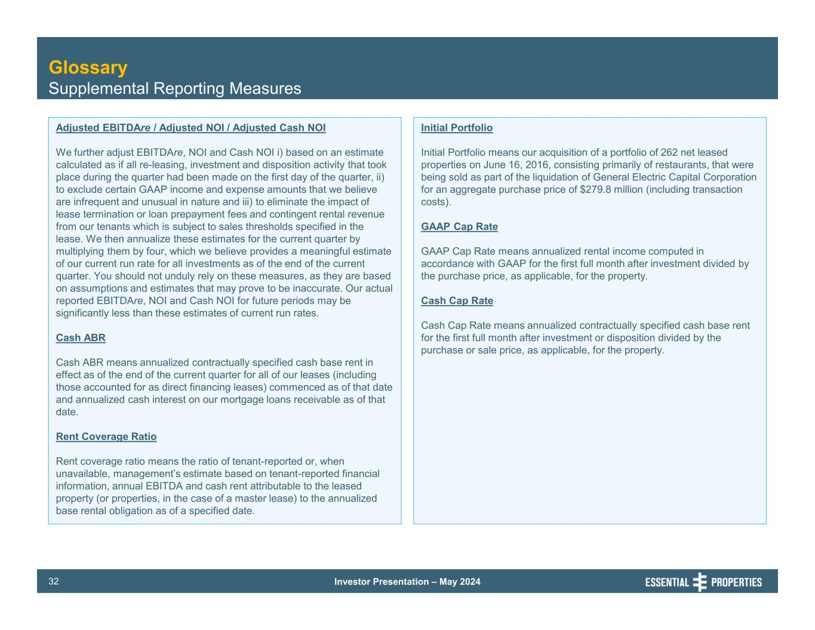
Investor Presentation – May 202432 Glossary Supplemental Reporting Measures Adjusted EBITDAre / Adjusted NOI / Adjusted Cash NOI We further adjust EBITDAre, NOI and Cash NOI i) based on an estimate calculated as if all re-leasing, investment and disposition activity that took place during the quarter had been made on the first day of the quarter, ii) to exclude certain GAAP income and expense amounts that we believe are infrequent and unusual in nature and iii) to eliminate the impact of lease termination or loan prepayment fees and contingent rental revenue from our tenants which is subject to sales thresholds specified in the lease. We then annualize these estimates for the current quarter by multiplying them by four, which we believe provides a meaningful estimate of our current run rate for all investments as of the end of the current quarter. You should not unduly rely on these measures, as they are based on assumptions and estimates that may prove to be inaccurate. Our actual reported EBITDAre, NOI and Cash NOI for future periods may be significantly less than these estimates of current run rates. Cash ABR Cash ABR means annualized contractually specified cash base rent in effect as of the end of the current quarter for all of our leases (including those accounted for as direct financing leases) commenced as of that date and annualized cash interest on our mortgage loans receivable as of that date. Rent Coverage Ratio Rent coverage ratio means the ratio of tenant-reported or, when unavailable, management’s estimate based on tenant-reported financial information, annual EBITDA and cash rent attributable to the leased property (or properties, in the case of a master lease) to the annualized base rental obligation as of a specified date. Initial Portfolio Initial Portfolio means our acquisition of a portfolio of 262 net leased properties on June 16, 2016, consisting primarily of restaurants, that were being sold as part of the liquidation of General Electric Capital Corporation for an aggregate purchase price of $279.8 million (including transaction costs). GAAP Cap Rate GAAP Cap Rate means annualized rental income computed in accordance with GAAP for the first full month after investment divided by the purchase price, as applicable, for the property. Cash Cap Rate Cash Cap Rate means annualized contractually specified cash base rent for the first full month after investment or disposition divided by the purchase or sale price, as applicable, for the property.

