UNITED STATES
SECURITIES AND EXCHANGE COMMISSION
Washington, D.C. 20549

FORM 8-K

CURRENT REPORT

Pursuant to Section 13 or 15(d)
of the Securities Exchange Act of 1934

November 6, 2019
Date of Report (Date of earliest event reported)

Essential Properties Realty Trust, Inc.
(Exact name of registrant as specified in its charter)

Maryland  (State or other jurisdiction of incorporation) |  | 001-38530  (Commission File Number) |  | 82-4005693  (IRS Employer Identification No.)

902 Carnegie Center Blvd., Suite 520  Princeton, New Jersey  (Address of principal executive offices) |  | 08540  (Zip Code)

Registrant’s telephone number, including area code: (609) 436-0619

Securities registered pursuant to Section 12(b) of the Act:
Title of Each Class | Trading Symbol(s) | Name of Each Exchange on Which Registered
Common Stock, $0.01 par value | EPRT | New York Stock Exchange

Check the appropriate box below if the Form 8-K filing is intended to simultaneously satisfy the filing obligations of the registrant under any of the following provisions:

☐ Written communications pursuant to Rule 425 under the Securities Act (17 CFR 230.425)

☐ Soliciting material pursuant to Rule 14a-12 under the Exchange Act (17 CFR 240.14a-12)

☐ Pre-commencement communications pursuant to Rule 14d-2(b) under the Exchange Act (17 CFR 240.14d-2(b))

☐ Pre-commencement communications pursuant to Rule 13e-4(c) under the Exchange Act (17 CFR 240.13e-4(c))

Indicate by check mark whether the registrant is an emerging growth company as defined in Rule 405 of the Securities Act of 1933 (§230.405 of this chapter) or Rule 12b-2 of the Securities Exchange Act of 1934 (§240.12b-2 of this chapter).
Emerging growth company ☒

If an emerging growth company, indicate by check mark if the registrant has elected not to use the extended transition period for complying with any new or revised financial accounting standards provided pursuant to Section 13(a) of the Exchange Act. ☒

Item 2.02 — Results of Operations and Financial Condition.
On November 6, 2019, Essential Properties Realty Trust, Inc. (the “Company”) issued a press release announcing the Company’s financial results for the three and nine months ended September 30, 2019. The press release is furnished hereto as Exhibit 99.1 and incorporated herein by reference.
Item 7.01— Regulation FD Disclosure.
On November 6, 2019, the Company issued its Supplemental Operating & Financial Data—Third Quarter Ended September 30, 2019. The Supplemental Operating & Financial Data is furnished hereto as Exhibit 99.2 and incorporated herein by reference.
The foregoing information is furnished pursuant to Item 2.02, “Results of Operations and Financial Condition,” and Item 7.01, “Regulation FD Disclosure.” The information in Items 2.02 and 7.01 of this Current Report on Form 8-K and the exhibits furnished therewith shall not be deemed “filed” for purposes of Section 18 of the Securities Exchange Act of 1934 or otherwise subject to the liabilities of that Section, and shall not be or be deemed to be incorporated by reference in any filing under the Securities Act of 1933 or the Securities Exchange Act of 1934, regardless of any general incorporation language in such filing.
Item 9.01 — Financial Statements and Exhibits.
(d) Exhibits.

Exhibit No. | Description
99.1 | Earnings Press Release dated November 6, 2019 for the quarter ended September 30, 2019
99.2 | Supplemental Operating & Financial Data—Third Quarter Ended September 30, 2019

SIGNATURES
Pursuant to the requirements of the Securities Exchange Act of 1934, the registrant has duly caused this report to be signed on its behalf by the undersigned hereunto duly authorized.

 |  | ESSENTIAL PROPERTIES REALTY TRUST, INC.
Date: November 6, 2019 |  | By: | /s/ Hillary P. Hai
 |  |  | Hillary P. Hai
 |  |  | Chief Financial Officer

Exhibit 99.1

Essential Properties Announces Third Quarter 2019 Results

- Increased Third Quarter Net Income per Share by 50% and AFFO per Share by 16% -
- Closed Investments of $173.6 Million at a 7.5% Weighted Average Cash Cap Rate -
- Raises Low End of 2019 AFFO per Share Guidance and Issues 2020 Guidance -
- Investment Grade Rating of BBB- Issued by Fitch Ratings Subsequent to Quarter End -

November 6, 2019

PRINCETON, N.J.--(BUSINESS WIRE)--Essential Properties Realty Trust, Inc. (NYSE: EPRT; “Essential Properties” or the “Company”), today announced operating results for the three and nine months ended September 30, 2019.

Third Quarter 2019 Financial and Operating Highlights

 | • | Ended the third quarter at 100.0% leased with a weighted average lease term (“WALT”) of 14.4 years and a weighted average rent coverage ratio of 2.9x
 | • | Grew Same-Store Contractual Cash Rents by 1.7%
 | • | Reduced top 10 tenant concentration to 25.5%, a 250 bps sequential decline
 | • | Invested $173.6 million in 139 properties at a 7.5% weighted average cash cap rate
 | • | Net income per fully diluted share increased 50% to $0.18 per share
 | • | Increased Funds from Operations (“FFO”) per fully diluted share 8% to $0.18 per share
 | • | Grew Core Funds from Operations (“Core FFO”) per fully diluted share by 24% to $0.31
 | • | Grew Adjusted Funds from Operations (“AFFO”) per fully diluted share by 16% to $0.29
 | • | Raised $75.0 million in gross proceeds from the sale of 3,344,805 shares of common stock through the Company’s at-the-market equity program (“ATM Program”)
 | • | Net Debt to Annualized Adjusted EBITDAre was 4.8x at quarter end

2019 and 2020 Guidance

The Company is increasing its expectation at the low end that 2019 AFFO per share on a fully diluted basis will be within a range of $1.13 to $1.15, which compares to its prior guidance of $1.11 to $1.15. For 2020, the Company currently expects AFFO per share on a fully diluted basis to be within a range of $1.27 to $1.30, which implies 13% growth at the midpoint of both guidance ranges.

CEO Comments

Commenting on the third quarter results, Essential Properties’ President and Chief Executive Officer, Pete Mavoides, said, “With third quarter AFFO per share increasing 16% year-over-year, our quarterly results exemplified the compelling growth potential of our focused and disciplined investment platform. Our portfolio fundamentals continue to be strong with solid same-store rent growth, full occupancy, healthy unit-level coverages, and improved tenant diversity. Looking ahead to 2020, our investment pipeline is full, and our balance sheet remains well capitalized and supportive of our external growth.”

Net Investment Activity

Investments
During the quarter ended September 30, 2019, Essential Properties invested $173.6 million in 139 properties in 28 separate transactions at a weighted average cash and GAAP cap rate of 7.5% and 8.2%, respectively. These properties are 100% leased with a WALT of 16.6 years. As a percentage of cash ABR, 87.8% of the Company’s investments for the quarter ended September 30, 2019 came from sale-leaseback transactions, 73.0% were subject to a master lease and 100% are required to provide the Company with financial reporting.

During the nine months ended September 30, 2019, Essential Properties invested $482.1 million in 281 properties in 95 separate transactions at a weighted average cash and GAAP cap rate of 7.4% and 8.2%, respectively. These properties are 100% leased with a WALT of 15.7 years. As a percentage of cash ABR, 78.8% of the Company’s investments for the nine months ended September 30, 2019 came from sale-leaseback transactions, 64.3% were subject to a master lease and 100% are required to provide the Company with financial reporting.

Dispositions
During the quarter ended September 30, 2019, Essential Properties sold 10 properties, including one vacant property, for $19.5 million, recording a net gain on these dispositions of $4.1 million. The disposition weighted average cash cap rate on the nine leased properties sold in the quarter ended September 30, 2019 was 6.7%.

During the nine months ended September 30, 2019, Essential Properties sold 28 properties, including two vacant properties, for $56.8 million, recording a net gain on these dispositions of $8.2 million. The disposition weighted average cash cap rate on the 26 leased properties sold in the nine months ended September 30, 2019 was 6.8%.

Portfolio Update

Portfolio Highlights
As of September 30, 2019, Essential Properties’ portfolio consisted of 917 freestanding net lease properties, which included 75 properties that secured mortgage notes receivable, with a WALT of 14.4 years and a weighted average rent coverage ratio of 2.9x. As of the same date, the portfolio was 100.0% leased by 199 tenants operating 233 different concepts across 45 states in 16 distinct industries. At quarter end, 93.5% of the Company’s cash ABR was generated from tenants that operate service-oriented or experience-based businesses, and 61.7% of its cash ABR was derived from properties subject to a master lease.

Leasing Activity
During the nine months ended September 30, 2019, the Company signed three new leases without vacancy and completed one lease assignment subject to a lease incentive at a total recovery rate of 103.6% vs. prior cash rents. Total leasing activity for the nine months ended September 30, 2019 represented 1.2% of total cash ABR.

Leverage and Balance Sheet and Liquidity

Leverage
As of September 30, 2019, the Company’s ratio of net debt to Annualized Adjusted EBITDAre was 4.8x.

Balance Sheet and Liquidity
Essential Properties had $155.0 million in outstanding borrowings under its $400 million unsecured revolving credit facility as of September 30, 2019, and had $245.0 million of unused borrowing capacity as of the same date. In addition, the Company had $26.2 million of cash and cash equivalents and restricted cash as of September 30, 2019.

ATM Program
In August 2019, the Company entered into a $200.0 million ATM Program through which the Company may, from time to time, sell shares of its common stock. The Company uses the proceeds generated from its ATM Program for general corporate purposes, including funding its investment activity, the repayment or refinancing of outstanding indebtedness, working capital and other general purposes. During the quarter ended September 30, 2019, the Company sold 3,344,805 shares of common stock through its ATM Program at an average price of $22.42 per share, raising gross proceeds of $75.0 million.

Subsequent to quarter end, the Company sold an additional 1,359,739 shares under its ATM program at an average price of $24.05, raising gross proceeds of $32.7 million.

Dividend Information

As previously announced, on September 6, 2019 Essential Properties declared a cash dividend of $0.22 per share of common stock for the quarter ended September 30, 2019. The dividend was paid on October 15, 2019 to stockholders of record as of the close of business on September 30, 2019.

2019 Guidance

The Company is increasing its expectation at the low end that 2019 AFFO per share on a fully diluted basis will be within a range of $1.13 to $1.15, which compares to its prior guidance of $1.11 to $1.15.

2020 Guidance

The Company currently expects 2020 AFFO per share on a fully diluted basis to be within a range of $1.27 to $1.30.

Note: The Company does not provide a reconciliation for its guidance range of AFFO per diluted share to net income available to common stockholders per diluted share, the most directly comparable forward looking GAAP financial measure, due to the inherent variability in timing and/or amount of various items that could impact net income available to common stockholders per diluted share, including, for example, gains or losses on debt extinguishment, impairments and other items that are outside the control of the Company.

Conference Call Information

In conjunction with the release of Essential Properties’ operating results, the Company will host a conference call on November 7, 2019 at 10:00 a.m. EST to discuss the results. To access the conference, dial (844) 369-8770. A live webcast will also be available in listen-only mode by clicking on the webcast link in the Investor Relations section at www.essentialproperties.com.

A telephone replay of the conference call can also be accessed by calling (877) 481-4010 and entering the access code: 54125. The telephone replay will be available through November 21, 2019.

A replay of the conference call webcast will be available approximately two hours after the conclusion of the live broadcast. The webcast replay will be available for 90 days. No access code is required for this replay.

Supplemental Materials

The Company’s Supplemental Operating & Financial Data—Third Quarter Ended September 30, 2019 is available on Essential Properties’ website at investors.essentialproperties.com.

About Essential Properties Realty Trust, Inc.

Essential Properties Realty Trust, Inc. is an internally managed REIT that acquires, owns and manages primarily single-tenant properties that are net leased on a long-term basis to companies operating service-oriented or experience-based businesses. As of September 30, 2019, the Company’s portfolio consisted of 917 freestanding net lease properties with a weighted average lease term of 14.4 years and a weighted average rent coverage ratio of 2.9x. As of the same date,

the Company’s portfolio was 100.0% leased to 199 tenants operating 233 different concepts in 16 distinct industries across 45 states.

Forward-Looking Statements

This press release contains forward-looking statements within the meaning of the federal securities laws. When used in this press release, the words “estimate,” “anticipate,” “expect,” “believe,” “intend,” “may,” “will,” “should,” “seek,” “approximately” or “plan,” or the negative of these words and phrases or similar words or phrases that are predictions of or indicate future events or trends and that do not relate solely to historical matters are intended to identify forward-looking statements. You can also identify forward-looking statements by discussions of strategy, plans or intentions of management. Forward-looking statements involve numerous risks and uncertainties and you should not rely on them as predictions of future events. Forward-looking statements depend on assumptions, data or methods that may be incorrect or imprecise and the Company may not be able to realize them. The Company does not guarantee that the transactions and events described will happen as described (or that they will happen at all). You are cautioned not to place undue reliance on forward-looking statements, which speak only as of the date of this press release. While forward-looking statements reflect the Company’s good faith beliefs, they are not guarantees of future performance. The Company undertakes no obligation to publicly release the results of any revisions to these forward-looking statements that may be made to reflect events or circumstances after the date of this press release or to reflect the occurrence of unanticipated events, except as required by law. In light of these risks and uncertainties, the forward-looking events discussed in this press release might not occur as described, or at all.

Additional information concerning factors that could cause actual results to differ materially from these forward-looking statements is contained from time to time in the company’s Securities and Exchange Commission (the "Commission”) filings, including, but not limited to, the Company’s Quarterly Reports on Form 10-Q. Copies of each filing may be obtained from the Company or the Commission. Such forward-looking statements should be regarded solely as reflections of the company’s current operating plans and estimates. Actual operating results may differ materially from what is expressed or forecast in this press release.

The results reported in this press release are preliminary and not final. There can be no assurance that these results will not vary from the final results reported in the Company’s Quarterly Report on Form 10-Q for the quarter ended September 30, 2019 that it will file with the Commission.

Non-GAAP Financial Measures and Certain Definitions

The Company’s reported results are presented in accordance with GAAP. The Company also discloses the following non-GAAP financial measures: FFO, Core FFO, AFFO, earnings before interest, taxes, depreciation and amortization (“EBITDA”), EBITDA further adjusted to exclude gains (or losses) on sales of depreciable property and real estate impairment losses (“EBITDAre”), adjusted EBITDAre, annualized adjusted EBITDAre, net debt, net operating income (“NOI”) and cash NOI (“Cash NOI”). The Company believes these non-GAAP financial

measures are industry measures used by analysts and investors to compare the operating performance of REITs.

FFO, Core FFO and AFFO

The Company computes FFO in accordance with the definition adopted by the Board of Governors of the National Association of Real Estate Investment Trusts ("NAREIT"). NAREIT defines FFO as GAAP net income or loss adjusted to exclude extraordinary items (as defined by GAAP), net gain or loss from sales of depreciable real estate assets, impairment write-downs associated with depreciable real estate assets and real estate-related depreciation and amortization (excluding amortization of deferred financing costs and depreciation of non-real estate assets), including the pro rata share of such adjustments of unconsolidated subsidiaries. FFO is used by management, and may be useful to investors and analysts, to facilitate meaningful comparisons of operating performance between periods and among the Company’s peers primarily because it excludes the effect of real estate depreciation and amortization and net gains and losses on sales (which are dependent on historical costs and implicitly assume that the value of real estate diminishes predictably over time, rather than fluctuating based on existing market conditions).

The Company computes Core FFO by excluding from NAREIT defined FFO certain GAAP income and expense amounts that we believe are infrequent and unusual in nature and/or not related to our core real estate operations. Exclusion of these items from similar FFO-type metrics is common within the equity REIT industry, and management believes that presentation of Core FFO provides investors with a metric to assist in their evaluation of our operating performance across multiple periods and in comparison to the operating performance of our peers, because it removes the effect of unusual items that are not expected to impact our operating performance on an ongoing basis. Core FFO is used by management in evaluating the performance of our core business operations. Items included in calculating FFO that may be excluded in calculating Core FFO include items like certain transaction related gains, losses, income or expense or other non-core amounts as they occur.

To derive AFFO, the Company modifies its computation of Core FFO to include other adjustments to GAAP net income related to certain items that it believes are not indicative of the Company’s operating performance, including straight-line rental revenue, non-cash interest expense, non-cash compensation expense, other amortization and non-cash charges, capitalized interest expense and transaction costs. Such items may cause short-term fluctuations in net income but have no impact on operating cash flows or long-term operating performance. The Company believes that AFFO is an additional useful supplemental measure for investors to consider to assess the Company’s operating performance without the distortions created by non-cash and certain other revenues and expenses.

FFO, Core FFO and AFFO do not include all items of revenue and expense included in net income, nor do they represent cash generated from operating activities, and they are not necessarily indicative of cash available to fund cash requirements; accordingly, they should not be considered alternatives to net income as a performance measure or cash flows from operations as a liquidity measure and should be considered in addition to, and not in lieu of, GAAP

financial measures. Additionally, our computation of FFO, Core FFO and AFFO may differ from the methodology for calculating these metrics used by other equity REITs and, therefore, may not be comparable to similarly titled measures reported by other equity REITs.

EBITDA and EBITDAre

The Company compute EBITDA as earnings before interest, income taxes and depreciation and amortization. In 2017, NAREIT issued a white paper recommending that companies that report EBITDA also report EBITDAre. The Company computes EBITDAre in accordance with the definition adopted by NAREIT. NAREIT defines EBITDAre as EBITDA (as defined above) excluding gains (or losses) from the sales of depreciable property and real estate impairment losses. The Company presents EBITDA and EBITDAre as they are measures commonly used in its industry and the Company believes that these measures are useful to investors and analysts because they provide important supplemental information concerning its operating performance, exclusive of certain non-cash items and other costs. The Company uses EBITDA and EBITDAre as measures of its operating performance and not as measures of liquidity.

EBITDA and EBITDAre are not measures of financial performance under GAAP. You should not consider EBITDA and EBITDAre as alternatives to net income or cash flows from operating activities determined in accordance with GAAP. Additionally, the Company’s computation of EBITDA and EBITDAre may differ from the methodology for calculating these metrics used by other equity REITs and, therefore, may not be comparable to similarly titled measures reported by other equity REITs.

Net Debt

The Company calculates its net debt as our gross debt (defined as total debt plus net deferred financing costs on its secured borrowings) less cash and cash equivalents and restricted cash deposits held for the benefit of lenders. The Company believes excluding cash and cash equivalents and restricted cash deposits held for the benefit of lenders from gross debt, all of which could be used to repay debt, provides an estimate of the net contractual amount of borrowed capital to be repaid, which it believes is a beneficial disclosure to investors and analysts.

NOI and Cash NOI

The Company computes NOI as total revenues less property expenses. NOI excludes all other items of expense and income included in the financial statements in calculating net income or loss. Cash NOI further excludes non-cash items included in total revenues and property expenses, such as straight-line rental revenue and other amortization and non-cash charges. The Company believes NOI and Cash NOI provide useful and relevant information because they reflect only those revenue and expense items that are incurred at the property level and present such items on an unlevered basis.

NOI and Cash NOI are not measures of financial performance under GAAP. You should not consider the Company’s NOI and Cash NOI as alternatives to net income or cash flows from

operating activities determined in accordance with GAAP. Additionally, the Company’s computation of NOI and Cash NOI may differ from the methodology for calculating these metrics used by other equity REITs, and, therefore, may not be comparable to similarly titled measures reported by other equity REITs.

Adjusted EBITDAre / Adjusted NOI / Adjusted Cash NOI

The Company further adjusts EBITDAre, NOI and Cash NOI i) based on an estimate calculated as if all investment and disposition activity that took place during the quarter had occurred on the first day of the quarter, ii) to exclude certain GAAP income and expense amounts that the Company believes are infrequent and unusual in nature and iii) to eliminate the impact of lease termination fees and contingent rental revenue from its tenants which is subject to sales thresholds specified in the lease. The Company then annualizes these estimates for the current quarter by multiplying them by four, which it believes provides a meaningful estimate of the Company’s current run rate for all investments as of the end of the current quarter. You should not unduly rely on these measures as they are based on assumptions and estimates that may prove to be inaccurate. The Company’s actual reported EBITDAre, NOI and Cash NOI for future periods may be significantly less than these estimates of current run rates.

Cash ABR

Cash ABR means annualized contractually specified cash base rent in effect as of the end of the current quarter for all of the Company’s leases (including those accounted for as direct financing leases) commenced as of that date and annualized cash interest on its mortgage loans receivable as of that date.

Cash Cap Rate

Cash Cap Rate means annualized contractually specified cash base rent for the first full month after investment or disposition divided by the purchase or sale price, as applicable, for the property.

GAAP Cap Rate

GAAP Cap Rate means annualized rental income computed in accordance with GAAP for the first full month after investment divided by the purchase price, as applicable, for the property.

Rent Coverage Ratio

Rent coverage ratio means the ratio of tenant-reported or, when unavailable, management’s estimate based on tenant-reported financial information, annual EBITDA and cash rent attributable to the leased property (or properties, in the case of a master lease) to the annualized base rental obligation as of a specified date.

Essential Properties Realty Trust, Inc.
Consolidated Statements of Operations

 |  | Three Months Ended September 30, |  |  |  |  |  |  |  | Nine Months Ended September 30,
(in thousands, except share and per share data) |  | 2019 |  |  |  | 2018 |  |  |  | 2019 |  |  |  | 2018
 |  | (unaudited) |  |  |  | (unaudited) |  |  |  | (unaudited) |  |  |  | (unaudited)
Revenues:
Rental revenue1,2 |  | $ | 34,958 |  |  | $ | 25,496 |  |  | $ | 97,842 |  |  | $ | 67,119
Interest on loans and direct financing leases |  |  | 940 |  |  |  | 220 |  |  |  | 1,669 |  |  |  | 379
Other revenue |  |  | 393 |  |  |  | 26 |  |  |  | 641 |  |  |  | 75
Total revenues |  |  | 36,291 |  |  |  | 25,742 |  |  |  | 100,152 |  |  |  | 67,573
Expenses:
Interest |  |  | 7,207 |  |  |  | 6,563 |  |  |  | 20,074 |  |  |  | 23,474
General and administrative3 |  |  | 7,530 |  |  |  | 3,529 |  |  |  | 16,455 |  |  |  | 9,872
Property expenses4 |  |  | 442 |  |  |  | 494 |  |  |  | 2,334 |  |  |  | 1,221
Depreciation and amortization |  |  | 11,141 |  |  |  | 8,763 |  |  |  | 30,367 |  |  |  | 22,842
Provision for impairment of real estate |  |  | — |  |  |  | 770 |  |  |  | 1,921 |  |  |  | 3,526
Total expenses |  |  | 26,320 |  |  |  | 20,119 |  |  |  | 71,151 |  |  |  | 60,935
Other operating income:
Gain on dispositions of real estate, net |  |  | 4,087 |  |  |  | 1,455 |  |  |  | 8,237 |  |  |  | 5,100
Income from operations |  |  | 14,058 |  |  |  | 7,078 |  |  |  | 37,238 |  |  |  | 11,738
Other (loss)/income:
Loss on repurchase of secured borrowings |  |  | — |  |  |  | — |  |  |  | (4,353 | ) |  |  | —
Interest |  |  | 114 |  |  |  | 655 |  |  |  | 723 |  |  |  | 719
Income before income tax expense |  |  | 14,172 |  |  |  | 7,733 |  |  |  | 33,608 |  |  |  | 12,457
Income tax expense |  |  | 66 |  |  |  | 26 |  |  |  | 209 |  |  |  | 143
Net income |  |  | 14,106 |  |  |  | 7,707 |  |  |  | 33,399 |  |  |  | 12,314
Net income attributable to non-controlling interests |  |  | (861 | ) |  |  | (2,383 | ) |  |  | (6,076 | ) |  |  | (2,482 | )
Net income attributable to stockholders and members |  | $ | 13,245 |  |  | $ | 5,324 |  |  | $ | 27,323 |  |  | $ | 9,832
 |  | Three Months Ended September 30, |  |  |  |  |  |  |  | Nine Months Ended September |  |  |  | Period from June 25, 2018 to September
 |  | 2019 |  |  |  | 2018 |  |  |  | 30, 2019 |  |  |  | 30, 2018
Basic weighted-average shares outstanding |  |  | 72,483,932 |  |  |  | 42,364,754 |  |  |  | 58,375,745 |  |  |  | 42,237,460
Basic net income per share |  | $ | 0.18 |  |  | $ | 0.12 |  |  | $ | 0.46 |  |  | $ | 0.13
Diluted weighted-average shares outstanding |  |  | 77,612,949 |  |  |  | 61,472,675 |  |  |  | 73,021,273 |  |  |  | 61,342,278
Diluted net income per share |  | $ | 0.18 |  |  | $ | 0.12 |  |  | $ | 0.45 |  |  | $ | 0.13

1. | Includes contingent rent (based on a percentage of the tenant's gross sales at the leased property) of $142, $194, $717 and $877 for the three and nine months ended September 30, 2019 and 2018, respectively.
2. | Includes reimbursable income from our tenants of $238, $7, $1,179 and $32 for the three and nine months ended September 30, 2019 and 2018, respectively.
3. | Includes non-recurring expenses of $2,473 for costs and charges incurred in connection with the Eldridge secondary offering and $275 for a provision for potential settlement of litigation for the three and nine months ended September 30, 2019.
4. | Includes reimbursable expenses from our tenants of $238, $7, $1,179 and $32 for the three and nine months ended September 30, 2019 and 2018, respectively.

Essential Properties Realty Trust, Inc.
Consolidated Balance Sheets

(in thousands, except share and per share amounts) |  | September 30, 2019 |  |  |  |  |  | December 31, 2018
 |  | (Unaudited) |  |  |  |  |  | (Audited)
ASSETS
Investments:
Real estate investments, at cost:
Land and improvements |  | $ | 547,549 |  |  |  |  | $ | 420,848
Building and improvements |  |  | 1,117,702 |  |  |  |  |  | 885,656
Lease incentive |  |  | 4,831 |  |  |  |  |  | 2,794
Construction in progress |  |  | 10,229 |  |  |  |  |  | 1,325
Intangible lease assets |  |  | 74,973 |  |  |  |  |  | 66,421
Total real estate investments, at cost |  |  | 1,755,284 |  |  |  |  |  | 1,377,044
Less: accumulated depreciation and amortization |  |  | (79,482 | ) |  |  |  |  | (51,855 | )
Total real estate investments, net |  |  | 1,675,802 |  |  |  |  |  | 1,325,189
Loans and direct financing lease receivables, net |  |  | 62,505 |  |  |  |  |  | 17,505
Net investments |  |  | 1,738,307 |  |  |  |  |  | 1,342,694
Cash and cash equivalents |  |  | 23,446 |  |  |  |  |  | 4,236
Restricted cash |  |  | 2,776 |  |  |  |  |  | 12,003
Straight-line rent receivable, net |  |  | 22,592 |  |  |  |  |  | 14,255
Prepaid expenses and other assets, net |  |  | 18,357 |  |  |  |  |  | 7,712
Total assets |  | $ | 1,805,478 |  |  |  |  | $ | 1,380,900
LIABILITIES AND EQUITY
Secured borrowings, net of deferred financing costs |  | $ | 305,702 |  |  |  |  | $ | 506,116
Unsecured term loan, net of deferred financing costs |  |  | 199,144 |  |  |  |  |  | —
Revolving credit facility |  |  | 155,000 |  |  |  |  |  | 34,000
Intangible lease liabilities, net |  |  | 9,635 |  |  |  |  |  | 11,616
Dividend payable |  |  | 17,652 |  |  |  |  |  | 13,189
Accrued liabilities and other payables |  |  | 17,316 |  |  |  |  |  | 4,938
Total liabilities |  |  | 704,449 |  |  |  |  |  | 569,859
Commitments and contingencies |  |  | — |  |  |  |  |  | —
Stockholders' equity:
Preferred stock, $0.01 par value; 150,000,000 authorized; none issued and outstanding as of September 30, 2019 and December 31, 2018 |  |  | — |  |  |  |  |  | —
Common stock, $0.01 par value; 500,000,000 authorized; 79,672,970 and 43,749,092 issued and outstanding as of September 30, 2019 and December 31, 2018, respectively |  |  | 796 |  |  |  |  |  | 431
Additional paid-in capital |  |  | 1,120,300 |  |  |  |  |  | 569,407
Distributions in excess of cumulative earnings |  |  | (22,733 | ) |  |  |  |  | (7,659 | )
Accumulated other comprehensive income |  |  | (5,001 | ) |  |  |  |  | —
Total stockholders' equity |  |  | 1,093,362 |  |  |  |  |  | 562,179
Non-controlling interests |  |  | 7,667 |  |  |  |  |  | 248,862
Total equity |  |  | 1,101,029 |  |  |  |  |  | 811,041
Total liabilities and equity |  | $ | 1,805,478 |  |  |  |  | $ | 1,380,900

Essential Properties Realty Trust, Inc.
Reconciliation of Non-GAAP Financial Measures

 |  | Three Months Ended September 30, |  |  |  |  |  |  |  | Nine Months Ended September 30,
(unaudited, in thousands except per share amounts) |  | 2019 |  |  |  | 2018 |  |  |  | 2019 |  |  |  | 2018
Net income |  | $ | 14,106 |  |  | $ | 7,707 |  |  | $ | 33,399 |  |  | $ | 12,314
Depreciation and amortization of real estate |  |  | 11,117 |  |  |  | 8,762 |  |  |  | 30,295 |  |  |  | 22,839
Provision for impairment of real estate |  |  | — |  |  |  | 770 |  |  |  | 1,921 |  |  |  | 3,526
Gain on dispositions of real estate, net |  |  | (4,087 | ) |  |  | (1,455 | ) |  |  | (8,237 | ) |  |  | (5,100 | )
Funds from Operations |  |  | 21,136 |  |  |  | 15,784 |  |  |  | 57,378 |  |  |  | 33,579
Other non-recurring expenses1 |  |  | 2,748 |  |  |  | — |  |  |  | 7,101 |  |  |  | —
Core Funds from Operations |  |  | 23,884 |  |  |  | 15,784 |  |  |  | 64,479 |  |  |  | 33,579
Adjustments:
Straight-line rental revenue, net |  |  | (2,982 | ) |  |  | (2,198 | ) |  |  | (8,879 | ) |  |  | (5,715 | )
Non-cash interest expense |  |  | 610 |  |  |  | 817 |  |  |  | 2,135 |  |  |  | 1,982
Non-cash compensation expense |  |  | 1,051 |  |  |  | 1,051 |  |  |  | 3,524 |  |  |  | 1,398
Other amortization and non-cash charges |  |  | 296 |  |  |  | 193 |  |  |  | 743 |  |  |  | 400
Capitalized interest expense |  |  | (95 | ) |  |  | (78 | ) |  |  | (165 | ) |  |  | (214 | )
Transaction costs |  |  | — |  |  |  | 32 |  |  |  | — |  |  |  | 58
Adjusted Funds from Operations |  | $ | 22,764 |  |  | $ | 15,601 |  |  | $ | 61,837 |  |  | $ | 31,488
Net income per share2:
Basic |  | $ | 0.18 |  |  | $ | 0.12 |  |  | $ | 0.46
Diluted |  | $ | 0.18 |  |  | $ | 0.12 |  |  | $ | 0.45
FFO per share2:
Basic |  | $ | 0.27 |  |  | $ | 0.25 |  |  | $ | 0.79
Diluted |  | $ | 0.27 |  |  | $ | 0.25 |  |  | $ | 0.78
Core FFO per share2:
Basic |  | $ | 0.31 |  |  | $ | 0.25 |  |  | $ | 0.89
Diluted |  | $ | 0.31 |  |  | $ | 0.25 |  |  | $ | 0.88
AFFO per share2:
Basic |  | $ | 0.29 |  |  | $ | 0.25 |  |  | $ | 0.85
Diluted |  | $ | 0.29 |  |  | $ | 0.25 |  |  | $ | 0.84

1. | Includes non-recurring expenses of $2,473 for costs and charges incurred in connection with the Eldridge secondary offering and $275 for a provision for potential settlement of litigation during the three and nine months ended September 30, 2019 and our $4,353 loss on repurchase of secured borrowings during the nine months ended September 30, 2019.
2. | Calculations exclude $111, $155 and $378 from the numerator for the three months ended September 30, 2019 and 2018 and the nine months ended September 30, 2019, respectively, related to dividends paid on unvested restricted share awards and restricted share units.

Essential Properties Realty Trust, Inc.
Reconciliation of Non-GAAP Financial Measures

 |  | Three Months Ended
(in thousands) |  | September 30, 2019
Net income |  | $ | 14,106
Depreciation and amortization |  |  | 11,141
Interest expense |  |  | 7,207
Interest income |  |  | (114 | )
Income tax expense |  |  | 66
EBITDA |  |  | 32,406
Provision for impairment of real estate |  |  | —
Gain on dispositions of real estate, net |  |  | (4,087 | )
EBITDAre |  |  | 28,319
Adjustment for current quarter investment and disposition activity1 |  |  | 2,355
Adjustment to exclude other non-recurring expenses2 |  |  | 2,748
Adjustment to exclude lease termination fees and certain percentage rent3 |  |  | (388 | )
Adjusted EBITDAre - Current Estimated Run Rate |  |  | 33,034
General and administrative |  |  | 4,782
Adjusted net operating income ("NOI") |  |  | 37,816
Straight-line rental revenue, net1 |  |  | (3,086 | )
Other amortization and non-cash charges |  |  | 292
Adjusted Cash NOI |  | $ | 35,022
Annualized EBITDAre |  | $ | 113,276
Annualized Adjusted EBITDAre |  | $ | 132,136
Annualized Adjusted NOI |  | $ | 151,264
Annualized Adjusted Cash NOI |  | $ | 140,088

1. | Adjustment assumes all investments in and dispositions of real estate made during the three months ended September 30, 2019 had occurred on July 1, 2019.
2. | Adjustment includes non-recurring expenses recorded within general and administrative expenses in our consolidated statement of operations of $2,473 for costs and charges incurred in connection with the Eldridge secondary offering and $275 for a provision for potential settlement of litigation.
3. | Adjustment excludes contingent rent (based on a percentage of the tenant's gross sales at the leased property) where payment is subject to exceeding a sales threshold specified in the lease.

Essential Properties Realty Trust, Inc.
Reconciliation of Non-GAAP Financial Measures

(dollars in thousands, except share and per share amounts) |  | September 30, 2019
Secured debt:
Series 2016-1, Class A |  | $ | 53,283
Series 2016-1, Class B |  |  | 17,243
Series 2017-1, Class A |  |  | 224,375
Series 2017-1, Class B |  |  | 15,669
Total secured debt |  |  | 310,570
Unsecured debt:
Term loan |  |  | 200,000
Revolving credit facility1 |  |  | 155,000
Total unsecured debt |  |  | 355,000
Gross debt |  |  | 665,570
Less: cash & cash equivalents |  |  | (23,446 | )
Less: restricted cash deposits held for the benefit of lenders |  |  | (2,776 | )
Net debt |  |  | 639,348
Equity:
Preferred stock |  |  | —
Common stock & OP units (80,226,817 shares @ $22.91/share as of 9/30/19)2 |  |  | 1,761,367
Total equity |  |  | 1,761,367
Total enterprise value ("TEV") |  | $ | 2,400,715
Net Debt / TEV |  |  | 26.6 | %
Net Debt / Annualized Adjusted EBITDAre |  |  | 4.8 | x

1. | The Company’s revolving credit facility provides a maximum aggregate initial original principal amount of up to $400 million and includes an accordion feature to increase, subject to certain conditions, the maximum availability of the facility by up to $200 million.
2. | Common equity & units as of September 30, 2019, based on 79,672,970 common shares outstanding (including unvested restricted share awards) and 553,847 OP units held by non-controlling interests.

Investor/Media:
Essential Properties Realty Trust, Inc.
Daniel Donlan
Senior Vice President, Capital Markets
609-436-0619
info@essentialproperties.com

Source: Essential Properties Realty Trust, Inc.


Supplemental Operating & Financial Data Third Quarter Ended September 30, 2019 Exhibit 99.2

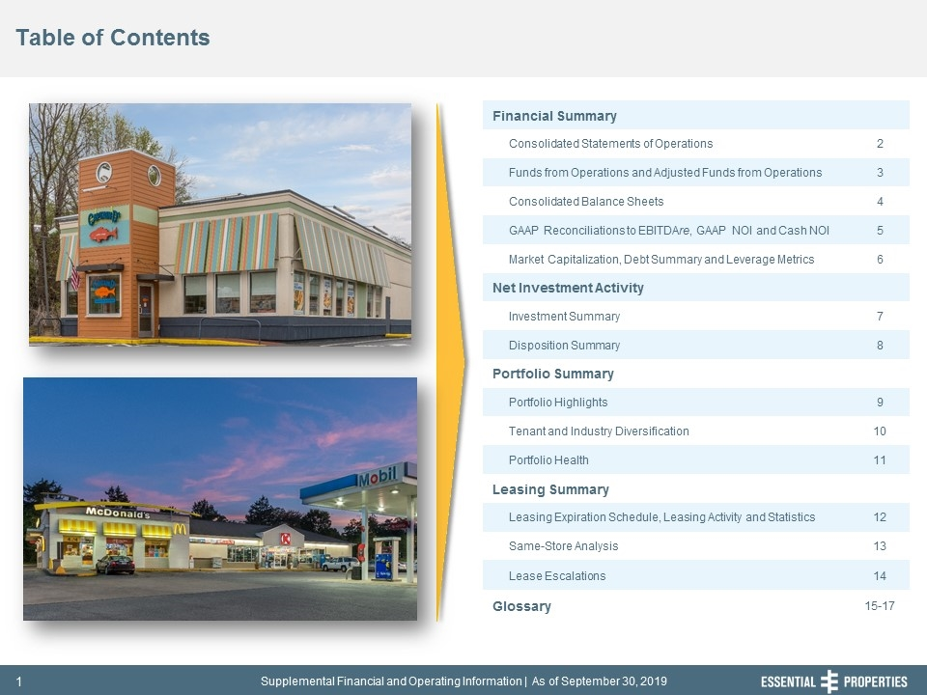
Table of Contents 242, 242, 242 Financial Summary Consolidated Statements of Operations 2 Funds from Operations and Adjusted Funds from Operations 3 Consolidated Balance Sheets 4 GAAP Reconciliations to EBITDAre, GAAP NOI and Cash NOI 5 Market Capitalization, Debt Summary and Leverage Metrics 6 Net Investment Activity Investment Summary 7 Disposition Summary 8 Portfolio Summary Portfolio Highlights 9 Tenant and Industry Diversification 10 Portfolio Health 11 Leasing Summary Leasing Expiration Schedule, Leasing Activity and Statistics 12 Same-Store Analysis 13 Lease Escalations 14 Glossary 15-17

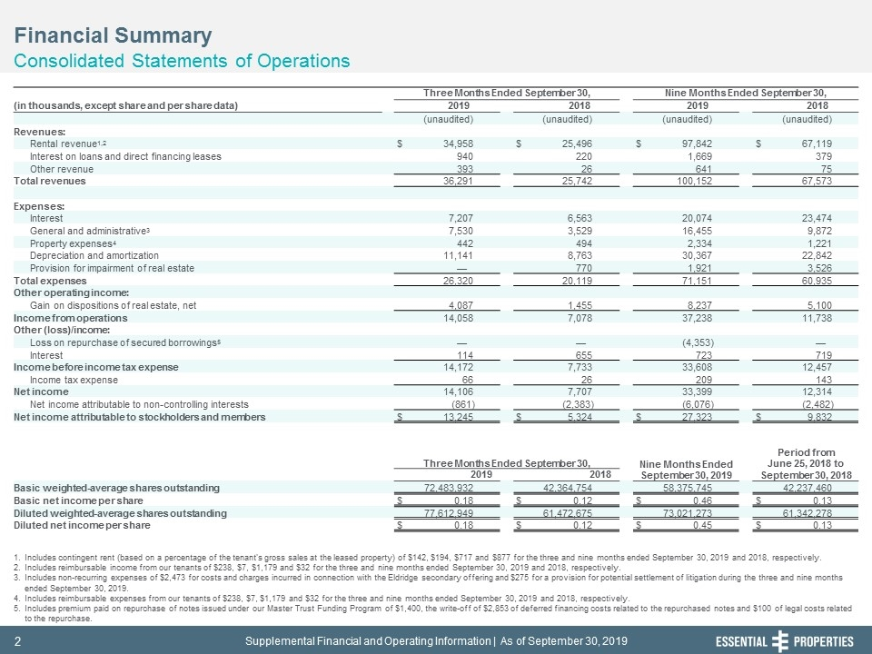
Financial Summary Consolidated Statements of Operations 242, 242, 242 Includes contingent rent (based on a percentage of the tenant's gross sales at the leased property) of $142, $194, $717 and $877 for the three and nine months ended September 30, 2019 and 2018, respectively. Includes reimbursable income from our tenants of $238, $7, $1,179 and $32 for the three and nine months ended September 30, 2019 and 2018, respectively. Includes non-recurring expenses of $2,473 for costs and charges incurred in connection with the Eldridge secondary offering and $275 for a provision for potential settlement of litigation during the three and nine months ended September 30, 2019. Includes reimbursable expenses from our tenants of $238, $7, $1,179 and $32 for the three and nine months ended September 30, 2019 and 2018, respectively. Includes premium paid on repurchase of notes issued under our Master Trust Funding Program of $1,400, the write-off of $2,853 of deferred financing costs related to the repurchased notes and $100 of legal costs related to the repurchase. Three Months Ended September 30, Nine Months Ended September 30, (in thousands, except share and per share data) 2019 2018 2019 2018 (unaudited) (unaudited) (unaudited) (unaudited) Revenues: Rental revenue1,2 $ 34,958 $ 25,496 $ 97,842 $ 67,119 Interest on loans and direct financing leases 940 220 1,669 379 Other revenue 393 26 641 75 Total revenues 36,291 25,742 100,152 67,573 Expenses: Interest 7,207 6,563 20,074 23,474 General and administrative3 7,530 3,529 16,455 9,872 Property expenses4 442 494 2,334 1,221 Depreciation and amortization 11,141 8,763 30,367 22,842 Provision for impairment of real estate — 770 1,921 3,526 Total expenses 26,320 20,119 71,151 60,935 Other operating income: Gain on dispositions of real estate, net 4,087 1,455 8,237 5,100 Income from operations 14,058 7,078 37,238 11,738 Other (loss)/income: Loss on repurchase of secured borrowings5 — — (4,353) — Interest 114 655 723 719 Income before income tax expense 14,172 7,733 33,608 12,457 Income tax expense 66 26 209 143 Net income 14,106 7,707 33,399 12,314 Net income attributable to non-controlling interests (861) (2,383) (6,076) (2,482) Net income attributable to stockholders and members $ 13,245 $ 5,324 $ 27,323 $ 9,832 Three Months Ended September 30, Nine Months Ended September 30, 2019 Period from June 25, 2018 to September 30, 2018 2019 2018 Basic weighted-average shares outstanding 72,483,932 42,364,754 58,375,745 42,237,460 Basic net income per share $ 0.18 $ 0.12 $ 0.46 $ 0.13 Diluted weighted-average shares outstanding 77,612,949 61,472,675 73,021,273 61,342,278 Diluted net income per share $ 0.18 $ 0.12 $ 0.45 $ 0.13

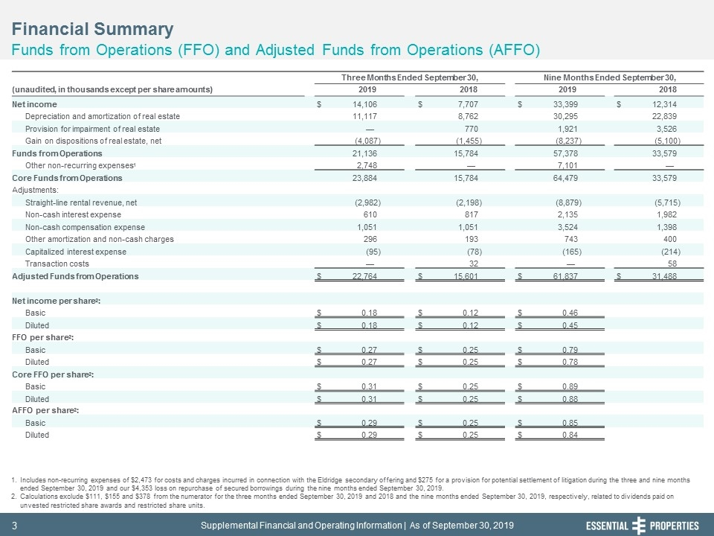
Financial Summary Funds from Operations (FFO) and Adjusted Funds from Operations (AFFO) 242, 242, 242 Includes non-recurring expenses of $2,473 for costs and charges incurred in connection with the Eldridge secondary offering and $275 for a provision for potential settlement of litigation during the three and nine months ended September 30, 2019 and our $4,353 loss on repurchase of secured borrowings during the nine months ended September 30, 2019. Calculations exclude $111, $155 and $378 from the numerator for the three months ended September 30, 2019 and 2018 and the nine months ended September 30, 2019, respectively, related to dividends paid on unvested restricted share awards and restricted share units. Three Months Ended September 30, Nine Months Ended September 30, (unaudited, in thousands except per share amounts) 2019 2018 2019 2018 Net income $ 14,106 $ 7,707 $ 33,399 $ 12,314 Depreciation and amortization of real estate 11,117 8,762 30,295 22,839 Provision for impairment of real estate — 770 1,921 3,526 Gain on dispositions of real estate, net (4,087) (1,455) (8,237) (5,100) Funds from Operations 21,136 15,784 57,378 33,579 Other non-recurring expenses1 2,748 — 7,101 — Core Funds from Operations 23,884 15,784 64,479 33,579 Adjustments: Straight-line rental revenue, net (2,982) (2,198) (8,879) (5,715) Non-cash interest expense 610 817 2,135 1,982 Non-cash compensation expense 1,051 1,051 3,524 1,398 Other amortization and non-cash charges 296 193 743 400 Capitalized interest expense (95) (78) (165) (214) Transaction costs — 32 — 58 Adjusted Funds from Operations $ 22,764 $ 15,601 $ 61,837 $ 31,488 Net income per share2: Basic $ 0.18 $ 0.12 $ 0.46 Diluted $ 0.18 $ 0.12 $ 0.45 FFO per share2: Basic $ 0.27 $ 0.25 $ 0.79 Diluted $ 0.27 $ 0.25 $ 0.78 Core FFO per share2: Basic $ 0.31 $ 0.25 $ 0.89 Diluted $ 0.31 $ 0.25 $ 0.88 AFFO per share2: Basic $ 0.29 $ 0.25 $ 0.85 Diluted $ 0.29 $ 0.25 $ 0.84

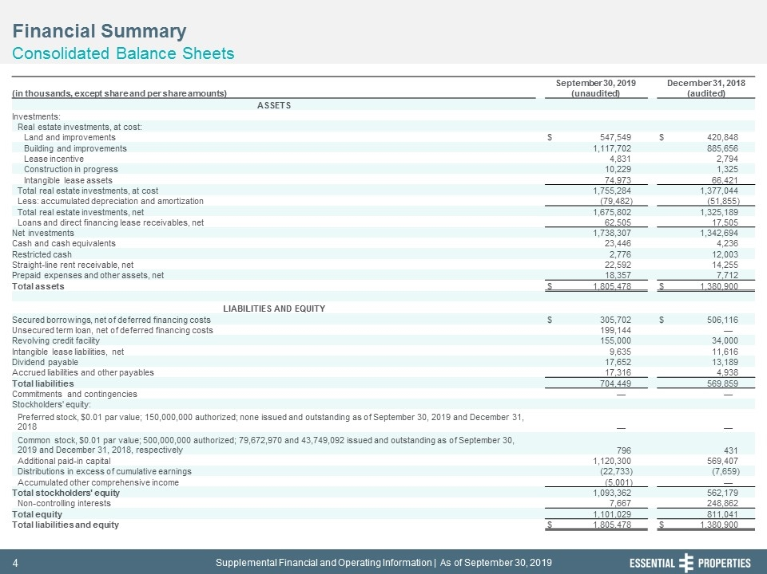
Financial Summary Consolidated Balance Sheets 242, 242, 242 September 30, 2019 December 31, 2018 (in thousands, except share and per share amounts) (unaudited) (audited) ASSETS Investments: Real estate investments, at cost: Land and improvements $ 547,549 $ 420,848 Building and improvements 1,117,702 885,656 Lease incentive 4,831 2,794 Construction in progress 10,229 1,325 Intangible lease assets 74,973 66,421 Total real estate investments, at cost 1,755,284 1,377,044 Less: accumulated depreciation and amortization (79,482) (51,855) Total real estate investments, net 1,675,802 1,325,189 Loans and direct financing lease receivables, net 62,505 17,505 Net investments 1,738,307 1,342,694 Cash and cash equivalents 23,446 4,236 Restricted cash 2,776 12,003 Straight-line rent receivable, net 22,592 14,255 Prepaid expenses and other assets, net 18,357 7,712 Total assets $ 1,805,478 $ 1,380,900 LIABILITIES AND EQUITY Secured borrowings, net of deferred financing costs $ 305,702 $ 506,116 Unsecured term loan, net of deferred financing costs 199,144 — Revolving credit facility 155,000 34,000 Intangible lease liabilities, net 9,635 11,616 Dividend payable 17,652 13,189 Accrued liabilities and other payables 17,316 4,938 Total liabilities 704,449 569,859 Commitments and contingencies — — Stockholders' equity: Preferred stock, $0.01 par value; 150,000,000 authorized; none issued and outstanding as of September 30, 2019 and December 31, 2018 — — Common stock, $0.01 par value; 500,000,000 authorized; 79,672,970 and 43,749,092 issued and outstanding as of September 30, 2019 and December 31, 2018, respectively 796 431 Additional paid-in capital 1,120,300 569,407 Distributions in excess of cumulative earnings (22,733) (7,659) Accumulated other comprehensive income (5,001) — Total stockholders' equity 1,093,362 562,179 Non-controlling interests 7,667 248,862 Total equity 1,101,029 811,041 Total liabilities and equity $ 1,805,478 $ 1,380,900

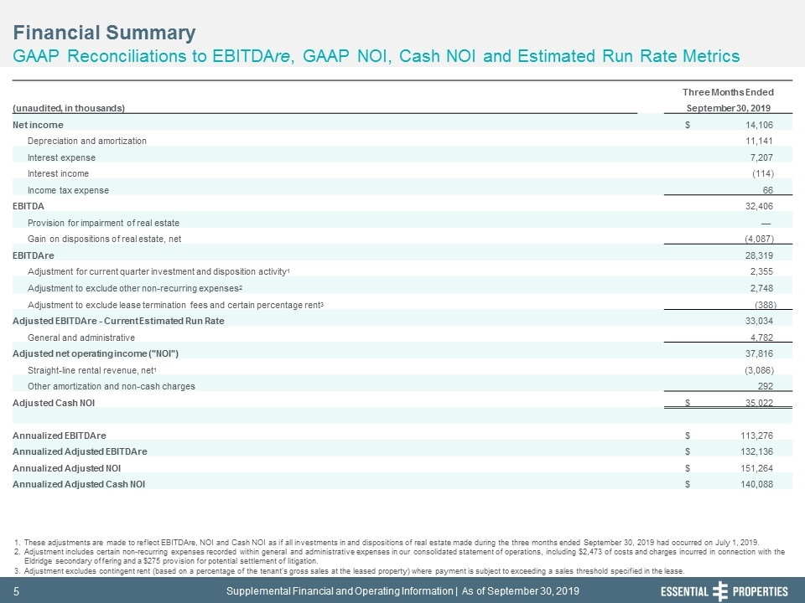
Financial Summary GAAP Reconciliations to EBITDAre, GAAP NOI, Cash NOI and Estimated Run Rate Metrics 242, 242, 242 These adjustments are made to reflect EBITDAre, NOI and Cash NOI as if all investments in and dispositions of real estate made during the three months ended September 30, 2019 had occurred on July 1, 2019. Adjustment includes certain non-recurring expenses recorded within general and administrative expenses in our consolidated statement of operations, including $2,473 of costs and charges incurred in connection with the Eldridge secondary offering and a $275 provision for potential settlement of litigation. Adjustment excludes contingent rent (based on a percentage of the tenant's gross sales at the leased property) where payment is subject to exceeding a sales threshold specified in the lease. Three Months Ended (unaudited, in thousands) September 30, 2019 Net income $ 14,106 Depreciation and amortization 11,141 Interest expense 7,207 Interest income (114) Income tax expense 66 EBITDA 32,406 Provision for impairment of real estate — Gain on dispositions of real estate, net (4,087) EBITDAre 28,319 Adjustment for current quarter investment and disposition activity1 2,355 Adjustment to exclude other non-recurring expenses2 2,748 Adjustment to exclude lease termination fees and certain percentage rent3 (388) Adjusted EBITDAre - Current Estimated Run Rate 33,034 General and administrative 4,782 Adjusted net operating income ("NOI") 37,816 Straight-line rental revenue, net1 (3,086) Other amortization and non-cash charges 292 Adjusted Cash NOI $ 35,022 Annualized EBITDAre $ 113,276 Annualized Adjusted EBITDAre $ 132,136 Annualized Adjusted NOI $ 151,264 Annualized Adjusted Cash NOI $ 140,088

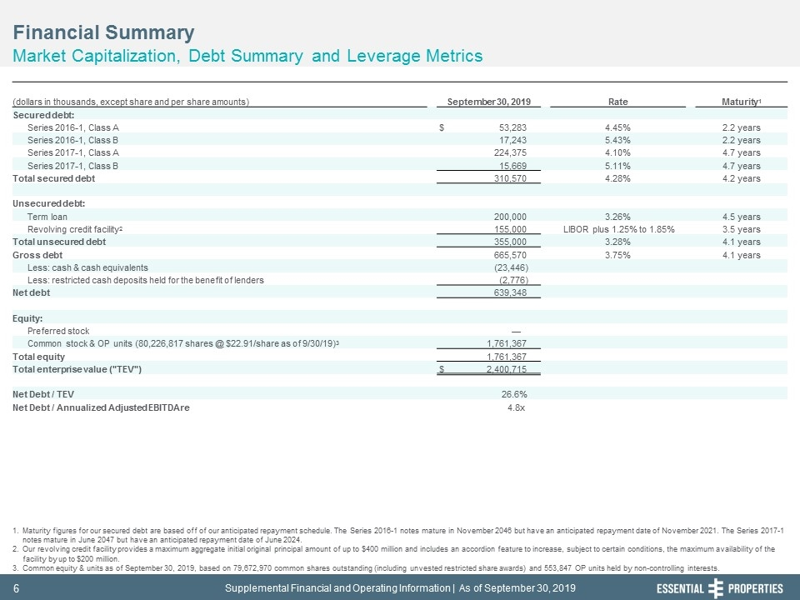
Financial Summary Market Capitalization, Debt Summary and Leverage Metrics 242, 242, 242 Maturity figures for our secured debt are based off of our anticipated repayment schedule. The Series 2016-1 notes mature in November 2046 but have an anticipated repayment date of November 2021. The Series 2017-1 notes mature in June 2047 but have an anticipated repayment date of June 2024. Our revolving credit facility provides a maximum aggregate initial original principal amount of up to $400 million and includes an accordion feature to increase, subject to certain conditions, the maximum availability of the facility by up to $200 million. Common equity & units as of September 30, 2019, based on 79,672,970 common shares outstanding (including unvested restricted share awards) and 553,847 OP units held by non-controlling interests. (dollars in thousands, except share and per share amounts) September 30, 2019 Rate Maturity1 Secured debt: Series 2016-1, Class A $ 53,283 4.45% 2.2 years Series 2016-1, Class B 17,243 5.43% 2.2 years Series 2017-1, Class A 224,375 4.10% 4.7 years Series 2017-1, Class B 15,669 5.11% 4.7 years Total secured debt 310,570 4.28% 4.2 years Unsecured debt: Term loan 200,000 3.26% 4.5 years Revolving credit facility2 155,000 LIBOR plus 1.25% to 1.85% 3.5 years Total unsecured debt 355,000 3.28% 4.1 years Gross debt 665,570 3.75% 4.1 years Less: cash & cash equivalents (23,446) Less: restricted cash deposits held for the benefit of lenders (2,776) Net debt 639,348 Equity: Preferred stock — Common stock & OP units (80,226,817 shares @ $22.91/share as of 9/30/19)3 1,761,367 Total equity 1,761,367 Total enterprise value ("TEV") $ 2,400,715 Net Debt / TEV 26.6% Net Debt / Annualized Adjusted EBITDAre 4.8x

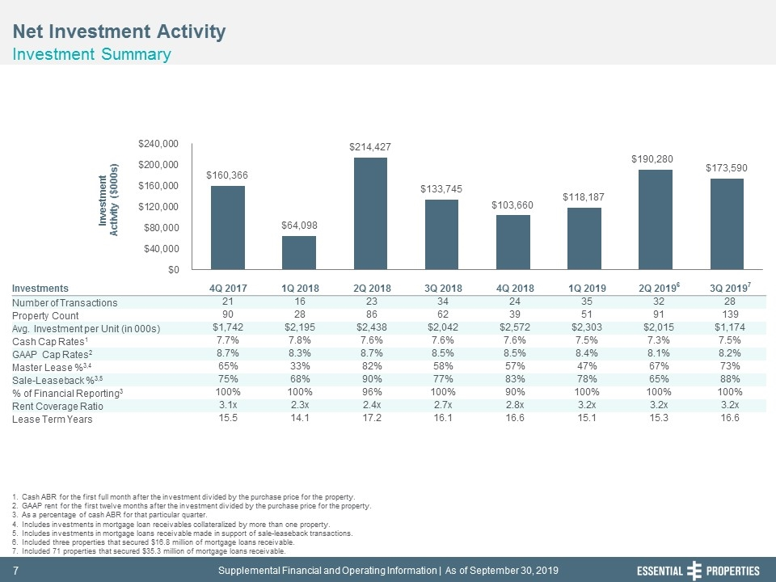
Net Investment Activity Investment Summary 242, 242, 242 Cash ABR for the first full month after the investment divided by the purchase price for the property. GAAP rent for the first twelve months after the investment divided by the purchase price for the property. As a percentage of cash ABR for that particular quarter. Includes investments in mortgage loan receivables collateralized by more than one property. Includes investments in mortgage loans receivable made in support of sale-leaseback transactions. Included three properties that secured $16.8 million of mortgage loans receivable. Included 71 properties that secured $35.3 million of mortgage loans receivable. Investments 4Q 2017 1Q 2018 2Q 2018 3Q 2018 4Q 2018 1Q 2019 2Q 20196 3Q 20197 Number of Transactions 21 16 23 34 24 35 32 28 Property Count 90 28 86 62 39 51 91 139 Avg. Investment per Unit (in 000s) $1,742 $2,195 $2,438 $2,042 $2,572 $2,303 $2,015 $1,174 Cash Cap Rates1 7.7% 7.8% 7.6% 7.6% 7.6% 7.5% 7.3% 7.5% GAAP Cap Rates2 8.7% 8.3% 8.7% 8.5% 8.5% 8.4% 8.1% 8.2% Master Lease %3,4 65% 33% 82% 58% 57% 47% 67% 73% Sale-Leaseback %3,5 75% 68% 90% 77% 83% 78% 65% 88% % of Financial Reporting3 100% 100% 96% 100% 90% 100% 100% 100% Rent Coverage Ratio 3.1x 2.3x 2.4x 2.7x 2.8x 3.2x 3.2x 3.2x Lease Term Years 15.5 14.1 17.2 16.1 16.6 15.1 15.3 16.6

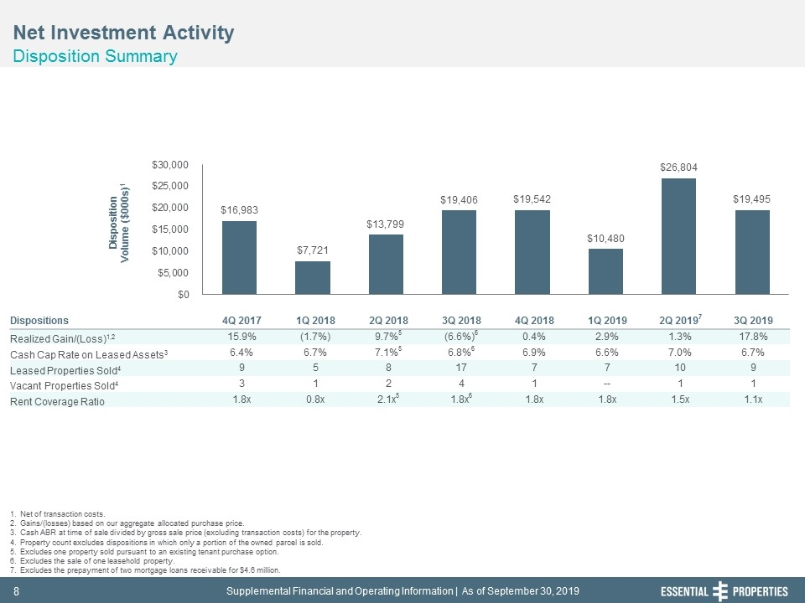
Net Investment Activity Disposition Summary 242, 242, 242 Net of transaction costs. Gains/(losses) based on our aggregate allocated purchase price. Cash ABR at time of sale divided by gross sale price (excluding transaction costs) for the property. Property count excludes dispositions in which only a portion of the owned parcel is sold. Excludes one property sold pursuant to an existing tenant purchase option. Excludes the sale of one leasehold property. Excludes the prepayment of two mortgage loans receivable for $4.6 million. Dispositions 4Q 2017 1Q 2018 2Q 2018 3Q 2018 4Q 2018 1Q 2019 2Q 20197 3Q 2019 Realized Gain/(Loss)1,2 15.9% (1.7%) 9.7%5 (6.6%)6 0.4% 2.9% 1.3% 17.8% Cash Cap Rate on Leased Assets3 6.4% 6.7% 7.1%5 6.8%6 6.9% 6.6% 7.0% 6.7% Leased Properties Sold4 9 5 8 17 7 7 10 9 Vacant Properties Sold4 3 1 2 4 1 -- 1 1 Rent Coverage Ratio 1.8x 0.8x 2.1x5 1.8x6 1.8x 1.8x 1.5x 1.1x

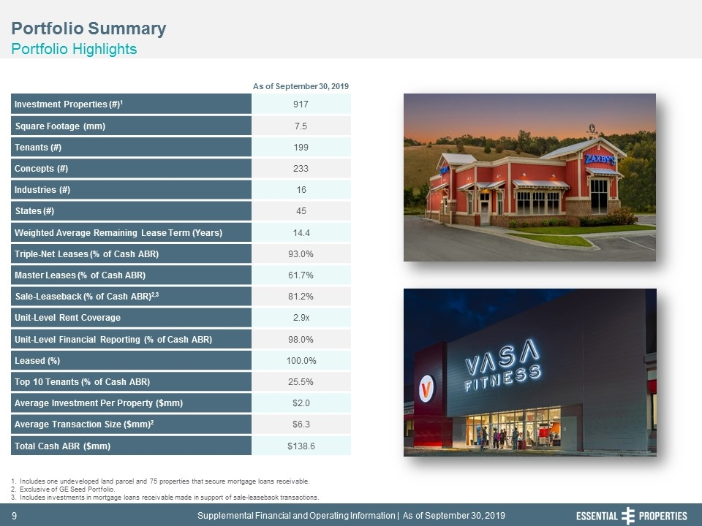
Portfolio Summary Portfolio Highlights 242, 242, 242 Investment Properties (#)1 917 Square Footage (mm) 7.5 Tenants (#) 199 Concepts (#) 233 Industries (#) 16 States (#) 45 Weighted Average Remaining Lease Term (Years) 14.4 Triple-Net Leases (% of Cash ABR) 93.0% Master Leases (% of Cash ABR) 61.7% Sale-Leaseback (% of Cash ABR)2,3 81.2% Unit-Level Rent Coverage 2.9x Unit-Level Financial Reporting (% of Cash ABR) 98.0% Leased (%) 100.0% Top 10 Tenants (% of Cash ABR) 25.5% Average Investment Per Property ($mm) $2.0 Average Transaction Size ($mm)2 $6.3 Total Cash ABR ($mm) $138.6 Includes one undeveloped land parcel and 75 properties that secure mortgage loans receivable. Exclusive of GE Seed Portfolio. Includes investments in mortgage loans receivable made in support of sale-leaseback transactions. As of September 30, 2019

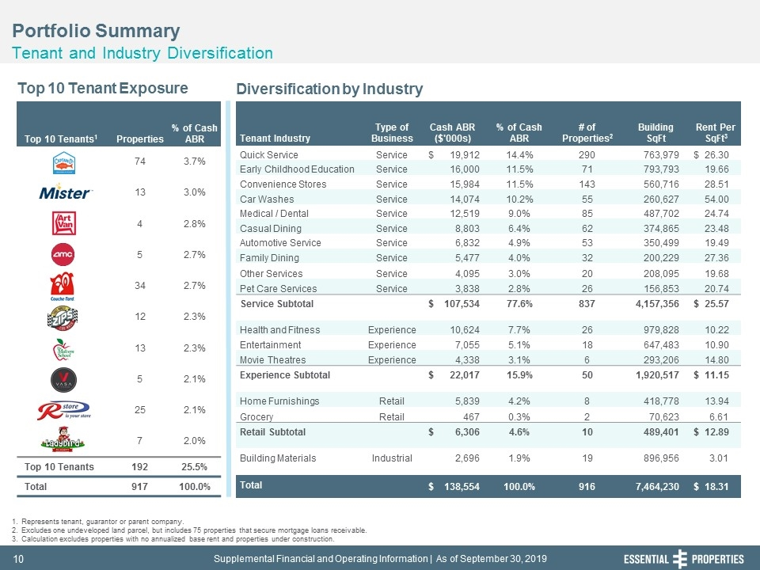
Portfolio Summary Tenant and Industry Diversification 242, 242, 242 Top 10 Tenants1 Properties % of Cash ABR 74 3.7% 13 3.0% 4 2.8% 5 2.7% 34 2.7% 12 2.3% 13 2.3% 5 2.1% 25 2.1% 7 2.0% Top 10 Tenants 192 25.5% Total 917 100.0% Top 10 Tenant Exposure Diversification by Industry Represents tenant, guarantor or parent company. Excludes one undeveloped land parcel, but includes 75 properties that secure mortgage loans receivable. Calculation excludes properties with no annualized base rent and properties under construction. Tenant Industry Type of Business Cash ABR ($'000s) % of Cash ABR # of Properties2 Building SqFt Rent Per SqFt3 Quick Service Service $ 19,912 14.4% 290 763,979 $ 26.30 Early Childhood Education Service 16,000 11.5% 71 793,793 19.66 Convenience Stores Service 15,984 11.5% 143 560,716 28.51 Car Washes Service 14,074 10.2% 55 260,627 54.00 Medical / Dental Service 12,519 9.0% 85 487,702 24.74 Casual Dining Service 8,803 6.4% 62 374,865 23.48 Automotive Service Service 6,832 4.9% 53 350,499 19.49 Family Dining Service 5,477 4.0% 32 200,229 27.36 Other Services Service 4,095 3.0% 20 208,095 19.68 Pet Care Services Service 3,838 2.8% 26 156,853 20.74 Service Subtotal $ 107,534 77.6% 837 4,157,356 $ 25.57 Health and Fitness Experience 10,624 7.7% 26 979,828 10.22 Entertainment Experience 7,055 5.1% 18 647,483 10.90 Movie Theatres Experience 4,338 3.1% 6 293,206 14.80 Experience Subtotal $ 22,017 15.9% 50 1,920,517 $ 11.15 Home Furnishings Retail 5,839 4.2% 8 418,778 13.94 Grocery Retail 467 0.3% 2 70,623 6.61 Retail Subtotal $ 6,306 4.6% 10 489,401 $ 12.89 Building Materials Industrial 2,696 1.9% 19 896,956 3.01 Total $ 138,554 100.0% 916 7,464,230 $ 18.31

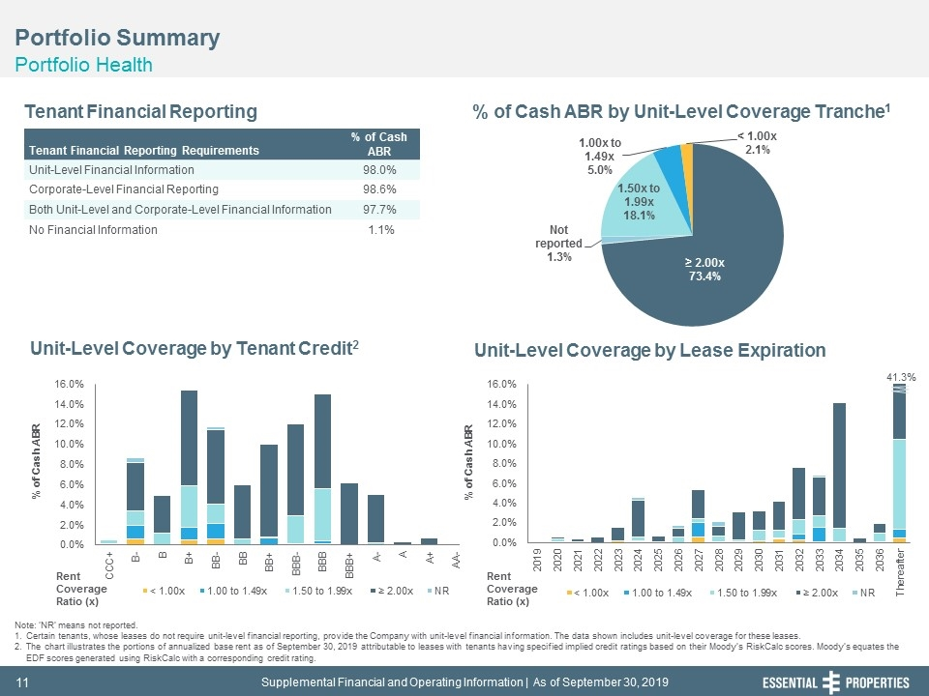
Portfolio Summary Portfolio Health 242, 242, 242 Tenant Financial Reporting % of Cash ABR by Unit-Level Coverage Tranche1 Unit-Level Coverage by Lease Expiration Unit-Level Coverage by Tenant Credit2 Note: ‘NR’ means not reported. Certain tenants, whose leases do not require unit-level financial reporting, provide the Company with unit-level financial information. The data shown includes unit-level coverage for these leases. The chart illustrates the portions of annualized base rent as of September 30, 2019 attributable to leases with tenants having specified implied credit ratings based on their Moody’s RiskCalc scores. Moody’s equates the EDF scores generated using RiskCalc with a corresponding credit rating. Tenant Financial Reporting Requirements % of Cash ABR Unit-Level Financial Information 98.0% Corporate-Level Financial Reporting 98.6% Both Unit-Level and Corporate-Level Financial Information 97.7% No Financial Information 1.1% Rent Coverage Ratio (x) Rent Coverage Ratio (x) 41.3%

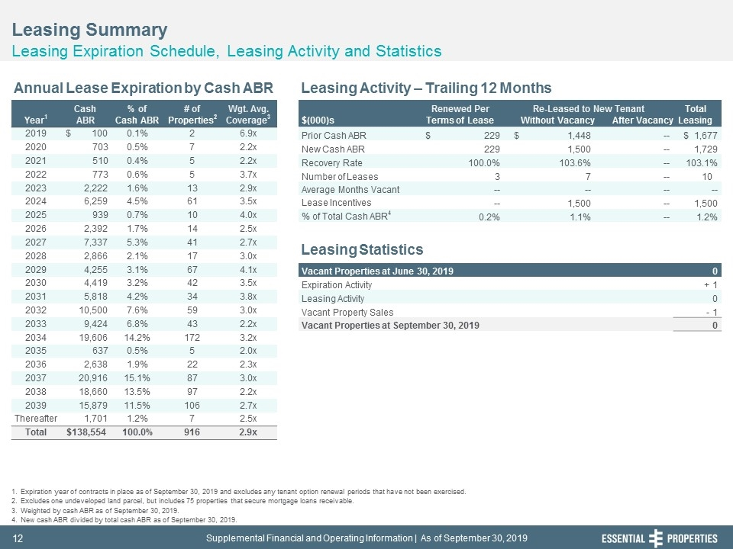
Cash % of # of Wgt. Avg. Renewed Per Re-Leased to New Tenant Total Year1 ABR Cash ABR Properties2 Coverage3 $(000)s Terms of Lease Without Vacancy After Vacancy Leasing 2019 $ 100 0.1% 2 6.9x Prior Cash ABR $ 229 $ 1,448 -- $ 1,677 2020 703 0.5% 7 2.2x New Cash ABR 229 1,500 -- 1,729 2021 510 0.4% 5 2.2x Recovery Rate 100.0% 103.6% -- 103.1% 2022 773 0.6% 5 3.7x Number of Leases 3 7 -- 10 2023 2,222 1.6% 13 2.9x Average Months Vacant -- -- -- -- 2024 6,259 4.5% 61 3.5x Lease Incentives -- 1,500 -- 1,500 2025 939 0.7% 10 4.0x % of Total Cash ABR4 0.2% 1.1% -- 1.2% 2026 2,392 1.7% 14 2.5x 2027 7,337 5.3% 41 2.7x 2028 2,866 2.1% 17 3.0x 2029 4,255 3.1% 67 4.1x Vacant Properties at June 30, 2019 0 2030 4,419 3.2% 42 3.5x Expiration Activity + 1 2031 5,818 4.2% 34 3.8x Leasing Activity 0 2032 10,500 7.6% 59 3.0x Vacant Property Sales - 1 2033 9,424 6.8% 43 2.2x Vacant Properties at September 30, 2019 0 2034 19,606 14.2% 172 3.2x 2035 637 0.5% 5 2.0x 2036 2,638 1.9% 22 2.3x 2037 20,916 15.1% 87 3.0x 2038 18,660 13.5% 97 2.2x 2039 15,879 11.5% 106 2.7x Thereafter 1,701 1.2% 7 2.5x Total $138,554 100.0% 916 2.9x Leasing Summary Leasing Expiration Schedule, Leasing Activity and Statistics 242, 242, 242 Expiration year of contracts in place as of September 30, 2019 and excludes any tenant option renewal periods that have not been exercised. Excludes one undeveloped land parcel, but includes 75 properties that secure mortgage loans receivable. Weighted by cash ABR as of September 30, 2019. New cash ABR divided by total cash ABR as of September 30, 2019. Annual Lease Expiration by Cash ABR Leasing Activity – Trailing 12 Months Leasing Statistics

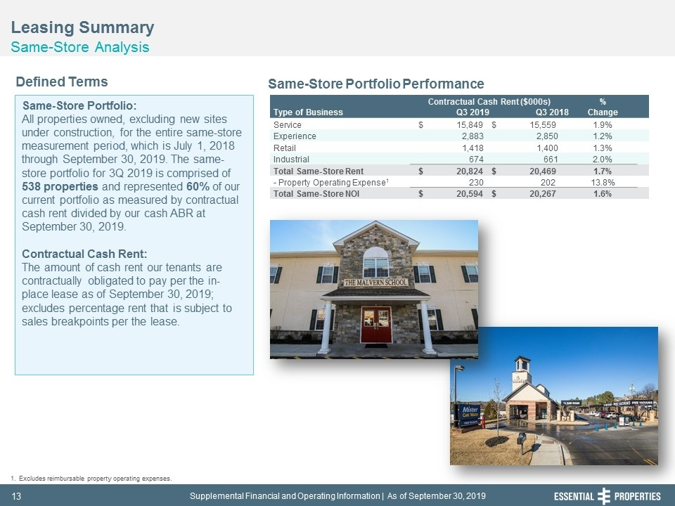
Leasing Summary Same-Store Analysis 242, 242, 242 Same-Store Portfolio: All properties owned, excluding new sites under construction, for the entire same-store measurement period, which is July 1, 2018 through September 30, 2019. The same-store portfolio for 3Q 2019 is comprised of 538 properties and represented 60% of our current portfolio as measured by contractual cash rent divided by our cash ABR at September 30, 2019. Contractual Cash Rent: The amount of cash rent our tenants are contractually obligated to pay per the in-place lease as of September 30, 2019; excludes percentage rent that is subject to sales breakpoints per the lease. Defined Terms Same-Store Portfolio Performance Excludes reimbursable property operating expenses. Contractual Cash Rent ($000s) % Type of Business Q3 2019 Q3 2018 Change Service $ 15,849 $ 15,559 1.9% Experience 2,883 2,850 1.2% Retail 1,418 1,400 1.3% Industrial 674 661 2.0% Total Same-Store Rent $ 20,824 $ 20,469 1.7% - Property Operating Expense1 230 202 13.8% Total Same-Store NOI $ 20,594 $ 20,267 1.6%

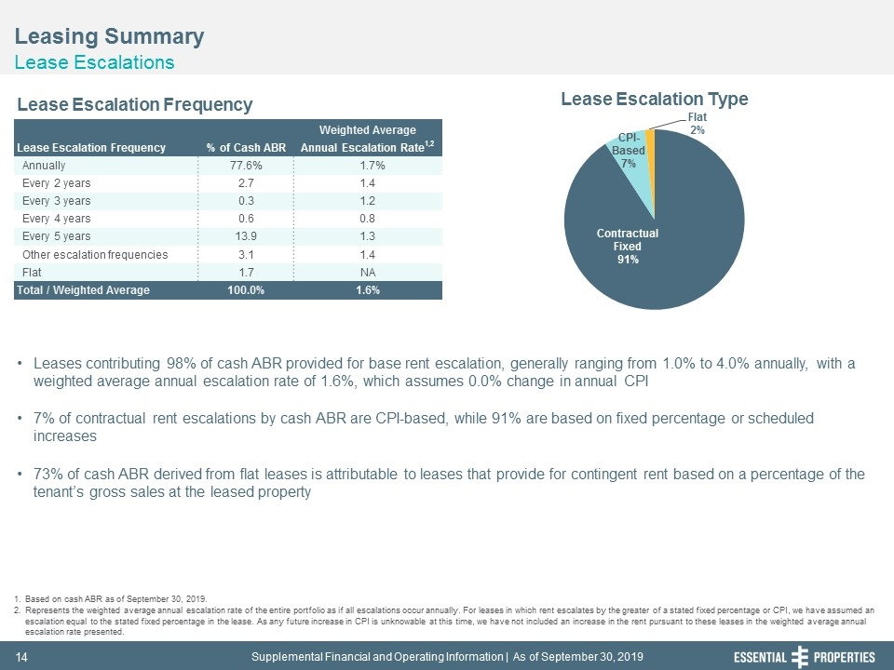
Leasing Summary Lease Escalations 242, 242, 242 Leases contributing 98% of cash ABR provided for base rent escalation, generally ranging from 1.0% to 4.0% annually, with a weighted average annual escalation rate of 1.6%, which assumes 0.0% change in annual CPI 7% of contractual rent escalations by cash ABR are CPI-based, while 91% are based on fixed percentage or scheduled increases 73% of cash ABR derived from flat leases is attributable to leases that provide for contingent rent based on a percentage of the tenant’s gross sales at the leased property Based on cash ABR as of September 30, 2019. Represents the weighted average annual escalation rate of the entire portfolio as if all escalations occur annually. For leases in which rent escalates by the greater of a stated fixed percentage or CPI, we have assumed an escalation equal to the stated fixed percentage in the lease. As any future increase in CPI is unknowable at this time, we have not included an increase in the rent pursuant to these leases in the weighted average annual escalation rate presented. Lease Escalation Frequency Lease Escalation Type Weighted Average Lease Escalation Frequency % of Cash ABR Annual Escalation Rate1,2 Annually 77.6% 1.7% Every 2 years 2.7 1.4 Every 3 years 0.3 1.2 Every 4 years 0.6 0.8 Every 5 years 13.9 1.3 Other escalation frequencies 3.1 1.4 Flat 1.7 NA Total / Weighted Average 100.0% 1.6%

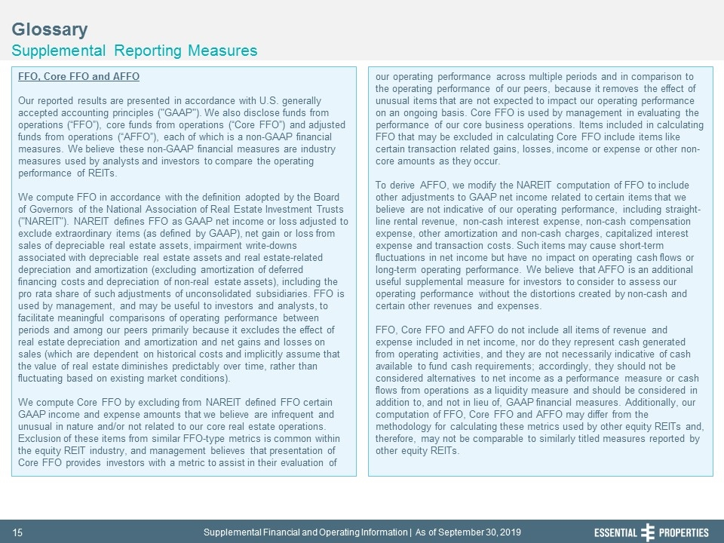
Glossary Supplemental Reporting Measures 242, 242, 242 FFO, Core FFO and AFFO Our reported results are presented in accordance with U.S. generally accepted accounting principles ("GAAP"). We also disclose funds from operations (“FFO”), core funds from operations (“Core FFO”) and adjusted funds from operations (“AFFO”), each of which is a non-GAAP financial measures. We believe these non-GAAP financial measures are industry measures used by analysts and investors to compare the operating performance of REITs. We compute FFO in accordance with the definition adopted by the Board of Governors of the National Association of Real Estate Investment Trusts ("NAREIT"). NAREIT defines FFO as GAAP net income or loss adjusted to exclude extraordinary items (as defined by GAAP), net gain or loss from sales of depreciable real estate assets, impairment write-downs associated with depreciable real estate assets and real estate-related depreciation and amortization (excluding amortization of deferred financing costs and depreciation of non-real estate assets), including the pro rata share of such adjustments of unconsolidated subsidiaries. FFO is used by management, and may be useful to investors and analysts, to facilitate meaningful comparisons of operating performance between periods and among our peers primarily because it excludes the effect of real estate depreciation and amortization and net gains and losses on sales (which are dependent on historical costs and implicitly assume that the value of real estate diminishes predictably over time, rather than fluctuating based on existing market conditions). We compute Core FFO by excluding from NAREIT defined FFO certain GAAP income and expense amounts that we believe are infrequent and unusual in nature and/or not related to our core real estate operations. Exclusion of these items from similar FFO-type metrics is common within the equity REIT industry, and management believes that presentation of Core FFO provides investors with a metric to assist in their evaluation of our operating performance across multiple periods and in comparison to the operating performance of our peers, because it removes the effect of unusual items that are not expected to impact our operating performance on an ongoing basis. Core FFO is used by management in evaluating the performance of our core business operations. Items included in calculating FFO that may be excluded in calculating Core FFO include items like certain transaction related gains, losses, income or expense or other non-core amounts as they occur. To derive AFFO, we modify the NAREIT computation of FFO to include other adjustments to GAAP net income related to certain items that we believe are not indicative of our operating performance, including straight-line rental revenue, non-cash interest expense, non-cash compensation expense, other amortization and non-cash charges, capitalized interest expense and transaction costs. Such items may cause short-term fluctuations in net income but have no impact on operating cash flows or long-term operating performance. We believe that AFFO is an additional useful supplemental measure for investors to consider to assess our operating performance without the distortions created by non-cash and certain other revenues and expenses. FFO, Core FFO and AFFO do not include all items of revenue and expense included in net income, nor do they represent cash generated from operating activities, and they are not necessarily indicative of cash available to fund cash requirements; accordingly, they should not be considered alternatives to net income as a performance measure or cash flows from operations as a liquidity measure and should be considered in addition to, and not in lieu of, GAAP financial measures. Additionally, our computation of FFO, Core FFO and AFFO may differ from the methodology for calculating these metrics used by other equity REITs and, therefore, may not be comparable to similarly titled measures reported by other equity REITs.

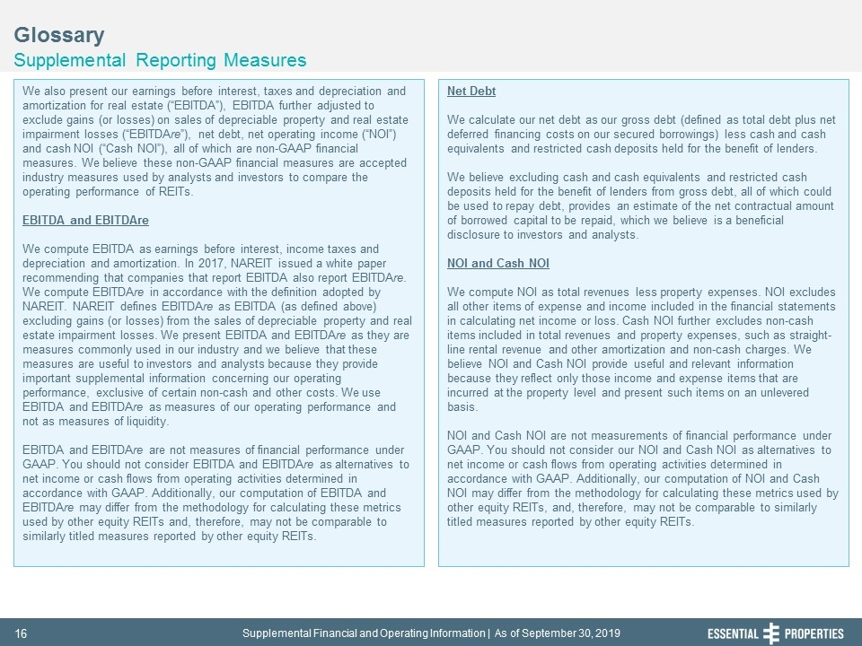
Glossary Supplemental Reporting Measures 242, 242, 242 We also present our earnings before interest, taxes and depreciation and amortization for real estate (“EBITDA”), EBITDA further adjusted to exclude gains (or losses) on sales of depreciable property and real estate impairment losses (“EBITDAre”), net debt, net operating income (“NOI”) and cash NOI (“Cash NOI”), all of which are non-GAAP financial measures. We believe these non-GAAP financial measures are accepted industry measures used by analysts and investors to compare the operating performance of REITs. EBITDA and EBITDAre We compute EBITDA as earnings before interest, income taxes and depreciation and amortization. In 2017, NAREIT issued a white paper recommending that companies that report EBITDA also report EBITDAre. We compute EBITDAre in accordance with the definition adopted by NAREIT. NAREIT defines EBITDAre as EBITDA (as defined above) excluding gains (or losses) from the sales of depreciable property and real estate impairment losses. We present EBITDA and EBITDAre as they are measures commonly used in our industry and we believe that these measures are useful to investors and analysts because they provide important supplemental information concerning our operating performance, exclusive of certain non-cash and other costs. We use EBITDA and EBITDAre as measures of our operating performance and not as measures of liquidity. EBITDA and EBITDAre are not measures of financial performance under GAAP. You should not consider EBITDA and EBITDAre as alternatives to net income or cash flows from operating activities determined in accordance with GAAP. Additionally, our computation of EBITDA and EBITDAre may differ from the methodology for calculating these metrics used by other equity REITs and, therefore, may not be comparable to similarly titled measures reported by other equity REITs. Net Debt We calculate our net debt as our gross debt (defined as total debt plus net deferred financing costs on our secured borrowings) less cash and cash equivalents and restricted cash deposits held for the benefit of lenders. We believe excluding cash and cash equivalents and restricted cash deposits held for the benefit of lenders from gross debt, all of which could be used to repay debt, provides an estimate of the net contractual amount of borrowed capital to be repaid, which we believe is a beneficial disclosure to investors and analysts. NOI and Cash NOI We compute NOI as total revenues less property expenses. NOI excludes all other items of expense and income included in the financial statements in calculating net income or loss. Cash NOI further excludes non-cash items included in total revenues and property expenses, such as straight-line rental revenue and other amortization and non-cash charges. We believe NOI and Cash NOI provide useful and relevant information because they reflect only those income and expense items that are incurred at the property level and present such items on an unlevered basis. NOI and Cash NOI are not measurements of financial performance under GAAP. You should not consider our NOI and Cash NOI as alternatives to net income or cash flows from operating activities determined in accordance with GAAP. Additionally, our computation of NOI and Cash NOI may differ from the methodology for calculating these metrics used by other equity REITs, and, therefore, may not be comparable to similarly titled measures reported by other equity REITs.

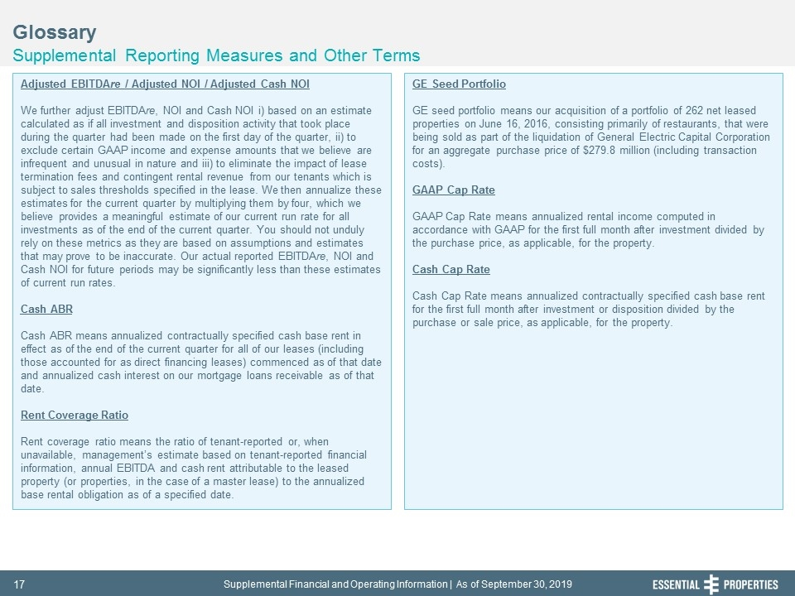
Glossary Supplemental Reporting Measures and Other Terms 242, 242, 242 Adjusted EBITDAre / Adjusted NOI / Adjusted Cash NOI We further adjust EBITDAre, NOI and Cash NOI i) based on an estimate calculated as if all investment and disposition activity that took place during the quarter had been made on the first day of the quarter, ii) to exclude certain GAAP income and expense amounts that we believe are infrequent and unusual in nature and iii) to eliminate the impact of lease termination fees and contingent rental revenue from our tenants which is subject to sales thresholds specified in the lease. We then annualize these estimates for the current quarter by multiplying them by four, which we believe provides a meaningful estimate of our current run rate for all investments as of the end of the current quarter. You should not unduly rely on these metrics as they are based on assumptions and estimates that may prove to be inaccurate. Our actual reported EBITDAre, NOI and Cash NOI for future periods may be significantly less than these estimates of current run rates. Cash ABR Cash ABR means annualized contractually specified cash base rent in effect as of the end of the current quarter for all of our leases (including those accounted for as direct financing leases) commenced as of that date and annualized cash interest on our mortgage loans receivable as of that date. Rent Coverage Ratio Rent coverage ratio means the ratio of tenant-reported or, when unavailable, management’s estimate based on tenant-reported financial information, annual EBITDA and cash rent attributable to the leased property (or properties, in the case of a master lease) to the annualized base rental obligation as of a specified date. GE Seed Portfolio GE seed portfolio means our acquisition of a portfolio of 262 net leased properties on June 16, 2016, consisting primarily of restaurants, that were being sold as part of the liquidation of General Electric Capital Corporation for an aggregate purchase price of $279.8 million (including transaction costs). GAAP Cap Rate GAAP Cap Rate means annualized rental income computed in accordance with GAAP for the first full month after investment divided by the purchase price, as applicable, for the property. Cash Cap Rate Cash Cap Rate means annualized contractually specified cash base rent for the first full month after investment or disposition divided by the purchase or sale price, as applicable, for the property.

