UNITED STATES
SECURITIES AND EXCHANGE COMMISSION
Washington, D.C. 20549

FORM 8-K

CURRENT REPORT

Pursuant to Section 13 or 15(d)
of the Securities Exchange Act of 1934

May 10, 2023
Date of Report (Date of earliest event reported)

Essential Properties Realty Trust, Inc.
(Exact name of registrant as specified in its charter)

Maryland |  |  |  |  |  | 001-38530 |  |  |  |  |  | 82-4005693
(State or other jurisdiction of incorporation) |  |  |  |  |  | (Commission File Number) |  |  |  |  |  | (IRS Employer Identification No.)
902 Carnegie Center Blvd., Suite 520
Princeton, New Jersey |  |  |  |  |  |  |  |  |  |  |  | 08540
(Address of principal executive offices) |  |  |  |  |  |  |  |  |  |  |  | (Zip Code)
Registrant’s telephone number, including area code: |  |  |  |  |  |  |  |  |  |  |  | (609) 436-0619

Check the appropriate box below if the Form 8-K filing is intended to simultaneously satisfy the filing obligations of the registrant under any of the following provisions:
☐ |  |  | Written communications pursuant to Rule 425 under the Securities Act 17 CFR 230.425)
☐ |  |  | Soliciting material pursuant to Rule 14a-12 under the Exchange Act (17 CFR 240.14a-12)
☐ |  |  | Pre-commencement communications pursuant to Rule 14d-2(b) under the Exchange Act (17 CFR 240.14d-2(b))
☐ |  |  | Pre-commencement communications pursuant to Rule 13e-4(c) under the Exchange Act (17 CFR 240.13e-4(c))

Securities registered pursuant to Section 12(b) of the Act:
Title of Each Class |  |  |  |  |  | Trading Symbol(s) |  |  |  |  |  | Name of Each Exchange on Which Registered
Common stock, $0.01 par value |  |  |  |  |  | EPRT |  |  |  |  |  | New York Stock Exchange

Indicate by check mark whether the registrant is an emerging growth company as defined in Rule 405 of the Securities Act of 1933 (§230.405 of this chapter) or Rule 12b-2 of the Securities Exchange Act of 1934 (§240.12b-2 of this chapter).

Emerging growth company ☐

If an emerging growth company, indicate by check mark if the registrant has elected not to use the extended transition period for complying with any new or revised financial accounting standards provided pursuant to Section 13(a) of the Exchange Act ☐

Item 7.01 — Regulation FD Disclosure.

Investor Presentation

On May 10, 2023, Essential Properties Realty Trust, Inc. released a presentation that it intends to use from time to time in meetings with investors. A copy of the presentation is attached hereto as Exhibit 99.1.

The information set forth in this item 7.01 and in the attached Exhibit 99.1 is being "furnished" and shall not be deemed "filed" for the purposes of Section 18 of the Securities Exchange Act of 1934, as amended (the "Exchange Act"), or otherwise subject to the liabilities of Section 18, nor shall it be deemed incorporated by reference into any filing of the company under the Securities Act of 1933, as amended, or the Exchange Act, whether made before or after the date hereof, regardless of any general incorporation language in any such filing.

Item 9.01 — Financial Statements and Exhibits.
(d) Exhibits. The following exhibit is being filed herewith:

Exhibit No. |  |  |  |  |  | Description
99.1 |  |  |  |  |  | May 2023 Investor Presentation
104 |  |  |  |  |  | Cover Page Interactive Data File (embedded within the Inline XBRL document).

SIGNATURES

Pursuant to the requirements of the Securities Exchange Act of 1934, the registrant has duly caused this report to be signed on its behalf by the undersigned hereunto duly authorized.

Date: May 10, 2023 |  |  | ESSENTIAL PROPERTIES REALTY TRUST, INC.
 |  |  | By: |  |  | /s/ Mark E. Patten
 |  |  |  |  |  | Mark E. Patten
 |  |  |  |  |  | Executive Vice President, Chief Financial Officer, Treasurer and Secretary

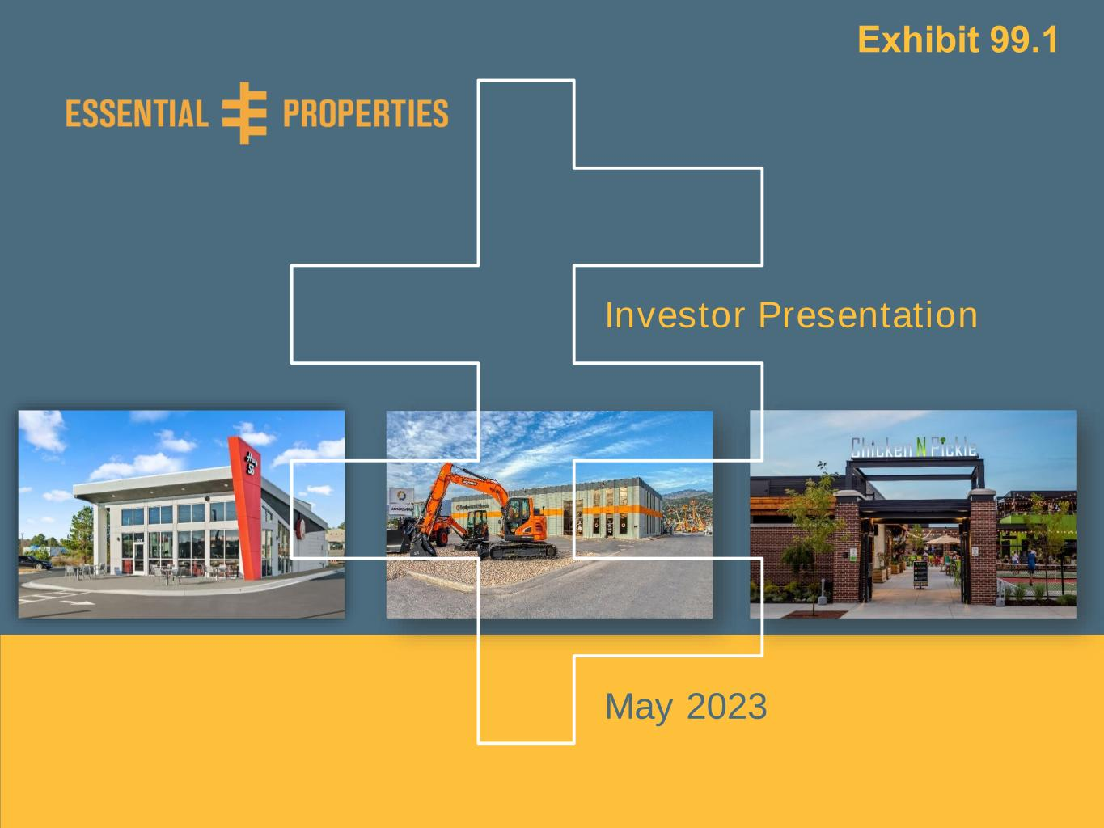
Investor Presentation – May 20230 Exhibit 99.1 May 2023 Investor Presentation

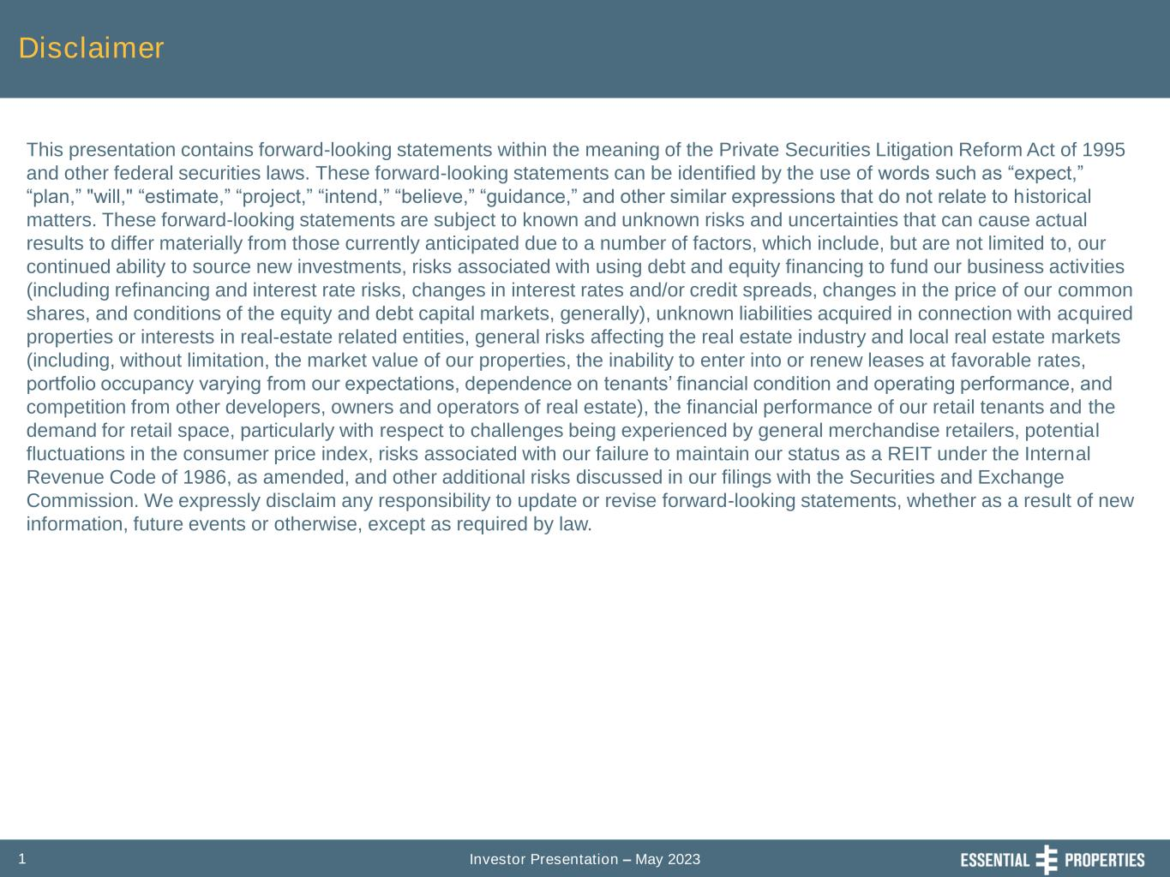
Investor Presentation – May 20231 Disclaimer This presentation contains forward-looking statements within the meaning of the Private Securities Litigation Reform Act of 1995 and other federal securities laws. These forward-looking statements can be identified by the use of words such as “expect,” “plan,” "will," “estimate,” “project,” “intend,” “believe,” “guidance,” and other similar expressions that do not relate to historical matters. These forward-looking statements are subject to known and unknown risks and uncertainties that can cause actual results to differ materially from those currently anticipated due to a number of factors, which include, but are not limited to, our continued ability to source new investments, risks associated with using debt and equity financing to fund our business activities (including refinancing and interest rate risks, changes in interest rates and/or credit spreads, changes in the price of our common shares, and conditions of the equity and debt capital markets, generally), unknown liabilities acquired in connection with acquired properties or interests in real-estate related entities, general risks affecting the real estate industry and local real estate markets (including, without limitation, the market value of our properties, the inability to enter into or renew leases at favorable rates, portfolio occupancy varying from our expectations, dependence on tenants’ financial condition and operating performance, and competition from other developers, owners and operators of real estate), the financial performance of our retail tenants and the demand for retail space, particularly with respect to challenges being experienced by general merchandise retailers, potential fluctuations in the consumer price index, risks associated with our failure to maintain our status as a REIT under the Internal Revenue Code of 1986, as amended, and other additional risks discussed in our filings with the Securities and Exchange Commission. We expressly disclaim any responsibility to update or revise forward-looking statements, whether as a result of new information, future events or otherwise, except as required by law.

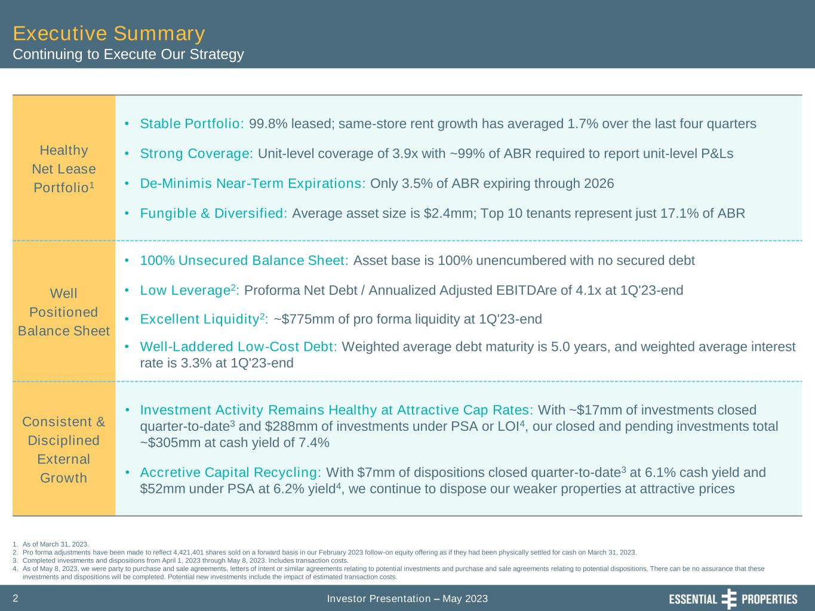
Investor Presentation – May 20232 Healthy Net Lease Portfolio1 • Stable Portfolio: 99.8% leased; same-store rent growth has averaged 1.7% over the last four quarters • Strong Coverage: Unit-level coverage of 3.9x with ~99% of ABR required to report unit-level P&Ls • De-Minimis Near-Term Expirations: Only 3.5% of ABR expiring through 2026 • Fungible & Diversified: Average asset size is $2.4mm; Top 10 tenants represent just 17.1% of ABR Well Positioned Balance Sheet • 100% Unsecured Balance Sheet: Asset base is 100% unencumbered with no secured debt • Low Leverage2: Proforma Net Debt / Annualized Adjusted EBITDAre of 4.1x at 1Q'23-end • Excellent Liquidity2: ~$775mm of pro forma liquidity at 1Q'23-end • Well-Laddered Low-Cost Debt: Weighted average debt maturity is 5.0 years, and weighted average interest rate is 3.3% at 1Q'23-end Consistent & Disciplined External Growth • Investment Activity Remains Healthy at Attractive Cap Rates: With ~$17mm of investments closed quarter-to-date3 and $288mm of investments under PSA or LOI4, our closed and pending investments total ~$305mm at cash yield of 7.4% • Accretive Capital Recycling: With $7mm of dispositions closed quarter-to-date3 at 6.1% cash yield and $52mm under PSA at 6.2% yield4, we continue to dispose our weaker properties at attractive prices 1. As of March 31, 2023. 2. Pro forma adjustments have been made to reflect 4,421,401 shares sold on a forward basis in our February 2023 follow-on equity offering as if they had been physically settled for cash on March 31, 2023. 3. Completed investments and dispositions from April 1, 2023 through May 8, 2023. Includes transaction costs. 4. As of May 8, 2023, we were party to purchase and sale agreements, letters of intent or similar agreements relating to potential investments and purchase and sale agreements relating to potential dispositions. There can be no assurance that these investments and dispositions will be completed. Potential new investments include the impact of estimated transaction costs. Executive Summary Continuing to Execute Our Strategy

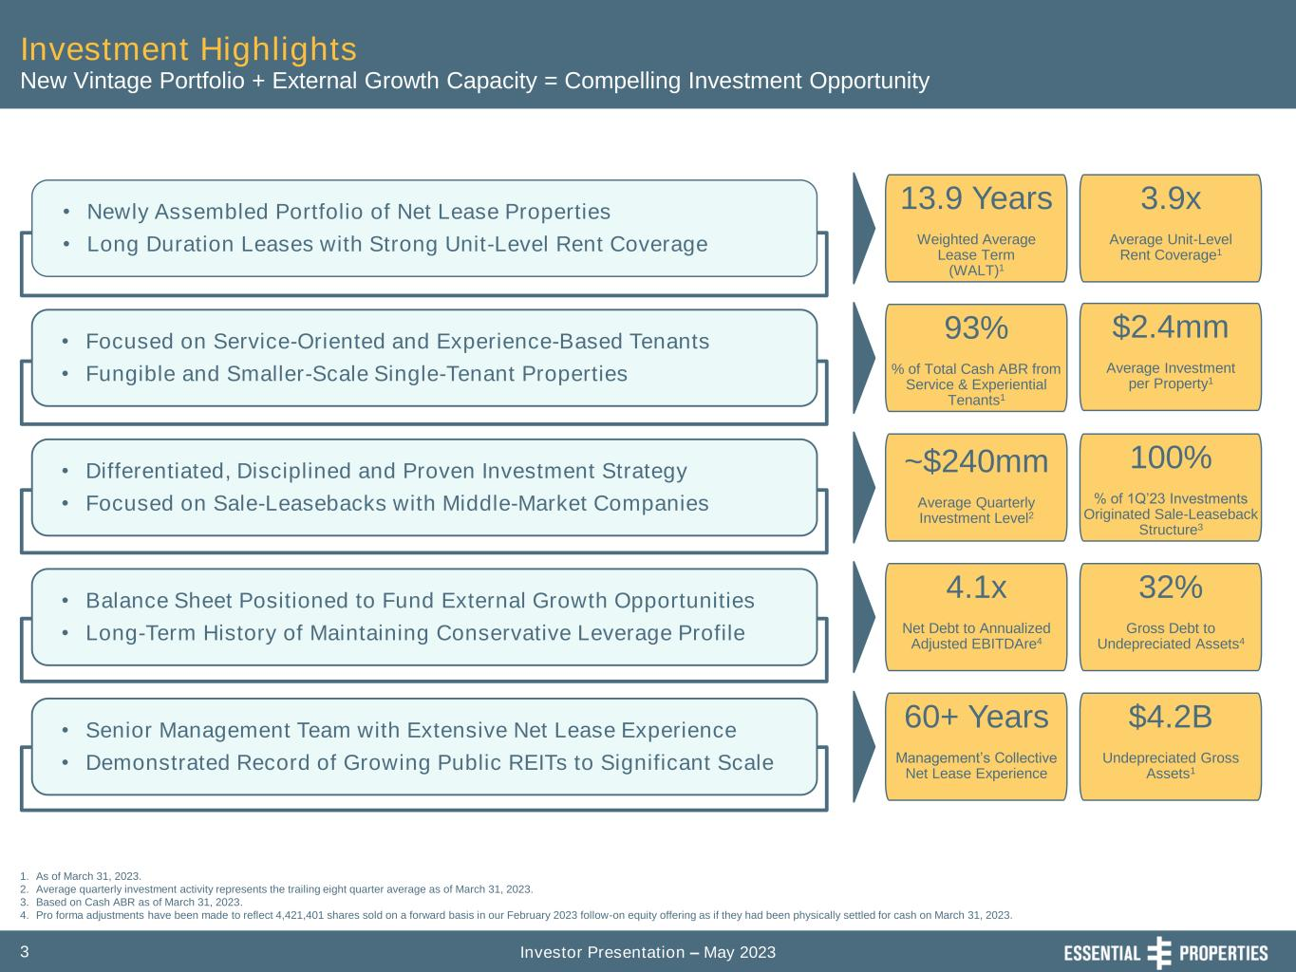
Investor Presentation – May 20233 Investment Highlights • Newly Assembled Portfolio of Net Lease Properties • Long Duration Leases with Strong Unit-Level Rent Coverage • Focused on Service-Oriented and Experience-Based Tenants • Fungible and Smaller-Scale Single-Tenant Properties • Differentiated, Disciplined and Proven Investment Strategy • Focused on Sale-Leasebacks with Middle-Market Companies • Balance Sheet Positioned to Fund External Growth Opportunities • Long-Term History of Maintaining Conservative Leverage Profile • Senior Management Team with Extensive Net Lease Experience • Demonstrated Record of Growing Public REITs to Significant Scale 1. As of March 31, 2023. 2. Average quarterly investment activity represents the trailing eight quarter average as of March 31, 2023. 3. Based on Cash ABR as of March 31, 2023. 4. Pro forma adjustments have been made to reflect 4,421,401 shares sold on a forward basis in our February 2023 follow-on equity offering as if they had been physically settled for cash on March 31, 2023. New Vintage Portfolio + External Growth Capacity = Compelling Investment Opportunity 13.9 Years Weighted Average Lease Term (WALT)1 3.9x Average Unit-Level Rent Coverage1 93% % of Total Cash ABR from Service & Experiential Tenants1 $2.4mm Average Investment per Property1 ~$240mm Average Quarterly Investment Level2 100% % of 1Q’23 Investments Originated Sale-Leaseback Structure3 4.1x Net Debt to Annualized Adjusted EBITDAre4 32% Gross Debt to Undepreciated Assets4 60+ Years Management’s Collective Net Lease Experience $4.2B Undepreciated Gross Assets1

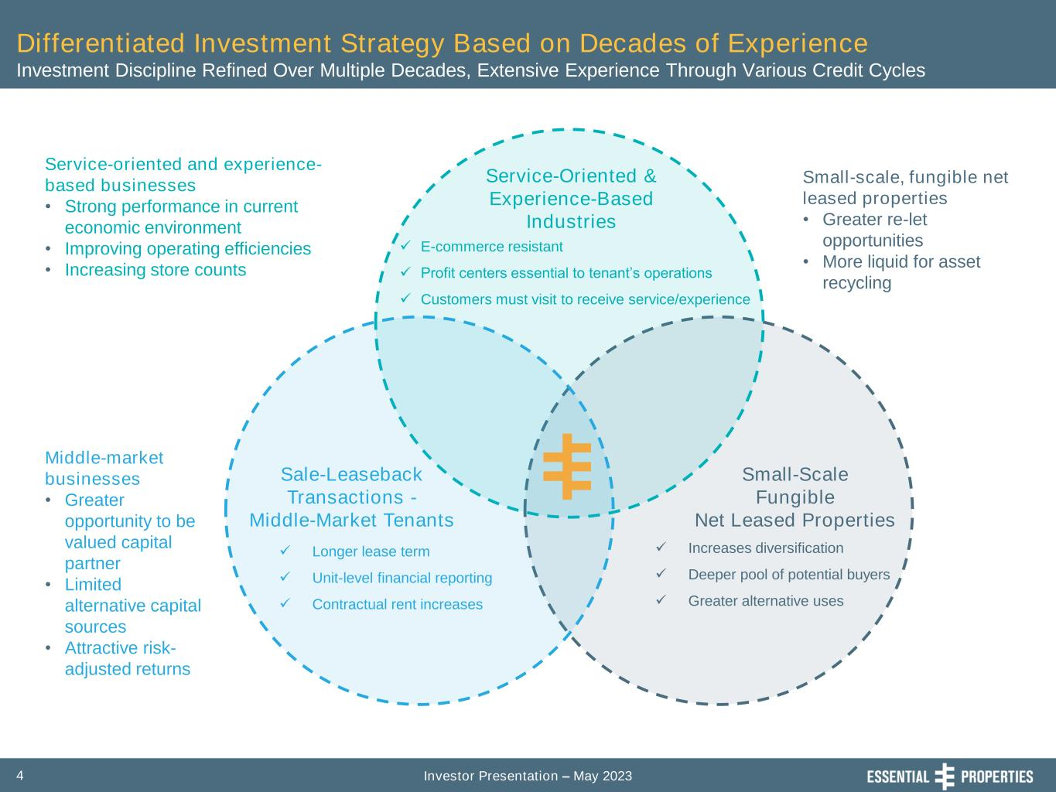
Investor Presentation – May 20234 Differentiated Investment Strategy Based on Decades of Experience Investment Discipline Refined Over Multiple Decades, Extensive Experience Through Various Credit Cycles Service-Oriented & Experience-Based Industries Sale-Leaseback Transactions - Middle-Market Tenants Small-Scale Fungible Net Leased Properties ✓ E-commerce resistant ✓ Profit centers essential to tenant’s operations ✓ Customers must visit to receive service/experience ✓ Longer lease term ✓ Unit-level financial reporting ✓ Contractual rent increases ✓ Increases diversification ✓ Deeper pool of potential buyers ✓ Greater alternative uses Small-scale, fungible net leased properties • Greater re-let opportunities • More liquid for asset recycling Service-oriented and experience- based businesses • Strong performance in current economic environment • Improving operating efficiencies • Increasing store counts Middle-market businesses • Greater opportunity to be valued capital partner • Limited alternative capital sources • Attractive risk- adjusted returns

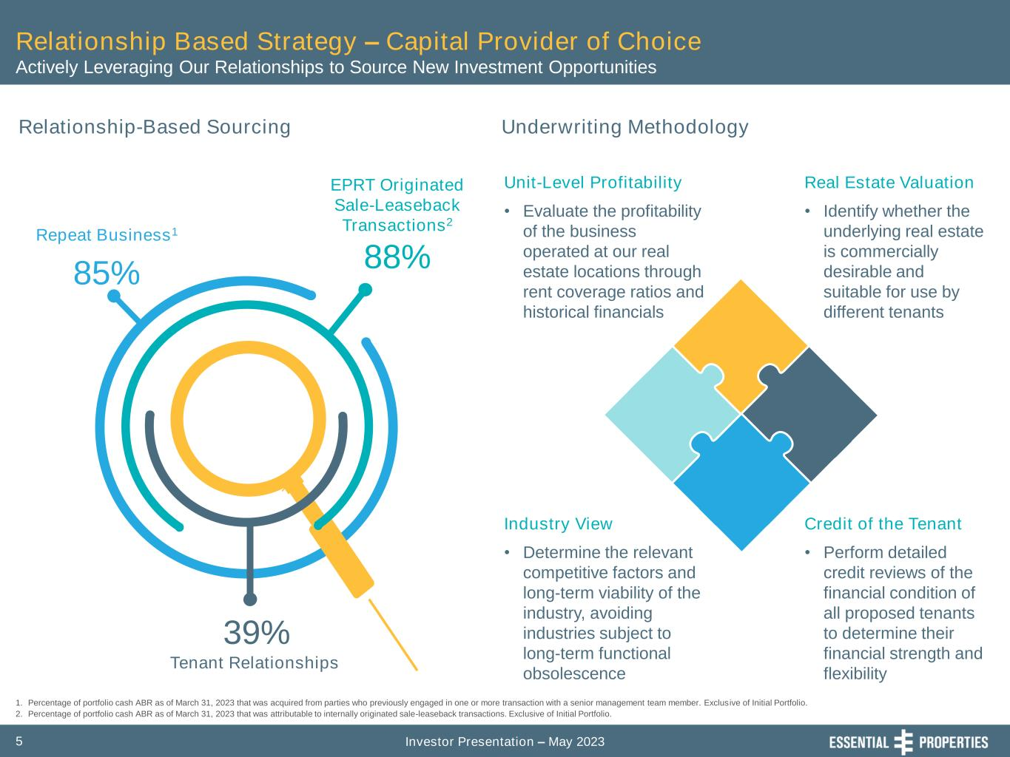
Investor Presentation – May 20235 Relationship Based Strategy – Capital Provider of Choice Actively Leveraging Our Relationships to Source New Investment Opportunities Relationship-Based Sourcing 1. Percentage of portfolio cash ABR as of March 31, 2023 that was acquired from parties who previously engaged in one or more transaction with a senior management team member. Exclusive of Initial Portfolio. 2. Percentage of portfolio cash ABR as of March 31, 2023 that was attributable to internally originated sale-leaseback transactions. Exclusive of Initial Portfolio. Repeat Business1 85% EPRT Originated Sale-Leaseback Transactions2 88% Tenant Relationships 39% Underwriting Methodology Industry View • Determine the relevant competitive factors and long-term viability of the industry, avoiding industries subject to long-term functional obsolescence Credit of the Tenant • Perform detailed credit reviews of the financial condition of all proposed tenants to determine their financial strength and flexibility Unit-Level Profitability • Evaluate the profitability of the business operated at our real estate locations through rent coverage ratios and historical financials Real Estate Valuation • Identify whether the underlying real estate is commercially desirable and suitable for use by different tenants

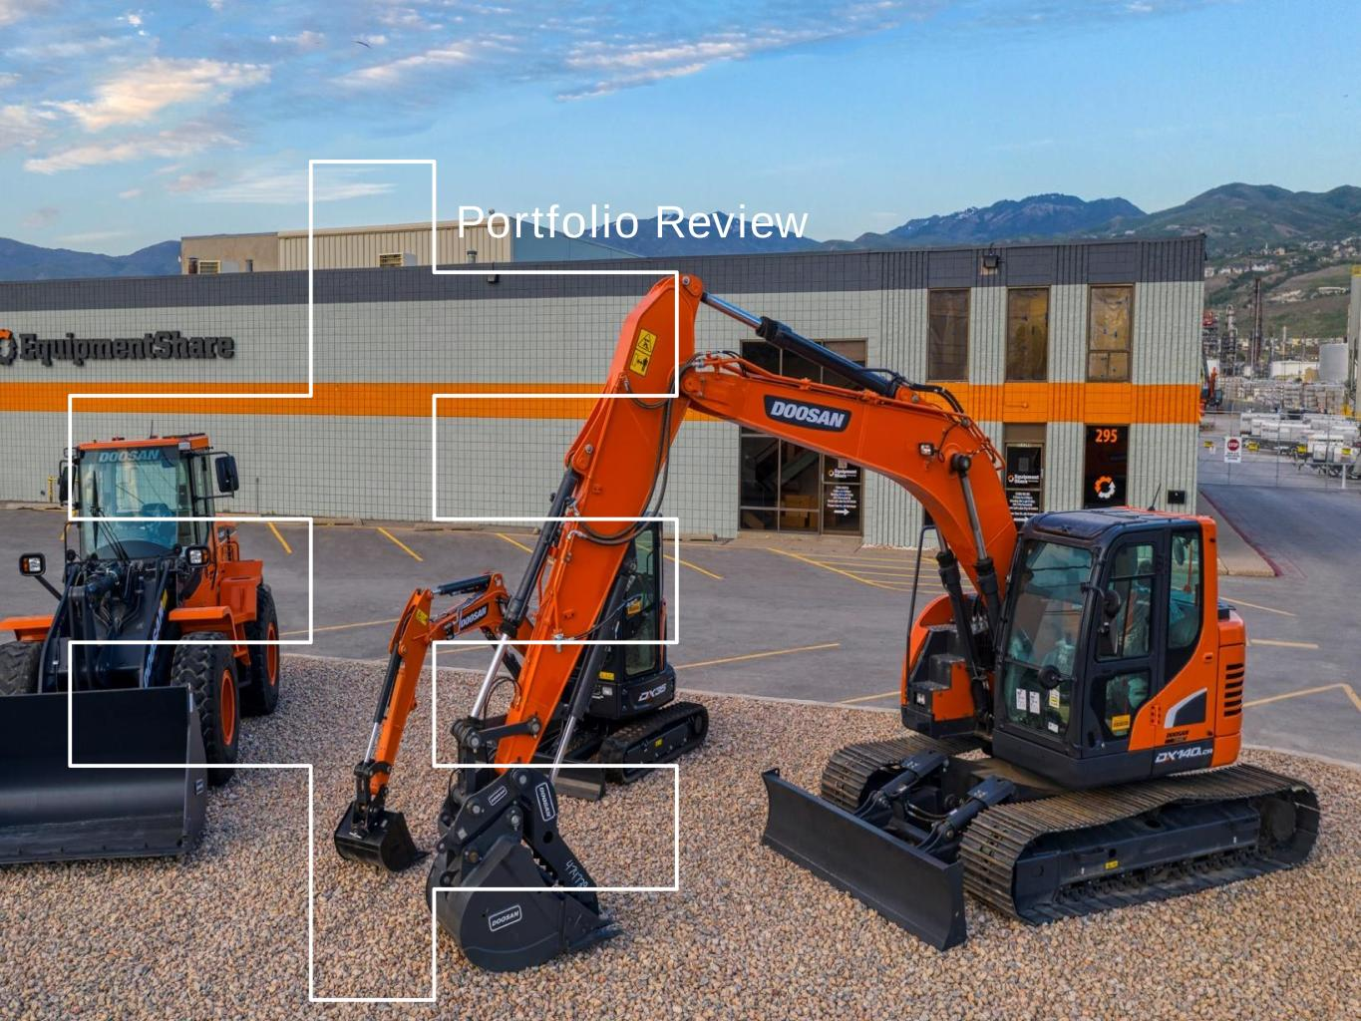
Portfolio Review

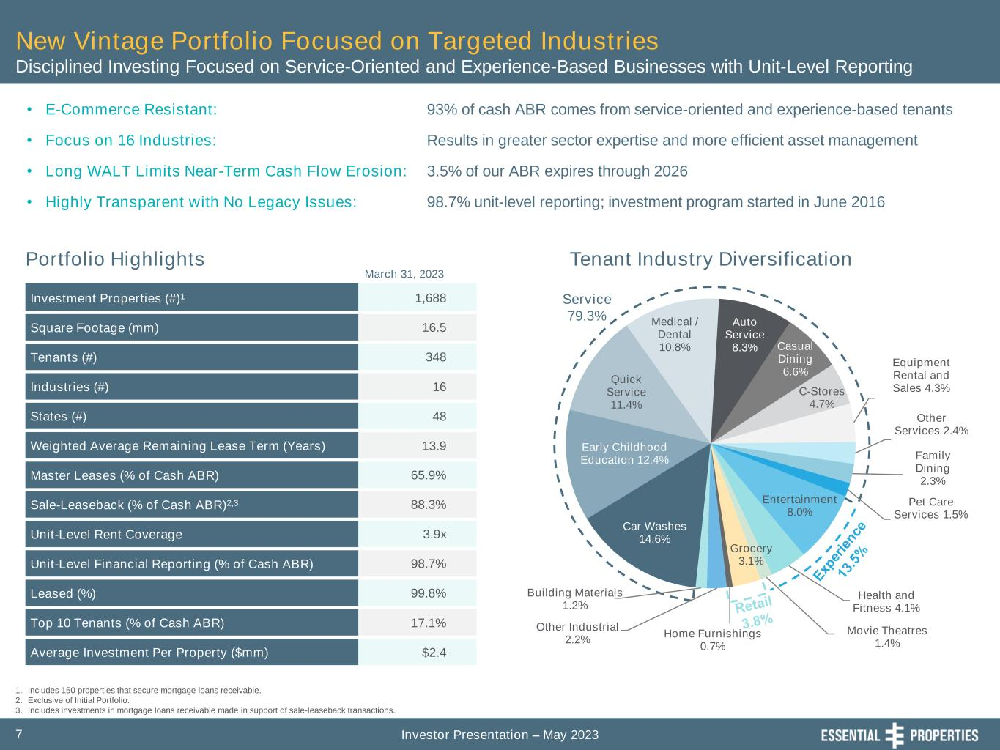
Investor Presentation – May 20237 Car Washes 14.6% Early Childhood Education 12.4% Quick Service 11.4% Medical / Dental 10.8% Auto Service 8.3% Casual Dining 6.6% C-Stores 4.7% Equipment Rental and Sales 4.3% Other Services 2.4% Family Dining 2.3% Pet Care Services 1.5% Entertainment 8.0% Health and Fitness 4.1% Movie Theatres 1.4% Grocery 3.1% Home Furnishings 0.7% Other Industrial 2.2% Building Materials 1.2% Service 79.3% New Vintage Portfolio Focused on Targeted Industries Disciplined Investing Focused on Service-Oriented and Experience-Based Businesses with Unit-Level Reporting 1. Includes 150 properties that secure mortgage loans receivable. 2. Exclusive of Initial Portfolio. 3. Includes investments in mortgage loans receivable made in support of sale-leaseback transactions. Portfolio Highlights March 31, 2023 Tenant Industry Diversification • E-Commerce Resistant: • Focus on 16 Industries: • Long WALT Limits Near-Term Cash Flow Erosion: • Highly Transparent with No Legacy Issues: Investment Properties (#)1 1,688 Square Footage (mm) 16.5 Tenants (#) 348 Industries (#) 16 States (#) 48 Weighted Average Remaining Lease Term (Years) 13.9 Master Leases (% of Cash ABR) 65.9% Sale-Leaseback (% of Cash ABR)2,3 88.3% Unit-Level Rent Coverage 3.9x Unit-Level Financial Reporting (% of Cash ABR) 98.7% Leased (%) 99.8% Top 10 Tenants (% of Cash ABR) 17.1% Average Investment Per Property ($mm) $2.4 93% of cash ABR comes from service-oriented and experience-based tenants Results in greater sector expertise and more efficient asset management 3.5% of our ABR expires through 2026 98.7% unit-level reporting; investment program started in June 2016

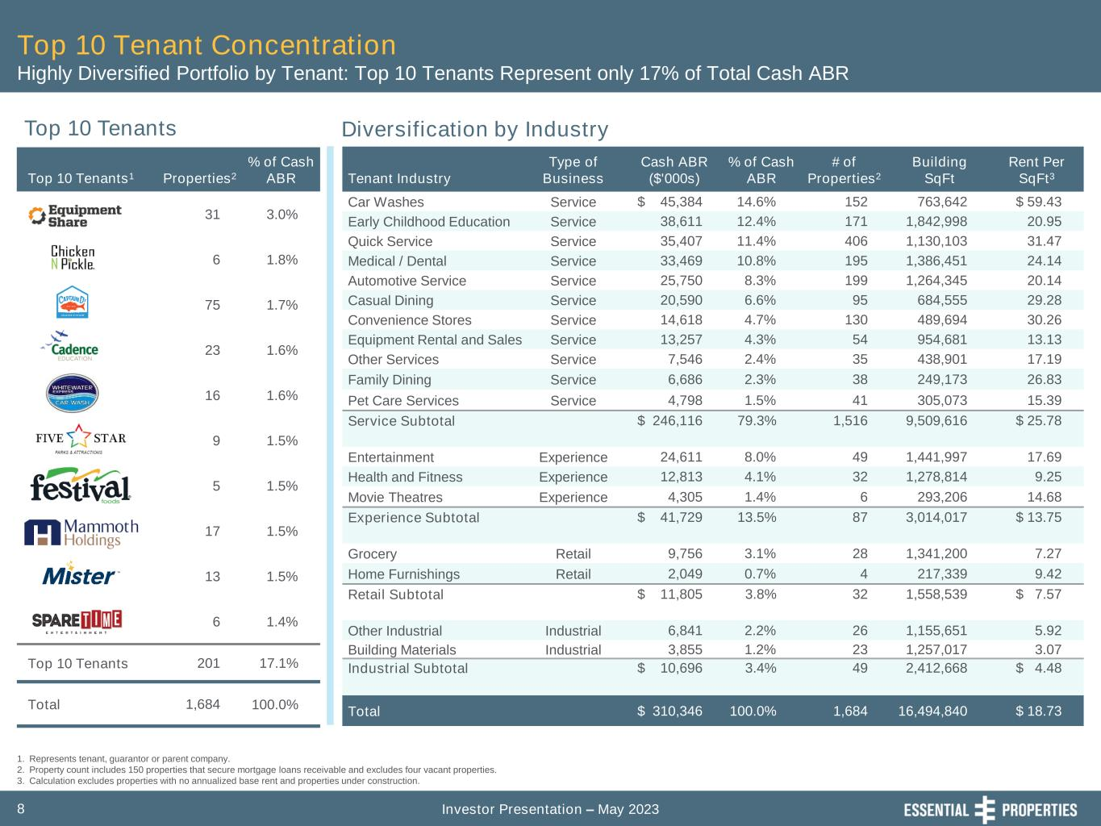
Investor Presentation – May 20238 Top 10 Tenant Concentration Highly Diversified Portfolio by Tenant: Top 10 Tenants Represent only 17% of Total Cash ABR Top 10 Tenants1 Properties2 % of Cash ABR 31 3.0% 6 1.8% 75 1.7% 23 1.6% 16 1.6% 9 1.5% 5 1.5% 17 1.5% 13 1.5% 6 1.4% Top 10 Tenants 201 17.1% Total 1,684 100.0% Top 10 Tenants Diversification by Industry 1. Represents tenant, guarantor or parent company. 2. Property count includes 150 properties that secure mortgage loans receivable and excludes four vacant properties. 3. Calculation excludes properties with no annualized base rent and properties under construction. Tenant Industry Type of Business Cash ABR ($'000s) % of Cash ABR # of Properties2 Building SqFt Rent Per SqFt3 Car Washes Service $ 45,384 14.6% 152 763,642 $ 59.43 Early Childhood Education Service 38,611 12.4% 171 1,842,998 20.95 Quick Service Service 35,407 11.4% 406 1,130,103 31.47 Medical / Dental Service 33,469 10.8% 195 1,386,451 24.14 Automotive Service Service 25,750 8.3% 199 1,264,345 20.14 Casual Dining Service 20,590 6.6% 95 684,555 29.28 Convenience Stores Service 14,618 4.7% 130 489,694 30.26 Equipment Rental and Sales Service 13,257 4.3% 54 954,681 13.13 Other Services Service 7,546 2.4% 35 438,901 17.19 Family Dining Service 6,686 2.3% 38 249,173 26.83 Pet Care Services Service 4,798 1.5% 41 305,073 15.39 Service Subtotal $ 246,116 79.3% 1,516 9,509,616 $ 25.78 Entertainment Experience 24,611 8.0% 49 1,441,997 17.69 Health and Fitness Experience 12,813 4.1% 32 1,278,814 9.25 Movie Theatres Experience 4,305 1.4% 6 293,206 14.68 Experience Subtotal $ 41,729 13.5% 87 3,014,017 $ 13.75 Grocery Retail 9,756 3.1% 28 1,341,200 7.27 Home Furnishings Retail 2,049 0.7% 4 217,339 9.42 Retail Subtotal $ 11,805 3.8% 32 1,558,539 $ 7.57 Other Industrial Industrial 6,841 2.2% 26 1,155,651 5.92 Building Materials Industrial 3,855 1.2% 23 1,257,017 3.07 Industrial Subtotal $ 10,696 3.4% 49 2,412,668 $ 4.48 Total $ 310,346 100.0% 1,684 16,494,840 $ 18.73

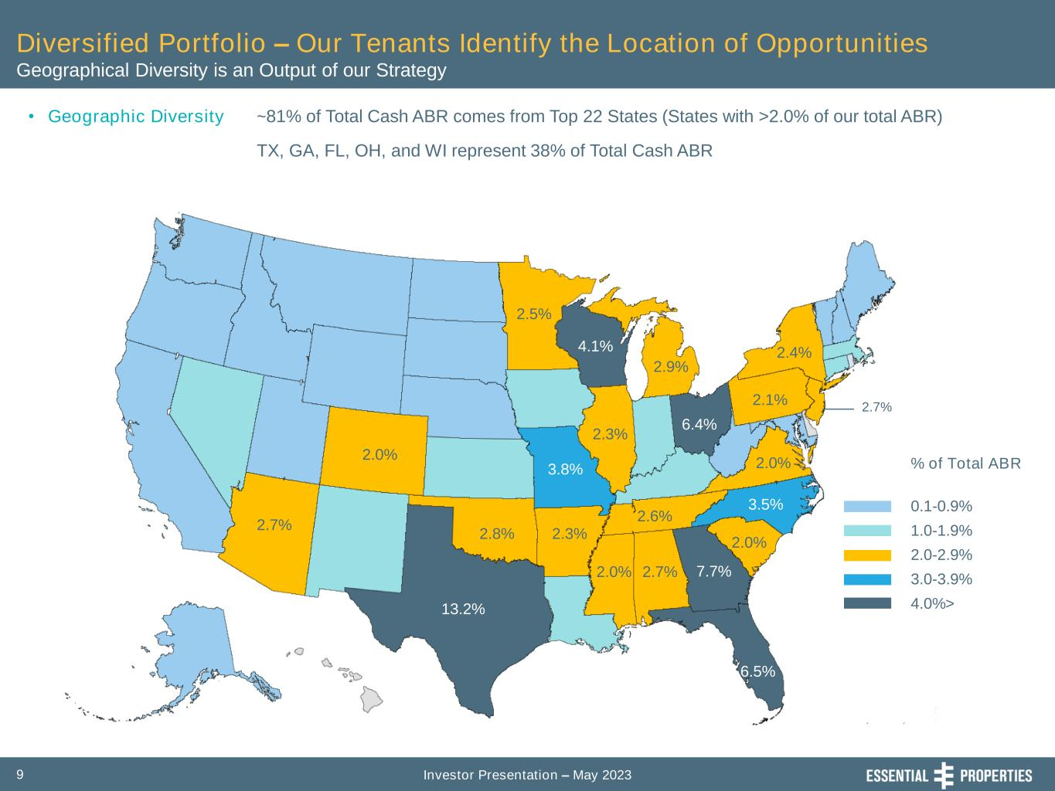
Investor Presentation – May 20239 Diversified Portfolio – Our Tenants Identify the Location of Opportunities Geographical Diversity is an Output of our Strategy • Geographic Diversity ~81% of Total Cash ABR comes from Top 22 States (States with >2.0% of our total ABR) TX, GA, FL, OH, and WI represent 38% of Total Cash ABR % of Total ABR 0.1-0.9% 1.0-1.9% 2.0-2.9% 3.0-3.9% 4.0%>13.2% 7.7% 4.1% 6.5% 6.4% 3.8% 3.5% 2.9% 2.1% 2.4% 2.5% 2.0% 2.7% 2.8% 2.3% 2.0% 2.7% 2.6% 2.0% 2.0% 2.7% 2.3%

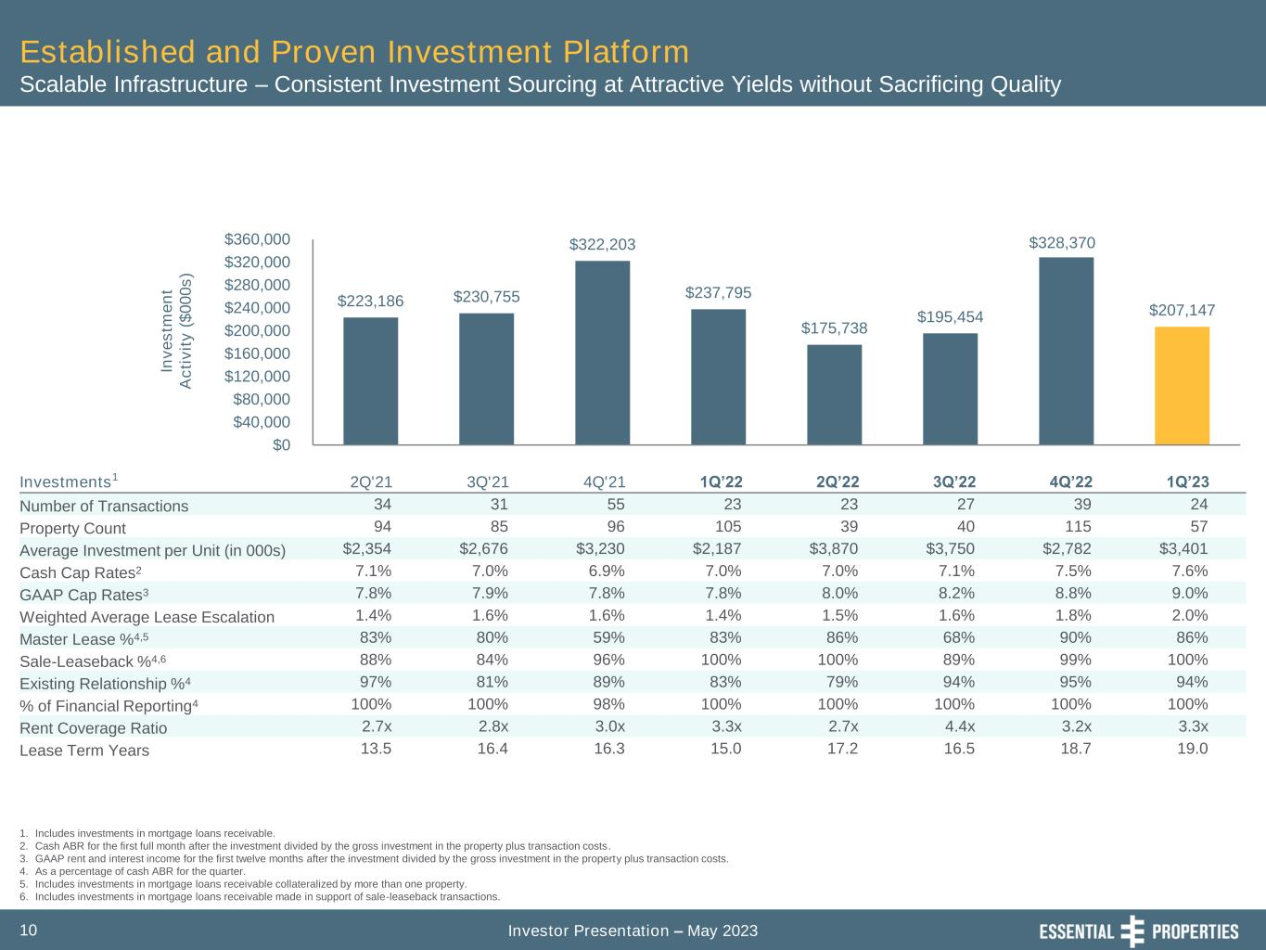
Investor Presentation – May 202310 Established and Proven Investment Platform Scalable Infrastructure – Consistent Investment Sourcing at Attractive Yields without Sacrificing Quality 1. Includes investments in mortgage loans receivable. 2. Cash ABR for the first full month after the investment divided by the gross investment in the property plus transaction costs. 3. GAAP rent and interest income for the first twelve months after the investment divided by the gross investment in the property plus transaction costs. 4. As a percentage of cash ABR for the quarter. 5. Includes investments in mortgage loans receivable collateralized by more than one property. 6. Includes investments in mortgage loans receivable made in support of sale-leaseback transactions. Investments1 2Q'21 3Q'21 4Q'21 1Q’22 2Q’22 3Q’22 4Q’22 1Q’23 Number of Transactions 34 31 55 23 23 27 39 24 Property Count 94 85 96 105 39 40 115 57 Average Investment per Unit (in 000s) $2,354 $2,676 $3,230 $2,187 $3,870 $3,750 $2,782 $3,401 Cash Cap Rates2 7.1% 7.0% 6.9% 7.0% 7.0% 7.1% 7.5% 7.6% GAAP Cap Rates3 7.8% 7.9% 7.8% 7.8% 8.0% 8.2% 8.8% 9.0% Weighted Average Lease Escalation 1.4% 1.6% 1.6% 1.4% 1.5% 1.6% 1.8% 2.0% Master Lease %4,5 83% 80% 59% 83% 86% 68% 90% 86% Sale-Leaseback %4,6 88% 84% 96% 100% 100% 89% 99% 100% Existing Relationship %4 97% 81% 89% 83% 79% 94% 95% 94% % of Financial Reporting4 100% 100% 98% 100% 100% 100% 100% 100% Rent Coverage Ratio 2.7x 2.8x 3.0x 3.3x 2.7x 4.4x 3.2x 3.3x Lease Term Years 13.5 16.4 16.3 15.0 17.2 16.5 18.7 19.0 $223,186 $230,755 $322,203 $237,795 $175,738 $195,454 $328,370 $207,147 $0 $40,000 $80,000 $120,000 $160,000 $200,000 $240,000 $280,000 $320,000 $360,000 In v e s tm e n t A c ti v it y ( $ 0 0 0 s )

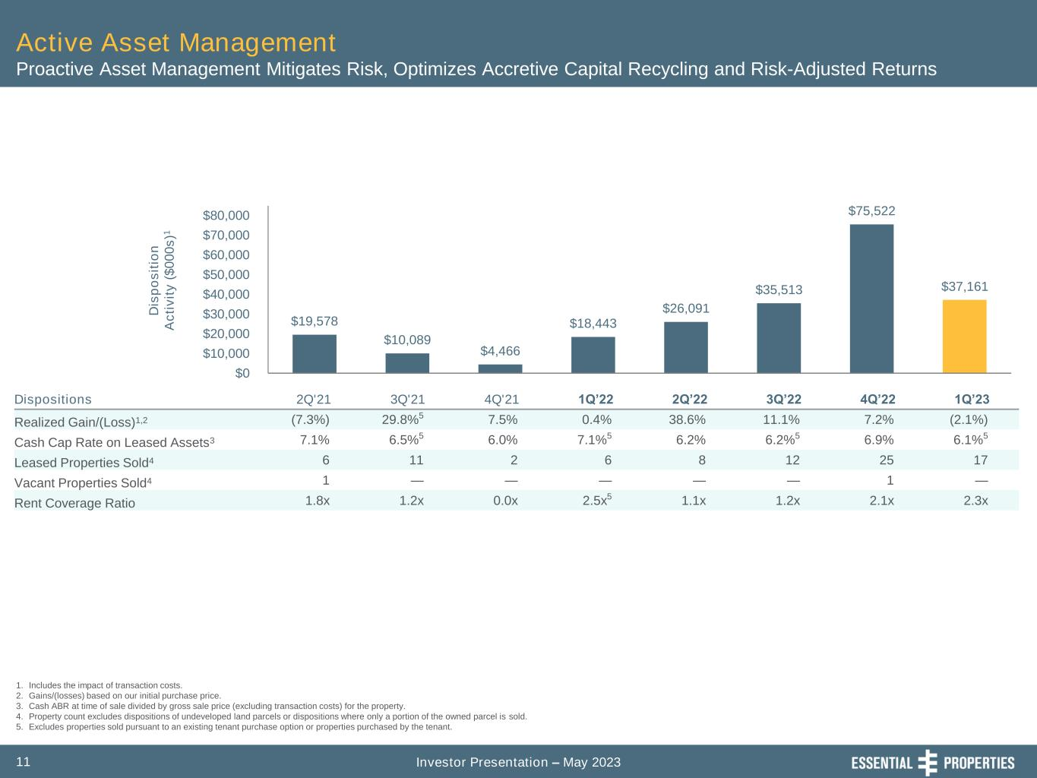
Investor Presentation – May 202311 Active Asset Management Proactive Asset Management Mitigates Risk, Optimizes Accretive Capital Recycling and Risk-Adjusted Returns 1. Includes the impact of transaction costs. 2. Gains/(losses) based on our initial purchase price. 3. Cash ABR at time of sale divided by gross sale price (excluding transaction costs) for the property. 4. Property count excludes dispositions of undeveloped land parcels or dispositions where only a portion of the owned parcel is sold. 5. Excludes properties sold pursuant to an existing tenant purchase option or properties purchased by the tenant. Dispositions 2Q'21 3Q'21 4Q'21 1Q’22 2Q’22 3Q’22 4Q’22 1Q’23 Realized Gain/(Loss)1,2 (7.3%) 29.8%5 7.5% 0.4% 38.6% 11.1% 7.2% (2.1%) Cash Cap Rate on Leased Assets3 7.1% 6.5%5 6.0% 7.1%5 6.2% 6.2%5 6.9% 6.1%5 Leased Properties Sold4 6 11 2 6 8 12 25 17 Vacant Properties Sold4 1 — — — — — 1 — Rent Coverage Ratio 1.8x 1.2x 0.0x 2.5x5 1.1x 1.2x 2.1x 2.3x $19,578 $10,089 $4,466 $18,443 $26,091 $35,513 $75,522 $37,161 $0 $10,000 $20,000 $30,000 $40,000 $50,000 $60,000 $70,000 $80,000 D is p o s it io n A c ti v it y ( $ 0 0 0 s )1

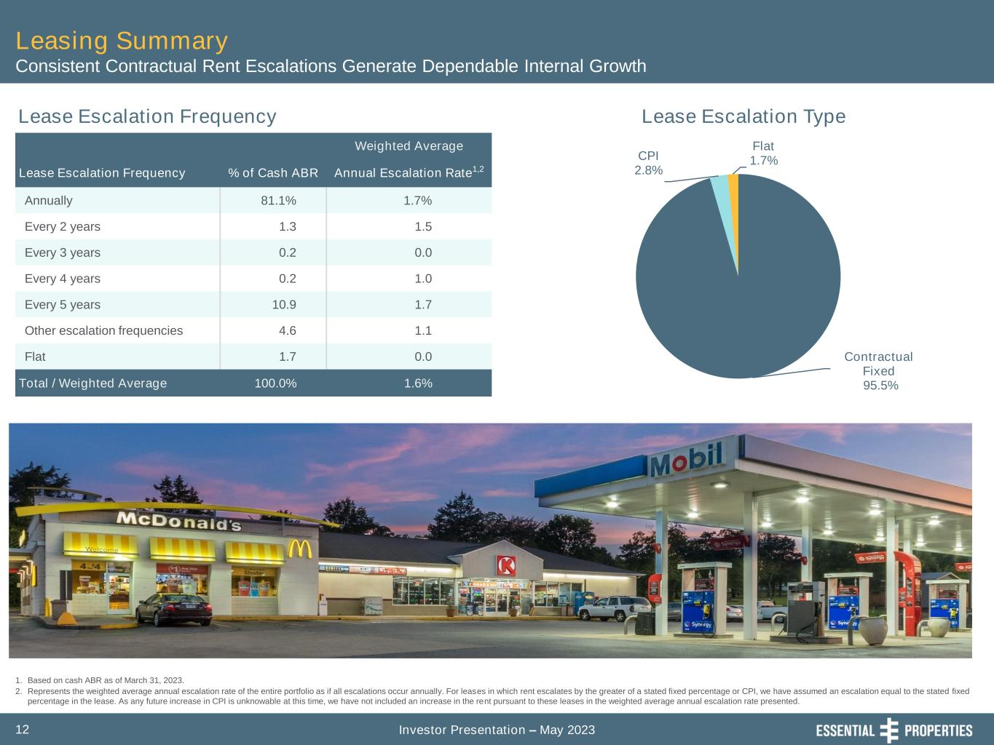
Investor Presentation – May 202312 Leasing Summary Consistent Contractual Rent Escalations Generate Dependable Internal Growth Contractual Fixed 95.5% CPI 2.8% Flat 1.7% 1. Based on cash ABR as of March 31, 2023. 2. Represents the weighted average annual escalation rate of the entire portfolio as if all escalations occur annually. For leases in which rent escalates by the greater of a stated fixed percentage or CPI, we have assumed an escalation equal to the stated fixed percentage in the lease. As any future increase in CPI is unknowable at this time, we have not included an increase in the rent pursuant to these leases in the weighted average annual escalation rate presented. Lease Escalation Frequency Lease Escalation Type Weighted Average Lease Escalation Frequency % of Cash ABR Annual Escalation Rate1,2 Annually 81.1% 1.7% Every 2 years 1.3 1.5 Every 3 years 0.2 0.0 Every 4 years 0.2 1.0 Every 5 years 10.9 1.7 Other escalation frequencies 4.6 1.1 Flat 1.7 0.0 Total / Weighted Average 100.0% 1.6%

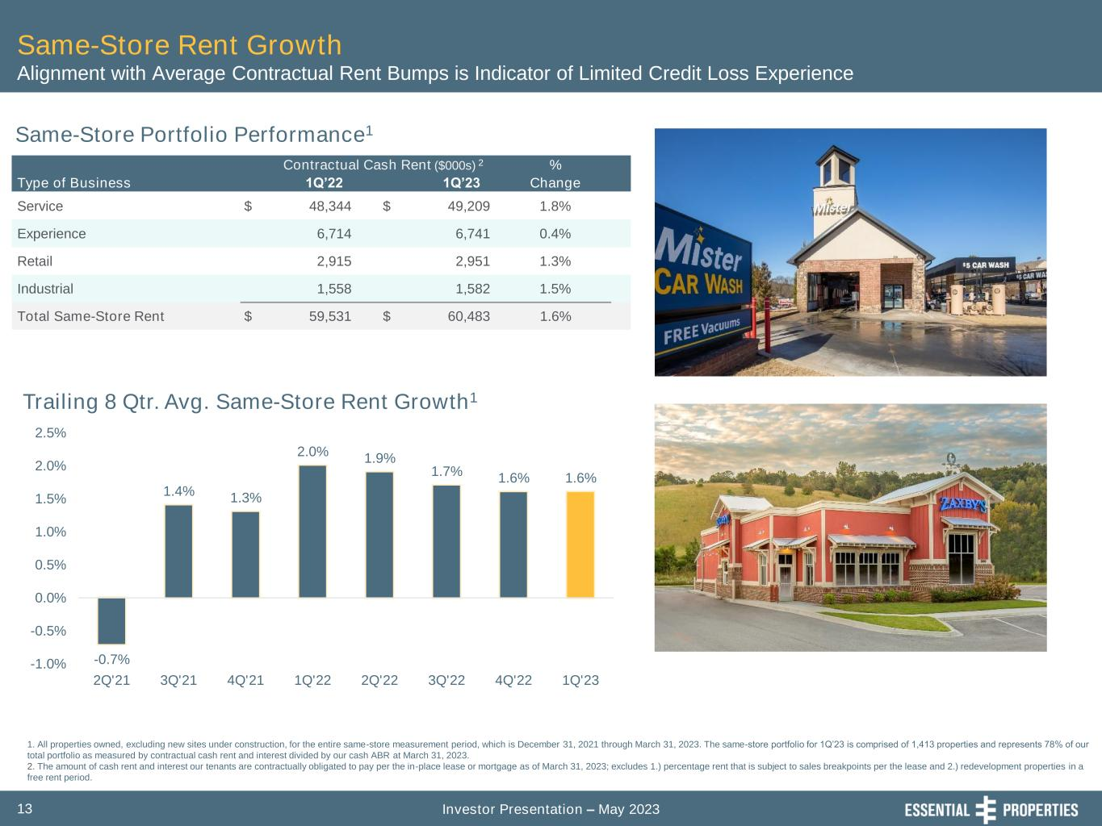
Investor Presentation – May 202313 Same-Store Rent Growth Alignment with Average Contractual Rent Bumps is Indicator of Limited Credit Loss Experience Same-Store Portfolio Performance1 Contractual Cash Rent ($000s) 2 % Type of Business 1Q’22 1Q’23 Change Service $ 48,344 $ 49,209 1.8% Experience 6,714 6,741 0.4% Retail 2,915 2,951 1.3% Industrial 1,558 1,582 1.5% Total Same-Store Rent $ 59,531 $ 60,483 1.6% 1. All properties owned, excluding new sites under construction, for the entire same-store measurement period, which is December 31, 2021 through March 31, 2023. The same-store portfolio for 1Q’23 is comprised of 1,413 properties and represents 78% of our total portfolio as measured by contractual cash rent and interest divided by our cash ABR at March 31, 2023. 2. The amount of cash rent and interest our tenants are contractually obligated to pay per the in-place lease or mortgage as of March 31, 2023; excludes 1.) percentage rent that is subject to sales breakpoints per the lease and 2.) redevelopment properties in a free rent period. -0.7% 1.4% 1.3% 2.0% 1.9% 1.7% 1.6% 1.6% -1.0% -0.5% 0.0% 0.5% 1.0% 1.5% 2.0% 2.5% 2Q'21 3Q'21 4Q'21 1Q'22 2Q'22 3Q'22 4Q'22 1Q'23 Trailing 8 Qtr. Avg. Same-Store Rent Growth1

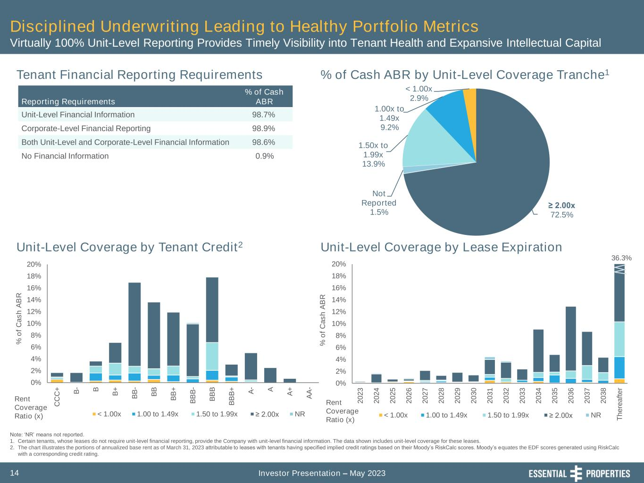
Investor Presentation – May 202314 Disciplined Underwriting Leading to Healthy Portfolio Metrics Virtually 100% Unit-Level Reporting Provides Timely Visibility into Tenant Health and Expansive Intellectual Capital 0% 2% 4% 6% 8% 10% 12% 14% 16% 18% 20% 2 0 2 3 2 0 2 4 2 0 2 5 2 0 2 6 2 0 2 7 2 0 2 8 2 0 2 9 2 0 3 0 2 0 3 1 2 0 3 2 2 0 3 3 2 0 3 4 2 0 3 5 2 0 3 6 2 0 3 7 2 0 3 8 T h e re a ft e r % o f C a s h A B R < 1.00x 1.00 to 1.49x 1.50 to 1.99x ≥ 2.00x NR 36.3% 0% 2% 4% 6% 8% 10% 12% 14% 16% 18% 20% C C C + B - B B + B B - B B B B + B B B - B B B B B B + A - A A + A A - % o f C a s h A B R < 1.00x 1.00 to 1.49x 1.50 to 1.99x ≥ 2.00x NR Rent Coverage Ratio (x) Tenant Financial Reporting Requirements % of Cash ABR by Unit-Level Coverage Tranche1 Unit-Level Coverage by Lease ExpirationUnit-Level Coverage by Tenant Credit2 Reporting Requirements % of Cash ABR Unit-Level Financial Information 98.7% Corporate-Level Financial Reporting 98.9% Both Unit-Level and Corporate-Level Financial Information 98.6% No Financial Information 0.9% Rent Coverage Ratio (x) ≥ 2.00x 72.5% Not Reported 1.5% 1.50x to 1.99x 13.9% 1.00x to 1.49x 9.2% < 1.00x 2.9% Note: ‘NR’ means not reported. 1. Certain tenants, whose leases do not require unit-level financial reporting, provide the Company with unit-level financial information. The data shown includes unit-level coverage for these leases. 2. The chart illustrates the portions of annualized base rent as of March 31, 2023 attributable to leases with tenants having specified implied credit ratings based on their Moody’s RiskCalc scores. Moody’s equates the EDF scores generated using RiskCalc with a corresponding credit rating.

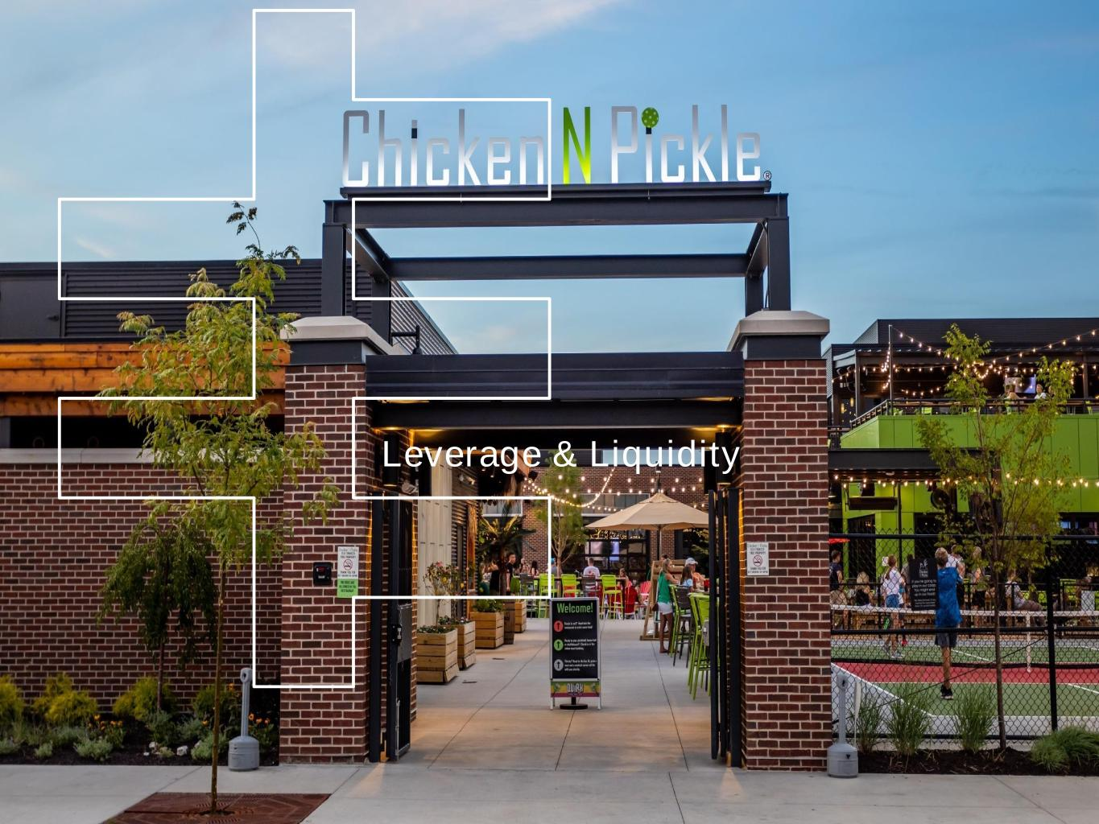
EPRT Board Meeting Management Presentation First Quarter Ended March 31, 2023 Leverage & Liquidity

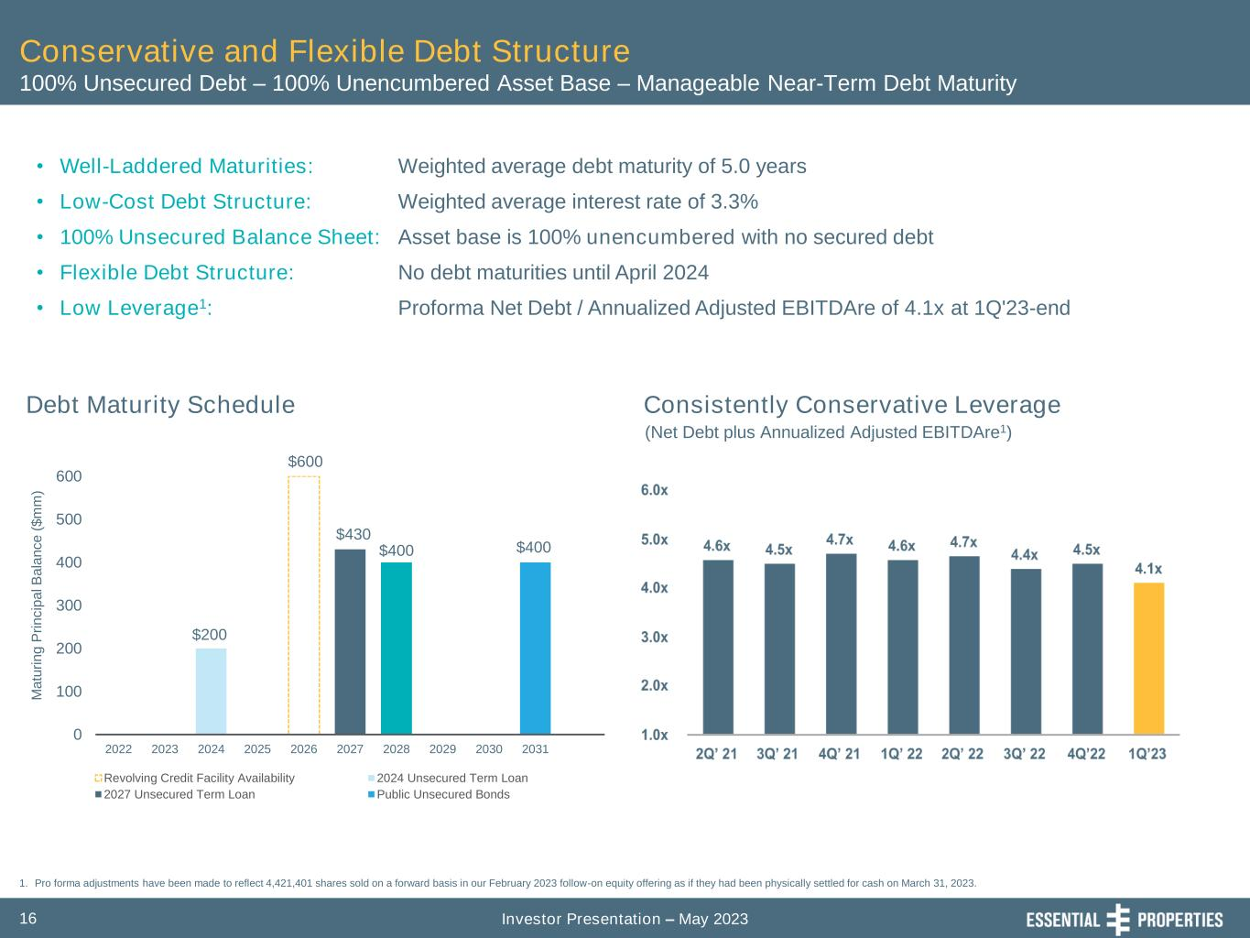
Investor Presentation – May 202316 $600 $200 $430 $400 $400 0 100 200 300 400 500 600 2022 2023 2024 2025 2026 2027 2028 2029 2030 2031 M a tu ri n g P ri n c ip a l B a la n c e ( $ m m ) Revolving Credit Facility Availability 2024 Unsecured Term Loan 2027 Unsecured Term Loan Public Unsecured Bonds Conservative and Flexible Debt Structure 100% Unsecured Debt – 100% Unencumbered Asset Base – Manageable Near-Term Debt Maturity Debt Maturity Schedule • Well-Laddered Maturities: • Low-Cost Debt Structure: • 100% Unsecured Balance Sheet: • Flexible Debt Structure: • Low Leverage1: Weighted average debt maturity of 5.0 years Weighted average interest rate of 3.3% Asset base is 100% unencumbered with no secured debt No debt maturities until April 2024 Proforma Net Debt / Annualized Adjusted EBITDAre of 4.1x at 1Q'23-end 1. Pro forma adjustments have been made to reflect 4,421,401 shares sold on a forward basis in our February 2023 follow-on equity offering as if they had been physically settled for cash on March 31, 2023. (Net Debt plus Annualized Adjusted EBITDAre1) Consistently Conservative Leverage

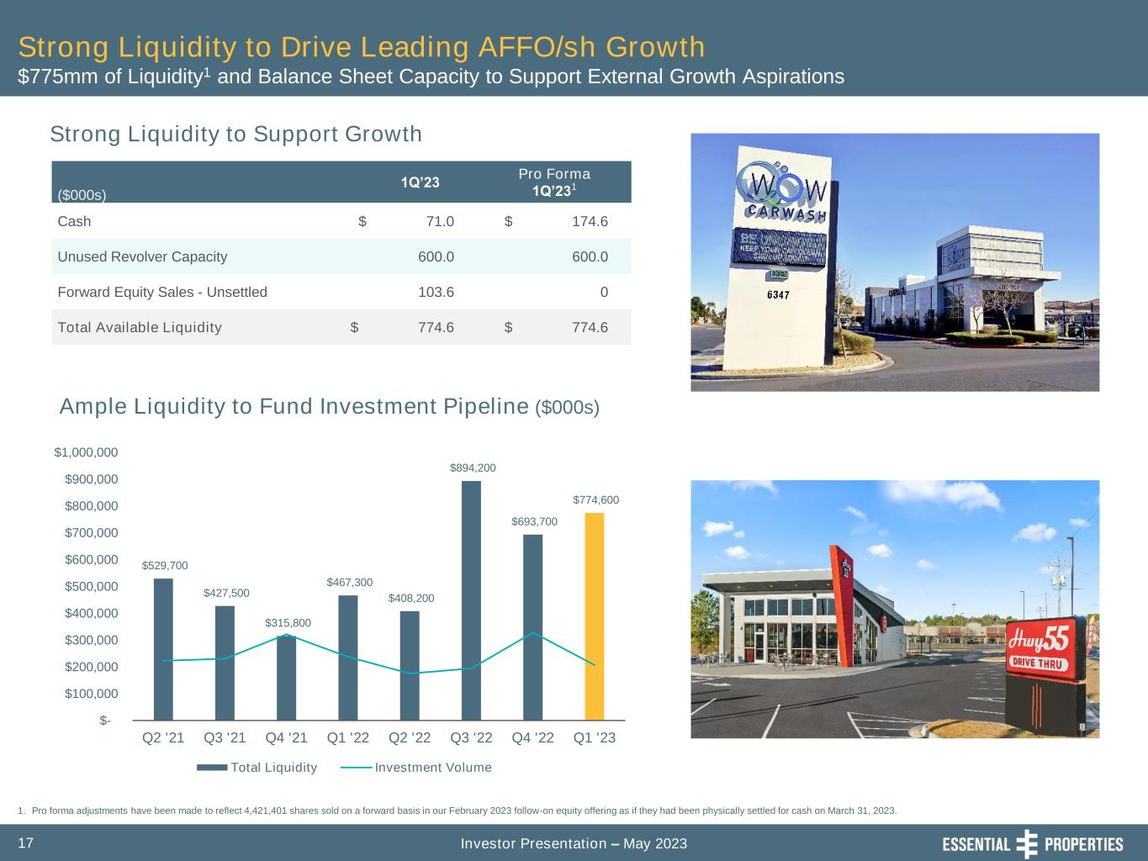
Investor Presentation – May 202317 Strong Liquidity to Drive Leading AFFO/sh Growth $775mm of Liquidity1 and Balance Sheet Capacity to Support External Growth Aspirations ($000s) 1Q’23 Pro Forma 1Q’231 Cash $ 71.0 $ 174.6 Unused Revolver Capacity 600.0 600.0 Forward Equity Sales - Unsettled 103.6 0 Total Available Liquidity $ 774.6 $ 774.6 1. Pro forma adjustments have been made to reflect 4,421,401 shares sold on a forward basis in our February 2023 follow-on equity offering as if they had been physically settled for cash on March 31, 2023. $529,700 $427,500 $315,800 $467,300 $408,200 $894,200 $693,700 $774,600 $- $100,000 $200,000 $300,000 $400,000 $500,000 $600,000 $700,000 $800,000 $900,000 $1,000,000 Q2 '21 Q3 '21 Q4 '21 Q1 '22 Q2 '22 Q3 '22 Q4 '22 Q1 '23 Total Liquidity Investment Volume Ample Liquidity to Fund Investment Pipeline ($000s) Strong Liquidity to Support Growth

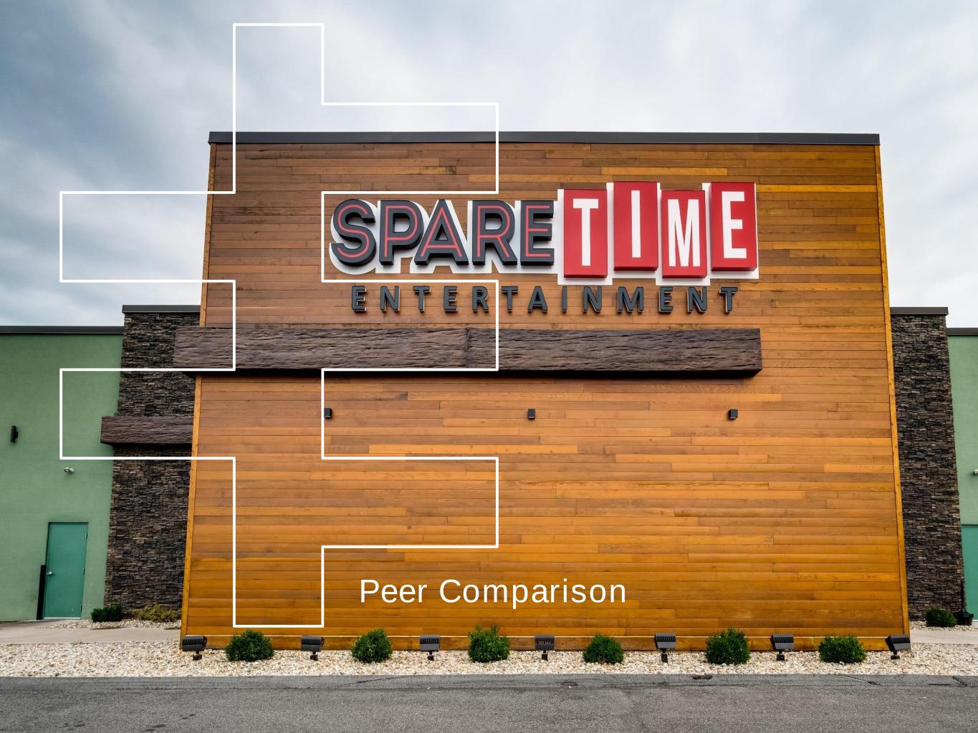
Peer Comparison

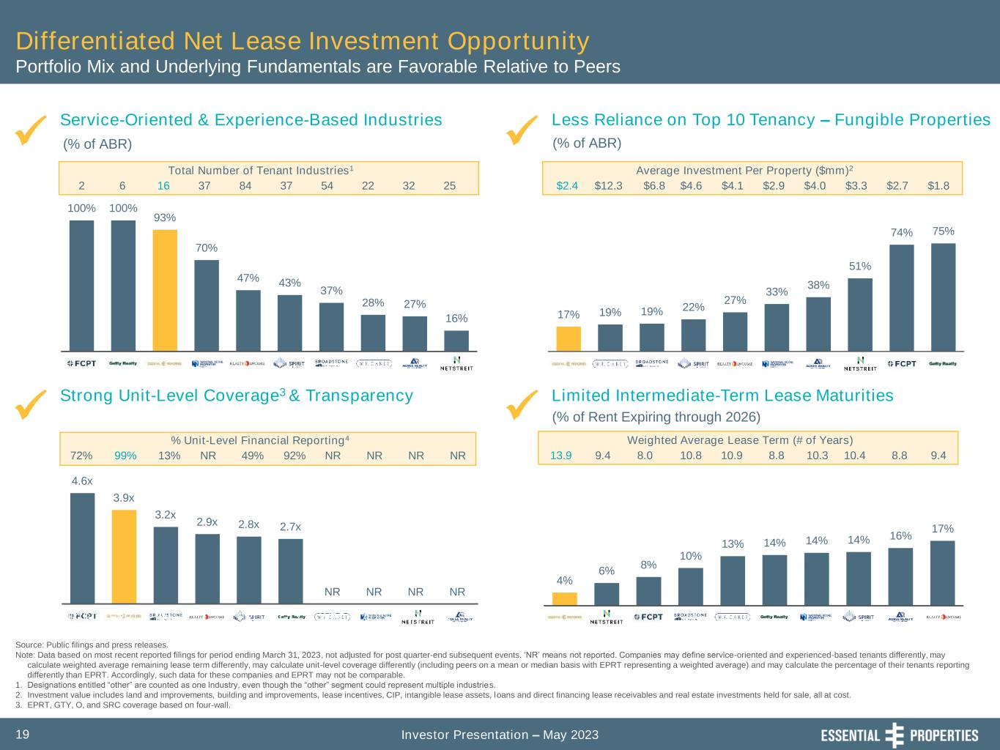
Investor Presentation – May 202319 Differentiated Net Lease Investment Opportunity Portfolio Mix and Underlying Fundamentals are Favorable Relative to Peers Strong Unit-Level Coverage3 & Transparency Service-Oriented & Experience-Based Industries Limited Intermediate-Term Lease Maturities ✓ ✓✓ Source: Public filings and press releases. Note: Data based on most recent reported filings for period ending March 31, 2023, not adjusted for post quarter-end subsequent events. ‘NR’ means not reported. Companies may define service-oriented and experienced-based tenants differently, may calculate weighted average remaining lease term differently, may calculate unit-level coverage differently (including peers on a mean or median basis with EPRT representing a weighted average) and may calculate the percentage of their tenants reporting differently than EPRT. Accordingly, such data for these companies and EPRT may not be comparable. 1. Designations entitled “other” are counted as one industry, even though the “other” segment could represent multiple industries. 2. Investment value includes land and improvements, building and improvements, lease incentives, CIP, intangible lease assets, loans and direct financing lease receivables and real estate investments held for sale, all at cost. 3. EPRT, GTY, O, and SRC coverage based on four-wall. (% of ABR) (% of Rent Expiring through 2026) Less Reliance on Top 10 Tenancy – Fungible Properties ✓ (% of ABR) 2 Total Number of Tenant Industries1 6 16 37 84 37 54 22 32 25 72% % Unit-Level Financial Reporting4 13% NR 49% 92% NR NR99% NR NR $2.4 Average Investment Per Property ($mm)2 $12.3 $6.8 $4.6 $4.1 $2.9 $4.0 $3.3 $2.7 $1.8 13.9 Weighted Average Lease Term (# of Years) 9.4 8.0 10.8 10.9 8.8 10.3 10.4 8.8 9.4 75% 74% 51% 38% 33% 27% 22% 19% 19% 17% 100% 100% 93% 70% 47% 43% 37% 28% 27% 16% FCPT GTY EPRT NNN O SRC BNL WPC ADC NTST 4% 6% 8% 10% 13% 14% 14% 14% 16% 17% 4.6x 3.9x 3.2x 2.9x 2.8x 2.7x NR NR NR NR FCPT EPRT BNL O SRC GTY WPC ADC NNN NTST

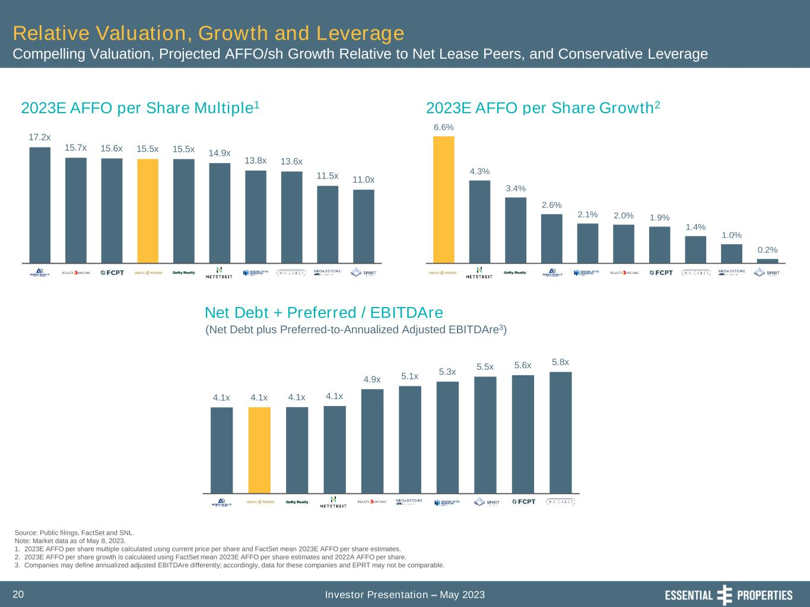
Investor Presentation – May 202320 Relative Valuation, Growth and Leverage Compelling Valuation, Projected AFFO/sh Growth Relative to Net Lease Peers, and Conservative Leverage Source: Public filings, FactSet and SNL. Note: Market data as of May 8, 2023. 1. 2023E AFFO per share multiple calculated using current price per share and FactSet mean 2023E AFFO per share estimates. 2. 2023E AFFO per share growth is calculated using FactSet mean 2023E AFFO per share estimates and 2022A AFFO per share. 3. Companies may define annualized adjusted EBITDAre differently; accordingly, data for these companies and EPRT may not be comparable. 2023E AFFO per Share Multiple1 2023E AFFO per Share Growth2 Net Debt + Preferred / EBITDAre (Net Debt plus Preferred-to-Annualized Adjusted EBITDAre3) 4.1x 4.1x 4.1x 4.1x 4.9x 5.1x 5.3x 5.5x 5.6x 5.8x 6.6% 4.3% 3.4% 2.6% 2.1% 2.0% 1.9% 1.4% 1.0% 0.2% 17.2x 15.7x 15.6x 15.5x 15.5x 14.9x 13.8x 13.6x 11.5x 11.0x

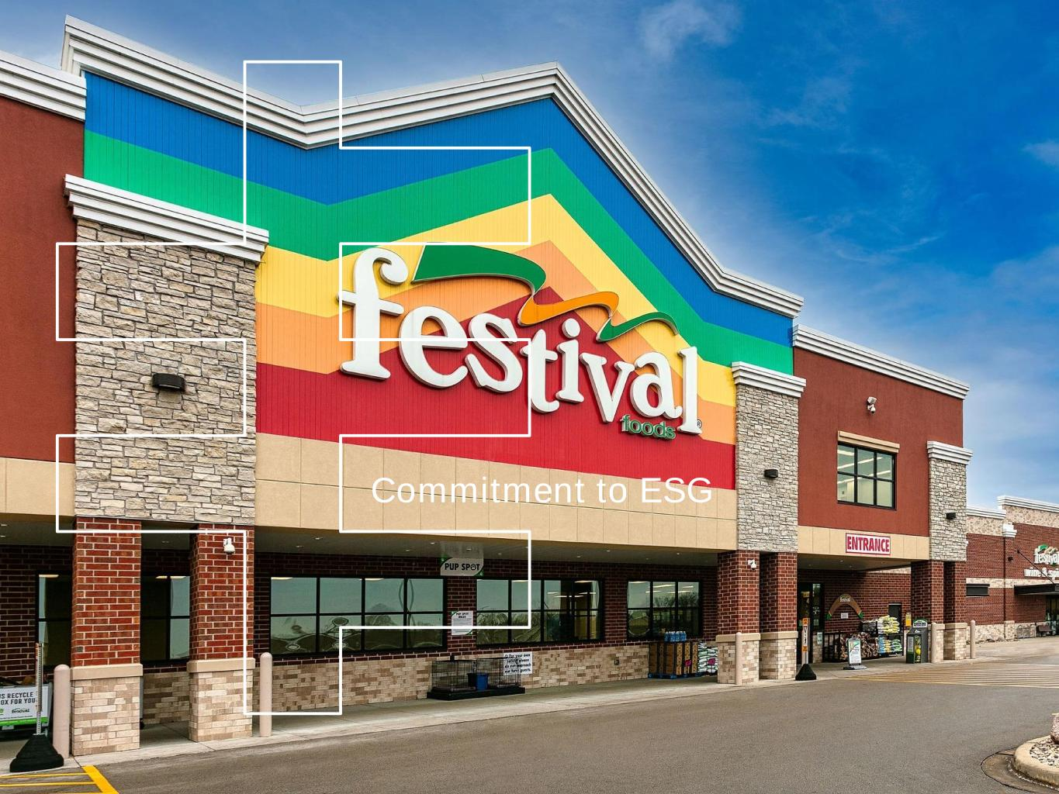
Commitment to ESG

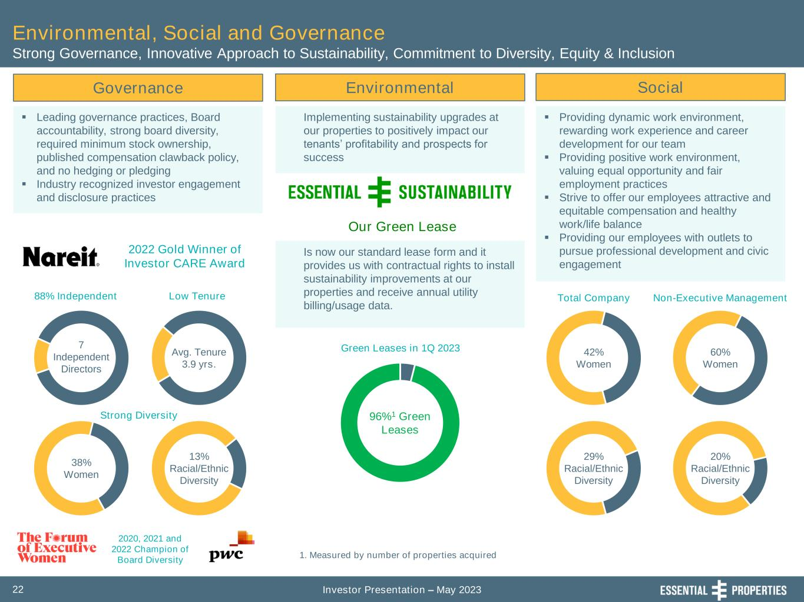
Investor Presentation – May 202322 Governance ▪ Leading governance practices, Board accountability, strong board diversity, required minimum stock ownership, published compensation clawback policy, and no hedging or pledging ▪ Industry recognized investor engagement and disclosure practices Environmental, Social and Governance Strong Governance, Innovative Approach to Sustainability, Commitment to Diversity, Equity & Inclusion Environmental Social Implementing sustainability upgrades at our properties to positively impact our tenants’ profitability and prospects for success ▪ Providing dynamic work environment, rewarding work experience and career development for our team ▪ Providing positive work environment, valuing equal opportunity and fair employment practices ▪ Strive to offer our employees attractive and equitable compensation and healthy work/life balance ▪ Providing our employees with outlets to pursue professional development and civic engagement 29% Racial/Ethnic Diversity 42% Women 60% Women 20% Racial/Ethnic Diversity Total Company Non-Executive Management 96%1 Green Leases 1. Measured by number of properties acquired 2020, 2021 and 2022 Champion of Board Diversity Avg. Tenure 3.9 yrs. 7 Independent Directors 38% Women 13% Racial/Ethnic Diversity Green Leases in 1Q 2023 88% Independent Low Tenure Strong Diversity 2022 Gold Winner of Investor CARE Award Is now our standard lease form and it provides us with contractual rights to install sustainability improvements at our properties and receive annual utility billing/usage data. Our Green Lease

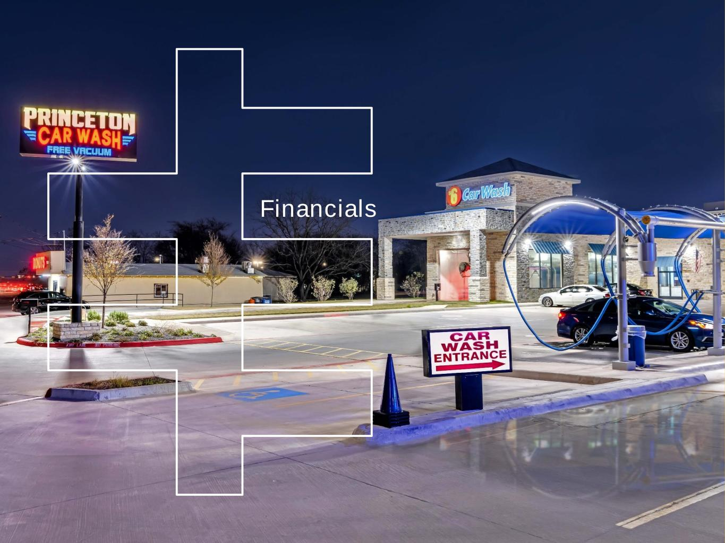
Financials

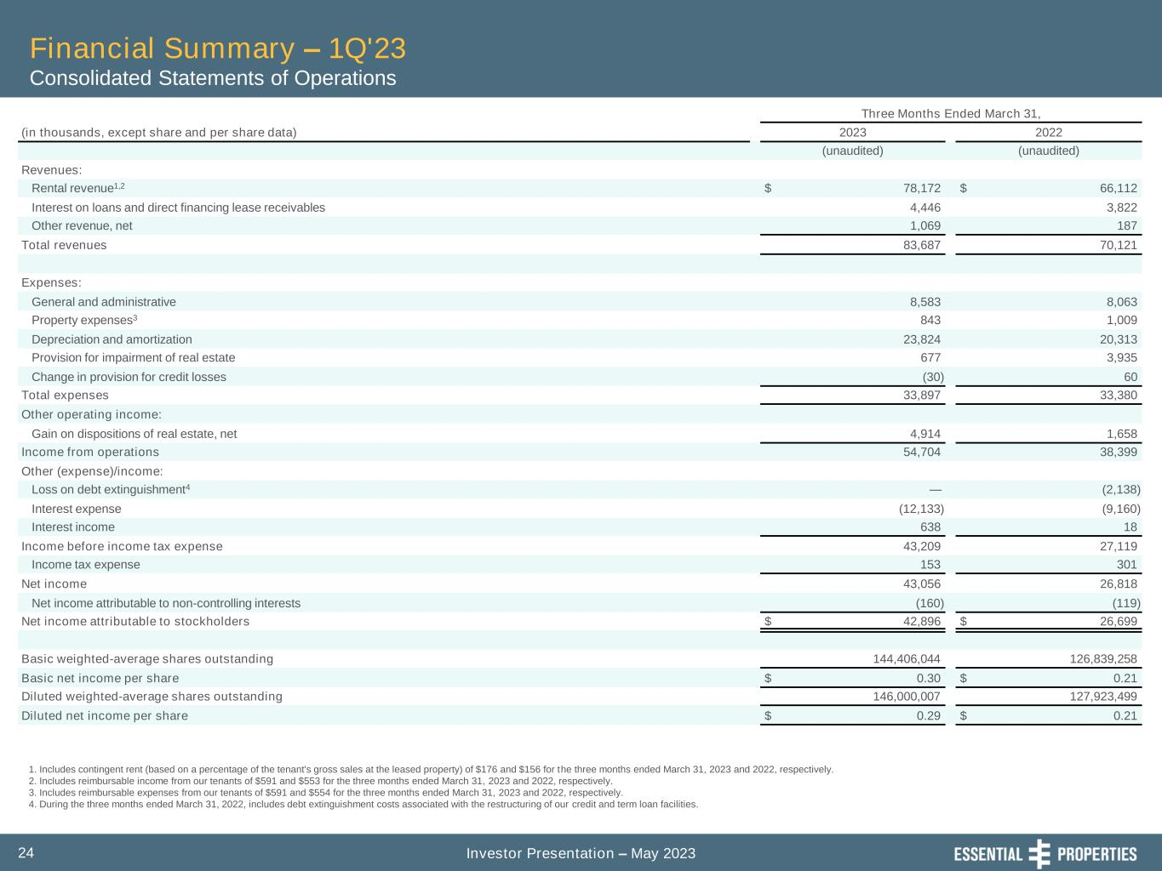
Investor Presentation – May 202324 Financial Summary – 1Q'23 Consolidated Statements of Operations 1. Includes contingent rent (based on a percentage of the tenant's gross sales at the leased property) of $176 and $156 for the three months ended March 31, 2023 and 2022, respectively. 2. Includes reimbursable income from our tenants of $591 and $553 for the three months ended March 31, 2023 and 2022, respectively. 3. Includes reimbursable expenses from our tenants of $591 and $554 for the three months ended March 31, 2023 and 2022, respectively. 4. During the three months ended March 31, 2022, includes debt extinguishment costs associated with the restructuring of our credit and term loan facilities. Three Months Ended March 31, (in thousands, except share and per share data) 2023 2022 (unaudited) (unaudited) Revenues: Rental revenue1,2 $ 78,172 $ 66,112 Interest on loans and direct financing lease receivables 4,446 3,822 Other revenue, net 1,069 187 Total revenues 83,687 70,121 Expenses: General and administrative 8,583 8,063 Property expenses3 843 1,009 Depreciation and amortization 23,824 20,313 Provision for impairment of real estate 677 3,935 Change in provision for credit losses (30) 60 Total expenses 33,897 33,380 Other operating income: Gain on dispositions of real estate, net 4,914 1,658 Income from operations 54,704 38,399 Other (expense)/income: Loss on debt extinguishment4 — (2,138) Interest expense (12,133) (9,160) Interest income 638 18 Income before income tax expense 43,209 27,119 Income tax expense 153 301 Net income 43,056 26,818 Net income attributable to non-controlling interests (160) (119) Net income attributable to stockholders $ 42,896 $ 26,699 Basic weighted-average shares outstanding 144,406,044 126,839,258 Basic net income per share $ 0.30 $ 0.21 Diluted weighted-average shares outstanding 146,000,007 127,923,499 Diluted net income per share $ 0.29 $ 0.21

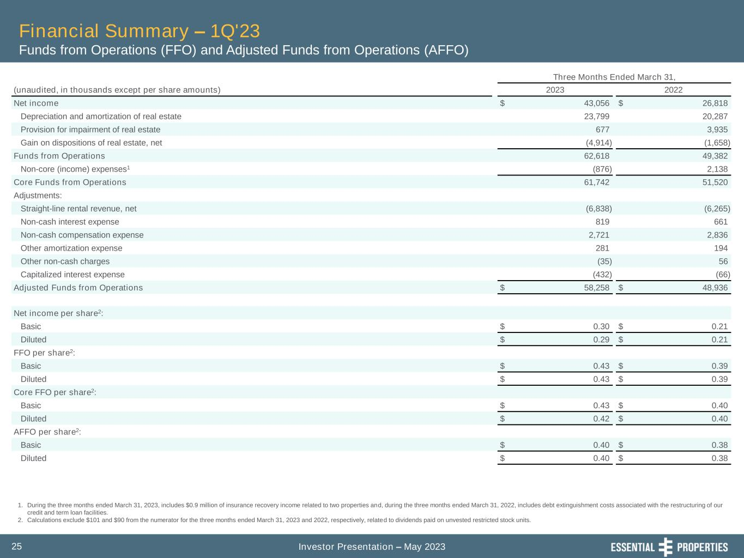
Investor Presentation – May 202325 Financial Summary – 1Q'23 Funds from Operations (FFO) and Adjusted Funds from Operations (AFFO) 1. During the three months ended March 31, 2023, includes $0.9 million of insurance recovery income related to two properties and, during the three months ended March 31, 2022, includes debt extinguishment costs associated with the restructuring of our credit and term loan facilities. 2. Calculations exclude $101 and $90 from the numerator for the three months ended March 31, 2023 and 2022, respectively, related to dividends paid on unvested restricted stock units. Three Months Ended March 31, (unaudited, in thousands except per share amounts) 2023 2022 Net income $ 43,056 $ 26,818 Depreciation and amortization of real estate 23,799 20,287 Provision for impairment of real estate 677 3,935 Gain on dispositions of real estate, net (4,914) (1,658) Funds from Operations 62,618 49,382 Non-core (income) expenses1 (876) 2,138 Core Funds from Operations 61,742 51,520 Adjustments: Straight-line rental revenue, net (6,838) (6,265) Non-cash interest expense 819 661 Non-cash compensation expense 2,721 2,836 Other amortization expense 281 194 Other non-cash charges (35) 56 Capitalized interest expense (432) (66) Adjusted Funds from Operations $ 58,258 $ 48,936 Net income per share2: Basic $ 0.30 $ 0.21 Diluted $ 0.29 $ 0.21 FFO per share2: Basic $ 0.43 $ 0.39 Diluted $ 0.43 $ 0.39 Core FFO per share2: Basic $ 0.43 $ 0.40 Diluted $ 0.42 $ 0.40 AFFO per share2: Basic $ 0.40 $ 0.38 Diluted $ 0.40 $ 0.38

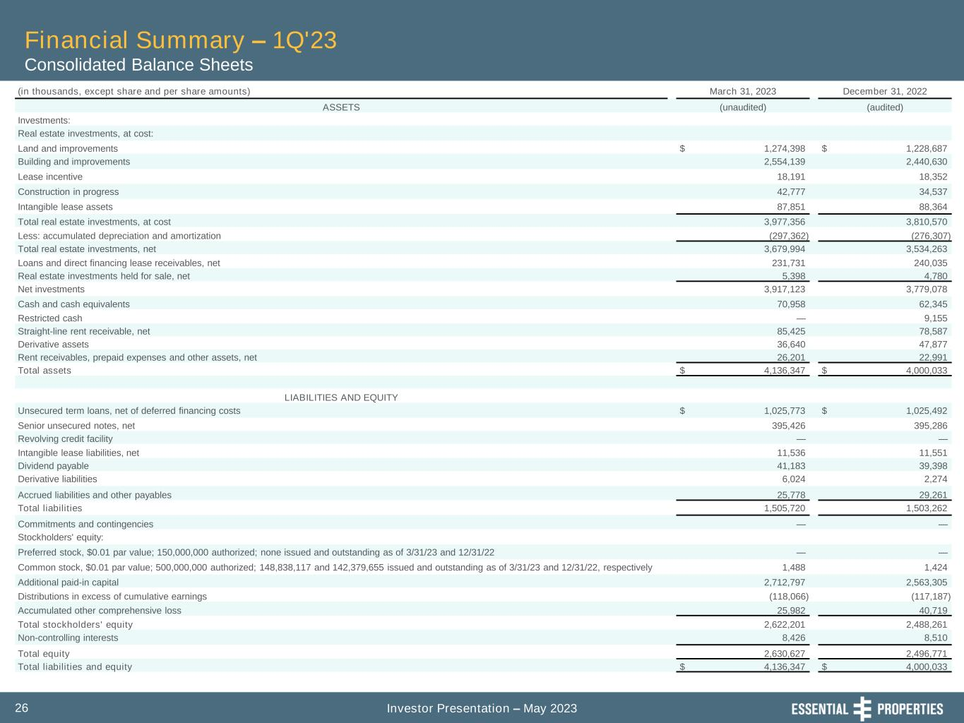
Investor Presentation – May 202326 Financial Summary – 1Q'23 Consolidated Balance Sheets (in thousands, except share and per share amounts) March 31, 2023 December 31, 2022 ASSETS (unaudited) (audited) Investments: Real estate investments, at cost: Land and improvements $ 1,274,398 $ 1,228,687 Building and improvements 2,554,139 2,440,630 Lease incentive 18,191 18,352 Construction in progress 42,777 34,537 Intangible lease assets 87,851 88,364 Total real estate investments, at cost 3,977,356 3,810,570 Less: accumulated depreciation and amortization (297,362) (276,307) Total real estate investments, net 3,679,994 3,534,263 Loans and direct financing lease receivables, net 231,731 240,035 Real estate investments held for sale, net 5,398 4,780 Net investments 3,917,123 3,779,078 Cash and cash equivalents 70,958 62,345 Restricted cash — 9,155 Straight-line rent receivable, net 85,425 78,587 Derivative assets 36,640 47,877 Rent receivables, prepaid expenses and other assets, net 26,201 22,991 Total assets $ 4,136,347 $ 4,000,033 LIABILITIES AND EQUITY Unsecured term loans, net of deferred financing costs $ 1,025,773 $ 1,025,492 Senior unsecured notes, net 395,426 395,286 Revolving credit facility — — Intangible lease liabilities, net 11,536 11,551 Dividend payable 41,183 39,398 Derivative liabilities 6,024 2,274 Accrued liabilities and other payables 25,778 29,261 Total liabilities 1,505,720 1,503,262 Commitments and contingencies — — Stockholders' equity: Preferred stock, $0.01 par value; 150,000,000 authorized; none issued and outstanding as of 3/31/23 and 12/31/22 — — Common stock, $0.01 par value; 500,000,000 authorized; 148,838,117 and 142,379,655 issued and outstanding as of 3/31/23 and 12/31/22, respectively 1,488 1,424 Additional paid-in capital 2,712,797 2,563,305 Distributions in excess of cumulative earnings (118,066) (117,187) Accumulated other comprehensive loss 25,982 40,719 Total stockholders' equity 2,622,201 2,488,261 Non-controlling interests 8,426 8,510 Total equity 2,630,627 2,496,771 Total liabilities and equity $ 4,136,347 $ 4,000,033

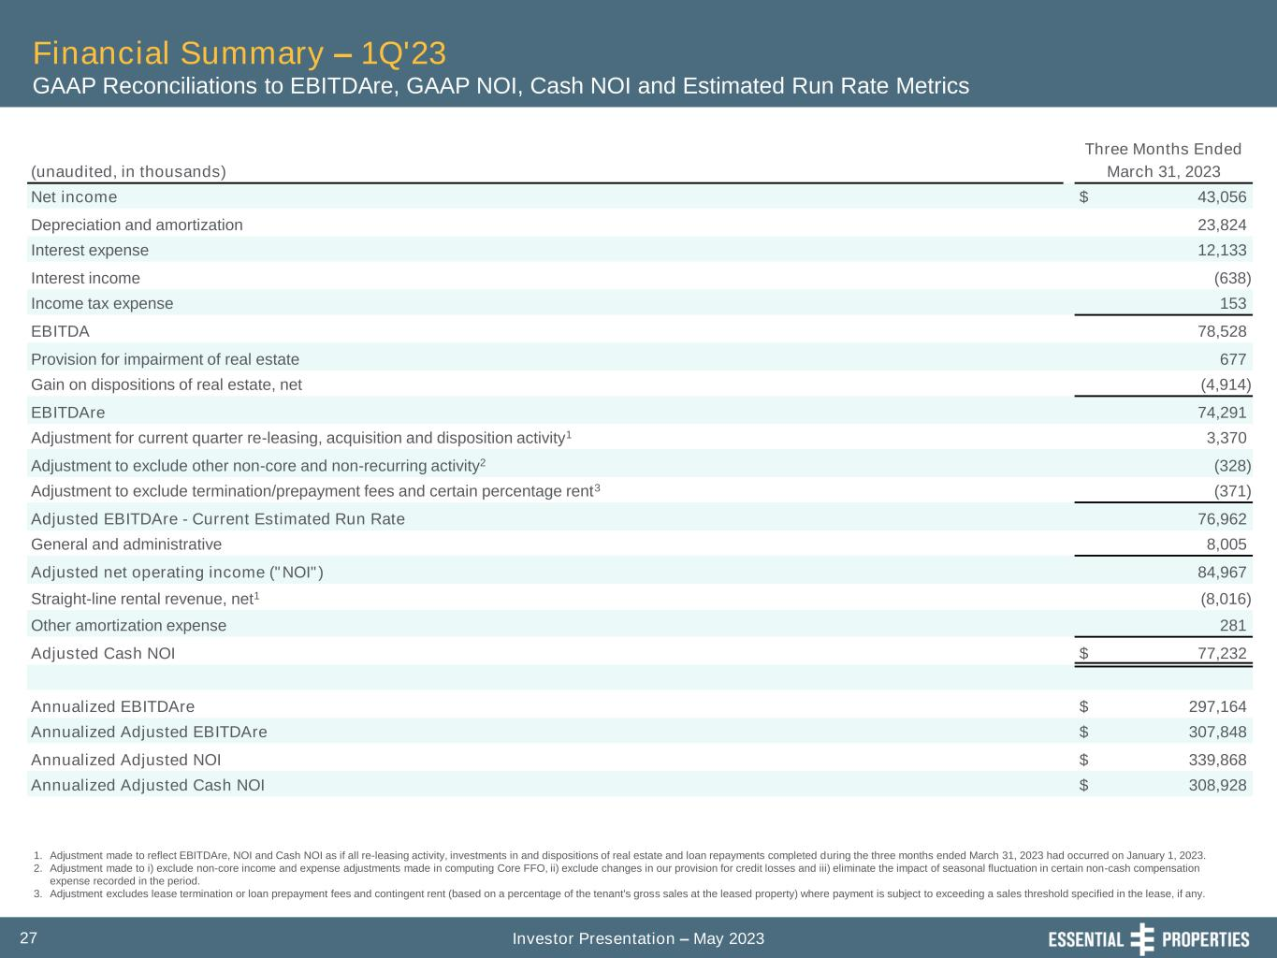
Investor Presentation – May 202327 Financial Summary – 1Q'23 GAAP Reconciliations to EBITDAre, GAAP NOI, Cash NOI and Estimated Run Rate Metrics 1. Adjustment made to reflect EBITDAre, NOI and Cash NOI as if all re-leasing activity, investments in and dispositions of real estate and loan repayments completed during the three months ended March 31, 2023 had occurred on January 1, 2023. 2. Adjustment made to i) exclude non-core income and expense adjustments made in computing Core FFO, ii) exclude changes in our provision for credit losses and iii) eliminate the impact of seasonal fluctuation in certain non-cash compensation expense recorded in the period. 3. Adjustment excludes lease termination or loan prepayment fees and contingent rent (based on a percentage of the tenant's gross sales at the leased property) where payment is subject to exceeding a sales threshold specified in the lease, if any. Three Months Ended (unaudited, in thousands) March 31, 2023 Net income $ 43,056 Depreciation and amortization 23,824 Interest expense 12,133 Interest income (638) Income tax expense 153 EBITDA 78,528 Provision for impairment of real estate 677 Gain on dispositions of real estate, net (4,914) EBITDAre 74,291 Adjustment for current quarter re-leasing, acquisition and disposition activity1 3,370 Adjustment to exclude other non-core and non-recurring activity2 (328) Adjustment to exclude termination/prepayment fees and certain percentage rent3 (371) Adjusted EBITDAre - Current Estimated Run Rate 76,962 General and administrative 8,005 Adjusted net operating income ("NOI") 84,967 Straight-line rental revenue, net1 (8,016) Other amortization expense 281 Adjusted Cash NOI $ 77,232 Annualized EBITDAre $ 297,164 Annualized Adjusted EBITDAre $ 307,848 Annualized Adjusted NOI $ 339,868 Annualized Adjusted Cash NOI $ 308,928

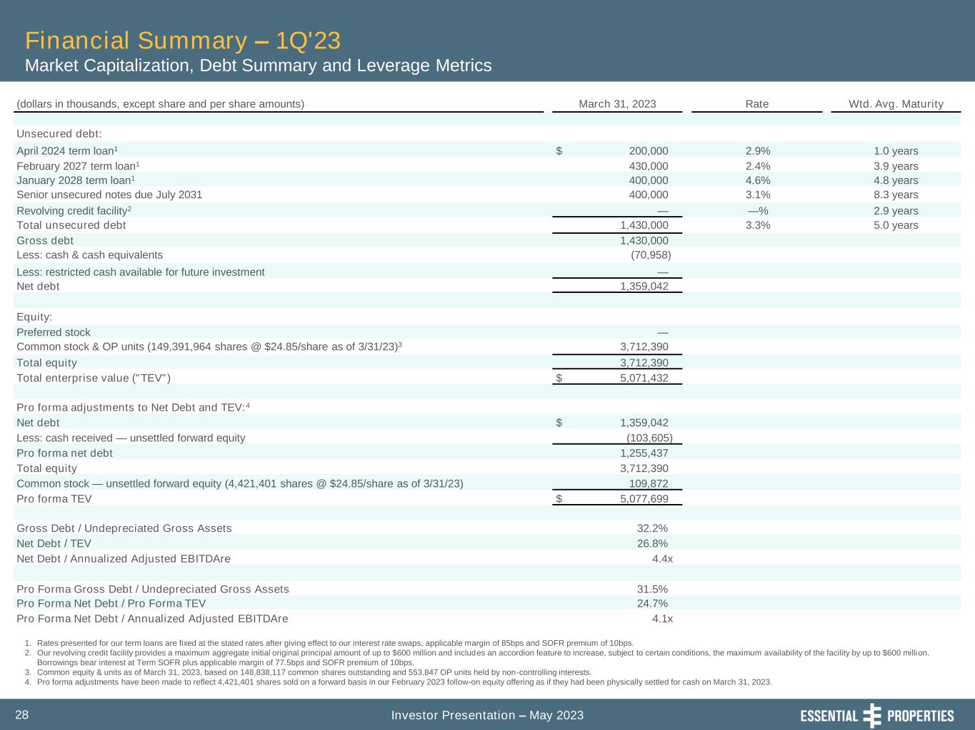
Investor Presentation – May 202328 Financial Summary – 1Q'23 Market Capitalization, Debt Summary and Leverage Metrics 1. Rates presented for our term loans are fixed at the stated rates after giving effect to our interest rate swaps, applicable margin of 85bps and SOFR premium of 10bps. 2. Our revolving credit facility provides a maximum aggregate initial original principal amount of up to $600 million and includes an accordion feature to increase, subject to certain conditions, the maximum availability of the facility by up to $600 million. Borrowings bear interest at Term SOFR plus applicable margin of 77.5bps and SOFR premium of 10bps. 3. Common equity & units as of March 31, 2023, based on 148,838,117 common shares outstanding and 553,847 OP units held by non-controlling interests. 4. Pro forma adjustments have been made to reflect 4,421,401 shares sold on a forward basis in our February 2023 follow-on equity offering as if they had been physically settled for cash on March 31, 2023. (dollars in thousands, except share and per share amounts) March 31, 2023 Rate Wtd. Avg. Maturity Unsecured debt: April 2024 term loan1 $ 200,000 2.9% 1.0 years February 2027 term loan1 430,000 2.4% 3.9 years January 2028 term loan1 400,000 4.6% 4.8 years Senior unsecured notes due July 2031 400,000 3.1% 8.3 years Revolving credit facility2 — —% 2.9 years Total unsecured debt 1,430,000 3.3% 5.0 years Gross debt 1,430,000 Less: cash & cash equivalents (70,958) Less: restricted cash available for future investment — Net debt 1,359,042 Equity: Preferred stock — Common stock & OP units (149,391,964 shares @ $24.85/share as of 3/31/23)3 3,712,390 Total equity 3,712,390 Total enterprise value ("TEV") $ 5,071,432 Pro forma adjustments to Net Debt and TEV:4 Net debt $ 1,359,042 Less: cash received — unsettled forward equity (103,605) Pro forma net debt 1,255,437 Total equity 3,712,390 Common stock — unsettled forward equity (4,421,401 shares @ $24.85/share as of 3/31/23) 109,872 Pro forma TEV $ 5,077,699 Gross Debt / Undepreciated Gross Assets 32.2% Net Debt / TEV 26.8% Net Debt / Annualized Adjusted EBITDAre 4.4x Pro Forma Gross Debt / Undepreciated Gross Assets 31.5% Pro Forma Net Debt / Pro Forma TEV 24.7% Pro Forma Net Debt / Annualized Adjusted EBITDAre 4.1x

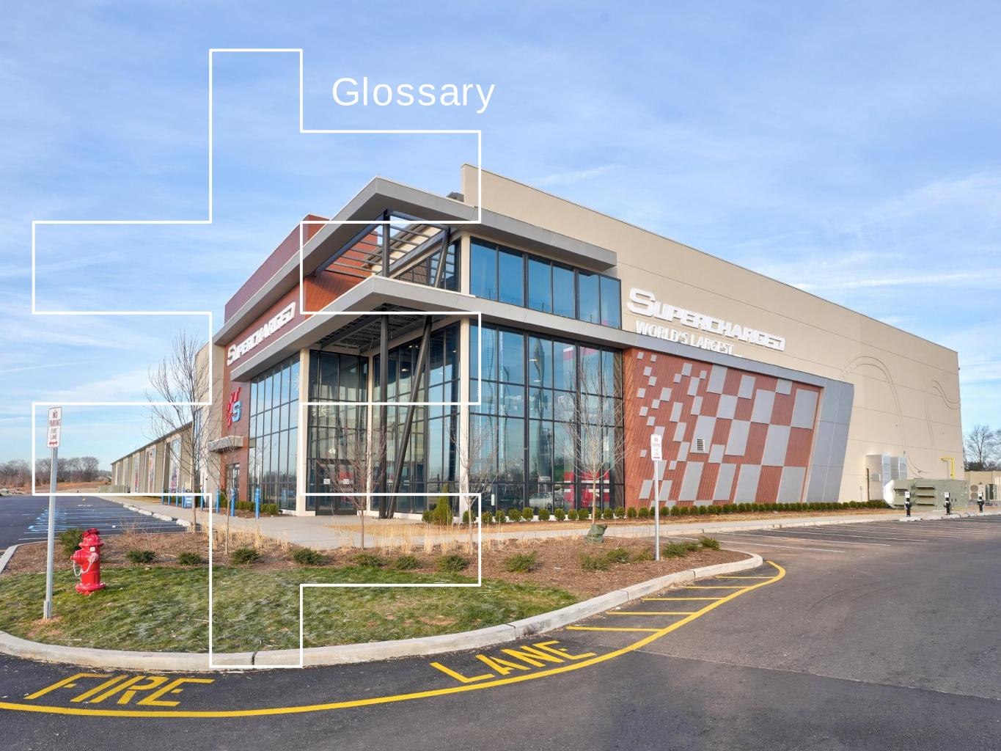
Glossary

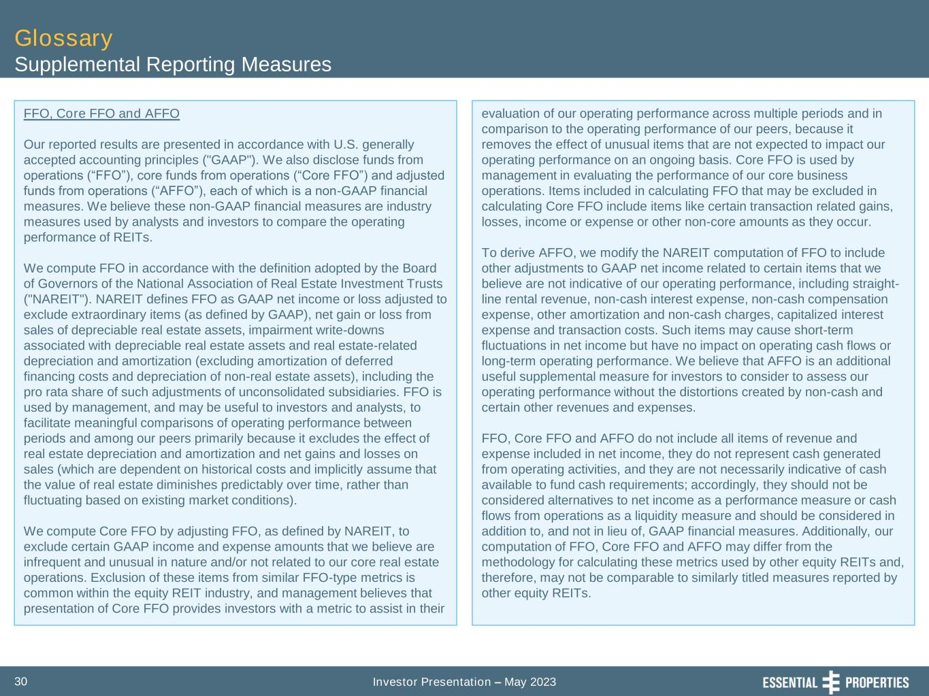
Investor Presentation – May 202330 Glossary Supplemental Reporting Measures FFO, Core FFO and AFFO Our reported results are presented in accordance with U.S. generally accepted accounting principles ("GAAP"). We also disclose funds from operations (“FFO”), core funds from operations (“Core FFO”) and adjusted funds from operations (“AFFO”), each of which is a non-GAAP financial measures. We believe these non-GAAP financial measures are industry measures used by analysts and investors to compare the operating performance of REITs. We compute FFO in accordance with the definition adopted by the Board of Governors of the National Association of Real Estate Investment Trusts ("NAREIT"). NAREIT defines FFO as GAAP net income or loss adjusted to exclude extraordinary items (as defined by GAAP), net gain or loss from sales of depreciable real estate assets, impairment write-downs associated with depreciable real estate assets and real estate-related depreciation and amortization (excluding amortization of deferred financing costs and depreciation of non-real estate assets), including the pro rata share of such adjustments of unconsolidated subsidiaries. FFO is used by management, and may be useful to investors and analysts, to facilitate meaningful comparisons of operating performance between periods and among our peers primarily because it excludes the effect of real estate depreciation and amortization and net gains and losses on sales (which are dependent on historical costs and implicitly assume that the value of real estate diminishes predictably over time, rather than fluctuating based on existing market conditions). We compute Core FFO by adjusting FFO, as defined by NAREIT, to exclude certain GAAP income and expense amounts that we believe are infrequent and unusual in nature and/or not related to our core real estate operations. Exclusion of these items from similar FFO-type metrics is common within the equity REIT industry, and management believes that presentation of Core FFO provides investors with a metric to assist in their evaluation of our operating performance across multiple periods and in comparison to the operating performance of our peers, because it removes the effect of unusual items that are not expected to impact our operating performance on an ongoing basis. Core FFO is used by management in evaluating the performance of our core business operations. Items included in calculating FFO that may be excluded in calculating Core FFO include items like certain transaction related gains, losses, income or expense or other non-core amounts as they occur. To derive AFFO, we modify the NAREIT computation of FFO to include other adjustments to GAAP net income related to certain items that we believe are not indicative of our operating performance, including straight- line rental revenue, non-cash interest expense, non-cash compensation expense, other amortization and non-cash charges, capitalized interest expense and transaction costs. Such items may cause short-term fluctuations in net income but have no impact on operating cash flows or long-term operating performance. We believe that AFFO is an additional useful supplemental measure for investors to consider to assess our operating performance without the distortions created by non-cash and certain other revenues and expenses. FFO, Core FFO and AFFO do not include all items of revenue and expense included in net income, they do not represent cash generated from operating activities, and they are not necessarily indicative of cash available to fund cash requirements; accordingly, they should not be considered alternatives to net income as a performance measure or cash flows from operations as a liquidity measure and should be considered in addition to, and not in lieu of, GAAP financial measures. Additionally, our computation of FFO, Core FFO and AFFO may differ from the methodology for calculating these metrics used by other equity REITs and, therefore, may not be comparable to similarly titled measures reported by other equity REITs.

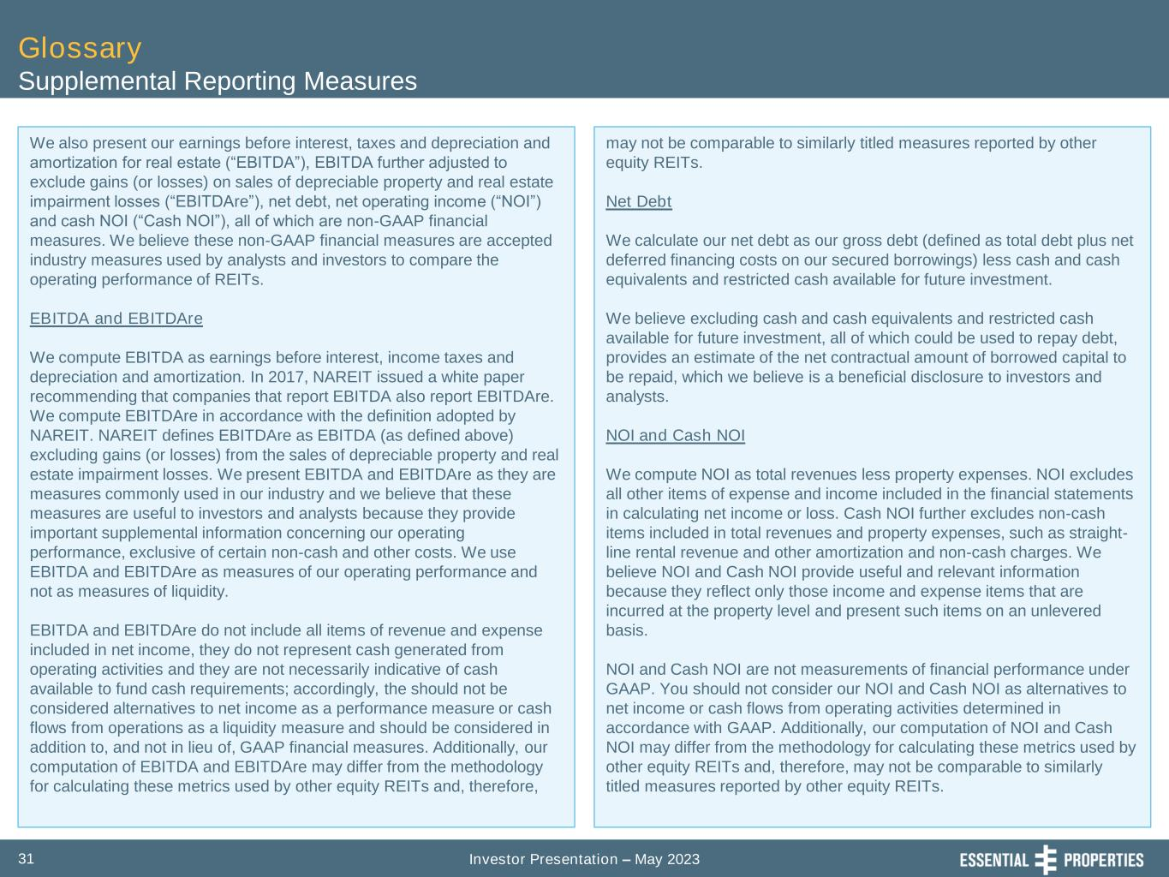
Investor Presentation – May 202331 Glossary Supplemental Reporting Measures We also present our earnings before interest, taxes and depreciation and amortization for real estate (“EBITDA”), EBITDA further adjusted to exclude gains (or losses) on sales of depreciable property and real estate impairment losses (“EBITDAre”), net debt, net operating income (“NOI”) and cash NOI (“Cash NOI”), all of which are non-GAAP financial measures. We believe these non-GAAP financial measures are accepted industry measures used by analysts and investors to compare the operating performance of REITs. EBITDA and EBITDAre We compute EBITDA as earnings before interest, income taxes and depreciation and amortization. In 2017, NAREIT issued a white paper recommending that companies that report EBITDA also report EBITDAre. We compute EBITDAre in accordance with the definition adopted by NAREIT. NAREIT defines EBITDAre as EBITDA (as defined above) excluding gains (or losses) from the sales of depreciable property and real estate impairment losses. We present EBITDA and EBITDAre as they are measures commonly used in our industry and we believe that these measures are useful to investors and analysts because they provide important supplemental information concerning our operating performance, exclusive of certain non-cash and other costs. We use EBITDA and EBITDAre as measures of our operating performance and not as measures of liquidity. EBITDA and EBITDAre do not include all items of revenue and expense included in net income, they do not represent cash generated from operating activities and they are not necessarily indicative of cash available to fund cash requirements; accordingly, the should not be considered alternatives to net income as a performance measure or cash flows from operations as a liquidity measure and should be considered in addition to, and not in lieu of, GAAP financial measures. Additionally, our computation of EBITDA and EBITDAre may differ from the methodology for calculating these metrics used by other equity REITs and, therefore, may not be comparable to similarly titled measures reported by other equity REITs. Net Debt We calculate our net debt as our gross debt (defined as total debt plus net deferred financing costs on our secured borrowings) less cash and cash equivalents and restricted cash available for future investment. We believe excluding cash and cash equivalents and restricted cash available for future investment, all of which could be used to repay debt, provides an estimate of the net contractual amount of borrowed capital to be repaid, which we believe is a beneficial disclosure to investors and analysts. NOI and Cash NOI We compute NOI as total revenues less property expenses. NOI excludes all other items of expense and income included in the financial statements in calculating net income or loss. Cash NOI further excludes non-cash items included in total revenues and property expenses, such as straight- line rental revenue and other amortization and non-cash charges. We believe NOI and Cash NOI provide useful and relevant information because they reflect only those income and expense items that are incurred at the property level and present such items on an unlevered basis. NOI and Cash NOI are not measurements of financial performance under GAAP. You should not consider our NOI and Cash NOI as alternatives to net income or cash flows from operating activities determined in accordance with GAAP. Additionally, our computation of NOI and Cash NOI may differ from the methodology for calculating these metrics used by other equity REITs and, therefore, may not be comparable to similarly titled measures reported by other equity REITs.

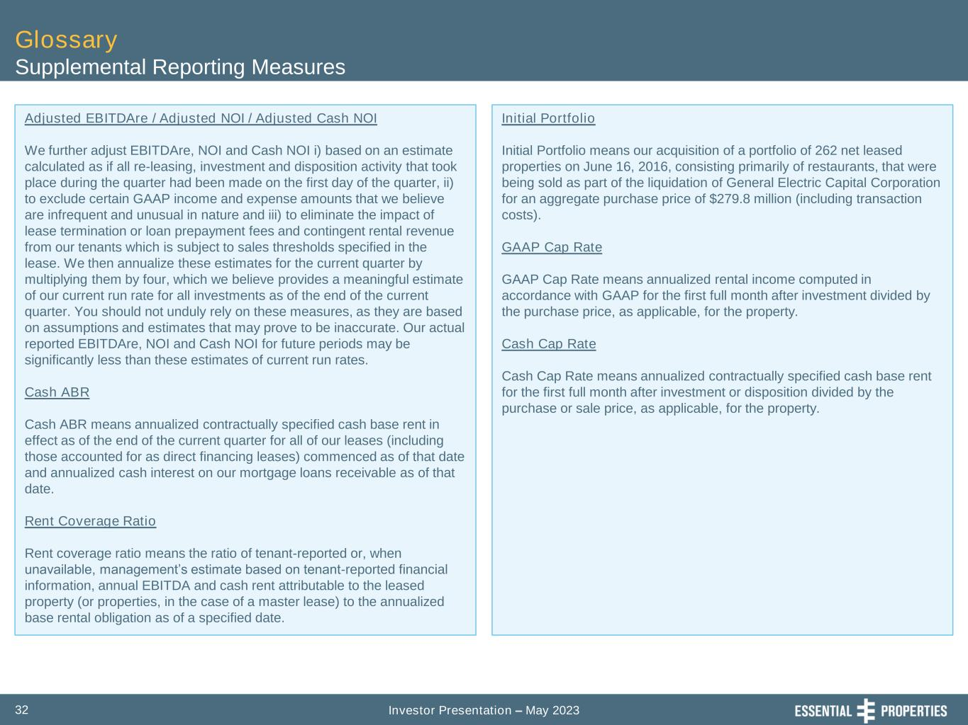
Investor Presentation – May 202332 Glossary Supplemental Reporting Measures Adjusted EBITDAre / Adjusted NOI / Adjusted Cash NOI We further adjust EBITDAre, NOI and Cash NOI i) based on an estimate calculated as if all re-leasing, investment and disposition activity that took place during the quarter had been made on the first day of the quarter, ii) to exclude certain GAAP income and expense amounts that we believe are infrequent and unusual in nature and iii) to eliminate the impact of lease termination or loan prepayment fees and contingent rental revenue from our tenants which is subject to sales thresholds specified in the lease. We then annualize these estimates for the current quarter by multiplying them by four, which we believe provides a meaningful estimate of our current run rate for all investments as of the end of the current quarter. You should not unduly rely on these measures, as they are based on assumptions and estimates that may prove to be inaccurate. Our actual reported EBITDAre, NOI and Cash NOI for future periods may be significantly less than these estimates of current run rates. Cash ABR Cash ABR means annualized contractually specified cash base rent in effect as of the end of the current quarter for all of our leases (including those accounted for as direct financing leases) commenced as of that date and annualized cash interest on our mortgage loans receivable as of that date. Rent Coverage Ratio Rent coverage ratio means the ratio of tenant-reported or, when unavailable, management’s estimate based on tenant-reported financial information, annual EBITDA and cash rent attributable to the leased property (or properties, in the case of a master lease) to the annualized base rental obligation as of a specified date. Initial Portfolio Initial Portfolio means our acquisition of a portfolio of 262 net leased properties on June 16, 2016, consisting primarily of restaurants, that were being sold as part of the liquidation of General Electric Capital Corporation for an aggregate purchase price of $279.8 million (including transaction costs). GAAP Cap Rate GAAP Cap Rate means annualized rental income computed in accordance with GAAP for the first full month after investment divided by the purchase price, as applicable, for the property. Cash Cap Rate Cash Cap Rate means annualized contractually specified cash base rent for the first full month after investment or disposition divided by the purchase or sale price, as applicable, for the property.

