UNITED STATES
SECURITIES AND EXCHANGE COMMISSION
Washington, D.C. 20549

FORM 8-K

CURRENT REPORT

Pursuant to Section 13 or 15(d)
of the Securities Exchange Act of 1934

April 9, 2024
Date of Report (Date of earliest event reported)

Essential Properties Realty Trust, Inc.
(Exact name of registrant as specified in its charter)

Maryland |  |  |  |  |  | 001-38530 |  |  |  |  |  | 82-4005693
(State or other jurisdiction of incorporation) |  |  |  |  |  | (Commission File Number) |  |  |  |  |  | (IRS Employer Identification No.)
902 Carnegie Center Blvd., Suite 520
Princeton, New Jersey |  |  |  |  |  |  |  |  |  |  |  | 08540
(Address of principal executive offices) |  |  |  |  |  |  |  |  |  |  |  | (Zip Code)
Registrant’s telephone number, including area code: |  |  |  |  |  |  |  |  |  |  |  | (609) 436-0619

Check the appropriate box below if the Form 8-K filing is intended to simultaneously satisfy the filing obligations of the registrant under any of the following provisions:
☐ |  |  | Written communications pursuant to Rule 425 under the Securities Act 17 CFR 230.425)
☐ |  |  | Soliciting material pursuant to Rule 14a-12 under the Exchange Act (17 CFR 240.14a-12)
☐ |  |  | Pre-commencement communications pursuant to Rule 14d-2(b) under the Exchange Act (17 CFR 240.14d-2(b))
☐ |  |  | Pre-commencement communications pursuant to Rule 13e-4(c) under the Exchange Act (17 CFR 240.13e-4(c))

Securities registered pursuant to Section 12(b) of the Act:
Title of Each Class |  |  |  |  |  | Trading Symbol(s) |  |  |  |  |  | Name of Each Exchange on Which Registered
Common stock, $0.01 par value |  |  |  |  |  | EPRT |  |  |  |  |  | New York Stock Exchange

Indicate by check mark whether the registrant is an emerging growth company as defined in Rule 405 of the Securities Act of 1933 (§230.405 of this chapter) or Rule 12b-2 of the Securities Exchange Act of 1934 (§240.12b-2 of this chapter).

Emerging growth company ☐

If an emerging growth company, indicate by check mark if the registrant has elected not to use the extended transition period for complying with any new or revised financial accounting standards provided pursuant to Section 13(a) of the Exchange Act ☐

Item 7.01 — Regulation FD Disclosure.

Investor Presentation

On April 9, 2024, Essential Properties Realty Trust, Inc. released a presentation that it intends to use from time to time in meetings with investors. A copy of the presentation is attached hereto as Exhibit 99.1.

The information set forth in this item 7.01 and in the attached Exhibit 99.1 is being "furnished" and shall not be deemed "filed" for the purposes of Section 18 of the Securities Exchange Act of 1934, as amended (the "Exchange Act"), or otherwise subject to the liabilities of Section 18, nor shall it be deemed incorporated by reference into any filing of the company under the Securities Act of 1933, as amended, or the Exchange Act, whether made before or after the date hereof, regardless of any general incorporation language in any such filing.

Item 9.01 — Financial Statements and Exhibits.
(d) Exhibits. The following exhibit is being filed herewith:

Exhibit No. |  |  |  |  |  | Description
99.1 |  |  |  |  |  | April 2024 Investor Presentation
104 |  |  |  |  |  | Cover Page Interactive Data File (embedded within the Inline XBRL document).

SIGNATURES

Pursuant to the requirements of the Securities Exchange Act of 1934, the registrant has duly caused this report to be signed on its behalf by the undersigned hereunto duly authorized.

Date: April 9, 2024 |  |  | ESSENTIAL PROPERTIES REALTY TRUST, INC.
 |  |  | By: |  |  | /s/ Mark E. Patten
 |  |  |  |  |  | Mark E. Patten
 |  |  |  |  |  | Executive Vice President, Chief Financial Officer, Treasurer and Secretary

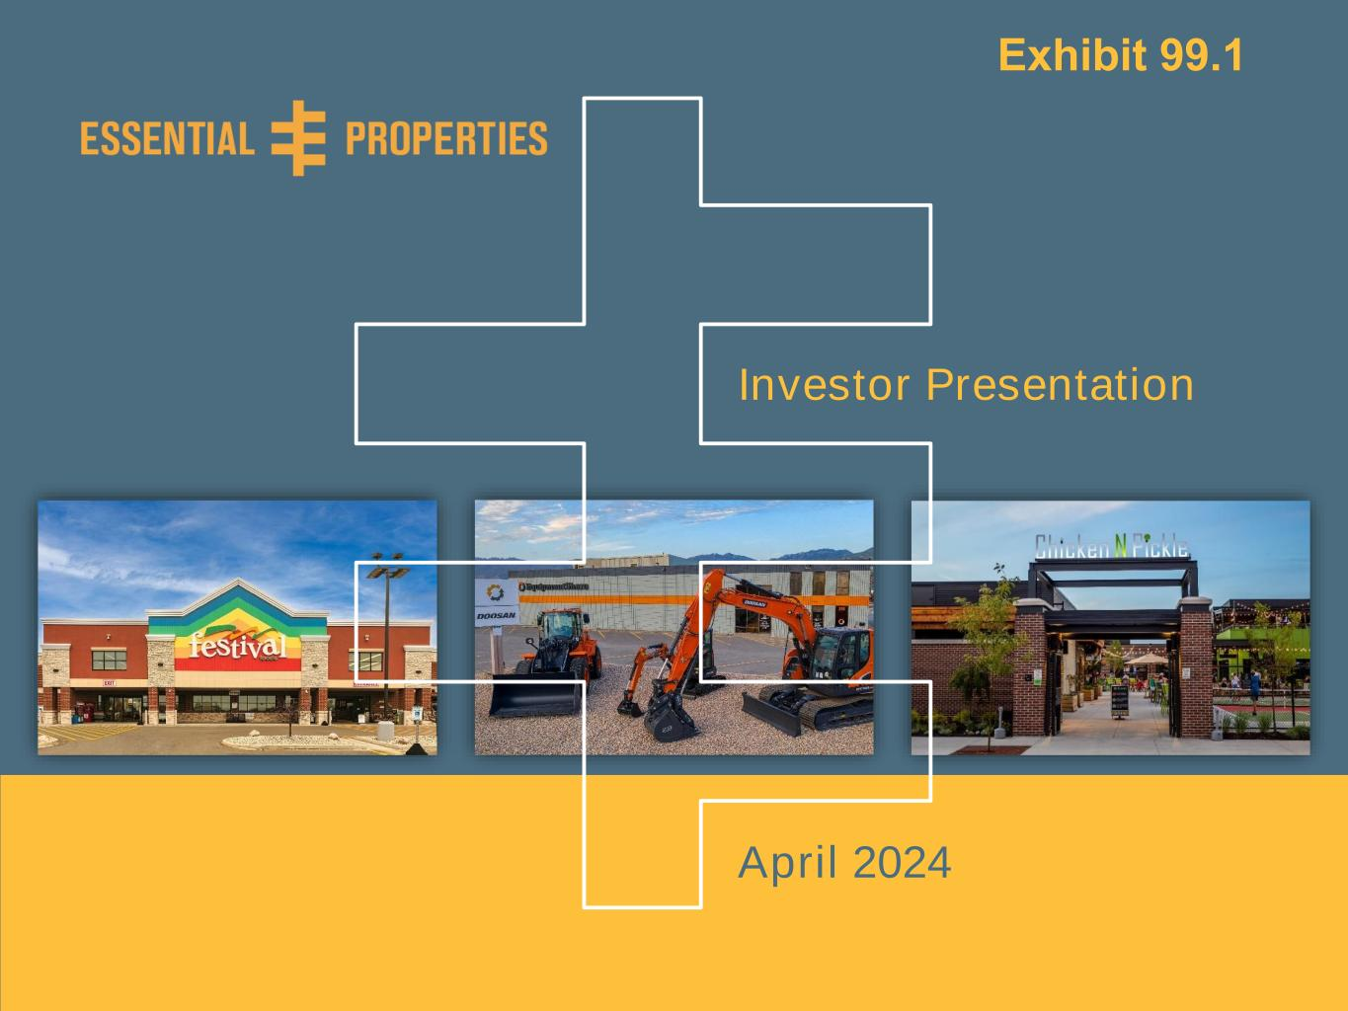
Investor Presentation – April 20240 Investor Presentation April 2024 Exhibit 99.1

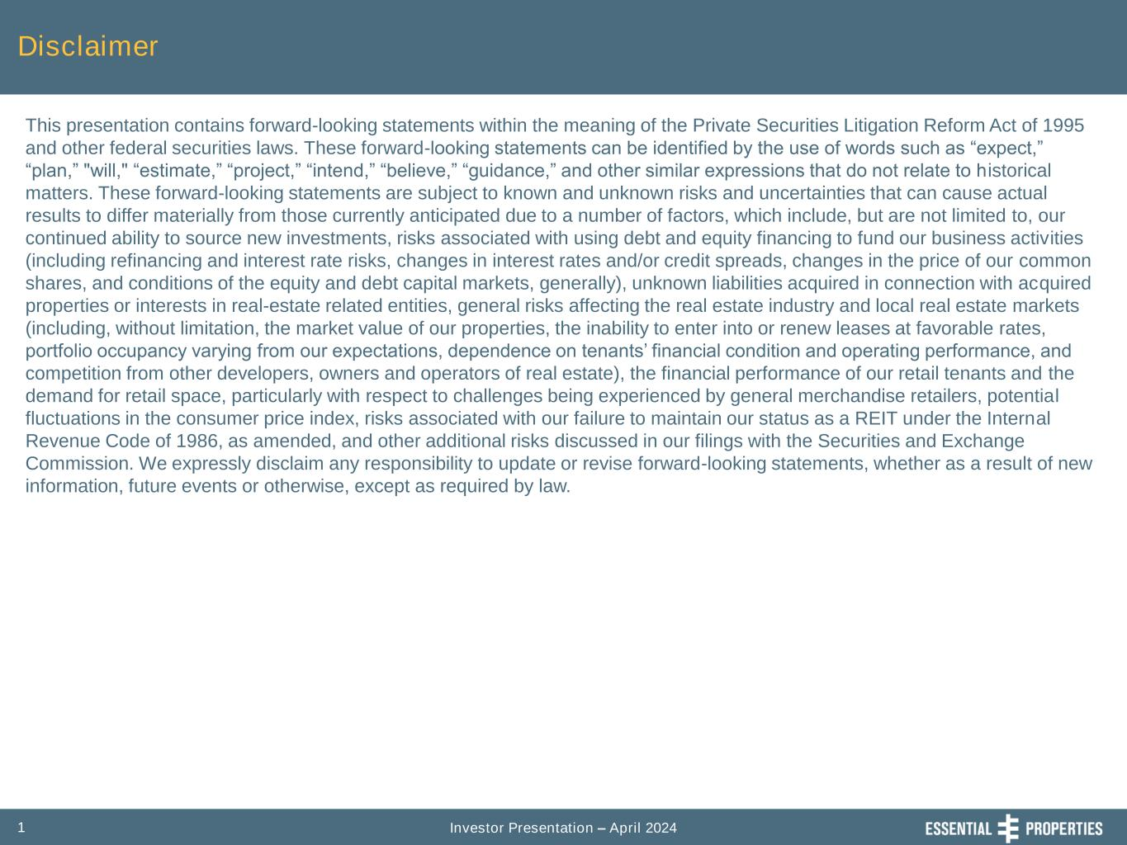
Investor Presentation – April 20241 Disclaimer This presentation contains forward-looking statements within the meaning of the Private Securities Litigation Reform Act of 1995 and other federal securities laws. These forward-looking statements can be identified by the use of words such as “expect,” “plan,” "will," “estimate,” “project,” “intend,” “believe,” “guidance,” and other similar expressions that do not relate to historical matters. These forward-looking statements are subject to known and unknown risks and uncertainties that can cause actual results to differ materially from those currently anticipated due to a number of factors, which include, but are not limited to, our continued ability to source new investments, risks associated with using debt and equity financing to fund our business activities (including refinancing and interest rate risks, changes in interest rates and/or credit spreads, changes in the price of our common shares, and conditions of the equity and debt capital markets, generally), unknown liabilities acquired in connection with acquired properties or interests in real-estate related entities, general risks affecting the real estate industry and local real estate markets (including, without limitation, the market value of our properties, the inability to enter into or renew leases at favorable rates, portfolio occupancy varying from our expectations, dependence on tenants’ financial condition and operating performance, and competition from other developers, owners and operators of real estate), the financial performance of our retail tenants and the demand for retail space, particularly with respect to challenges being experienced by general merchandise retailers, potential fluctuations in the consumer price index, risks associated with our failure to maintain our status as a REIT under the Internal Revenue Code of 1986, as amended, and other additional risks discussed in our filings with the Securities and Exchange Commission. We expressly disclaim any responsibility to update or revise forward-looking statements, whether as a result of new information, future events or otherwise, except as required by law.

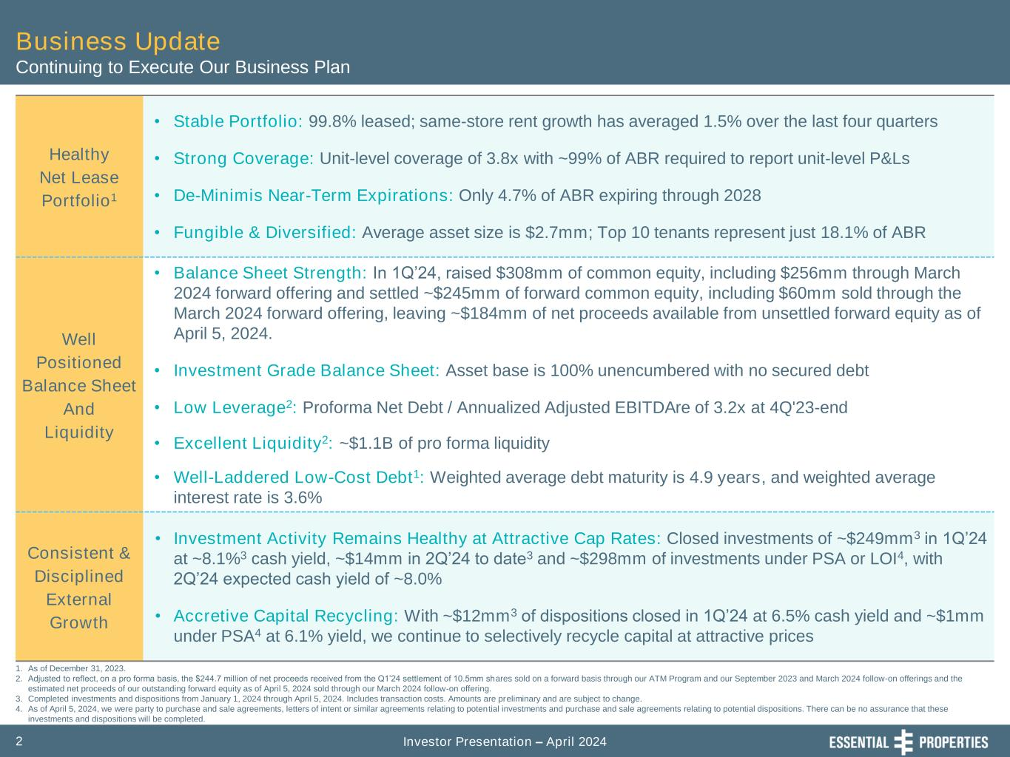
Investor Presentation – April 20242 Healthy Net Lease Portfolio1 • Stable Portfolio: 99.8% leased; same-store rent growth has averaged 1.5% over the last four quarters • Strong Coverage: Unit-level coverage of 3.8x with ~99% of ABR required to report unit-level P&Ls • De-Minimis Near-Term Expirations: Only 4.7% of ABR expiring through 2028 • Fungible & Diversified: Average asset size is $2.7mm; Top 10 tenants represent just 18.1% of ABR Well Positioned Balance Sheet And Liquidity • Balance Sheet Strength: In 1Q’24, raised $308mm of common equity, including $256mm through March 2024 forward offering and settled ~$245mm of forward common equity, including $60mm sold through the March 2024 forward offering, leaving ~$184mm of net proceeds available from unsettled forward equity as of April 5, 2024. • Investment Grade Balance Sheet: Asset base is 100% unencumbered with no secured debt • Low Leverage2: Proforma Net Debt / Annualized Adjusted EBITDAre of 3.2x at 4Q'23-end • Excellent Liquidity2: ~$1.1B of pro forma liquidity • Well-Laddered Low-Cost Debt1: Weighted average debt maturity is 4.9 years, and weighted average interest rate is 3.6% Consistent & Disciplined External Growth • Investment Activity Remains Healthy at Attractive Cap Rates: Closed investments of ~$249mm3 in 1Q’24 at ~8.1%3 cash yield, ~$14mm in 2Q’24 to date3 and ~$298mm of investments under PSA or LOI4, with 2Q’24 expected cash yield of ~8.0% • Accretive Capital Recycling: With ~$12mm3 of dispositions closed in 1Q’24 at 6.5% cash yield and ~$1mm under PSA4 at 6.1% yield, we continue to selectively recycle capital at attractive prices 1. As of December 31, 2023. 2. Adjusted to reflect, on a pro forma basis, the $244.7 million of net proceeds received from the Q1’24 settlement of 10.5mm shares sold on a forward basis through our ATM Program and our September 2023 and March 2024 follow-on offerings and the estimated net proceeds of our outstanding forward equity as of April 5, 2024 sold through our March 2024 follow-on offering. 3. Completed investments and dispositions from January 1, 2024 through April 5, 2024. Includes transaction costs. Amounts are preliminary and are subject to change. 4. As of April 5, 2024, we were party to purchase and sale agreements, letters of intent or similar agreements relating to potential investments and purchase and sale agreements relating to potential dispositions. There can be no assurance that these investments and dispositions will be completed. Business Update Continuing to Execute Our Business Plan

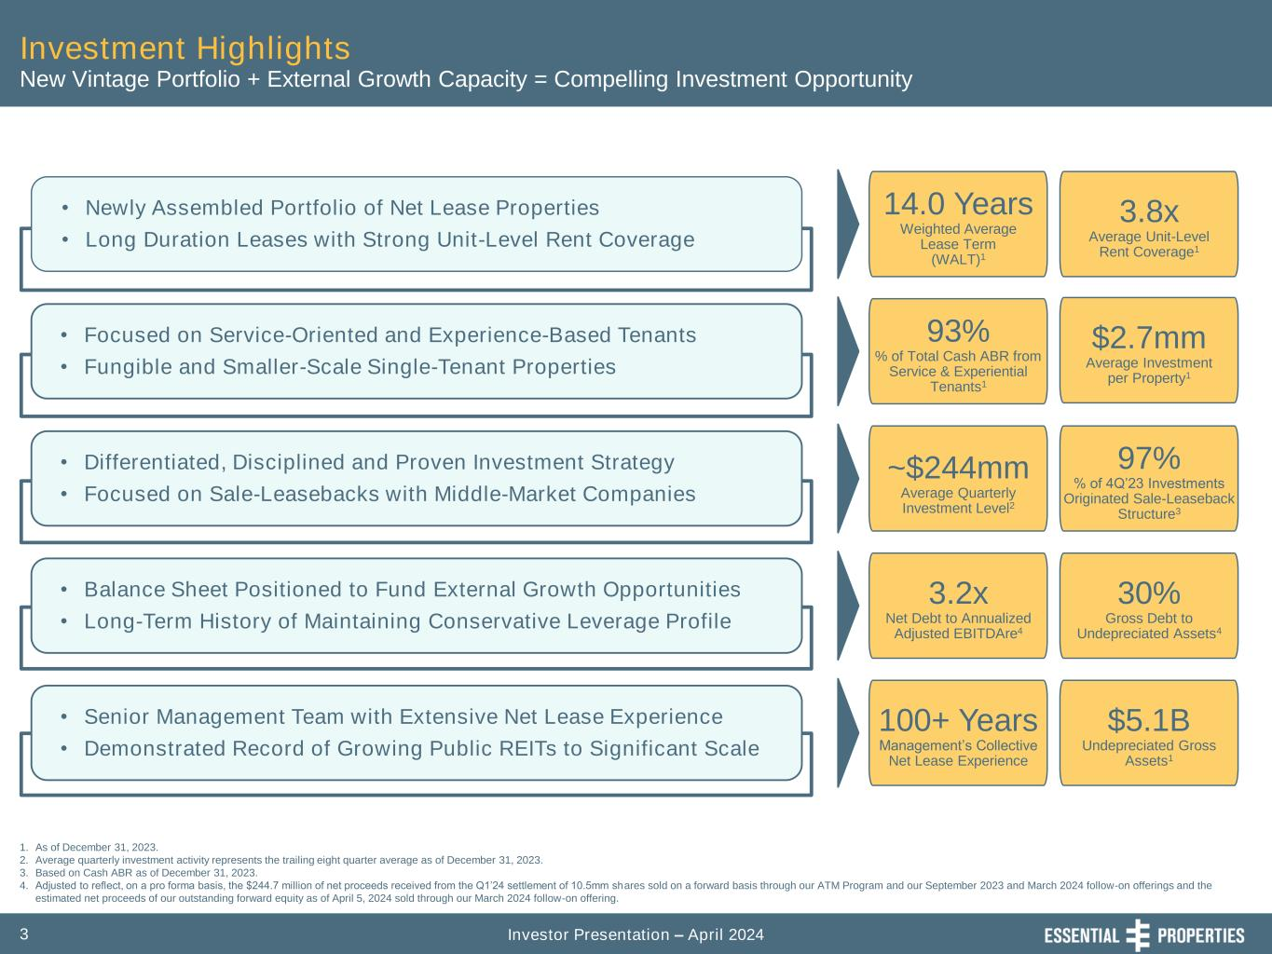
Investor Presentation – April 20243 Investment Highlights • Newly Assembled Portfolio of Net Lease Properties • Long Duration Leases with Strong Unit-Level Rent Coverage • Focused on Service-Oriented and Experience-Based Tenants • Fungible and Smaller-Scale Single-Tenant Properties • Differentiated, Disciplined and Proven Investment Strategy • Focused on Sale-Leasebacks with Middle-Market Companies • Balance Sheet Positioned to Fund External Growth Opportunities • Long-Term History of Maintaining Conservative Leverage Profile • Senior Management Team with Extensive Net Lease Experience • Demonstrated Record of Growing Public REITs to Significant Scale 1. As of December 31, 2023. 2. Average quarterly investment activity represents the trailing eight quarter average as of December 31, 2023. 3. Based on Cash ABR as of December 31, 2023. 4. Adjusted to reflect, on a pro forma basis, the $244.7 million of net proceeds received from the Q1’24 settlement of 10.5mm shares sold on a forward basis through our ATM Program and our September 2023 and March 2024 follow-on offerings and the estimated net proceeds of our outstanding forward equity as of April 5, 2024 sold through our March 2024 follow-on offering. New Vintage Portfolio + External Growth Capacity = Compelling Investment Opportunity 14.0 Years Weighted Average Lease Term (WALT)1 3.8x Average Unit-Level Rent Coverage1 93% % of Total Cash ABR from Service & Experiential Tenants1 $2.7mm Average Investment per Property1 ~$244mm Average Quarterly Investment Level2 97% % of 4Q’23 Investments Originated Sale-Leaseback Structure3 3.2x Net Debt to Annualized Adjusted EBITDAre4 30% Gross Debt to Undepreciated Assets4 100+ Years Management’s Collective Net Lease Experience $5.1B Undepreciated Gross Assets1

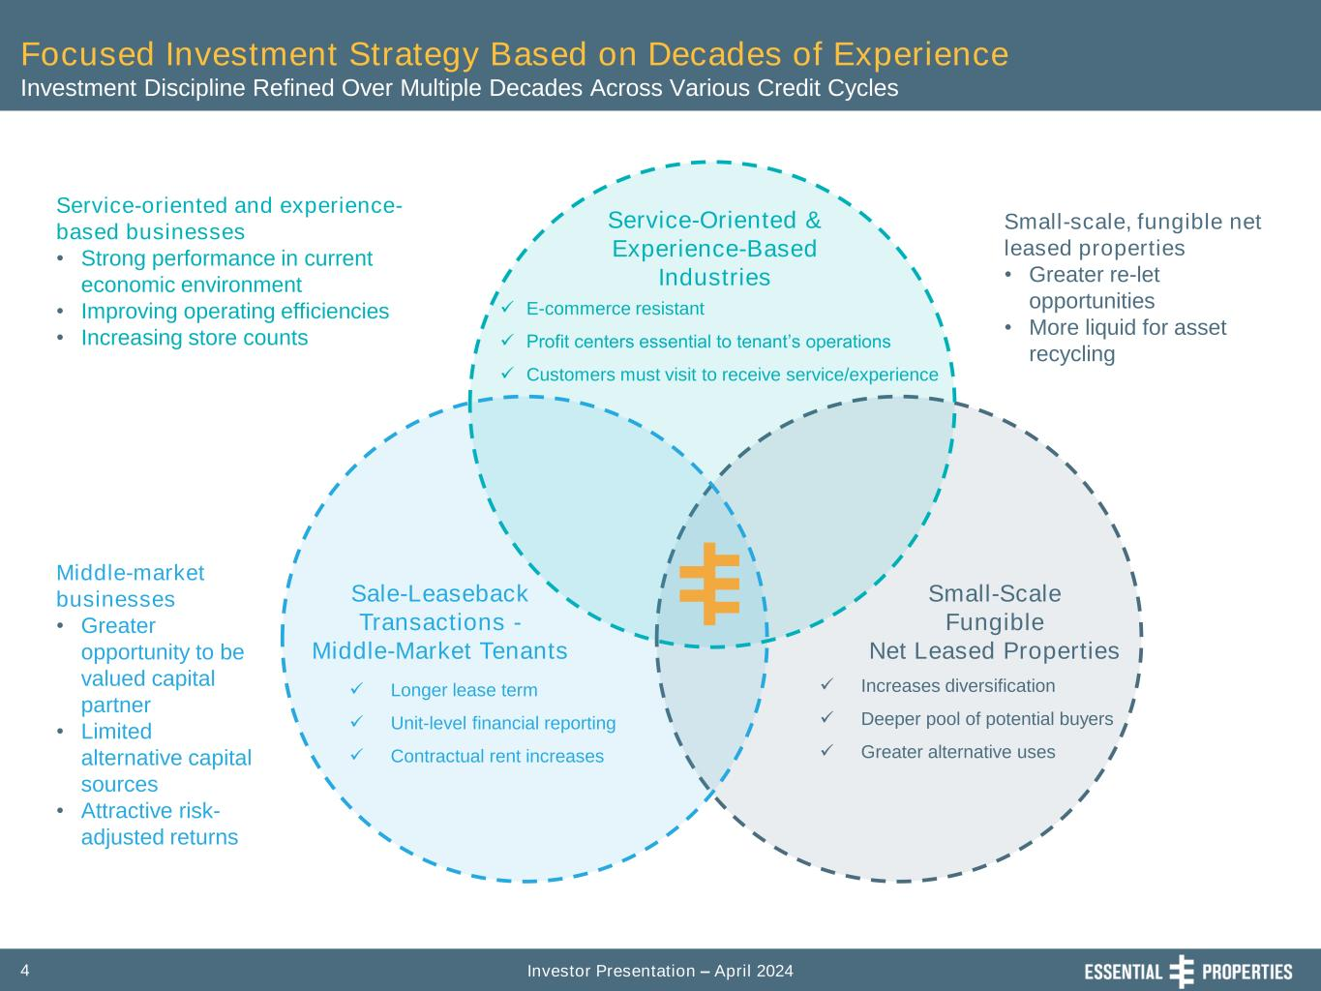
Investor Presentation – April 20244 Focused Investment Strategy Based on Decades of Experience Investment Discipline Refined Over Multiple Decades Across Various Credit Cycles Service-Oriented & Experience-Based Industries Sale-Leaseback Transactions - Middle-Market Tenants Small-Scale Fungible Net Leased Properties ✓ E-commerce resistant ✓ Profit centers essential to tenant’s operations ✓ Customers must visit to receive service/experience ✓ Longer lease term ✓ Unit-level financial reporting ✓ Contractual rent increases ✓ Increases diversification ✓ Deeper pool of potential buyers ✓ Greater alternative uses Small-scale, fungible net leased properties • Greater re-let opportunities • More liquid for asset recycling Service-oriented and experience- based businesses • Strong performance in current economic environment • Improving operating efficiencies • Increasing store counts Middle-market businesses • Greater opportunity to be valued capital partner • Limited alternative capital sources • Attractive risk- adjusted returns

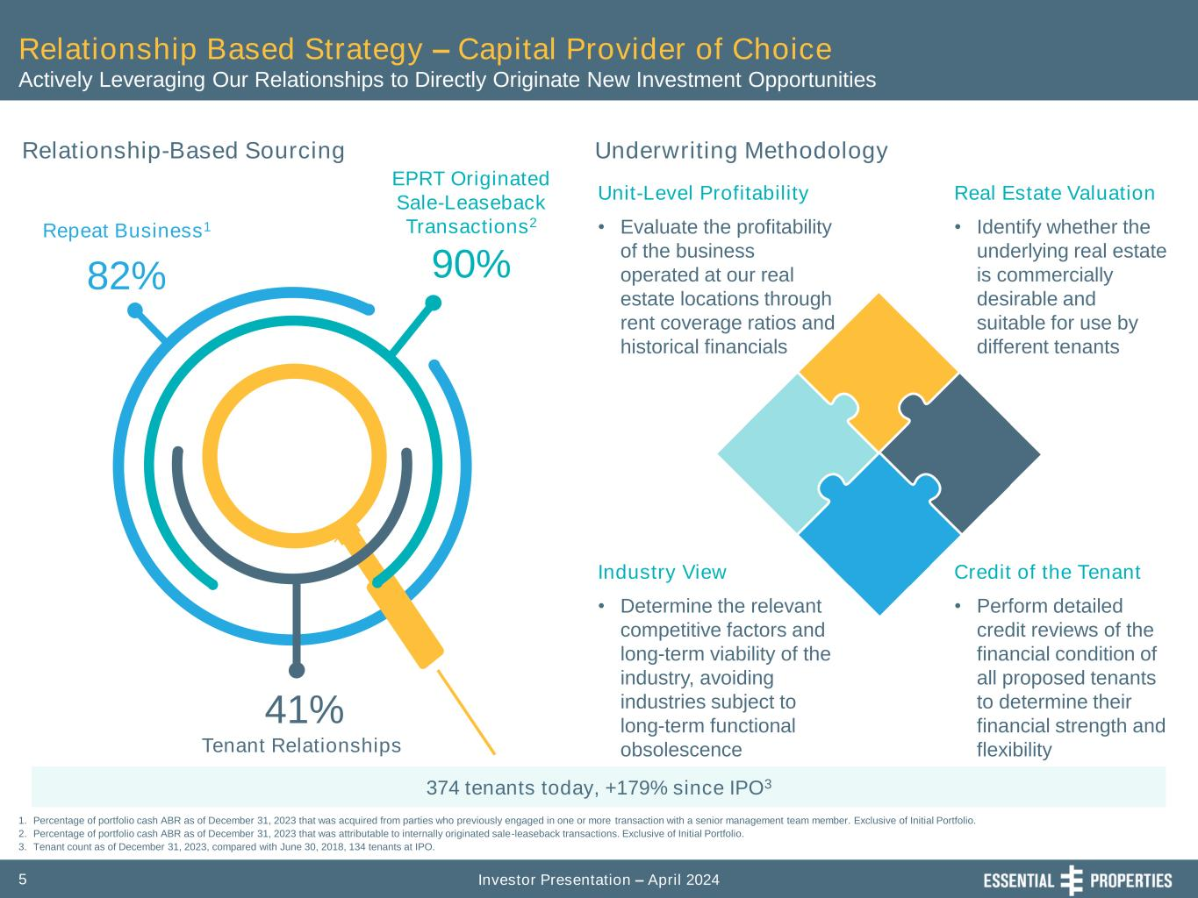
Investor Presentation – April 20245 Relationship Based Strategy – Capital Provider of Choice Actively Leveraging Our Relationships to Directly Originate New Investment Opportunities Relationship-Based Sourcing 1. Percentage of portfolio cash ABR as of December 31, 2023 that was acquired from parties who previously engaged in one or more transaction with a senior management team member. Exclusive of Initial Portfolio. 2. Percentage of portfolio cash ABR as of December 31, 2023 that was attributable to internally originated sale-leaseback transactions. Exclusive of Initial Portfolio. 3. Tenant count as of December 31, 2023, compared with June 30, 2018, 134 tenants at IPO. Repeat Business1 82% EPRT Originated Sale-Leaseback Transactions2 90% Tenant Relationships 41% Underwriting Methodology Industry View • Determine the relevant competitive factors and long-term viability of the industry, avoiding industries subject to long-term functional obsolescence Credit of the Tenant • Perform detailed credit reviews of the financial condition of all proposed tenants to determine their financial strength and flexibility Unit-Level Profitability • Evaluate the profitability of the business operated at our real estate locations through rent coverage ratios and historical financials Real Estate Valuation • Identify whether the underlying real estate is commercially desirable and suitable for use by different tenants 374 tenants today, +179% since IPO3

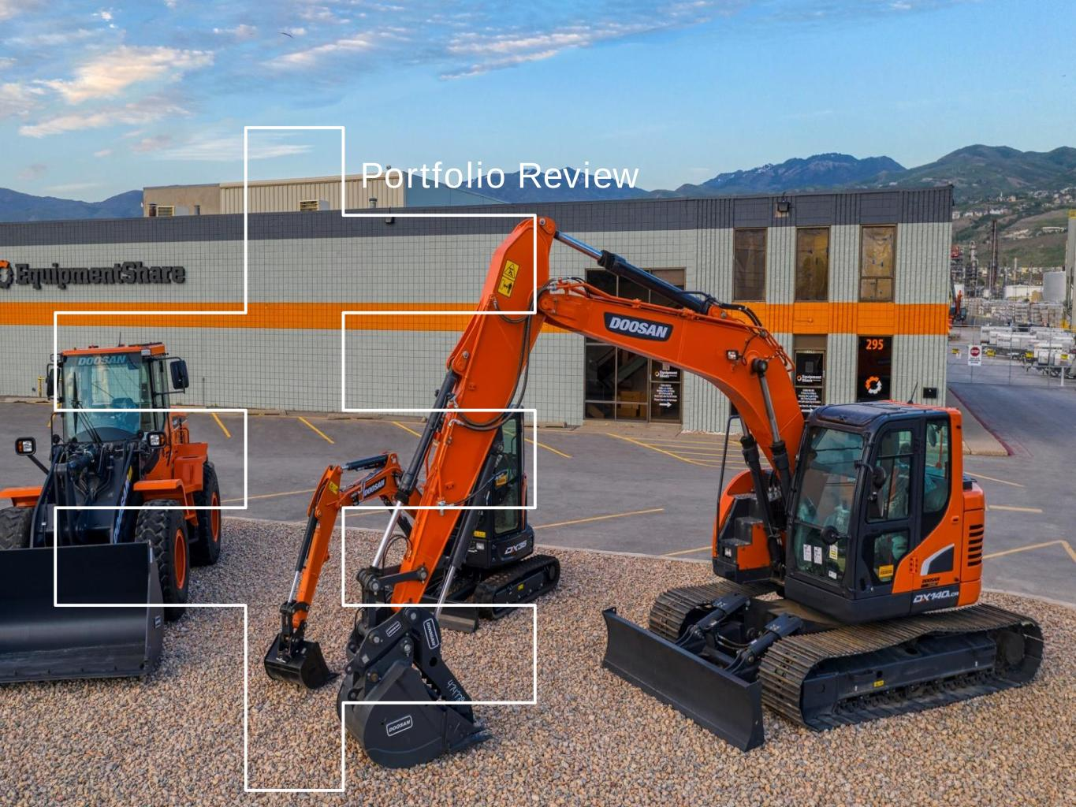
Portfolio Review

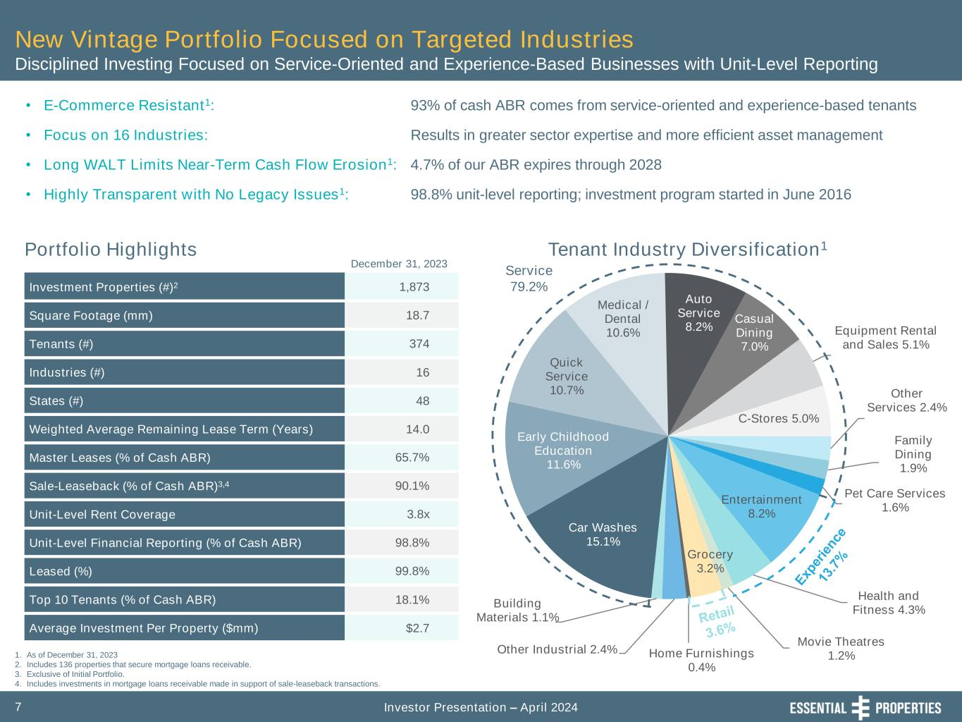
Investor Presentation – April 20247 Car Washes 15.1% Early Childhood Education 11.6% Quick Service 10.7% Medical / Dental 10.6% Auto Service 8.2% Casual Dining 7.0% Equipment Rental and Sales 5.1% C-Stores 5.0% Other Services 2.4% Family Dining 1.9% Pet Care Services 1.6% Entertainment 8.2% Health and Fitness 4.3% Movie Theatres 1.2% Grocery 3.2% Home Furnishings 0.4% Other Industrial 2.4% Building Materials 1.1% Service 79.2% New Vintage Portfolio Focused on Targeted Industries Disciplined Investing Focused on Service-Oriented and Experience-Based Businesses with Unit-Level Reporting 1. As of December 31, 2023 2. Includes 136 properties that secure mortgage loans receivable. 3. Exclusive of Initial Portfolio. 4. Includes investments in mortgage loans receivable made in support of sale-leaseback transactions. Portfolio Highlights December 31, 2023 Tenant Industry Diversification1 • E-Commerce Resistant1: • Focus on 16 Industries: • Long WALT Limits Near-Term Cash Flow Erosion1: • Highly Transparent with No Legacy Issues1: Investment Properties (#)2 1,873 Square Footage (mm) 18.7 Tenants (#) 374 Industries (#) 16 States (#) 48 Weighted Average Remaining Lease Term (Years) 14.0 Master Leases (% of Cash ABR) 65.7% Sale-Leaseback (% of Cash ABR)3,4 90.1% Unit-Level Rent Coverage 3.8x Unit-Level Financial Reporting (% of Cash ABR) 98.8% Leased (%) 99.8% Top 10 Tenants (% of Cash ABR) 18.1% Average Investment Per Property ($mm) $2.7 93% of cash ABR comes from service-oriented and experience-based tenants Results in greater sector expertise and more efficient asset management 4.7% of our ABR expires through 2028 98.8% unit-level reporting; investment program started in June 2016

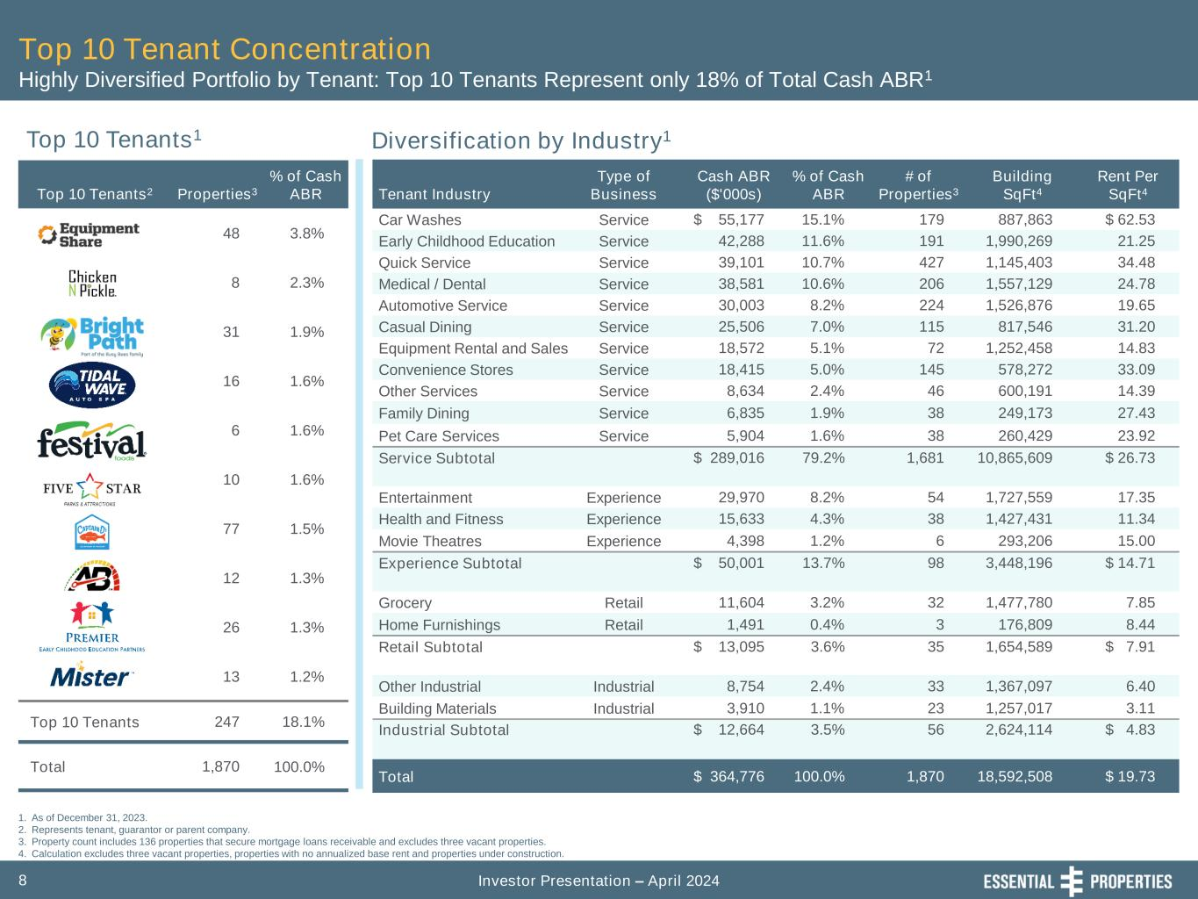
Investor Presentation – April 20248 Top 10 Tenant Concentration Highly Diversified Portfolio by Tenant: Top 10 Tenants Represent only 18% of Total Cash ABR1 Top 10 Tenants1 Diversification by Industry1 1. As of December 31, 2023. 2. Represents tenant, guarantor or parent company. 3. Property count includes 136 properties that secure mortgage loans receivable and excludes three vacant properties. 4. Calculation excludes three vacant properties, properties with no annualized base rent and properties under construction. Tenant Industry Type of Business Cash ABR ($'000s) % of Cash ABR # of Properties3 Building SqFt4 Rent Per SqFt4 Car Washes Service $ 55,177 15.1% 179 887,863 $ 62.53 Early Childhood Education Service 42,288 11.6% 191 1,990,269 21.25 Quick Service Service 39,101 10.7% 427 1,145,403 34.48 Medical / Dental Service 38,581 10.6% 206 1,557,129 24.78 Automotive Service Service 30,003 8.2% 224 1,526,876 19.65 Casual Dining Service 25,506 7.0% 115 817,546 31.20 Equipment Rental and Sales Service 18,572 5.1% 72 1,252,458 14.83 Convenience Stores Service 18,415 5.0% 145 578,272 33.09 Other Services Service 8,634 2.4% 46 600,191 14.39 Family Dining Service 6,835 1.9% 38 249,173 27.43 Pet Care Services Service 5,904 1.6% 38 260,429 23.92 Service Subtotal $ 289,016 79.2% 1,681 10,865,609 $ 26.73 Entertainment Experience 29,970 8.2% 54 1,727,559 17.35 Health and Fitness Experience 15,633 4.3% 38 1,427,431 11.34 Movie Theatres Experience 4,398 1.2% 6 293,206 15.00 Experience Subtotal $ 50,001 13.7% 98 3,448,196 $ 14.71 Grocery Retail 11,604 3.2% 32 1,477,780 7.85 Home Furnishings Retail 1,491 0.4% 3 176,809 8.44 Retail Subtotal $ 13,095 3.6% 35 1,654,589 $ 7.91 Other Industrial Industrial 8,754 2.4% 33 1,367,097 6.40 Building Materials Industrial 3,910 1.1% 23 1,257,017 3.11 Industrial Subtotal $ 12,664 3.5% 56 2,624,114 $ 4.83 Total $ 364,776 100.0% 1,870 18,592,508 $ 19.73 Top 10 Tenants2 Properties3 % of Cash ABR 48 3.8% 8 2.3% 31 1.9% 16 1.6% 6 1.6% 10 1.6% 77 1.5% 12 1.3% 26 1.3% 13 1.2% Top 10 Tenants 247 18.1% Total 1,870 100.0%

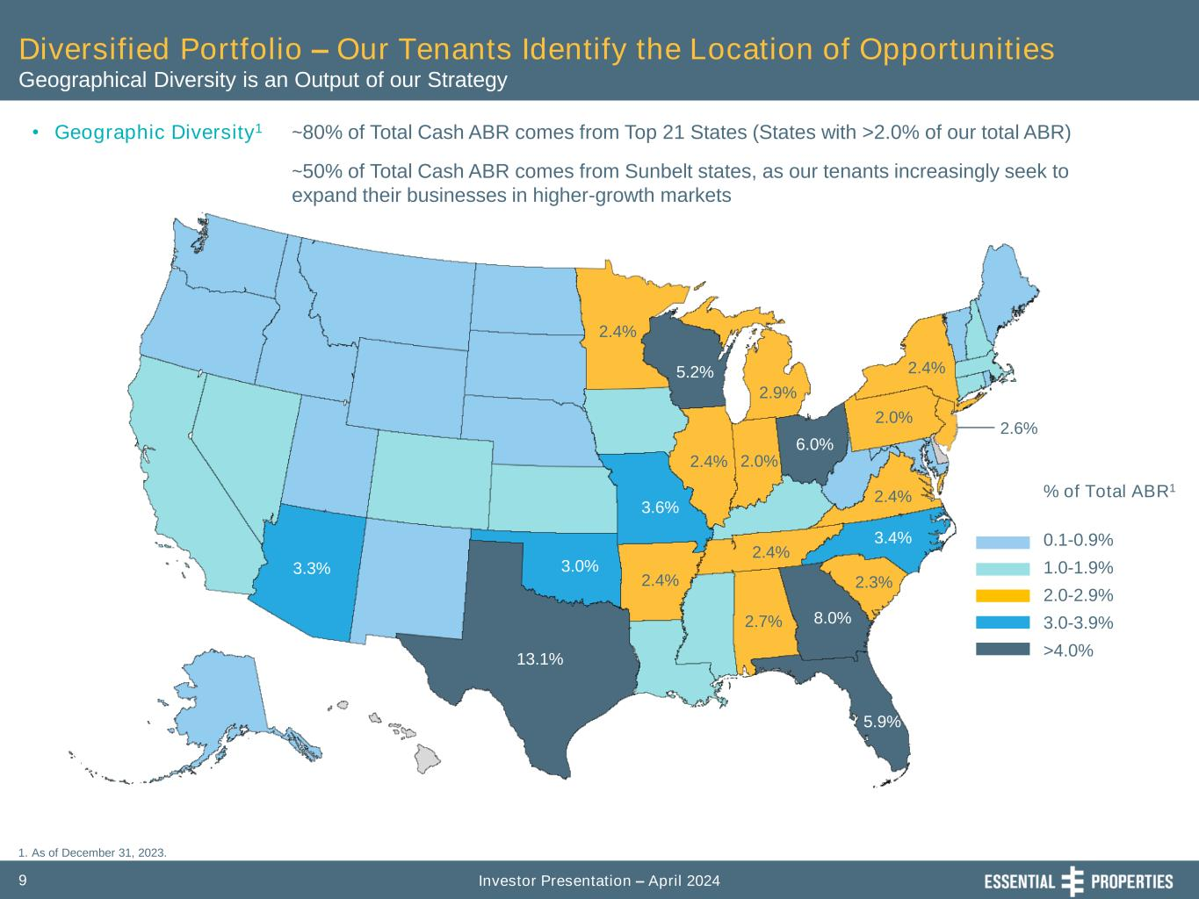
Investor Presentation – April 20249 Diversified Portfolio – Our Tenants Identify the Location of Opportunities Geographical Diversity is an Output of our Strategy • Geographic Diversity1 ~80% of Total Cash ABR comes from Top 21 States (States with >2.0% of our total ABR) ~50% of Total Cash ABR comes from Sunbelt states, as our tenants increasingly seek to expand their businesses in higher-growth markets % of Total ABR1 0.1-0.9% 1.0-1.9% 2.0-2.9% 3.0-3.9% >4.0% 2.4% 2.6% 13.1% 3.3% 3.6% 2.4% 5.2% 2.9% 2.4% 3.0% 2.4% 6.0% 2.4% 3.4% 8.0%2.7% 5.9% 2.4% 2.0% 2.0% 2.3% 1. As of December 31, 2023.

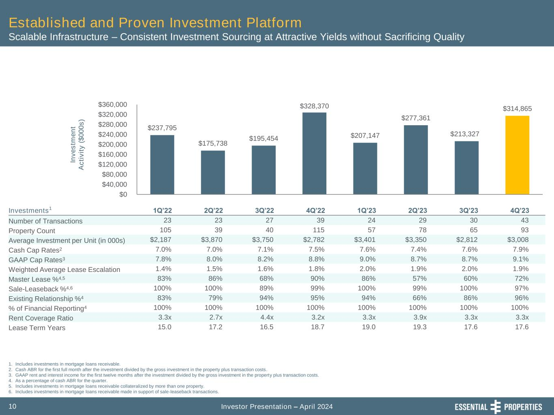
Investor Presentation – April 202410 Established and Proven Investment Platform Scalable Infrastructure – Consistent Investment Sourcing at Attractive Yields without Sacrificing Quality 1. Includes investments in mortgage loans receivable. 2. Cash ABR for the first full month after the investment divided by the gross investment in the property plus transaction costs. 3. GAAP rent and interest income for the first twelve months after the investment divided by the gross investment in the property plus transaction costs. 4. As a percentage of cash ABR for the quarter. 5. Includes investments in mortgage loans receivable collateralized by more than one property. 6. Includes investments in mortgage loans receivable made in support of sale-leaseback transactions. In v e s tm e n t A c ti v it y ( $ 0 0 0 s ) Investments1 1Q’22 2Q’22 3Q’22 4Q’22 1Q’23 2Q’23 3Q’23 4Q’23 Number of Transactions 23 23 27 39 24 29 30 43 Property Count 105 39 40 115 57 78 65 93 Average Investment per Unit (in 000s) $2,187 $3,870 $3,750 $2,782 $3,401 $3,350 $2,812 $3,008 Cash Cap Rates2 7.0% 7.0% 7.1% 7.5% 7.6% 7.4% 7.6% 7.9% GAAP Cap Rates3 7.8% 8.0% 8.2% 8.8% 9.0% 8.7% 8.7% 9.1% Weighted Average Lease Escalation 1.4% 1.5% 1.6% 1.8% 2.0% 1.9% 2.0% 1.9% Master Lease %4,5 83% 86% 68% 90% 86% 57% 60% 72% Sale-Leaseback %4,6 100% 100% 89% 99% 100% 99% 100% 97% Existing Relationship %4 83% 79% 94% 95% 94% 66% 86% 96% % of Financial Reporting4 100% 100% 100% 100% 100% 100% 100% 100% Rent Coverage Ratio 3.3x 2.7x 4.4x 3.2x 3.3x 3.9x 3.3x 3.3x Lease Term Years 15.0 17.2 16.5 18.7 19.0 19.3 17.6 17.6 $237,795 $175,738 $195,454 $328,370 $207,147 $277,361 $213,327 $314,865 $0 $40,000 $80,000 $120,000 $160,000 $200,000 $240,000 $280,000 $320,000 $360,000 In v e s tm e n t A c ti v it y ( $ 0 0 0 s )

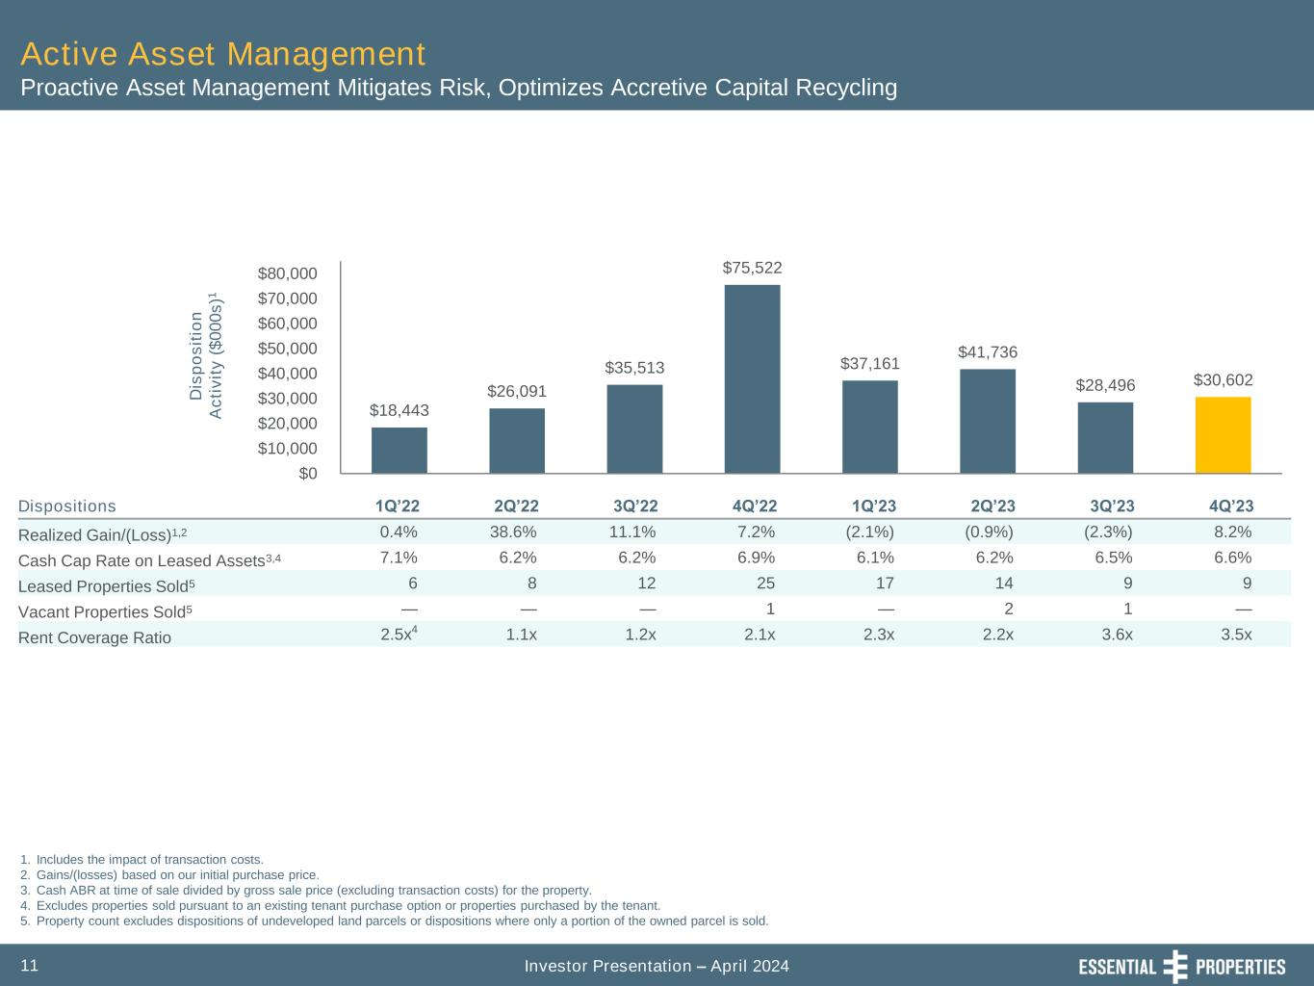
Investor Presentation – April 202411 Active Asset Management Proactive Asset Management Mitigates Risk, Optimizes Accretive Capital Recycling 1. Includes the impact of transaction costs. 2. Gains/(losses) based on our initial purchase price. 3. Cash ABR at time of sale divided by gross sale price (excluding transaction costs) for the property. 4. Excludes properties sold pursuant to an existing tenant purchase option or properties purchased by the tenant. 5. Property count excludes dispositions of undeveloped land parcels or dispositions where only a portion of the owned parcel is sold. Dispositions 1Q’22 2Q’22 3Q’22 4Q’22 1Q’23 2Q’23 3Q’23 4Q’23 Realized Gain/(Loss)1,2 0.4% 38.6% 11.1% 7.2% (2.1%) (0.9%) (2.3%) 8.2% Cash Cap Rate on Leased Assets3,4 7.1% 6.2% 6.2% 6.9% 6.1% 6.2% 6.5% 6.6% Leased Properties Sold5 6 8 12 25 17 14 9 9 Vacant Properties Sold5 — — — 1 — 2 1 — Rent Coverage Ratio 2.5x4 1.1x 1.2x 2.1x 2.3x 2.2x 3.6x 3.5x $18,443 $26,091 $35,513 $75,522 $37,161 $41,736 $28,496 $30,602 $0 $10,000 $20,000 $30,000 $40,000 $50,000 $60,000 $70,000 $80,000 D is p o s it io n A c ti v it y ( $ 0 0 0 s )1

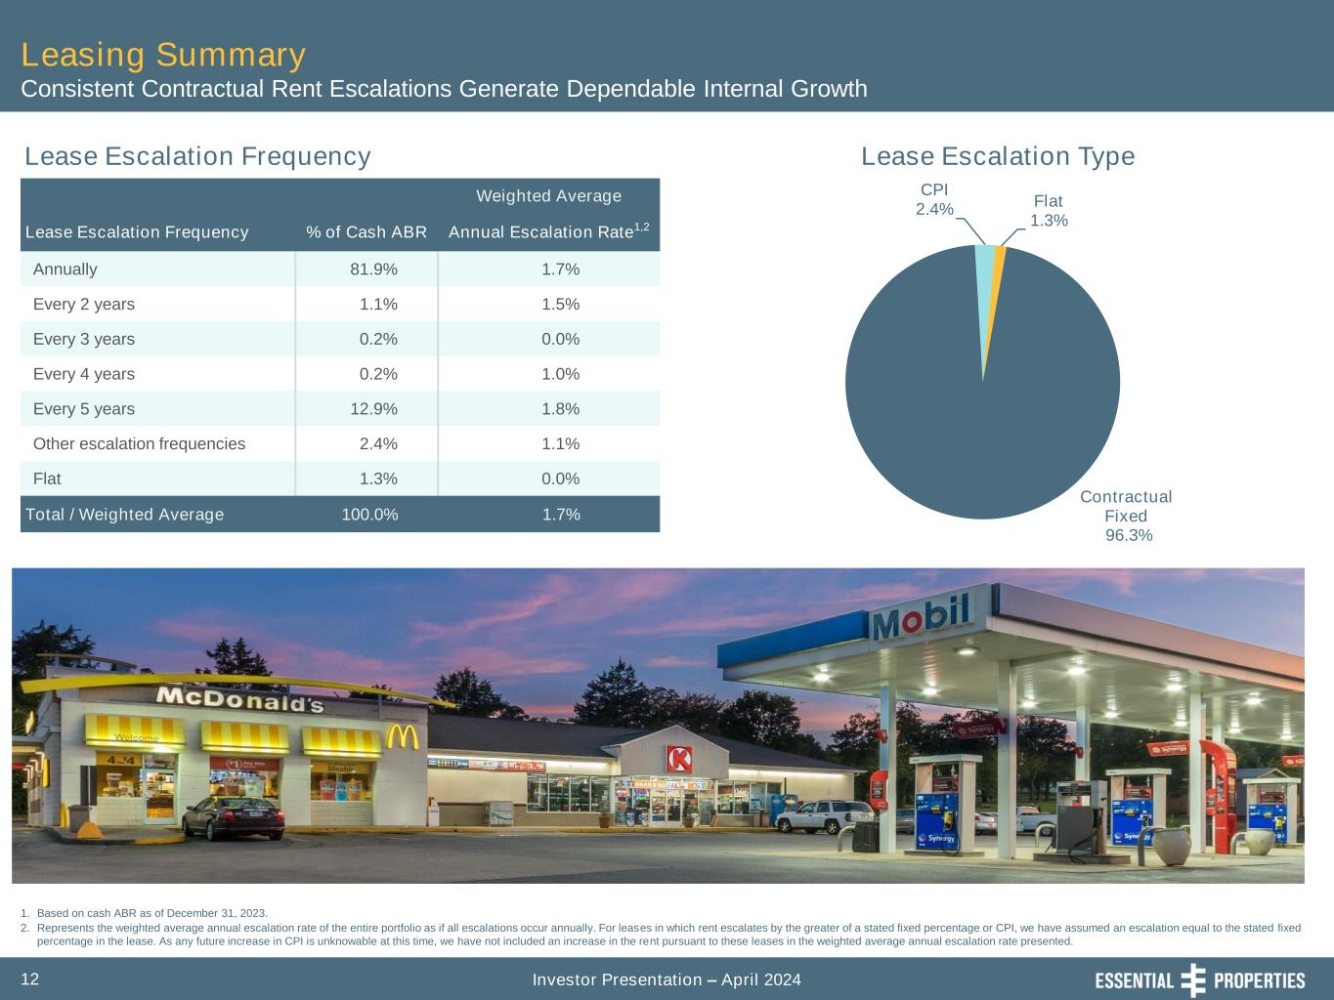
Investor Presentation – April 202412 Leasing Summary Consistent Contractual Rent Escalations Generate Dependable Internal Growth Lease Escalation Frequency Lease Escalation Type 1. Based on cash ABR as of December 31, 2023. 2. Represents the weighted average annual escalation rate of the entire portfolio as if all escalations occur annually. For leases in which rent escalates by the greater of a stated fixed percentage or CPI, we have assumed an escalation equal to the stated fixed percentage in the lease. As any future increase in CPI is unknowable at this time, we have not included an increase in the rent pursuant to these leases in the weighted average annual escalation rate presented. Weighted Average Lease Escalation Frequency % of Cash ABR Annual Escalation Rate1,2 Annually 81.9% 1.7% Every 2 years 1.1% 1.5% Every 3 years 0.2% 0.0% Every 4 years 0.2% 1.0% Every 5 years 12.9% 1.8% Other escalation frequencies 2.4% 1.1% Flat 1.3% 0.0% Total / Weighted Average 100.0% 1.7% Contractual Fixed 96.3% CPI 2.4% Flat 1.3%

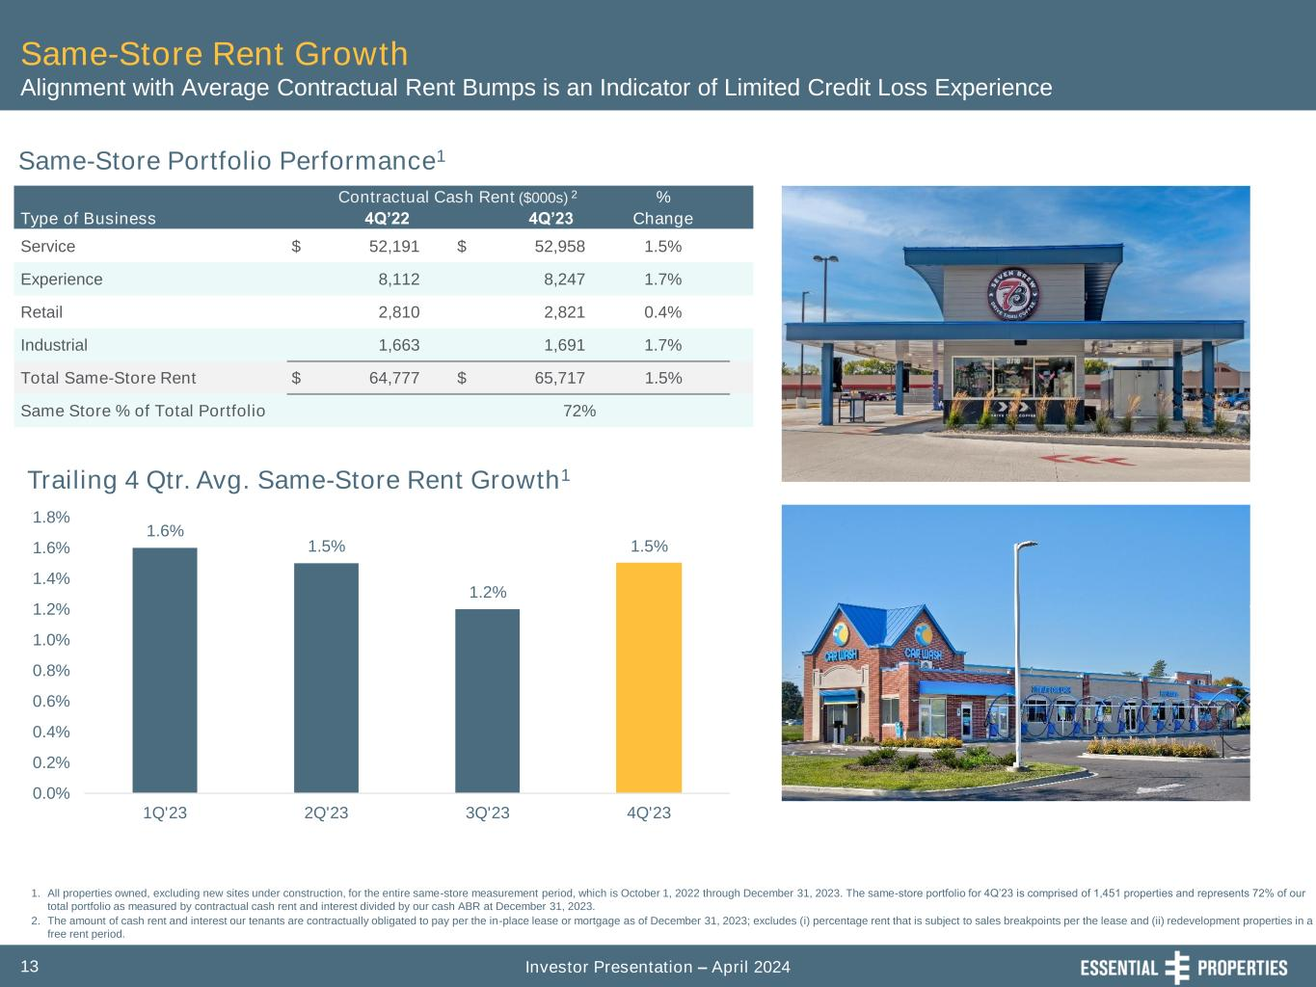
Investor Presentation – April 202413 1. All properties owned, excluding new sites under construction, for the entire same-store measurement period, which is October 1, 2022 through December 31, 2023. The same-store portfolio for 4Q’23 is comprised of 1,451 properties and represents 72% of our total portfolio as measured by contractual cash rent and interest divided by our cash ABR at December 31, 2023. 2. The amount of cash rent and interest our tenants are contractually obligated to pay per the in-place lease or mortgage as of December 31, 2023; excludes (i) percentage rent that is subject to sales breakpoints per the lease and (ii) redevelopment properties in a free rent period. Same-Store Rent Growth Alignment with Average Contractual Rent Bumps is an Indicator of Limited Credit Loss Experience Same-Store Portfolio Performance1 Trailing 4 Qtr. Avg. Same-Store Rent Growth1 Contractual Cash Rent ($000s) 2 % Type of Business 4Q’22 4Q’23 Change Service $ 52,191 $ 52,958 1.5% Experience 8,112 8,247 1.7% Retail 2,810 2,821 0.4% Industrial 1,663 1,691 1.7% Total Same-Store Rent $ 64,777 $ 65,717 1.5% Same Store % of Total Portfolio 72% 1.6% 1.5% 1.2% 1.5% 0.0% 0.2% 0.4% 0.6% 0.8% 1.0% 1.2% 1.4% 1.6% 1.8% 1Q'23 2Q'23 3Q'23 4Q'23

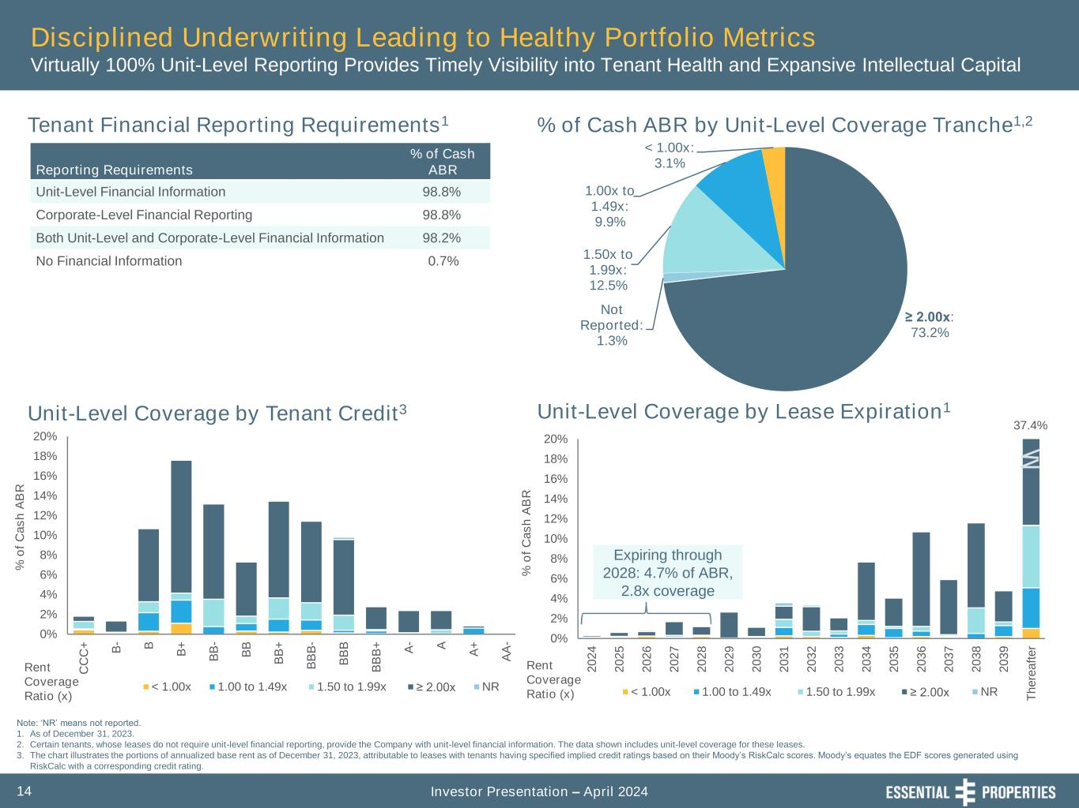
Investor Presentation – April 202414 Tenant Financial Reporting Requirements1 % of Cash ABR by Unit-Level Coverage Tranche1,2 Unit-Level Coverage by Lease Expiration1Unit-Level Coverage by Tenant Credit3 Reporting Requirements % of Cash ABR Unit-Level Financial Information 98.8% Corporate-Level Financial Reporting 98.8% Both Unit-Level and Corporate-Level Financial Information 98.2% No Financial Information 0.7% Note: ‘NR’ means not reported. 1. As of December 31, 2023. 2. Certain tenants, whose leases do not require unit-level financial reporting, provide the Company with unit-level financial information. The data shown includes unit-level coverage for these leases. 3. The chart illustrates the portions of annualized base rent as of December 31, 2023, attributable to leases with tenants having specified implied credit ratings based on their Moody’s RiskCalc scores. Moody’s equates the EDF scores generated using RiskCalc with a corresponding credit rating. 0% 2% 4% 6% 8% 10% 12% 14% 16% 18% 20% C C C + B - B B + B B - B B B B + B B B - B B B B B B + A - A A + A A - % o f C a s h A B R < 1.00x 1.00 to 1.49x 1.50 to 1.99x ≥ 2.00x NR 0% 2% 4% 6% 8% 10% 12% 14% 16% 18% 20% 2 0 2 4 2 0 2 5 2 0 2 6 2 0 2 7 2 0 2 8 2 0 2 9 2 0 3 0 2 0 3 1 2 0 3 2 2 0 3 3 2 0 3 4 2 0 3 5 2 0 3 6 2 0 3 7 2 0 3 8 2 0 3 9 T h e re a ft e r % o f C a s h A B R < 1.00x 1.00 to 1.49x 1.50 to 1.99x ≥ 2.00x NR Rent Coverage Ratio (x) Rent Coverage Ratio (x) ≥ 2.00x: 73.2% Not Reported: 1.3% 1.50x to 1.99x: 12.5% 1.00x to 1.49x: 9.9% < 1.00x: 3.1% Expiring through 2028: 4.7% of ABR, 2.8x coverage 37.4% Disciplined Underwriting Leading to Healthy Portfolio Metrics Virtually 100% Unit-Level Reporting Provides Timely Visibility into Tenant Health and Expansive Intellectual Capital

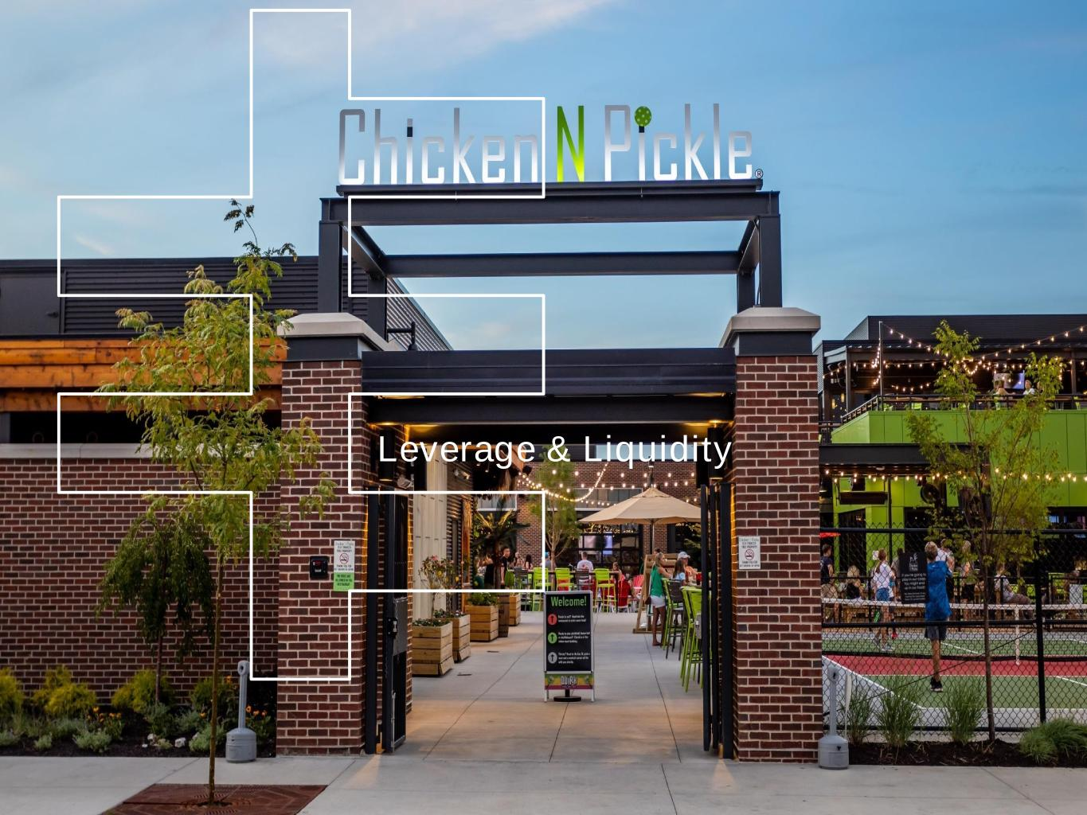
EPRT Board Meeting Management Presentation First Quarter Ended March 31, 2023 Leverage & Liquidity

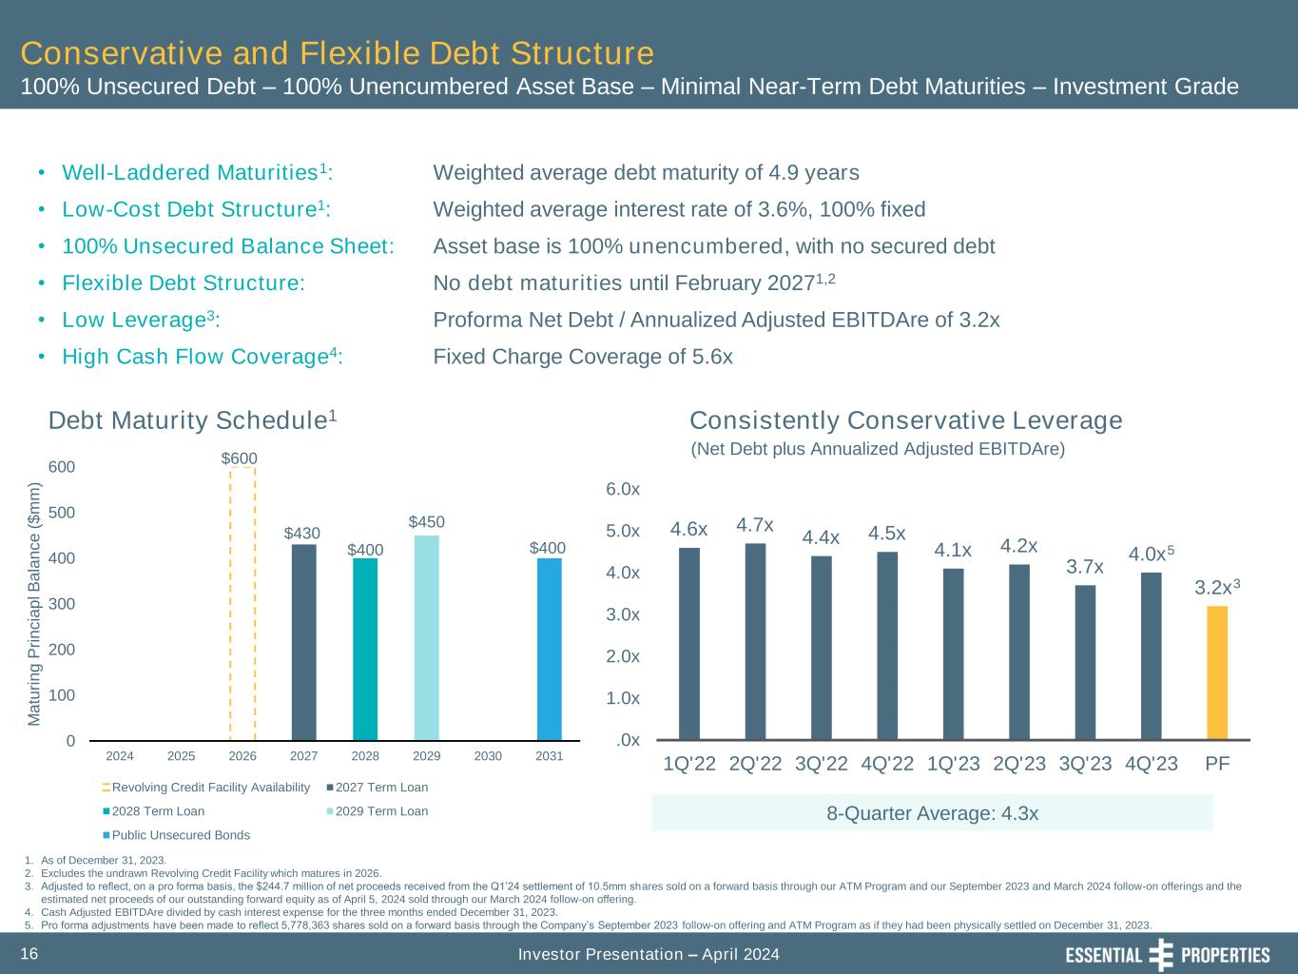
Investor Presentation – April 202416 4.6x 4.7x 4.4x 4.5x 4.1x 4.2x 3.7x 4.0x5 3.2x3 .0x 1.0x 2.0x 3.0x 4.0x 5.0x 6.0x 1Q'22 2Q'22 3Q'22 4Q'22 1Q'23 2Q'23 3Q'23 4Q'23 PF Conservative and Flexible Debt Structure 100% Unsecured Debt – 100% Unencumbered Asset Base – Minimal Near-Term Debt Maturities – Investment Grade Debt Maturity Schedule1 • Well-Laddered Maturities1: • Low-Cost Debt Structure1: • 100% Unsecured Balance Sheet: • Flexible Debt Structure: • Low Leverage3: • High Cash Flow Coverage4: Weighted average debt maturity of 4.9 years Weighted average interest rate of 3.6%, 100% fixed Asset base is 100% unencumbered, with no secured debt No debt maturities until February 20271,2 Proforma Net Debt / Annualized Adjusted EBITDAre of 3.2x Fixed Charge Coverage of 5.6x 1. As of December 31, 2023. 2. Excludes the undrawn Revolving Credit Facility which matures in 2026. 3. Adjusted to reflect, on a pro forma basis, the $244.7 million of net proceeds received from the Q1’24 settlement of 10.5mm shares sold on a forward basis through our ATM Program and our September 2023 and March 2024 follow-on offerings and the estimated net proceeds of our outstanding forward equity as of April 5, 2024 sold through our March 2024 follow-on offering. 4. Cash Adjusted EBITDAre divided by cash interest expense for the three months ended December 31, 2023. 5. Pro forma adjustments have been made to reflect 5,778,363 shares sold on a forward basis through the Company’s September 2023 follow-on offering and ATM Program as if they had been physically settled on December 31, 2023. (Net Debt plus Annualized Adjusted EBITDAre) Consistently Conservative Leverage 8-Quarter Average: 4.3x $600 $430 $400 $450 $400 0 100 200 300 400 500 600 2024 2025 2026 2027 2028 2029 2030 2031 M a tu ri n g P ri n c ia p l B a la n c e ( $ m m ) Revolving Credit Facility Availability 2027 Term Loan 2028 Term Loan 2029 Term Loan Public Unsecured Bonds

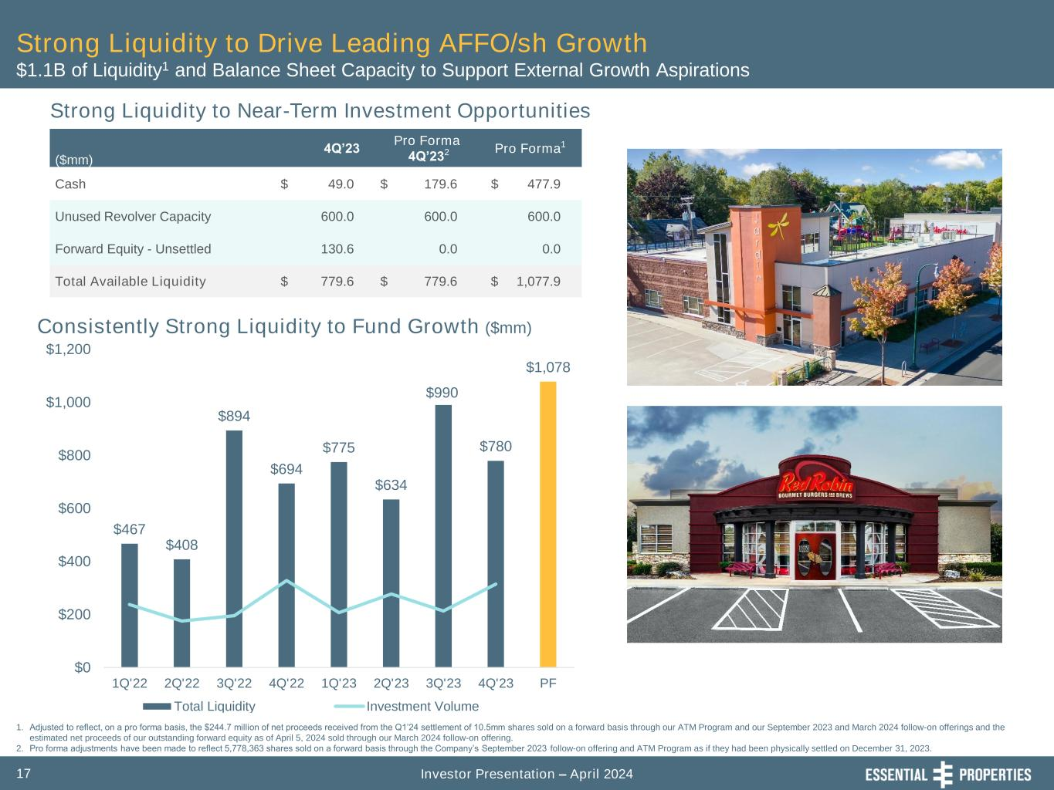
Investor Presentation – April 202417 Consistently Strong Liquidity to Fund Growth ($mm) $467 $408 $894 $694 $775 $634 $990 $780 $1,078 $0 $200 $400 $600 $800 $1,000 $1,200 1Q'22 2Q'22 3Q'22 4Q'22 1Q'23 2Q'23 3Q'23 4Q'23 PF Total Liquidity Investment Volume Strong Liquidity to Drive Leading AFFO/sh Growth $1.1B of Liquidity1 and Balance Sheet Capacity to Support External Growth Aspirations ($mm) 4Q’23 Pro Forma 4Q’232 Pro Forma1 Cash $ 49.0 $ 179.6 $ 477.9 Unused Revolver Capacity 600.0 600.0 600.0 Forward Equity - Unsettled 130.6 0.0 0.0 Total Available Liquidity $ 779.6 $ 779.6 $ 1,077.9 1. Adjusted to reflect, on a pro forma basis, the $244.7 million of net proceeds received from the Q1’24 settlement of 10.5mm shares sold on a forward basis through our ATM Program and our September 2023 and March 2024 follow-on offerings and the estimated net proceeds of our outstanding forward equity as of April 5, 2024 sold through our March 2024 follow-on offering. 2. Pro forma adjustments have been made to reflect 5,778,363 shares sold on a forward basis through the Company’s September 2023 follow-on offering and ATM Program as if they had been physically settled on December 31, 2023. Strong Liquidity to Near-Term Investment Opportunities

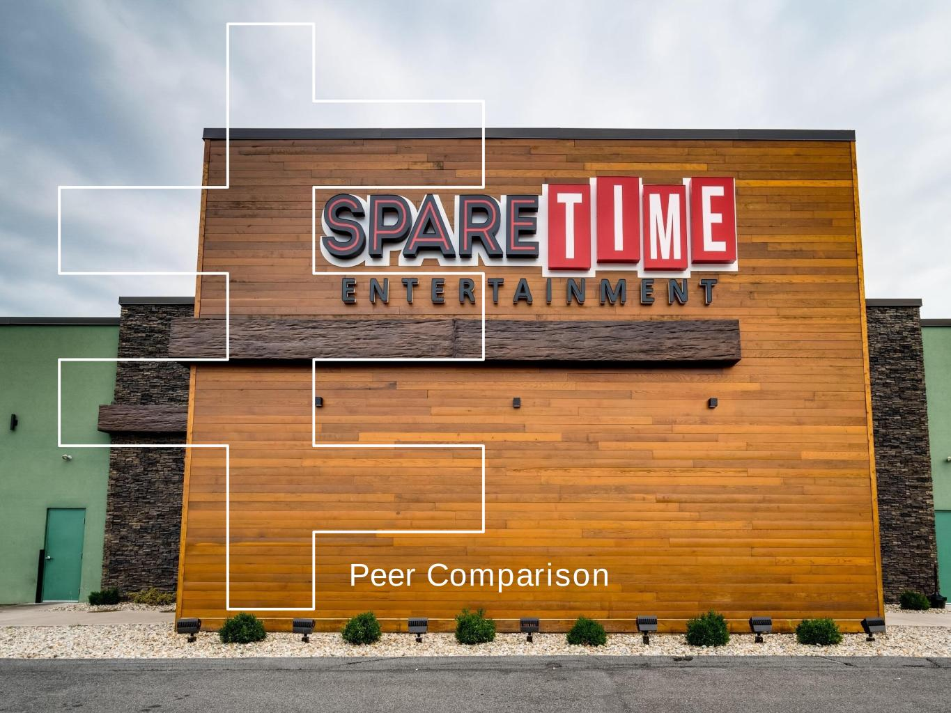
Peer Comparison

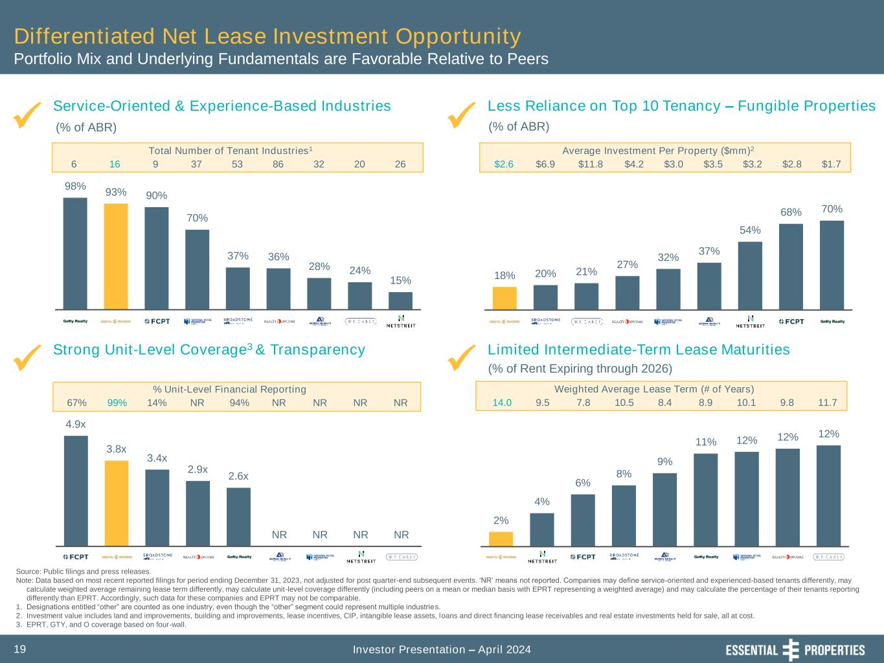
Investor Presentation – April 202419 4.9x 3.8x 3.4x 2.9x 2.6x NR NR NR NR 70% 68% 54% 37% 32% 27% 21% 20% 18% 2% 4% 6% 8% 9% 11% 12% 12% 12% 98% 93% 90% 70% 37% 36% 28% 24% 15% Differentiated Net Lease Investment Opportunity Portfolio Mix and Underlying Fundamentals are Favorable Relative to Peers Strong Unit-Level Coverage3 & Transparency Service-Oriented & Experience-Based Industries Limited Intermediate-Term Lease Maturities ✓ ✓✓ Source: Public filings and press releases. Note: Data based on most recent reported filings for period ending December 31, 2023, not adjusted for post quarter-end subsequent events. ‘NR’ means not reported. Companies may define service-oriented and experienced-based tenants differently, may calculate weighted average remaining lease term differently, may calculate unit-level coverage differently (including peers on a mean or median basis with EPRT representing a weighted average) and may calculate the percentage of their tenants reporting differently than EPRT. Accordingly, such data for these companies and EPRT may not be comparable. 1. Designations entitled “other” are counted as one industry, even though the “other” segment could represent multiple industries. 2. Investment value includes land and improvements, building and improvements, lease incentives, CIP, intangible lease assets, loans and direct financing lease receivables and real estate investments held for sale, all at cost. 3. EPRT, GTY, and O coverage based on four-wall. (% of ABR) (% of Rent Expiring through 2026) Less Reliance on Top 10 Tenancy – Fungible Properties ✓ (% of ABR) 6 Total Number of Tenant Industries1 16 9 37 53 86 32 20 26 67% % Unit-Level Financial Reporting 14% NR 94% NR NR99% NR NR $2.6 Average Investment Per Property ($mm)2 $6.9 $11.8 $4.2 $3.0 $3.5 $3.2 $2.8 $1.7 14.0 Weighted Average Lease Term (# of Years) 9.5 7.8 10.5 8.4 8.9 10.1 9.8 11.7

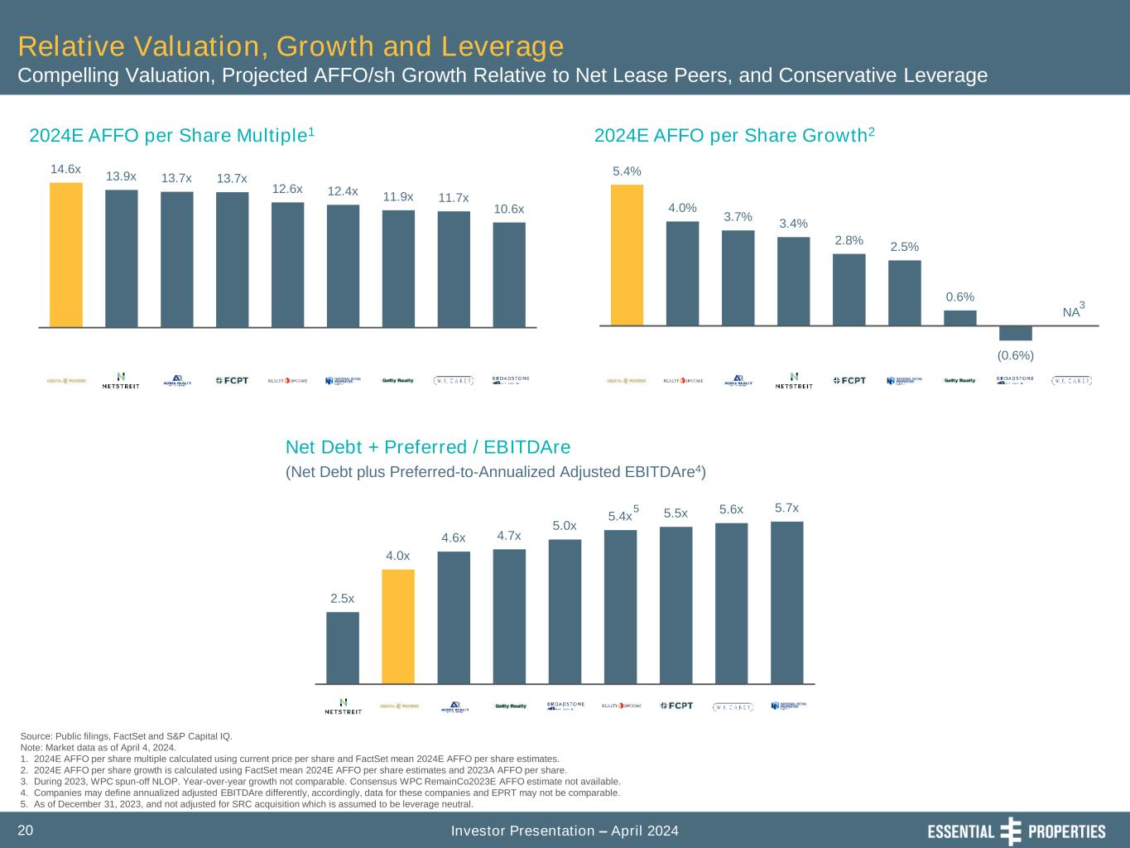
Investor Presentation – April 202420 2.5x 4.0x 4.6x 4.7x 5.0x 5.4x 5.5x 5.6x 5.7x 14.6x 13.9x 13.7x 13.7x 12.6x 12.4x 11.9x 11.7x 10.6x 5.4% 4.0% 3.7% 3.4% 2.8% 2.5% 0.6% (0.6%) NA Source: Public filings, FactSet and S&P Capital IQ. Note: Market data as of April 4, 2024. 1. 2024E AFFO per share multiple calculated using current price per share and FactSet mean 2024E AFFO per share estimates. 2. 2024E AFFO per share growth is calculated using FactSet mean 2024E AFFO per share estimates and 2023A AFFO per share. 3. During 2023, WPC spun-off NLOP. Year-over-year growth not comparable. Consensus WPC RemainCo2023E AFFO estimate not available. 4. Companies may define annualized adjusted EBITDAre differently, accordingly, data for these companies and EPRT may not be comparable. 5. As of December 31, 2023, and not adjusted for SRC acquisition which is assumed to be leverage neutral. 2024E AFFO per Share Multiple1 2024E AFFO per Share Growth2 Relative Valuation, Growth and Leverage Compelling Valuation, Projected AFFO/sh Growth Relative to Net Lease Peers, and Conservative Leverage Net Debt + Preferred / EBITDAre (Net Debt plus Preferred-to-Annualized Adjusted EBITDAre4) 3 5

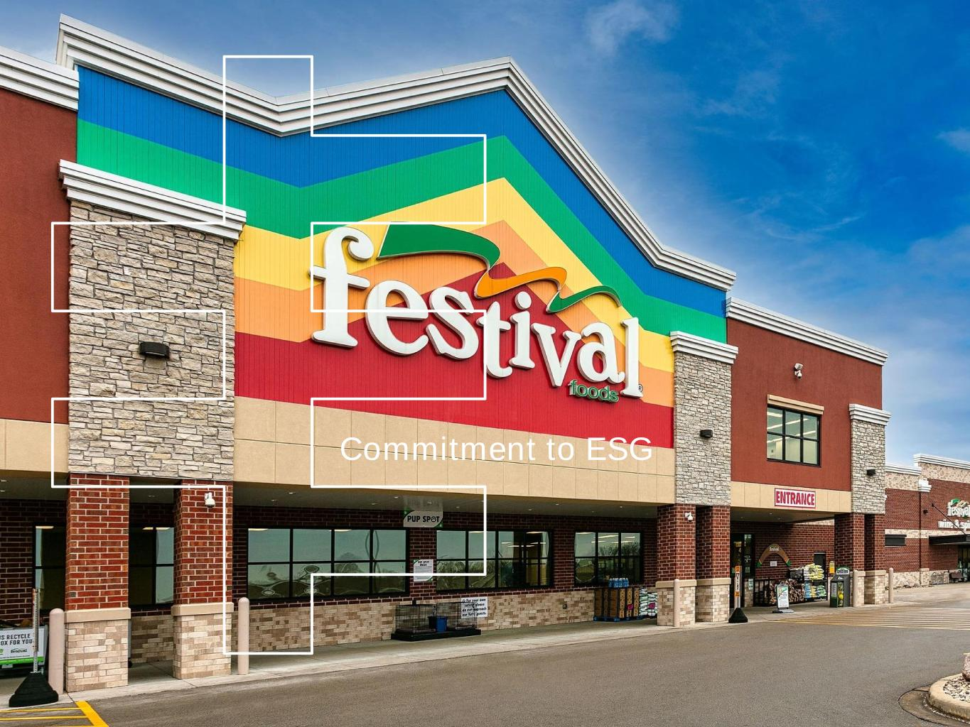
Commitment to ESG

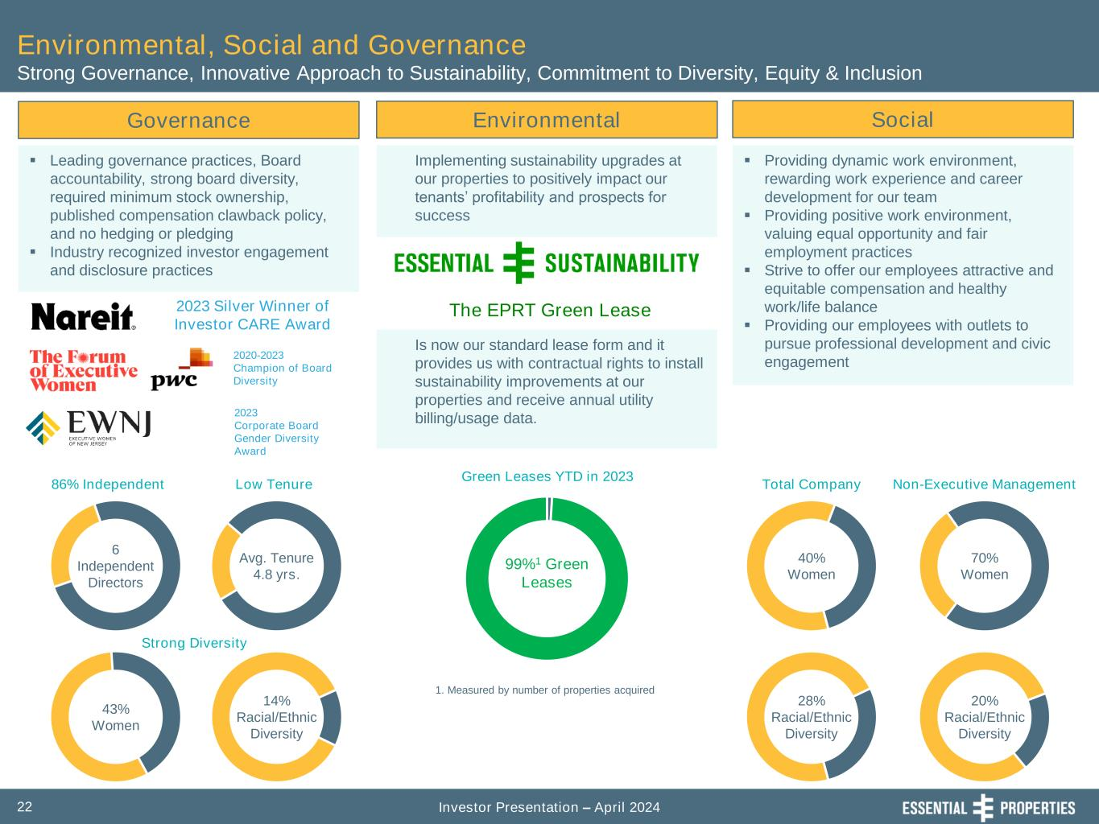
Investor Presentation – April 202422 Governance ▪ Leading governance practices, Board accountability, strong board diversity, required minimum stock ownership, published compensation clawback policy, and no hedging or pledging ▪ Industry recognized investor engagement and disclosure practices Environmental, Social and Governance Strong Governance, Innovative Approach to Sustainability, Commitment to Diversity, Equity & Inclusion Environmental Social Implementing sustainability upgrades at our properties to positively impact our tenants’ profitability and prospects for success ▪ Providing dynamic work environment, rewarding work experience and career development for our team ▪ Providing positive work environment, valuing equal opportunity and fair employment practices ▪ Strive to offer our employees attractive and equitable compensation and healthy work/life balance ▪ Providing our employees with outlets to pursue professional development and civic engagement 28% Racial/Ethnic Diversity 40% Women 70% Women 20% Racial/Ethnic Diversity Total Company Non-Executive Management 99%1 Green Leases 1. Measured by number of properties acquired 2020-2023 Champion of Board Diversity Avg. Tenure 4.8 yrs. 6 Independent Directors 43% Women 14% Racial/Ethnic Diversity Green Leases YTD in 2023 86% Independent Low Tenure Strong Diversity 2023 Silver Winner of Investor CARE Award Is now our standard lease form and it provides us with contractual rights to install sustainability improvements at our properties and receive annual utility billing/usage data. The EPRT Green Lease 2023 Corporate Board Gender Diversity Award

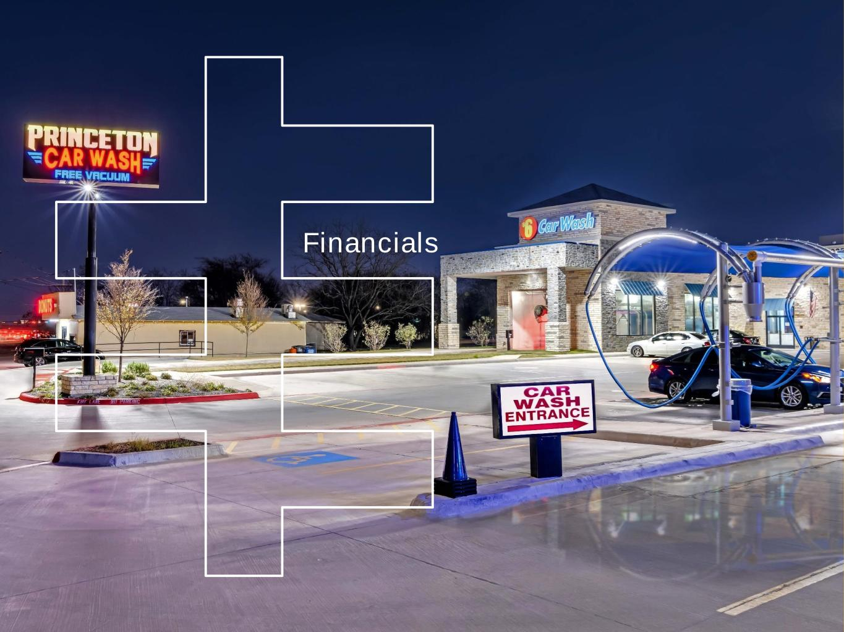
Financials

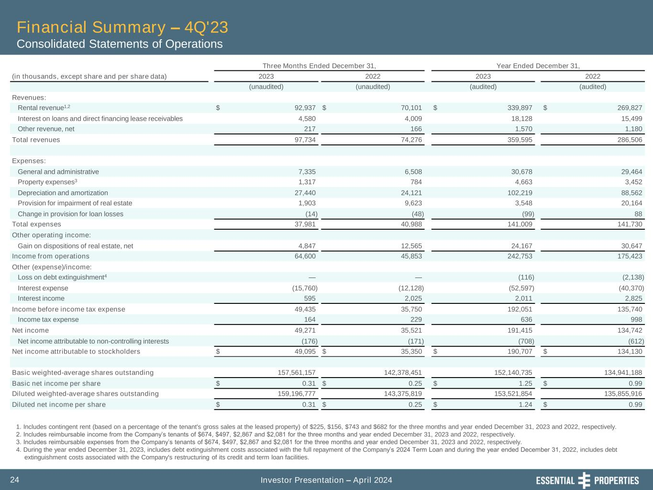
Investor Presentation – April 202424 Financial Summary – 4Q'23 Consolidated Statements of Operations Three Months Ended December 31, Year Ended December 31, (in thousands, except share and per share data) 2023 2022 2023 2022 (unaudited) (unaudited) (audited) (audited) Revenues: Rental revenue1,2 $ 92,937 $ 70,101 $ 339,897 $ 269,827 Interest on loans and direct financing lease receivables 4,580 4,009 18,128 15,499 Other revenue, net 217 166 1,570 1,180 Total revenues 97,734 74,276 359,595 286,506 Expenses: General and administrative 7,335 6,508 30,678 29,464 Property expenses3 1,317 784 4,663 3,452 Depreciation and amortization 27,440 24,121 102,219 88,562 Provision for impairment of real estate 1,903 9,623 3,548 20,164 Change in provision for loan losses (14) (48) (99) 88 Total expenses 37,981 40,988 141,009 141,730 Other operating income: Gain on dispositions of real estate, net 4,847 12,565 24,167 30,647 Income from operations 64,600 45,853 242,753 175,423 Other (expense)/income: Loss on debt extinguishment4 — — (116) (2,138) Interest expense (15,760) (12,128) (52,597) (40,370) Interest income 595 2,025 2,011 2,825 Income before income tax expense 49,435 35,750 192,051 135,740 Income tax expense 164 229 636 998 Net income 49,271 35,521 191,415 134,742 Net income attributable to non-controlling interests (176) (171) (708) (612) Net income attributable to stockholders $ 49,095 $ 35,350 $ 190,707 $ 134,130 Basic weighted-average shares outstanding 157,561,157 142,378,451 152,140,735 134,941,188 Basic net income per share $ 0.31 $ 0.25 $ 1.25 $ 0.99 Diluted weighted-average shares outstanding 159,196,777 143,375,819 153,521,854 135,855,916 Diluted net income per share $ 0.31 $ 0.25 $ 1.24 $ 0.99 1. Includes contingent rent (based on a percentage of the tenant's gross sales at the leased property) of $225, $156, $743 and $682 for the three months and year ended December 31, 2023 and 2022, respectively. 2. Includes reimbursable income from the Company’s tenants of $674, $497, $2,867 and $2,081 for the three months and year ended December 31, 2023 and 2022, respectively. 3. Includes reimbursable expenses from the Company’s tenants of $674, $497, $2,867 and $2,081 for the three months and year ended December 31, 2023 and 2022, respectively. 4. During the year ended December 31, 2023, includes debt extinguishment costs associated with the full repayment of the Company’s 2024 Term Loan and during the year ended December 31, 2022, includes debt extinguishment costs associated with the Company's restructuring of its credit and term loan facilities.

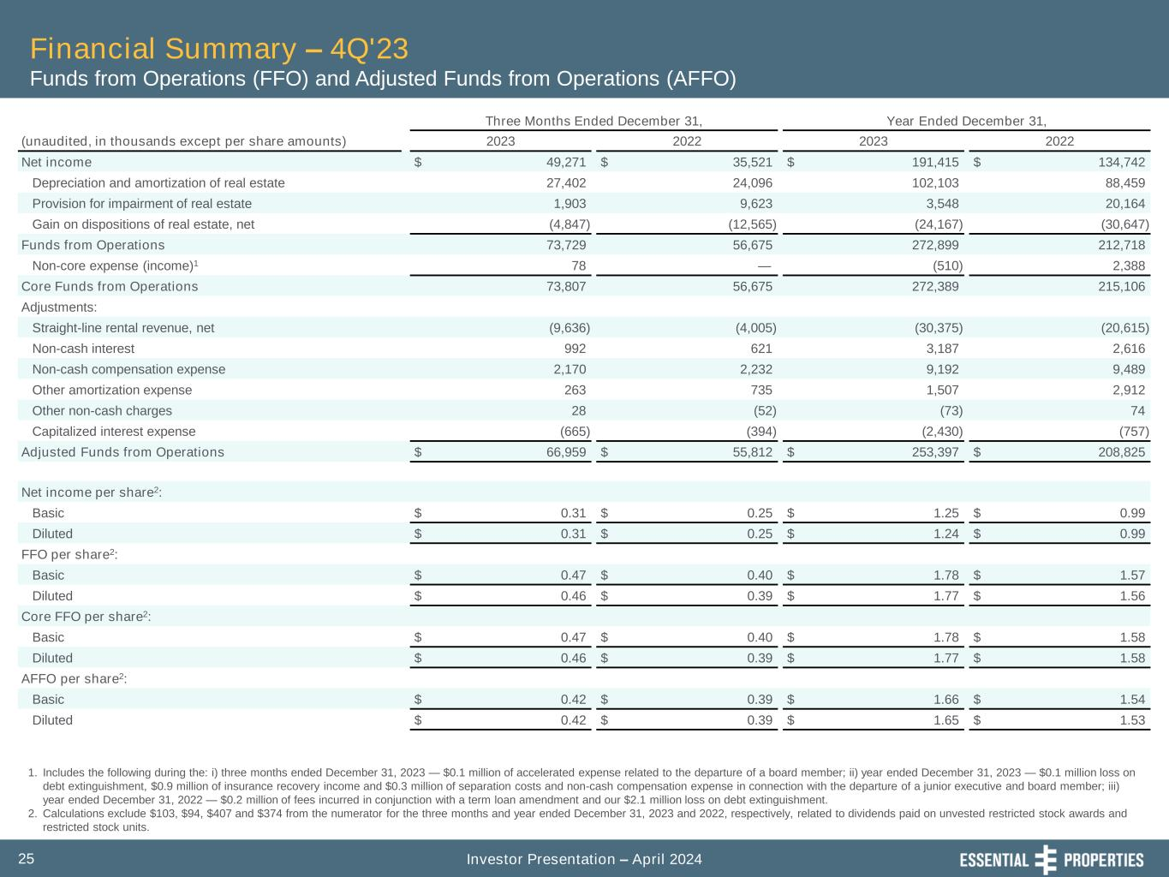
Investor Presentation – April 202425 Financial Summary – 4Q'23 Funds from Operations (FFO) and Adjusted Funds from Operations (AFFO) Three Months Ended December 31, Year Ended December 31, (unaudited, in thousands except per share amounts) 2023 2022 2023 2022 Net income $ 49,271 $ 35,521 $ 191,415 $ 134,742 Depreciation and amortization of real estate 27,402 24,096 102,103 88,459 Provision for impairment of real estate 1,903 9,623 3,548 20,164 Gain on dispositions of real estate, net (4,847) (12,565) (24,167) (30,647) Funds from Operations 73,729 56,675 272,899 212,718 Non-core expense (income)1 78 — (510) 2,388 Core Funds from Operations 73,807 56,675 272,389 215,106 Adjustments: Straight-line rental revenue, net (9,636) (4,005) (30,375) (20,615) Non-cash interest 992 621 3,187 2,616 Non-cash compensation expense 2,170 2,232 9,192 9,489 Other amortization expense 263 735 1,507 2,912 Other non-cash charges 28 (52) (73) 74 Capitalized interest expense (665) (394) (2,430) (757) Adjusted Funds from Operations $ 66,959 $ 55,812 $ 253,397 $ 208,825 Net income per share2: Basic $ 0.31 $ 0.25 $ 1.25 $ 0.99 Diluted $ 0.31 $ 0.25 $ 1.24 $ 0.99 FFO per share2: Basic $ 0.47 $ 0.40 $ 1.78 $ 1.57 Diluted $ 0.46 $ 0.39 $ 1.77 $ 1.56 Core FFO per share2: Basic $ 0.47 $ 0.40 $ 1.78 $ 1.58 Diluted $ 0.46 $ 0.39 $ 1.77 $ 1.58 AFFO per share2: Basic $ 0.42 $ 0.39 $ 1.66 $ 1.54 Diluted $ 0.42 $ 0.39 $ 1.65 $ 1.53 1. Includes the following during the: i) three months ended December 31, 2023 — $0.1 million of accelerated expense related to the departure of a board member; ii) year ended December 31, 2023 — $0.1 million loss on debt extinguishment, $0.9 million of insurance recovery income and $0.3 million of separation costs and non-cash compensation expense in connection with the departure of a junior executive and board member; iii) year ended December 31, 2022 — $0.2 million of fees incurred in conjunction with a term loan amendment and our $2.1 million loss on debt extinguishment. 2. Calculations exclude $103, $94, $407 and $374 from the numerator for the three months and year ended December 31, 2023 and 2022, respectively, related to dividends paid on unvested restricted stock awards and restricted stock units.

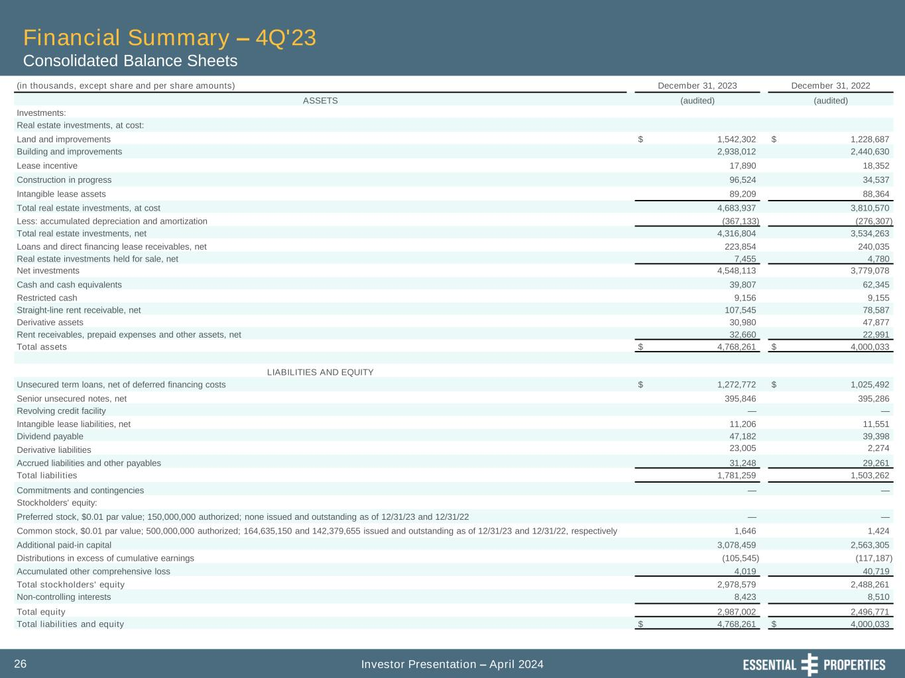
Investor Presentation – April 202426 Financial Summary – 4Q'23 Consolidated Balance Sheets (in thousands, except share and per share amounts) December 31, 2023 December 31, 2022 ASSETS (audited) (audited) Investments: Real estate investments, at cost: Land and improvements $ 1,542,302 $ 1,228,687 Building and improvements 2,938,012 2,440,630 Lease incentive 17,890 18,352 Construction in progress 96,524 34,537 Intangible lease assets 89,209 88,364 Total real estate investments, at cost 4,683,937 3,810,570 Less: accumulated depreciation and amortization (367,133) (276,307) Total real estate investments, net 4,316,804 3,534,263 Loans and direct financing lease receivables, net 223,854 240,035 Real estate investments held for sale, net 7,455 4,780 Net investments 4,548,113 3,779,078 Cash and cash equivalents 39,807 62,345 Restricted cash 9,156 9,155 Straight-line rent receivable, net 107,545 78,587 Derivative assets 30,980 47,877 Rent receivables, prepaid expenses and other assets, net 32,660 22,991 Total assets $ 4,768,261 $ 4,000,033 LIABILITIES AND EQUITY Unsecured term loans, net of deferred financing costs $ 1,272,772 $ 1,025,492 Senior unsecured notes, net 395,846 395,286 Revolving credit facility — — Intangible lease liabilities, net 11,206 11,551 Dividend payable 47,182 39,398 Derivative liabilities 23,005 2,274 Accrued liabilities and other payables 31,248 29,261 Total liabilities 1,781,259 1,503,262 Commitments and contingencies — — Stockholders' equity: Preferred stock, $0.01 par value; 150,000,000 authorized; none issued and outstanding as of 12/31/23 and 12/31/22 — — Common stock, $0.01 par value; 500,000,000 authorized; 164,635,150 and 142,379,655 issued and outstanding as of 12/31/23 and 12/31/22, respectively 1,646 1,424 Additional paid-in capital 3,078,459 2,563,305 Distributions in excess of cumulative earnings (105,545) (117,187) Accumulated other comprehensive loss 4,019 40,719 Total stockholders' equity 2,978,579 2,488,261 Non-controlling interests 8,423 8,510 Total equity 2,987,002 2,496,771 Total liabilities and equity $ 4,768,261 $ 4,000,033

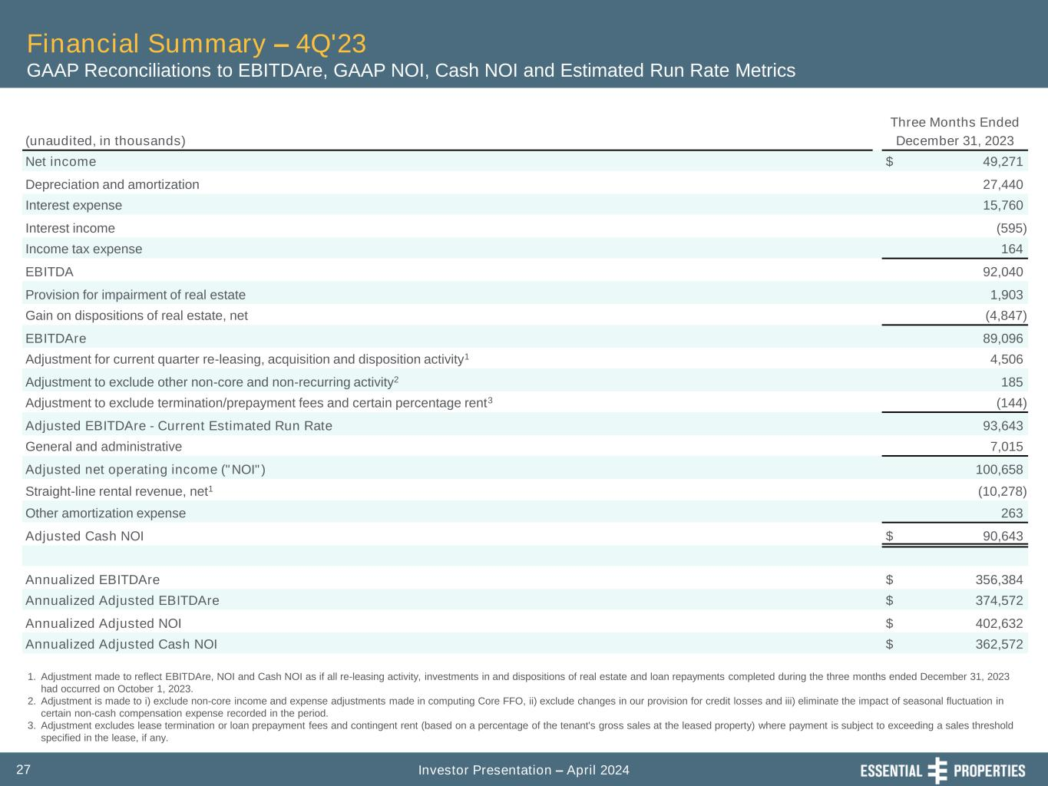
Investor Presentation – April 202427 Financial Summary – 4Q'23 GAAP Reconciliations to EBITDAre, GAAP NOI, Cash NOI and Estimated Run Rate Metrics Three Months Ended (unaudited, in thousands) December 31, 2023 Net income $ 49,271 Depreciation and amortization 27,440 Interest expense 15,760 Interest income (595) Income tax expense 164 EBITDA 92,040 Provision for impairment of real estate 1,903 Gain on dispositions of real estate, net (4,847) EBITDAre 89,096 Adjustment for current quarter re-leasing, acquisition and disposition activity1 4,506 Adjustment to exclude other non-core and non-recurring activity2 185 Adjustment to exclude termination/prepayment fees and certain percentage rent3 (144) Adjusted EBITDAre - Current Estimated Run Rate 93,643 General and administrative 7,015 Adjusted net operating income ("NOI") 100,658 Straight-line rental revenue, net1 (10,278) Other amortization expense 263 Adjusted Cash NOI $ 90,643 Annualized EBITDAre $ 356,384 Annualized Adjusted EBITDAre $ 374,572 Annualized Adjusted NOI $ 402,632 Annualized Adjusted Cash NOI $ 362,572 1. Adjustment made to reflect EBITDAre, NOI and Cash NOI as if all re-leasing activity, investments in and dispositions of real estate and loan repayments completed during the three months ended December 31, 2023 had occurred on October 1, 2023. 2. Adjustment is made to i) exclude non-core income and expense adjustments made in computing Core FFO, ii) exclude changes in our provision for credit losses and iii) eliminate the impact of seasonal fluctuation in certain non-cash compensation expense recorded in the period. 3. Adjustment excludes lease termination or loan prepayment fees and contingent rent (based on a percentage of the tenant's gross sales at the leased property) where payment is subject to exceeding a sales threshold specified in the lease, if any.

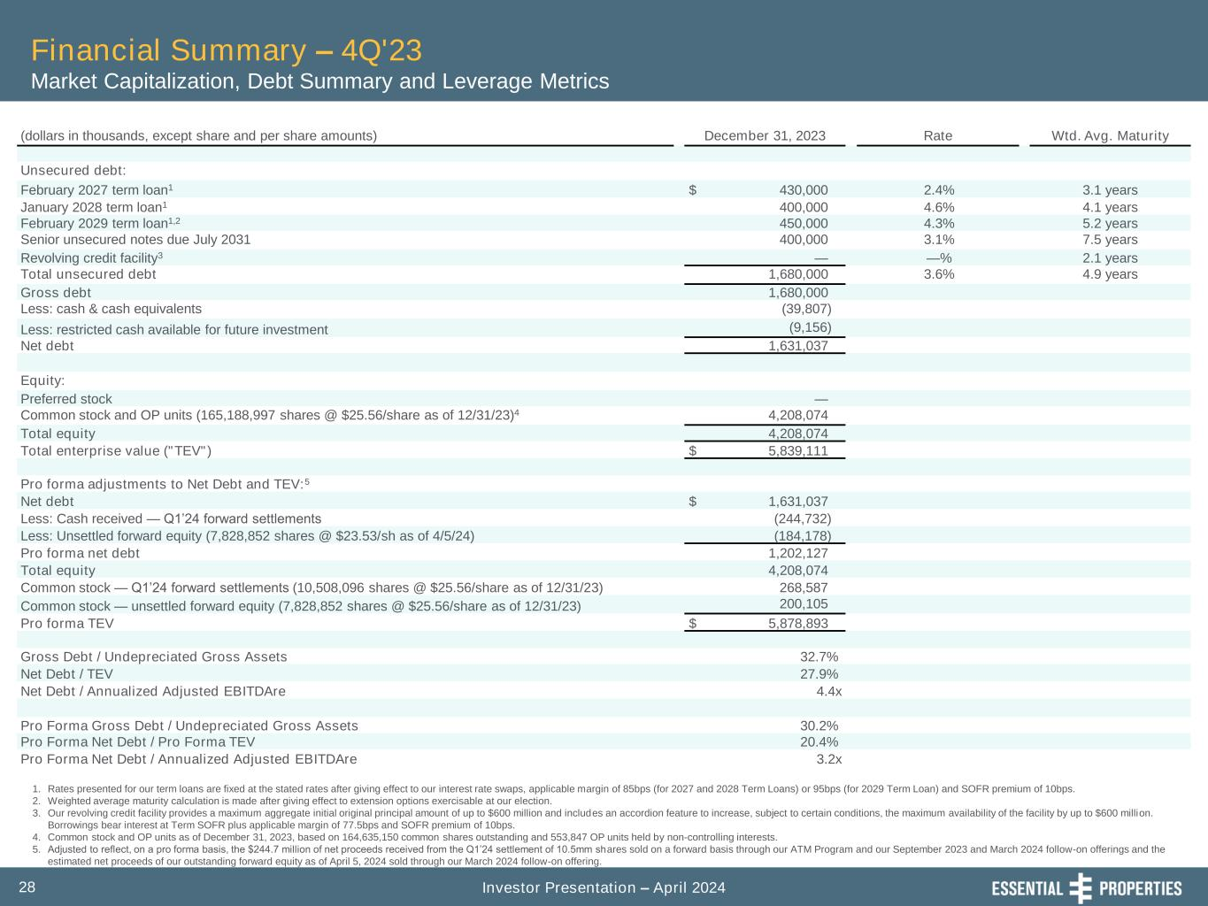
Investor Presentation – April 202428 Financial Summary – 4Q'23 Market Capitalization, Debt Summary and Leverage Metrics 1. Rates presented for our term loans are fixed at the stated rates after giving effect to our interest rate swaps, applicable margin of 85bps (for 2027 and 2028 Term Loans) or 95bps (for 2029 Term Loan) and SOFR premium of 10bps. 2. Weighted average maturity calculation is made after giving effect to extension options exercisable at our election. 3. Our revolving credit facility provides a maximum aggregate initial original principal amount of up to $600 million and includes an accordion feature to increase, subject to certain conditions, the maximum availability of the facility by up to $600 million. Borrowings bear interest at Term SOFR plus applicable margin of 77.5bps and SOFR premium of 10bps. 4. Common stock and OP units as of December 31, 2023, based on 164,635,150 common shares outstanding and 553,847 OP units held by non-controlling interests. 5. Adjusted to reflect, on a pro forma basis, the $244.7 million of net proceeds received from the Q1’24 settlement of 10.5mm shares sold on a forward basis through our ATM Program and our September 2023 and March 2024 follow-on offerings and the estimated net proceeds of our outstanding forward equity as of April 5, 2024 sold through our March 2024 follow-on offering. (dollars in thousands, except share and per share amounts) December 31, 2023 Rate Wtd. Avg. Maturity Unsecured debt: February 2027 term loan1 $ 430,000 2.4% 3.1 years January 2028 term loan1 400,000 4.6% 4.1 years February 2029 term loan1,2 450,000 4.3% 5.2 years Senior unsecured notes due July 2031 400,000 3.1% 7.5 years Revolving credit facility3 — —% 2.1 years Total unsecured debt 1,680,000 3.6% 4.9 years Gross debt 1,680,000 Less: cash & cash equivalents (39,807) Less: restricted cash available for future investment (9,156) Net debt 1,631,037 Equity: Preferred stock — Common stock and OP units (165,188,997 shares @ $25.56/share as of 12/31/23)4 4,208,074 Total equity 4,208,074 Total enterprise value ("TEV") $ 5,839,111 Pro forma adjustments to Net Debt and TEV:5 Net debt $ 1,631,037 Less: Cash received — Q1’24 forward settlements (244,732) Less: Unsettled forward equity (7,828,852 shares @ $23.53/sh as of 4/5/24) (184,178) Pro forma net debt 1,202,127 Total equity 4,208,074 Common stock — Q1’24 forward settlements (10,508,096 shares @ $25.56/share as of 12/31/23) 268,587 Common stock — unsettled forward equity (7,828,852 shares @ $25.56/share as of 12/31/23) 200,105 Pro forma TEV $ 5,878,893 Gross Debt / Undepreciated Gross Assets 32.7% Net Debt / TEV 27.9% Net Debt / Annualized Adjusted EBITDAre 4.4x Pro Forma Gross Debt / Undepreciated Gross Assets 30.2% Pro Forma Net Debt / Pro Forma TEV 20.4% Pro Forma Net Debt / Annualized Adjusted EBITDAre 3.2x

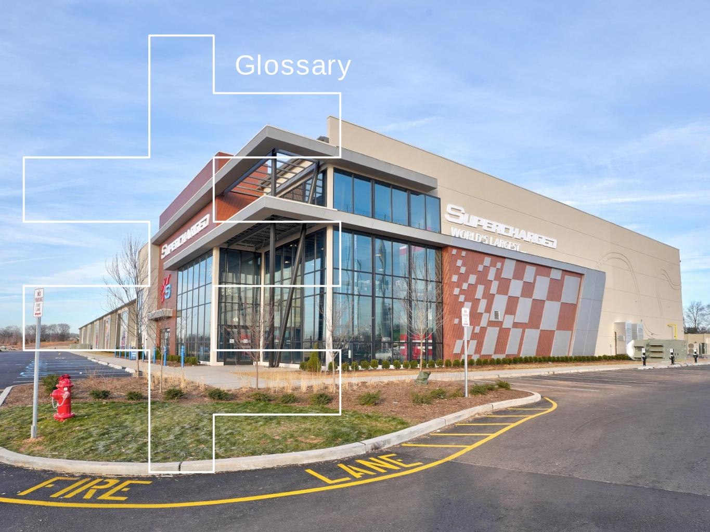
Glossary

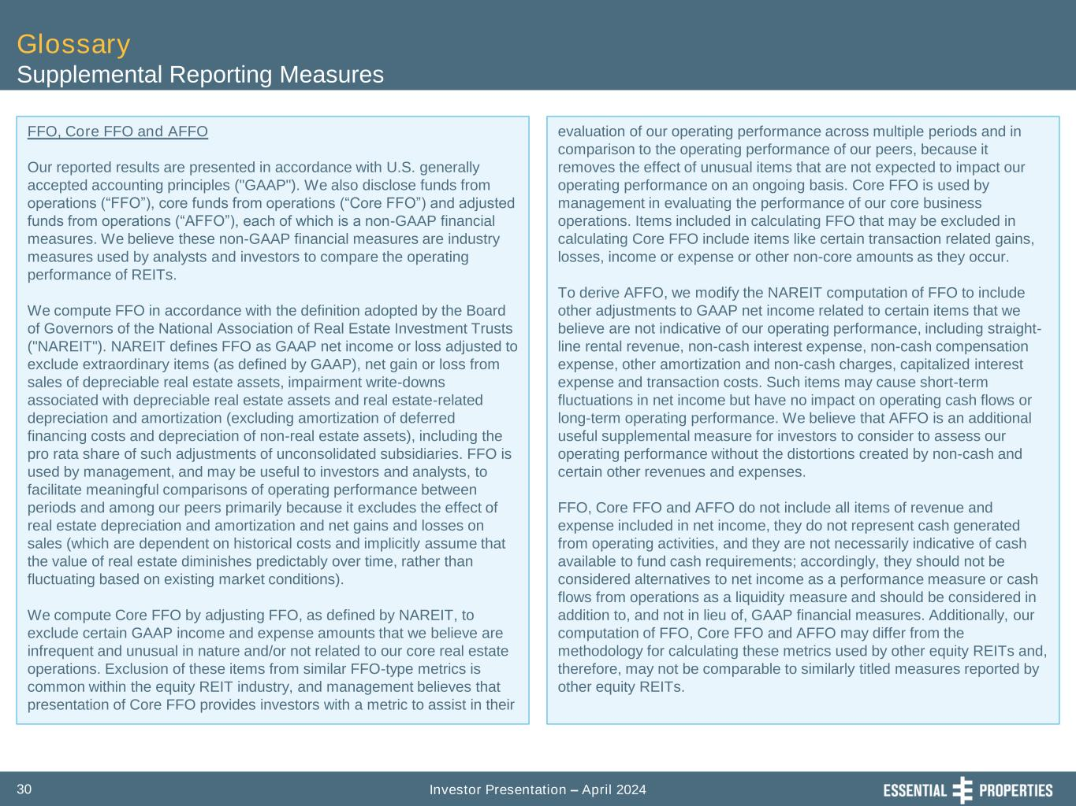
Investor Presentation – April 202430 Glossary Supplemental Reporting Measures FFO, Core FFO and AFFO Our reported results are presented in accordance with U.S. generally accepted accounting principles ("GAAP"). We also disclose funds from operations (“FFO”), core funds from operations (“Core FFO”) and adjusted funds from operations (“AFFO”), each of which is a non-GAAP financial measures. We believe these non-GAAP financial measures are industry measures used by analysts and investors to compare the operating performance of REITs. We compute FFO in accordance with the definition adopted by the Board of Governors of the National Association of Real Estate Investment Trusts ("NAREIT"). NAREIT defines FFO as GAAP net income or loss adjusted to exclude extraordinary items (as defined by GAAP), net gain or loss from sales of depreciable real estate assets, impairment write-downs associated with depreciable real estate assets and real estate-related depreciation and amortization (excluding amortization of deferred financing costs and depreciation of non-real estate assets), including the pro rata share of such adjustments of unconsolidated subsidiaries. FFO is used by management, and may be useful to investors and analysts, to facilitate meaningful comparisons of operating performance between periods and among our peers primarily because it excludes the effect of real estate depreciation and amortization and net gains and losses on sales (which are dependent on historical costs and implicitly assume that the value of real estate diminishes predictably over time, rather than fluctuating based on existing market conditions). We compute Core FFO by adjusting FFO, as defined by NAREIT, to exclude certain GAAP income and expense amounts that we believe are infrequent and unusual in nature and/or not related to our core real estate operations. Exclusion of these items from similar FFO-type metrics is common within the equity REIT industry, and management believes that presentation of Core FFO provides investors with a metric to assist in their evaluation of our operating performance across multiple periods and in comparison to the operating performance of our peers, because it removes the effect of unusual items that are not expected to impact our operating performance on an ongoing basis. Core FFO is used by management in evaluating the performance of our core business operations. Items included in calculating FFO that may be excluded in calculating Core FFO include items like certain transaction related gains, losses, income or expense or other non-core amounts as they occur. To derive AFFO, we modify the NAREIT computation of FFO to include other adjustments to GAAP net income related to certain items that we believe are not indicative of our operating performance, including straight- line rental revenue, non-cash interest expense, non-cash compensation expense, other amortization and non-cash charges, capitalized interest expense and transaction costs. Such items may cause short-term fluctuations in net income but have no impact on operating cash flows or long-term operating performance. We believe that AFFO is an additional useful supplemental measure for investors to consider to assess our operating performance without the distortions created by non-cash and certain other revenues and expenses. FFO, Core FFO and AFFO do not include all items of revenue and expense included in net income, they do not represent cash generated from operating activities, and they are not necessarily indicative of cash available to fund cash requirements; accordingly, they should not be considered alternatives to net income as a performance measure or cash flows from operations as a liquidity measure and should be considered in addition to, and not in lieu of, GAAP financial measures. Additionally, our computation of FFO, Core FFO and AFFO may differ from the methodology for calculating these metrics used by other equity REITs and, therefore, may not be comparable to similarly titled measures reported by other equity REITs.

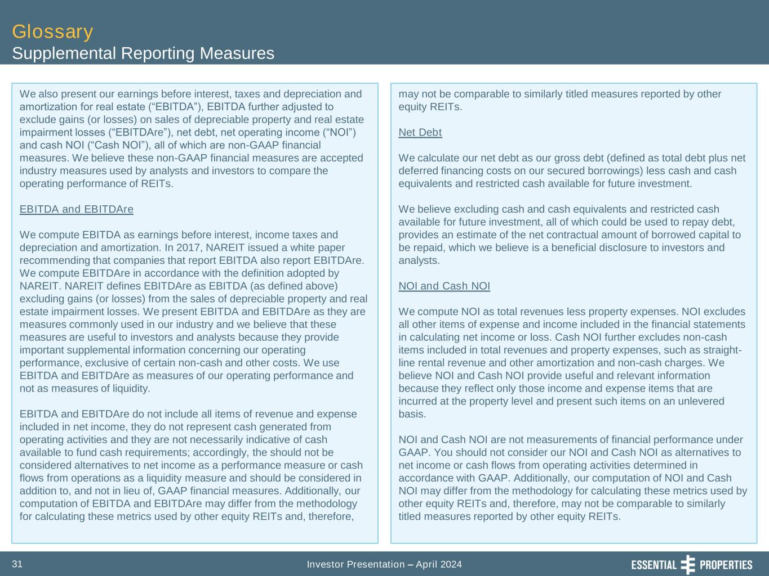
Investor Presentation – April 202431 Glossary Supplemental Reporting Measures We also present our earnings before interest, taxes and depreciation and amortization for real estate (“EBITDA”), EBITDA further adjusted to exclude gains (or losses) on sales of depreciable property and real estate impairment losses (“EBITDAre”), net debt, net operating income (“NOI”) and cash NOI (“Cash NOI”), all of which are non-GAAP financial measures. We believe these non-GAAP financial measures are accepted industry measures used by analysts and investors to compare the operating performance of REITs. EBITDA and EBITDAre We compute EBITDA as earnings before interest, income taxes and depreciation and amortization. In 2017, NAREIT issued a white paper recommending that companies that report EBITDA also report EBITDAre. We compute EBITDAre in accordance with the definition adopted by NAREIT. NAREIT defines EBITDAre as EBITDA (as defined above) excluding gains (or losses) from the sales of depreciable property and real estate impairment losses. We present EBITDA and EBITDAre as they are measures commonly used in our industry and we believe that these measures are useful to investors and analysts because they provide important supplemental information concerning our operating performance, exclusive of certain non-cash and other costs. We use EBITDA and EBITDAre as measures of our operating performance and not as measures of liquidity. EBITDA and EBITDAre do not include all items of revenue and expense included in net income, they do not represent cash generated from operating activities and they are not necessarily indicative of cash available to fund cash requirements; accordingly, the should not be considered alternatives to net income as a performance measure or cash flows from operations as a liquidity measure and should be considered in addition to, and not in lieu of, GAAP financial measures. Additionally, our computation of EBITDA and EBITDAre may differ from the methodology for calculating these metrics used by other equity REITs and, therefore, may not be comparable to similarly titled measures reported by other equity REITs. Net Debt We calculate our net debt as our gross debt (defined as total debt plus net deferred financing costs on our secured borrowings) less cash and cash equivalents and restricted cash available for future investment. We believe excluding cash and cash equivalents and restricted cash available for future investment, all of which could be used to repay debt, provides an estimate of the net contractual amount of borrowed capital to be repaid, which we believe is a beneficial disclosure to investors and analysts. NOI and Cash NOI We compute NOI as total revenues less property expenses. NOI excludes all other items of expense and income included in the financial statements in calculating net income or loss. Cash NOI further excludes non-cash items included in total revenues and property expenses, such as straight- line rental revenue and other amortization and non-cash charges. We believe NOI and Cash NOI provide useful and relevant information because they reflect only those income and expense items that are incurred at the property level and present such items on an unlevered basis. NOI and Cash NOI are not measurements of financial performance under GAAP. You should not consider our NOI and Cash NOI as alternatives to net income or cash flows from operating activities determined in accordance with GAAP. Additionally, our computation of NOI and Cash NOI may differ from the methodology for calculating these metrics used by other equity REITs and, therefore, may not be comparable to similarly titled measures reported by other equity REITs.

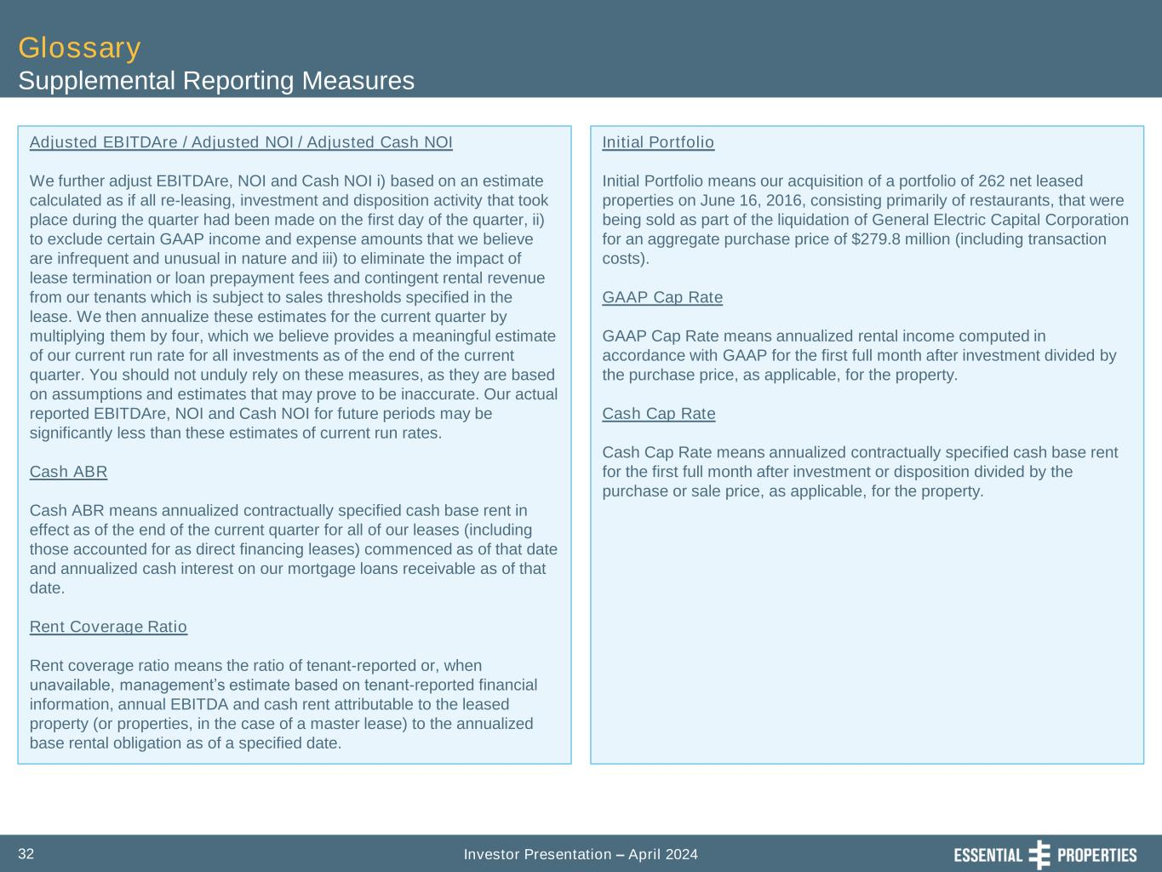
Investor Presentation – April 202432 Glossary Supplemental Reporting Measures Adjusted EBITDAre / Adjusted NOI / Adjusted Cash NOI We further adjust EBITDAre, NOI and Cash NOI i) based on an estimate calculated as if all re-leasing, investment and disposition activity that took place during the quarter had been made on the first day of the quarter, ii) to exclude certain GAAP income and expense amounts that we believe are infrequent and unusual in nature and iii) to eliminate the impact of lease termination or loan prepayment fees and contingent rental revenue from our tenants which is subject to sales thresholds specified in the lease. We then annualize these estimates for the current quarter by multiplying them by four, which we believe provides a meaningful estimate of our current run rate for all investments as of the end of the current quarter. You should not unduly rely on these measures, as they are based on assumptions and estimates that may prove to be inaccurate. Our actual reported EBITDAre, NOI and Cash NOI for future periods may be significantly less than these estimates of current run rates. Cash ABR Cash ABR means annualized contractually specified cash base rent in effect as of the end of the current quarter for all of our leases (including those accounted for as direct financing leases) commenced as of that date and annualized cash interest on our mortgage loans receivable as of that date. Rent Coverage Ratio Rent coverage ratio means the ratio of tenant-reported or, when unavailable, management’s estimate based on tenant-reported financial information, annual EBITDA and cash rent attributable to the leased property (or properties, in the case of a master lease) to the annualized base rental obligation as of a specified date. Initial Portfolio Initial Portfolio means our acquisition of a portfolio of 262 net leased properties on June 16, 2016, consisting primarily of restaurants, that were being sold as part of the liquidation of General Electric Capital Corporation for an aggregate purchase price of $279.8 million (including transaction costs). GAAP Cap Rate GAAP Cap Rate means annualized rental income computed in accordance with GAAP for the first full month after investment divided by the purchase price, as applicable, for the property. Cash Cap Rate Cash Cap Rate means annualized contractually specified cash base rent for the first full month after investment or disposition divided by the purchase or sale price, as applicable, for the property.

