UNITED STATES
SECURITIES AND EXCHANGE COMMISSION
WASHINGTON, D.C. 20549

SCHEDULE 14A
Proxy Statement Pursuant to Section 14(a) of the
Securities Exchange Act of 1934 (Amendment No. )-

Filed by the Registrant ☒
Filed by a Party other than the Registrant ☐
Check the appropriate box:

☐ |  | Preliminary Proxy Statement
☐ |  | Confidential, for Use of the Commission Only (as permitted by Rule 14a-6(e)(2))
☐ |  | Definitive Proxy Statement
☒ |  | Definitive Additional Materials
☐ |  | Soliciting Material under Rule 14a-12
ESSENTIAL PROPERTIES REALTY TRUST, INC.
(Name of Registrant as Specified in its Charter)
Not applicable.
(Name of Person(s) Filing Proxy Statement, if other than the Registrant)
Payment of Filing Fee (Check the appropriate box):

☒ |  | No fee required.
☐ |  | Fee paid previously with preliminary materials.
☐ |  | Fee computed on table in exhibit required by Item 25(b) per Exchange Act Rules 14a-6(i)(1) and 0-11.

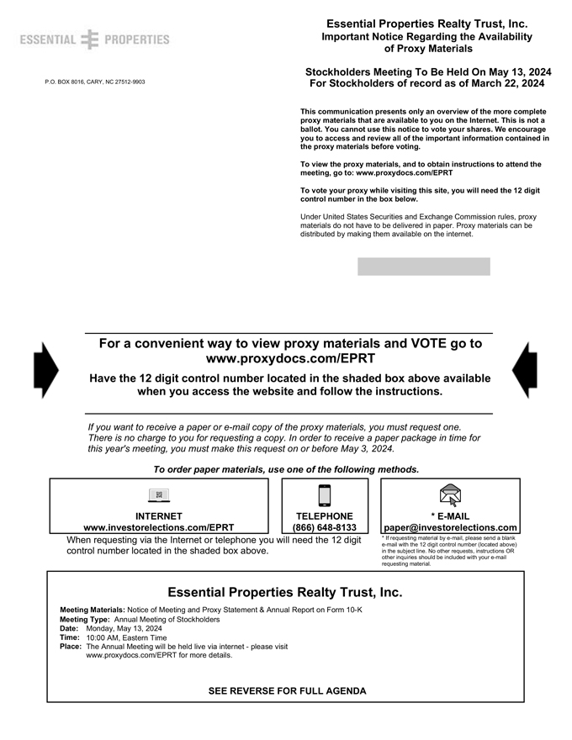
ESSENTIAL PROPERTIES P.O. BOX 8016, CARY, NC 27512-9903 Essential Properties Realty Trust, Inc. Important Notice Regarding the Availability of Proxy Materials Stockholders Meeting To Be Held On May 13, 2024 For Stockholders of record as of March 22, 2024 This communication presents only an overview of the more complete proxy materials that are available to you on the Internet. This is not a ballot. You cannot use this notice to vote your shares. We encourage you to access and review all of the important information contained in the proxy materials before voting. To view the proxy materials, and to obtain instructions to attend the meeting, go to: www.proxydocs.com/EPRT To vote your proxy while visiting this site, you will need the 12 digit control number in the box below. Under United States Securities and Exchange Commission rules, proxy materials do not have to be delivered in paper. Proxy materials can be distributed by making them available on the internet. For a convenient way to view proxy materials and VOTE go to www.proxydocs.com/EPRT Have the 12 digit control number located in the shaded box above available when you access the website and follow the instructions. If you want to receive a paper or e-mail copy of the proxy materials, you must request one. There is no charge to you for requesting a copy. In order to receive a paper package in time for this year’s meeting, you must make this request on or before May 3, 2024. To order paper materials, use one of the following methods. INTERNET www.investorelections.com/EPRT TELEPHONE (866) 648-8133 * E-MAIL paper@investorelections.com When requesting via the Internet or telephone you will need the 12 digit control number located in the shaded box above. * If requesting material by e-mail, please send a blank e-mail with the 12 digit control number (located above) in the subject line. No other requests, instructions OR other inquiries should be included with your e-mail requesting material. Essential Properties Realty Trust, Inc. Meeting Materials: Notice of Meeting and Proxy Statement & Annual Report on Form 10-K Meeting Type: Annual Meeting of Stockholders Date: Monday, May 13, 2024 Time: 10:00 AM, Eastern Time Place: The Annual Meeting will be held live via internet - please visit www.proxydocs.com/EPRT for more details. SEE REVERSE FOR FULL AGENDA

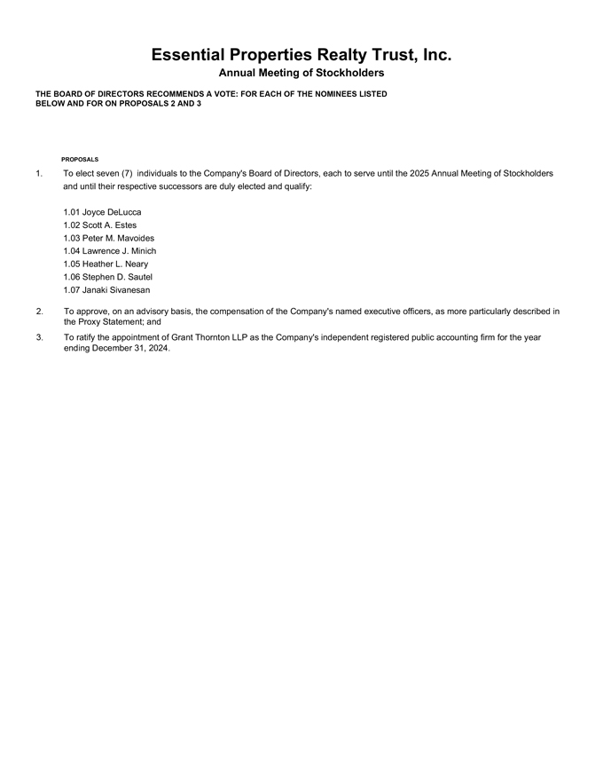
Essential Properties Realty Trust, Inc. Annual Meeting of Stockholders THE BOARD OF DIRECTORS RECOMMENDS A VOTE: FOR EACH OF THE NOMINEES LISTED BELOW AND FOR ON PROPOSALS 2 AND 3 PROPOSALS 1. To elect seven (7) individuals to the Company’s Board of Directors, each to serve until the 2025 Annual Meeting of Stockholders and until their respective successors are duly elected and qualify: 1.01 Joyce DeLucca 1.02 Scott A. Estes 1.03 Peter M. Mavoides 1.04 Lawrence J. Minich 1.05 Heather L. Neary 1.06 Stephen D. Sautel 1.07 Janaki Sivanesan 2. To approve, on an advisory basis, the compensation of the Company’s named executive officers, as more particularly described in the Proxy Statement; and 3. To ratify the appointment of Grant Thornton LLP as the Company’s independent registered public accounting firm for the year ending December 31, 2024.

