UNITED STATES
SECURITIES AND EXCHANGE COMMISSION
WASHINGTON, D.C. 20549

SCHEDULE 14A
Proxy Statement Pursuant to Section 14(a) of the
Securities Exchange Act of 1934 (Amendment No. )-

Filed by the Registrant ☒
Filed by a Party other than the Registrant ☐
Check the appropriate box:

☐ |  | Preliminary Proxy Statement
☐ |  | Confidential, for Use of the Commission Only (as permitted by Rule 14a-6(e)(2))
☐ |  | Definitive Proxy Statement
☒ |  | Definitive Additional Materials
☐ |  | Soliciting Material under Rule 14a-12
ESSENTIAL PROPERTIES REALTY TRUST, INC.
(Name of Registrant as Specified in its Charter)
Not applicable.
(Name of Person(s) Filing Proxy Statement, if other than the Registrant)
Payment of Filing Fee (Check the appropriate box):

☒ |  | No fee required.
☐ |  | Fee paid previously with preliminary materials.
☐ |  | Fee computed on table in exhibit required by Item 25(b) per Exchange Act Rules 14a-6(i)(1) and 0-11.

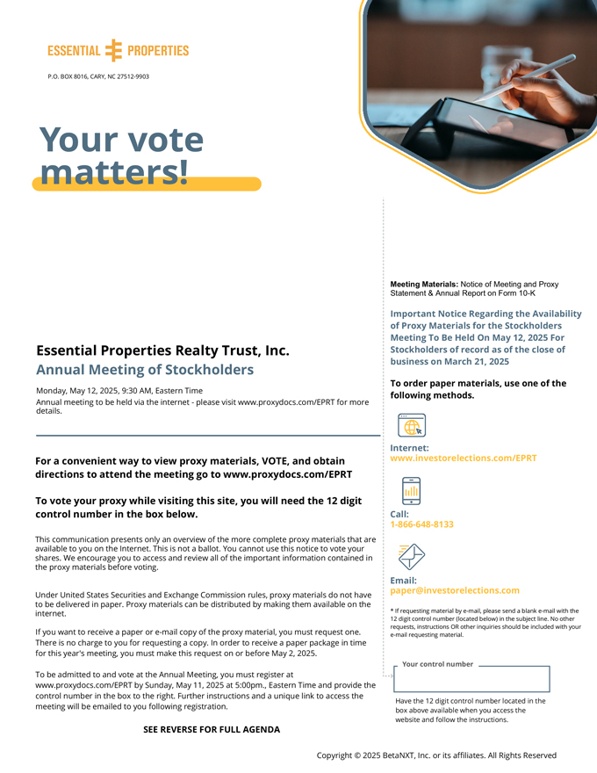
P.O. BOX 8016, CARY, NC 27512-9903 Meeting Materials: Notice of Meeting and Proxy Statement & Annual Report on Form 10-K Important Notice Regarding the Availability of Proxy Materials for the Stockholders Meeting To Be Held On May 12, 2025 For Essential Properties Realty Trust, Inc. Stockholders of record as of the close of business on March 21, 2025 Annual Meeting of Stockholders To order paper materials, use one of the Monday, May 12, 2025, 9:30 AM, Eastern Time following methods. Annual meeting to be held via the internet - please visit www.proxydocs.com/EPRT for more details. Internet: For a convenient way to view proxy materials, VOTE, and obtain www.investorelections.com/EPRT directions to attend the meeting go to www.proxydocs.com/EPRT To vote your proxy while visiting this site, you will need the 12 digit control number in the box below. Call: 1-866-648-8133 This communication presents only an overview of the more complete proxy materials that are available to you on the Internet. This is not a ballot. You cannot use this notice to vote your shares. We encourage you to access and review all of the important information contained in the proxy materials before voting. Email: paper@investorelections.com Under United States Securities and Exchange Commission rules, proxy materials do not have to be delivered in paper. Proxy materials can be distributed by making them available on the * If requesting material by e-mail, please send a blank e-mail with the internet. 12 digit control number (located below) in the subject line. No other requests, instructions OR other inquiries should be included with your If you want to receive a paper or e-mail copy of the proxy material, you must request one. e-mail requesting material. There is no charge to you for requesting a copy. In order to receive a paper package in time for this year’s meeting, you must make this request on or before May 2, 2025. Your control number To be admitted to and vote at the Annual Meeting, you must register at www.proxydocs.com/EPRT by Sunday, May 11, 2025 at 5:00pm., Eastern Time and provide the control number in the box to the right. Further instructions and a unique link to access the Have the 12 digit control number located in the meeting will be emailed to you following registration. box above available when you access the website and follow the instructions. 844831-001 SEE REVERSE 31Mar25FOR FULL AGENDA16:07 Page 1 Copyright © 2025 BetaNXT, Inc. or its affiliates. All Rights Reserved

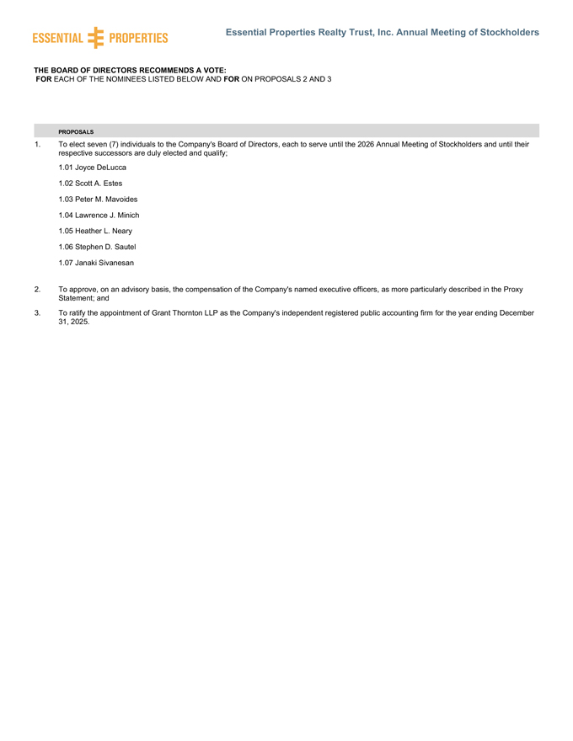
Essential Properties Realty Trust, Inc. Annual Meeting of Stockholders THE BOARD OF DIRECTORS RECOMMENDS A VOTE: FOR EACH OF THE NOMINEES LISTED BELOW AND FOR ON PROPOSALS 2 AND 3 PROPOSALS 1. To elect seven (7) individuals to the Company’s Board of Directors, each to serve until the 2026 Annual Meeting of Stockholders and until their respective successors are duly elected and qualify; 1.01 Joyce DeLucca 1.02 Scott A. Estes 1.03 Peter M. Mavoides 1.04 Lawrence J. Minich 1.05 Heather L. Neary 1.06 Stephen D. Sautel 1.07 Janaki Sivanesan 2. To approve, on an advisory basis, the compensation of the Company’s named executive officers, as more particularly described in the Proxy Statement; and 3. To ratify the appointment of Grant Thornton LLP as the Company’s independent registered public accounting firm for the year ending December 31, 2025.

