UNITED STATES
SECURITIES AND EXCHANGE COMMISSION
Washington, D.C. 20549

FORM 8-K

CURRENT REPORT

Pursuant to Section 13 or 15(d)
of the Securities Exchange Act of 1934

April 24, 2024
Date of Report (Date of earliest event reported)

Essential Properties Realty Trust, Inc.
(Exact name of registrant as specified in its charter)

Maryland |  |  |  |  |  | 001-38530 |  |  |  |  |  | 82-4005693
(State or other jurisdiction of incorporation) |  |  |  |  |  | (Commission File Number) |  |  |  |  |  | (IRS Employer Identification No.)
902 Carnegie Center Blvd., Suite 520
Princeton, New Jersey |  |  |  |  |  |  |  |  |  |  |  | 08540
(Address of principal executive offices) |  |  |  |  |  |  |  |  |  |  |  | (Zip Code)
Registrant’s telephone number, including area code: |  |  |  |  |  |  |  |  |  |  |  | (609) 436-0619

Check the appropriate box below if the Form 8-K filing is intended to simultaneously satisfy the filing obligations of the registrant under any of the following provisions:
☐ |  |  | Written communications pursuant to Rule 425 under the Securities Act 17 CFR 230.425)
☐ |  |  | Soliciting material pursuant to Rule 14a-12 under the Exchange Act (17 CFR 240.14a-12)
☐ |  |  | Pre-commencement communications pursuant to Rule 14d-2(b) under the Exchange Act (17 CFR 240.14d-2(b))
☐ |  |  | Pre-commencement communications pursuant to Rule 13e-4(c) under the Exchange Act (17 CFR 240.13e-4(c))

Securities registered pursuant to Section 12(b) of the Act:
Title of Each Class |  |  |  |  |  | Trading Symbol(s) |  |  |  |  |  | Name of Each Exchange on Which Registered
Common stock, $0.01 par value |  |  |  |  |  | EPRT |  |  |  |  |  | New York Stock Exchange

Indicate by check mark whether the registrant is an emerging growth company as defined in Rule 405 of the Securities Act of 1933 (§230.405 of this chapter) or Rule 12b-2 of the Securities Exchange Act of 1934 (§240.12b-2 of this chapter).
Emerging growth company ☐

If an emerging growth company, indicate by check mark if the registrant has elected not to use the extended transition period for complying with any new or revised financial accounting standards provided pursuant to Section 13(a) of the Exchange Act ☐

Item 2.02 — Results of Operations and Financial Condition.
On April 24, 2024, Essential Properties Realty Trust, Inc. (the “Company”) issued a press release announcing the Company’s financial results for the three months ended March 31, 2024. The press release is furnished hereto as Exhibit 99.1 and incorporated herein by reference.

Item 7.01— Regulation FD Disclosure.
On April 24, 2024, the Company issued its Supplemental Operating & Financial Data—First Quarter Ended March 31, 2024. The Supplemental Operating & Financial Data is furnished hereto as Exhibit 99.2 and incorporated herein by reference.
The foregoing information is furnished pursuant to Item 2.02, “Results of Operations and Financial Condition,” and Item 7.01, “Regulation FD Disclosure.” The information in Items 2.02 and 7.01 of this Current Report on Form 8-K and the exhibits furnished therewith shall not be deemed “filed” for purposes of Section 18 of the Securities Exchange Act of 1934 or otherwise subject to the liabilities of that Section, and shall not be or be deemed to be incorporated by reference in any filing under the Securities Act of 1933 or the Securities Exchange Act of 1934, regardless of any general incorporation language in such filing.

Item 9.01 — Financial Statements and Exhibits.
(d) Exhibits.

Exhibit No. |  |  | Description
99.1 |  |  | Earnings Press Release dated April 24, 2024 for the quarter ended March 31, 2024
99.2 |  |  | Supplemental Operating & Financial Data—First Quarter Ended March 31, 2024
104 |  |  | Cover Page Interactive Data File (embedded within the Inline XBRL document)

SIGNATURES

Pursuant to the requirements of the Securities Exchange Act of 1934, the registrant has duly caused this report to be signed on its behalf by the undersigned hereunto duly authorized.

Date: April 24, 2024 |  |  | ESSENTIAL PROPERTIES REALTY TRUST, INC.
 |  |  | By: |  |  | /s/ Mark E. Patten
 |  |  |  |  |  | Mark E. Patten
 |  |  |  |  |  | Executive Vice President, Chief Financial Officer, Treasurer and Secretary

Exhibit 99.1

Essential Properties Announces First Quarter 2024 Results
- First Quarter Net Income per Share of $0.28 and AFFO per Share of $0.42 -
- Closed Investments of $248.8 million at an 8.1% Weighted Average Cash Cap Rate -
- Updates 2024 AFFO Guidance to $1.72 to $1.75 per Share -
April 24, 2024
PRINCETON, N.J.--(BUSINESS WIRE)--Essential Properties Realty Trust, Inc. (NYSE: EPRT; “Essential Properties” or the “Company”) today announced operating results for the three months ended March 31, 2024.
First Quarter 2024 Financial and Operating Highlights:
Operating Results (compared to First Quarter 2023):
•Investments (79 properties) |  |  | $ Invested |  |  | $248.8 million
 |  |  | Weighted Avg Cash Cap Rate |  |  | 8.1%
•Dispositions (7 properties) |  |  | Net Proceeds |  |  | $11.9 million
 |  |  | Weighted Avg Cash Cap Rate |  |  | 6.5%
•Net Income per Share |  |  | Decreased by 5% |  |  | $0.28
•Funds from Operations ("FFO") per Share |  |  | Increased by 7% |  |  | $0.46
•Core Funds from Operations ("Core FFO") per Share |  |  | Increased by 9% |  |  | $0.46
•Adjusted Funds from Operations ("AFFO") per Share |  |  | Increased by 5% |  |  | $0.42
Debt, Equity & Leverage Update:
•Equity Raised (Gross) - Follow-On Offering (March 14, 2024) (1) |  |  | $24.75/share |  |  | $256.2 million
•Equity Raised (Gross) - ATM Program |  |  | $24.17/share |  |  | $53.4 million
•Pro Forma Net Debt to Annualized Adjusted EBITDAre (2) |  |  | As of Quarter End |  |  | 3.6x
1.All shares were sold on a forward basis and 7,828,852 shares remain unsettled for estimated net proceeds of $184.2 million.
2.See page 12 for detailed calculation.
Activity Subsequent to First Quarter 2024:
•Investments (20 properties) |  |  | $ Invested |  |  | $61.0 million
•Dispositions (2 properties) |  |  | $ Gross Proceeds |  |  | $1.3 million
CEO Comments
Commenting on the first quarter 2024 results, the Company's President and Chief Executive Officer, Pete Mavoides, said, “The year has started off on a positive note, with our highest first quarter amount of investments since inception, reflecting favorable competitive dynamics and the benefits of our differentiated relationship-driven sale-leaseback platform. With a healthy portfolio and strong tenant credit trends, coupled with our conservative leverage position and strong liquidity, we are well-positioned to continue to invest accretively. Our favorable performance in the first quarter and a strong second quarter investment pipeline provide us with the support to increase the bottom end of our 2024 AFFO per share guidance range to $1.72 to $1.75.”
1

Portfolio Highlights
The Company’s investment portfolio as of March 31, 2024 is summarized as follows:

Number of properties |  |  |  |  |  | 1,937
Weighted average lease term (WALT) |  |  |  |  |  | 14.1 years
Weighted average rent coverage ratio |  |  |  |  |  | 3.9x
Number of tenants |  |  |  |  |  | 383
Number of concepts (i.e., brands) |  |  |  |  |  | 548
Number of industries |  |  |  |  |  | 16
Number of states |  |  |  |  |  | 48
Weighted average occupancy |  |  |  |  |  | 99.9%
Total square feet of rentable space |  |  |  |  |  | 19,254,998
Cash ABR - service-oriented or experience-based |  |  |  |  |  | 93.2%
Cash ABR - properties subject to master lease |  |  |  |  |  | 67.0%
Portfolio Update
Investments
The Company’s investment activity during the three months ended March 31, 2024 is summarized as follows:
Quarter Ended
March 31, 2024
Investments:
Investment volume |  |  |  |  |  | $248.8 million
Number of transactions |  |  |  |  |  | 36
Property count |  |  |  |  |  | 79
Weighted average cash / GAAP cap rate |  |  |  |  |  | 8.1%/9.3%
Weighted average lease escalation |  |  |  |  |  | 1.9%
% Subject to master lease |  |  |  |  |  | 82%
% Sale-leaseback transactions |  |  |  |  |  | 100%
% Existing relationship |  |  |  |  |  | 87%
% Required financial reporting (tenant/guarantor) |  |  |  |  |  | 100%
WALT |  |  |  |  |  | 17.2 years
Dispositions
The Company’s disposition activity during the three months ended March 31, 2024 is summarized as follows:
Quarter Ended
March 31, 2024
Dispositions:
Net proceeds |  |  |  |  |  | $11.9 million
Number of properties sold |  |  |  |  |  | 7
Net gain / (loss) |  |  |  |  |  | $1.5 million
Weighted average cash cap rate (excluding vacant properties and sales subject to a tenant purchase option ) |  |  |  |  |  | 6.5%
2

Loan Repayments
Loan repayments to the Company during the three months ended March 31, 2024 are summarized as follows:

Quarter Ended
March 31, 2024
Loan Repayments:
Proceeds—Principal |  |  |  |  |  | $2.8 million
Number of properties |  |  |  |  |  | 6
Weighted average interest rate |  |  |  |  |  | 7.0%
Leverage and Balance Sheet and Liquidity
The Company's leverage, balance sheet and liquidity as of March 31, 2024 are summarized in the following table.
 |  |  |  |  |  | March 31, 2024 |  |  |  |  |  | Pro Forma (1) March 31, 2024
Leverage:
Net debt to Annualized Adjusted EBITDAre |  |  |  |  |  | 4.1x |  |  |  |  |  | 3.6x
Balance Sheet and Liquidity:
Cash and cash equivalents and restricted cash |  |  |  |  |  | $79.2 million |  |  |  |  |  | $263.3 million
Unused revolving credit facility capacity |  |  |  |  |  | $600.0 million |  |  |  |  |  | $600.0 million
Forward equity sales - unsettled |  |  |  |  |  | $184.2 million |  |  |  |  |  | —
Total available liquidity |  |  |  |  |  | $863.3 million |  |  |  |  |  | $863.3 million
ATM Program:
2022 ATM Program initial availability |  |  |  |  |  | $500.0 million
Aggregate gross sales under the 2022 ATM Program |  |  |  |  |  | $274.0 million
Availability remaining under the 2022 ATM Program |  |  |  |  |  | $226.0 million
Average price per share of gross sales since inception in May 2022 |  |  |  |  |  | $23.72
1.Pro forma adjustments have been made to reflect the 7,828,852 unsettled shares sold on a forward basis in the Company's March 2024 follow-on offering as if they had been physically settled for cash on March 31, 2024.
Guidance
2024 Guidance
The Company has increased the low end of its previously issued fully diluted 2024 AFFO per share estimate and now expects that 2024 AFFO per share on a fully diluted basis will be within a range of $1.72 to $1.75.
Note: The Company does not provide guidance for the most comparable GAAP financial measure, net income, or a reconciliation of the forward-looking non-GAAP financial measure of AFFO to net income computed in accordance with GAAP, because it is unable to reasonably predict, without unreasonable efforts, certain items that would be contained in the GAAP measure, including items that are not indicative of the Company's ongoing operations, such as, without limitation, potential impairments of real estate assets, net gain/loss on dispositions of real estate assets, changes in allowance for credit losses and stock-based compensation expense. These items are uncertain, depend on various factors, and could have a material impact on the Company's GAAP results for the guidance period.
Dividend Information
As previously announced, on March 7, 2024, Essential Properties' board of directors declared a cash dividend of $0.285 per share of common stock for the quarter ended March 31, 2024. The first quarter 2024 dividend represents an annualized dividend of $1.14 per share of common stock. The dividend was paid on April 12, 2024 to stockholders of record as of the close of business on March 29, 2024.
3

Conference Call Information
In conjunction with the release of Essential Properties’ operating results, the Company will host a conference call on Thursday, April 25, 2024 at 10:00 a.m. EDT to discuss the results. To access the conference, dial 877-407-9208 (International: 201-493-6784). A live webcast will also be available in listen-only mode by clicking on the webcast link in the Investor Relations section at www.essentialproperties.com.
A telephone replay of the conference call can also be accessed by calling 844-512-2921 (International: 412-317-6671) and entering the access code: 13745503. The telephone replay will be available through May 9, 2024.
A replay of the conference call webcast will be available on our website approximately two hours after the conclusion of the live broadcast. The webcast replay will be available for 90 days. No access code is required for this replay.
Supplemental Materials
The Company’s Supplemental Operating & Financial Data—First Quarter Ended March 31, 2024 is available on Essential Properties’ website at investors.essentialproperties.com.
About Essential Properties Realty Trust, Inc.
Essential Properties Realty Trust, Inc. is an internally managed REIT that acquires, owns and manages primarily single- tenant properties that are net leased on a long-term basis to companies operating service-oriented or experience-based businesses. As of March 31, 2024, the Company’s portfolio consisted of 1,937 freestanding net lease properties with a weighted average lease term of 14.1 years and a weighted average rent coverage ratio of 3.9x. In addition, as of March 31, 2024, the Company’s portfolio was 99.9% leased to 383 tenants operating 548 different concepts in 16 industries across 48 states.
Forward-Looking Statements
This press release contains forward-looking statements within the meaning of the federal securities laws. When used in this press release, the words “estimate,” “anticipate,” “expect,” “believe,” “intend,” “may,” “will,” “should,” “seek,” “approximately” or “plan,” or the negative of these words and phrases or similar words or phrases that are predictions of or indicate future events or trends and that do not relate solely to historical matters are intended to identify forward-looking statements. You can also identify forward-looking statements by discussions of strategy, plans or intentions of management. Forward-looking statements involve numerous risks and uncertainties and you should not rely on them as predictions of future events. Forward-looking statements depend on assumptions, data or methods that may be incorrect or imprecise and the Company may not be able to realize them. The Company does not guarantee that the transactions and events described will happen as described (or that they will happen at all). You are cautioned not to place undue reliance on forward-looking statements, which speak only as of the date of this press release. While forward-looking statements reflect the Company’s good faith beliefs, they are not guarantees of future performance. The Company undertakes no obligation to publicly release the results of any revisions to these forward-looking statements that may be made to reflect events or circumstances after the date of this press release or to reflect the occurrence of unanticipated events, except as required by law. In light of these risks and uncertainties, the forward-looking events discussed in this press release might not occur as described, or at all.
Additional information concerning factors that could cause actual results to differ materially from these forward-looking statements is contained in the company’s Securities and Exchange Commission (the "Commission”) filings, including, but not limited to, the Company’s most recent Annual Report on Form 10-K. Copies of each filing may be obtained from the Company or the Commission. Such forward-looking statements should be regarded solely as reflections of the Company’s current operating plans and estimates. Actual operating results may differ materially from what is expressed or forecast in this press release.
The results reported in this press release are preliminary and not final. There can be no assurance that these results will not vary from the final results reported in the Company’s Quarterly Report on Form 10-Q for the year ended March 31, 2024 that it will file with the Commission.
4

Non-GAAP Financial Measures and Certain Definitions
The Company’s reported results are presented in accordance with GAAP. The Company also discloses the following non-GAAP financial measures: FFO, Core FFO, AFFO, earnings before interest, taxes, depreciation and amortization (“EBITDA”), EBITDA further adjusted to exclude gains (or losses) on sales of depreciable property and real estate impairment losses (“EBITDAre”), adjusted EBITDAre, annualized adjusted EBITDAre, net debt, net operating income (“NOI”) and cash NOI (“Cash NOI”). The Company believes these non-GAAP financial measures are industry measures used by analysts and investors to compare the operating performance of REITs.
FFO, Core FFO and AFFO
The Company computes FFO in accordance with the definition adopted by the Board of Governors of the National Association of Real Estate Investment Trusts ("NAREIT"). NAREIT defines FFO as GAAP net income or loss adjusted to exclude extraordinary items (as defined by GAAP), net gain or loss from sales of depreciable real estate assets, impairment write-downs associated with depreciable real estate assets and real estate-related depreciation and amortization (excluding amortization of deferred financing costs and depreciation of non-real estate assets), including the pro rata share of such adjustments of unconsolidated subsidiaries. FFO is used by management, and may be useful to investors and analysts, to facilitate meaningful comparisons of operating performance between periods and among the Company’s peers primarily because it excludes the effect of real estate depreciation and amortization and net gains and losses on sales (which are dependent on historical costs and implicitly assume that the value of real estate diminishes predictably over time, rather than fluctuating based on existing market conditions).
The Company computes Core FFO by adjusting FFO, as defined by NAREIT, to exclude certain GAAP income and expense amounts that it believes are infrequent and unusual in nature and/or not related to its core real estate operations. Exclusion of these items from similar FFO-type metrics is common within the equity REIT industry, and management believes that presentation of Core FFO provides investors with a metric to assist in their evaluation of our operating performance across multiple periods and in comparison to the operating performance of our peers, because it removes the effect of unusual items that are not expected to impact our operating performance on an ongoing basis.
Core FFO is used by management in evaluating the performance of our core business operations. Items included in calculating FFO that may be excluded in calculating Core FFO include certain transaction related gains, losses, income or expenses or other non-core amounts as they occur.
To derive AFFO, the Company modifies its computation of Core FFO to include other adjustments to GAAP net income related to certain items that it believes are not indicative of the Company’s operating performance, including straight-line rental revenue, non-cash interest expense, non-cash compensation expense, other amortization expense, other non-cash charges (including changes to our provision for loan losses following the adoption of ASC 326), capitalized interest expense and transaction costs. Such items may cause short-term fluctuations in net income but have no impact on operating cash flows or long-term operating performance. The Company believes that AFFO is an additional useful supplemental measure for investors to consider when assessing the Company’s operating performance without the distortions created by non-cash items and certain other revenues and expenses.
FFO, Core FFO and AFFO do not include all items of revenue and expense included in net income, they do not represent cash generated from operating activities and they are not necessarily indicative of cash available to fund cash requirements; accordingly, they should not be considered alternatives to net income as a performance measure or cash flows from operations as a liquidity measure and should be considered in addition to, and not in lieu of, GAAP financial measures. Additionally, our computation of FFO, Core FFO and AFFO may differ from the methodology for calculating these metrics used by other equity REITs and, therefore, may not be comparable to similarly titled measures reported by other equity REITs.
EBITDA and EBITDAre
The Company computes EBITDA as earnings before interest, income taxes and depreciation and amortization. In 2017, NAREIT issued a white paper recommending that companies that report EBITDA also report EBITDAre. The Company computes EBITDAre in accordance with the definition adopted by NAREIT. NAREIT defines EBITDAre as EBITDA (as defined above) excluding gains (or losses) from the sales of depreciable property and real estate impairment losses.
5

The Company presents EBITDA and EBITDAre as they are measures commonly used in its industry and the Company believes that these measures are useful to investors and analysts because they provide supplemental information concerning its operating performance, exclusive of certain non-cash items and other costs. The Company uses EBITDA and EBITDAre as measures of its operating performance and not as measures of liquidity.
EBITDA and EBITDAre do not include all items of revenue and expense included in net income, they do not represent cash generated from operating activities and they are not necessarily indicative of cash available to fund cash requirements; accordingly, they should not be considered alternatives to net income as a performance measure or cash flows from operations as a liquidity measure and should be considered in addition to, and not in lieu of, GAAP financial measures. Additionally, the Company’s computation of EBITDA and EBITDAre may differ from the methodology for calculating these metrics used by other equity REITs and, therefore, may not be comparable to similarly titled measures reported by other equity REITs.
Net Debt
The Company calculates its net debt as its gross debt (defined as total debt plus net deferred financing costs on its secured borrowings) less cash and cash equivalents and restricted cash available for future investment. The Company believes excluding cash and cash equivalents and restricted cash available for future investment from gross debt, all of which could be used to repay debt, provides an estimate of the net contractual amount of borrowed capital to be repaid, which it believes is a beneficial disclosure to investors and analysts.
NOI and Cash NOI
The Company computes NOI as total revenues less property expenses. NOI excludes all other items of expense and income included in the financial statements in calculating net income or loss. Cash NOI further excludes non-cash items included in total revenues and property expenses, such as straight-line rental revenue and other amortization and non-cash charges. The Company believes NOI and Cash NOI provide useful information because they reflect only those revenue and expense items that are incurred at the property level and present such items on an unlevered basis.
NOI and Cash NOI are not measures of financial performance under GAAP. You should not consider the Company’s NOI and Cash NOI as alternatives to net income or cash flows from operating activities determined in accordance with GAAP. Additionally, the Company’s computation of NOI and Cash NOI may differ from the methodology for calculating these metrics used by other equity REITs and, therefore, may not be comparable to similarly titled measures reported by other equity REITs.
Adjusted EBITDAre / Adjusted NOI / Adjusted Cash NOI
The Company further adjusts EBITDAre, NOI and Cash NOI i) based on an estimate calculated as if all investment and disposition activity that took place during the quarter had occurred on the first day of the quarter, ii) to exclude certain GAAP income and expense amounts that the Company believes are infrequent and unusual in nature and iii) to eliminate the impact of lease termination or loan prepayment fees and contingent rental revenue from its tenants which is subject to sales thresholds specified in the lease. The Company then annualizes these estimates for the current quarter by multiplying them by four, which it believes provides a meaningful estimate of the Company’s current run rate for all investments as of the end of the current quarter. You should not unduly rely on these measures, as they are based on assumptions and estimates that may prove to be inaccurate. The Company’s actual reported EBITDAre, NOI and Cash NOI for future periods may be significantly less than these estimates of current run rates.
Cash ABR
Cash ABR means annualized contractually specified cash base rent in effect as of the end of the current quarter for all of the Company’s leases (including those accounted for as direct financing leases) commenced as of that date and annualized cash interest on its mortgage loans receivable as of that date.
Cash Cap Rate
Cash Cap Rate means annualized contractually specified cash base rent for the first full month after investment or disposition divided by the purchase or sale price, as applicable, for the property.
6

GAAP Cap Rate
GAAP Cap Rate means annualized rental income computed in accordance with GAAP for the first full month after investment divided by the purchase price, as applicable, for the property.
Rent Coverage Ratio
Rent coverage ratio means the ratio of tenant-reported or, when unavailable, management’s estimate based on tenant-reported financial information, annual EBITDA and cash rent attributable to the leased property (or properties, in the case of a master lease) to the annualized base rental obligation as of a specified date.
7

Essential Properties Realty Trust, Inc.
Consolidated Statements of Operations

 |  |  |  |  |  | Three months ended March 31,
(in thousands, except share and per share data) |  |  |  |  |  | 2024 |  |  |  |  |  | 2023
 |  |  |  |  |  | (Unaudited) |  |  |  |  |  | (Unaudited)
Revenues:
Rental revenue1,2 |  |  |  |  |  | $ | 98,510 |  |  |  |  | $ | 78,172
Interest on loans and direct financing lease receivables |  |  |  |  |  | 4,740 |  |  |  |  |  | 4,446
Other revenue |  |  |  |  |  | 251 |  |  |  |  |  | 1,069
Total revenues |  |  |  |  |  | 103,501 |  |  |  |  |  | 83,687
Expenses:
General and administrative |  |  |  |  |  | 9,358 |  |  |  |  |  | 8,583
Property expenses2 |  |  |  |  |  | 993 |  |  |  |  |  | 843
Depreciation and amortization |  |  |  |  |  | 28,525 |  |  |  |  |  | 23,824
Provision for impairment of real estate |  |  |  |  |  | 3,752 |  |  |  |  |  | 677
Change in provision for credit losses |  |  |  |  |  | 2 |  |  |  |  |  | (30)
Total expenses |  |  |  |  |  | 42,630 |  |  |  |  |  | 33,897
Other operating income:
Gain on dispositions of real estate, net |  |  |  |  |  | 1,512 |  |  |  |  |  | 4,914
Income from operations |  |  |  |  |  | 62,383 |  |  |  |  |  | 54,704
Other (expense)/income:
Interest expense |  |  |  |  |  | (15,597) |  |  |  |  |  | (12,133)
Interest income |  |  |  |  |  | 493 |  |  |  |  |  | 638
Income before income tax expense |  |  |  |  |  | 47,279 |  |  |  |  |  | 43,209
Income tax expense |  |  |  |  |  | 156 |  |  |  |  |  | 153
Net income |  |  |  |  |  | 47,123 |  |  |  |  |  | 43,056
Net income attributable to non-controlling interests |  |  |  |  |  | (148) |  |  |  |  |  | (160)
Net income attributable to stockholders |  |  |  |  |  | $ | 46,975 |  |  |  |  | $ | 42,896
Basic weighted-average shares outstanding |  |  |  |  |  | 167,290,702 |  |  |  |  |  | 144,406,044
Basic net income per share |  |  |  |  |  | $ | 0.28 |  |  |  |  | $ | 0.30
Diluted weighted-average shares outstanding |  |  |  |  |  | 168,854,601 |  |  |  |  |  | 146,000,007
Diluted net income per share |  |  |  |  |  | $ | 0.28 |  |  |  |  | $ | 0.29
1.Includes contingent rent (based on a percentage of the tenant's gross sales at the leased property) of $238 and $176 for the three months ended March 31, 2024 and 2023, respectively.
2.Includes reimbursable income or reimbursable expenses from the Company’s tenants of $548 and $591 for the three months ended March 31, 2024 and 2023, respectively.
8

Essential Properties Realty Trust, Inc.
Consolidated Balance Sheets

(in thousands, expect share and per share amounts) |  |  |  |  |  | March 31, 2024 |  |  |  |  |  | December 31, 2023
 |  |  |  |  |  | (Unaudited) |  |  |  |  |  | (Audited)
ASSETS
Investments:
Real estate investments, at cost:
Land and improvements |  |  |  |  |  | $ | 1,635,673 |  |  |  |  | $ | 1,542,302
Building and improvements |  |  |  |  |  | 3,045,579 |  |  |  |  |  | 2,938,012
Lease incentive |  |  |  |  |  | 17,892 |  |  |  |  |  | 17,890
Construction in progress |  |  |  |  |  | 121,633 |  |  |  |  |  | 96,524
Intangible lease assets |  |  |  |  |  | 88,320 |  |  |  |  |  | 89,209
Total real estate investments, at cost |  |  |  |  |  | 4,909,097 |  |  |  |  |  | 4,683,937
Less: accumulated depreciation and amortization |  |  |  |  |  | (393,784) |  |  |  |  |  | (367,133)
Total real estate investments, net |  |  |  |  |  | 4,515,313 |  |  |  |  |  | 4,316,804
Loans and direct financing lease receivables, net |  |  |  |  |  | 235,905 |  |  |  |  |  | 223,854
Real estate investments held for sale, net |  |  |  |  |  | 1,235 |  |  |  |  |  | 7,455
Net investments |  |  |  |  |  | 4,752,453 |  |  |  |  |  | 4,548,113
Cash and cash equivalents |  |  |  |  |  | 79,161 |  |  |  |  |  | 39,807
Restricted cash |  |  |  |  |  | 3 |  |  |  |  |  | 9,156
Straight-line rent receivable, net |  |  |  |  |  | 117,130 |  |  |  |  |  | 107,545
Derivative assets |  |  |  |  |  | 37,207 |  |  |  |  |  | 30,980
Rent receivables, prepaid expenses and other assets, net |  |  |  |  |  | 27,491 |  |  |  |  |  | 32,660
Total assets |  |  |  |  |  | $ | 5,013,445 |  |  |  |  | $ | 4,768,261
LIABILITIES AND EQUITY
Unsecured term loans, net of deferred financing costs |  |  |  |  |  | $ | 1,273,365 |  |  |  |  | $ | 1,272,772
Senior unsecured notes, net |  |  |  |  |  | 395,985 |  |  |  |  |  | 395,846
Revolving credit facility |  |  |  |  |  | — |  |  |  |  |  | —
Intangible lease liabilities, net |  |  |  |  |  | 10,936 |  |  |  |  |  | 11,206
Intangible lease liabilities held for sale, net |  |  |  |  |  | 76 |  |  |  |  |  | —
Dividend payable |  |  |  |  |  | 50,236 |  |  |  |  |  | 47,182
Derivative liabilities |  |  |  |  |  | 9,490 |  |  |  |  |  | 23,005
Accrued liabilities and other payables |  |  |  |  |  | 25,798 |  |  |  |  |  | 31,248
Total liabilities |  |  |  |  |  | 1,765,886 |  |  |  |  |  | 1,781,259
Commitments and contingencies |  |  |  |  |  | — |  |  |  |  |  | —
Stockholders' equity:
Preferred stock, $0.01 par value; 150,000,000 authorized; none issued and outstanding as of March 31, 2024 and December 31, 2023 |  |  |  |  |  | — |  |  |  |  |  | —
Common stock, $0.01 par value; 500,000,000 authorized; 175,306,386 and 164,635,150 issued and outstanding as of March 31, 2024 and December 31, 2023, respectively |  |  |  |  |  | 1,753 |  |  |  |  |  | 1,646
Additional paid-in capital |  |  |  |  |  | 3,325,668 |  |  |  |  |  | 3,078,459
Distributions in excess of cumulative earnings |  |  |  |  |  | (111,926) |  |  |  |  |  | (105,545)
Accumulated other comprehensive loss |  |  |  |  |  | 23,594 |  |  |  |  |  | 4,019
Total stockholders' equity |  |  |  |  |  | 3,239,089 |  |  |  |  |  | 2,978,579
Non-controlling interests |  |  |  |  |  | 8,470 |  |  |  |  |  | 8,423
Total equity |  |  |  |  |  | 3,247,559 |  |  |  |  |  | 2,987,002
Total liabilities and equity |  |  |  |  |  | $ | 5,013,445 |  |  |  |  | $ | 4,768,261
9

Essential Properties Realty Trust, Inc.
Reconciliation of Non-GAAP Financial Measures

 |  |  |  |  |  | Three months ended March 31,
(unaudited, in thousands except per share amounts) |  |  |  |  |  | 2024 |  |  |  |  |  | 2023
Net income |  |  |  |  |  | $ | 47,123 |  |  |  |  | $ | 43,056
Depreciation and amortization of real estate |  |  |  |  |  | 28,485 |  |  |  |  |  | 23,799
Provision for impairment of real estate |  |  |  |  |  | 3,752 |  |  |  |  |  | 677
Gain on dispositions of real estate, net |  |  |  |  |  | (1,512) |  |  |  |  |  | (4,914)
Funds from Operations |  |  |  |  |  | 77,848 |  |  |  |  |  | 62,618
Non-core expense (income)1 |  |  |  |  |  | — |  |  |  |  |  | (876)
Core Funds from Operations |  |  |  |  |  | 77,848 |  |  |  |  |  | 61,742
Adjustments:
Straight-line rental revenue, net |  |  |  |  |  | (9,980) |  |  |  |  |  | (6,838)
Non-cash interest |  |  |  |  |  | 949 |  |  |  |  |  | 819
Non-cash compensation expense |  |  |  |  |  | 2,945 |  |  |  |  |  | 2,721
Other amortization expense |  |  |  |  |  | 219 |  |  |  |  |  | 281
Other non-cash adjustments |  |  |  |  |  | (7) |  |  |  |  |  | (35)
Capitalized interest expense |  |  |  |  |  | (859) |  |  |  |  |  | (432)
Adjusted Funds from Operations |  |  |  |  |  | $ | 71,115 |  |  |  |  | $ | 58,258
Net income per share2:
Basic |  |  |  |  |  | $ | 0.28 |  |  |  |  | $ | 0.30
Diluted |  |  |  |  |  | $ | 0.28 |  |  |  |  | $ | 0.29
FFO per share2:
Basic |  |  |  |  |  | $ | 0.46 |  |  |  |  | $ | 0.43
Diluted |  |  |  |  |  | $ | 0.46 |  |  |  |  | $ | 0.43
Core FFO per share2:
Basic |  |  |  |  |  | $ | 0.46 |  |  |  |  | $ | 0.43
Diluted |  |  |  |  |  | $ | 0.46 |  |  |  |  | $ | 0.42
AFFO per share2:
Basic |  |  |  |  |  | $ | 0.42 |  |  |  |  | $ | 0.40
Diluted |  |  |  |  |  | $ | 0.42 |  |  |  |  | $ | 0.40
1.During the three months ended March 31, 2023, includes $0.9 million of insurance recovery income related to two properties.
2.Calculations exclude $116 and $101 from the numerator for the three months ended March 31, 2024 and 2023, respectively, related to dividends paid on unvested restricted stock units.
10

Essential Properties Realty Trust, Inc.
Reconciliation of Non-GAAP Financial Measures

(in thousands) |  |  |  |  |  | Three months ended March 31, 2024
Net income |  |  |  |  |  | $ | 47,123
Depreciation and amortization |  |  |  |  |  | 28,525
Interest expense |  |  |  |  |  | 15,597
Interest income |  |  |  |  |  | (493)
Income tax expense |  |  |  |  |  | 156
EBITDA |  |  |  |  |  | 90,908
Provision for impairment of real estate |  |  |  |  |  | 3,752
Gain on dispositions of real estate, net |  |  |  |  |  | (1,512)
EBITDAre |  |  |  |  |  | 93,148
Adjustment for current quarter re-leasing, acquisition and disposition activity1 |  |  |  |  |  | 4,122
Adjustment to exclude other non-core or non-recurring activity2 |  |  |  |  |  | 392
Adjustment to exclude termination/prepayment fees and certain percentage rent3 |  |  |  |  |  | (183)
Adjusted EBITDAre - Current Estimated Run Rate |  |  |  |  |  | 97,479
General and administrative expense |  |  |  |  |  | 8,784
Adjusted net operating income ("NOI") |  |  |  |  |  | 106,263
Straight-line rental revenue, net1 |  |  |  |  |  | (10,544)
Other amortization expense |  |  |  |  |  | 219
Adjusted Cash NOI |  |  |  |  |  | $ | 95,938
Annualized EBITDAre |  |  |  |  |  | $ | 372,592
Annualized Adjusted EBITDAre |  |  |  |  |  | $ | 389,916
Annualized Adjusted NOI |  |  |  |  |  | $ | 425,052
Annualized Adjusted Cash NOI |  |  |  |  |  | $ | 383,752
1.Adjustment is made to reflect EBITDAre, NOI and Cash NOI as if all re-leasing activity, investments in and dispositions of real estate and loan repayments completed during the three months ended March 31, 2024 had occurred on January 1, 2024.
2.Adjustment is made to i) exclude non-core expenses added back to compute Core FFO, ii) exclude changes in the Company's provision for credit losses and iii) eliminate the impact of seasonal fluctuation in certain non-cash compensation expense recorded in the period.
3.Adjustment excludes lease termination or loan prepayment fees and contingent rent (based on a percentage of the tenant's gross sales at the leased property) where payment is subject to exceeding a sales threshold specified in the lease, if any.
11

Essential Properties Realty Trust, Inc.
Reconciliation of Non-GAAP Financial Measures

(dollars in thousands, except share and per share amounts) |  |  |  |  |  | March 31, 2024 |  |  |  |  |  | Rate |  |  |  |  |  | Wtd. Avg. Maturity
Unsecured debt:
February 2027 term loan1 |  |  |  |  |  | $ | 430,000 |  |  |  |  | 2.4% |  |  |  |  |  | 2.9 years
January 2028 term loan1 |  |  |  |  |  | 400,000 |  |  |  |  |  | 4.6% |  |  |  |  |  | 3.8 years
February 2029 term loan1,2 |  |  |  |  |  | 450,000 |  |  |  |  |  | 4.3% |  |  |  |  |  | 4.9 years
Senior unsecured notes due July 2031 |  |  |  |  |  | 400,000 |  |  |  |  |  | 3.1% |  |  |  |  |  | 7.3 years
Revolving credit facility3 |  |  |  |  |  | — |  |  |  |  |  | —% |  |  |  |  |  | 1.9 years
Total unsecured debt |  |  |  |  |  | 1,680,000 |  |  |  |  |  | 3.6% |  |  |  |  |  | 4.7 years
Gross debt |  |  |  |  |  | 1,680,000
Less: cash & cash equivalents |  |  |  |  |  | (79,161)
Less: restricted cash available for future investment |  |  |  |  |  | (3)
Net debt |  |  |  |  |  | 1,600,836
Equity:
Preferred stock |  |  |  |  |  | —
Common stock & OP units (175,860,233 shares @ $26.66/share as of 3/31/24)4 |  |  |  |  |  | 4,688,434
Total equity |  |  |  |  |  | 4,688,434
Total enterprise value ("TEV") |  |  |  |  |  | $ | 6,289,270
Pro forma adjustments to Net debt and TEV:5
Net debt |  |  |  |  |  | $ | 1,600,836
Less: Unsettled forward equity (7,828,852 shares @ $23.53/share as of 3/31/24) |  |  |  |  |  | (184,178)
Pro forma net debt |  |  |  |  |  | 1,416,658
Total equity |  |  |  |  |  | 4,688,434
Common stock — unsettled forward equity (7,828,852 shares @ $26.66/share as of 3/31/24) |  |  |  |  |  | 208,717
Pro forma TEV |  |  |  |  |  | $ | 6,313,809
Gross Debt / Undepreciated Gross Assets |  |  |  |  |  | 31.1 |  | %
Net Debt / TEV |  |  |  |  |  | 25.5 |  | %
Net Debt / Annualized Adjusted EBITDAre |  |  |  |  |  | 4.1x
Pro Forma Gross Debt / Undepreciated Gross Assets |  |  |  |  |  | 30.0 |  | %
Pro Forma Net Debt / Pro Forma TEV |  |  |  |  |  | 22.4 |  | %
Pro Forma Net Debt / Annualized Adjusted EBITDAre |  |  |  |  |  | 3.6x
1.Rates presented for the Company's term loans are fixed at the stated rates after giving effect to its interest rate swaps, applicable margin of 85bps (for 2027 and 2028 Term Loans) or 95bps (for 2029 Term Loan) and SOFR premium of 10bps.
2.Weighted average maturity calculation is made after giving effect to extension options exercisable at the Company's election.
3.The Company's revolving credit facility provides a maximum aggregate initial original principal amount of up to $600 million and includes an accordion feature to increase, subject to certain conditions, the maximum availability of the facility by up to $600 million. Borrowings bear interest at Term SOFR plus applicable margin of 77.5bps and SOFR premium of 10bps.
4.Common stock & OP units as of March 31, 2024, based on 175,306,386 common shares outstanding and 553,847 OP units held by non-controlling interests.
5.Pro forma adjustments have been made to reflect the unsettled portion of shares sold on a forward basis in the Company's March 2024 follow-on offering as if they had been physically settled on March 31, 2024.
12

Investor/Media:
Essential Properties Realty Trust, Inc.
Robert W. Salisbury, CFA
Senior Vice President, Head of Capital Markets
609-436-0619
investors@essentialproperties.com
Source: Essential Properties Realty Trust, Inc.
13

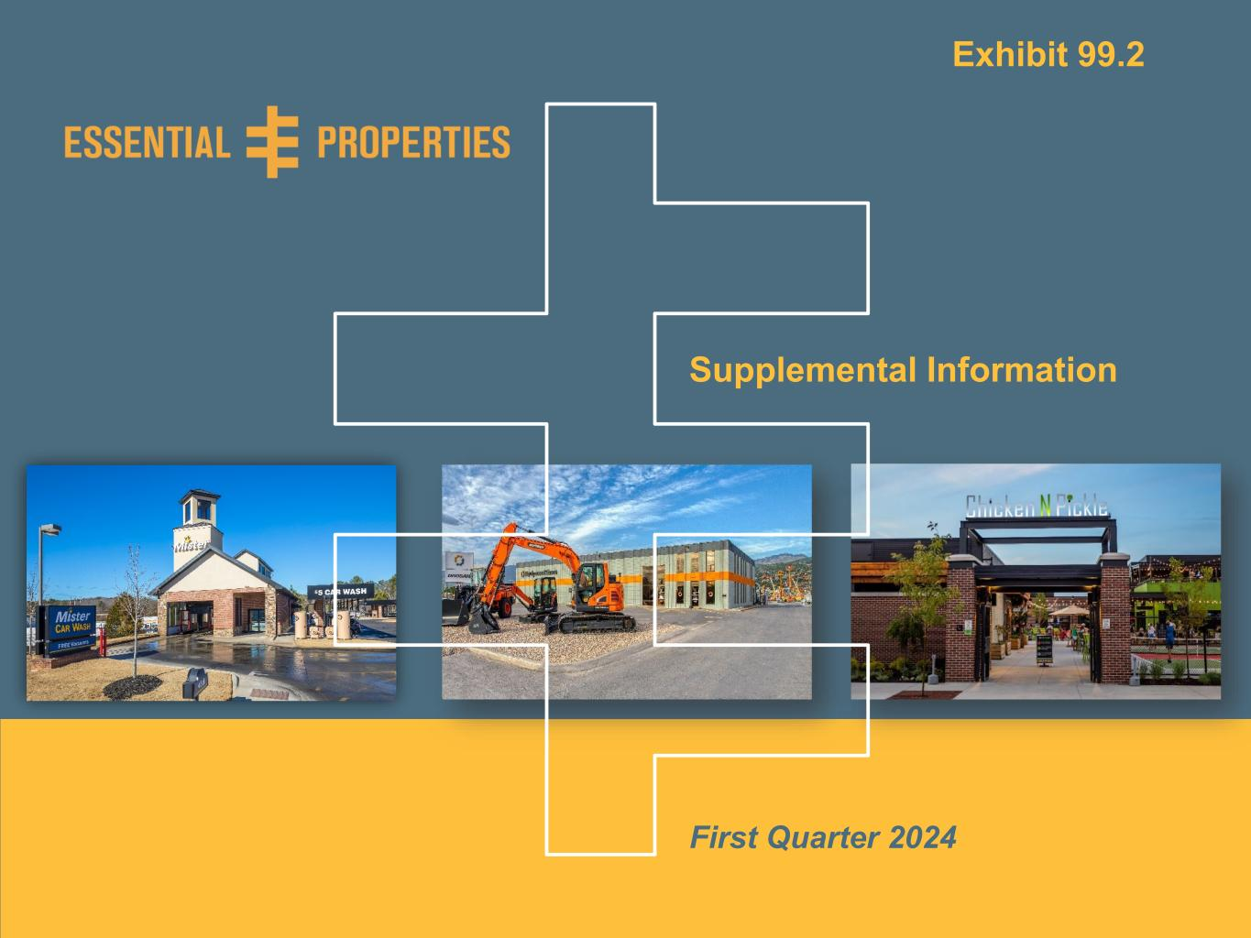
Supplemental Information | As of March 31, 20240 Supplemental Information First Quarter 2024 Exhibit 99.2

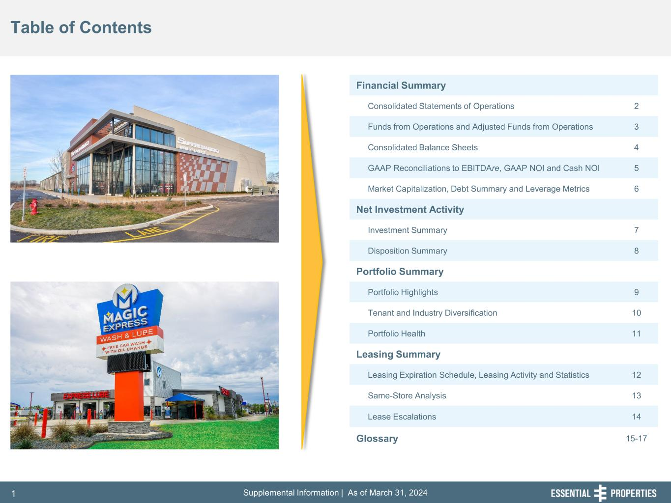
Supplemental Information | As of March 31, 20241 Table of Contents Financial Summary Consolidated Statements of Operations 2 Funds from Operations and Adjusted Funds from Operations 3 Consolidated Balance Sheets 4 GAAP Reconciliations to EBITDAre, GAAP NOI and Cash NOI 5 Market Capitalization, Debt Summary and Leverage Metrics 6 Net Investment Activity Investment Summary 7 Disposition Summary 8 Portfolio Summary Portfolio Highlights 9 Tenant and Industry Diversification 10 Portfolio Health 11 Leasing Summary Leasing Expiration Schedule, Leasing Activity and Statistics 12 Same-Store Analysis 13 Lease Escalations 14 Glossary 15-17

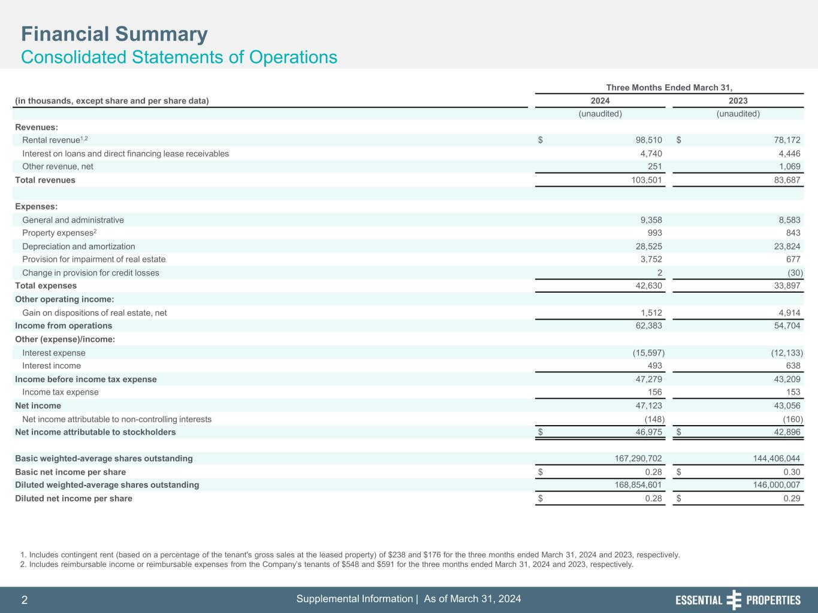
Supplemental Information | As of March 31, 20242 l t l I f r ti | s f rc , 2 Three Months Ended March 31, (in thousands, except share and per share data) 2024 2023 (unaudited) (unaudited) Revenues: Rental revenue1,2 $ 98,510 $ 78,172 Interest on loans and direct financing lease receivables 4,740 4,446 Other revenue, net 251 1,069 Total revenues 103,501 83,687 Expenses: General and administrative 9,358 8,583 Property expenses2 993 843 Depreciation and amortization 28,525 23,824 Provision for impairment of real estate 3,752 677 Change in provision for credit losses 2 (30) Total expenses 42,630 33,897 Other operating income: Gain on dispositions of real estate, net 1,512 4,914 Income from operations 62,383 54,704 Other (expense)/income: Interest expense (15,597) (12,133) Interest income 493 638 Income before income tax expense 47,279 43,209 Income tax expense 156 153 Net income 47,123 43,056 Net income attributable to non-controlling interests (148) (160) Net income attributable to stockholders $ 46,975 $ 42,896 Basic weighted-average shares outstanding 167,290,702 144,406,044 Basic net income per share $ 0.28 $ 0.30 Diluted weighted-average shares outstanding 168,854,601 146,000,007 Diluted net income per share $ 0.28 $ 0.29 1. Includes contingent rent (based on a percentage of the tenant's gross sales at the leased property) of $238 and $176 for the three months ended March 31, 2024 and 2023, respectively. 2. Includes reimbursable income or reimbursable expenses from the Company’s tenants of $548 and $591 for the three months ended March 31, 2024 and 2023, respectively. Financial Summary Consolidated Statements of Operations

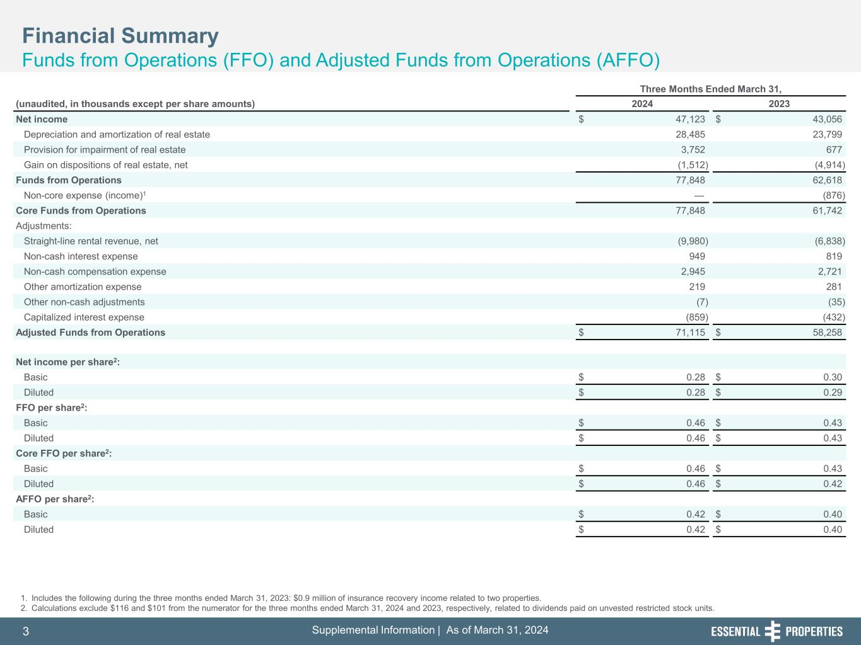
Supplemental Information | As of March 31, 20243 l t l I f r ti | s f rc , 3 Three Months Ended March 31, (unaudited, in thousands except per share amounts) 2024 2023 Net income $ 47,123 $ 43,056 Depreciation and amortization of real estate 28,485 23,799 Provision for impairment of real estate 3,752 677 Gain on dispositions of real estate, net (1,512) (4,914) Funds from Operations 77,848 62,618 Non-core expense (income)1 — (876) Core Funds from Operations 77,848 61,742 Adjustments: Straight-line rental revenue, net (9,980) (6,838) Non-cash interest expense 949 819 Non-cash compensation expense 2,945 2,721 Other amortization expense 219 281 Other non-cash adjustments (7) (35) Capitalized interest expense (859) (432) Adjusted Funds from Operations $ 71,115 $ 58,258 Net income per share2: Basic $ 0.28 $ 0.30 Diluted $ 0.28 $ 0.29 FFO per share2: Basic $ 0.46 $ 0.43 Diluted $ 0.46 $ 0.43 Core FFO per share2: Basic $ 0.46 $ 0.43 Diluted $ 0.46 $ 0.42 AFFO per share2: Basic $ 0.42 $ 0.40 Diluted $ 0.42 $ 0.40 1. Includes the following during the three months ended March 31, 2023: $0.9 million of insurance recovery income related to two properties. 2. Calculations exclude $116 and $101 from the numerator for the three months ended March 31, 2024 and 2023, respectively, related to dividends paid on unvested restricted stock units. Financial Summary Funds from Operations (FFO) and Adjusted Funds from Operations (AFFO)

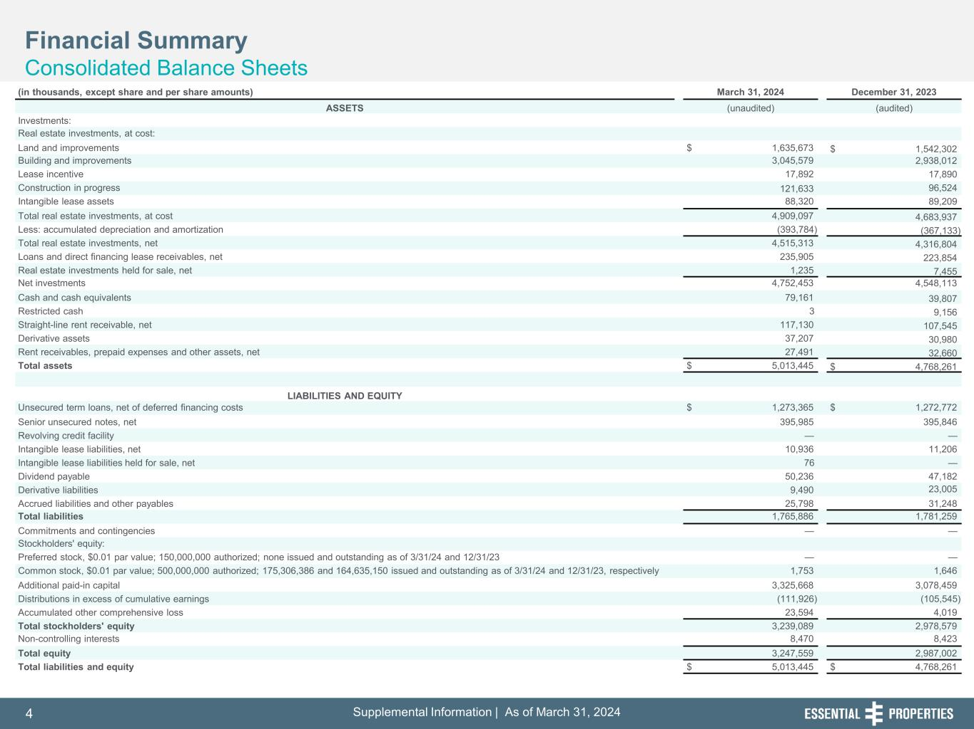
Supplemental Information | As of March 31, 20244 l t l I f r ti | s f rc , 4 Financial Summary Consolidated Balance Sheets (in thousands, except share and per share amounts) March 31, 2024 December 31, 2023 ASSETS (unaudited) (audited) Investments: Real estate investments, at cost: Land and improvements $ 1,635,673 $ 1,542,302 Building and improvements 3,045,579 2,938,012 Lease incentive 17,892 17,890 Construction in progress 121,633 96,524 Intangible lease assets 88,320 89,209 Total real estate investments, at cost 4,909,097 4,683,937 Less: accumulated depreciation and amortization (393,784) (367,133) Total real estate investments, net 4,515,313 4,316,804 Loans and direct financing lease receivables, net 235,905 223,854 Real estate investments held for sale, net 1,235 7,455 Net investments 4,752,453 4,548,113 Cash and cash equivalents 79,161 39,807 Restricted cash 3 9,156 Straight-line rent receivable, net 117,130 107,545 Derivative assets 37,207 30,980 Rent receivables, prepaid expenses and other assets, net 27,491 32,660 Total assets $ 5,013,445 $ 4,768,261 LIABILITIES AND EQUITY Unsecured term loans, net of deferred financing costs $ 1,273,365 $ 1,272,772 Senior unsecured notes, net 395,985 395,846 Revolving credit facility — — Intangible lease liabilities, net 10,936 11,206 Intangible lease liabilities held for sale, net 76 — Dividend payable 50,236 47,182 Derivative liabilities 9,490 23,005 Accrued liabilities and other payables 25,798 31,248 Total liabilities 1,765,886 1,781,259 Commitments and contingencies — — Stockholders' equity: Preferred stock, $0.01 par value; 150,000,000 authorized; none issued and outstanding as of 3/31/24 and 12/31/23 — — Common stock, $0.01 par value; 500,000,000 authorized; 175,306,386 and 164,635,150 issued and outstanding as of 3/31/24 and 12/31/23, respectively 1,753 1,646 Additional paid-in capital 3,325,668 3,078,459 Distributions in excess of cumulative earnings (111,926) (105,545) Accumulated other comprehensive loss 23,594 4,019 Total stockholders' equity 3,239,089 2,978,579 Non-controlling interests 8,470 8,423 Total equity 3,247,559 2,987,002 Total liabilities and equity $ 5,013,445 $ 4,768,261

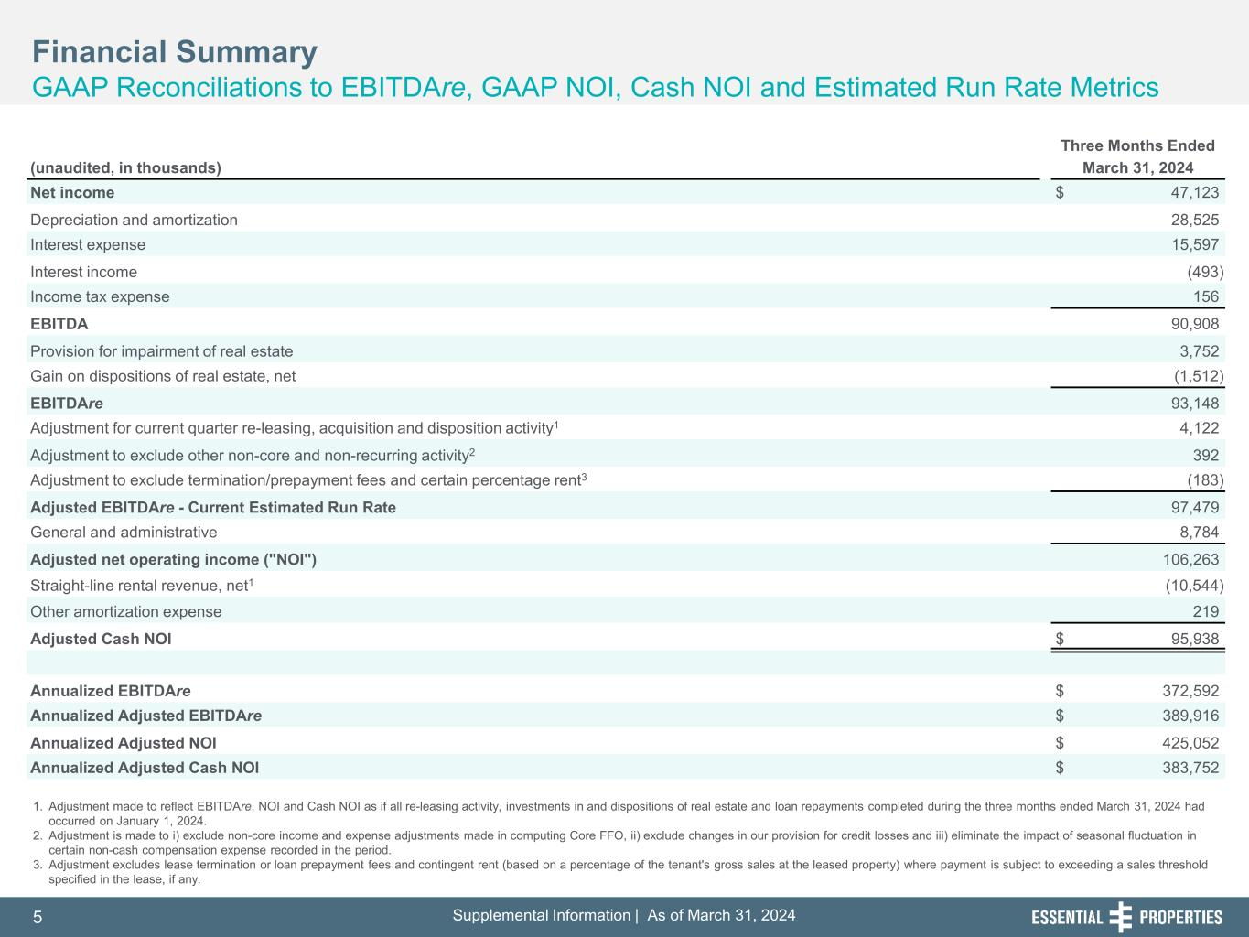
Supplemental Information | As of March 31, 20245 l t l I f r ti | s f rc , 5 Financial Summary GAAP Reconciliations to EBITDAre, GAAP NOI, Cash NOI and Estimated Run Rate Metrics 1. Adjustment made to reflect EBITDAre, NOI and Cash NOI as if all re-leasing activity, investments in and dispositions of real estate and loan repayments completed during the three months ended March 31, 2024 had occurred on January 1, 2024. 2. Adjustment is made to i) exclude non-core income and expense adjustments made in computing Core FFO, ii) exclude changes in our provision for credit losses and iii) eliminate the impact of seasonal fluctuation in certain non-cash compensation expense recorded in the period. 3. Adjustment excludes lease termination or loan prepayment fees and contingent rent (based on a percentage of the tenant's gross sales at the leased property) where payment is subject to exceeding a sales threshold specified in the lease, if any. Three Months Ended (unaudited, in thousands) March 31, 2024 Net income $ 47,123 Depreciation and amortization 28,525 Interest expense 15,597 Interest income (493) Income tax expense 156 EBITDA 90,908 Provision for impairment of real estate 3,752 Gain on dispositions of real estate, net (1,512) EBITDAre 93,148 Adjustment for current quarter re-leasing, acquisition and disposition activity1 4,122 Adjustment to exclude other non-core and non-recurring activity2 392 Adjustment to exclude termination/prepayment fees and certain percentage rent3 (183) Adjusted EBITDAre - Current Estimated Run Rate 97,479 General and administrative 8,784 Adjusted net operating income ("NOI") 106,263 Straight-line rental revenue, net1 (10,544) Other amortization expense 219 Adjusted Cash NOI $ 95,938 Annualized EBITDAre $ 372,592 Annualized Adjusted EBITDAre $ 389,916 Annualized Adjusted NOI $ 425,052 Annualized Adjusted Cash NOI $ 383,752

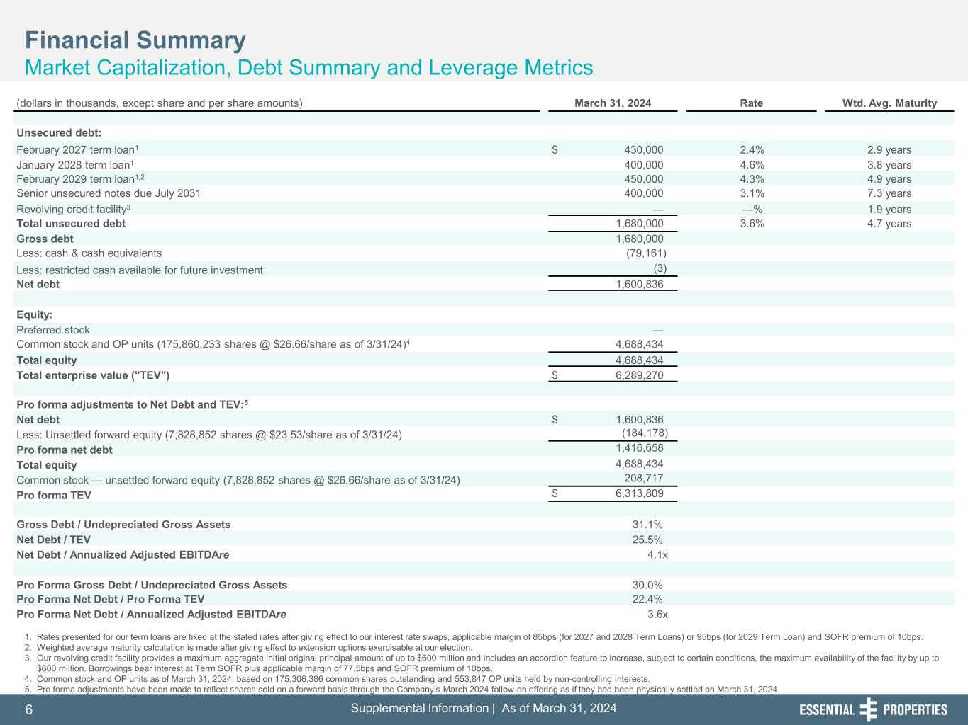
Supplemental Information | As of March 31, 20246 l t l I f r ti | s f rc , 6 Financial Summary Market Capitalization, Debt Summary and Leverage Metrics 1. Rates presented for our term loans are fixed at the stated rates after giving effect to our interest rate swaps, applicable margin of 85bps (for 2027 and 2028 Term Loans) or 95bps (for 2029 Term Loan) and SOFR premium of 10bps. 2. Weighted average maturity calculation is made after giving effect to extension options exercisable at our election. 3. Our revolving credit facility provides a maximum aggregate initial original principal amount of up to $600 million and includes an accordion feature to increase, subject to certain conditions, the maximum availability of the facility by up to $600 million. Borrowings bear interest at Term SOFR plus applicable margin of 77.5bps and SOFR premium of 10bps. 4. Common stock and OP units as of March 31, 2024, based on 175,306,386 common shares outstanding and 553,847 OP units held by non-controlling interests. 5. Pro forma adjustments have been made to reflect shares sold on a forward basis through the Company’s March 2024 follow-on offering as if they had been physically settled on March 31, 2024. (dollars in thousands, except share and per share amounts) March 31, 2024 Rate Wtd. Avg. Maturity Unsecured debt: February 2027 term loan1 $ 430,000 2.4% 2.9 years January 2028 term loan1 400,000 4.6% 3.8 years February 2029 term loan1,2 450,000 4.3% 4.9 years Senior unsecured notes due July 2031 400,000 3.1% 7.3 years Revolving credit facility3 — —% 1.9 years Total unsecured debt 1,680,000 3.6% 4.7 years Gross debt 1,680,000 Less: cash & cash equivalents (79,161) Less: restricted cash available for future investment (3) Net debt 1,600,836 Equity: Preferred stock — Common stock and OP units (175,860,233 shares @ $26.66/share as of 3/31/24)4 4,688,434 Total equity 4,688,434 Total enterprise value ("TEV") $ 6,289,270 Pro forma adjustments to Net Debt and TEV:5 Net debt $ 1,600,836 Less: Unsettled forward equity (7,828,852 shares @ $23.53/share as of 3/31/24) (184,178) Pro forma net debt 1,416,658 Total equity 4,688,434 Common stock — unsettled forward equity (7,828,852 shares @ $26.66/share as of 3/31/24) 208,717 Pro forma TEV $ 6,313,809 Gross Debt / Undepreciated Gross Assets 31.1% Net Debt / TEV 25.5% Net Debt / Annualized Adjusted EBITDAre 4.1x Pro Forma Gross Debt / Undepreciated Gross Assets 30.0% Pro Forma Net Debt / Pro Forma TEV 22.4% Pro Forma Net Debt / Annualized Adjusted EBITDAre 3.6x

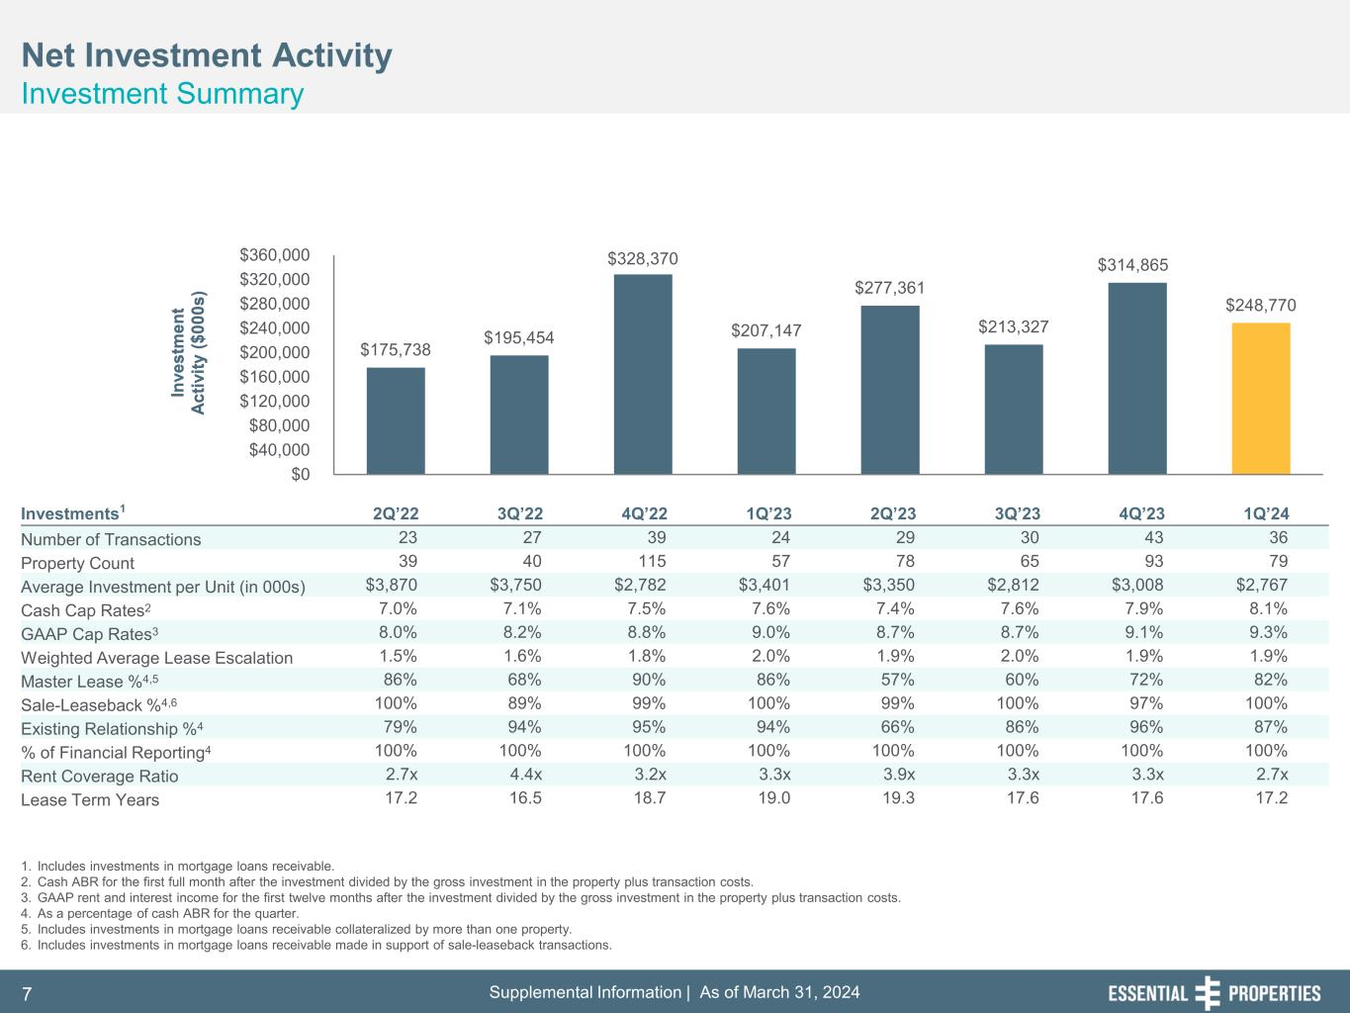
Supplemental Information | As of March 31, 20247 $175,738 $195,454 $328,370 $207,147 $277,361 $213,327 $314,865 $248,770 $0 $40,000 $80,000 $120,000 $160,000 $200,000 $240,000 $280,000 $320,000 $360,000 In ve st m en t Ac tiv ity ($ 00 0s ) In ve st m en t Ac tiv ity ($ 00 0s ) Net Investment Activity Investment Summary 1. Includes investments in mortgage loans receivable. 2. Cash ABR for the first full month after the investment divided by the gross investment in the property plus transaction costs. 3. GAAP rent and interest income for the first twelve months after the investment divided by the gross investment in the property plus transaction costs. 4. As a percentage of cash ABR for the quarter. 5. Includes investments in mortgage loans receivable collateralized by more than one property. 6. Includes investments in mortgage loans receivable made in support of sale-leaseback transactions. Investments1 2Q’22 3Q’22 4Q’22 1Q’23 2Q’23 3Q’23 4Q’23 1Q’24 Number of Transactions 23 27 39 24 29 30 43 36 Property Count 39 40 115 57 78 65 93 79 Average Investment per Unit (in 000s) $3,870 $3,750 $2,782 $3,401 $3,350 $2,812 $3,008 $2,767 Cash Cap Rates2 7.0% 7.1% 7.5% 7.6% 7.4% 7.6% 7.9% 8.1% GAAP Cap Rates3 8.0% 8.2% 8.8% 9.0% 8.7% 8.7% 9.1% 9.3% Weighted Average Lease Escalation 1.5% 1.6% 1.8% 2.0% 1.9% 2.0% 1.9% 1.9% Master Lease %4,5 86% 68% 90% 86% 57% 60% 72% 82% Sale-Leaseback %4,6 100% 89% 99% 100% 99% 100% 97% 100% Existing Relationship %4 79% 94% 95% 94% 66% 86% 96% 87% % of Financial Reporting4 100% 100% 100% 100% 100% 100% 100% 100% Rent Coverage Ratio 2.7x 4.4x 3.2x 3.3x 3.9x 3.3x 3.3x 2.7x Lease Term Years 17.2 16.5 18.7 19.0 19.3 17.6 17.6 17.2

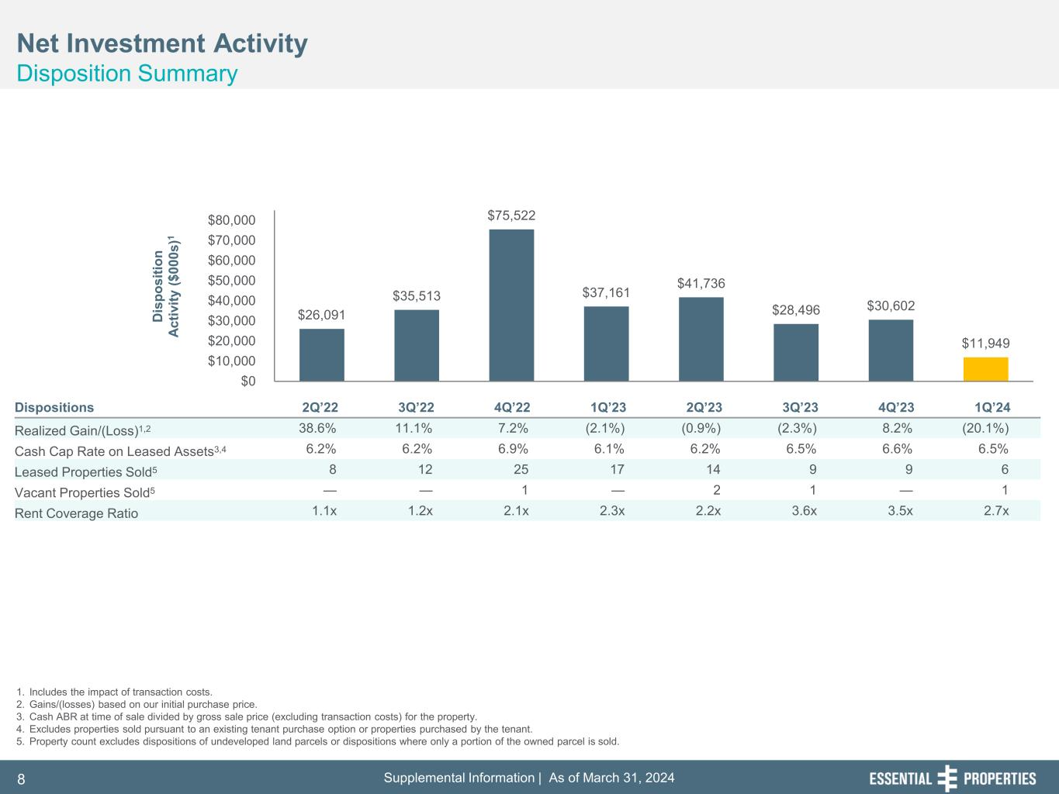
Supplemental Information | As of March 31, 20248 $26,091 $35,513 $75,522 $37,161 $41,736 $28,496 $30,602 $11,949 $0 $10,000 $20,000 $30,000 $40,000 $50,000 $60,000 $70,000 $80,000 D is po si tio n Ac tiv ity ($ 00 0s )1 D is po si tio n Ac tiv ity ($ 00 0s )1 Net Investment Activity Disposition Summary 1. Includes the impact of transaction costs. 2. Gains/(losses) based on our initial purchase price. 3. Cash ABR at time of sale divided by gross sale price (excluding transaction costs) for the property. 4. Excludes properties sold pursuant to an existing tenant purchase option or properties purchased by the tenant. 5. Property count excludes dispositions of undeveloped land parcels or dispositions where only a portion of the owned parcel is sold. Dispositions 2Q’22 3Q’22 4Q’22 1Q’23 2Q’23 3Q’23 4Q’23 1Q’24 Realized Gain/(Loss)1,2 38.6% 11.1% 7.2% (2.1%) (0.9%) (2.3%) 8.2% (20.1%) Cash Cap Rate on Leased Assets3,4 6.2% 6.2% 6.9% 6.1% 6.2% 6.5% 6.6% 6.5% Leased Properties Sold5 8 12 25 17 14 9 9 6 Vacant Properties Sold5 — — 1 — 2 1 — 1 Rent Coverage Ratio 1.1x 1.2x 2.1x 2.3x 2.2x 3.6x 3.5x 2.7x

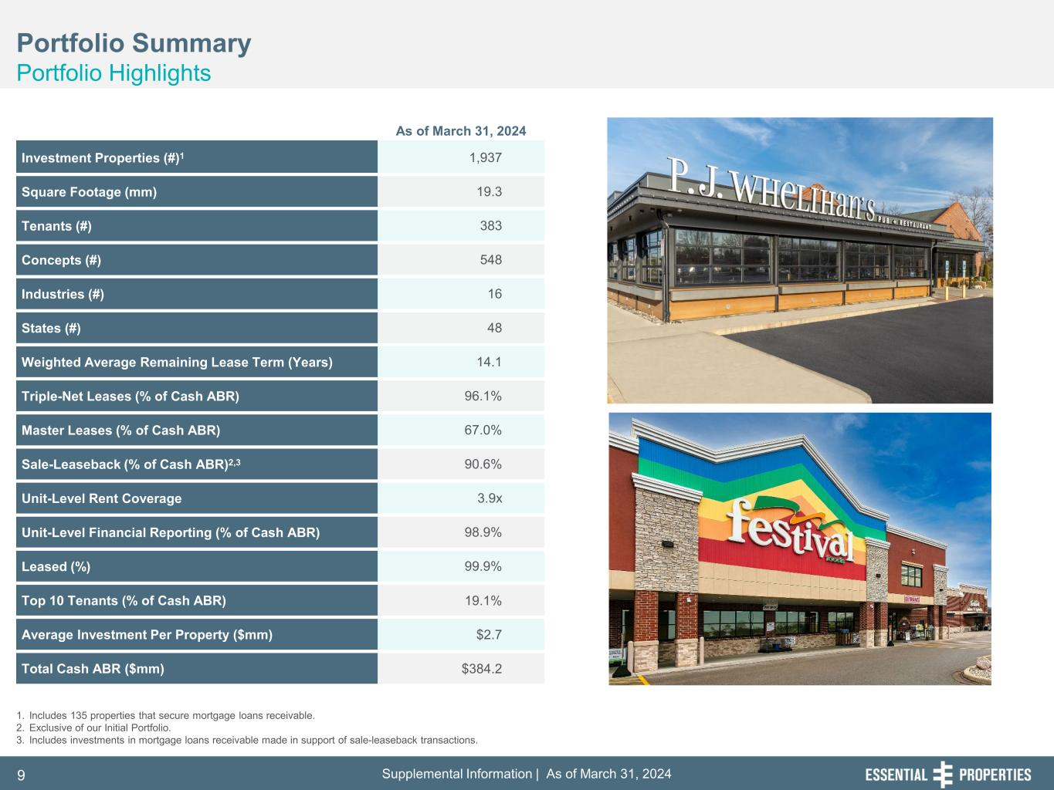
Supplemental Information | As of March 31, 20249 Portfolio Summary Portfolio Highlights Investment Properties (#)1 1,937 Square Footage (mm) 19.3 Tenants (#) 383 Concepts (#) 548 Industries (#) 16 States (#) 48 Weighted Average Remaining Lease Term (Years) 14.1 Triple-Net Leases (% of Cash ABR) 96.1% Master Leases (% of Cash ABR) 67.0% Sale-Leaseback (% of Cash ABR)2,3 90.6% Unit-Level Rent Coverage 3.9x Unit-Level Financial Reporting (% of Cash ABR) 98.9% Leased (%) 99.9% Top 10 Tenants (% of Cash ABR) 19.1% Average Investment Per Property ($mm) $2.7 Total Cash ABR ($mm) $384.2 1. Includes 135 properties that secure mortgage loans receivable. 2. Exclusive of our Initial Portfolio. 3. Includes investments in mortgage loans receivable made in support of sale-leaseback transactions. As of March 31, 2024

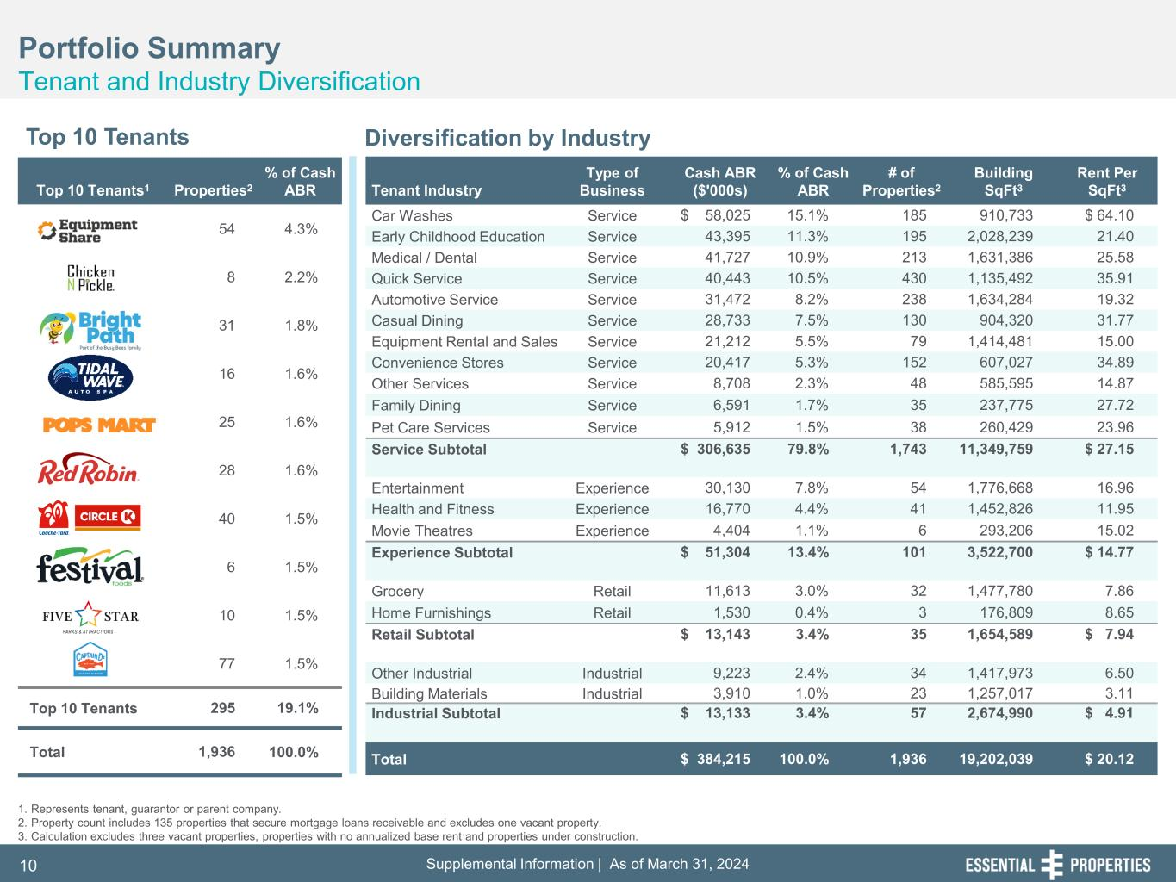
Supplemental Information | As of March 31, 202410 Top 10 Tenants1 Properties2 % of Cash ABR 54 4.3% 8 2.2% 31 1.8% 16 1.6% 25 1.6% 28 1.6% 40 1.5% 6 1.5% 10 1.5% 77 1.5% Top 10 Tenants 295 19.1% Total 1,936 100.0% Portfolio Summary Tenant and Industry Diversification Top 10 Tenants Diversification by Industry 1. Represents tenant, guarantor or parent company. 2. Property count includes 135 properties that secure mortgage loans receivable and excludes one vacant property. 3. Calculation excludes three vacant properties, properties with no annualized base rent and properties under construction. Tenant Industry Type of Business Cash ABR ($'000s) % of Cash ABR # of Properties2 Building SqFt3 Rent Per SqFt3 Car Washes Service $ 58,025 15.1% 185 910,733 $ 64.10 Early Childhood Education Service 43,395 11.3% 195 2,028,239 21.40 Medical / Dental Service 41,727 10.9% 213 1,631,386 25.58 Quick Service Service 40,443 10.5% 430 1,135,492 35.91 Automotive Service Service 31,472 8.2% 238 1,634,284 19.32 Casual Dining Service 28,733 7.5% 130 904,320 31.77 Equipment Rental and Sales Service 21,212 5.5% 79 1,414,481 15.00 Convenience Stores Service 20,417 5.3% 152 607,027 34.89 Other Services Service 8,708 2.3% 48 585,595 14.87 Family Dining Service 6,591 1.7% 35 237,775 27.72 Pet Care Services Service 5,912 1.5% 38 260,429 23.96 Service Subtotal $ 306,635 79.8% 1,743 11,349,759 $ 27.15 Entertainment Experience 30,130 7.8% 54 1,776,668 16.96 Health and Fitness Experience 16,770 4.4% 41 1,452,826 11.95 Movie Theatres Experience 4,404 1.1% 6 293,206 15.02 Experience Subtotal $ 51,304 13.4% 101 3,522,700 $ 14.77 Grocery Retail 11,613 3.0% 32 1,477,780 7.86 Home Furnishings Retail 1,530 0.4% 3 176,809 8.65 Retail Subtotal $ 13,143 3.4% 35 1,654,589 $ 7.94 Other Industrial Industrial 9,223 2.4% 34 1,417,973 6.50 Building Materials Industrial 3,910 1.0% 23 1,257,017 3.11 Industrial Subtotal $ 13,133 3.4% 57 2,674,990 $ 4.91 Total $ 384,215 100.0% 1,936 19,202,039 $ 20.12

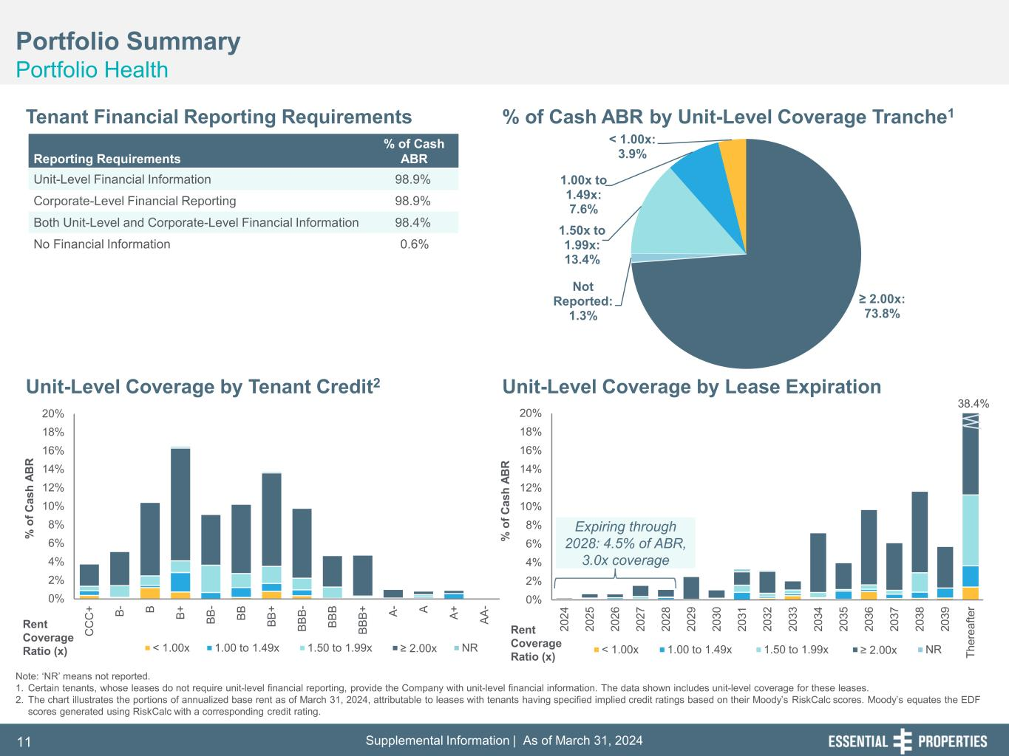
Supplemental Information | As of March 31, 202411 0% 2% 4% 6% 8% 10% 12% 14% 16% 18% 20% 20 24 20 25 20 26 20 27 20 28 20 29 20 30 20 31 20 32 20 33 20 34 20 35 20 36 20 37 20 38 20 39 Th er ea fte r % o f C as h AB R < 1.00x 1.00 to 1.49x 1.50 to 1.99x ≥ 2.00x NR 38.4% 0% 2% 4% 6% 8% 10% 12% 14% 16% 18% 20% C C C + B- B B+ BB - BB BB + BB B- BB B BB B+ A- A A+ AA - % o f C as h AB R < 1.00x 1.00 to 1.49x 1.50 to 1.99x ≥ 2.00x NR ≥ 2.00x: 73.8% Not Reported: 1.3% 1.50x to 1.99x: 13.4% 1.00x to 1.49x: 7.6% < 1.00x: 3.9% Portfolio Summary Portfolio Health Tenant Financial Reporting Requirements % of Cash ABR by Unit-Level Coverage Tranche1 Unit-Level Coverage by Lease ExpirationUnit-Level Coverage by Tenant Credit2 Note: ‘NR’ means not reported. 1. Certain tenants, whose leases do not require unit-level financial reporting, provide the Company with unit-level financial information. The data shown includes unit-level coverage for these leases. 2. The chart illustrates the portions of annualized base rent as of March 31, 2024, attributable to leases with tenants having specified implied credit ratings based on their Moody’s RiskCalc scores. Moody’s equates the EDF scores generated using RiskCalc with a corresponding credit rating. Reporting Requirements % of Cash ABR Unit-Level Financial Information 98.9% Corporate-Level Financial Reporting 98.9% Both Unit-Level and Corporate-Level Financial Information 98.4% No Financial Information 0.6% Rent Coverage Ratio (x) Rent Coverage Ratio (x) Expiring through 2028: 4.5% of ABR, 3.0x coverage

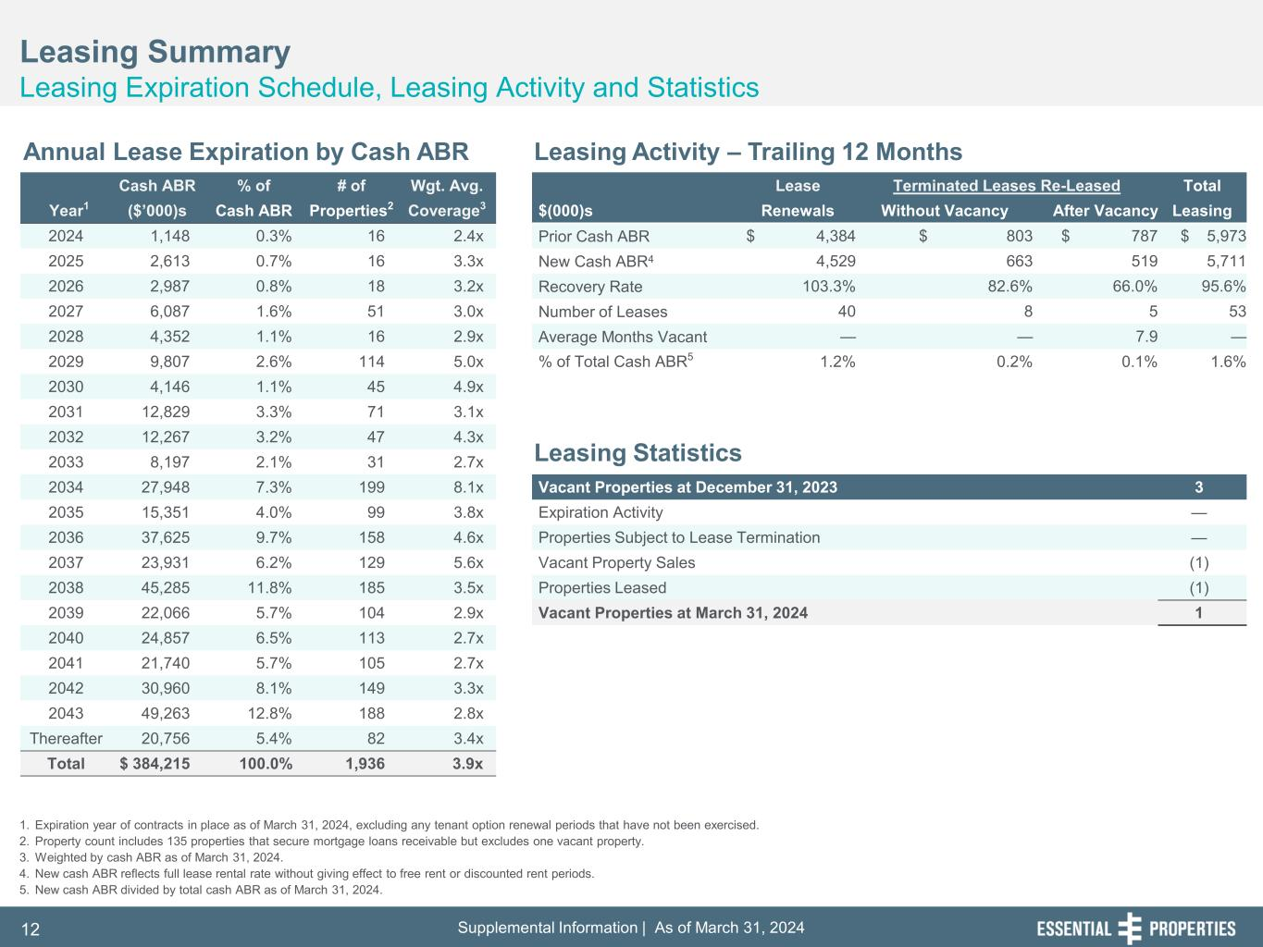
Supplemental Information | As of March 31, 202412 Cash ABR % of # of Wgt. Avg. Lease Terminated Leases Re-Leased Total Year1 ($’000)s Cash ABR Properties2 Coverage3 $(000)s Renewals Without Vacancy After Vacancy Leasing 2024 1,148 0.3% 16 2.4x Prior Cash ABR $ 4,384 $ 803 $ 787 $ 5,973 2025 2,613 0.7% 16 3.3x New Cash ABR4 4,529 663 519 5,711 2026 2,987 0.8% 18 3.2x Recovery Rate 103.3% 82.6% 66.0% 95.6% 2027 6,087 1.6% 51 3.0x Number of Leases 40 8 5 53 2028 4,352 1.1% 16 2.9x Average Months Vacant — — 7.9 — 2029 9,807 2.6% 114 5.0x % of Total Cash ABR5 1.2% 0.2% 0.1% 1.6% 2030 4,146 1.1% 45 4.9x 2031 12,829 3.3% 71 3.1x 2032 12,267 3.2% 47 4.3x 2033 8,197 2.1% 31 2.7x 2034 27,948 7.3% 199 8.1x Vacant Properties at December 31, 2023 3 2035 15,351 4.0% 99 3.8x Expiration Activity — 2036 37,625 9.7% 158 4.6x Properties Subject to Lease Termination — 2037 23,931 6.2% 129 5.6x Vacant Property Sales (1) 2038 45,285 11.8% 185 3.5x Properties Leased (1) 2039 22,066 5.7% 104 2.9x Vacant Properties at March 31, 2024 1 2040 24,857 6.5% 113 2.7x 2041 21,740 5.7% 105 2.7x 2042 30,960 8.1% 149 3.3x 2043 49,263 12.8% 188 2.8x Thereafter 20,756 5.4% 82 3.4x Total $ 384,215 100.0% 1,936 3.9x Leasing Summary Leasing Expiration Schedule, Leasing Activity and Statistics 1. Expiration year of contracts in place as of March 31, 2024, excluding any tenant option renewal periods that have not been exercised. 2. Property count includes 135 properties that secure mortgage loans receivable but excludes one vacant property. 3. Weighted by cash ABR as of March 31, 2024. 4. New cash ABR reflects full lease rental rate without giving effect to free rent or discounted rent periods. 5. New cash ABR divided by total cash ABR as of March 31, 2024. Annual Lease Expiration by Cash ABR Leasing Activity – Trailing 12 Months Leasing Statistics

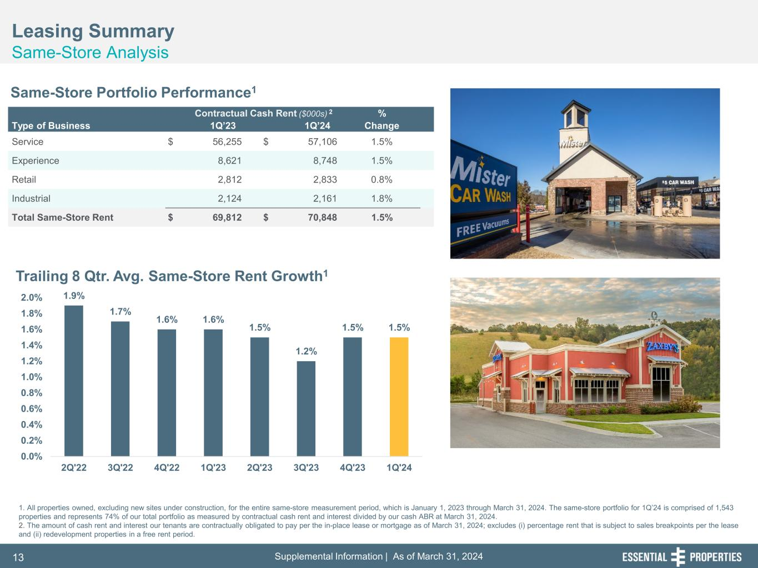
Supplemental Information | As of March 31, 202413 Leasing Summary Same-Store Analysis Same-Store Portfolio Performance1 Contractual Cash Rent ($000s) 2 % Type of Business 1Q’23 1Q’24 Change Service $ 56,255 $ 57,106 1.5% Experience 8,621 8,748 1.5% Retail 2,812 2,833 0.8% Industrial 2,124 2,161 1.8% Total Same-Store Rent $ 69,812 $ 70,848 1.5% 1. All properties owned, excluding new sites under construction, for the entire same-store measurement period, which is January 1, 2023 through March 31, 2024. The same-store portfolio for 1Q’24 is comprised of 1,543 properties and represents 74% of our total portfolio as measured by contractual cash rent and interest divided by our cash ABR at March 31, 2024. 2. The amount of cash rent and interest our tenants are contractually obligated to pay per the in-place lease or mortgage as of March 31, 2024; excludes (i) percentage rent that is subject to sales breakpoints per the lease and (ii) redevelopment properties in a free rent period. 1.9% 1.7% 1.6% 1.6% 1.5% 1.2% 1.5% 1.5% 0.0% 0.2% 0.4% 0.6% 0.8% 1.0% 1.2% 1.4% 1.6% 1.8% 2.0% 2Q'22 3Q'22 4Q'22 1Q'23 2Q'23 3Q'23 4Q'23 1Q'24 Trailing 8 Qtr. Avg. Same-Store Rent Growth1

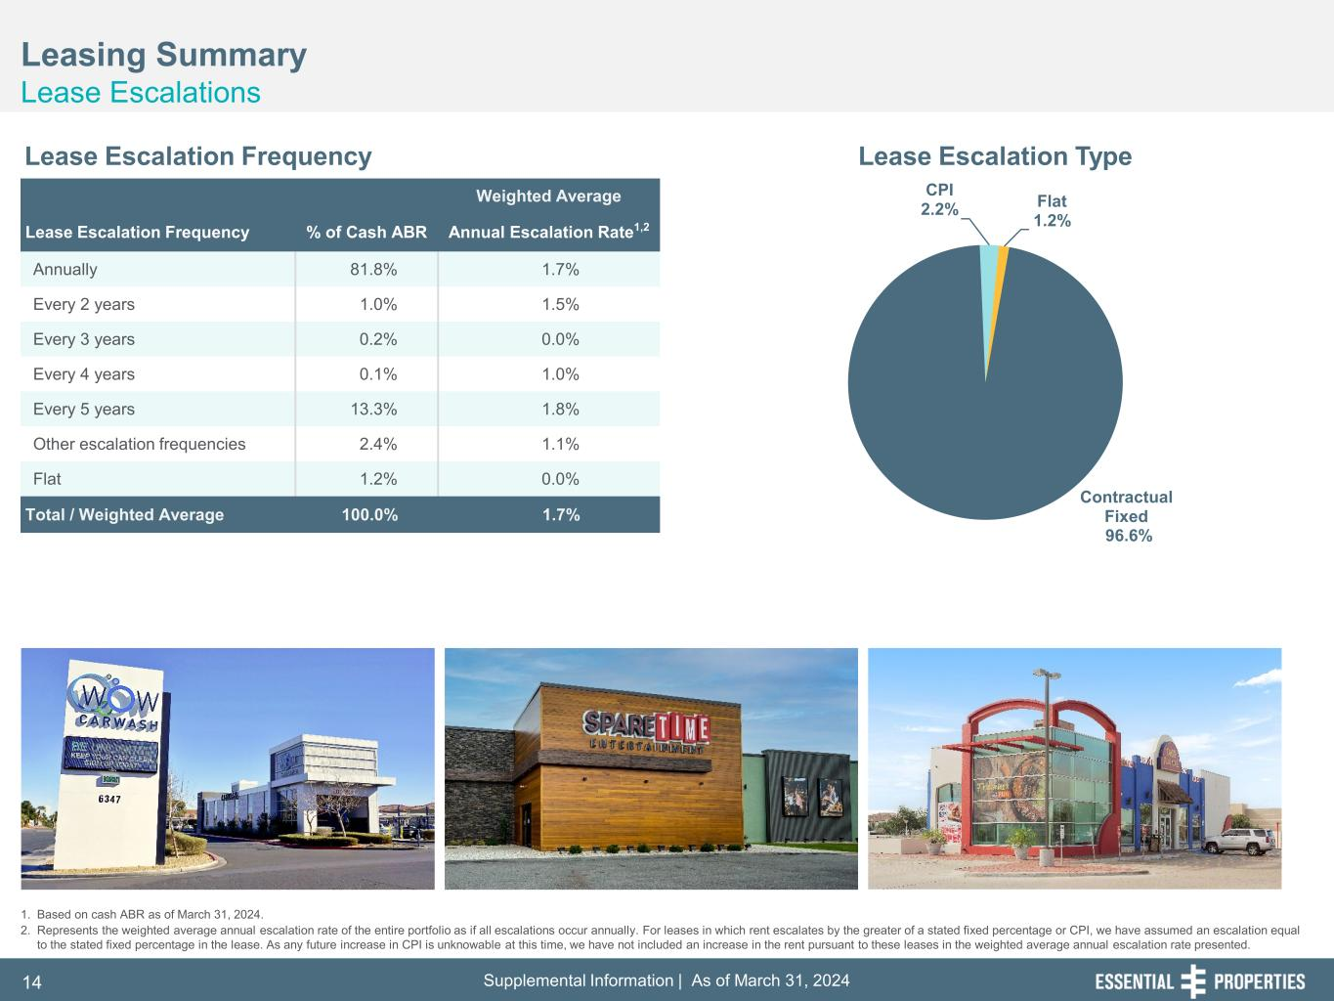
Supplemental Information | As of March 31, 202414 Contractual Fixed 96.6% CPI 2.2% Flat 1.2% Leasing Summary Lease Escalations 1. Based on cash ABR as of March 31, 2024. 2. Represents the weighted average annual escalation rate of the entire portfolio as if all escalations occur annually. For leases in which rent escalates by the greater of a stated fixed percentage or CPI, we have assumed an escalation equal to the stated fixed percentage in the lease. As any future increase in CPI is unknowable at this time, we have not included an increase in the rent pursuant to these leases in the weighted average annual escalation rate presented. Lease Escalation Frequency Lease Escalation Type Weighted Average Lease Escalation Frequency % of Cash ABR Annual Escalation Rate1,2 Annually 81.8% 1.7% Every 2 years 1.0% 1.5% Every 3 years 0.2% 0.0% Every 4 years 0.1% 1.0% Every 5 years 13.3% 1.8% Other escalation frequencies 2.4% 1.1% Flat 1.2% 0.0% Total / Weighted Average 100.0% 1.7%

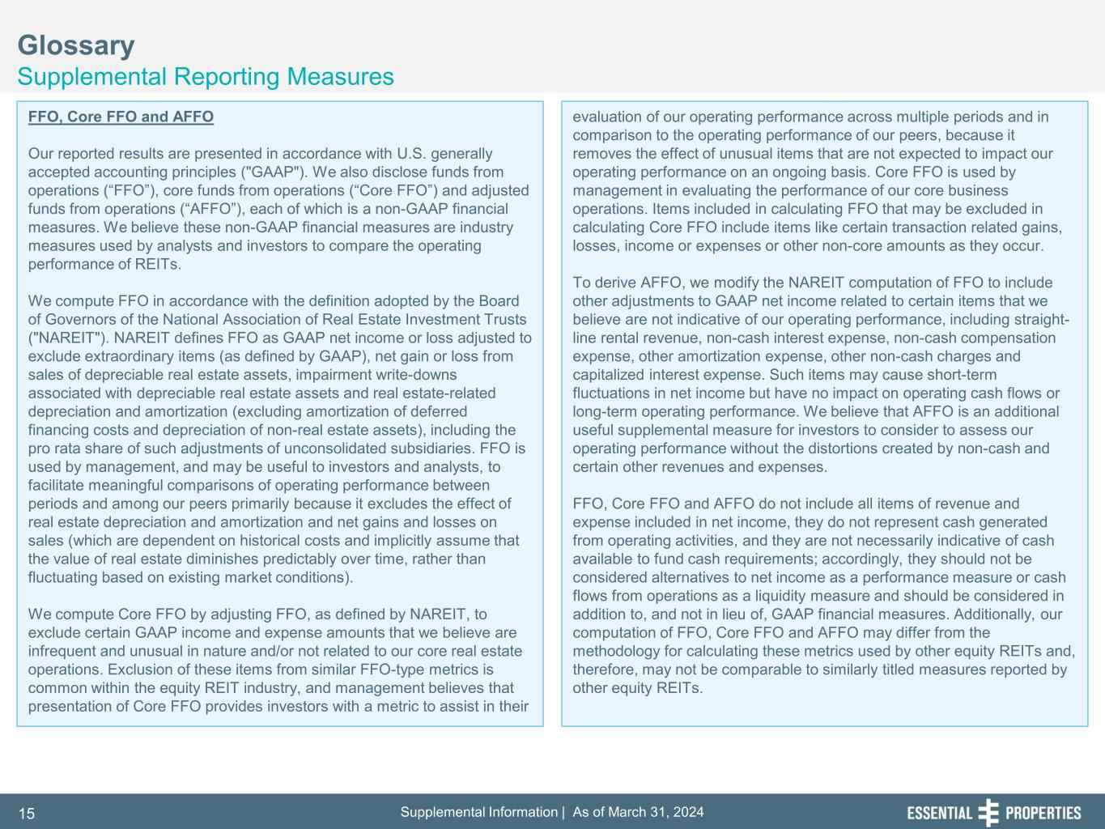
Supplemental Information | As of March 31, 202415 Glossary Supplemental Reporting Measures FFO, Core FFO and AFFO Our reported results are presented in accordance with U.S. generally accepted accounting principles ("GAAP"). We also disclose funds from operations (“FFO”), core funds from operations (“Core FFO”) and adjusted funds from operations (“AFFO”), each of which is a non-GAAP financial measures. We believe these non-GAAP financial measures are industry measures used by analysts and investors to compare the operating performance of REITs. We compute FFO in accordance with the definition adopted by the Board of Governors of the National Association of Real Estate Investment Trusts ("NAREIT"). NAREIT defines FFO as GAAP net income or loss adjusted to exclude extraordinary items (as defined by GAAP), net gain or loss from sales of depreciable real estate assets, impairment write-downs associated with depreciable real estate assets and real estate-related depreciation and amortization (excluding amortization of deferred financing costs and depreciation of non-real estate assets), including the pro rata share of such adjustments of unconsolidated subsidiaries. FFO is used by management, and may be useful to investors and analysts, to facilitate meaningful comparisons of operating performance between periods and among our peers primarily because it excludes the effect of real estate depreciation and amortization and net gains and losses on sales (which are dependent on historical costs and implicitly assume that the value of real estate diminishes predictably over time, rather than fluctuating based on existing market conditions). We compute Core FFO by adjusting FFO, as defined by NAREIT, to exclude certain GAAP income and expense amounts that we believe are infrequent and unusual in nature and/or not related to our core real estate operations. Exclusion of these items from similar FFO-type metrics is common within the equity REIT industry, and management believes that presentation of Core FFO provides investors with a metric to assist in their evaluation of our operating performance across multiple periods and in comparison to the operating performance of our peers, because it removes the effect of unusual items that are not expected to impact our operating performance on an ongoing basis. Core FFO is used by management in evaluating the performance of our core business operations. Items included in calculating FFO that may be excluded in calculating Core FFO include items like certain transaction related gains, losses, income or expenses or other non-core amounts as they occur. To derive AFFO, we modify the NAREIT computation of FFO to include other adjustments to GAAP net income related to certain items that we believe are not indicative of our operating performance, including straight- line rental revenue, non-cash interest expense, non-cash compensation expense, other amortization expense, other non-cash charges and capitalized interest expense. Such items may cause short-term fluctuations in net income but have no impact on operating cash flows or long-term operating performance. We believe that AFFO is an additional useful supplemental measure for investors to consider to assess our operating performance without the distortions created by non-cash and certain other revenues and expenses. FFO, Core FFO and AFFO do not include all items of revenue and expense included in net income, they do not represent cash generated from operating activities, and they are not necessarily indicative of cash available to fund cash requirements; accordingly, they should not be considered alternatives to net income as a performance measure or cash flows from operations as a liquidity measure and should be considered in addition to, and not in lieu of, GAAP financial measures. Additionally, our computation of FFO, Core FFO and AFFO may differ from the methodology for calculating these metrics used by other equity REITs and, therefore, may not be comparable to similarly titled measures reported by other equity REITs.

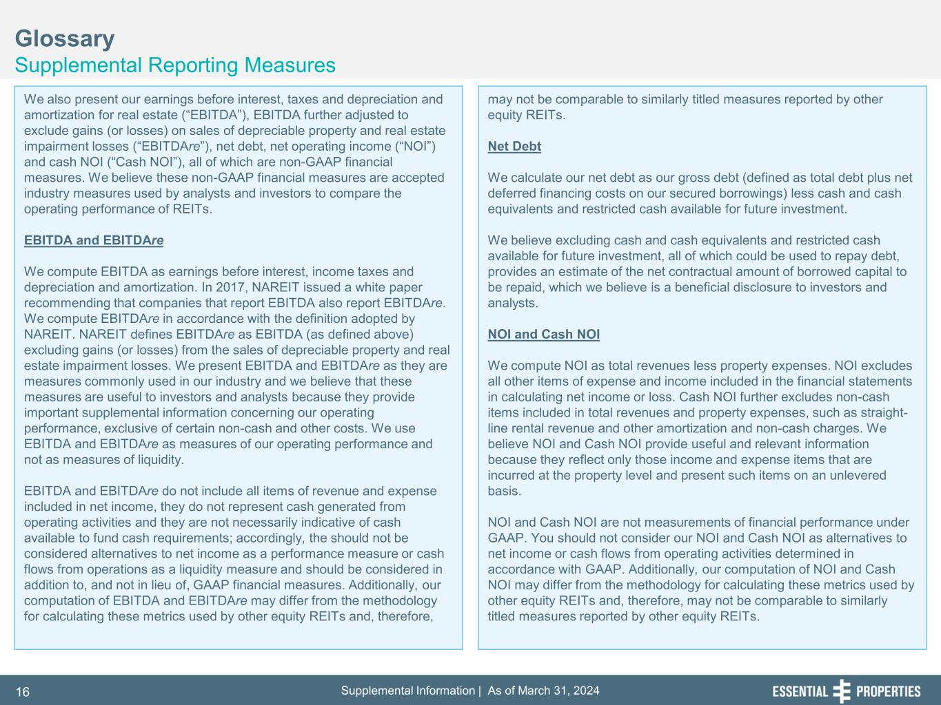
Supplemental Information | As of March 31, 202416 Glossary Supplemental Reporting Measures We also present our earnings before interest, taxes and depreciation and amortization for real estate (“EBITDA”), EBITDA further adjusted to exclude gains (or losses) on sales of depreciable property and real estate impairment losses (“EBITDAre”), net debt, net operating income (“NOI”) and cash NOI (“Cash NOI”), all of which are non-GAAP financial measures. We believe these non-GAAP financial measures are accepted industry measures used by analysts and investors to compare the operating performance of REITs. EBITDA and EBITDAre We compute EBITDA as earnings before interest, income taxes and depreciation and amortization. In 2017, NAREIT issued a white paper recommending that companies that report EBITDA also report EBITDAre. We compute EBITDAre in accordance with the definition adopted by NAREIT. NAREIT defines EBITDAre as EBITDA (as defined above) excluding gains (or losses) from the sales of depreciable property and real estate impairment losses. We present EBITDA and EBITDAre as they are measures commonly used in our industry and we believe that these measures are useful to investors and analysts because they provide important supplemental information concerning our operating performance, exclusive of certain non-cash and other costs. We use EBITDA and EBITDAre as measures of our operating performance and not as measures of liquidity. EBITDA and EBITDAre do not include all items of revenue and expense included in net income, they do not represent cash generated from operating activities and they are not necessarily indicative of cash available to fund cash requirements; accordingly, the should not be considered alternatives to net income as a performance measure or cash flows from operations as a liquidity measure and should be considered in addition to, and not in lieu of, GAAP financial measures. Additionally, our computation of EBITDA and EBITDAre may differ from the methodology for calculating these metrics used by other equity REITs and, therefore, may not be comparable to similarly titled measures reported by other equity REITs. Net Debt We calculate our net debt as our gross debt (defined as total debt plus net deferred financing costs on our secured borrowings) less cash and cash equivalents and restricted cash available for future investment. We believe excluding cash and cash equivalents and restricted cash available for future investment, all of which could be used to repay debt, provides an estimate of the net contractual amount of borrowed capital to be repaid, which we believe is a beneficial disclosure to investors and analysts. NOI and Cash NOI We compute NOI as total revenues less property expenses. NOI excludes all other items of expense and income included in the financial statements in calculating net income or loss. Cash NOI further excludes non-cash items included in total revenues and property expenses, such as straight- line rental revenue and other amortization and non-cash charges. We believe NOI and Cash NOI provide useful and relevant information because they reflect only those income and expense items that are incurred at the property level and present such items on an unlevered basis. NOI and Cash NOI are not measurements of financial performance under GAAP. You should not consider our NOI and Cash NOI as alternatives to net income or cash flows from operating activities determined in accordance with GAAP. Additionally, our computation of NOI and Cash NOI may differ from the methodology for calculating these metrics used by other equity REITs and, therefore, may not be comparable to similarly titled measures reported by other equity REITs.

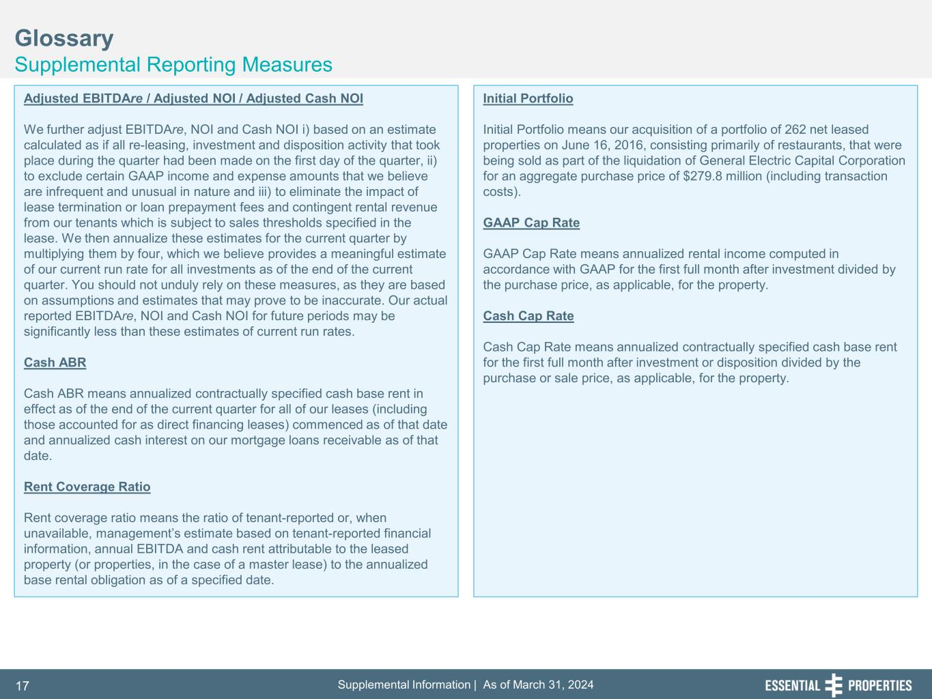
Supplemental Information | As of March 31, 202417 Glossary Supplemental Reporting Measures Adjusted EBITDAre / Adjusted NOI / Adjusted Cash NOI We further adjust EBITDAre, NOI and Cash NOI i) based on an estimate calculated as if all re-leasing, investment and disposition activity that took place during the quarter had been made on the first day of the quarter, ii) to exclude certain GAAP income and expense amounts that we believe are infrequent and unusual in nature and iii) to eliminate the impact of lease termination or loan prepayment fees and contingent rental revenue from our tenants which is subject to sales thresholds specified in the lease. We then annualize these estimates for the current quarter by multiplying them by four, which we believe provides a meaningful estimate of our current run rate for all investments as of the end of the current quarter. You should not unduly rely on these measures, as they are based on assumptions and estimates that may prove to be inaccurate. Our actual reported EBITDAre, NOI and Cash NOI for future periods may be significantly less than these estimates of current run rates. Cash ABR Cash ABR means annualized contractually specified cash base rent in effect as of the end of the current quarter for all of our leases (including those accounted for as direct financing leases) commenced as of that date and annualized cash interest on our mortgage loans receivable as of that date. Rent Coverage Ratio Rent coverage ratio means the ratio of tenant-reported or, when unavailable, management’s estimate based on tenant-reported financial information, annual EBITDA and cash rent attributable to the leased property (or properties, in the case of a master lease) to the annualized base rental obligation as of a specified date. Initial Portfolio Initial Portfolio means our acquisition of a portfolio of 262 net leased properties on June 16, 2016, consisting primarily of restaurants, that were being sold as part of the liquidation of General Electric Capital Corporation for an aggregate purchase price of $279.8 million (including transaction costs). GAAP Cap Rate GAAP Cap Rate means annualized rental income computed in accordance with GAAP for the first full month after investment divided by the purchase price, as applicable, for the property. Cash Cap Rate Cash Cap Rate means annualized contractually specified cash base rent for the first full month after investment or disposition divided by the purchase or sale price, as applicable, for the property.

