UNITED STATES
SECURITIES AND EXCHANGE COMMISSION
Washington, D.C. 20549

FORM 8-K

CURRENT REPORT

Pursuant to Section 13 or 15(d)
of the Securities Exchange Act of 1934

July 24, 2024
Date of Report (Date of earliest event reported)

Essential Properties Realty Trust, Inc.
(Exact name of registrant as specified in its charter)

Maryland |  |  |  |  |  | 001-38530 |  |  |  |  |  | 82-4005693
(State or other jurisdiction of incorporation) |  |  |  |  |  | (Commission File Number) |  |  |  |  |  | (IRS Employer Identification No.)
902 Carnegie Center Blvd., Suite 520
Princeton, New Jersey |  |  |  |  |  |  |  |  |  |  |  | 08540
(Address of principal executive offices) |  |  |  |  |  |  |  |  |  |  |  | (Zip Code)
Registrant’s telephone number, including area code: |  |  |  |  |  |  |  |  |  |  |  | (609) 436-0619

Check the appropriate box below if the Form 8-K filing is intended to simultaneously satisfy the filing obligations of the registrant under any of the following provisions:
☐ |  |  | Written communications pursuant to Rule 425 under the Securities Act 17 CFR 230.425)
☐ |  |  | Soliciting material pursuant to Rule 14a-12 under the Exchange Act (17 CFR 240.14a-12)
☐ |  |  | Pre-commencement communications pursuant to Rule 14d-2(b) under the Exchange Act (17 CFR 240.14d-2(b))
☐ |  |  | Pre-commencement communications pursuant to Rule 13e-4(c) under the Exchange Act (17 CFR 240.13e-4(c))

Securities registered pursuant to Section 12(b) of the Act:
Title of Each Class |  |  |  |  |  | Trading Symbol(s) |  |  |  |  |  | Name of Each Exchange on Which Registered
Common stock, $0.01 par value |  |  |  |  |  | EPRT |  |  |  |  |  | New York Stock Exchange

Indicate by check mark whether the registrant is an emerging growth company as defined in Rule 405 of the Securities Act of 1933 (§230.405 of this chapter) or Rule 12b-2 of the Securities Exchange Act of 1934 (§240.12b-2 of this chapter).
Emerging growth company ☐

If an emerging growth company, indicate by check mark if the registrant has elected not to use the extended transition period for complying with any new or revised financial accounting standards provided pursuant to Section 13(a) of the Exchange Act ☐

Item 2.02 — Results of Operations and Financial Condition.
On July 24, 2024, Essential Properties Realty Trust, Inc. (the “Company”) issued a press release announcing the Company’s financial results for the three and six months ended June 30, 2024. The press release is furnished hereto as Exhibit 99.1 and incorporated herein by reference.

Item 7.01— Regulation FD Disclosure.
On July 24, 2024, the Company issued its Supplemental Information—Second Quarter 2024. The Supplemental Information is furnished hereto as Exhibit 99.2 and incorporated herein by reference.
The foregoing information is furnished pursuant to Item 2.02, “Results of Operations and Financial Condition,” and Item 7.01, “Regulation FD Disclosure.” The information in Items 2.02 and 7.01 of this Current Report on Form 8-K and the exhibits furnished therewith shall not be deemed “filed” for purposes of Section 18 of the Securities Exchange Act of 1934 or otherwise subject to the liabilities of that Section, and shall not be or be deemed to be incorporated by reference in any filing under the Securities Act of 1933 or the Securities Exchange Act of 1934, regardless of any general incorporation language in such filing.

Item 9.01 — Financial Statements and Exhibits.
(d) Exhibits.

Exhibit No. |  |  | Description
99.1 |  |  | Earnings Press Release dated July 24, 2024 for the quarter ended June 30, 2024
99.2 |  |  | Supplemental Information—Second Quarter 2024
104 |  |  | Cover Page Interactive Data File (embedded within the Inline XBRL document)

SIGNATURES

Pursuant to the requirements of the Securities Exchange Act of 1934, the registrant has duly caused this report to be signed on its behalf by the undersigned hereunto duly authorized.

Date: July 24, 2024 |  |  | ESSENTIAL PROPERTIES REALTY TRUST, INC.
 |  |  | By: |  |  | /s/ Mark E. Patten
 |  |  |  |  |  | Mark E. Patten
 |  |  |  |  |  | Executive Vice President, Chief Financial Officer, Treasurer and Corporate Secretary

Exhibit 99.1

Essential Properties Announces Second Quarter 2024 Results
- Second Quarter Net Income per Share of $0.29 and AFFO per Share of $0.43 -
- Closed Investments of $333.9 million at an 8.0% Weighted Average Cash Cap Rate -
- Reiterates 2024 AFFO Guidance range of $1.72 to $1.75 per Share -
July 24, 2024
PRINCETON, N.J.--(BUSINESS WIRE)--Essential Properties Realty Trust, Inc. (NYSE: EPRT; “Essential Properties” or the “Company”) today announced operating results for the three and six months ended June 30, 2024.
Second Quarter 2024 Financial and Operating Highlights:
Operating Results (compared to Second Quarter 2023):
•Investments (83 properties) |  |  | $ Invested |  |  | $333.9 million
 |  |  | Weighted Avg Cash Cap Rate |  |  | 8.0%
•Dispositions (6 properties) |  |  | Net Proceeds |  |  | $4.8 million
 |  |  | Weighted Avg Cash Cap Rate |  |  | 7.3%
•Net Income per Share |  |  | Decreased by 17% |  |  | $0.29
•Funds from Operations ("FFO") per Share |  |  | Increased by 9% |  |  | $0.47
•Core Funds from Operations ("Core FFO") per Share |  |  | Increased by 7% |  |  | $0.47
•Adjusted Funds from Operations ("AFFO") per Share |  |  | Increased by 5% |  |  | $0.43
Debt, Equity & Leverage Update:
•Equity Raised (Gross) - ATM Program (1) |  |  | $27.15/share |  |  | $137.0 million
•Pro Forma Net Debt to Annualized Adjusted EBITDAre (2) |  |  | As of Quarter End |  |  | 3.8x
Year to Date 2024 Financial and Operating Highlights:
Operating Results (compared to YTD Second Quarter 2023):
•Investments (162 properties) |  |  | $ Invested |  |  | $582.7 million
 |  |  | Weighted Avg Cash Cap Rate |  |  | 8.0%
•Dispositions (13 properties) |  |  | Net Proceeds |  |  | $16.7 million
 |  |  | Weighted Avg Cash Cap Rate |  |  | 6.7%
•Net Income per share |  |  | Decreased by 11% |  |  | $0.57
•FFO per share |  |  | Increased by 8% |  |  | $0.93
•Core FFO per share |  |  | Increased by 8% |  |  | $0.93
•AFFO per share |  |  | Increased by 5% |  |  | $0.85
Debt & Equity Activity:
•Equity Raised (Gross) - Follow-On Offering (March 14, 2024) (1) |  |  | $24.75/share |  |  | $256.2 million
•Equity Raised (Gross) - ATM Program (1) |  |  | $26.24/share |  |  | $190.4 million
1.All shares were sold on a forward basis and 12,876,300 shares remain unsettled for estimated net proceeds of $318.7 million.
2.See page 11 for detailed calculation.
1

Activity Subsequent to Second Quarter 2024:
•Investments |  |  | $ Invested |  |  | $13.3 million
•Dispositions |  |  | $ Gross Proceeds |  |  | $4.9 million
Debt Activity:
•New 2030 Term Loan (Delayed Draw) |  |  | 5.5 Year Tenor; Adjusted Term SOFR + 105bps |  |  | $450.0 million
•Initial Draw |  |  | Fully Swapped to Fixed Rate - 4.99% All In Rate |  |  | $320.0 million
CEO Comments
Commenting on the second quarter 2024 results, the Company's President and Chief Executive Officer, Pete Mavoides, said, “Our company continued to execute at a high level in the second quarter, raising and deploying capital accretively into attractive investments against the backdrop of a growing opportunity set. With our debt and equity capital needs met for the year, our focus remains on responsibly deploying our dry powder to drive earnings growth into 2025."
Portfolio Highlights
The Company’s investment portfolio as of June 30, 2024 is summarized as follows:

 |  |  |  |  |  | June 30, 2024
Number of properties |  |  |  |  |  | 2,009
Weighted average lease term (WALT) |  |  |  |  |  | 14.1 years
Weighted average rent coverage ratio |  |  |  |  |  | 3.7x
Number of tenants |  |  |  |  |  | 395
Number of industries |  |  |  |  |  | 16
Weighted average occupancy |  |  |  |  |  | 99.8%
Total square feet of rentable space |  |  |  |  |  | 20,094,363
Cash ABR - service-oriented or experience-based |  |  |  |  |  | 93.3%
Cash ABR - properties subject to master lease |  |  |  |  |  | 70.2%
Portfolio Update
Investments
The Company’s investment activity during the three and six months ended June 30, 2024 is summarized as follows:
 |  |  |  |  |  | Quarter Ended  June 30, 2024 |  |  |  |  |  | Year to Date  June 30, 2024
Investments:
Investment volume |  |  |  |  |  | $333.9 million |  |  |  |  |  | $582.7 million
Number of transactions |  |  |  |  |  | 35 |  |  |  |  |  | 71
Property count |  |  |  |  |  | 83 |  |  |  |  |  | 162
Weighted average cash / GAAP cap rate |  |  |  |  |  | 8.0%/9.1% |  |  |  |  |  | 8.0%/9.2%
Weighted average lease escalation |  |  |  |  |  | 1.9% |  |  |  |  |  | 1.9%
% Subject to master lease |  |  |  |  |  | 76% |  |  |  |  |  | 79%
% Sale-leaseback transactions |  |  |  |  |  | 100% |  |  |  |  |  | 100%
% Existing relationship |  |  |  |  |  | 82% |  |  |  |  |  | 84%
% Required financial reporting (tenant/guarantor) |  |  |  |  |  | 100% |  |  |  |  |  | 100%
WALT |  |  |  |  |  | 17.8 years |  |  |  |  |  | 17.5 years
2

Dispositions
The Company’s disposition activity during the three and six months ended June 30, 2024 is summarized as follows:
 |  |  |  |  |  | Quarter Ended  June 30, 2024 |  |  |  |  |  | Year to Date  June 30, 2024
Dispositions:
Net proceeds |  |  |  |  |  | $4.8 million |  |  |  |  |  | $16.7 million
Number of properties sold |  |  |  |  |  | 6 |  |  |  |  |  | 13
Net gain / (loss) |  |  |  |  |  | $0.1 million |  |  |  |  |  | $1.6 million
Weighted average cash cap rate  (excluding vacant properties and sales subject to a tenant purchase option ) |  |  |  |  |  | 7.3% |  |  |  |  |  | 6.7%
Loan Repayments
Loan repayments to the Company during the three and six months ended June 30, 2024 are summarized as follows:

 |  |  |  |  |  | Quarter Ended  June 30, 2024 |  |  |  |  |  | Year to Date  June 30, 2024
Loan Repayments:
Proceeds—Principal |  |  |  |  |  | $2.0 million |  |  |  |  |  | $4.7 million
Number of properties |  |  |  |  |  | 4 |  |  |  |  |  | 10
Weighted average interest rate |  |  |  |  |  | 7.3% |  |  |  |  |  | 7.1%
Leverage and Liquidity
The Company's leverage and liquidity as of June 30, 2024 are summarized in the following table.
 |  |  |  |  |  | June 30, 2024 |  |  |  |  |  | Pro Forma (1) June 30, 2024
Leverage:
Net debt to Annualized Adjusted EBITDAre |  |  |  |  |  | 4.6x |  |  |  |  |  | 3.8x
Liquidity:
Cash and cash equivalents and restricted cash |  |  |  |  |  | $24.5 million |  |  |  |  |  | $418.2 million
Unused revolving credit facility capacity |  |  |  |  |  | $355.0 million |  |  |  |  |  | $600.0 million
2030 Term Loan - remaining availability |  |  |  |  |  | — |  |  |  |  |  | $130.0 million
Forward equity sales - unsettled |  |  |  |  |  | $318.7 million |  |  |  |  |  | —
Total available liquidity |  |  |  |  |  | $698.2 million |  |  |  |  |  | $1.1 billion
1.Pro forma adjustments have been made to reflect the 12,876,300 unsettled shares sold on a forward basis through the Company's March 2024 follow-on offering and through its ATM Program as if they had been physically settled for cash on June 30, 2024 and to adjust for the Company's new $450 million 2030 Term Loan (see below for details). A portion of the $320.0 million initial draw on the 2030 Term Loan was used to repay the full amount outstanding on the Company's revolving credit facility.
3

Equity Activity
The Company's equity activity during the three months ended June 30, 2024 is summarized in the following table.
 |  |  |  |  |  | Primary Offerings |  |  |  |  |  |  |  |  |  |  |  | ATM Program |  |  |  |  |  |  |  |  |  |  |  | Total
 |  |  |  |  |  | Shares |  |  |  |  |  | Price  (Net) (1) |  |  |  |  |  | Shares |  |  |  |  |  | Price  (Net) (1) |  |  |  |  |  | Shares |  |  |  |  |  |  | Price  (Net) (1) |  |  |  |  |  | Net Proceeds (000s)
Forward Shares Unsettled - March 31, 2024 |  |  |  |  |  | 7,828,852 |  |  |  |  |  | $23.51 |  |  |  |  |  | — |  |  |  |  |  | $— |  |  |  |  |  | 7,828,852 |  |  |  |  |  |  | $23.51 |  |  |  |  |  | $184,017
Shares Sold |  |  |  |  |  | — |  |  |  |  |  | — |  |  |  |  |  | 5,047,448 |  |  |  |  |  | 26.68 |  |  |  |  |  | 5,047,448 |  |  |  |  |  |  | 26.68 |  |  |  |  |  | 134,643
Shares Settled |  |  |  |  |  | — |  |  |  |  |  | — |  |  |  |  |  | — |  |  |  |  |  | — |  |  |  |  |  | — |  |  |  |  |  |  | — |  |  |  |  |  | —
Forward Shares Unsettled - June 30, 2024 |  |  |  |  |  | 7,828,852 |  |  |  |  |  |  |  |  |  |  |  | 5,047,448 |  |  |  |  |  |  |  |  |  |  |  | 12,876,300 |  |  |  |  |  |  | $24.75 |  |  |  |  |  | $318,660
1.All prices are inclusive of forward price adjustments as of June 30, 2024.
In June 2024, the Company established a new $500 million ATM Program and simultaneously terminated its previous 2022 ATM Program. The following table summarizes the Company's sales under the 2024 ATM Program through June 30, 2024.
 |  |  |  |  |  | June 30, 2024
ATM Program:
2024 ATM Program initial availability |  |  |  |  |  | $500.0 million
Aggregate gross sales under the 2024 ATM Program |  |  |  |  |  | $27.6 million
Availability remaining under the 2024 ATM Program |  |  |  |  |  | $472.4 million
Average price per share of gross sales since inception in June 2024 |  |  |  |  |  | $27.11
Subsequent Debt Activity
In July 2024, the Company entered into a new term loan permitting up to $450.0 million of borrowings. The below
table provides a summary of this new debt agreement.
 |  |  |  |  |  | 2030 Term Loan
Maturity Date (1) |  |  |  |  |  | January 2030
Initial Principal Drawn |  |  |  |  |  | $320.0 million
Maximum Available Principal |  |  |  |  |  | $450.0 million
Delayed Draw Period |  |  |  |  |  | 180 Days
Interest Rate |  |  |  |  |  | Adjusted Term SOFR + 105 bps(2)
Floating Rate Swapped to Fixed Rate for Initial Draw |  |  |  |  |  | 4.99% All-In Rate
1.After giving effect to extension options exercisable at the Company's election.
2.Includes 10 bps SOFR premium adjustment.

Guidance
2024 Guidance
The Company reiterates its previously issued expectation that 2024 AFFO per share on a fully diluted basis will be within a range of $1.72 to $1.75. The guidance range includes an estimate for the dilutive effect of unsettled shares under the Company's outstanding forward sale agreements as calculated under the treasury stock method.
Note: The Company does not provide guidance for the most comparable GAAP financial measure, net income, or a reconciliation of the forward-looking non-GAAP financial measure of AFFO to net income computed in accordance with GAAP, because it is unable to reasonably predict, without unreasonable efforts, certain items that would be contained in the GAAP measure, including items that are not indicative of the Company's ongoing operations, such as, without limitation, potential impairments of real estate assets, net gain/loss on dispositions of real estate assets, changes in
4

allowance for credit losses and stock-based compensation expense. These items are uncertain, depend on various factors, and could have a material impact on the Company's GAAP results for the guidance period.
Dividend Information
As previously announced, on May 31, 2024, Essential Properties' board of directors declared a cash dividend of $0.29 per share of common stock for the quarter ended June 30, 2024. The second quarter 2024 dividend represents an annualized dividend of $1.16 per share of common stock. The dividend was paid on July 12, 2024 to stockholders of record as of the close of business on June 28, 2024.
Conference Call Information
In conjunction with the release of Essential Properties’ operating results, the Company will host a conference call on Thursday, July 25, 2024 at 10:00 a.m. EDT to discuss the results. To access the conference, dial 877-407-9208 (International: 201-493-6784). A live webcast will also be available in listen-only mode by clicking on the webcast link in the Investor Relations section at www.essentialproperties.com.
A telephone replay of the conference call can also be accessed by calling 844-512-2921 (International: 412-317-6671) and entering the access code: 13747626. The telephone replay will be available through August 8, 2024.
A replay of the conference call webcast will be available on our website approximately two hours after the conclusion of the live broadcast. The webcast replay will be available for 90 days. No access code is required for this replay.
Supplemental Materials
The Company’s Supplemental Operating & Financial Data—Second Quarter Ended June 30, 2024 is available on Essential Properties’ website at investors.essentialproperties.com.
About Essential Properties Realty Trust, Inc.
Essential Properties Realty Trust, Inc. is an internally managed REIT that acquires, owns and manages primarily single- tenant properties that are net leased on a long-term basis to companies operating service-oriented or experience-based businesses. As of June 30, 2024, the Company’s portfolio consisted of 2,009 freestanding net lease properties with a weighted average lease term of 14.1 years and a weighted average rent coverage ratio of 3.7x. In addition, as of June 30, 2024, the Company’s portfolio was 99.8% leased to 395 tenants operating 568 different concepts in 16 industries across 49 states.
Forward-Looking Statements
This press release contains forward-looking statements within the meaning of the federal securities laws. When used in this press release, the words “estimate,” “anticipate,” “expect,” “believe,” “intend,” “may,” “will,” “should,” “seek,” “approximately” or “plan,” or the negative of these words and phrases or similar words or phrases that are predictions of or indicate future events or trends and that do not relate solely to historical matters are intended to identify forward-looking statements. You can also identify forward-looking statements by discussions of strategy, plans or intentions of management. Forward-looking statements involve numerous risks and uncertainties and you should not rely on them as predictions of future events. Forward-looking statements depend on assumptions, data or methods that may be incorrect or imprecise and the Company may not be able to realize them. The Company does not guarantee that the transactions and events described will happen as described (or that they will happen at all). You are cautioned not to place undue reliance on forward-looking statements, which speak only as of the date of this press release. While forward-looking statements reflect the Company’s good faith beliefs, they are not guarantees of future performance. The Company undertakes no obligation to publicly release the results of any revisions to these forward-looking statements that may be made to reflect events or circumstances after the date of this press release or to reflect the occurrence of unanticipated events, except as required by law. In light of these risks and uncertainties, the forward-looking events discussed in this press release might not occur as described, or at all.
Additional information concerning factors that could cause actual results to differ materially from these forward-looking statements is contained in the company’s Securities and Exchange Commission (the "Commission”) filings, including,
5

but not limited to, the Company’s most recent Annual Report on Form 10-K. Copies of each filing may be obtained from the Company or the Commission. Such forward-looking statements should be regarded solely as reflections of the Company’s current operating plans and estimates. Actual operating results may differ materially from what is expressed or forecast in this press release.
The results reported in this press release are preliminary and not final. There can be no assurance that these results will not vary from the final results reported in the Company’s Quarterly Report on Form 10-Q for the year ended June 30, 2024 that it will file with the Commission.

6

Essential Properties Realty Trust, Inc.
Consolidated Statements of Operations

 |  |  |  |  |  | Three months ended June 30, |  |  |  |  |  |  |  |  |  |  |  | Six months ended June 30,
(in thousands, except share and per share data) |  |  |  |  |  | 2024 |  |  |  |  |  | 2023 |  |  |  |  |  | 2024 |  |  |  |  |  | 2023
 |  |  |  |  |  | (Unaudited) |  |  |  |  |  | (Unaudited) |  |  |  |  |  | (Unaudited) |  |  |  |  |  | (Unaudited)
Revenues:
Rental revenue1,2 |  |  |  |  |  | $ | 104,369 |  |  |  |  | $ | 81,819 |  |  |  |  | $ | 202,880 |  |  |  |  | $ | 159,991
Interest on loans and direct financing lease receivables |  |  |  |  |  | 4,858 |  |  |  |  |  | 4,534 |  |  |  |  |  | 9,598 |  |  |  |  |  | 8,981
Other revenue |  |  |  |  |  | 41 |  |  |  |  |  | 163 |  |  |  |  |  | 292 |  |  |  |  |  | 1,232
Total revenues |  |  |  |  |  | 109,268 |  |  |  |  |  | 86,516 |  |  |  |  |  | 212,770 |  |  |  |  |  | 170,204
Expenses:
General and administrative |  |  |  |  |  | 8,710 |  |  |  |  |  | 7,585 |  |  |  |  |  | 18,068 |  |  |  |  |  | 16,169
Property expenses2 |  |  |  |  |  | 1,155 |  |  |  |  |  | 1,144 |  |  |  |  |  | 2,148 |  |  |  |  |  | 1,987
Depreciation and amortization |  |  |  |  |  | 29,927 |  |  |  |  |  | 24,742 |  |  |  |  |  | 58,453 |  |  |  |  |  | 48,567
Provision for impairment of real estate |  |  |  |  |  | 2,812 |  |  |  |  |  | 802 |  |  |  |  |  | 6,564 |  |  |  |  |  | 1,479
Change in provision for credit losses |  |  |  |  |  | 1 |  |  |  |  |  | 8 |  |  |  |  |  | 3 |  |  |  |  |  | (22)
Total expenses |  |  |  |  |  | 42,605 |  |  |  |  |  | 34,281 |  |  |  |  |  | 85,236 |  |  |  |  |  | 68,180
Other operating income:
Gain on dispositions of real estate, net |  |  |  |  |  | 134 |  |  |  |  |  | 12,547 |  |  |  |  |  | 1,645 |  |  |  |  |  | 17,461
Income from operations |  |  |  |  |  | 66,797 |  |  |  |  |  | 64,782 |  |  |  |  |  | 129,179 |  |  |  |  |  | 119,485
Other (expense)/income:
Interest expense |  |  |  |  |  | (17,361) |  |  |  |  |  | (12,071) |  |  |  |  |  | (32,958) |  |  |  |  |  | (24,204)
Interest income |  |  |  |  |  | 847 |  |  |  |  |  | 448 |  |  |  |  |  | 1,340 |  |  |  |  |  | 1,086
Other income |  |  |  |  |  | 1,548 |  |  |  |  |  | — |  |  |  |  |  | 1,548 |  |  |  |  |  | —
Income before income tax expense |  |  |  |  |  | 51,831 |  |  |  |  |  | 53,159 |  |  |  |  |  | 99,109 |  |  |  |  |  | 96,367
Income tax expense |  |  |  |  |  | 155 |  |  |  |  |  | 159 |  |  |  |  |  | 311 |  |  |  |  |  | 311
Net income |  |  |  |  |  | 51,676 |  |  |  |  |  | 53,000 |  |  |  |  |  | 98,798 |  |  |  |  |  | 96,056
Net income attributable to non-controlling interests |  |  |  |  |  | (159) |  |  |  |  |  | (198) |  |  |  |  |  | (307) |  |  |  |  |  | (358)
Net income attributable to stockholders |  |  |  |  |  | $ | 51,517 |  |  |  |  | $ | 52,802 |  |  |  |  | $ | 98,491 |  |  |  |  | $ | 95,698
Basic weighted-average shares outstanding |  |  |  |  |  | 175,319,270 |  |  |  |  |  | 150,492,454 |  |  |  |  |  | 171,304,986 |  |  |  |  |  | 147,466,087
Basic net income per share |  |  |  |  |  | $ | 0.29 |  |  |  |  | $ | 0.35 |  |  |  |  | $ | 0.57 |  |  |  |  | $ | 0.65
Diluted weighted-average shares outstanding |  |  |  |  |  | 177,583,989 |  |  |  |  |  | 151,522,350 |  |  |  |  |  | 173,219,295 |  |  |  |  |  | 148,776,458
Diluted net income per share |  |  |  |  |  | $ | 0.29 |  |  |  |  | $ | 0.35 |  |  |  |  | $ | 0.57 |  |  |  |  | $ | 0.64
1.Includes contingent rent (based on a percentage of the tenant's gross sales at the leased property) of $96, $144, $334 and $320 for the three and six months ended June 30, 2024 and 2023, respectively.
2.Includes reimbursable income or reimbursable expenses from the Company’s tenants of $613, $750, $1,161 and $1,341 for the three and six months ended June 30, 2024 and 2023, respectively.
7

Essential Properties Realty Trust, Inc.
Consolidated Balance Sheets

(in thousands, expect share and per share amounts) |  |  |  |  |  | June 30, 2024 |  |  |  |  |  | December 31, 2023
 |  |  |  |  |  | (Unaudited) |  |  |  |  |  | (Audited)
ASSETS
Investments:
Real estate investments, at cost:
Land and improvements |  |  |  |  |  | $ | 1,730,117 |  |  |  |  | $ | 1,542,302
Building and improvements |  |  |  |  |  | 3,162,052 |  |  |  |  |  | 2,938,012
Lease incentive |  |  |  |  |  | 17,918 |  |  |  |  |  | 17,890
Construction in progress |  |  |  |  |  | 169,844 |  |  |  |  |  | 96,524
Intangible lease assets |  |  |  |  |  | 87,734 |  |  |  |  |  | 89,209
Total real estate investments, at cost |  |  |  |  |  | 5,167,665 |  |  |  |  |  | 4,683,937
Less: accumulated depreciation and amortization |  |  |  |  |  | (421,486) |  |  |  |  |  | (367,133)
Total real estate investments, net |  |  |  |  |  | 4,746,179 |  |  |  |  |  | 4,316,804
Loans and direct financing lease receivables, net |  |  |  |  |  | 294,982 |  |  |  |  |  | 223,854
Real estate investments held for sale, net |  |  |  |  |  | 8,677 |  |  |  |  |  | 7,455
Net investments |  |  |  |  |  | 5,049,838 |  |  |  |  |  | 4,548,113
Cash and cash equivalents |  |  |  |  |  | 23,557 |  |  |  |  |  | 39,807
Restricted cash |  |  |  |  |  | 935 |  |  |  |  |  | 9,156
Straight-line rent receivable, net |  |  |  |  |  | 127,210 |  |  |  |  |  | 107,545
Derivative assets |  |  |  |  |  | 36,049 |  |  |  |  |  | 30,980
Rent receivables, prepaid expenses and other assets, net |  |  |  |  |  | 29,608 |  |  |  |  |  | 32,660
Total assets |  |  |  |  |  | $ | 5,267,197 |  |  |  |  | $ | 4,768,261
LIABILITIES AND EQUITY
Unsecured term loans, net of deferred financing costs |  |  |  |  |  | $ | 1,273,958 |  |  |  |  | $ | 1,272,772
Senior unsecured notes, net |  |  |  |  |  | 396,125 |  |  |  |  |  | 395,846
Revolving credit facility |  |  |  |  |  | 245,000 |  |  |  |  |  | —
Intangible lease liabilities, net |  |  |  |  |  | 10,762 |  |  |  |  |  | 11,206
Dividend payable |  |  |  |  |  | 51,124 |  |  |  |  |  | 47,182
Derivative liabilities |  |  |  |  |  | 7,018 |  |  |  |  |  | 23,005
Accrued liabilities and other payables |  |  |  |  |  | 30,939 |  |  |  |  |  | 31,248
Total liabilities |  |  |  |  |  | 2,014,926 |  |  |  |  |  | 1,781,259
Commitments and contingencies |  |  |  |  |  | — |  |  |  |  |  | —
Stockholders' equity:
Preferred stock, $0.01 par value; 150,000,000 authorized; none issued and outstanding as of June 30, 2024 and December 31, 2023 |  |  |  |  |  | — |  |  |  |  |  | —
Common stock, $0.01 par value; 500,000,000 authorized; 175,330,314 and 164,635,150 issued and outstanding as of June 30, 2024 and December 31, 2023, respectively |  |  |  |  |  | 1,753 |  |  |  |  |  | 1,646
Additional paid-in capital |  |  |  |  |  | 3,328,082 |  |  |  |  |  | 3,078,459
Distributions in excess of cumulative earnings |  |  |  |  |  | (111,373) |  |  |  |  |  | (105,545)
Accumulated other comprehensive income |  |  |  |  |  | 25,336 |  |  |  |  |  | 4,019
Total stockholders' equity |  |  |  |  |  | 3,243,798 |  |  |  |  |  | 2,978,579
Non-controlling interests |  |  |  |  |  | 8,473 |  |  |  |  |  | 8,423
Total equity |  |  |  |  |  | 3,252,271 |  |  |  |  |  | 2,987,002
Total liabilities and equity |  |  |  |  |  | $ | 5,267,197 |  |  |  |  | $ | 4,768,261
8

Essential Properties Realty Trust, Inc.
Reconciliation of Non-GAAP Financial Measures

 |  |  |  |  |  | Three months ended June 30, |  |  |  |  |  |  |  |  |  |  |  | Six months ended June 30,
(unaudited, in thousands except per share amounts) |  |  |  |  |  | 2024 |  |  |  |  |  | 2023 |  |  |  |  |  | 2024 |  |  |  |  |  | 2023
Net income |  |  |  |  |  | $ | 51,676 |  |  |  |  | $ | 53,000 |  |  |  |  | $ | 98,798 |  |  |  |  | $ | 96,056
Depreciation and amortization of real estate |  |  |  |  |  | 29,887 |  |  |  |  |  | 24,717 |  |  |  |  |  | 58,372 |  |  |  |  |  | 48,515
Provision for impairment of real estate |  |  |  |  |  | 2,812 |  |  |  |  |  | 802 |  |  |  |  |  | 6,564 |  |  |  |  |  | 1,479
Gain on dispositions of real estate, net |  |  |  |  |  | (134) |  |  |  |  |  | (12,547) |  |  |  |  |  | (1,645) |  |  |  |  |  | (17,461)
Funds from Operations |  |  |  |  |  | 84,241 |  |  |  |  |  | 65,972 |  |  |  |  |  | 162,089 |  |  |  |  |  | 128,589
Non-core expense (income)1 |  |  |  |  |  | — |  |  |  |  |  | 172 |  |  |  |  |  | — |  |  |  |  |  | (704)
Core Funds from Operations |  |  |  |  |  | 84,241 |  |  |  |  |  | 66,144 |  |  |  |  |  | 162,089 |  |  |  |  |  | 127,885
Adjustments:
Straight-line rental revenue, net |  |  |  |  |  | (10,180) |  |  |  |  |  | (6,710) |  |  |  |  |  | (20,159) |  |  |  |  |  | (13,548)
Non-cash interest |  |  |  |  |  | 934 |  |  |  |  |  | 615 |  |  |  |  |  | 1,884 |  |  |  |  |  | 1,434
Non-cash compensation expense |  |  |  |  |  | 2,642 |  |  |  |  |  | 2,157 |  |  |  |  |  | 5,587 |  |  |  |  |  | 4,878
Other amortization expense |  |  |  |  |  | 257 |  |  |  |  |  | 254 |  |  |  |  |  | 475 |  |  |  |  |  | 535
Other non-cash adjustments |  |  |  |  |  | 568 |  |  |  |  |  | 2 |  |  |  |  |  | 561 |  |  |  |  |  | (33)
Capitalized interest expense |  |  |  |  |  | (1,345) |  |  |  |  |  | (582) |  |  |  |  |  | (2,203) |  |  |  |  |  | (1,015)
Adjusted Funds from Operations |  |  |  |  |  | $ | 77,117 |  |  |  |  | $ | 61,880 |  |  |  |  | $ | 148,234 |  |  |  |  | $ | 120,136
Net income per share2:
Basic |  |  |  |  |  | $ | 0.29 |  |  |  |  | $ | 0.35 |  |  |  |  | $ | 0.57 |  |  |  |  | $ | 0.65
Diluted |  |  |  |  |  | $ | 0.29 |  |  |  |  | $ | 0.35 |  |  |  |  | $ | 0.57 |  |  |  |  | $ | 0.64
FFO per share2:
Basic |  |  |  |  |  | $ | 0.48 |  |  |  |  | $ | 0.44 |  |  |  |  | $ | 0.94 |  |  |  |  | $ | 0.87
Diluted |  |  |  |  |  | $ | 0.47 |  |  |  |  | $ | 0.43 |  |  |  |  | $ | 0.93 |  |  |  |  | $ | 0.86
Core FFO per share2:
Basic |  |  |  |  |  | $ | 0.48 |  |  |  |  | $ | 0.44 |  |  |  |  | $ | 0.94 |  |  |  |  | $ | 0.86
Diluted |  |  |  |  |  | $ | 0.47 |  |  |  |  | $ | 0.44 |  |  |  |  | $ | 0.93 |  |  |  |  | $ | 0.86
AFFO per share2:
Basic |  |  |  |  |  | $ | 0.44 |  |  |  |  | $ | 0.41 |  |  |  |  | $ | 0.86 |  |  |  |  | $ | 0.81
Diluted |  |  |  |  |  | $ | 0.43 |  |  |  |  | $ | 0.41 |  |  |  |  | $ | 0.85 |  |  |  |  | $ | 0.81
1.During the three and six months ended June 30, 2023, includes $0.2 million of severance expense and accelerated non-cash compensation expense; during the six months ended June 30, 2023, includes $0.9 million of insurance recovery income related to two properties.
2.Calculations exclude $118, $102, $234 and $203 from the numerator for the three and six months ended June 30, 2024 and 2023, respectively, related to dividends paid on unvested restricted share awards and restricted share units.
9

Essential Properties Realty Trust, Inc.
Reconciliation of Non-GAAP Financial Measures

(in thousands) |  |  |  |  |  | Three months ended June 30, 2024
Net income |  |  |  |  |  | $ | 51,676
Depreciation and amortization |  |  |  |  |  | 29,927
Interest expense |  |  |  |  |  | 17,361
Interest income |  |  |  |  |  | (847)
Income tax expense |  |  |  |  |  | 155
EBITDA |  |  |  |  |  | 98,272
Provision for impairment of real estate |  |  |  |  |  | 2,812
Gain on dispositions of real estate, net |  |  |  |  |  | (134)
EBITDAre |  |  |  |  |  | 100,950
Adjustment for current quarter re-leasing, acquisition and disposition activity1 |  |  |  |  |  | 5,446
Adjustment to exclude other non-core or non-recurring activity2 |  |  |  |  |  | (2,196)
Adjustment to exclude termination/prepayment fees and certain percentage rent3 |  |  |  |  |  | (19)
Adjusted EBITDAre - Current Estimated Run Rate |  |  |  |  |  | 104,181
General and administrative expense |  |  |  |  |  | 8,822
Adjusted net operating income ("NOI") |  |  |  |  |  | 113,003
Straight-line rental revenue, net1 |  |  |  |  |  | (10,697)
Other amortization expense |  |  |  |  |  | 257
Adjusted Cash NOI |  |  |  |  |  | $ | 102,563
Annualized EBITDAre |  |  |  |  |  | $ | 403,800
Annualized Adjusted EBITDAre |  |  |  |  |  | $ | 416,724
Annualized Adjusted NOI |  |  |  |  |  | $ | 452,012
Annualized Adjusted Cash NOI |  |  |  |  |  | $ | 410,252
1.Adjustment is made to reflect EBITDAre, NOI and Cash NOI as if all re-leasing activity, investments in and dispositions of real estate and loan repayments completed during the three months ended June 30, 2024 had occurred on April 1, 2024.
2.Adjustment is made to i) exclude non-core adjustments made in computing Core FFO, ii) exclude changes in the Company's provision for credit losses and iii) eliminate the impact of seasonal fluctuation in certain non-cash compensation expense recorded in the period.
3.Adjustment excludes lease termination or loan prepayment fees and contingent rent (based on a percentage of the tenant's gross sales at the leased property) where payment is subject to exceeding a sales threshold specified in the lease, if any.
10

Essential Properties Realty Trust, Inc.
Reconciliation of Non-GAAP Financial Measures

(dollars in thousands, except share and per share amounts) |  |  |  |  |  | June 30, 2024 |  |  |  |  |  | Rate |  |  |  |  |  | Wtd. Avg. Maturity
Unsecured debt:
February 2027 term loan1 |  |  |  |  |  | $ | 430,000 |  |  |  |  | 2.4% |  |  |  |  |  | 2.6 years
January 2028 term loan1 |  |  |  |  |  | 400,000 |  |  |  |  |  | 4.6% |  |  |  |  |  | 3.6 years
February 2029 term loan1,2 |  |  |  |  |  | 450,000 |  |  |  |  |  | 5.4% |  |  |  |  |  | 4.7 years
Senior unsecured notes due July 2031 |  |  |  |  |  | 400,000 |  |  |  |  |  | 3.1% |  |  |  |  |  | 7.0 years
Revolving credit facility3 |  |  |  |  |  | 245,000 |  |  |  |  |  | 6.2% |  |  |  |  |  | 1.6 years
Total unsecured debt |  |  |  |  |  | 1,925,000 |  |  |  |  |  | 4.2% |  |  |  |  |  | 4.1 years
Gross debt |  |  |  |  |  | 1,925,000
Less: cash & cash equivalents |  |  |  |  |  | (23,557)
Less: restricted cash available for future investment |  |  |  |  |  | (935)
Net debt |  |  |  |  |  | 1,900,508
Equity:
Preferred stock |  |  |  |  |  | —
Common stock & OP units (175,884,161 shares @ $27.71/share as of 6/30/24)4 |  |  |  |  |  | 4,873,750
Total equity |  |  |  |  |  | 4,873,750
Total enterprise value ("TEV") |  |  |  |  |  | $ | 6,774,258
Pro forma adjustments to Net debt and TEV:5
Net debt |  |  |  |  |  | $ | 1,900,508
Less: Unsettled forward equity (12,876,300 shares @ $24.75/share as of 6/30/24) |  |  |  |  |  | (318,660)
Pro forma net debt |  |  |  |  |  | 1,581,848
Total equity |  |  |  |  |  | 4,873,750
Common stock — unsettled forward equity (12,876,300 shares @ $27.71/share as of 6/30/24) |  |  |  |  |  | 356,802
Pro forma TEV |  |  |  |  |  | $ | 6,812,400
Gross Debt / Undepreciated Gross Assets |  |  |  |  |  | 33.8 |  | %
Net Debt / TEV |  |  |  |  |  | 28.1 |  | %
Net Debt / Annualized Adjusted EBITDAre |  |  |  |  |  | 4.6x
Pro Forma Gross Debt / Undepreciated Gross Assets |  |  |  |  |  | 32.0 |  | %
Pro Forma Net Debt / Pro Forma TEV |  |  |  |  |  | 23.2 |  | %
Pro Forma Net Debt / Annualized Adjusted EBITDAre |  |  |  |  |  | 3.8x
1.Rates presented for the Company's term loans are fixed at the stated rates after giving effect to its interest rate swaps plus applicable margin and SOFR premium of 95bps (for 2027 and 2028 Term Loans) or 105bps (for 2029 Term Loan).
2.Weighted average maturity calculation is made after giving effect to extension options exercisable at the Company's election.
3.The Company's revolving credit facility provides a maximum aggregate initial original principal amount of up to $600 million. Borrowings bear interest at Term SOFR plus applicable margin and SOFR premium of 87.5bps.
4.Common stock & OP units as of June 30, 2024, based on 175,330,314 common shares outstanding and 553,847 OP units held by non-controlling interests.
5.Pro forma adjustments have been made to reflect the unsettled portion of shares sold on a forward basis through the Company's March 2024 follow-on offering and through its ATM Program as if they had been physically settled on June 30, 2024.
11

Investor/Media:
Essential Properties Realty Trust, Inc.
Robert W. Salisbury, CFA
Senior Vice President, Head of Capital Markets
609-436-0619
investors@essentialproperties.com
Source: Essential Properties Realty Trust, Inc.
12

Appendix A
Non-GAAP Financial Measures and Certain Definitions
The Company’s reported results are presented in accordance with GAAP. The Company also discloses the following non-GAAP financial measures: FFO, Core FFO, AFFO, earnings before interest, taxes, depreciation and amortization (“EBITDA”), EBITDA further adjusted to exclude gains (or losses) on sales of depreciable property and real estate impairment losses (“EBITDAre”), adjusted EBITDAre, annualized adjusted EBITDAre, net debt, net operating income (“NOI”) and cash NOI (“Cash NOI”). The Company believes these non-GAAP financial measures are industry measures used by analysts and investors to compare the operating performance of REITs.
FFO, Core FFO and AFFO
The Company computes FFO in accordance with the definition adopted by the Board of Governors of the National Association of Real Estate Investment Trusts ("NAREIT"). NAREIT defines FFO as GAAP net income or loss adjusted to exclude extraordinary items (as defined by GAAP), net gain or loss from sales of depreciable real estate assets, impairment write-downs associated with depreciable real estate assets and real estate-related depreciation and amortization (excluding amortization of deferred financing costs and depreciation of non-real estate assets), including the pro rata share of such adjustments of unconsolidated subsidiaries. FFO is used by management, and may be useful to investors and analysts, to facilitate meaningful comparisons of operating performance between periods and among the Company’s peers primarily because it excludes the effect of real estate depreciation and amortization and net gains and losses on sales (which are dependent on historical costs and implicitly assume that the value of real estate diminishes predictably over time, rather than fluctuating based on existing market conditions).
The Company computes Core FFO by adjusting FFO, as defined by NAREIT, to exclude certain GAAP income and expense amounts that it believes are infrequent and unusual in nature and/or not related to its core real estate operations. Exclusion of these items from similar FFO-type metrics is common within the equity REIT industry, and management believes that presentation of Core FFO provides investors with a metric to assist in their evaluation of our operating performance across multiple periods and in comparison to the operating performance of our peers, because it removes the effect of unusual items that are not expected to impact our operating performance on an ongoing basis.
Core FFO is used by management in evaluating the performance of our core business operations. Items included in calculating FFO that may be excluded in calculating Core FFO include certain transaction related gains, losses, income or expenses or other non-core amounts as they occur.
To derive AFFO, the Company modifies its computation of Core FFO to include other adjustments to GAAP net income related to certain items that it believes are not indicative of the Company’s operating performance, including straight-line rental revenue, non-cash interest expense, non-cash compensation expense, other amortization expense, other non-cash charges (including changes to our provision for loan losses following the adoption of ASC 326), capitalized interest expense and transaction costs. Such items may cause short-term fluctuations in net income but have no impact on operating cash flows or long-term operating performance. The Company believes that AFFO is an additional useful supplemental measure for investors to consider when assessing the Company’s operating performance without the distortions created by non-cash items and certain other revenues and expenses.
FFO, Core FFO and AFFO do not include all items of revenue and expense included in net income, they do not represent cash generated from operating activities and they are not necessarily indicative of cash available to fund cash requirements; accordingly, they should not be considered alternatives to net income as a performance measure or cash flows from operations as a liquidity measure and should be considered in addition to, and not in lieu of, GAAP financial measures. Additionally, our computation of FFO, Core FFO and AFFO may differ from the methodology for calculating these metrics used by other equity REITs and, therefore, may not be comparable to similarly titled measures reported by other equity REITs.
EBITDA and EBITDAre
The Company computes EBITDA as earnings before interest, income taxes and depreciation and amortization. In 2017, NAREIT issued a white paper recommending that companies that report EBITDA also report EBITDAre. The Company
13

computes EBITDAre in accordance with the definition adopted by NAREIT. NAREIT defines EBITDAre as EBITDA (as defined above) excluding gains (or losses) from the sales of depreciable property and real estate impairment losses. The Company presents EBITDA and EBITDAre as they are measures commonly used in its industry and the Company believes that these measures are useful to investors and analysts because they provide supplemental information concerning its operating performance, exclusive of certain non-cash items and other costs. The Company uses EBITDA and EBITDAre as measures of its operating performance and not as measures of liquidity.
EBITDA and EBITDAre do not include all items of revenue and expense included in net income, they do not represent cash generated from operating activities and they are not necessarily indicative of cash available to fund cash requirements; accordingly, they should not be considered alternatives to net income as a performance measure or cash flows from operations as a liquidity measure and should be considered in addition to, and not in lieu of, GAAP financial measures. Additionally, the Company’s computation of EBITDA and EBITDAre may differ from the methodology for calculating these metrics used by other equity REITs and, therefore, may not be comparable to similarly titled measures reported by other equity REITs.
Net Debt
The Company calculates its net debt as its gross debt (defined as total debt plus net deferred financing costs on its secured borrowings) less cash and cash equivalents and restricted cash available for future investment. The Company believes excluding cash and cash equivalents and restricted cash available for future investment from gross debt, all of which could be used to repay debt, provides an estimate of the net contractual amount of borrowed capital to be repaid, which it believes is a beneficial disclosure to investors and analysts.
NOI and Cash NOI
The Company computes NOI as total revenues less property expenses. NOI excludes all other items of expense and income included in the financial statements in calculating net income or loss. Cash NOI further excludes non-cash items included in total revenues and property expenses, such as straight-line rental revenue and other amortization and non-cash charges. The Company believes NOI and Cash NOI provide useful information because they reflect only those revenue and expense items that are incurred at the property level and present such items on an unlevered basis.
NOI and Cash NOI are not measures of financial performance under GAAP. You should not consider the Company’s NOI and Cash NOI as alternatives to net income or cash flows from operating activities determined in accordance with GAAP. Additionally, the Company’s computation of NOI and Cash NOI may differ from the methodology for calculating these metrics used by other equity REITs and, therefore, may not be comparable to similarly titled measures reported by other equity REITs.
Adjusted EBITDAre / Adjusted NOI / Adjusted Cash NOI
The Company further adjusts EBITDAre, NOI and Cash NOI i) based on an estimate calculated as if all investment and disposition activity that took place during the quarter had occurred on the first day of the quarter, ii) to exclude certain GAAP income and expense amounts that the Company believes are infrequent and unusual in nature and iii) to eliminate the impact of lease termination or loan prepayment fees and contingent rental revenue from its tenants which is subject to sales thresholds specified in the lease. The Company then annualizes these estimates for the current quarter by multiplying them by four, which it believes provides a meaningful estimate of the Company’s current run rate for all investments as of the end of the current quarter. You should not unduly rely on these measures, as they are based on assumptions and estimates that may prove to be inaccurate. The Company’s actual reported EBITDAre, NOI and Cash NOI for future periods may be significantly less than these estimates of current run rates.
Cash ABR
Cash ABR means annualized contractually specified cash base rent in effect as of the end of the current quarter for all of the Company’s leases (including those accounted for as direct financing leases) commenced as of that date and annualized cash interest on its mortgage loans receivable as of that date.
14

Cash Cap Rate
Cash Cap Rate means annualized contractually specified cash base rent for the first full month after investment or disposition divided by the purchase or sale price, as applicable, for the property.
GAAP Cap Rate
GAAP Cap Rate means annualized rental income computed in accordance with GAAP for the first full month after investment divided by the purchase price, as applicable, for the property.
Rent Coverage Ratio
Rent coverage ratio means the ratio of tenant-reported or, when unavailable, management’s estimate based on tenant-reported financial information, annual EBITDA and cash rent attributable to the leased property (or properties, in the case of a master lease) to the annualized base rental obligation as of a specified date.
15

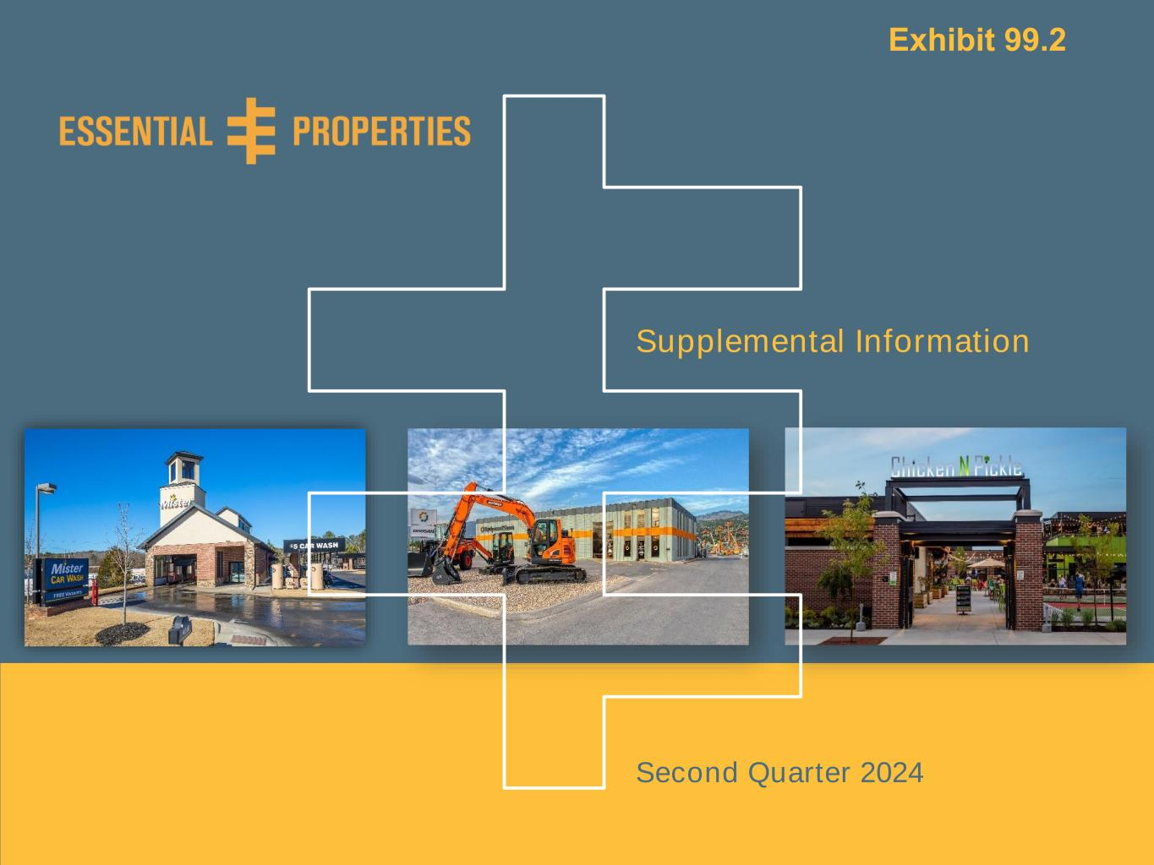
Supplemental Information | As of June 30, 20240 Supplemental Information Second Quarter 2024 Exhibit 99.2

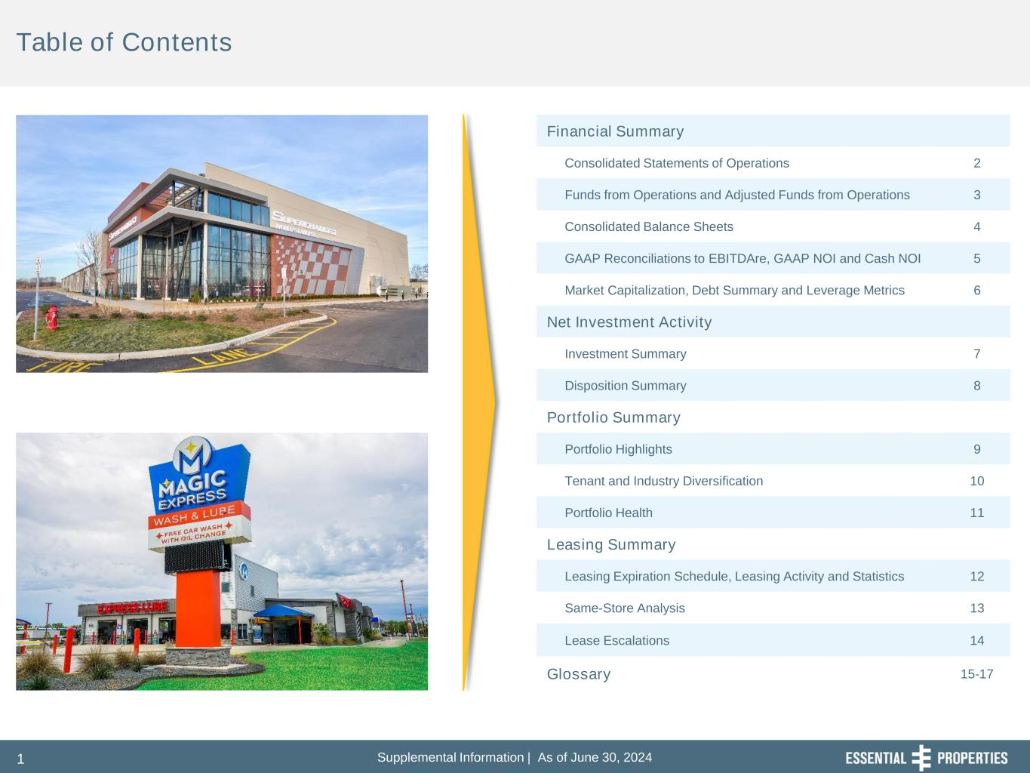
Supplemental Information | As of June 30, 20241 Table of Contents Financial Summary Consolidated Statements of Operations 2 Funds from Operations and Adjusted Funds from Operations 3 Consolidated Balance Sheets 4 GAAP Reconciliations to EBITDAre, GAAP NOI and Cash NOI 5 Market Capitalization, Debt Summary and Leverage Metrics 6 Net Investment Activity Investment Summary 7 Disposition Summary 8 Portfolio Summary Portfolio Highlights 9 Tenant and Industry Diversification 10 Portfolio Health 11 Leasing Summary Leasing Expiration Schedule, Leasing Activity and Statistics 12 Same-Store Analysis 13 Lease Escalations 14 Glossary 15-17

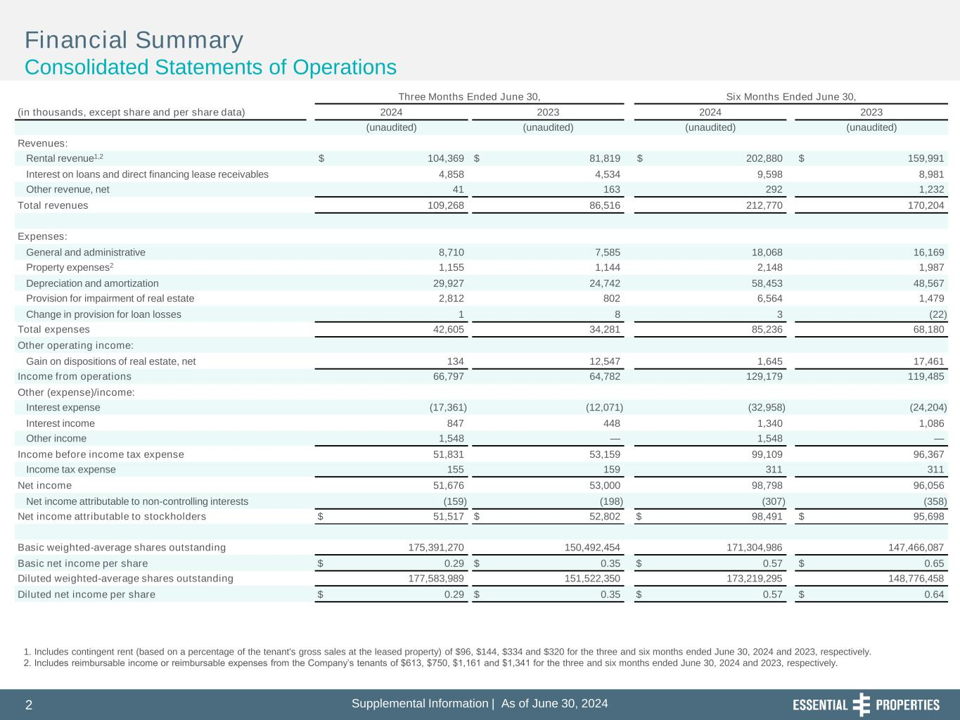
Supplemental Information | As of June 30, 20242 l t l I f r ti | s f J , 2 1. Includes contingent rent (based on a percentage of the tenant's gross sales at the leased property) of $96, $144, $334 and $320 for the three and six months ended June 30, 2024 and 2023, respectively. 2. Includes reimbursable income or reimbursable expenses from the Company’s tenants of $613, $750, $1,161 and $1,341 for the three and six months ended June 30, 2024 and 2023, respectively. Financial Summary Consolidated Statements of Operations Three Months Ended June 30, Six Months Ended June 30, (in thousands, except share and per share data) 2024 2023 2024 2023 (unaudited) (unaudited) (unaudited) (unaudited) Revenues: Rental revenue1,2 $ 104,369 $ 81,819 $ 202,880 $ 159,991 Interest on loans and direct financing lease receivables 4,858 4,534 9,598 8,981 Other revenue, net 41 163 292 1,232 Total revenues 109,268 86,516 212,770 170,204 Expenses: General and administrative 8,710 7,585 18,068 16,169 Property expenses2 1,155 1,144 2,148 1,987 Depreciation and amortization 29,927 24,742 58,453 48,567 Provision for impairment of real estate 2,812 802 6,564 1,479 Change in provision for loan losses 1 8 3 (22) Total expenses 42,605 34,281 85,236 68,180 Other operating income: Gain on dispositions of real estate, net 134 12,547 1,645 17,461 Income from operations 66,797 64,782 129,179 119,485 Other (expense)/income: Interest expense (17,361) (12,071) (32,958) (24,204) Interest income 847 448 1,340 1,086 Other income 1,548 — 1,548 — Income before income tax expense 51,831 53,159 99,109 96,367 Income tax expense 155 159 311 311 Net income 51,676 53,000 98,798 96,056 Net income attributable to non-controlling interests (159) (198) (307) (358) Net income attributable to stockholders $ 51,517 $ 52,802 $ 98,491 $ 95,698 Basic weighted-average shares outstanding 175,391,270 150,492,454 171,304,986 147,466,087 Basic net income per share $ 0.29 $ 0.35 $ 0.57 $ 0.65 Diluted weighted-average shares outstanding 177,583,989 151,522,350 173,219,295 148,776,458 Diluted net income per share $ 0.29 $ 0.35 $ 0.57 $ 0.64

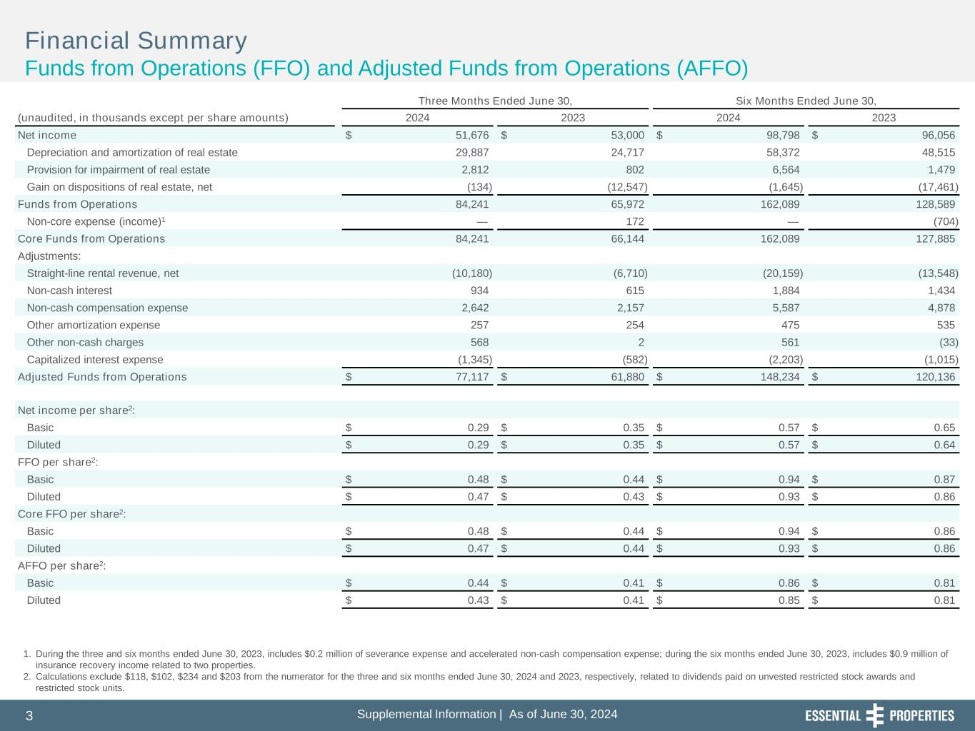
Supplemental Information | As of June 30, 20243 l t l I f r ti | s f J , 3 1. During the three and six months ended June 30, 2023, includes $0.2 million of severance expense and accelerated non-cash compensation expense; during the six months ended June 30, 2023, includes $0.9 million of insurance recovery income related to two properties. 2. Calculations exclude $118, $102, $234 and $203 from the numerator for the three and six months ended June 30, 2024 and 2023, respectively, related to dividends paid on unvested restricted stock awards and restricted stock units. Financial Summary Funds from Operations (FFO) and Adjusted Funds from Operations (AFFO) Three Months Ended June 30, Six Months Ended June 30, (unaudited, in thousands except per share amounts) 2024 2023 2024 2023 Net income $ 51,676 $ 53,000 $ 98,798 $ 96,056 Depreciation and amortization of real estate 29,887 24,717 58,372 48,515 Provision for impairment of real estate 2,812 802 6,564 1,479 Gain on dispositions of real estate, net (134) (12,547) (1,645) (17,461) Funds from Operations 84,241 65,972 162,089 128,589 Non-core expense (income)1 — 172 — (704) Core Funds from Operations 84,241 66,144 162,089 127,885 Adjustments: Straight-line rental revenue, net (10,180) (6,710) (20,159) (13,548) Non-cash interest 934 615 1,884 1,434 Non-cash compensation expense 2,642 2,157 5,587 4,878 Other amortization expense 257 254 475 535 Other non-cash charges 568 2 561 (33) Capitalized interest expense (1,345) (582) (2,203) (1,015) Adjusted Funds from Operations $ 77,117 $ 61,880 $ 148,234 $ 120,136 Net income per share2: Basic $ 0.29 $ 0.35 $ 0.57 $ 0.65 Diluted $ 0.29 $ 0.35 $ 0.57 $ 0.64 FFO per share2: Basic $ 0.48 $ 0.44 $ 0.94 $ 0.87 Diluted $ 0.47 $ 0.43 $ 0.93 $ 0.86 Core FFO per share2: Basic $ 0.48 $ 0.44 $ 0.94 $ 0.86 Diluted $ 0.47 $ 0.44 $ 0.93 $ 0.86 AFFO per share2: Basic $ 0.44 $ 0.41 $ 0.86 $ 0.81 Diluted $ 0.43 $ 0.41 $ 0.85 $ 0.81

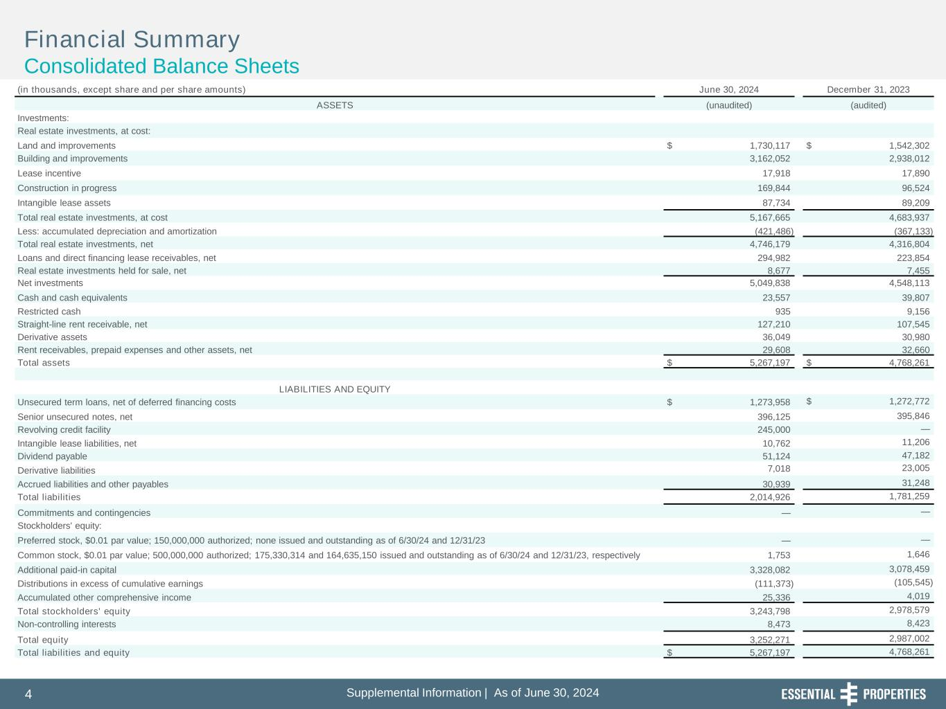
Supplemental Information | As of June 30, 20244 l t l I f r ti | s f J , 4 Financial Summary Consolidated Balance Sheets (in thousands, except share and per share amounts) June 30, 2024 December 31, 2023 ASSETS (unaudited) (audited) Investments: Real estate investments, at cost: Land and improvements $ 1,730,117 $ 1,542,302 Building and improvements 3,162,052 2,938,012 Lease incentive 17,918 17,890 Construction in progress 169,844 96,524 Intangible lease assets 87,734 89,209 Total real estate investments, at cost 5,167,665 4,683,937 Less: accumulated depreciation and amortization (421,486) (367,133) Total real estate investments, net 4,746,179 4,316,804 Loans and direct financing lease receivables, net 294,982 223,854 Real estate investments held for sale, net 8,677 7,455 Net investments 5,049,838 4,548,113 Cash and cash equivalents 23,557 39,807 Restricted cash 935 9,156 Straight-line rent receivable, net 127,210 107,545 Derivative assets 36,049 30,980 Rent receivables, prepaid expenses and other assets, net 29,608 32,660 Total assets $ 5,267,197 $ 4,768,261 LIABILITIES AND EQUITY Unsecured term loans, net of deferred financing costs $ 1,273,958 $ 1,272,772 Senior unsecured notes, net 396,125 395,846 Revolving credit facility 245,000 — Intangible lease liabilities, net 10,762 11,206 Dividend payable 51,124 47,182 Derivative liabilities 7,018 23,005 Accrued liabilities and other payables 30,939 31,248 Total liabilities 2,014,926 1,781,259 Commitments and contingencies — — Stockholders' equity: Preferred stock, $0.01 par value; 150,000,000 authorized; none issued and outstanding as of 6/30/24 and 12/31/23 — — Common stock, $0.01 par value; 500,000,000 authorized; 175,330,314 and 164,635,150 issued and outstanding as of 6/30/24 and 12/31/23, respectively 1,753 1,646 Additional paid-in capital 3,328,082 3,078,459 Distributions in excess of cumulative earnings (111,373) (105,545) Accumulated other comprehensive income 25,336 4,019 Total stockholders' equity 3,243,798 2,978,579 Non-controlling interests 8,473 8,423 Total equity 3,252,271 2,987,002 Total liabilities and equity $ 5,267,197 4,768,261

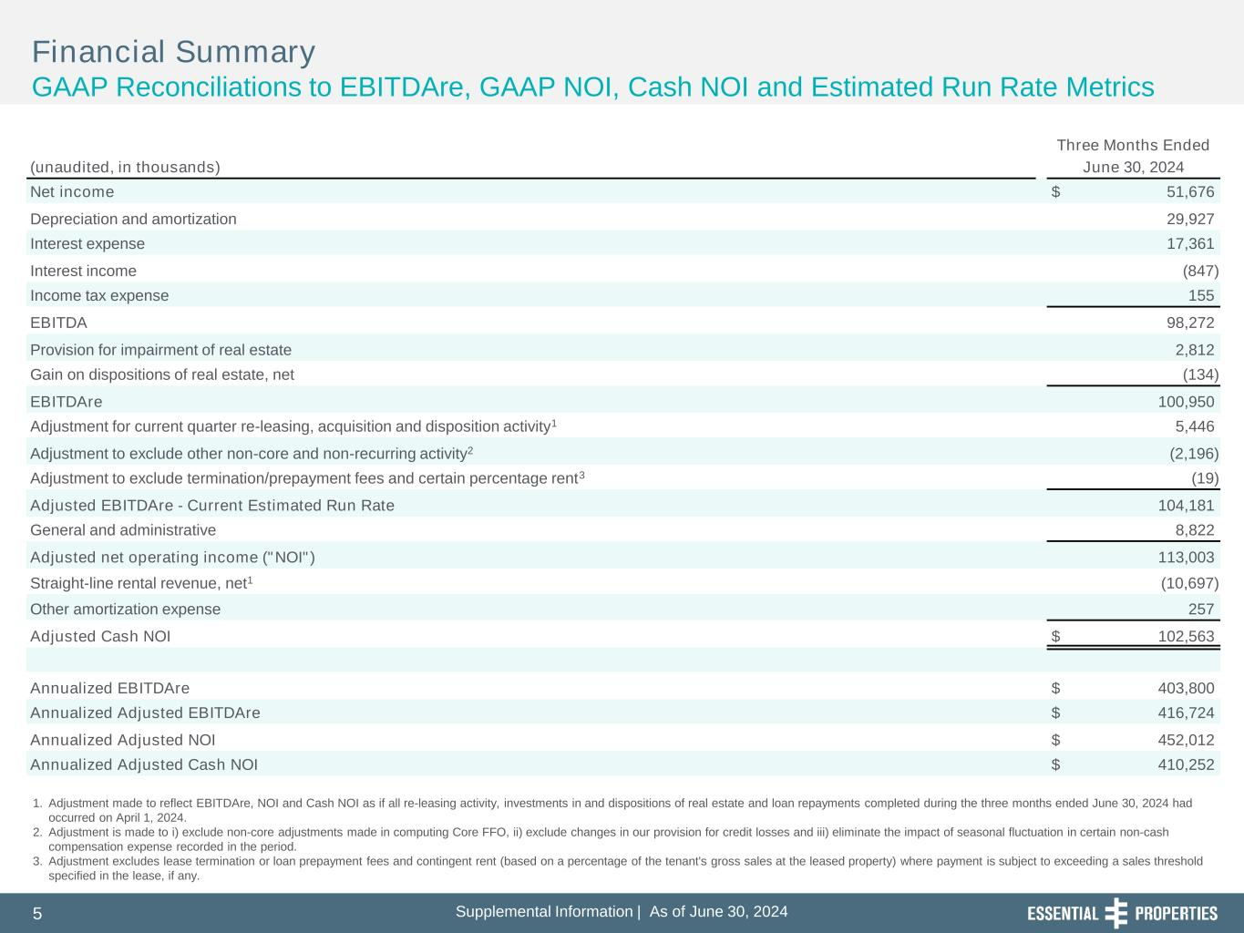
Supplemental Information | As of June 30, 20245 l t l I f r ti | s f J , 5 Financial Summary GAAP Reconciliations to EBITDAre, GAAP NOI, Cash NOI and Estimated Run Rate Metrics 1. Adjustment made to reflect EBITDAre, NOI and Cash NOI as if all re-leasing activity, investments in and dispositions of real estate and loan repayments completed during the three months ended June 30, 2024 had occurred on April 1, 2024. 2. Adjustment is made to i) exclude non-core adjustments made in computing Core FFO, ii) exclude changes in our provision for credit losses and iii) eliminate the impact of seasonal fluctuation in certain non-cash compensation expense recorded in the period. 3. Adjustment excludes lease termination or loan prepayment fees and contingent rent (based on a percentage of the tenant's gross sales at the leased property) where payment is subject to exceeding a sales threshold specified in the lease, if any. Three Months Ended (unaudited, in thousands) June 30, 2024 Net income $ 51,676 Depreciation and amortization 29,927 Interest expense 17,361 Interest income (847) Income tax expense 155 EBITDA 98,272 Provision for impairment of real estate 2,812 Gain on dispositions of real estate, net (134) EBITDAre 100,950 Adjustment for current quarter re-leasing, acquisition and disposition activity1 5,446 Adjustment to exclude other non-core and non-recurring activity2 (2,196) Adjustment to exclude termination/prepayment fees and certain percentage rent3 (19) Adjusted EBITDAre - Current Estimated Run Rate 104,181 General and administrative 8,822 Adjusted net operating income ("NOI") 113,003 Straight-line rental revenue, net1 (10,697) Other amortization expense 257 Adjusted Cash NOI $ 102,563 Annualized EBITDAre $ 403,800 Annualized Adjusted EBITDAre $ 416,724 Annualized Adjusted NOI $ 452,012 Annualized Adjusted Cash NOI $ 410,252

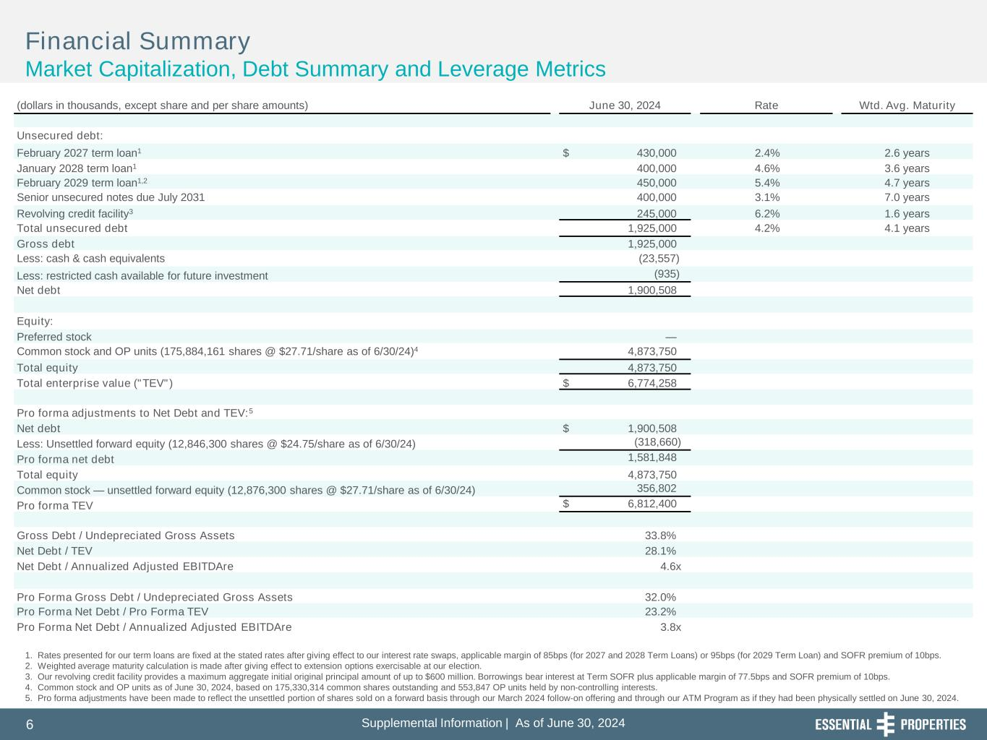
Supplemental Information | As of June 30, 20246 l t l I f r ti | s f J , 6 Financial Summary Market Capitalization, Debt Summary and Leverage Metrics 1. Rates presented for our term loans are fixed at the stated rates after giving effect to our interest rate swaps, applicable margin of 85bps (for 2027 and 2028 Term Loans) or 95bps (for 2029 Term Loan) and SOFR premium of 10bps. 2. Weighted average maturity calculation is made after giving effect to extension options exercisable at our election. 3. Our revolving credit facility provides a maximum aggregate initial original principal amount of up to $600 million. Borrowings bear interest at Term SOFR plus applicable margin of 77.5bps and SOFR premium of 10bps. 4. Common stock and OP units as of June 30, 2024, based on 175,330,314 common shares outstanding and 553,847 OP units held by non-controlling interests. 5. Pro forma adjustments have been made to reflect the unsettled portion of shares sold on a forward basis through our March 2024 follow-on offering and through our ATM Program as if they had been physically settled on June 30, 2024. (dollars in thousands, except share and per share amounts) June 30, 2024 Rate Wtd. Avg. Maturity Unsecured debt: February 2027 term loan1 $ 430,000 2.4% 2.6 years January 2028 term loan1 400,000 4.6% 3.6 years February 2029 term loan1,2 450,000 5.4% 4.7 years Senior unsecured notes due July 2031 400,000 3.1% 7.0 years Revolving credit facility3 245,000 6.2% 1.6 years Total unsecured debt 1,925,000 4.2% 4.1 years Gross debt 1,925,000 Less: cash & cash equivalents (23,557) Less: restricted cash available for future investment (935) Net debt 1,900,508 Equity: Preferred stock — Common stock and OP units (175,884,161 shares @ $27.71/share as of 6/30/24)4 4,873,750 Total equity 4,873,750 Total enterprise value ("TEV") $ 6,774,258 Pro forma adjustments to Net Debt and TEV:5 Net debt $ 1,900,508 Less: Unsettled forward equity (12,846,300 shares @ $24.75/share as of 6/30/24) (318,660) Pro forma net debt 1,581,848 Total equity 4,873,750 Common stock — unsettled forward equity (12,876,300 shares @ $27.71/share as of 6/30/24) 356,802 Pro forma TEV $ 6,812,400 Gross Debt / Undepreciated Gross Assets 33.8% Net Debt / TEV 28.1% Net Debt / Annualized Adjusted EBITDAre 4.6x Pro Forma Gross Debt / Undepreciated Gross Assets 32.0% Pro Forma Net Debt / Pro Forma TEV 23.2% Pro Forma Net Debt / Annualized Adjusted EBITDAre 3.8x

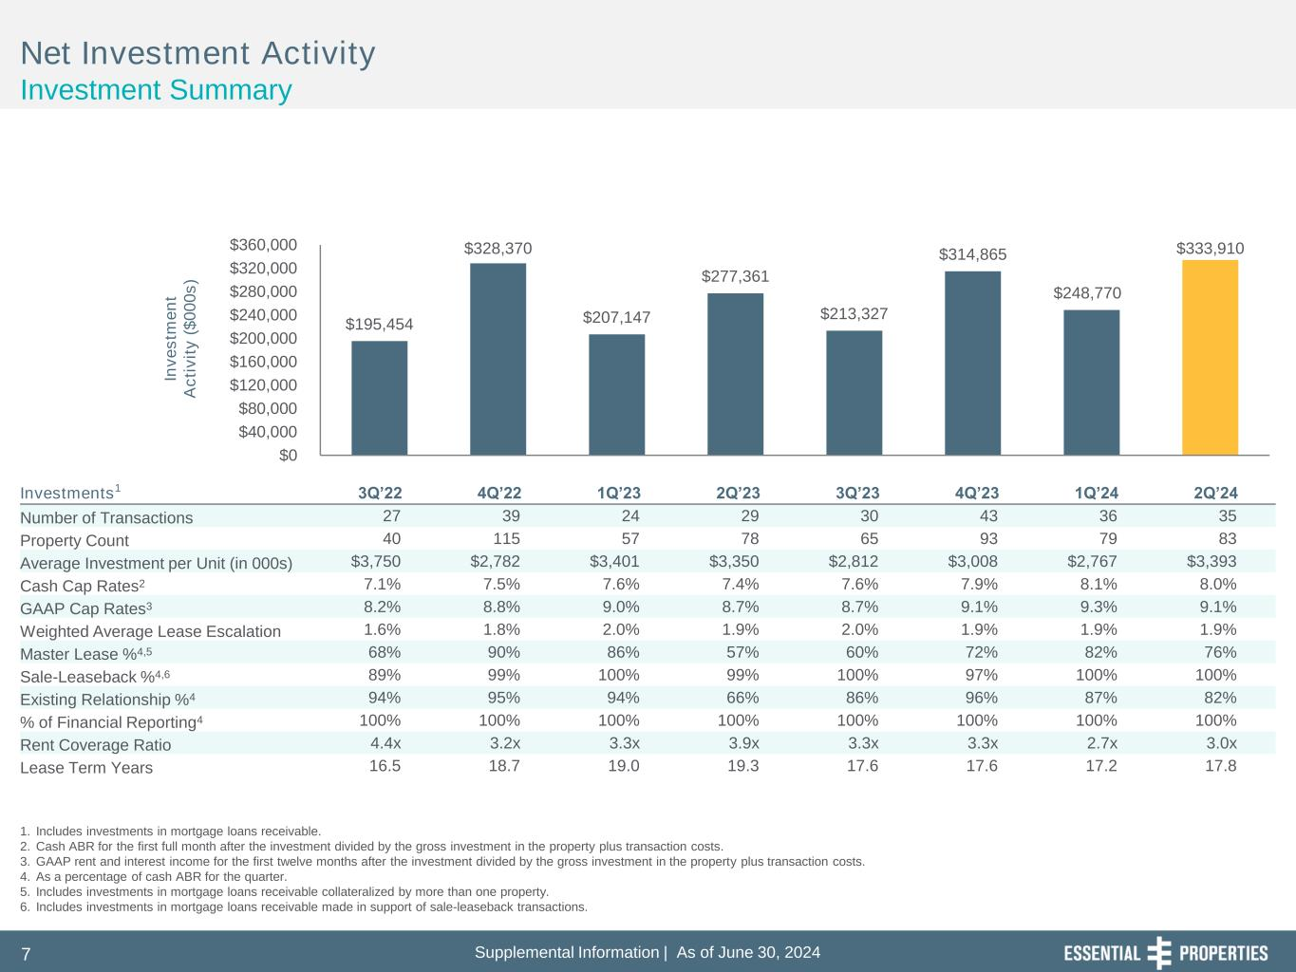
Supplemental Information | As of June 30, 20247 $195,454 $328,370 $207,147 $277,361 $213,327 $314,865 $248,770 $333,910 $0 $40,000 $80,000 $120,000 $160,000 $200,000 $240,000 $280,000 $320,000 $360,000 In v e s tm e n t A c ti v it y ( $ 0 0 0 s ) Net Investment Activity Investment Summary 1. Includes investments in mortgage loans receivable. 2. Cash ABR for the first full month after the investment divided by the gross investment in the property plus transaction costs. 3. GAAP rent and interest income for the first twelve months after the investment divided by the gross investment in the property plus transaction costs. 4. As a percentage of cash ABR for the quarter. 5. Includes investments in mortgage loans receivable collateralized by more than one property. 6. Includes investments in mortgage loans receivable made in support of sale-leaseback transactions. Investments1 3Q’22 4Q’22 1Q’23 2Q’23 3Q’23 4Q’23 1Q’24 2Q’24 Number of Transactions 27 39 24 29 30 43 36 35 Property Count 40 115 57 78 65 93 79 83 Average Investment per Unit (in 000s) $3,750 $2,782 $3,401 $3,350 $2,812 $3,008 $2,767 $3,393 Cash Cap Rates2 7.1% 7.5% 7.6% 7.4% 7.6% 7.9% 8.1% 8.0% GAAP Cap Rates3 8.2% 8.8% 9.0% 8.7% 8.7% 9.1% 9.3% 9.1% Weighted Average Lease Escalation 1.6% 1.8% 2.0% 1.9% 2.0% 1.9% 1.9% 1.9% Master Lease %4,5 68% 90% 86% 57% 60% 72% 82% 76% Sale-Leaseback %4,6 89% 99% 100% 99% 100% 97% 100% 100% Existing Relationship %4 94% 95% 94% 66% 86% 96% 87% 82% % of Financial Reporting4 100% 100% 100% 100% 100% 100% 100% 100% Rent Coverage Ratio 4.4x 3.2x 3.3x 3.9x 3.3x 3.3x 2.7x 3.0x Lease Term Years 16.5 18.7 19.0 19.3 17.6 17.6 17.2 17.8

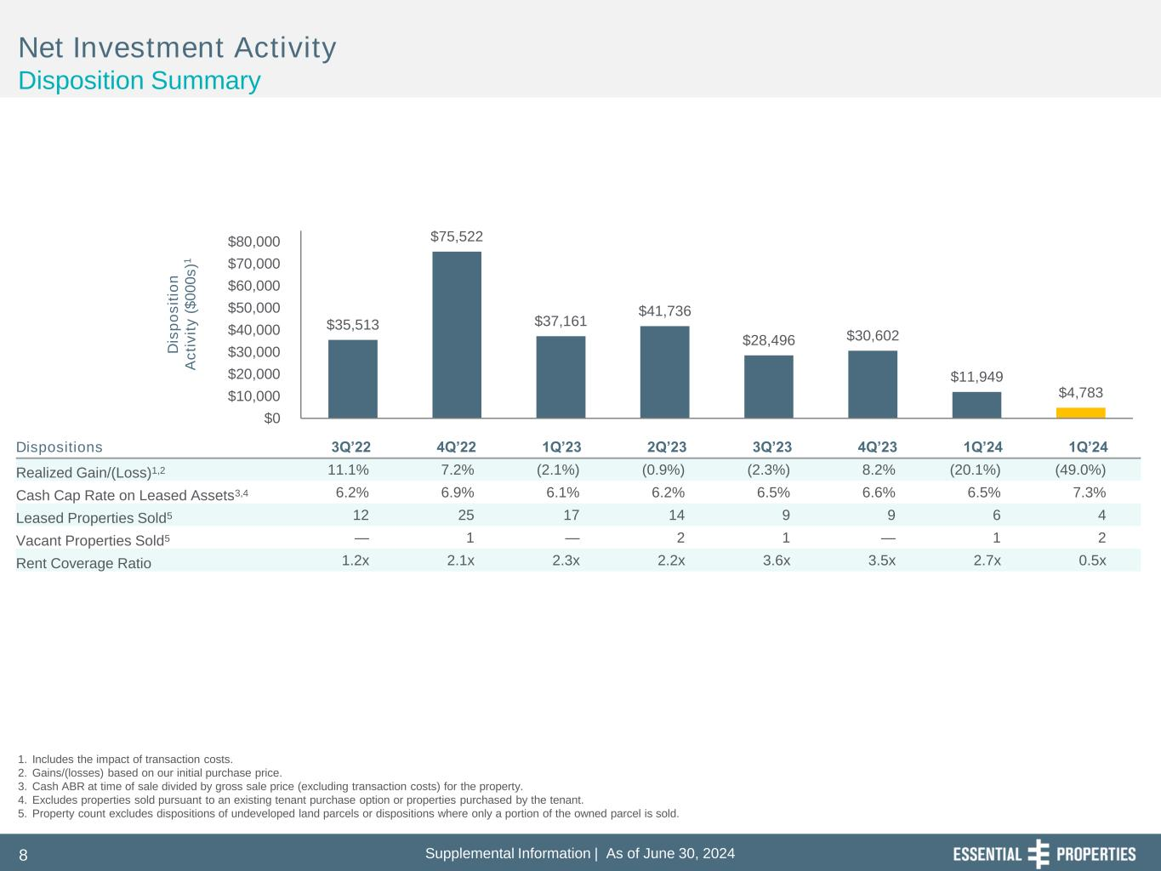
Supplemental Information | As of June 30, 20248 $35,513 $75,522 $37,161 $41,736 $28,496 $30,602 $11,949 $4,783 $0 $10,000 $20,000 $30,000 $40,000 $50,000 $60,000 $70,000 $80,000 D is p o s it io n A c ti v it y ( $ 0 0 0 s )1 Net Investment Activity Disposition Summary 1. Includes the impact of transaction costs. 2. Gains/(losses) based on our initial purchase price. 3. Cash ABR at time of sale divided by gross sale price (excluding transaction costs) for the property. 4. Excludes properties sold pursuant to an existing tenant purchase option or properties purchased by the tenant. 5. Property count excludes dispositions of undeveloped land parcels or dispositions where only a portion of the owned parcel is sold. Dispositions 3Q’22 4Q’22 1Q’23 2Q’23 3Q’23 4Q’23 1Q’24 1Q’24 Realized Gain/(Loss)1,2 11.1% 7.2% (2.1%) (0.9%) (2.3%) 8.2% (20.1%) (49.0%) Cash Cap Rate on Leased Assets3,4 6.2% 6.9% 6.1% 6.2% 6.5% 6.6% 6.5% 7.3% Leased Properties Sold5 12 25 17 14 9 9 6 4 Vacant Properties Sold5 — 1 — 2 1 — 1 2 Rent Coverage Ratio 1.2x 2.1x 2.3x 2.2x 3.6x 3.5x 2.7x 0.5x

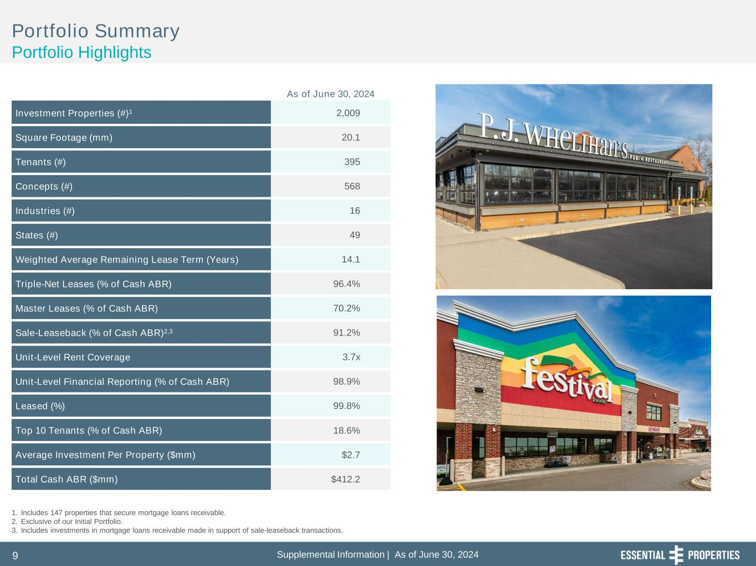
Supplemental Information | As of June 30, 20249 Portfolio Summary Portfolio Highlights Investment Properties (#)1 2,009 Square Footage (mm) 20.1 Tenants (#) 395 Concepts (#) 568 Industries (#) 16 States (#) 49 Weighted Average Remaining Lease Term (Years) 14.1 Triple-Net Leases (% of Cash ABR) 96.4% Master Leases (% of Cash ABR) 70.2% Sale-Leaseback (% of Cash ABR)2,3 91.2% Unit-Level Rent Coverage 3.7x Unit-Level Financial Reporting (% of Cash ABR) 98.9% Leased (%) 99.8% Top 10 Tenants (% of Cash ABR) 18.6% Average Investment Per Property ($mm) $2.7 Total Cash ABR ($mm) $412.2 1. Includes 147 properties that secure mortgage loans receivable. 2. Exclusive of our Initial Portfolio. 3. Includes investments in mortgage loans receivable made in support of sale-leaseback transactions. As of June 30, 2024

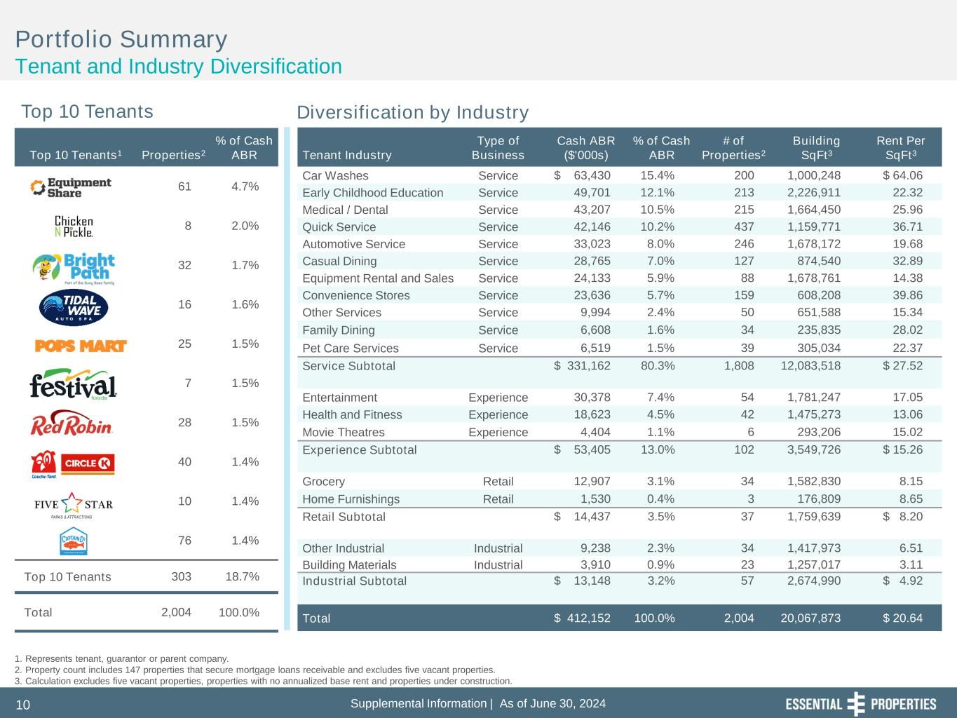
Supplemental Information | As of June 30, 202410 Top 10 Tenants1 Properties2 % of Cash ABR 61 4.7% 8 2.0% 32 1.7% 16 1.6% 25 1.5% 7 1.5% 28 1.5% 40 1.4% 10 1.4% 76 1.4% Top 10 Tenants 303 18.7% Total 2,004 100.0% Portfolio Summary Tenant and Industry Diversification Top 10 Tenants Diversification by Industry 1. Represents tenant, guarantor or parent company. 2. Property count includes 147 properties that secure mortgage loans receivable and excludes five vacant properties. 3. Calculation excludes five vacant properties, properties with no annualized base rent and properties under construction. Tenant Industry Type of Business Cash ABR ($'000s) % of Cash ABR # of Properties2 Building SqFt3 Rent Per SqFt3 Car Washes Service $ 63,430 15.4% 200 1,000,248 $ 64.06 Early Childhood Education Service 49,701 12.1% 213 2,226,911 22.32 Medical / Dental Service 43,207 10.5% 215 1,664,450 25.96 Quick Service Service 42,146 10.2% 437 1,159,771 36.71 Automotive Service Service 33,023 8.0% 246 1,678,172 19.68 Casual Dining Service 28,765 7.0% 127 874,540 32.89 Equipment Rental and Sales Service 24,133 5.9% 88 1,678,761 14.38 Convenience Stores Service 23,636 5.7% 159 608,208 39.86 Other Services Service 9,994 2.4% 50 651,588 15.34 Family Dining Service 6,608 1.6% 34 235,835 28.02 Pet Care Services Service 6,519 1.5% 39 305,034 22.37 Service Subtotal $ 331,162 80.3% 1,808 12,083,518 $ 27.52 Entertainment Experience 30,378 7.4% 54 1,781,247 17.05 Health and Fitness Experience 18,623 4.5% 42 1,475,273 13.06 Movie Theatres Experience 4,404 1.1% 6 293,206 15.02 Experience Subtotal $ 53,405 13.0% 102 3,549,726 $ 15.26 Grocery Retail 12,907 3.1% 34 1,582,830 8.15 Home Furnishings Retail 1,530 0.4% 3 176,809 8.65 Retail Subtotal $ 14,437 3.5% 37 1,759,639 $ 8.20 Other Industrial Industrial 9,238 2.3% 34 1,417,973 6.51 Building Materials Industrial 3,910 0.9% 23 1,257,017 3.11 Industrial Subtotal $ 13,148 3.2% 57 2,674,990 $ 4.92 Total $ 412,152 100.0% 2,004 20,067,873 $ 20.64

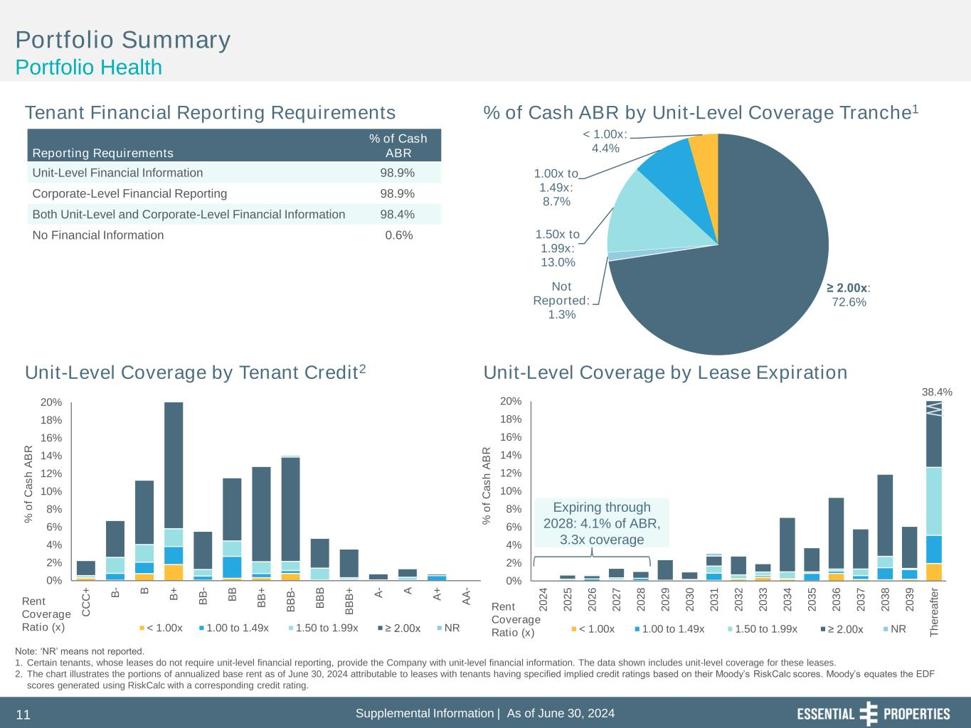
Supplemental Information | As of June 30, 202411 0% 2% 4% 6% 8% 10% 12% 14% 16% 18% 20% 2 0 2 4 2 0 2 5 2 0 2 6 2 0 2 7 2 0 2 8 2 0 2 9 2 0 3 0 2 0 3 1 2 0 3 2 2 0 3 3 2 0 3 4 2 0 3 5 2 0 3 6 2 0 3 7 2 0 3 8 2 0 3 9 T h e re a ft e r % o f C a s h A B R < 1.00x 1.00 to 1.49x 1.50 to 1.99x ≥ 2.00x NR 38.4% 0% 2% 4% 6% 8% 10% 12% 14% 16% 18% 20% C C C + B - B B + B B - B B B B + B B B - B B B B B B + A - A A + A A - % o f C a s h A B R < 1.00x 1.00 to 1.49x 1.50 to 1.99x ≥ 2.00x NR ≥ 2.00x: 72.6% Not Reported: 1.3% 1.50x to 1.99x: 13.0% 1.00x to 1.49x: 8.7% < 1.00x: 4.4% Portfolio Summary Portfolio Health Tenant Financial Reporting Requirements % of Cash ABR by Unit-Level Coverage Tranche1 Unit-Level Coverage by Lease ExpirationUnit-Level Coverage by Tenant Credit2 Note: ‘NR’ means not reported. 1. Certain tenants, whose leases do not require unit-level financial reporting, provide the Company with unit-level financial information. The data shown includes unit-level coverage for these leases. 2. The chart illustrates the portions of annualized base rent as of June 30, 2024 attributable to leases with tenants having specified implied credit ratings based on their Moody’s RiskCalc scores. Moody’s equates the EDF scores generated using RiskCalc with a corresponding credit rating. Reporting Requirements % of Cash ABR Unit-Level Financial Information 98.9% Corporate-Level Financial Reporting 98.9% Both Unit-Level and Corporate-Level Financial Information 98.4% No Financial Information 0.6% Rent Coverage Ratio (x) Rent Coverage Ratio (x) Expiring through 2028: 4.1% of ABR, 3.3x coverage

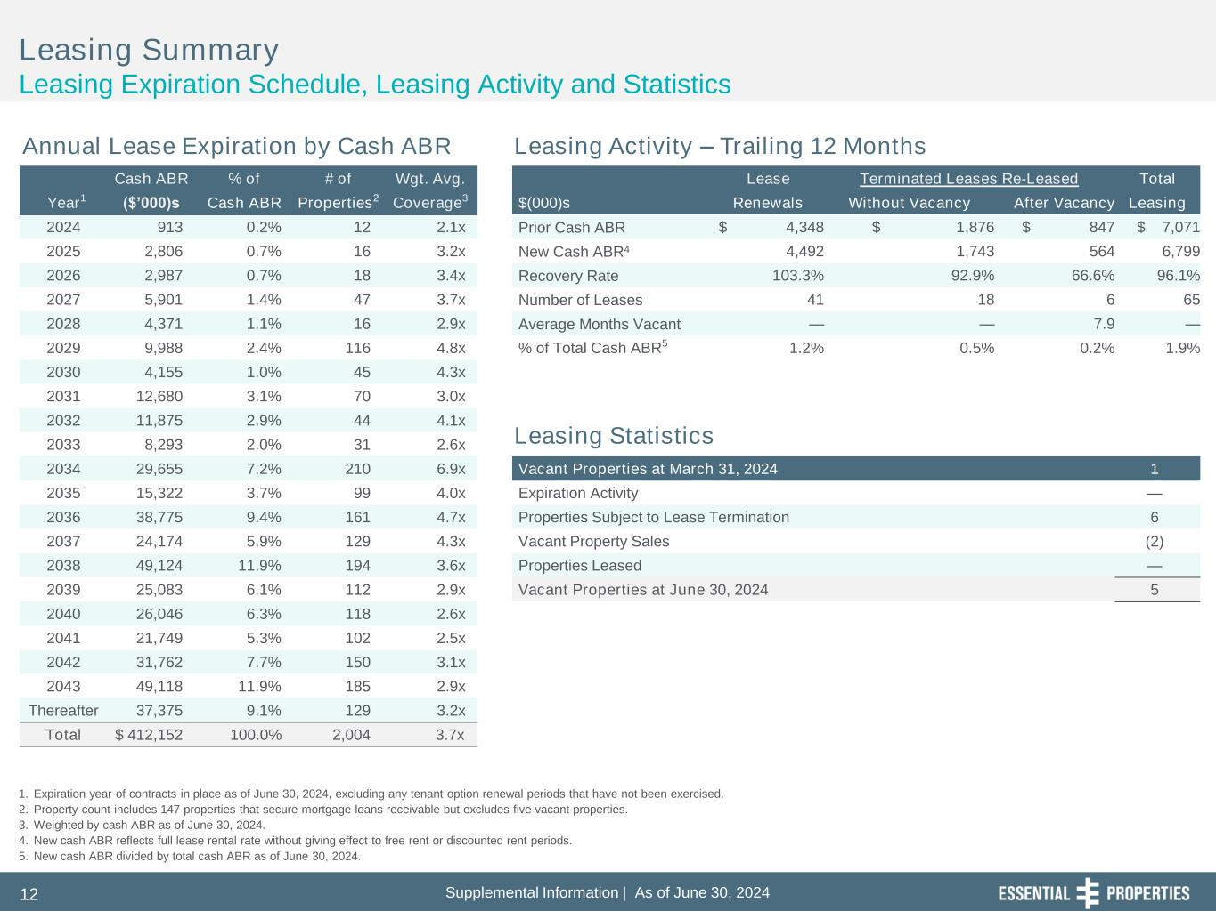
Supplemental Information | As of June 30, 202412 Cash ABR % of # of Wgt. Avg. Lease Terminated Leases Re-Leased Total Year1 ($’000)s Cash ABR Properties2 Coverage3 $(000)s Renewals Without Vacancy After Vacancy Leasing 2024 913 0.2% 12 2.1x Prior Cash ABR $ 4,348 $ 1,876 $ 847 $ 7,071 2025 2,806 0.7% 16 3.2x New Cash ABR4 4,492 1,743 564 6,799 2026 2,987 0.7% 18 3.4x Recovery Rate 103.3% 92.9% 66.6% 96.1% 2027 5,901 1.4% 47 3.7x Number of Leases 41 18 6 65 2028 4,371 1.1% 16 2.9x Average Months Vacant — — 7.9 — 2029 9,988 2.4% 116 4.8x % of Total Cash ABR5 1.2% 0.5% 0.2% 1.9% 2030 4,155 1.0% 45 4.3x 2031 12,680 3.1% 70 3.0x 2032 11,875 2.9% 44 4.1x 2033 8,293 2.0% 31 2.6x 2034 29,655 7.2% 210 6.9x Vacant Properties at March 31, 2024 1 2035 15,322 3.7% 99 4.0x Expiration Activity — 2036 38,775 9.4% 161 4.7x Properties Subject to Lease Termination 6 2037 24,174 5.9% 129 4.3x Vacant Property Sales (2) 2038 49,124 11.9% 194 3.6x Properties Leased — 2039 25,083 6.1% 112 2.9x Vacant Properties at June 30, 2024 5 2040 26,046 6.3% 118 2.6x 2041 21,749 5.3% 102 2.5x 2042 31,762 7.7% 150 3.1x 2043 49,118 11.9% 185 2.9x Thereafter 37,375 9.1% 129 3.2x Total $ 412,152 100.0% 2,004 3.7x Leasing Summary Leasing Expiration Schedule, Leasing Activity and Statistics 1. Expiration year of contracts in place as of June 30, 2024, excluding any tenant option renewal periods that have not been exercised. 2. Property count includes 147 properties that secure mortgage loans receivable but excludes five vacant properties. 3. Weighted by cash ABR as of June 30, 2024. 4. New cash ABR reflects full lease rental rate without giving effect to free rent or discounted rent periods. 5. New cash ABR divided by total cash ABR as of June 30, 2024. Annual Lease Expiration by Cash ABR Leasing Activity – Trailing 12 Months Leasing Statistics

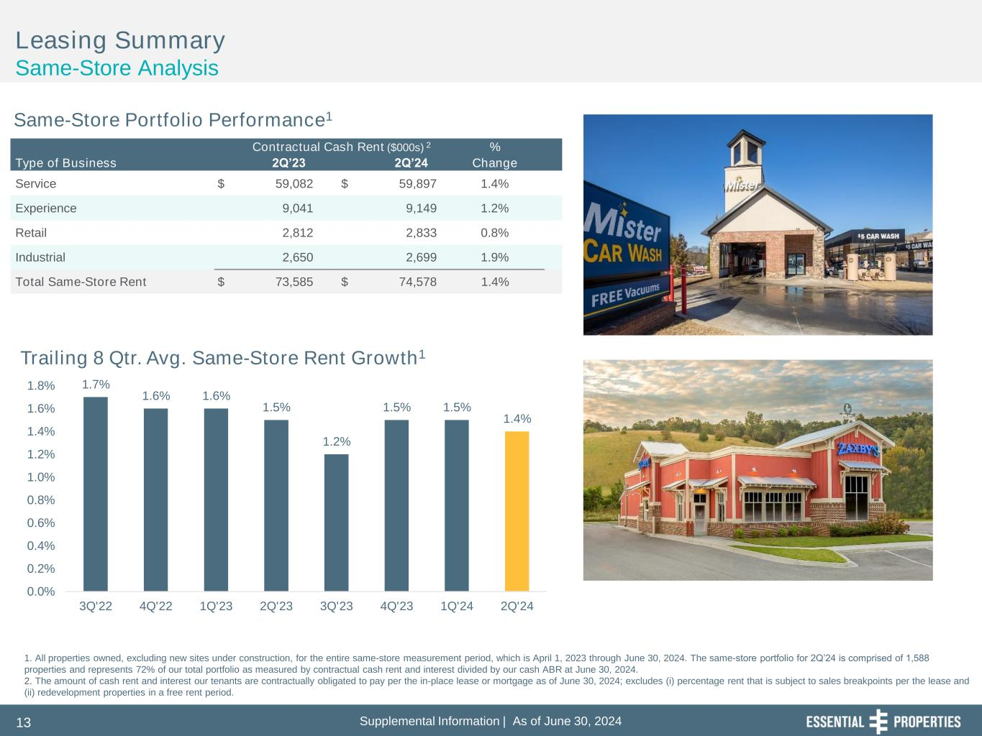
Supplemental Information | As of June 30, 202413 Leasing Summary Same-Store Analysis Same-Store Portfolio Performance1 Contractual Cash Rent ($000s) 2 % Type of Business 2Q’23 2Q’24 Change Service $ 59,082 $ 59,897 1.4% Experience 9,041 9,149 1.2% Retail 2,812 2,833 0.8% Industrial 2,650 2,699 1.9% Total Same-Store Rent $ 73,585 $ 74,578 1.4% 1. All properties owned, excluding new sites under construction, for the entire same-store measurement period, which is April 1, 2023 through June 30, 2024. The same-store portfolio for 2Q’24 is comprised of 1,588 properties and represents 72% of our total portfolio as measured by contractual cash rent and interest divided by our cash ABR at June 30, 2024. 2. The amount of cash rent and interest our tenants are contractually obligated to pay per the in-place lease or mortgage as of June 30, 2024; excludes (i) percentage rent that is subject to sales breakpoints per the lease and (ii) redevelopment properties in a free rent period. 1.7% 1.6% 1.6% 1.5% 1.2% 1.5% 1.5% 1.4% 0.0% 0.2% 0.4% 0.6% 0.8% 1.0% 1.2% 1.4% 1.6% 1.8% 3Q'22 4Q'22 1Q'23 2Q'23 3Q'23 4Q'23 1Q'24 2Q'24 Trailing 8 Qtr. Avg. Same-Store Rent Growth1

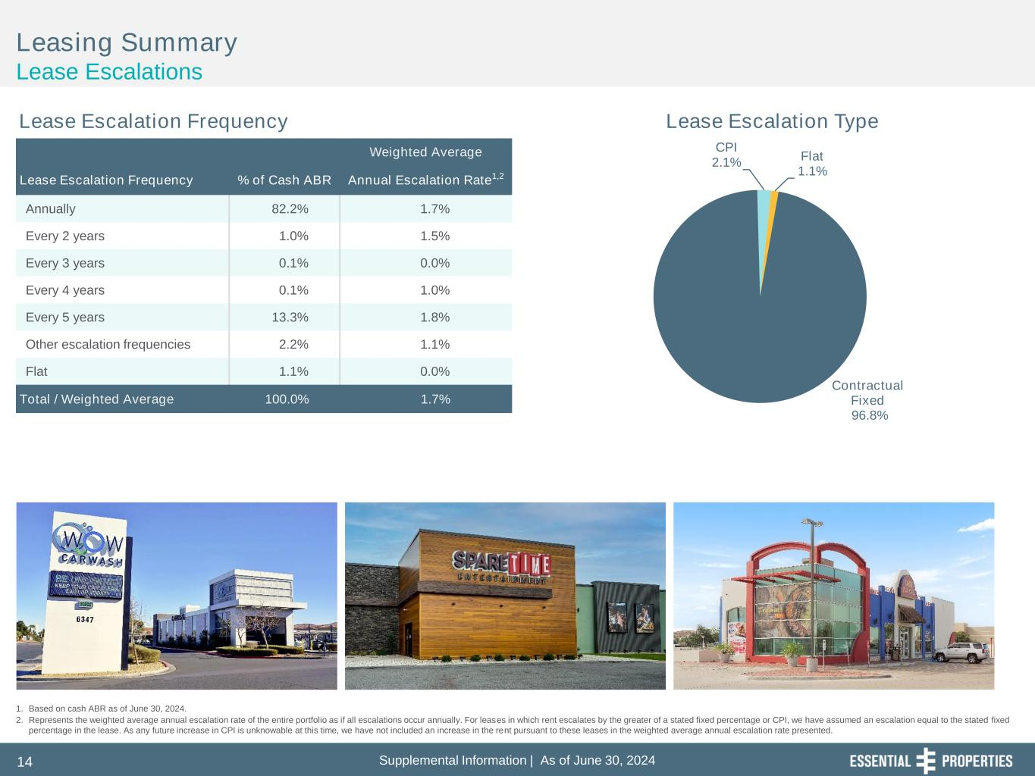
Supplemental Information | As of June 30, 202414 Contractual Fixed 96.8% CPI 2.1% Flat 1.1% Leasing Summary Lease Escalations 1. Based on cash ABR as of June 30, 2024. 2. Represents the weighted average annual escalation rate of the entire portfolio as if all escalations occur annually. For leases in which rent escalates by the greater of a stated fixed percentage or CPI, we have assumed an escalation equal to the stated fixed percentage in the lease. As any future increase in CPI is unknowable at this time, we have not included an increase in the rent pursuant to these leases in the weighted average annual escalation rate presented. Lease Escalation Frequency Lease Escalation Type Weighted Average Lease Escalation Frequency % of Cash ABR Annual Escalation Rate1,2 Annually 82.2% 1.7% Every 2 years 1.0% 1.5% Every 3 years 0.1% 0.0% Every 4 years 0.1% 1.0% Every 5 years 13.3% 1.8% Other escalation frequencies 2.2% 1.1% Flat 1.1% 0.0% Total / Weighted Average 100.0% 1.7%

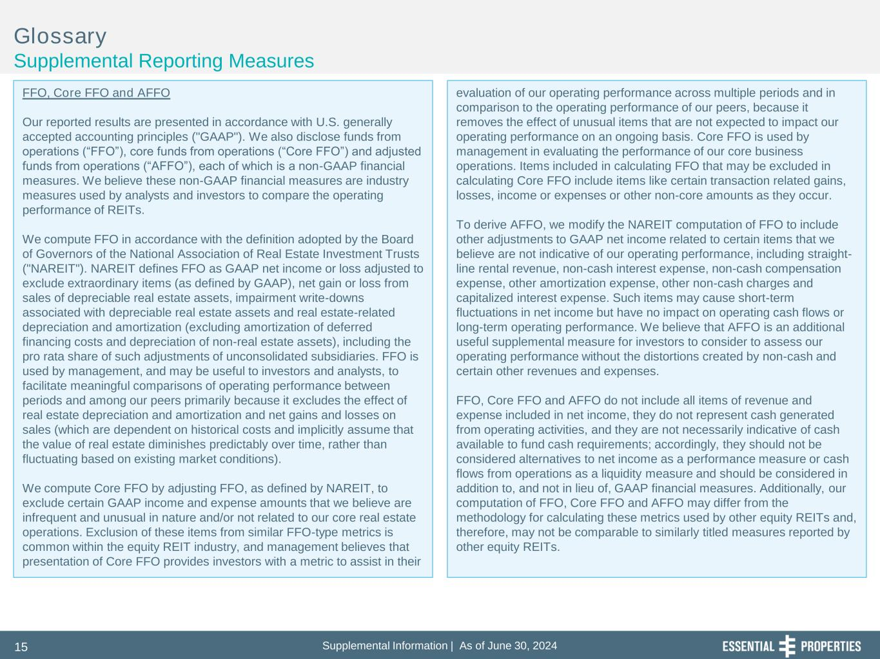
Supplemental Information | As of June 30, 202415 Glossary Supplemental Reporting Measures FFO, Core FFO and AFFO Our reported results are presented in accordance with U.S. generally accepted accounting principles ("GAAP"). We also disclose funds from operations (“FFO”), core funds from operations (“Core FFO”) and adjusted funds from operations (“AFFO”), each of which is a non-GAAP financial measures. We believe these non-GAAP financial measures are industry measures used by analysts and investors to compare the operating performance of REITs. We compute FFO in accordance with the definition adopted by the Board of Governors of the National Association of Real Estate Investment Trusts ("NAREIT"). NAREIT defines FFO as GAAP net income or loss adjusted to exclude extraordinary items (as defined by GAAP), net gain or loss from sales of depreciable real estate assets, impairment write-downs associated with depreciable real estate assets and real estate-related depreciation and amortization (excluding amortization of deferred financing costs and depreciation of non-real estate assets), including the pro rata share of such adjustments of unconsolidated subsidiaries. FFO is used by management, and may be useful to investors and analysts, to facilitate meaningful comparisons of operating performance between periods and among our peers primarily because it excludes the effect of real estate depreciation and amortization and net gains and losses on sales (which are dependent on historical costs and implicitly assume that the value of real estate diminishes predictably over time, rather than fluctuating based on existing market conditions). We compute Core FFO by adjusting FFO, as defined by NAREIT, to exclude certain GAAP income and expense amounts that we believe are infrequent and unusual in nature and/or not related to our core real estate operations. Exclusion of these items from similar FFO-type metrics is common within the equity REIT industry, and management believes that presentation of Core FFO provides investors with a metric to assist in their evaluation of our operating performance across multiple periods and in comparison to the operating performance of our peers, because it removes the effect of unusual items that are not expected to impact our operating performance on an ongoing basis. Core FFO is used by management in evaluating the performance of our core business operations. Items included in calculating FFO that may be excluded in calculating Core FFO include items like certain transaction related gains, losses, income or expenses or other non-core amounts as they occur. To derive AFFO, we modify the NAREIT computation of FFO to include other adjustments to GAAP net income related to certain items that we believe are not indicative of our operating performance, including straight- line rental revenue, non-cash interest expense, non-cash compensation expense, other amortization expense, other non-cash charges and capitalized interest expense. Such items may cause short-term fluctuations in net income but have no impact on operating cash flows or long-term operating performance. We believe that AFFO is an additional useful supplemental measure for investors to consider to assess our operating performance without the distortions created by non-cash and certain other revenues and expenses. FFO, Core FFO and AFFO do not include all items of revenue and expense included in net income, they do not represent cash generated from operating activities, and they are not necessarily indicative of cash available to fund cash requirements; accordingly, they should not be considered alternatives to net income as a performance measure or cash flows from operations as a liquidity measure and should be considered in addition to, and not in lieu of, GAAP financial measures. Additionally, our computation of FFO, Core FFO and AFFO may differ from the methodology for calculating these metrics used by other equity REITs and, therefore, may not be comparable to similarly titled measures reported by other equity REITs.

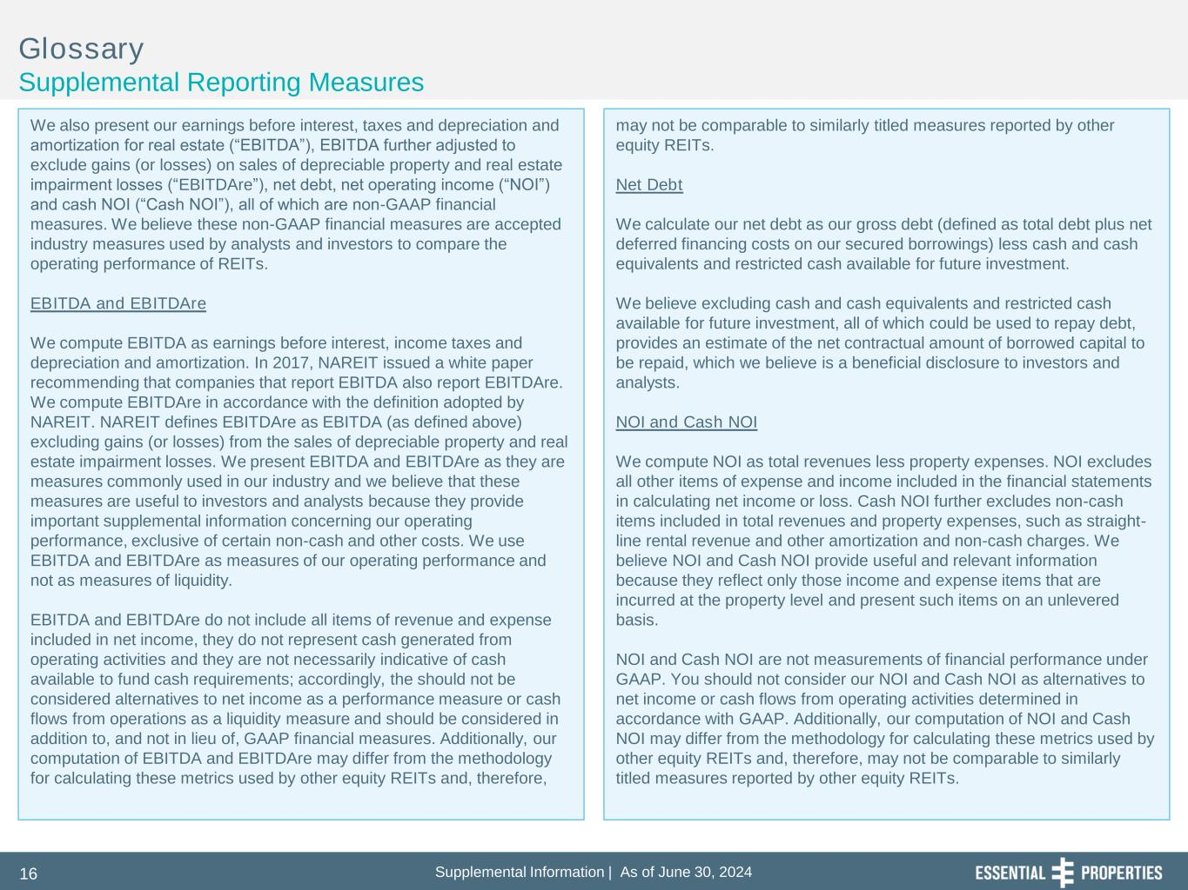
Supplemental Information | As of June 30, 202416 Glossary Supplemental Reporting Measures We also present our earnings before interest, taxes and depreciation and amortization for real estate (“EBITDA”), EBITDA further adjusted to exclude gains (or losses) on sales of depreciable property and real estate impairment losses (“EBITDAre”), net debt, net operating income (“NOI”) and cash NOI (“Cash NOI”), all of which are non-GAAP financial measures. We believe these non-GAAP financial measures are accepted industry measures used by analysts and investors to compare the operating performance of REITs. EBITDA and EBITDAre We compute EBITDA as earnings before interest, income taxes and depreciation and amortization. In 2017, NAREIT issued a white paper recommending that companies that report EBITDA also report EBITDAre. We compute EBITDAre in accordance with the definition adopted by NAREIT. NAREIT defines EBITDAre as EBITDA (as defined above) excluding gains (or losses) from the sales of depreciable property and real estate impairment losses. We present EBITDA and EBITDAre as they are measures commonly used in our industry and we believe that these measures are useful to investors and analysts because they provide important supplemental information concerning our operating performance, exclusive of certain non-cash and other costs. We use EBITDA and EBITDAre as measures of our operating performance and not as measures of liquidity. EBITDA and EBITDAre do not include all items of revenue and expense included in net income, they do not represent cash generated from operating activities and they are not necessarily indicative of cash available to fund cash requirements; accordingly, the should not be considered alternatives to net income as a performance measure or cash flows from operations as a liquidity measure and should be considered in addition to, and not in lieu of, GAAP financial measures. Additionally, our computation of EBITDA and EBITDAre may differ from the methodology for calculating these metrics used by other equity REITs and, therefore, may not be comparable to similarly titled measures reported by other equity REITs. Net Debt We calculate our net debt as our gross debt (defined as total debt plus net deferred financing costs on our secured borrowings) less cash and cash equivalents and restricted cash available for future investment. We believe excluding cash and cash equivalents and restricted cash available for future investment, all of which could be used to repay debt, provides an estimate of the net contractual amount of borrowed capital to be repaid, which we believe is a beneficial disclosure to investors and analysts. NOI and Cash NOI We compute NOI as total revenues less property expenses. NOI excludes all other items of expense and income included in the financial statements in calculating net income or loss. Cash NOI further excludes non-cash items included in total revenues and property expenses, such as straight- line rental revenue and other amortization and non-cash charges. We believe NOI and Cash NOI provide useful and relevant information because they reflect only those income and expense items that are incurred at the property level and present such items on an unlevered basis. NOI and Cash NOI are not measurements of financial performance under GAAP. You should not consider our NOI and Cash NOI as alternatives to net income or cash flows from operating activities determined in accordance with GAAP. Additionally, our computation of NOI and Cash NOI may differ from the methodology for calculating these metrics used by other equity REITs and, therefore, may not be comparable to similarly titled measures reported by other equity REITs.

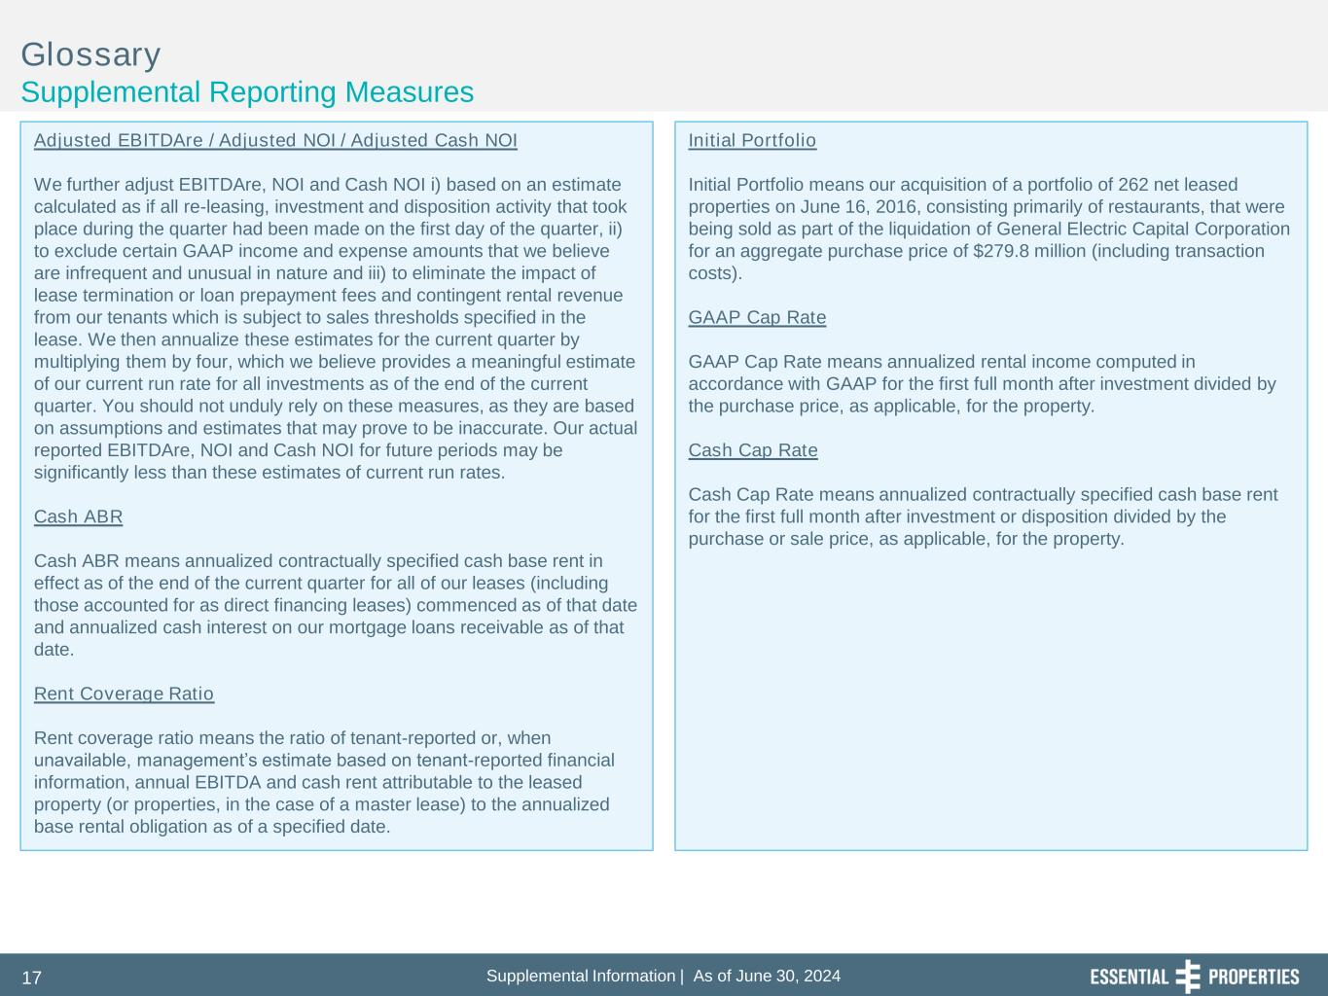
Supplemental Information | As of June 30, 202417 Glossary Supplemental Reporting Measures Adjusted EBITDAre / Adjusted NOI / Adjusted Cash NOI We further adjust EBITDAre, NOI and Cash NOI i) based on an estimate calculated as if all re-leasing, investment and disposition activity that took place during the quarter had been made on the first day of the quarter, ii) to exclude certain GAAP income and expense amounts that we believe are infrequent and unusual in nature and iii) to eliminate the impact of lease termination or loan prepayment fees and contingent rental revenue from our tenants which is subject to sales thresholds specified in the lease. We then annualize these estimates for the current quarter by multiplying them by four, which we believe provides a meaningful estimate of our current run rate for all investments as of the end of the current quarter. You should not unduly rely on these measures, as they are based on assumptions and estimates that may prove to be inaccurate. Our actual reported EBITDAre, NOI and Cash NOI for future periods may be significantly less than these estimates of current run rates. Cash ABR Cash ABR means annualized contractually specified cash base rent in effect as of the end of the current quarter for all of our leases (including those accounted for as direct financing leases) commenced as of that date and annualized cash interest on our mortgage loans receivable as of that date. Rent Coverage Ratio Rent coverage ratio means the ratio of tenant-reported or, when unavailable, management’s estimate based on tenant-reported financial information, annual EBITDA and cash rent attributable to the leased property (or properties, in the case of a master lease) to the annualized base rental obligation as of a specified date. Initial Portfolio Initial Portfolio means our acquisition of a portfolio of 262 net leased properties on June 16, 2016, consisting primarily of restaurants, that were being sold as part of the liquidation of General Electric Capital Corporation for an aggregate purchase price of $279.8 million (including transaction costs). GAAP Cap Rate GAAP Cap Rate means annualized rental income computed in accordance with GAAP for the first full month after investment divided by the purchase price, as applicable, for the property. Cash Cap Rate Cash Cap Rate means annualized contractually specified cash base rent for the first full month after investment or disposition divided by the purchase or sale price, as applicable, for the property.

