UNITED STATES
SECURITIES AND EXCHANGE COMMISSION
Washington, D.C. 20549

FORM 8-K

CURRENT REPORT

Pursuant to Section 13 or 15(d)
of the Securities Exchange Act of 1934

May 11, 2020
Date of Report (Date of earliest event reported)

Essential Properties Realty Trust, Inc.
(Exact name of registrant as specified in its charter)

Maryland  (State or other jurisdiction of incorporation) |  | 001-38530  (Commission File Number) |  | 82-4005693  (IRS Employer Identification No.)

902 Carnegie Center Blvd., Suite 520  Princeton, New Jersey  (Address of principal executive offices) |  | 08540  (Zip Code)

Registrant’s telephone number, including area code: (609) 436-0619

Check the appropriate box below if the Form 8-K filing is intended to simultaneously satisfy the filing obligations of the registrant under any of the following provisions:

☐ Written communications pursuant to Rule 425 under the Securities Act (17 CFR 230.425)

☐ Soliciting material pursuant to Rule 14a-12 under the Exchange Act (17 CFR 240.14a-12)

☐ Pre-commencement communications pursuant to Rule 14d-2(b) under the Exchange Act (17 CFR 240.14d-2(b))

☐ Pre-commencement communications pursuant to Rule 13e-4(c) under the Exchange Act (17 CFR 240.13e-4(c))

Securities registered pursuant to Section 12(b) of the Act:
Title of Each Class | Trading Symbol(s) | Name of Each Exchange on Which Registered
Common Stock, $0.01 par value | EPRT | New York Stock Exchange

Indicate by check mark whether the registrant is an emerging growth company as defined in Rule 405 of the Securities Act of 1933 (§230.405 of this chapter) or Rule 12b-2 of the Securities Exchange Act of 1934 (§240.12b-2 of this chapter).
Emerging growth company ☐

If an emerging growth company, indicate by check mark if the registrant has elected not to use the extended transition period for complying with any new or revised financial accounting standards provided pursuant to Section 13(a) of the Exchange Act ☐

Item 2.02 — Results of Operations and Financial Condition.
On May 11, 2020, Essential Properties Realty Trust, Inc. (the “Company”) issued a press release announcing the Company’s financial results for the three months March 31, 2020. The press release is furnished hereto as Exhibit 99.1 and incorporated herein by reference.
Item 7.01— Regulation FD Disclosure.
On May 11, 2020, the Company issued its Supplemental Operating & Financial Data—First Quarter Ended March 31, 2020. The Supplemental Operating & Financial Data is furnished hereto as Exhibit 99.2 and incorporated herein by reference.
The foregoing information is furnished pursuant to Item 2.02, “Results of Operations and Financial Condition,” and Item 7.01, “Regulation FD Disclosure.” The information in Items 2.02 and 7.01 of this Current Report on Form 8-K and the exhibits furnished therewith shall not be deemed “filed” for purposes of Section 18 of the Securities Exchange Act of 1934 or otherwise subject to the liabilities of that Section, and shall not be or be deemed to be incorporated by reference in any filing under the Securities Act of 1933 or the Securities Exchange Act of 1934, regardless of any general incorporation language in such filing.
Item 9.01 — Financial Statements and Exhibits.
(d) Exhibits.

Exhibit No. | Description
99.1 | Earnings Press Release dated May 11, 2020 for the quarter ended March 31, 2020
99.2 | Supplemental Operating & Financial Data— First Quarter Ended March 31, 2020

SIGNATURES
Pursuant to the requirements of the Securities Exchange Act of 1934, the registrant has duly caused this report to be signed on its behalf by the undersigned hereunto duly authorized.

 |  | ESSENTIAL PROPERTIES REALTY TRUST, INC.
Date: May 11, 2020 |  | By: | /s/ Anthony K. Dobkin
 |  |  | Anthony K. Dobkin
 |  |  | Interim Chief Financial Officer

Exhibit 99.1

Essential Properties Announces First Quarter 2020 Results

- Increased First Quarter Net Income per Share by 15.4% and AFFO per Share by 7.4% -
- Closed Quarterly Investments of $167.5 Million at a 7.1% Weighted Average Cash Cap Rate -
- Withdraws 2020 AFFO per Share Guidance -
- Collected 61% of April Rent -

May 11, 2020

PRINCETON, N.J.--(BUSINESS WIRE)--Essential Properties Realty Trust, Inc. (NYSE: EPRT; “Essential Properties” or the “Company”), today announced operating results for the three months ended March 31, 2020.

First Quarter 2020 Financial and Operating Highlights

 | • | Ended the quarter with a 99.5% leased portfolio with a weighted average lease term (“WALT”) of 14.6 years and a weighted average rent coverage ratio of 2.9x
 | • | Reduced top 10 tenant concentration to 23.1%, a 30 bps sequential decline
 | • | Invested $167.5 million in 63 properties at a 7.1% weighted average cash cap rate
 | • | Net income per fully diluted share increased 15% to $0.15 per share
 | • | Funds from Operations (“FFO”) per fully diluted share decreased 3% to $0.28 per share
 | • | Grew Core Funds from Operations (“Core FFO”) per fully diluted share by 3% to $0.30
 | • | Grew Adjusted Funds from Operations (“AFFO”) per fully diluted share by 7% to $0.29
 | • | Raised $206.3 million in gross proceeds from the sale of shares of common stock through a follow-on equity offering and the Company’s at-the-market equity program (“ATM Program”)
 | • | Net Debt to Annualized Adjusted EBITDAre was 4.6x at quarter end
 | • | Cash and cash equivalents and restricted cash plus available capacity under revolving credit facility of $549.1 million at quarter end

CEO Comments

Commenting on the first quarter 2020 results, Essential Properties’ President and Chief Executive Officer, Pete Mavoides, said, “Our first quarter results were consistent with past quarters as our reliable execution resulted in a high percentage of our first quarter investment activity being relationship-based sale-leaseback transactions with operators of service-oriented and experience-based businesses. However, with the Covid-19 pandemic and wide-spread stay-at-home orders having a significant impact on the vast majority of our tenants, our focus has shifted away from external growth in order to stabilize our portfolio by proactively collaborating with our tenants to manage through the current crisis. While much uncertainty remains, we are confident in our portfolio’s ability to produce an attractive and predictable stream of cash flow over the long-term. Our balance sheet remains in excellent shape with nearly $550 million in available liquidity at quarter-end. Coupled with our experienced team of professionals, we are well positioned to manage the current situation and position this Company for growth as we emerge.”

Net Investment Activity

Investments
During the quarter ended March 31, 2020, Essential Properties invested $167.5 million in 63 properties in 32 separate transactions at a weighted average cash and GAAP cap rate of 7.1% and 8.0%, respectively. These properties are 100% leased with a WALT of 16.1 years. As a percentage of cash ABR, 88.1% of the Company’s investments for the quarter ended March 31, 2020 came from sale-leaseback transactions, 54.1% were subject to a master lease and 100% are required to provide the Company with financial reporting.

Dispositions
During the quarter ended March 31, 2020, Essential Properties sold 10 properties for $19.6 million in net proceeds, recording a net gain on these dispositions of $1.9 million. The disposition weighted average cash cap rate on the properties sold in the quarter ended March 31, 2020 was 7.1%, excluding one property sold pursuant to an existing tenant purchase option.

Portfolio Update

Portfolio Highlights
As of March 31, 2020, Essential Properties’ portfolio consisted of 1,050 freestanding net lease properties, which included 92 properties that secured mortgage notes receivable, with a WALT of 14.6 years and a weighted average rent coverage ratio of 2.9x. As of the same date, the portfolio was 99.5% leased by 212 tenants operating 283 different concepts across 43 states in 16 industries. At quarter end, 94.4% of the Company’s cash ABR was generated from tenants that operate service-oriented or experience-based businesses, and 60.1% of its cash ABR was derived from properties subject to a master lease.

Leasing Activity
During the trailing 12 months ended March 31, 2020, the Company signed three new leases without vacancy and renewed three leases that were expiring for a total recovery rate of 80.5% vs. prior cash rents. Total leasing activity for the trailing 12 months ended March 31, 2020 represented 0.1% of total current cash ABR.

Leverage and Balance Sheet and Liquidity

Leverage
As of March 31, 2020, the Company’s ratio of net debt to Annualized Adjusted EBITDAre was 4.6x.

Balance Sheet and Liquidity
Essential Properties had $214.1 million of cash and cash equivalents and restricted cash as of March 31, 2020. Additionally, Essential Properties had $335 million of unused borrowing capacity under its $400 million unsecured revolving credit facility as of the same date, with $65.0 million in outstanding borrowings.

Partial Repayment of Series 2017-1 ABS Notes
In February 2020, Essential Properties repaid (without penalty) $62 million of its Series 2017-1 ABS Notes.

Seven-Year Unsecured Term Loan
In March 2020, Essential Properties drew the remaining $180 million on its $430 million seven-year unsecured term loan facility. In addition, the Company entered into forward swap agreements that lock in one-month LIBOR at 1.362% for the duration of the loan starting on July 9, 2020.

Follow-On Offering
In January 2020, Essential Properties completed a follow-on offering of 7,935,000 shares of its common stock, including 1,035,000 shares issued pursuant to the underwriters’ exercise of an option to purchase additional shares, raising gross proceeds of $200.0 million at $25.20 per share.

ATM Program
Essential Properties has a $200.0 million ATM Program through which it may, from time to time, sell shares of its common stock. Essential Properties uses the proceeds generated from its ATM Program for general corporate purposes, including funding its investment activity, the repayment or refinancing of outstanding indebtedness, working capital and other general purposes. During the quarter ended March 31, 2020, Essential Properties sold 253,698 shares of common stock through its ATM Program at an average price of $24.74 per share, raising gross proceeds of $6.3 million.

Dividend Information

As previously announced, on March 18, 2020 Essential Properties declared a cash dividend of $0.23 per share of common stock for the quarter ended March 31, 2020. The dividend was paid on April 15, 2020 to stockholders of record as of the close of business on March 31, 2020.

2020 Guidance

The Company has withdrawn its previously issued 2020 AFFO guidance due to the significant volatility in the capital markets and the unprecedented economic uncertainty related to the impact of COVID-19.

Conference Call Information

In conjunction with the release of Essential Properties’ operating results, the Company will host a conference call on Monday, May 11, 2020 at 10:00 a.m. EDT to discuss the results. To access the conference, dial (844) 369-8770. A live webcast will also be available in listen-only mode by clicking on the webcast link in the Investor Relations section at www.essentialproperties.com.

A telephone replay of the conference call can also be accessed by calling (877) 481-4010 and entering the access code: 34443. The telephone replay will be available through May 25, 2020.

A replay of the conference call webcast will be available approximately two hours after the conclusion of the live broadcast. The webcast replay will be available for 90 days. No access code is required for this replay.

Supplemental Materials

The Company’s Supplemental Operating & Financial Data—First Quarter Ended March 31, 2020 is available on Essential Properties’ website at investors.essentialproperties.com.

About Essential Properties Realty Trust, Inc.

Essential Properties Realty Trust, Inc. is an internally managed REIT that acquires, owns and manages primarily single-tenant properties that are net leased on a long-term basis to companies operating service-oriented or experience-based businesses. As of March 31, 2020, the Company’s portfolio consisted of 1,050 freestanding net lease properties with a weighted average lease term of 14.6 years and a weighted average rent coverage ratio of 2.9x. As of the same date, the Company’s portfolio was 99.5% leased to 212 tenants operating 283 different concepts in 16 industries across 43 states.

Forward-Looking Statements

This press release contains forward-looking statements within the meaning of the federal securities laws. When used in this press release, the words “estimate,” “anticipate,” “expect,” “believe,” “intend,” “may,” “will,” “should,” “seek,” “approximately” or “plan,” or the negative of these words and phrases or similar words or phrases that are predictions of or indicate future events or trends and that do not relate solely to historical matters are intended to identify forward-looking statements. You can also identify forward-looking statements by discussions of strategy, plans or intentions of management. Forward-looking statements involve numerous risks and uncertainties and you should not rely on them as predictions of future events. Forward-looking statements depend on assumptions, data or methods that may be incorrect or imprecise

and the Company may not be able to realize them. The Company does not guarantee that the transactions and events described will happen as described (or that they will happen at all). You are cautioned not to place undue reliance on forward-looking statements, which speak only as of the date of this press release. While forward-looking statements reflect the Company’s good faith beliefs, they are not guarantees of future performance. The Company undertakes no obligation to publicly release the results of any revisions to these forward-looking statements that may be made to reflect events or circumstances after the date of this press release or to reflect the occurrence of unanticipated events, except as required by law. In light of these risks and uncertainties, the forward-looking events discussed in this press release might not occur as described, or at all.

Additional information concerning factors that could cause actual results to differ materially from these forward-looking statements is contained from time to time in the company’s Securities and Exchange Commission (the "Commission”) filings, including, but not limited to, the Company’s Quarterly Reports on Form 10-Q. Copies of each filing may be obtained from the Company or the Commission. Such forward-looking statements should be regarded solely as reflections of the company’s current operating plans and estimates. Actual operating results may differ materially from what is expressed or forecast in this press release.

The results reported in this press release are preliminary and not final. There can be no assurance that these results will not vary from the final results reported in the Company’s Quarterly Report on Form 10-Q for the quarter ended March 31, 2020 that it will file with the Commission.

Non-GAAP Financial Measures and Certain Definitions

The Company’s reported results are presented in accordance with GAAP. The Company also discloses the following non-GAAP financial measures: FFO, Core FFO, AFFO, earnings before interest, taxes, depreciation and amortization (“EBITDA”), EBITDA further adjusted to exclude gains (or losses) on sales of depreciable property and real estate impairment losses (“EBITDAre”), adjusted EBITDAre, annualized adjusted EBITDAre, net debt, net operating income (“NOI”) and cash NOI (“Cash NOI”). The Company believes these non-GAAP financial measures are industry measures used by analysts and investors to compare the operating performance of REITs.

FFO, Core FFO and AFFO

The Company computes FFO in accordance with the definition adopted by the Board of Governors of the National Association of Real Estate Investment Trusts ("NAREIT"). NAREIT defines FFO as GAAP net income or loss adjusted to exclude extraordinary items (as defined by GAAP), net gain or loss from sales of depreciable real estate assets, impairment write-downs associated with depreciable real estate assets and real estate-related depreciation and amortization (excluding amortization of deferred financing costs and depreciation of non-real estate assets), including the pro rata share of such adjustments of unconsolidated subsidiaries. FFO is used by management, and may be useful to investors and analysts, to facilitate meaningful comparisons of operating performance between periods and among the Company’s peers primarily because it excludes the effect of real estate depreciation and amortization and net

gains and losses on sales (which are dependent on historical costs and implicitly assume that the value of real estate diminishes predictably over time, rather than fluctuating based on existing market conditions).

The Company computes Core FFO by adjusting FFO, as defined by NAREIT, to exclude certain GAAP income and expense amounts that we believe are infrequent and unusual in nature and/or not related to our core real estate operations. Exclusion of these items from similar FFO-type metrics is common within the equity REIT industry, and management believes that presentation of Core FFO provides investors with a metric to assist in their evaluation of our operating performance across multiple periods and in comparison to the operating performance of our peers, because it removes the effect of unusual items that are not expected to impact our operating performance on an ongoing basis. Core FFO is used by management in evaluating the performance of our core business operations. Items included in calculating FFO that may be excluded in calculating Core FFO include certain transaction related gains, losses, income or expense or other non-core amounts as they occur.

To derive AFFO, the Company modifies its computation of Core FFO to include other adjustments to GAAP net income related to certain items that it believes are not indicative of the Company’s operating performance, including straight-line rental revenue, non-cash interest expense, non-cash compensation expense, other amortization expense, other non-cash charges (including changes to our provision for loan losses following the adoption of ASC 326), capitalized interest expense and transaction costs. Such items may cause short-term fluctuations in net income but have no impact on operating cash flows or long-term operating performance. The Company believes that AFFO is an additional useful supplemental measure for investors to consider when assessing the Company’s operating performance without the distortions created by non-cash items and certain other revenues and expenses.

FFO, Core FFO and AFFO do not include all items of revenue and expense included in net income, they do not represent cash generated from operating activities and they are not necessarily indicative of cash available to fund cash requirements; accordingly, they should not be considered alternatives to net income as a performance measure or cash flows from operations as a liquidity measure and should be considered in addition to, and not in lieu of, GAAP financial measures. Additionally, our computation of FFO, Core FFO and AFFO may differ from the methodology for calculating these metrics used by other equity REITs and, therefore, may not be comparable to similarly titled measures reported by other equity REITs.

EBITDA and EBITDAre

The Company computes EBITDA as earnings before interest, income taxes and depreciation and amortization. In 2017, NAREIT issued a white paper recommending that companies that report EBITDA also report EBITDAre. The Company computes EBITDAre in accordance with the definition adopted by NAREIT. NAREIT defines EBITDAre as EBITDA (as defined above) excluding gains (or losses) from the sales of depreciable property and real estate impairment losses. The Company presents EBITDA and EBITDAre as they are measures commonly used in its industry and the Company believes that these measures are useful to investors and analysts because they provide supplemental information concerning its operating performance, exclusive

of certain non-cash items and other costs. The Company uses EBITDA and EBITDAre as measures of its operating performance and not as measures of liquidity.

EBITDA and EBITDAre do not include all items of revenue and expense included in net income, they do not represent cash generated from operating activities and they are not necessarily indicative of cash available to fund cash requirements; accordingly, they should not be considered alternatives to net income as a performance measure or cash flows from operations as a liquidity measure and should be considered in addition to, and not in lieu of, GAAP financial measures. Additionally, the Company’s computation of EBITDA and EBITDAre may differ from the methodology for calculating these metrics used by other equity REITs and, therefore, may not be comparable to similarly titled measures reported by other equity REITs.

Net Debt

The Company calculates its net debt as our gross debt (defined as total debt plus net deferred financing costs on its secured borrowings) less cash and cash equivalents and restricted cash deposits held for the benefit of lenders. The Company believes excluding cash and cash equivalents and restricted cash deposits held for the benefit of lenders from gross debt, all of which could be used to repay debt, provides an estimate of the net contractual amount of borrowed capital to be repaid, which it believes is a beneficial disclosure to investors and analysts.

NOI and Cash NOI

The Company computes NOI as total revenues less property expenses. NOI excludes all other items of expense and income included in the financial statements in calculating net income or loss. Cash NOI further excludes non-cash items included in total revenues and property expenses, such as straight-line rental revenue and other amortization and non-cash charges. The Company believes NOI and Cash NOI provide useful and relevant information because they reflect only those revenue and expense items that are incurred at the property level and present such items on an unlevered basis.

NOI and Cash NOI are not measures of financial performance under GAAP. You should not consider the Company’s NOI and Cash NOI as alternatives to net income or cash flows from operating activities determined in accordance with GAAP. Additionally, the Company’s computation of NOI and Cash NOI may differ from the methodology for calculating these metrics used by other equity REITs and, therefore, may not be comparable to similarly titled measures reported by other equity REITs.

Adjusted EBITDAre / Adjusted NOI / Adjusted Cash NOI

The Company further adjusts EBITDAre, NOI and Cash NOI i) based on an estimate calculated as if all investment and disposition activity that took place during the quarter had occurred on the first day of the quarter, ii) to exclude certain GAAP income and expense amounts that the Company believes are infrequent and unusual in nature and iii) to eliminate the impact of lease termination fees and contingent rental revenue from its tenants which is subject to sales

thresholds specified in the lease. The Company then annualizes these estimates for the current quarter by multiplying them by four, which it believes provides a meaningful estimate of the Company’s current run rate for all investments as of the end of the current quarter. You should not unduly rely on these measures, as they are based on assumptions and estimates that may prove to be inaccurate. The Company’s actual reported EBITDAre, NOI and Cash NOI for future periods may be significantly less than these estimates of current run rates.

Cash ABR

Cash ABR means annualized contractually specified cash base rent in effect as of the end of the current quarter for all of the Company’s leases (including those accounted for as direct financing leases) commenced as of that date and annualized cash interest on its mortgage loans receivable as of that date.

Cash Cap Rate

Cash Cap Rate means annualized contractually specified cash base rent for the first full month after investment or disposition divided by the purchase or sale price, as applicable, for the property.

GAAP Cap Rate

GAAP Cap Rate means annualized rental income computed in accordance with GAAP for the first full month after investment divided by the purchase price, as applicable, for the property.

Rent Coverage Ratio

Rent coverage ratio means the ratio of tenant-reported or, when unavailable, management’s estimate based on tenant-reported financial information, annual EBITDA and cash rent attributable to the leased property (or properties, in the case of a master lease) to the annualized base rental obligation as of a specified date.

Disclaimer

Essential Properties Realty Trust, Inc. and the Essential Properties Realty Trust REIT are not affiliated with or sponsored by Griffin Capital Essential Asset Operating Partnership, L.P. or the Griffin Capital Essential Asset REIT, information about which can be obtained at (https://www.gcear.com).

Essential Properties Realty Trust, Inc.
Consolidated Statements of Operations

 |  | Three Months Ended March 31,
(in thousands, except share and per share data) |  | 2020 |  |  |  | 2019
 |  | (unaudited) |  |  |  | (unaudited)
Revenues:
Rental revenue1,2 |  | $ | 39,542 |  |  | $ | 30,774
Interest on loans and direct financing leases |  |  | 1,938 |  |  |  | 326
Other revenue |  |  | 7 |  |  |  | 7
Total revenues |  |  | 41,487 |  |  |  | 31,107
Expenses:
Interest |  |  | 6,833 |  |  |  | 7,089
General and administrative3 |  |  | 7,536 |  |  |  | 4,188
Property expenses4 |  |  | 373 |  |  |  | 1,247
Depreciation and amortization |  |  | 13,012 |  |  |  | 9,120
Provision for impairment of real estate |  |  | 373 |  |  |  | 1,440
Provision for loan losses |  |  | 468 |  |  |  | -
Total expenses |  |  | 28,595 |  |  |  | 23,084
Other operating income:
Gain on dispositions of real estate, net |  |  | 1,875 |  |  |  | 676
Income from operations |  |  | 14,767 |  |  |  | 8,699
Other (loss)/income:
Loss on repayment of secured borrowings5 |  |  | (924 | ) |  |  | —
Interest |  |  | 231 |  |  |  | 91
Income before income tax expense |  |  | 14,074 |  |  |  | 8,790
Income tax expense |  |  | 31 |  |  |  | 67
Net income |  |  | 14,043 |  |  |  | 8,723
Net income attributable to non-controlling interests |  |  | (84 | ) |  |  | (2,594 | )
Net income attributable to stockholders and members |  | $ | 13,959 |  |  | $ | 6,129
Basic weighted-average shares outstanding |  |  | 90,322,402 |  |  |  | 45,240,247
Basic net income per share |  | $ | 0.15 |  |  | $ | 0.13
Diluted weighted-average shares outstanding |  |  | 91,332,297 |  |  |  | 64,640,054
Diluted net income per share |  | $ | 0.15 |  |  | $ | 0.13

1. | Includes contingent rent (based on a percentage of the tenant's gross sales at the leased property) of $192 and $349 for the three months ended March 31, 2020 and 2019, respectively.
2. | Includes reimbursable income from the Company’s tenants of $165 and $743 for the three months ended March 31, 2020 and 2019, respectively.
3. | During the three months ended March 31, 2020, includes non-recurring expenses of $652 for costs and charges incurred in connection with the termination of one of our executive officers.
4. | Includes reimbursable expenses from the Company’s tenants of $165 and $743 for the three months ended March 31, 2020 and 2019, respectively.
5. | Includes the write-off of $924 of deferred financing costs during the three months ended March 31, 2020.

Essential Properties Realty Trust, Inc.
Consolidated Balance Sheets

(in thousands, except share and per share amounts) |  | March 31, 2020 |  |  |  |  |  | December 31, 2019
 |  | (Unaudited) |  |  |  |  |  | (Audited)
ASSETS
Investments:
Real estate investments, at cost:
Land and improvements |  | $ | 632,628 |  |  |  |  | $ | 588,279
Building and improvements |  |  | 1,317,406 |  |  |  |  |  | 1,224,682
Lease incentive |  |  | 5,358 |  |  |  |  |  | 4,908
Construction in progress |  |  | 11,558 |  |  |  |  |  | 12,128
Intangible lease assets |  |  | 80,592 |  |  |  |  |  | 78,922
Total real estate investments, at cost |  |  | 2,047,542 |  |  |  |  |  | 1,908,919
Less: accumulated depreciation and amortization |  |  | (100,473 | ) |  |  |  |  | (90,071 | )
Total real estate investments, net |  |  | 1,947,069 |  |  |  |  |  | 1,818,848
Loans and direct financing lease receivables, net |  |  | 99,487 |  |  |  |  |  | 92,184
Real estate investments held for sale, net |  |  | 1,528 |  |  |  |  |  | 1,211
Net investments |  |  | 2,048,084 |  |  |  |  |  | 1,912,243
Cash and cash equivalents |  |  | 192,616 |  |  |  |  |  | 8,304
Restricted cash |  |  | 21,456 |  |  |  |  |  | 13,015
Straight-line rent receivable, net |  |  | 29,117 |  |  |  |  |  | 25,926
Prepaid expenses and other assets, net |  |  | 14,173 |  |  |  |  |  | 15,959
Total assets |  | $ | 2,305,446 |  |  |  |  | $ | 1,975,447
LIABILITIES AND EQUITY
Secured borrowings, net of deferred financing costs |  | $ | 173,470 |  |  |  |  | $ | 235,336
Unsecured term loans, net of deferred financing costs |  |  | 625,770 |  |  |  |  |  | 445,586
Revolving credit facility |  |  | 65,000 |  |  |  |  |  | 46,000
Intangible lease liabilities, net |  |  | 9,306 |  |  |  |  |  | 9,564
Dividend payable |  |  | 21,295 |  |  |  |  |  | 19,395
Accrued liabilities and other payables |  |  | 54,825 |  |  |  |  |  | 17,453
Total liabilities |  |  | 949,666 |  |  |  |  |  | 773,334
Commitments and contingencies |  |  | — |  |  |  |  |  | —
Stockholders' equity:
Preferred stock, $0.01 par value; 150,000,000 authorized; none issued and outstanding as of March 31, 2020 and December 31, 2019 |  |  | — |  |  |  |  |  | —
Common stock, $0.01 par value; 500,000,000 authorized; 91,949,849 and 83,761,151 issued and outstanding as of March 31, 2020 and December 31, 2019, respectively |  |  | 919 |  |  |  |  |  | 838
Additional paid-in capital |  |  | 1,422,169 |  |  |  |  |  | 1,223,043
Distributions in excess of cumulative earnings |  |  | (34,878 | ) |  |  |  |  | (27,482 | )
Accumulated other comprehensive loss |  |  | (39,820 | ) |  |  |  |  | (1,949 | )
Total stockholders' equity |  |  | 1,348,390 |  |  |  |  |  | 1,194,450
Non-controlling interests |  |  | 7,390 |  |  |  |  |  | 7,663
Total equity |  |  | 1,355,780 |  |  |  |  |  | 1,202,113
Total liabilities and equity |  | $ | 2,305,446 |  |  |  |  | $ | 1,975,447

Essential Properties Realty Trust, Inc.
Reconciliation of Non-GAAP Financial Measures

 |  | Three Months Ended March 31,
(unaudited, in thousands except per share amounts) |  | 2020 |  |  |  | 2019
Net income |  | $ | 14,043 |  |  | $ | 8,723
Depreciation and amortization of real estate |  |  | 12,988 |  |  |  | 9,097
Provision for impairment of real estate |  |  | 373 |  |  |  | 1,440
Gain on dispositions of real estate, net |  |  | (1,875 | ) |  |  | (676 | )
Funds from Operations |  |  | 25,529 |  |  |  | 18,584
Other non-recurring expenses1 |  |  | 1,576 |  |  |  | —
Core Funds from Operations |  |  | 27,105 |  |  |  | 18,584
Adjustments:
Straight-line rental revenue, net |  |  | (3,191 | ) |  |  | (2,903 | )
Non-cash interest expense |  |  | 534 |  |  |  | 816
Non-cash compensation expense |  |  | 1,291 |  |  |  | 1,226
Other amortization expense |  |  | 434 |  |  |  | 228
Other non-cash charges |  |  | 468 |  |  |  | 3
Capitalized interest expense |  |  | (95 | ) |  |  | (25 | )
Transaction costs |  |  | 67 |  |  |  | —
Adjusted Funds from Operations |  | $ | 26,613 |  |  | $ | 17,929
Net income per share2:
Basic |  | $ | 0.15 |  |  | $ | 0.13
Diluted |  | $ | 0.15 |  |  | $ | 0.13
FFO per share2:
Basic |  | $ | 0.28 |  |  | $ | 0.29
Diluted |  | $ | 0.28 |  |  | $ | 0.29
Core FFO per share2:
Basic |  | $ | 0.30 |  |  | $ | 0.29
Diluted |  | $ | 0.30 |  |  | $ | 0.29
AFFO per share2:
Basic |  | $ | 0.29 |  |  | $ | 0.28
Diluted |  | $ | 0.29 |  |  | $ | 0.27

1. | Includes non-recurring expenses of $652 for accruals of severance payments and acceleration of non-cash compensation expense in connection with the termination of one of our executive officers and our $924 loss on repayment of secured borrowings during the three months ended March 31, 2020.
2. | Calculations exclude $130 and $155 from the numerator for the three months ended March 31, 2020 and 2019, respectively, related to dividends paid on unvested restricted share awards and restricted share units.

Essential Properties Realty Trust, Inc.
Reconciliation of Non-GAAP Financial Measures

 |  | Three Months Ended
(in thousands) |  | March 31, 2020
Net income |  | $ | 14,043
Depreciation and amortization |  |  | 13,012
Interest expense |  |  | 6,833
Interest income |  |  | (231 | )
Income tax expense |  |  | 31
EBITDA |  |  | 33,688
Provision for impairment of real estate |  |  | 373
Gain on dispositions of real estate, net |  |  | (1,875 | )
EBITDAre |  |  | 32,186
Adjustment for current quarter investment and disposition activity1 |  |  | 1,846
Adjustment to exclude other non-recurring expenses2 |  |  | 2,044
Adjustment to exclude lease termination fees and certain percentage rent3 |  |  | (98 | )
Adjusted EBITDAre - Current Estimated Run Rate |  |  | 35,978
General and administrative |  |  | 6,884
Adjusted net operating income ("NOI") |  |  | 42,862
Straight-line rental revenue, net1 |  |  | (2,966 | )
Other amortization expense |  |  | 434
Adjusted Cash NOI |  | $ | 40,330
Annualized EBITDAre |  | $ | 128,744
Annualized Adjusted EBITDAre |  | $ | 143,912
Annualized Adjusted NOI |  | $ | 171,448
Annualized Adjusted Cash NOI |  | $ | 161,320

1. | These adjustments are made to reflect EBITDAre, NOI and Cash NOI as if all investments in and dispositions of real estate made during the three months ended March 31, 2020 had occurred on January 1, 2020.
2. | Adjustment excludes $1,576 of non-core expenses added back to compute Core FFO and our $468 provision for loan loss.
3. | Adjustment excludes contingent rent (based on a percentage of the tenant's gross sales at the leased property) where payment is subject to exceeding a sales threshold specified in the lease and lease termination fees.

Essential Properties Realty Trust, Inc.
Reconciliation of Non-GAAP Financial Measures

(dollars in thousands, except share and per share amounts) |  | March 31, 2020
Secured debt:
Series 2017-1, Class A |  | $ | 160,455
Series 2017-1, Class B |  |  | 15,669
Total secured debt |  |  | 176,124
Unsecured debt:
$200mm term loan |  |  | 200,000
$430mm term loan |  |  | 430,000
Revolving credit facility1 |  |  | 65,000
Total unsecured debt |  |  | 695,000
Gross debt |  |  | 871,124
Less: cash & cash equivalents |  |  | (192,616 | )
Less: restricted cash deposits held for the benefit of lenders |  |  | (21,456 | )
Net debt |  |  | 657,052
Equity:
Preferred stock |  |  | —
Common stock & OP units (92,503,696 shares @ $13.06/share as of 3/31/20)2 |  |  | 1,208,098
Total equity |  |  | 1,208,098
Total enterprise value ("TEV") |  | $ | 1,865,150
Net Debt / TEV |  |  | 35.2 | %
Net Debt / Annualized Adjusted EBITDAre |  |  | 4.6 | x

1. | The Company’s revolving credit facility provides a maximum aggregate initial original principal amount of up to $400 million and includes an accordion feature to increase, subject to certain conditions, the maximum availability of the facility by up to $200 million.
2. | Common equity & units as of March 31, 2020, based on 91,949,849 common shares outstanding (including unvested restricted share awards) and 553,847 OP units held by non-controlling interests.

Investor/Media:

Essential Properties Realty Trust, Inc.
Daniel Donlan
Senior Vice President, Capital Markets
609-436-0619
info@essentialproperties.com

Source: Essential Properties Realty Trust, Inc.


Supplemental Operating & Financial Data First Quarter Ended March 31, 2020 Exhibit 99.2

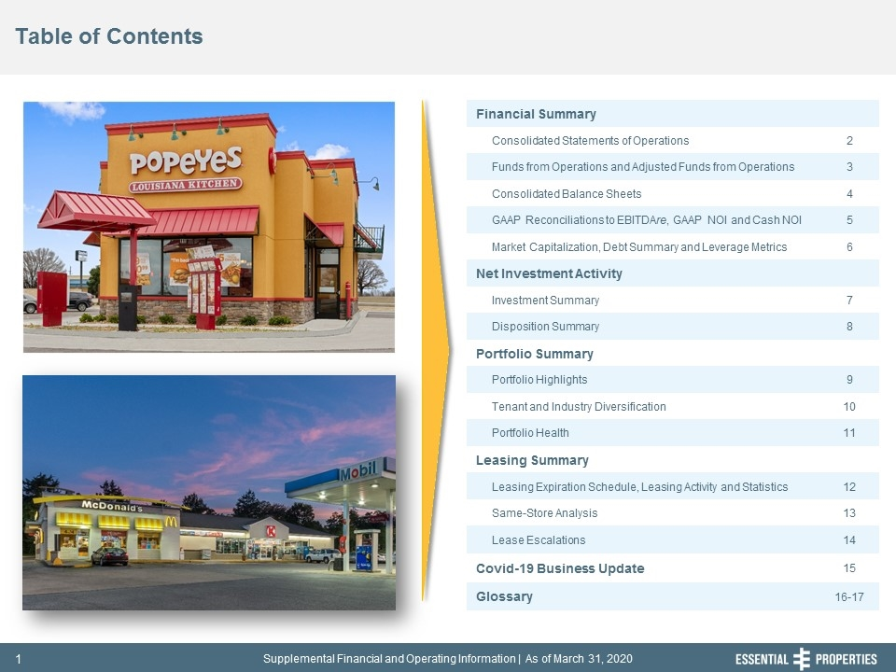
Table of Contents 242, 242, 242 Financial Summary Consolidated Statements of Operations 2 Funds from Operations and Adjusted Funds from Operations 3 Consolidated Balance Sheets 4 GAAP Reconciliations to EBITDAre, GAAP NOI and Cash NOI 5 Market Capitalization, Debt Summary and Leverage Metrics 6 Net Investment Activity Investment Summary 7 Disposition Summary 8 Portfolio Summary Portfolio Highlights 9 Tenant and Industry Diversification 10 Portfolio Health 11 Leasing Summary Leasing Expiration Schedule, Leasing Activity and Statistics 12 Same-Store Analysis 13 Lease Escalations 14 Covid-19 Business Update 15 Glossary 16-17

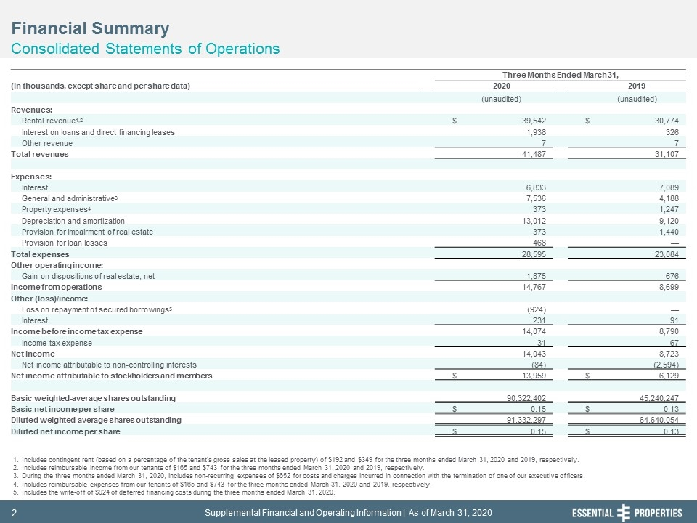
Financial Summary Consolidated Statements of Operations 242, 242, 242 Includes contingent rent (based on a percentage of the tenant's gross sales at the leased property) of $192 and $349 for the three months ended March 31, 2020 and 2019, respectively. Includes reimbursable income from our tenants of $165 and $743 for the three months ended March 31, 2020 and 2019, respectively. During the three months ended March 31, 2020, includes non-recurring expenses of $652 for costs and charges incurred in connection with the termination of one of our executive officers. Includes reimbursable expenses from our tenants of $165 and $743 for the three months ended March 31, 2020 and 2019, respectively. Includes the write-off of $924 of deferred financing costs during the three months ended March 31, 2020. Three Months Ended March 31, (in thousands, except share and per share data) 2020 2019 (unaudited) (unaudited) Revenues: Rental revenue1,2 $ 39,542 $ 30,774 Interest on loans and direct financing leases 1,938 326 Other revenue 7 7 Total revenues 41,487 31,107 Expenses: Interest 6,833 7,089 General and administrative3 7,536 4,188 Property expenses4 373 1,247 Depreciation and amortization 13,012 9,120 Provision for impairment of real estate 373 1,440 Provision for loan losses 468 — Total expenses 28,595 23,084 Other operating income: Gain on dispositions of real estate, net 1,875 676 Income from operations 14,767 8,699 Other (loss)/income: Loss on repayment of secured borrowings5 (924) — Interest 231 91 Income before income tax expense 14,074 8,790 Income tax expense 31 67 Net income 14,043 8,723 Net income attributable to non-controlling interests (84) (2,594) Net income attributable to stockholders and members $ 13,959 $ 6,129 Basic weighted-average shares outstanding 90,322,402 45,240,247 Basic net income per share $ 0.15 $ 0.13 Diluted weighted-average shares outstanding 91,332,297 64,640,054 Diluted net income per share $ 0.15 $ 0.13

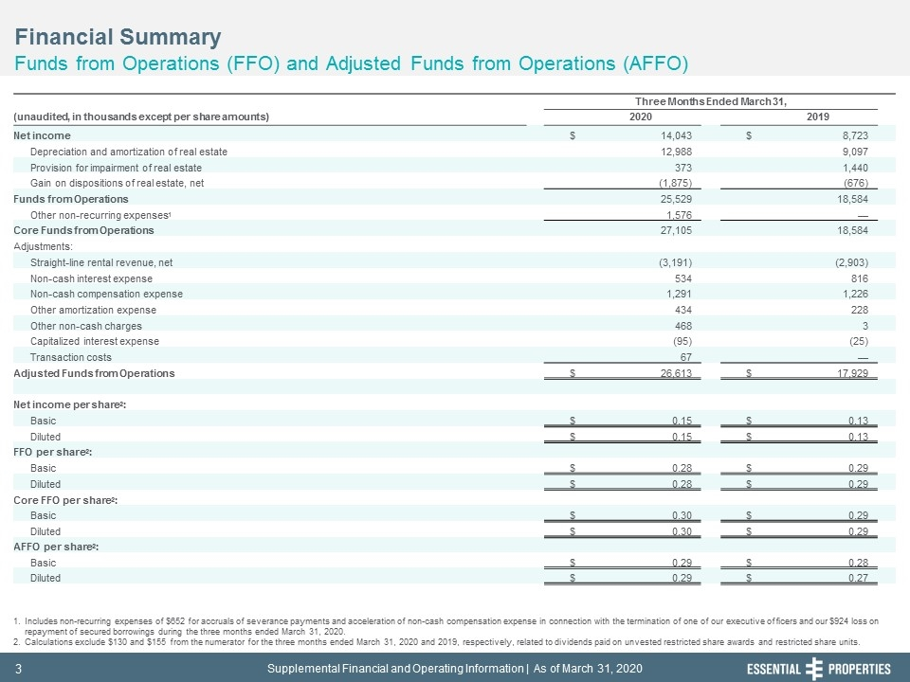
Financial Summary Funds from Operations (FFO) and Adjusted Funds from Operations (AFFO) 242, 242, 242 Includes non-recurring expenses of $652 for accruals of severance payments and acceleration of non-cash compensation expense in connection with the termination of one of our executive officers and our $924 loss on repayment of secured borrowings during the three months ended March 31, 2020. Calculations exclude $130 and $155 from the numerator for the three months ended March 31, 2020 and 2019, respectively, related to dividends paid on unvested restricted share awards and restricted share units. Three Months Ended March 31, (unaudited, in thousands except per share amounts) 2020 2019 Net income $ 14,043 $ 8,723 Depreciation and amortization of real estate 12,988 9,097 Provision for impairment of real estate 373 1,440 Gain on dispositions of real estate, net (1,875) (676) Funds from Operations 25,529 18,584 Other non-recurring expenses1 1,576 — Core Funds from Operations 27,105 18,584 Adjustments: Straight-line rental revenue, net (3,191) (2,903) Non-cash interest expense 534 816 Non-cash compensation expense 1,291 1,226 Other amortization expense 434 228 Other non-cash charges 468 3 Capitalized interest expense (95) (25) Transaction costs 67 — Adjusted Funds from Operations $ 26,613 $ 17,929 Net income per share2: Basic $ 0.15 $ 0.13 Diluted $ 0.15 $ 0.13 FFO per share2: Basic $ 0.28 $ 0.29 Diluted $ 0.28 $ 0.29 Core FFO per share2: Basic $ 0.30 $ 0.29 Diluted $ 0.30 $ 0.29 AFFO per share2: Basic $ 0.29 $ 0.28 Diluted $ 0.29 $ 0.27

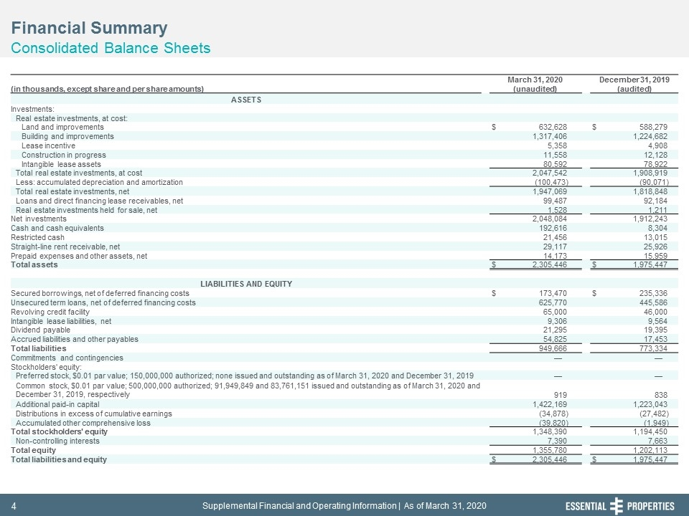
Financial Summary Consolidated Balance Sheets 242, 242, 242 March 31, 2020 December 31, 2019 (in thousands, except share and per share amounts) (unaudited) (audited) ASSETS Investments: Real estate investments, at cost: Land and improvements $ 632,628 $ 588,279 Building and improvements 1,317,406 1,224,682 Lease incentive 5,358 4,908 Construction in progress 11,558 12,128 Intangible lease assets 80,592 78,922 Total real estate investments, at cost 2,047,542 1,908,919 Less: accumulated depreciation and amortization (100,473) (90,071) Total real estate investments, net 1,947,069 1,818,848 Loans and direct financing lease receivables, net 99,487 92,184 Real estate investments held for sale, net 1,528 1,211 Net investments 2,048,084 1,912,243 Cash and cash equivalents 192,616 8,304 Restricted cash 21,456 13,015 Straight-line rent receivable, net 29,117 25,926 Prepaid expenses and other assets, net 14,173 15,959 Total assets $ 2,305,446 $ 1,975,447 LIABILITIES AND EQUITY Secured borrowings, net of deferred financing costs $ 173,470 $ 235,336 Unsecured term loans, net of deferred financing costs 625,770 445,586 Revolving credit facility 65,000 46,000 Intangible lease liabilities, net 9,306 9,564 Dividend payable 21,295 19,395 Accrued liabilities and other payables 54,825 17,453 Total liabilities 949,666 773,334 Commitments and contingencies — — Stockholders' equity: Preferred stock, $0.01 par value; 150,000,000 authorized; none issued and outstanding as of March 31, 2020 and December 31, 2019 — — Common stock, $0.01 par value; 500,000,000 authorized; 91,949,849 and 83,761,151 issued and outstanding as of March 31, 2020 and December 31, 2019, respectively 919 838 Additional paid-in capital 1,422,169 1,223,043 Distributions in excess of cumulative earnings (34,878) (27,482) Accumulated other comprehensive loss (39,820) (1,949) Total stockholders' equity 1,348,390 1,194,450 Non-controlling interests 7,390 7,663 Total equity 1,355,780 1,202,113 Total liabilities and equity $ 2,305,446 $ 1,975,447

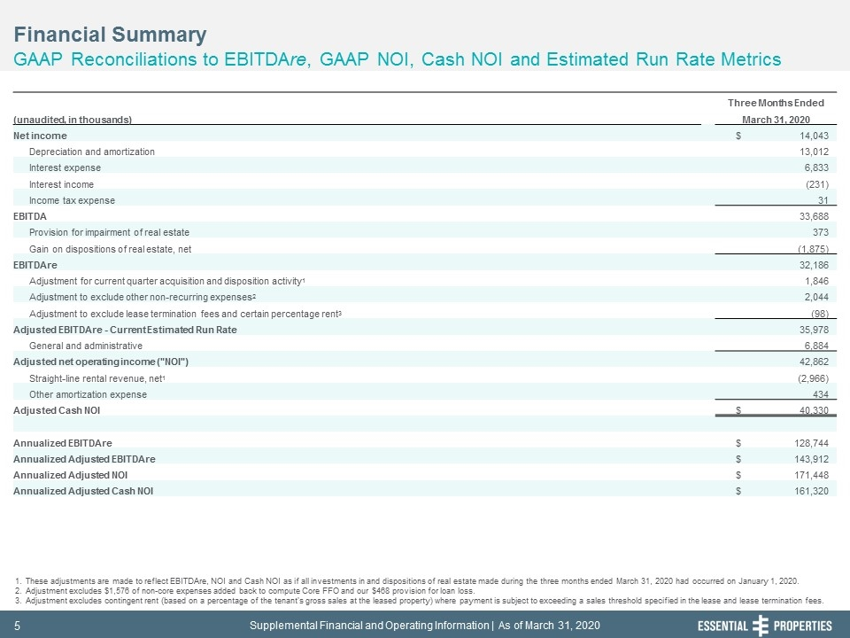
Financial Summary GAAP Reconciliations to EBITDAre, GAAP NOI, Cash NOI and Estimated Run Rate Metrics 242, 242, 242 These adjustments are made to reflect EBITDAre, NOI and Cash NOI as if all investments in and dispositions of real estate made during the three months ended March 31, 2020 had occurred on January 1, 2020. Adjustment excludes $1,576 of non-core expenses added back to compute Core FFO and our $468 provision for loan loss. Adjustment excludes contingent rent (based on a percentage of the tenant's gross sales at the leased property) where payment is subject to exceeding a sales threshold specified in the lease and lease termination fees. Three Months Ended (unaudited, in thousands) March 31, 2020 Net income $ 14,043 Depreciation and amortization 13,012 Interest expense 6,833 Interest income (231) Income tax expense 31 EBITDA 33,688 Provision for impairment of real estate 373 Gain on dispositions of real estate, net (1,875) EBITDAre 32,186 Adjustment for current quarter acquisition and disposition activity1 1,846 Adjustment to exclude other non-recurring expenses2 2,044 Adjustment to exclude lease termination fees and certain percentage rent3 (98) Adjusted EBITDAre - Current Estimated Run Rate 35,978 General and administrative 6,884 Adjusted net operating income ("NOI") 42,862 Straight-line rental revenue, net1 (2,966) Other amortization expense 434 Adjusted Cash NOI $ 40,330 Annualized EBITDAre $ 128,744 Annualized Adjusted EBITDAre $ 143,912 Annualized Adjusted NOI $ 171,448 Annualized Adjusted Cash NOI $ 161,320

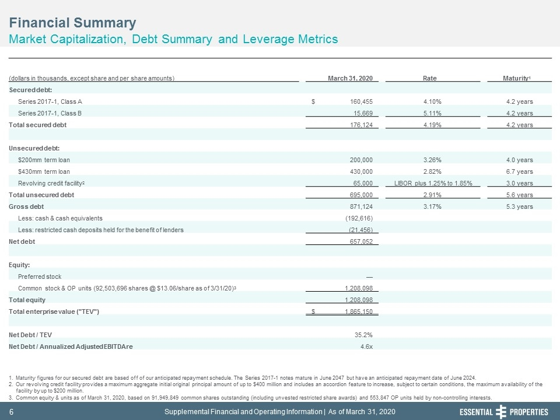
Financial Summary Market Capitalization, Debt Summary and Leverage Metrics 242, 242, 242 Maturity figures for our secured debt are based off of our anticipated repayment schedule. The Series 2017-1 notes mature in June 2047 but have an anticipated repayment date of June 2024. Our revolving credit facility provides a maximum aggregate initial original principal amount of up to $400 million and includes an accordion feature to increase, subject to certain conditions, the maximum availability of the facility by up to $200 million. Common equity & units as of March 31, 2020, based on 91,949,849 common shares outstanding (including unvested restricted share awards) and 553,847 OP units held by non-controlling interests. (dollars in thousands, except share and per share amounts) March 31, 2020 Rate Maturity1 Secured debt: Series 2017-1, Class A $ 160,455 4.10% 4.2 years Series 2017-1, Class B 15,669 5.11% 4.2 years Total secured debt 176,124 4.19% 4.2 years Unsecured debt: $200mm term loan 200,000 3.26% 4.0 years $430mm term loan 430,000 2.82% 6.7 years Revolving credit facility2 65,000 LIBOR plus 1.25% to 1.85% 3.0 years Total unsecured debt 695,000 2.91% 5.6 years Gross debt 871,124 3.17% 5.3 years Less: cash & cash equivalents (192,616) Less: restricted cash deposits held for the benefit of lenders (21,456) Net debt 657,052 Equity: Preferred stock — Common stock & OP units (92,503,696 shares @ $13.06/share as of 3/31/20)3 1,208,098 Total equity 1,208,098 Total enterprise value ("TEV") $ 1,865,150 Net Debt / TEV 35.2% Net Debt / Annualized Adjusted EBITDAre 4.6x

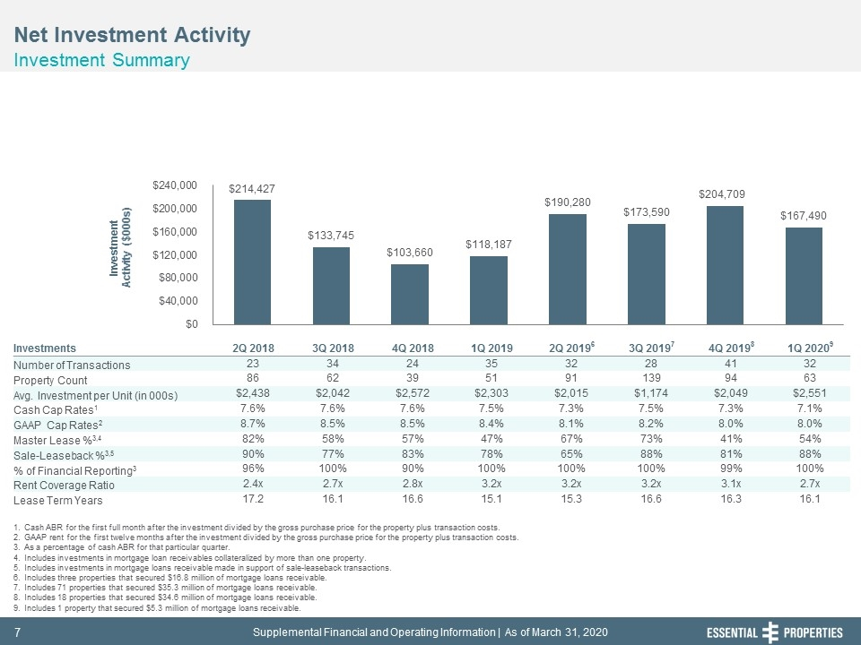
Net Investment Activity Investment Summary 242, 242, 242 Cash ABR for the first full month after the investment divided by the gross purchase price for the property plus transaction costs. GAAP rent for the first twelve months after the investment divided by the gross purchase price for the property plus transaction costs. As a percentage of cash ABR for that particular quarter. Includes investments in mortgage loan receivables collateralized by more than one property. Includes investments in mortgage loans receivable made in support of sale-leaseback transactions. Includes three properties that secured $16.8 million of mortgage loans receivable. Includes 71 properties that secured $35.3 million of mortgage loans receivable. Includes 18 properties that secured $34.6 million of mortgage loans receivable. Includes 1 property that secured $5.3 million of mortgage loans receivable. Investments 2Q 2018 3Q 2018 4Q 2018 1Q 2019 2Q 20196 3Q 20197 4Q 20198 1Q 20209 Number of Transactions 23 34 24 35 32 28 41 32 Property Count 86 62 39 51 91 139 94 63 Avg. Investment per Unit (in 000s) $2,438 $2,042 $2,572 $2,303 $2,015 $1,174 $2,049 $2,551 Cash Cap Rates1 7.6% 7.6% 7.6% 7.5% 7.3% 7.5% 7.3% 7.1% GAAP Cap Rates2 8.7% 8.5% 8.5% 8.4% 8.1% 8.2% 8.0% 8.0% Master Lease %3,4 82% 58% 57% 47% 67% 73% 41% 54% Sale-Leaseback %3,5 90% 77% 83% 78% 65% 88% 81% 88% % of Financial Reporting3 96% 100% 90% 100% 100% 100% 99% 100% Rent Coverage Ratio 2.4x 2.7x 2.8x 3.2x 3.2x 3.2x 3.1x 2.7x Lease Term Years 17.2 16.1 16.6 15.1 15.3 16.6 16.3 16.1

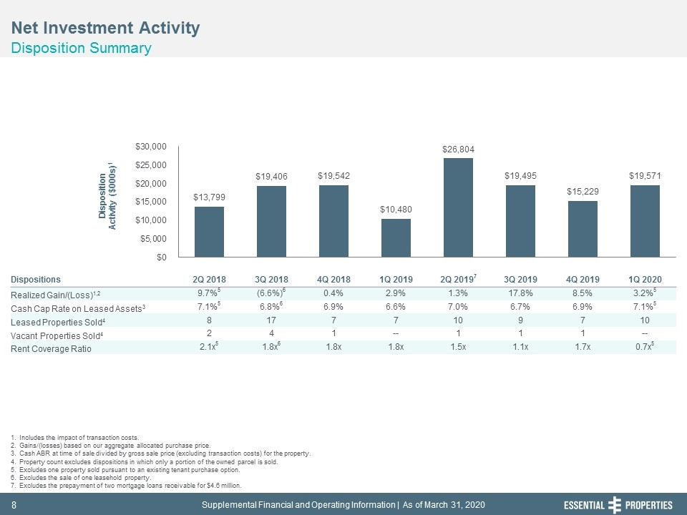
Net Investment Activity Disposition Summary 242, 242, 242 Includes the impact of transaction costs. Gains/(losses) based on our aggregate allocated purchase price. Cash ABR at time of sale divided by gross sale price (excluding transaction costs) for the property. Property count excludes dispositions in which only a portion of the owned parcel is sold. Excludes one property sold pursuant to an existing tenant purchase option. Excludes the sale of one leasehold property. Excludes the prepayment of two mortgage loans receivable for $4.6 million. Dispositions 2Q 2018 3Q 2018 4Q 2018 1Q 2019 2Q 20197 3Q 2019 4Q 2019 1Q 2020 Realized Gain/(Loss)1,2 9.7%5 (6.6%)6 0.4% 2.9% 1.3% 17.8% 8.5% 3.2%5 Cash Cap Rate on Leased Assets3 7.1%5 6.8%6 6.9% 6.6% 7.0% 6.7% 6.9% 7.1%5 Leased Properties Sold4 8 17 7 7 10 9 7 10 Vacant Properties Sold4 2 4 1 -- 1 1 1 -- Rent Coverage Ratio 2.1x5 1.8x6 1.8x 1.8x 1.5x 1.1x 1.7x 0.7x5

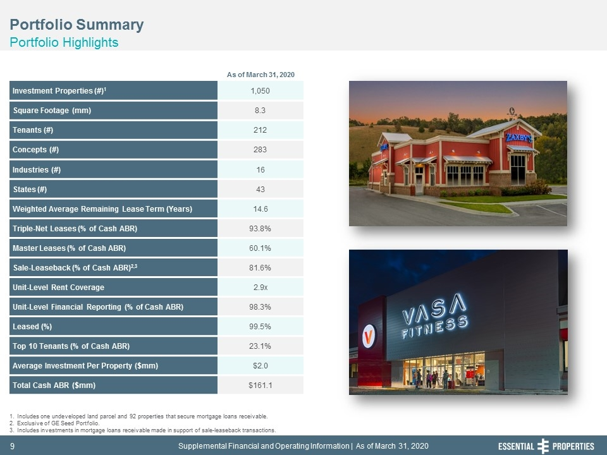
Portfolio Summary Portfolio Highlights 242, 242, 242 Investment Properties (#)1 1,050 Square Footage (mm) 8.3 Tenants (#) 212 Concepts (#) 283 Industries (#) 16 States (#) 43 Weighted Average Remaining Lease Term (Years) 14.6 Triple-Net Leases (% of Cash ABR) 93.8% Master Leases (% of Cash ABR) 60.1% Sale-Leaseback (% of Cash ABR)2,3 81.6% Unit-Level Rent Coverage 2.9x Unit-Level Financial Reporting (% of Cash ABR) 98.3% Leased (%) 99.5% Top 10 Tenants (% of Cash ABR) 23.1% Average Investment Per Property ($mm) $2.0 Total Cash ABR ($mm) $161.1 Includes one undeveloped land parcel and 92 properties that secure mortgage loans receivable. Exclusive of GE Seed Portfolio. Includes investments in mortgage loans receivable made in support of sale-leaseback transactions. As of March 31, 2020

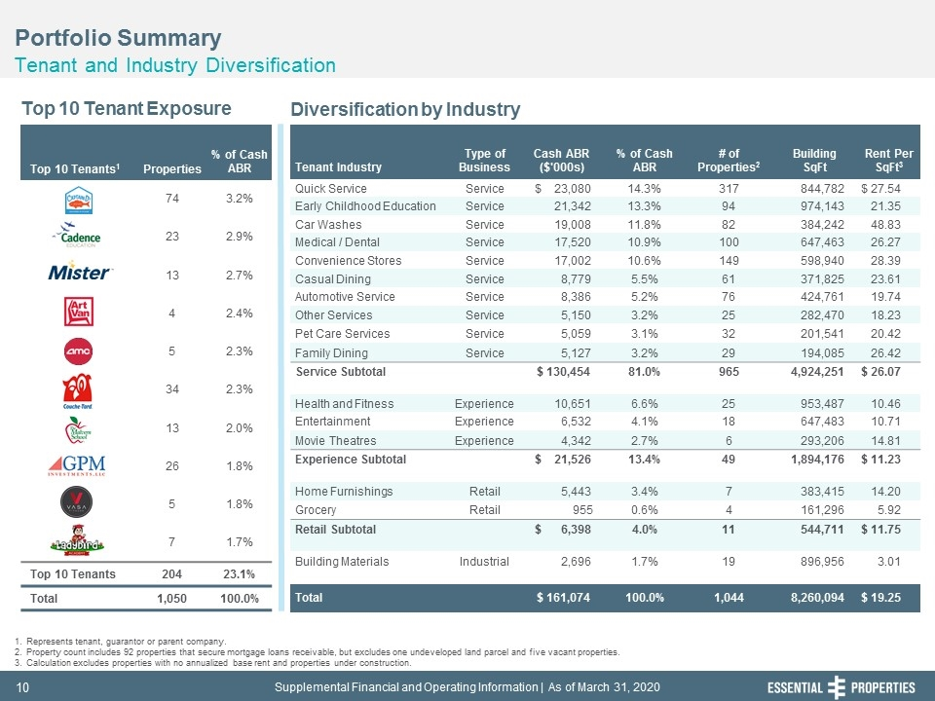
Portfolio Summary Tenant and Industry Diversification 242, 242, 242 Top 10 Tenants1 Properties % of Cash ABR 74 3.2% 23 2.9% 13 2.7% 4 2.4% 5 2.3% 34 2.3% 13 2.0% 26 1.8% 5 1.8% 7 1.7% Top 10 Tenants 204 23.1% Total 1,050 100.0% Top 10 Tenant Exposure Diversification by Industry Represents tenant, guarantor or parent company. Property count includes 92 properties that secure mortgage loans receivable, but excludes one undeveloped land parcel and five vacant properties. Calculation excludes properties with no annualized base rent and properties under construction. Tenant Industry Type of Business Cash ABR ($'000s) % of Cash ABR # of Properties2 Building SqFt Rent Per SqFt3 Quick Service Service $ 23,080 14.3% 317 844,782 $ 27.54 Early Childhood Education Service 21,342 13.3% 94 974,143 21.35 Car Washes Service 19,008 11.8% 82 384,242 48.83 Medical / Dental Service 17,520 10.9% 100 647,463 26.27 Convenience Stores Service 17,002 10.6% 149 598,940 28.39 Casual Dining Service 8,779 5.5% 61 371,825 23.61 Automotive Service Service 8,386 5.2% 76 424,761 19.74 Other Services Service 5,150 3.2% 25 282,470 18.23 Pet Care Services Service 5,059 3.1% 32 201,541 20.42 Family Dining Service 5,127 3.2% 29 194,085 26.42 Service Subtotal $ 130,454 81.0% 965 4,924,251 $ 26.07 Health and Fitness Experience 10,651 6.6% 25 953,487 10.46 Entertainment Experience 6,532 4.1% 18 647,483 10.71 Movie Theatres Experience 4,342 2.7% 6 293,206 14.81 Experience Subtotal $ 21,526 13.4% 49 1,894,176 $ 11.23 Home Furnishings Retail 5,443 3.4% 7 383,415 14.20 Grocery Retail 955 0.6% 4 161,296 5.92 Retail Subtotal $ 6,398 4.0% 11 544,711 $ 11.75 Building Materials Industrial 2,696 1.7% 19 896,956 3.01 Total $ 161,074 100.0% 1,044 8,260,094 $ 19.25

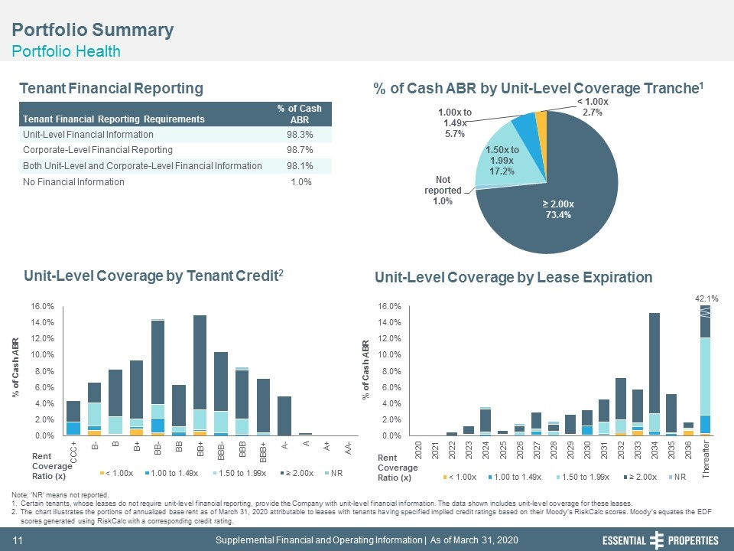
42.1% Portfolio Summary Portfolio Health 242, 242, 242 Tenant Financial Reporting % of Cash ABR by Unit-Level Coverage Tranche1 Unit-Level Coverage by Lease Expiration Unit-Level Coverage by Tenant Credit2 Note: ‘NR’ means not reported. Certain tenants, whose leases do not require unit-level financial reporting, provide the Company with unit-level financial information. The data shown includes unit-level coverage for these leases. The chart illustrates the portions of annualized base rent as of March 31, 2020 attributable to leases with tenants having specified implied credit ratings based on their Moody’s RiskCalc scores. Moody’s equates the EDF scores generated using RiskCalc with a corresponding credit rating. Tenant Financial Reporting Requirements % of Cash ABR Unit-Level Financial Information 98.3% Corporate-Level Financial Reporting 98.7% Both Unit-Level and Corporate-Level Financial Information 98.1% No Financial Information 1.0% Rent Coverage Ratio (x) Rent Coverage Ratio (x)

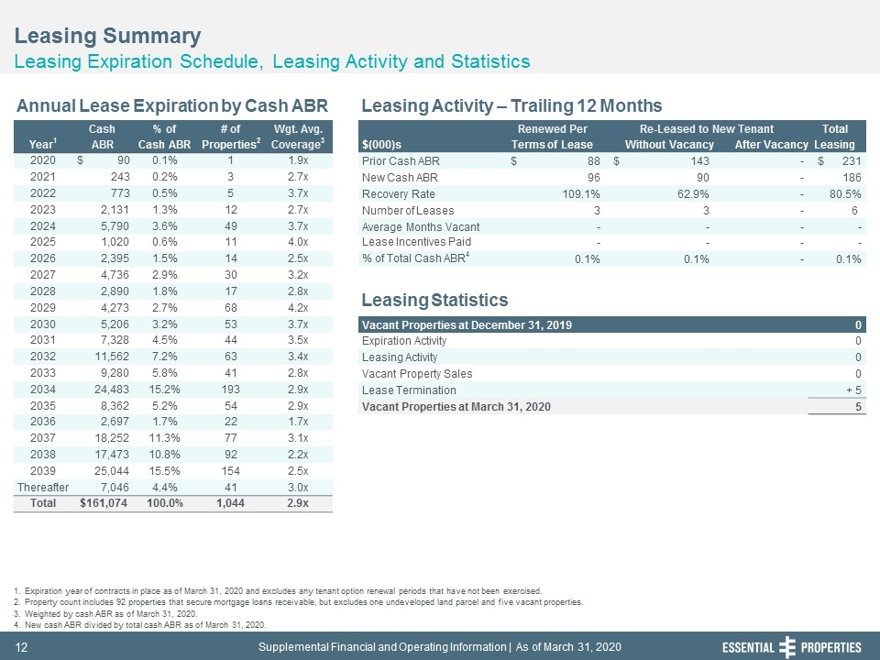
Cash % of # of Wgt. Avg. Renewed Per Re-Leased to New Tenant Total Year1 ABR Cash ABR Properties2 Coverage3 $(000)s Terms of Lease Without Vacancy After Vacancy Leasing 2020 $ 90 0.1% 1 1.9x Prior Cash ABR $ 88 $ 143 - $ 231 2021 243 0.2% 3 2.7x New Cash ABR 96 90 - 186 2022 773 0.5% 5 3.7x Recovery Rate 109.1% 62.9% - 80.5% 2023 2,131 1.3% 12 2.7x Number of Leases 3 3 - 6 2024 5,790 3.6% 49 3.7x Average Months Vacant - - - - 2025 1,020 0.6% 11 4.0x Lease Incentives Paid - - - - 2026 2,395 1.5% 14 2.5x % of Total Cash ABR4 0.1% 0.1% - 0.1% 2027 4,736 2.9% 30 3.2x 2028 2,890 1.8% 17 2.8x 2029 4,273 2.7% 68 4.2x 2030 5,206 3.2% 53 3.7x Vacant Properties at December 31, 2019 0 2031 7,328 4.5% 44 3.5x Expiration Activity 0 2032 11,562 7.2% 63 3.4x Leasing Activity 0 2033 9,280 5.8% 41 2.8x Vacant Property Sales 0 2034 24,483 15.2% 193 2.9x Lease Termination + 5 2035 8,362 5.2% 54 2.9x Vacant Properties at March 31, 2020 5 2036 2,697 1.7% 22 1.7x 2037 18,252 11.3% 77 3.1x 2038 17,473 10.8% 92 2.2x 2039 25,044 15.5% 154 2.5x Thereafter 7,046 4.4% 41 3.0x Total $161,074 100.0% 1,044 2.9x Leasing Summary Leasing Expiration Schedule, Leasing Activity and Statistics 242, 242, 242 Expiration year of contracts in place as of March 31, 2020 and excludes any tenant option renewal periods that have not been exercised. Property count includes 92 properties that secure mortgage loans receivable, but excludes one undeveloped land parcel and five vacant properties. Weighted by cash ABR as of March 31, 2020. New cash ABR divided by total cash ABR as of March 31, 2020. Annual Lease Expiration by Cash ABR Leasing Activity – Trailing 12 Months Leasing Statistics

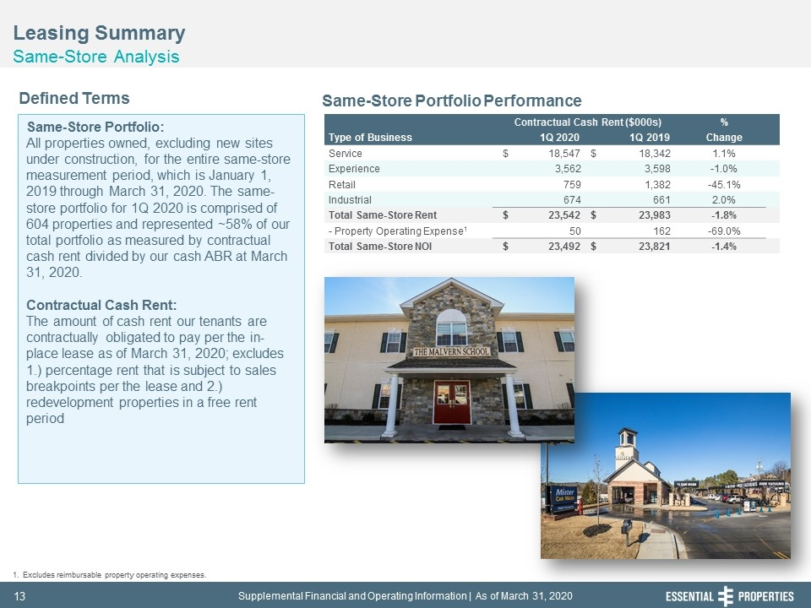
Leasing Summary Same-Store Analysis 242, 242, 242 Same-Store Portfolio: All properties owned, excluding new sites under construction, for the entire same-store measurement period, which is January 1, 2019 through March 31, 2020. The same-store portfolio for 1Q 2020 is comprised of 604 properties and represented ~58% of our total portfolio as measured by contractual cash rent divided by our cash ABR at March 31, 2020. Contractual Cash Rent: The amount of cash rent our tenants are contractually obligated to pay per the in-place lease as of March 31, 2020; excludes 1.) percentage rent that is subject to sales breakpoints per the lease and 2.) redevelopment properties in a free rent period Defined Terms Same-Store Portfolio Performance Excludes reimbursable property operating expenses. Contractual Cash Rent ($000s) % Type of Business 1Q 2020 1Q 2019 Change Service $ 18,547 $ 18,342 1.1% Experience 3,562 3,598 -1.0% Retail 759 1,382 -45.1% Industrial 674 661 2.0% Total Same-Store Rent $ 23,542 $ 23,983 -1.8% - Property Operating Expense1 50 162 -69.0% Total Same-Store NOI $ 23,492 $ 23,821 -1.4%

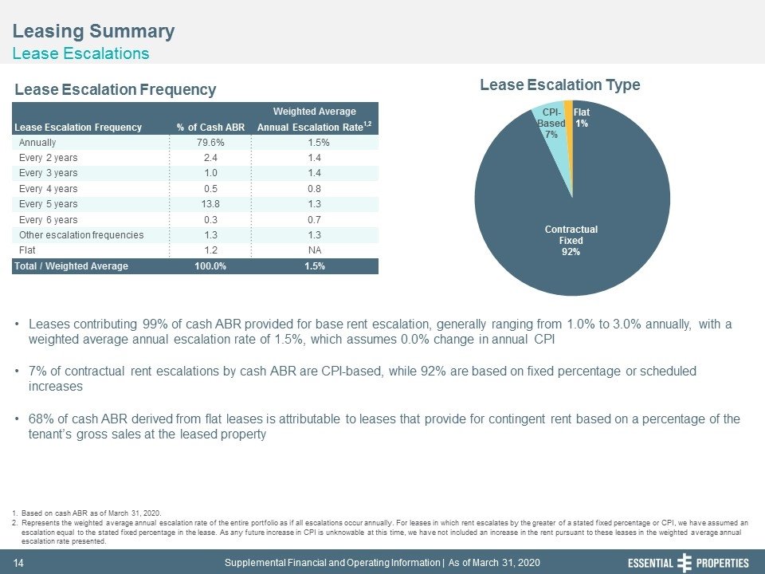
Leasing Summary Lease Escalations 242, 242, 242 Leases contributing 99% of cash ABR provided for base rent escalation, generally ranging from 1.0% to 3.0% annually, with a weighted average annual escalation rate of 1.5%, which assumes 0.0% change in annual CPI 7% of contractual rent escalations by cash ABR are CPI-based, while 92% are based on fixed percentage or scheduled increases 68% of cash ABR derived from flat leases is attributable to leases that provide for contingent rent based on a percentage of the tenant’s gross sales at the leased property Based on cash ABR as of March 31, 2020. Represents the weighted average annual escalation rate of the entire portfolio as if all escalations occur annually. For leases in which rent escalates by the greater of a stated fixed percentage or CPI, we have assumed an escalation equal to the stated fixed percentage in the lease. As any future increase in CPI is unknowable at this time, we have not included an increase in the rent pursuant to these leases in the weighted average annual escalation rate presented. Lease Escalation Frequency Lease Escalation Type Weighted Average Lease Escalation Frequency % of Cash ABR Annual Escalation Rate1,2 Annually 79.6% 1.5% Every 2 years 2.4 1.4 Every 3 years 1.0 1.4 Every 4 years 0.5 0.8 Every 5 years 13.8 1.3 Every 6 years 0.3 0.7 Other escalation frequencies 1.3 1.3 Flat 1.2 NA Total / Weighted Average 100.0% 1.5%

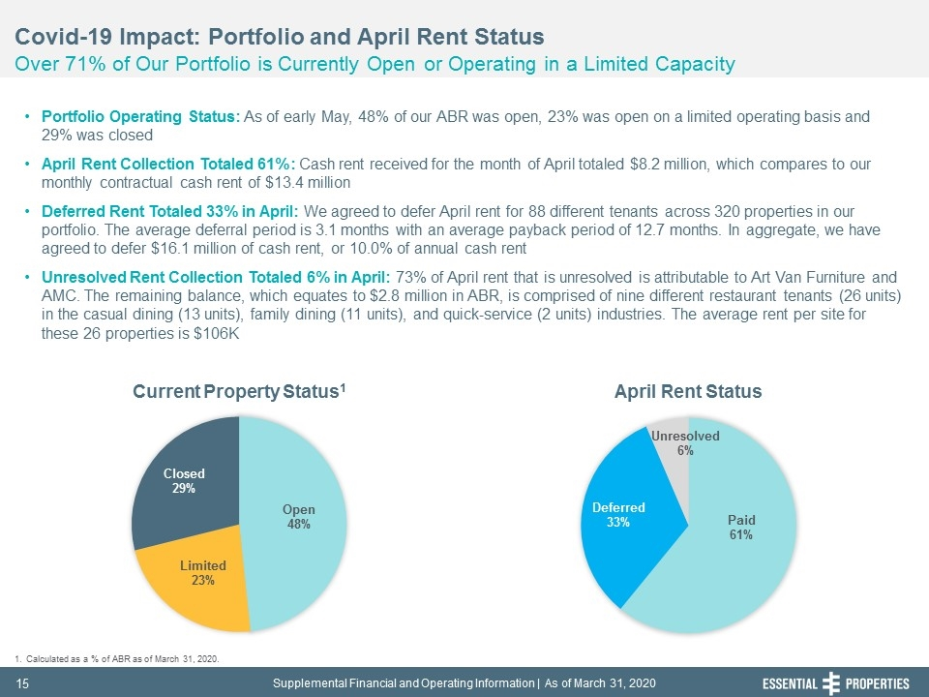
242, 242, 242 Covid-19 Impact: Portfolio and April Rent Status Over 71% of Our Portfolio is Currently Open or Operating in a Limited Capacity Portfolio Operating Status: As of early May, 48% of our ABR was open, 23% was open on a limited operating basis and 29% was closed April Rent Collection Totaled 61%: Cash rent received for the month of April totaled $8.2 million, which compares to our monthly contractual cash rent of $13.4 million Deferred Rent Totaled 33% in April: We agreed to defer April rent for 88 different tenants across 320 properties in our portfolio. The average deferral period is 3.1 months with an average payback period of 12.7 months. In aggregate, we have agreed to defer $16.1 million of cash rent, or 10.0% of annual cash rent Unresolved Rent Collection Totaled 6% in April: 73% of April rent that is unresolved is attributable to Art Van Furniture and AMC. The remaining balance, which equates to $2.8 million in ABR, is comprised of nine different restaurant tenants (26 units) in the casual dining (13 units), family dining (11 units), and quick-service (2 units) industries. The average rent per site for these 26 properties is $106K Calculated as a % of ABR as of March 31, 2020. Current Property Status1 April Rent Status

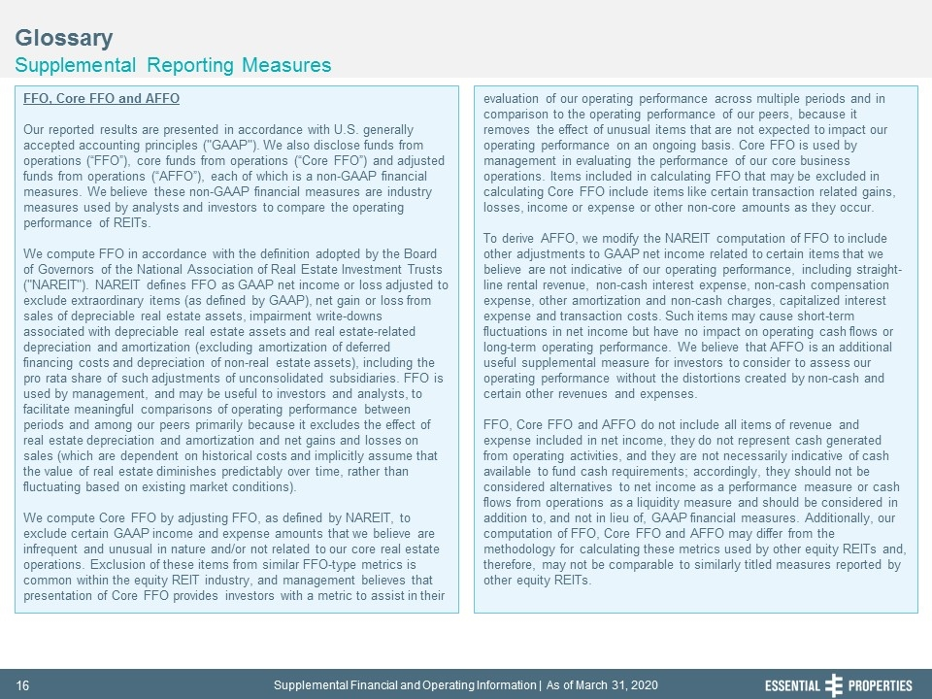
Glossary Supplemental Reporting Measures 242, 242, 242 FFO, Core FFO and AFFO Our reported results are presented in accordance with U.S. generally accepted accounting principles ("GAAP"). We also disclose funds from operations (“FFO”), core funds from operations (“Core FFO”) and adjusted funds from operations (“AFFO”), each of which is a non-GAAP financial measures. We believe these non-GAAP financial measures are industry measures used by analysts and investors to compare the operating performance of REITs. We compute FFO in accordance with the definition adopted by the Board of Governors of the National Association of Real Estate Investment Trusts ("NAREIT"). NAREIT defines FFO as GAAP net income or loss adjusted to exclude extraordinary items (as defined by GAAP), net gain or loss from sales of depreciable real estate assets, impairment write-downs associated with depreciable real estate assets and real estate-related depreciation and amortization (excluding amortization of deferred financing costs and depreciation of non-real estate assets), including the pro rata share of such adjustments of unconsolidated subsidiaries. FFO is used by management, and may be useful to investors and analysts, to facilitate meaningful comparisons of operating performance between periods and among our peers primarily because it excludes the effect of real estate depreciation and amortization and net gains and losses on sales (which are dependent on historical costs and implicitly assume that the value of real estate diminishes predictably over time, rather than fluctuating based on existing market conditions). We compute Core FFO by adjusting FFO, as defined by NAREIT, to exclude certain GAAP income and expense amounts that we believe are infrequent and unusual in nature and/or not related to our core real estate operations. Exclusion of these items from similar FFO-type metrics is common within the equity REIT industry, and management believes that presentation of Core FFO provides investors with a metric to assist in their evaluation of our operating performance across multiple periods and in comparison to the operating performance of our peers, because it removes the effect of unusual items that are not expected to impact our operating performance on an ongoing basis. Core FFO is used by management in evaluating the performance of our core business operations. Items included in calculating FFO that may be excluded in calculating Core FFO include items like certain transaction related gains, losses, income or expense or other non-core amounts as they occur. To derive AFFO, we modify the NAREIT computation of FFO to include other adjustments to GAAP net income related to certain items that we believe are not indicative of our operating performance, including straight-line rental revenue, non-cash interest expense, non-cash compensation expense, other amortization and non-cash charges, capitalized interest expense and transaction costs. Such items may cause short-term fluctuations in net income but have no impact on operating cash flows or long-term operating performance. We believe that AFFO is an additional useful supplemental measure for investors to consider to assess our operating performance without the distortions created by non-cash and certain other revenues and expenses. FFO, Core FFO and AFFO do not include all items of revenue and expense included in net income, they do not represent cash generated from operating activities, and they are not necessarily indicative of cash available to fund cash requirements; accordingly, they should not be considered alternatives to net income as a performance measure or cash flows from operations as a liquidity measure and should be considered in addition to, and not in lieu of, GAAP financial measures. Additionally, our computation of FFO, Core FFO and AFFO may differ from the methodology for calculating these metrics used by other equity REITs and, therefore, may not be comparable to similarly titled measures reported by other equity REITs.

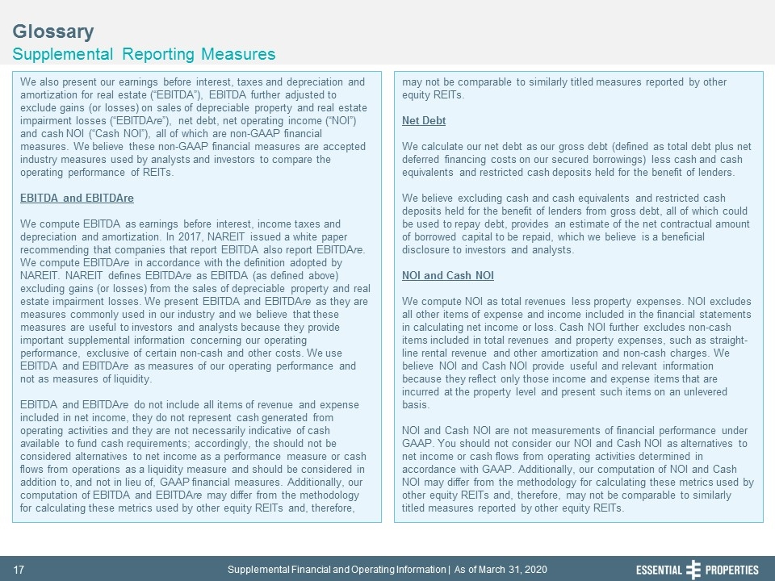
Glossary Supplemental Reporting Measures 242, 242, 242 We also present our earnings before interest, taxes and depreciation and amortization for real estate (“EBITDA”), EBITDA further adjusted to exclude gains (or losses) on sales of depreciable property and real estate impairment losses (“EBITDAre”), net debt, net operating income (“NOI”) and cash NOI (“Cash NOI”), all of which are non-GAAP financial measures. We believe these non-GAAP financial measures are accepted industry measures used by analysts and investors to compare the operating performance of REITs. EBITDA and EBITDAre We compute EBITDA as earnings before interest, income taxes and depreciation and amortization. In 2017, NAREIT issued a white paper recommending that companies that report EBITDA also report EBITDAre. We compute EBITDAre in accordance with the definition adopted by NAREIT. NAREIT defines EBITDAre as EBITDA (as defined above) excluding gains (or losses) from the sales of depreciable property and real estate impairment losses. We present EBITDA and EBITDAre as they are measures commonly used in our industry and we believe that these measures are useful to investors and analysts because they provide important supplemental information concerning our operating performance, exclusive of certain non-cash and other costs. We use EBITDA and EBITDAre as measures of our operating performance and not as measures of liquidity. EBITDA and EBITDAre do not include all items of revenue and expense included in net income, they do not represent cash generated from operating activities and they are not necessarily indicative of cash available to fund cash requirements; accordingly, the should not be considered alternatives to net income as a performance measure or cash flows from operations as a liquidity measure and should be considered in addition to, and not in lieu of, GAAP financial measures. Additionally, our computation of EBITDA and EBITDAre may differ from the methodology for calculating these metrics used by other equity REITs and, therefore, may not be comparable to similarly titled measures reported by other equity REITs. Net Debt We calculate our net debt as our gross debt (defined as total debt plus net deferred financing costs on our secured borrowings) less cash and cash equivalents and restricted cash deposits held for the benefit of lenders. We believe excluding cash and cash equivalents and restricted cash deposits held for the benefit of lenders from gross debt, all of which could be used to repay debt, provides an estimate of the net contractual amount of borrowed capital to be repaid, which we believe is a beneficial disclosure to investors and analysts. NOI and Cash NOI We compute NOI as total revenues less property expenses. NOI excludes all other items of expense and income included in the financial statements in calculating net income or loss. Cash NOI further excludes non-cash items included in total revenues and property expenses, such as straight-line rental revenue and other amortization and non-cash charges. We believe NOI and Cash NOI provide useful and relevant information because they reflect only those income and expense items that are incurred at the property level and present such items on an unlevered basis. NOI and Cash NOI are not measurements of financial performance under GAAP. You should not consider our NOI and Cash NOI as alternatives to net income or cash flows from operating activities determined in accordance with GAAP. Additionally, our computation of NOI and Cash NOI may differ from the methodology for calculating these metrics used by other equity REITs and, therefore, may not be comparable to similarly titled measures reported by other equity REITs.

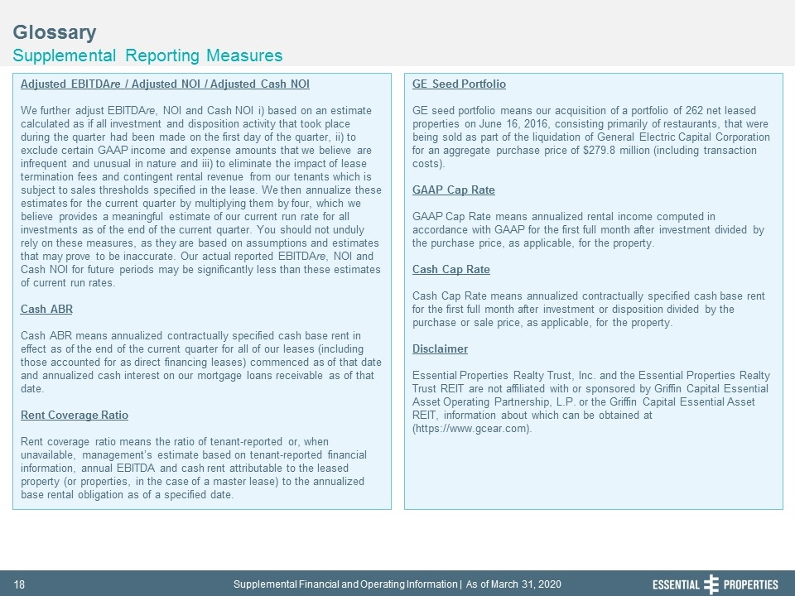
Glossary Supplemental Reporting Measures 242, 242, 242 Adjusted EBITDAre / Adjusted NOI / Adjusted Cash NOI We further adjust EBITDAre, NOI and Cash NOI i) based on an estimate calculated as if all investment and disposition activity that took place during the quarter had been made on the first day of the quarter, ii) to exclude certain GAAP income and expense amounts that we believe are infrequent and unusual in nature and iii) to eliminate the impact of lease termination fees and contingent rental revenue from our tenants which is subject to sales thresholds specified in the lease. We then annualize these estimates for the current quarter by multiplying them by four, which we believe provides a meaningful estimate of our current run rate for all investments as of the end of the current quarter. You should not unduly rely on these measures, as they are based on assumptions and estimates that may prove to be inaccurate. Our actual reported EBITDAre, NOI and Cash NOI for future periods may be significantly less than these estimates of current run rates. Cash ABR Cash ABR means annualized contractually specified cash base rent in effect as of the end of the current quarter for all of our leases (including those accounted for as direct financing leases) commenced as of that date and annualized cash interest on our mortgage loans receivable as of that date. Rent Coverage Ratio Rent coverage ratio means the ratio of tenant-reported or, when unavailable, management’s estimate based on tenant-reported financial information, annual EBITDA and cash rent attributable to the leased property (or properties, in the case of a master lease) to the annualized base rental obligation as of a specified date. GE Seed Portfolio GE seed portfolio means our acquisition of a portfolio of 262 net leased properties on June 16, 2016, consisting primarily of restaurants, that were being sold as part of the liquidation of General Electric Capital Corporation for an aggregate purchase price of $279.8 million (including transaction costs). GAAP Cap Rate GAAP Cap Rate means annualized rental income computed in accordance with GAAP for the first full month after investment divided by the purchase price, as applicable, for the property. Cash Cap Rate Cash Cap Rate means annualized contractually specified cash base rent for the first full month after investment or disposition divided by the purchase or sale price, as applicable, for the property. Disclaimer Essential Properties Realty Trust, Inc. and the Essential Properties Realty Trust REIT are not affiliated with or sponsored by Griffin Capital Essential Asset Operating Partnership, L.P. or the Griffin Capital Essential Asset REIT, information about which can be obtained at (https://www.gcear.com).

