UNITED STATES
SECURITIES AND EXCHANGE COMMISSION
Washington, D.C. 20549

FORM 8-K

CURRENT REPORT

Pursuant to Section 13 or 15(d)
of the Securities Exchange Act of 1934

October 23, 2024
Date of Report (Date of earliest event reported)

Essential Properties Realty Trust, Inc.
(Exact name of registrant as specified in its charter)

Maryland |  |  |  |  |  | 001-38530 |  |  |  |  |  | 82-4005693
(State or other jurisdiction of incorporation) |  |  |  |  |  | (Commission File Number) |  |  |  |  |  | (IRS Employer Identification No.)
902 Carnegie Center Blvd., Suite 520
Princeton, New Jersey |  |  |  |  |  |  |  |  |  |  |  | 08540
(Address of principal executive offices) |  |  |  |  |  |  |  |  |  |  |  | (Zip Code)
Registrant’s telephone number, including area code: |  |  |  |  |  |  |  |  |  |  |  | (609) 436-0619

Check the appropriate box below if the Form 8-K filing is intended to simultaneously satisfy the filing obligations of the registrant under any of the following provisions:
☐ |  |  | Written communications pursuant to Rule 425 under the Securities Act 17 CFR 230.425)
☐ |  |  | Soliciting material pursuant to Rule 14a-12 under the Exchange Act (17 CFR 240.14a-12)
☐ |  |  | Pre-commencement communications pursuant to Rule 14d-2(b) under the Exchange Act (17 CFR 240.14d-2(b))
☐ |  |  | Pre-commencement communications pursuant to Rule 13e-4(c) under the Exchange Act (17 CFR 240.13e-4(c))

Securities registered pursuant to Section 12(b) of the Act:
Title of Each Class |  |  |  |  |  | Trading Symbol(s) |  |  |  |  |  | Name of Each Exchange on Which Registered
Common stock, $0.01 par value |  |  |  |  |  | EPRT |  |  |  |  |  | New York Stock Exchange

Indicate by check mark whether the registrant is an emerging growth company as defined in Rule 405 of the Securities Act of 1933 (§230.405 of this chapter) or Rule 12b-2 of the Securities Exchange Act of 1934 (§240.12b-2 of this chapter).
Emerging growth company ☐

If an emerging growth company, indicate by check mark if the registrant has elected not to use the extended transition period for complying with any new or revised financial accounting standards provided pursuant to Section 13(a) of the Exchange Act ☐

Item 2.02 — Results of Operations and Financial Condition.
On October 23, 2024, Essential Properties Realty Trust, Inc. (the “Company”) issued a press release announcing the Company’s financial results for the three and nine months ended September 30, 2024. The press release is furnished hereto as Exhibit 99.1 and incorporated herein by reference.

Item 7.01— Regulation FD Disclosure.
On October 23, 2024, the Company issued its Supplemental Information—Third Quarter 2024. The Supplemental Information is furnished hereto as Exhibit 99.2 and incorporated herein by reference.
The foregoing information is furnished pursuant to Item 2.02, “Results of Operations and Financial Condition,” and Item 7.01, “Regulation FD Disclosure.” The information in Items 2.02 and 7.01 of this Current Report on Form 8-K and the exhibits furnished therewith shall not be deemed “filed” for purposes of Section 18 of the Securities Exchange Act of 1934 or otherwise subject to the liabilities of that Section, and shall not be or be deemed to be incorporated by reference in any filing under the Securities Act of 1933 or the Securities Exchange Act of 1934, regardless of any general incorporation language in such filing.

Item 9.01 — Financial Statements and Exhibits.
(d) Exhibits.

Exhibit No. |  |  | Description
99.1 |  |  | Earnings Press Release dated October 23, 2024 for the quarter ended September 30, 2024
99.2 |  |  | Supplemental Information—Third Quarter 2024
104 |  |  | Cover Page Interactive Data File (embedded within the Inline XBRL document)

SIGNATURES

Pursuant to the requirements of the Securities Exchange Act of 1934, the registrant has duly caused this report to be signed on its behalf by the undersigned hereunto duly authorized.

Date: October 23, 2024 |  |  | ESSENTIAL PROPERTIES REALTY TRUST, INC.
 |  |  | By: |  |  | /s/ Mark E. Patten
 |  |  |  |  |  | Mark E. Patten
 |  |  |  |  |  | Executive Vice President, Chief Financial Officer, Treasurer and Corporate Secretary

Exhibit 99.1

Essential Properties Announces Third Quarter 2024 Results
- Third Quarter Net Income per Share of $0.27 and AFFO per Share of $0.43 -
- Closed Investments of $307.6 million at an 8.1% Weighted Average Cash Cap Rate -
- Issues 2025 AFFO Guidance of $1.84 to $1.89 per Share -
October 23, 2024
PRINCETON, N.J.--(BUSINESS WIRE)--Essential Properties Realty Trust, Inc. (NYSE: EPRT; “Essential Properties” or the “Company”) today announced operating results for the three and nine months ended September 30, 2024.
Third Quarter 2024 Financial and Operating Highlights:
Operating Results (compared to Third Quarter 2023):
•Investments (57 properties) |  |  | $ Invested |  |  | $307.6 million
 |  |  | Weighted Avg Cash Cap Rate |  |  | 8.1%
•Dispositions (9 properties) |  |  | Net Proceeds |  |  | $17.0 million
 |  |  | Weighted Avg Cash Cap Rate |  |  | 6.8%
•Net Income per Share |  |  | Decreased by 7% |  |  | $0.27
•Funds from Operations ("FFO") per Share |  |  | Increased by 7% |  |  | $0.48
•Core Funds from Operations ("Core FFO") per Share |  |  | Increased by 7% |  |  | $0.48
•Adjusted Funds from Operations ("AFFO") per Share |  |  | Increased by 2% |  |  | $0.43
Debt, Equity & Leverage Update:
•New $450mm 2030 Term Loan (fully swapped at 4.9% rate) |  |  | Amount drawn at Sept. 30, 2024 |  |  | $450.0 million
•Equity Raised (Gross) - ATM Program (1) |  |  | $31.04/share |  |  | $312.4 million
•Pro Forma Net Debt to Annualized Adjusted EBITDAre (2) |  |  | As of Quarter End |  |  | 3.5x
Year to Date 2024 Financial and Operating Highlights:
Operating Results (compared to YTD Third Quarter 2023):
•Investments (219 properties) |  |  | $ Invested |  |  | $890.3 million
 |  |  | Weighted Avg Cash Cap Rate |  |  | 8.1%
•Dispositions (22 properties) |  |  | Net Proceeds |  |  | $33.7 million
 |  |  | Weighted Avg Cash Cap Rate |  |  | 6.8%
•Net Income per share |  |  | Decreased by 11% |  |  | $0.84
•FFO per share |  |  | Increased by 8% |  |  | $1.41
•Core FFO per share |  |  | Increased by 8% |  |  | $1.41
•AFFO per share |  |  | Increased by 5% |  |  | $1.29
Debt & Equity Activity:
•Equity Raised (Gross) - Follow-On Offering (March 14, 2024) (1) |  |  | $24.75/share |  |  | $256.2 million
•Equity Raised (Gross) - ATM Program (1) |  |  | $29.03/share |  |  | $502.8 million
1.All shares were sold on a forward basis and a total of 22,937,762 shares remain unsettled for estimated net proceeds of $626.0 million.
2.See page 10 for detailed calculation.
Activity Subsequent to Third Quarter 2024:
•Investments |  |  | $ Invested |  |  | $50.7 million
•Dispositions |  |  | $ Gross Proceeds |  |  | $4.0 million
1

CEO Comments
Commenting on the third quarter 2024 results, the Company's President and Chief Executive Officer, Pete Mavoides, said, “In the third quarter, our portfolio continued to perform well, as our middle market tenancy broadly remained healthy. The normalization of capital markets afforded us the opportunity to stay on the front foot, raising over $700 million of debt and equity capital, taking our liquidity position to over $1 billion. While this normalization is likely to bring increased competition on investments, our strong balance sheet and differentiated investment strategy position us for continued success in 2025. Our AFFO per share guidance for 2025 reflects these dynamics as we look to continue to execute our business plan."
Portfolio Highlights
The Company’s investment portfolio as of September 30, 2024 is summarized as follows:

 |  |  |  |  |  | September 30, 2024
Number of properties |  |  |  |  |  | 2,053
Weighted average lease term (WALT) |  |  |  |  |  | 14.1 years
Weighted average rent coverage ratio |  |  |  |  |  | 3.6x
Number of tenants |  |  |  |  |  | 407
Number of industries |  |  |  |  |  | 16
Weighted average occupancy |  |  |  |  |  | 99.9%
Total square feet of rentable space |  |  |  |  |  | 21,037,576
Cash ABR - service-oriented or experience-based |  |  |  |  |  | 93.2%
Cash ABR - properties subject to master lease |  |  |  |  |  | 65.6%
Portfolio Update
Investments
During the three months ended September 30, 2024, the Company's $307.6 million of investment activity had a weighted average closing date of September 7, 2024. Additional details about the Company’s investment activity during the three and nine months ended September 30, 2024 are summarized as follows:
 |  |  |  |  |  | Quarter Ended  September 30, 2024 |  |  |  |  |  | Year to Date  September 30, 2024
Investments:
Investment volume |  |  |  |  |  | $307.6 million |  |  |  |  |  | $890.3 million
Number of transactions |  |  |  |  |  | 37 |  |  |  |  |  | 108
Property count |  |  |  |  |  | 57 |  |  |  |  |  | 219
Weighted average cash / GAAP cap rate |  |  |  |  |  | 8.1%/9.1% |  |  |  |  |  | 8.1%/9.2%
Weighted average lease escalation |  |  |  |  |  | 2.1% |  |  |  |  |  | 2.0%
% Subject to master lease |  |  |  |  |  | 57% |  |  |  |  |  | 71%
% Sale-leaseback transactions |  |  |  |  |  | 89% |  |  |  |  |  | 96%
% Existing relationship |  |  |  |  |  | 79% |  |  |  |  |  | 82%
% Required financial reporting (tenant/guarantor) |  |  |  |  |  | 100% |  |  |  |  |  | 100%
WALT |  |  |  |  |  | 17.2 years |  |  |  |  |  | 17.4 years
2

Dispositions
The Company’s disposition activity during the three and nine months ended September 30, 2024 is summarized as follows:
 |  |  |  |  |  | Quarter Ended  September 30, 2024 |  |  |  |  |  | Year to Date  September 30, 2024
Dispositions:
Net proceeds |  |  |  |  |  | $17.0 million |  |  |  |  |  | $33.7 million
Number of properties sold |  |  |  |  |  | 9 |  |  |  |  |  | 22
Net gain / (loss) |  |  |  |  |  | $(0.2) million |  |  |  |  |  | $1.4 million
Weighted average cash cap rate  (excluding vacant properties and sales subject to a tenant purchase option ) |  |  |  |  |  | 6.8% |  |  |  |  |  | 6.8%
Loan Repayments
Loan repayments to the Company during the three and nine months ended September 30, 2024 are summarized as follows:

 |  |  |  |  |  | Quarter Ended  September 30, 2024 |  |  |  |  |  | Year to Date  September 30, 2024
Loan Repayments:
Proceeds—Principal |  |  |  |  |  | $3.0 million |  |  |  |  |  | $7.7 million
Number of properties |  |  |  |  |  | 4 |  |  |  |  |  | 14
Weighted average interest rate |  |  |  |  |  | 7.0% |  |  |  |  |  | 7.1%
Leverage and Liquidity
The Company's leverage and liquidity as of September 30, 2024 are summarized in the following table.
 |  |  |  |  |  | September 30, 2024 |  |  |  |  |  | Pro Forma (1) September 30, 2024
Leverage:
Net debt to Annualized Adjusted EBITDAre |  |  |  |  |  | 4.8x |  |  |  |  |  | 3.5x
Liquidity:
Cash and cash equivalents and restricted cash |  |  |  |  |  | $38.7 million |  |  |  |  |  | $584.7 million
Unused revolving credit facility capacity |  |  |  |  |  | $520.0 million |  |  |  |  |  | $600.0 million
Forward equity sales - unsettled |  |  |  |  |  | $626.0 million |  |  |  |  |  | —
Total available liquidity |  |  |  |  |  | $1.2 billion |  |  |  |  |  | $1.2 billion
ATM Program:
2024 ATM Program initial availability |  |  |  |  |  | $500.0 million
Aggregate gross sales under the 2024 ATM Program |  |  |  |  |  | $340.0 million
Availability remaining under the 2024 ATM Program |  |  |  |  |  | $160.0 million
Average price per share of gross sales since inception in June 2024 |  |  |  |  |  | $30.68
1.Pro forma adjustments have been made to reflect the 22,937,762 unsettled shares sold on a forward basis through the Company's March 2024 follow-on offering and through its ATM Program as if they had been physically settled for cash on September 30, 2024.
3

Equity Activity
The Company's equity activity during the three months ended September 30, 2024 is summarized in the following table.
 |  |  |  |  |  | Primary Offerings |  |  |  |  |  |  |  |  |  |  |  | ATM Program |  |  |  |  |  |  |  |  |  |  |  | Total
 |  |  |  |  |  | Shares |  |  |  |  |  | Price  (Net) (1) |  |  |  |  |  | Shares |  |  |  |  |  | Price  (Net) (1) |  |  |  |  |  | Shares |  |  |  |  |  | Price  (Net) (1) |  |  |  |  |  | Net Proceeds (000s)
Forward Shares Unsettled -  June 30, 2024 |  |  |  |  |  | 7,828,852 |  |  |  |  |  | $23.48 |  |  |  |  |  | 5,047,448 |  |  |  |  |  | $26.69 |  |  |  |  |  | 12,876,300 |  |  |  |  |  | $24.74 |  |  |  |  |  | $318,568
Shares Sold - Current Quarter |  |  |  |  |  | — |  |  |  |  |  | — |  |  |  |  |  | 10,061,462 |  |  |  |  |  | 30.55 |  |  |  |  |  | 10,061,462 |  |  |  |  |  | 30.55 |  |  |  |  |  | 307,404
Shares Settled - Current Quarter |  |  |  |  |  | — |  |  |  |  |  | — |  |  |  |  |  | — |  |  |  |  |  | — |  |  |  |  |  | — |  |  |  |  |  | — |  |  |  |  |  | —
Forward Shares Unsettled - September 30, 2024 |  |  |  |  |  | 7,828,852 |  |  |  |  |  |  |  |  |  |  |  | 15,108,910 |  |  |  |  |  |  |  |  |  |  |  | 22,937,762 |  |  |  |  |  | $27.29 |  |  |  |  |  | $625,972
1.All prices are inclusive of forward price adjustments as of September 30, 2024.

Guidance
2025 Guidance
The Company currently expects 2025 AFFO per share on a fully diluted basis to be within a range of $1.84 to $1.89. The guidance range includes an estimate for investment volume of $900 million to $1.1 billion, and Cash G&A expense of $28 million to $31 million. Additionally, the guidance range includes an estimate for the dilutive effect of unsettled shares under the Company's outstanding forward sale agreements as calculated under the treasury stock method.
2024 Guidance
The Company reiterates its previously issued expectation that 2024 AFFO per share on a fully diluted basis will be within a range of $1.72 to $1.75.
Note: The Company does not provide guidance for the most comparable GAAP financial measure, net income, or a reconciliation of the forward-looking non-GAAP financial measure of AFFO to net income computed in accordance with GAAP, because it is unable to reasonably predict, without unreasonable efforts, certain items that would be contained in the GAAP measure, including items that are not indicative of the Company's ongoing operations, such as, without limitation, potential impairments of real estate assets, net gain/loss on dispositions of real estate assets, changes in allowance for credit losses and stock-based compensation expense. These items are uncertain, depend on various factors, and could have a material impact on the Company's GAAP results for the guidance period.
Dividend Information
As previously announced, on September 5, 2024, Essential Properties' board of directors declared a cash dividend of $0.29 per share of common stock for the quarter ended September 30, 2024. The third quarter 2024 dividend represents an annualized dividend of $1.16 per share of common stock. The dividend was paid on October 11, 2024 to stockholders of record as of the close of business on September 30, 2024.
Conference Call Information
In conjunction with the release of Essential Properties’ operating results, the Company will host a conference call on Thursday, October 24, 2024 at 10:00 a.m. EDT to discuss the results. To access the conference, dial 877-407-9208 (International: 201-493-6784). A live webcast will also be available in listen-only mode by clicking on the webcast link in the Investor Relations section at www.essentialproperties.com.
A telephone replay of the conference call can also be accessed by calling 844-512-2921 (International: 412-317-6671) and entering the access code: 13749125. The telephone replay will be available through November 7, 2024.
A replay of the conference call webcast will be available on our website approximately three hours after the conclusion of the live broadcast. The webcast replay will be available for 90 days. No access code is required for this replay.
4

Supplemental Materials
The Company’s Supplemental Operating & Financial Data—Third Quarter 2024 is available on Essential Properties’ website at investors.essentialproperties.com.
About Essential Properties Realty Trust, Inc.
Essential Properties Realty Trust, Inc. is an internally managed REIT that acquires, owns and manages primarily single- tenant properties that are net leased on a long-term basis to companies operating service-oriented or experience-based businesses. As of September 30, 2024, the Company’s portfolio consisted of 2,053 freestanding net lease properties with a weighted average lease term of 14.1 years and a weighted average rent coverage ratio of 3.6x. In addition, as of September 30, 2024, the Company’s portfolio was 99.9% leased to 407 tenants operating 583 different concepts in 16 industries across 49 states.
Forward-Looking Statements
This press release contains forward-looking statements within the meaning of the federal securities laws. When used in this press release, the words “estimate,” “anticipate,” “expect,” “believe,” “intend,” “may,” “will,” “should,” “seek,” “approximately” or “plan,” or the negative of these words and phrases or similar words or phrases that are predictions of or indicate future events or trends and that do not relate solely to historical matters are intended to identify forward-looking statements. You can also identify forward-looking statements by discussions of strategy, plans or intentions of management. Forward-looking statements involve numerous risks and uncertainties and you should not rely on them as predictions of future events. Forward-looking statements depend on assumptions, data or methods that may be incorrect or imprecise and the Company may not be able to realize them. The Company does not guarantee that the transactions and events described will happen as described (or that they will happen at all). You are cautioned not to place undue reliance on forward-looking statements, which speak only as of the date of this press release. While forward-looking statements reflect the Company’s good faith beliefs, they are not guarantees of future performance. The Company undertakes no obligation to publicly release the results of any revisions to these forward-looking statements that may be made to reflect events or circumstances after the date of this press release or to reflect the occurrence of unanticipated events, except as required by law. In light of these risks and uncertainties, the forward-looking events discussed in this press release might not occur as described, or at all.
Additional information concerning factors that could cause actual results to differ materially from these forward-looking statements is contained in the company’s Securities and Exchange Commission (the "Commission”) filings, including, but not limited to, the Company’s most recent Annual Report on Form 10-K. Copies of each filing may be obtained from the Company or the Commission. Such forward-looking statements should be regarded solely as reflections of the Company’s current operating plans and estimates. Actual operating results may differ materially from what is expressed or forecast in this press release.
The results reported in this press release are preliminary and not final. There can be no assurance that these results will not vary from the final results reported in the Company’s Quarterly Report on Form 10-Q for the quarter ended September 30, 2024 that it will file with the Commission.

5

Essential Properties Realty Trust, Inc.
Consolidated Statements of Operations

 |  |  |  |  |  | Three months ended September 30, |  |  |  |  |  |  |  |  |  |  |  | Nine months ended September 30,
(in thousands, except share and per share data) |  |  |  |  |  | 2024 |  |  |  |  |  | 2023 |  |  |  |  |  | 2024 |  |  |  |  |  | 2023
 |  |  |  |  |  | (Unaudited) |  |  |  |  |  | (Unaudited) |  |  |  |  |  | (Unaudited) |  |  |  |  |  | (Unaudited)
Revenues:
Rental revenue1,2 |  |  |  |  |  | $ | 110,512 |  |  |  |  | $ | 86,969 |  |  |  |  | $ | 313,392 |  |  |  |  | $ | 246,960
Interest on loans and direct financing lease receivables |  |  |  |  |  | 6,477 |  |  |  |  |  | 4,568 |  |  |  |  |  | 16,075 |  |  |  |  |  | 13,548
Other revenue |  |  |  |  |  | 143 |  |  |  |  |  | 120 |  |  |  |  |  | 434 |  |  |  |  |  | 1,353
Total revenues |  |  |  |  |  | 117,132 |  |  |  |  |  | 91,657 |  |  |  |  |  | 329,901 |  |  |  |  |  | 261,861
Expenses:
General and administrative |  |  |  |  |  | 8,623 |  |  |  |  |  | 7,174 |  |  |  |  |  | 26,691 |  |  |  |  |  | 23,343
Property expenses2 |  |  |  |  |  | 1,536 |  |  |  |  |  | 1,359 |  |  |  |  |  | 3,685 |  |  |  |  |  | 3,346
Depreciation and amortization |  |  |  |  |  | 30,879 |  |  |  |  |  | 26,212 |  |  |  |  |  | 89,332 |  |  |  |  |  | 74,779
Provision for impairment of real estate |  |  |  |  |  | 5,695 |  |  |  |  |  | 165 |  |  |  |  |  | 12,259 |  |  |  |  |  | 1,645
Change in provision for credit losses |  |  |  |  |  | 246 |  |  |  |  |  | (63) |  |  |  |  |  | 249 |  |  |  |  |  | (85)
Total expenses |  |  |  |  |  | 46,979 |  |  |  |  |  | 34,847 |  |  |  |  |  | 132,216 |  |  |  |  |  | 103,028
Other operating income:
(Loss) gain on dispositions of real estate, net |  |  |  |  |  | (243) |  |  |  |  |  | 1,859 |  |  |  |  |  | 1,402 |  |  |  |  |  | 19,320
Income from operations |  |  |  |  |  | 69,910 |  |  |  |  |  | 58,669 |  |  |  |  |  | 199,087 |  |  |  |  |  | 178,153
Other (expense)/income:
Loss on debt extinguishment |  |  |  |  |  | — |  |  |  |  |  | (116) |  |  |  |  |  | — |  |  |  |  |  | (116)
Interest expense |  |  |  |  |  | (21,627) |  |  |  |  |  | (12,633) |  |  |  |  |  | (54,586) |  |  |  |  |  | (36,837)
Interest income |  |  |  |  |  | 1,169 |  |  |  |  |  | 330 |  |  |  |  |  | 2,510 |  |  |  |  |  | 1,416
Other income |  |  |  |  |  | — |  |  |  |  |  | — |  |  |  |  |  | 1,548 |  |  |  |  |  | —
Income before income tax expense |  |  |  |  |  | 49,452 |  |  |  |  |  | 46,250 |  |  |  |  |  | 148,559 |  |  |  |  |  | 142,616
Income tax expense |  |  |  |  |  | 159 |  |  |  |  |  | 162 |  |  |  |  |  | 470 |  |  |  |  |  | 472
Net income |  |  |  |  |  | 49,293 |  |  |  |  |  | 46,088 |  |  |  |  |  | 148,089 |  |  |  |  |  | 142,144
Net income attributable to non-controlling interests |  |  |  |  |  | (153) |  |  |  |  |  | (174) |  |  |  |  |  | (460) |  |  |  |  |  | (532)
Net income attributable to stockholders |  |  |  |  |  | $ | 49,140 |  |  |  |  | $ | 45,914 |  |  |  |  | $ | 147,629 |  |  |  |  | $ | 141,612
Basic weighted-average shares outstanding |  |  |  |  |  | 175,330,976 |  |  |  |  |  | 155,917,176 |  |  |  |  |  | 172,656,778 |  |  |  |  |  | 150,314,073
Basic net income per share |  |  |  |  |  | $ | 0.28 |  |  |  |  | $ | 0.29 |  |  |  |  | $ | 0.85 |  |  |  |  | $ | 0.94
Diluted weighted-average shares outstanding |  |  |  |  |  | 179,610,599 |  |  |  |  |  | 157,182,984 |  |  |  |  |  | 175,365,280 |  |  |  |  |  | 151,609,426
Diluted net income per share |  |  |  |  |  | $ | 0.27 |  |  |  |  | $ | 0.29 |  |  |  |  | $ | 0.84 |  |  |  |  | $ | 0.94
1.Includes contingent rent (based on a percentage of the tenant's gross sales at the leased property) of $285, $198, $619 and $518 for the three and nine months ended September 30, 2024 and 2023, respectively.
2.Includes reimbursable income or reimbursable expenses from the Company’s tenants of $1,172, $820, $2,333 and $2,161 for the three and nine months ended September 30, 2024 and 2023, respectively.
6

Essential Properties Realty Trust, Inc.
Consolidated Balance Sheets

(in thousands, expect share and per share amounts) |  |  |  |  |  | September 30, 2024 |  |  |  |  |  | December 31, 2023
 |  |  |  |  |  | (Unaudited) |  |  |  |  |  | (Audited)
ASSETS
Investments:
Real estate investments, at cost:
Land and improvements |  |  |  |  |  | $ | 1,799,183 |  |  |  |  | $ | 1,542,302
Building and improvements |  |  |  |  |  | 3,302,198 |  |  |  |  |  | 2,938,012
Lease incentive |  |  |  |  |  | 18,731 |  |  |  |  |  | 17,890
Construction in progress |  |  |  |  |  | 200,725 |  |  |  |  |  | 96,524
Intangible lease assets |  |  |  |  |  | 94,894 |  |  |  |  |  | 89,209
Total real estate investments, at cost |  |  |  |  |  | 5,415,731 |  |  |  |  |  | 4,683,937
Less: accumulated depreciation and amortization |  |  |  |  |  | (450,454) |  |  |  |  |  | (367,133)
Total real estate investments, net |  |  |  |  |  | 4,965,277 |  |  |  |  |  | 4,316,804
Loans and direct financing lease receivables, net |  |  |  |  |  | 336,210 |  |  |  |  |  | 223,854
Real estate investments held for sale, net |  |  |  |  |  | 6,882 |  |  |  |  |  | 7,455
Net investments |  |  |  |  |  | 5,308,369 |  |  |  |  |  | 4,548,113
Cash and cash equivalents |  |  |  |  |  | 32,656 |  |  |  |  |  | 39,807
Restricted cash |  |  |  |  |  | 6,055 |  |  |  |  |  | 9,156
Straight-line rent receivable, net |  |  |  |  |  | 137,729 |  |  |  |  |  | 107,545
Derivative assets |  |  |  |  |  | 17,823 |  |  |  |  |  | 30,980
Rent receivables, prepaid expenses and other assets, net |  |  |  |  |  | 29,423 |  |  |  |  |  | 32,660
Total assets |  |  |  |  |  | $ | 5,532,055 |  |  |  |  | $ | 4,768,261
LIABILITIES AND EQUITY
Unsecured term loans, net of deferred financing costs |  |  |  |  |  | $ | 1,720,158 |  |  |  |  | $ | 1,272,772
Senior unsecured notes, net |  |  |  |  |  | 396,264 |  |  |  |  |  | 395,846
Revolving credit facility |  |  |  |  |  | 80,000 |  |  |  |  |  | —
Intangible lease liabilities, net |  |  |  |  |  | 10,894 |  |  |  |  |  | 11,206
Dividend payable |  |  |  |  |  | 51,124 |  |  |  |  |  | 47,182
Derivative liabilities |  |  |  |  |  | 40,403 |  |  |  |  |  | 23,005
Accrued liabilities and other payables |  |  |  |  |  | 31,566 |  |  |  |  |  | 31,248
Total liabilities |  |  |  |  |  | 2,330,409 |  |  |  |  |  | 1,781,259
Commitments and contingencies |  |  |  |  |  | — |  |  |  |  |  | —
Stockholders' equity:
Preferred stock, $0.01 par value; 150,000,000 authorized; none issued and outstanding as of September 30, 2024 and December 31, 2023 |  |  |  |  |  | — |  |  |  |  |  | —
Common stock, $0.01 par value; 500,000,000 authorized; 175,331,836 and 164,635,150 issued and outstanding as of September 30, 2024 and December 31, 2023, respectively |  |  |  |  |  | 1,753 |  |  |  |  |  | 1,646
Additional paid-in capital |  |  |  |  |  | 3,330,653 |  |  |  |  |  | 3,078,459
Distributions in excess of cumulative earnings |  |  |  |  |  | (113,232) |  |  |  |  |  | (105,545)
Accumulated other comprehensive income |  |  |  |  |  | (25,834) |  |  |  |  |  | 4,019
Total stockholders' equity |  |  |  |  |  | 3,193,340 |  |  |  |  |  | 2,978,579
Non-controlling interests |  |  |  |  |  | 8,306 |  |  |  |  |  | 8,423
Total equity |  |  |  |  |  | 3,201,646 |  |  |  |  |  | 2,987,002
Total liabilities and equity |  |  |  |  |  | $ | 5,532,055 |  |  |  |  | $ | 4,768,261
7

Essential Properties Realty Trust, Inc.
Reconciliation of Non-GAAP Financial Measures

 |  |  |  |  |  | Three months ended September 30, |  |  |  |  |  |  |  |  |  |  |  | Nine months ended September 30,
(unaudited, in thousands except per share amounts) |  |  |  |  |  | 2024 |  |  |  |  |  | 2023 |  |  |  |  |  | 2024 |  |  |  |  |  | 2023
Net income |  |  |  |  |  | $ | 49,293 |  |  |  |  | $ | 46,088 |  |  |  |  | $ | 148,089 |  |  |  |  | $ | 142,144
Depreciation and amortization of real estate |  |  |  |  |  | 30,839 |  |  |  |  |  | 26,186 |  |  |  |  |  | 89,211 |  |  |  |  |  | 74,701
Provision for impairment of real estate |  |  |  |  |  | 5,695 |  |  |  |  |  | 165 |  |  |  |  |  | 12,259 |  |  |  |  |  | 1,645
(Loss) gain on dispositions of real estate, net |  |  |  |  |  | 243 |  |  |  |  |  | (1,859) |  |  |  |  |  | (1,402) |  |  |  |  |  | (19,320)
Funds from Operations |  |  |  |  |  | 86,070 |  |  |  |  |  | 70,580 |  |  |  |  |  | 248,157 |  |  |  |  |  | 199,170
Non-core expense (income)1 |  |  |  |  |  | — |  |  |  |  |  | 116 |  |  |  |  |  | — |  |  |  |  |  | (588)
Core Funds from Operations |  |  |  |  |  | 86,070 |  |  |  |  |  | 70,696 |  |  |  |  |  | 248,157 |  |  |  |  |  | 198,582
Adjustments:
Straight-line rental revenue, net |  |  |  |  |  | (11,099) |  |  |  |  |  | (7,191) |  |  |  |  |  | (31,259) |  |  |  |  |  | (20,739)
Non-cash interest |  |  |  |  |  | 1,115 |  |  |  |  |  | 762 |  |  |  |  |  | 2,999 |  |  |  |  |  | 2,195
Non-cash compensation expense |  |  |  |  |  | 2,618 |  |  |  |  |  | 2,144 |  |  |  |  |  | 8,205 |  |  |  |  |  | 7,022
Other amortization expense |  |  |  |  |  | 261 |  |  |  |  |  | 708 |  |  |  |  |  | 736 |  |  |  |  |  | 1,244
Other non-cash adjustments |  |  |  |  |  | 413 |  |  |  |  |  | (68) |  |  |  |  |  | 974 |  |  |  |  |  | (101)
Capitalized interest expense |  |  |  |  |  | (1,486) |  |  |  |  |  | (750) |  |  |  |  |  | (3,690) |  |  |  |  |  | (1,765)
Adjusted Funds from Operations |  |  |  |  |  | $ | 77,892 |  |  |  |  | $ | 66,301 |  |  |  |  | $ | 226,122 |  |  |  |  | $ | 186,438
Net income per share2:
Basic |  |  |  |  |  | $ | 0.28 |  |  |  |  | $ | 0.29 |  |  |  |  | $ | 0.85 |  |  |  |  | $ | 0.94
Diluted |  |  |  |  |  | $ | 0.27 |  |  |  |  | $ | 0.29 |  |  |  |  | $ | 0.84 |  |  |  |  | $ | 0.94
FFO per share2:
Basic |  |  |  |  |  | $ | 0.49 |  |  |  |  | $ | 0.45 |  |  |  |  | $ | 1.43 |  |  |  |  | $ | 1.32
Diluted |  |  |  |  |  | $ | 0.48 |  |  |  |  | $ | 0.45 |  |  |  |  | $ | 1.41 |  |  |  |  | $ | 1.31
Core FFO per share2:
Basic |  |  |  |  |  | $ | 0.49 |  |  |  |  | $ | 0.45 |  |  |  |  | $ | 1.43 |  |  |  |  | $ | 1.31
Diluted |  |  |  |  |  | $ | 0.48 |  |  |  |  | $ | 0.45 |  |  |  |  | $ | 1.41 |  |  |  |  | $ | 1.31
AFFO per share2:
Basic |  |  |  |  |  | $ | 0.44 |  |  |  |  | $ | 0.42 |  |  |  |  | $ | 1.30 |  |  |  |  | $ | 1.23
Diluted |  |  |  |  |  | $ | 0.43 |  |  |  |  | $ | 0.42 |  |  |  |  | $ | 1.29 |  |  |  |  | $ | 1.23
1.Includes the following during the: i) three months ended September 30, 2023 — $0.1 million loss on debt extinguishment; ii) nine months ended September 30, 2023 — $0.1 million loss on debt extinguishment, $0.9 million of insurance recovery income and $0.2 million of severance expense and non-cash compensation expense.
2.Calculations exclude $118, $101, $352 and $304 from the numerator for the three and nine months ended September 30, 2024 and 2023, respectively, related to dividends paid on unvested restricted share awards and restricted share units.
8

Essential Properties Realty Trust, Inc.
Reconciliation of Non-GAAP Financial Measures

(in thousands) |  |  |  |  |  | Three months ended September 30, 2024
Net income |  |  |  |  |  | $ | 49,293
Depreciation and amortization |  |  |  |  |  | 30,879
Interest expense |  |  |  |  |  | 21,627
Interest income |  |  |  |  |  | (1,169)
Income tax expense |  |  |  |  |  | 159
EBITDA |  |  |  |  |  | 100,789
Provision for impairment of real estate |  |  |  |  |  | 5,695
(Loss) gain on dispositions of real estate, net |  |  |  |  |  | 243
EBITDAre |  |  |  |  |  | 106,727
Adjustment for current quarter re-leasing, acquisition and disposition activity1 |  |  |  |  |  | 5,052
Adjustment to exclude other non-core or non-recurring activity2 |  |  |  |  |  | 319
Adjustment to exclude termination/prepayment fees and certain percentage rent3 |  |  |  |  |  | (172)
Adjusted EBITDAre - Current Estimated Run Rate |  |  |  |  |  | 111,926
General and administrative expense |  |  |  |  |  | 8,814
Adjusted net operating income ("NOI") |  |  |  |  |  | 120,740
Straight-line rental revenue, net1 |  |  |  |  |  | (11,713)
Other amortization expense |  |  |  |  |  | 261
Adjusted Cash NOI |  |  |  |  |  | $ | 109,288
Annualized EBITDAre |  |  |  |  |  | $ | 426,908
Annualized Adjusted EBITDAre |  |  |  |  |  | $ | 447,704
Annualized Adjusted NOI |  |  |  |  |  | $ | 482,960
Annualized Adjusted Cash NOI |  |  |  |  |  | $ | 437,152
1.Adjustment is made to reflect EBITDAre, NOI and Cash NOI as if all re-leasing activity, investments in and dispositions of real estate and loan repayments completed during the three months ended September 30, 2024 had occurred on July 1, 2024.
2.Adjustment is made to i) exclude non-core adjustments made in computing Core FFO, ii) exclude changes in the Company's provision for credit losses and iii) eliminate the impact of seasonal fluctuation in certain non-cash compensation expense recorded in the period.
3.Adjustment excludes lease termination or loan prepayment fees and contingent rent (based on a percentage of the tenant's gross sales at the leased property) where payment is subject to exceeding a sales threshold specified in the lease, if any.
9

Essential Properties Realty Trust, Inc.
Reconciliation of Non-GAAP Financial Measures

(dollars in thousands, except share and per share amounts) |  |  |  |  |  | September 30, 2024 |  |  |  |  |  | Rate |  |  |  |  |  | Wtd. Avg. Maturity
Unsecured debt:
February 2027 term loan1 |  |  |  |  |  | $ | 430,000 |  |  |  |  | 2.4% |  |  |  |  |  | 2.4 years
January 2028 term loan1 |  |  |  |  |  | 400,000 |  |  |  |  |  | 4.6% |  |  |  |  |  | 3.3 years
February 2029 term loan1,2 |  |  |  |  |  | 450,000 |  |  |  |  |  | 5.4% |  |  |  |  |  | 4.4 years
January 2030 term loan1,2 |  |  |  |  |  | 450,000 |  |  |  |  |  | 4.9% |  |  |  |  |  | 5.3 years
Senior unsecured notes due July 2031 |  |  |  |  |  | 400,000 |  |  |  |  |  | 3.1% |  |  |  |  |  | 6.8 years
Revolving credit facility3 |  |  |  |  |  | 80,000 |  |  |  |  |  | 5.7% |  |  |  |  |  | 1.4 years
Total unsecured debt |  |  |  |  |  | 2,210,000 |  |  |  |  |  | 4.2% |  |  |  |  |  | 4.3 years
Gross debt |  |  |  |  |  | 2,210,000
Less: cash & cash equivalents |  |  |  |  |  | (32,656)
Less: restricted cash available for future investment |  |  |  |  |  | (6,055)
Net debt |  |  |  |  |  | 2,171,289
Equity:
Preferred stock |  |  |  |  |  | —
Common stock & OP units (175,885,683 shares @ $34.15/share as of 9/30/24)4 |  |  |  |  |  | 6,006,496
Total equity |  |  |  |  |  | 6,006,496
Total enterprise value ("TEV") |  |  |  |  |  | $ | 8,177,785
Pro forma adjustments to Net debt and TEV:5
Net debt |  |  |  |  |  | $ | 2,171,289
Less: Unsettled forward equity (22,937,762 shares @ $27.29/share as of 9/30/24) |  |  |  |  |  | (625,972)
Pro forma net debt |  |  |  |  |  | 1,545,317
Total equity |  |  |  |  |  | 6,006,496
Common stock — unsettled forward equity (22,937,762 shares @ $34.15/share as of 9/30/24) |  |  |  |  |  | 783,325
Pro forma TEV |  |  |  |  |  | $ | 8,335,138
Gross Debt / Undepreciated Gross Assets |  |  |  |  |  | 36.9 |  | %
Net Debt / TEV |  |  |  |  |  | 26.6 |  | %
Net Debt / Annualized Adjusted EBITDAre |  |  |  |  |  | 4.8x
Pro Forma Gross Debt / Undepreciated Gross Assets |  |  |  |  |  | 33.4 |  | %
Pro Forma Net Debt / Pro Forma TEV |  |  |  |  |  | 18.5 |  | %
Pro Forma Net Debt / Annualized Adjusted EBITDAre |  |  |  |  |  | 3.5x
1.Rates presented for the Company's term loans are fixed at the stated rates after giving effect to its interest rate swaps plus applicable margin and SOFR premium of 95bps (for 2027 and 2028 Term Loans) or 105bps (for 2029 and 2030 Term Loans).
2.Weighted average maturity calculation is made after giving effect to extension options exercisable at the Company's election.
3.The Company's revolving credit facility provides a maximum aggregate initial original principal amount of up to $600 million. Borrowings bear interest at Term SOFR plus applicable margin and SOFR premium of 87.5bps.
4.Common stock & OP units as of September 30, 2024, based on 175,331,836 common shares outstanding and 553,847 OP units held by non-controlling interests.
5.Pro forma adjustments have been made to reflect the unsettled portion of shares sold on a forward basis through the Company's March 2024 follow-on offering and through its ATM Program as if they had been physically settled for cash on September 30, 2024.
10

Investor/Media:
Essential Properties Realty Trust, Inc.
Robert W. Salisbury, CFA
Senior Vice President, Head of Capital Markets
609-436-0619
investors@essentialproperties.com
Source: Essential Properties Realty Trust, Inc.
11

Non-GAAP Financial Measures and Certain Definitions
The Company’s reported results are presented in accordance with GAAP. The Company also discloses the following non-GAAP financial measures: FFO, Core FFO, AFFO, earnings before interest, taxes, depreciation and amortization (“EBITDA”), EBITDA further adjusted to exclude gains (or losses) on sales of depreciable property and real estate impairment losses (“EBITDAre”), adjusted EBITDAre, annualized adjusted EBITDAre, net debt, net operating income (“NOI”) and cash NOI (“Cash NOI”). The Company believes these non-GAAP financial measures are industry measures used by analysts and investors to compare the operating performance of REITs.
FFO, Core FFO and AFFO
The Company computes FFO in accordance with the definition adopted by the Board of Governors of the National Association of Real Estate Investment Trusts ("NAREIT"). NAREIT defines FFO as GAAP net income or loss adjusted to exclude extraordinary items (as defined by GAAP), net gain or loss from sales of depreciable real estate assets, impairment write-downs associated with depreciable real estate assets and real estate-related depreciation and amortization (excluding amortization of deferred financing costs and depreciation of non-real estate assets), including the pro rata share of such adjustments of unconsolidated subsidiaries. FFO is used by management, and may be useful to investors and analysts, to facilitate meaningful comparisons of operating performance between periods and among the Company’s peers primarily because it excludes the effect of real estate depreciation and amortization and net gains and losses on sales (which are dependent on historical costs and implicitly assume that the value of real estate diminishes predictably over time, rather than fluctuating based on existing market conditions).
The Company computes Core FFO by adjusting FFO, as defined by NAREIT, to exclude certain GAAP income and expense amounts that it believes are infrequent and unusual in nature and/or not related to its core real estate operations. Exclusion of these items from similar FFO-type metrics is common within the equity REIT industry, and management believes that presentation of Core FFO provides investors with a metric to assist in their evaluation of our operating performance across multiple periods and in comparison to the operating performance of our peers, because it removes the effect of unusual items that are not expected to impact our operating performance on an ongoing basis. Core FFO is used by management in evaluating the performance of our core business operations. Items included in calculating FFO that may be excluded in calculating Core FFO include certain transaction related gains, losses, income or expenses or other non-core amounts as they occur.
To derive AFFO, the Company modifies its computation of Core FFO to include other adjustments to GAAP net income related to certain items that it believes are not indicative of the Company’s operating performance, including straight-line rental revenue, non-cash interest, non-cash compensation expense, other amortization expense, other non-cash charges and capitalized interest expense. Such items may cause short-term fluctuations in net income but have no impact on operating cash flows or long-term operating performance. The Company believes that AFFO is an additional useful supplemental measure for investors to consider when assessing the Company’s operating performance without the distortions created by non-cash items and certain other revenues and expenses.
FFO, Core FFO and AFFO do not include all items of revenue and expense included in net income, they do not represent cash generated from operating activities and they are not necessarily indicative of cash available to fund cash requirements; accordingly, they should not be considered alternatives to net income as a performance measure or cash flows from operations as a liquidity measure and should be considered in addition to, and not in lieu of, GAAP financial measures. Additionally, our computation of FFO, Core FFO and AFFO may differ from the methodology for calculating these metrics used by other equity REITs and, therefore, may not be comparable to similarly titled measures reported by other equity REITs.
EBITDA and EBITDAre
The Company computes EBITDA as earnings before interest, income taxes and depreciation and amortization. In 2017, NAREIT issued a white paper recommending that companies that report EBITDA also report EBITDAre. The Company computes EBITDAre in accordance with the definition adopted by NAREIT. NAREIT defines EBITDAre as EBITDA (as defined above) excluding gains (or losses) from the sales of depreciable property and real estate impairment losses. The
12

Company presents EBITDA and EBITDAre as they are measures commonly used in its industry and the Company believes that these measures are useful to investors and analysts because they provide supplemental information concerning its operating performance, exclusive of certain non-cash items and other costs. The Company uses EBITDA and EBITDAre as measures of its operating performance and not as measures of liquidity.
EBITDA and EBITDAre do not include all items of revenue and expense included in net income, they do not represent cash generated from operating activities and they are not necessarily indicative of cash available to fund cash requirements; accordingly, they should not be considered alternatives to net income as a performance measure or cash flows from operations as a liquidity measure and should be considered in addition to, and not in lieu of, GAAP financial measures. Additionally, the Company’s computation of EBITDA and EBITDAre may differ from the methodology for calculating these metrics used by other equity REITs and, therefore, may not be comparable to similarly titled measures reported by other equity REITs.
Net Debt
The Company calculates its net debt as its gross debt (defined as total debt plus net deferred financing costs on its secured borrowings) less cash and cash equivalents and restricted cash available for future investment. The Company believes excluding cash and cash equivalents and restricted cash available for future investment from gross debt, all of which could be used to repay debt, provides an estimate of the net contractual amount of borrowed capital to be repaid, which it believes is a beneficial disclosure to investors and analysts.
NOI and Cash NOI
The Company computes NOI as total revenues less property expenses. NOI excludes all other items of expense and income included in the financial statements in calculating net income or loss. Cash NOI further excludes non-cash items included in total revenues and property expenses, such as straight-line rental revenue and other amortization and non-cash charges. The Company believes NOI and Cash NOI provide useful information because they reflect only those revenue and expense items that are incurred at the property level and present such items on an unlevered basis.
NOI and Cash NOI are not measures of financial performance under GAAP. You should not consider the Company’s NOI and Cash NOI as alternatives to net income or cash flows from operating activities determined in accordance with GAAP. Additionally, the Company’s computation of NOI and Cash NOI may differ from the methodology for calculating these metrics used by other equity REITs and, therefore, may not be comparable to similarly titled measures reported by other equity REITs.
Adjusted EBITDAre / Adjusted NOI / Adjusted Cash NOI
The Company further adjusts EBITDAre, NOI and Cash NOI i) based on an estimate calculated as if all investment and disposition activity that took place during the quarter had occurred on the first day of the quarter, ii) to exclude certain GAAP income and expense amounts that the Company believes are infrequent and unusual in nature and iii) to eliminate the impact of lease termination or loan prepayment fees and contingent rental revenue from its tenants which is subject to sales thresholds specified in the lease. The Company then annualizes these estimates for the current quarter by multiplying them by four, which it believes provides a meaningful estimate of the Company’s current run rate for all investments as of the end of the current quarter. You should not unduly rely on these measures, as they are based on assumptions and estimates that may prove to be inaccurate. The Company’s actual reported EBITDAre, NOI and Cash NOI for future periods may be significantly less than these estimates of current run rates.
Cash ABR
Cash ABR means annualized contractually specified cash base rent in effect as of the end of the current quarter for all of the Company’s leases (including those accounted for as direct financing leases) commenced as of that date and annualized cash interest on its mortgage loans receivable as of that date.
13

Cash Cap Rate
Cash Cap Rate means annualized contractually specified cash base rent for the first full month after investment or disposition divided by the purchase or sale price, as applicable, for the property.
GAAP Cap Rate
GAAP Cap Rate means annualized rental income computed in accordance with GAAP for the first full month after investment divided by the purchase price, as applicable, for the property.
Rent Coverage Ratio
Rent coverage ratio means the ratio of tenant-reported or, when unavailable, management’s estimate based on tenant-reported financial information, annual EBITDA and cash rent attributable to the leased property (or properties, in the case of a master lease) to the annualized base rental obligation as of a specified date.
14

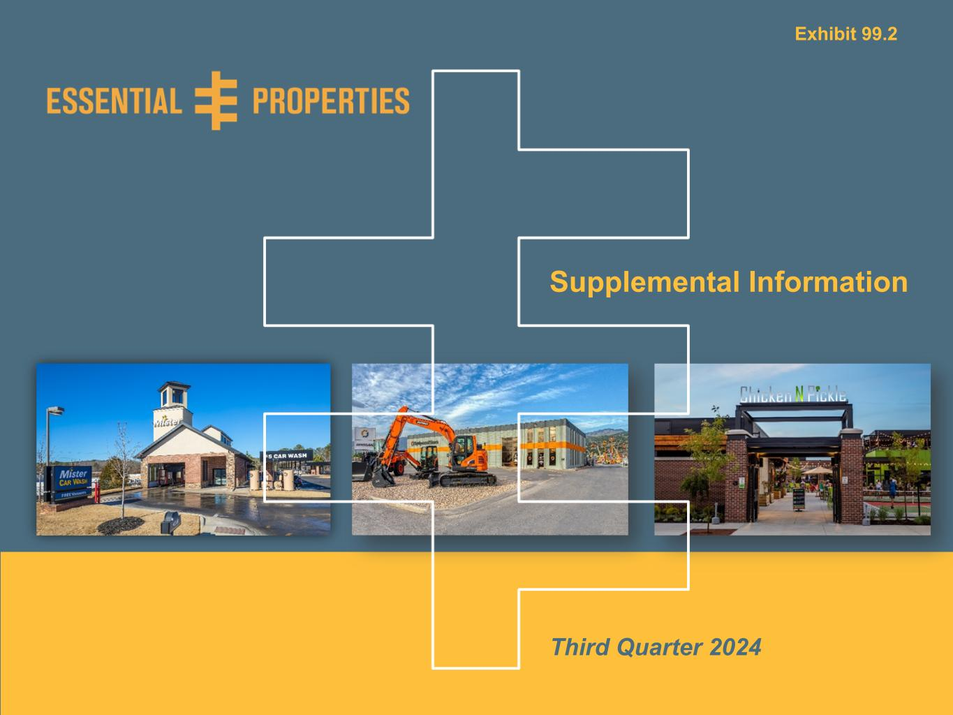
Supplemental Information Third Quarter 2024 Exhibit 99.2

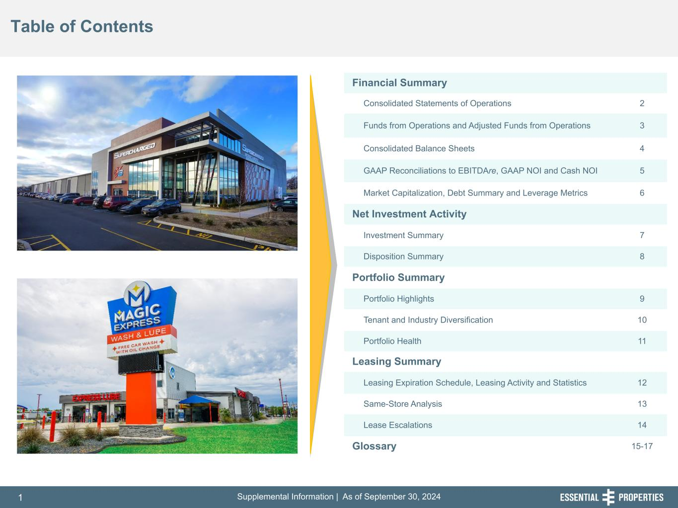
Supplemental Information | As of September 30, 20241 254, 192, 59 75, 108, 127 146, 204, 238 0, 0, 0 38, 169, 224 153, 223, 227 Table of Contents 242, 242, 242 Financial Summary Consolidated Statements of Operations 2 Funds from Operations and Adjusted Funds from Operations 3 Consolidated Balance Sheets 4 GAAP Reconciliations to EBITDAre, GAAP NOI and Cash NOI 5 Market Capitalization, Debt Summary and Leverage Metrics 6 Net Investment Activity Investment Summary 7 Disposition Summary 8 Portfolio Summary Portfolio Highlights 9 Tenant and Industry Diversification 10 Portfolio Health 11 Leasing Summary Leasing Expiration Schedule, Leasing Activity and Statistics 12 Same-Store Analysis 13 Lease Escalations 14 Glossary 15-17

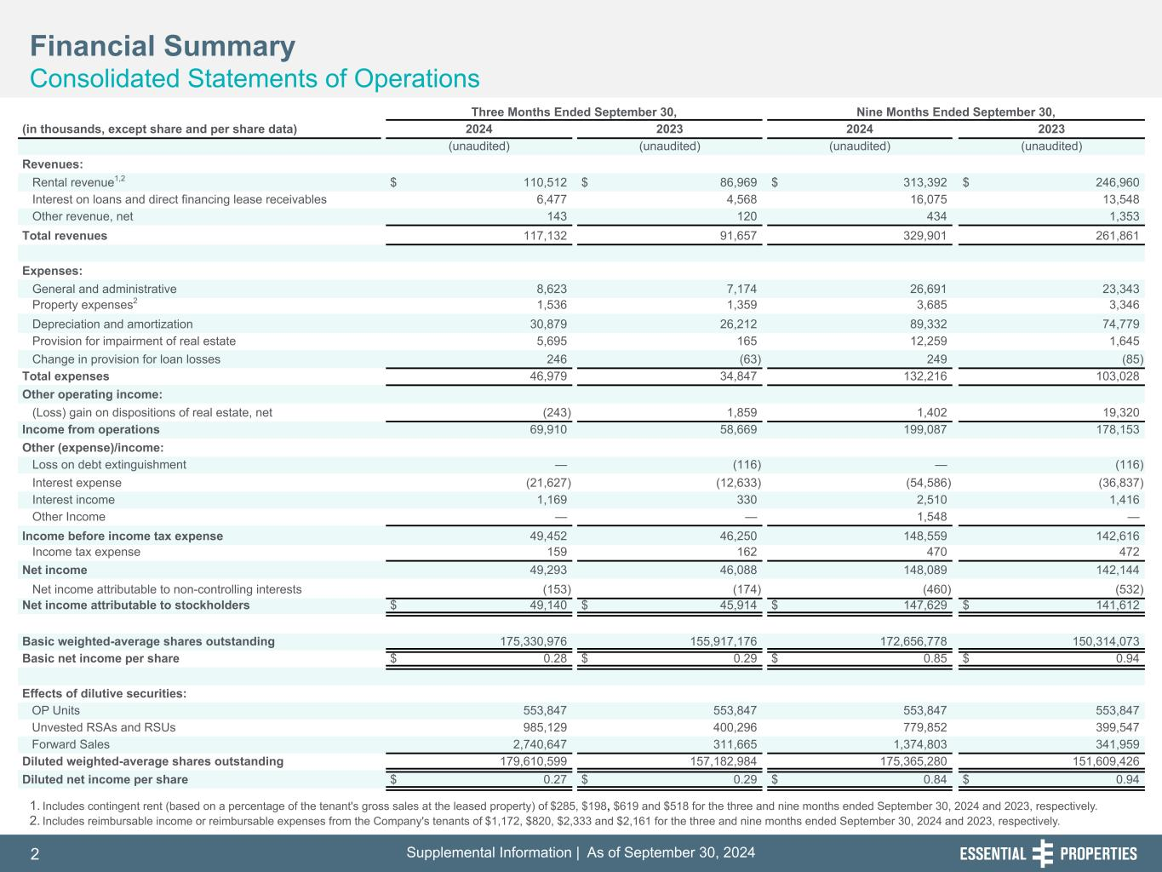
Supplemental Information | As of September 30, 20242 254, 192, 59 75, 108, 127 146, 204, 238 0, 0, 0 38, 169, 224 153, 223, 227 Three Months Ended September 30, Nine Months Ended September 30, (in thousands, except share and per share data) 2024 2023 2024 2023 (unaudited) (unaudited) (unaudited) (unaudited) Revenues: Rental revenue1,2 $ 110,512 $ 86,969 $ 313,392 $ 246,960 Interest on loans and direct financing lease receivables 6,477 4,568 16,075 13,548 Other revenue, net 143 120 434 1,353 Total revenues 117,132 91,657 329,901 261,861 Expenses: General and administrative 8,623 7,174 26,691 23,343 Property expenses2 1,536 1,359 3,685 3,346 Depreciation and amortization 30,879 26,212 89,332 74,779 Provision for impairment of real estate 5,695 165 12,259 1,645 Change in provision for loan losses 246 (63) 249 (85) Total expenses 46,979 34,847 132,216 103,028 Other operating income: (Loss) gain on dispositions of real estate, net (243) 1,859 1,402 19,320 Income from operations 69,910 58,669 199,087 178,153 Other (expense)/income: Loss on debt extinguishment — (116) — (116) Interest expense (21,627) (12,633) (54,586) (36,837) Interest income 1,169 330 2,510 1,416 Other Income — — 1,548 — Income before income tax expense 49,452 46,250 148,559 142,616 Income tax expense 159 162 470 472 Net income 49,293 46,088 148,089 142,144 Net income attributable to non-controlling interests (153) (174) (460) (532) Net income attributable to stockholders $ 49,140 $ 45,914 $ 147,629 $ 141,612 Basic weighted-average shares outstanding 175,330,976 155,917,176 172,656,778 150,314,073 Basic net income per share $ 0.28 $ 0.29 $ 0.85 $ 0.94 Effects of dilutive securities: OP Units 553,847 553,847 553,847 553,847 Unvested RSAs and RSUs 985,129 400,296 779,852 399,547 Forward Sales 2,740,647 311,665 1,374,803 341,959 Diluted weighted-average shares outstanding 179,610,599 157,182,984 175,365,280 151,609,426 Diluted net income per share $ 0.27 $ 0.29 $ 0.84 $ 0.94 1. Includes contingent rent (based on a percentage of the tenant's gross sales at the leased property) of $285, $198, $619 and $518 for the three and nine months ended September 30, 2024 and 2023, respectively. 2. Includes reimbursable income or reimbursable expenses from the Company's tenants of $1,172, $820, $2,333 and $2,161 for the three and nine months ended September 30, 2024 and 2023, respectively. Financial Summary Consolidated Statements of Operations 242, 242, 242

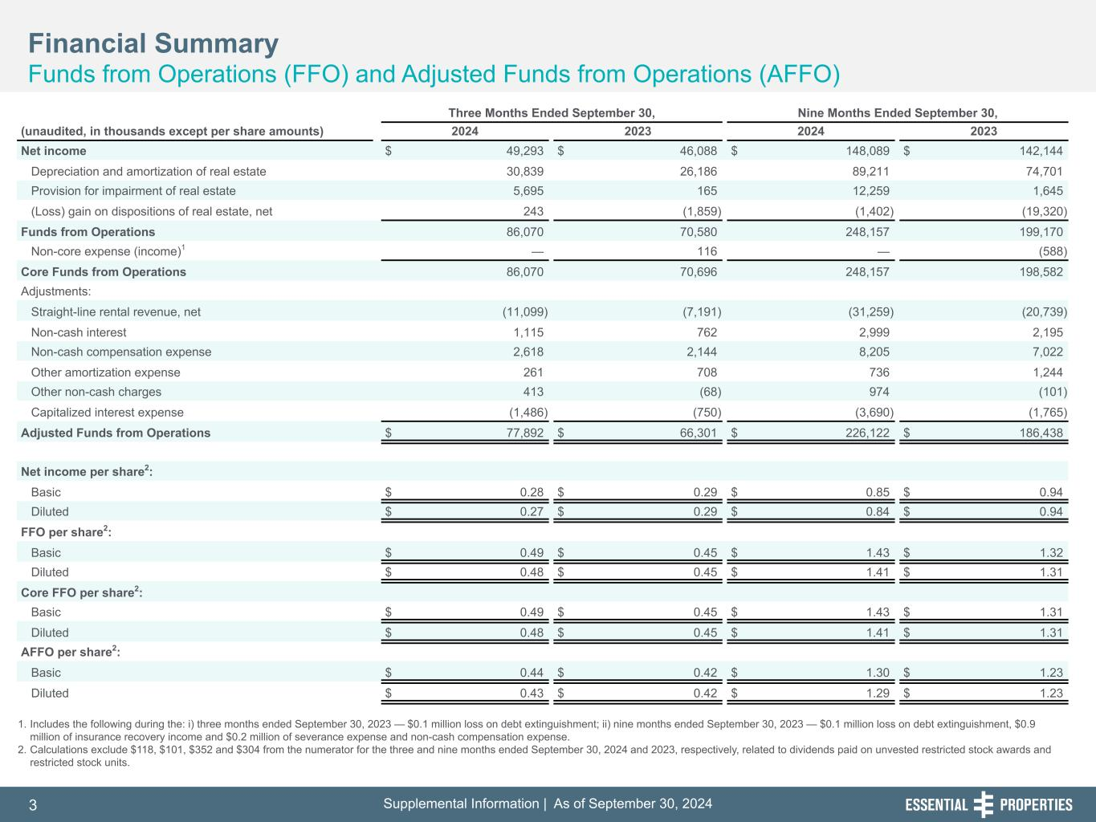
Supplemental Information | As of September 30, 20243 254, 192, 59 75, 108, 127 146, 204, 238 0, 0, 0 38, 169, 224 153, 223, 227 1. Includes the following during the: i) three months ended September 30, 2023 — $0.1 million loss on debt extinguishment; ii) nine months ended September 30, 2023 — $0.1 million loss on debt extinguishment, $0.9 million of insurance recovery income and $0.2 million of severance expense and non-cash compensation expense. 2. Calculations exclude $118, $101, $352 and $304 from the numerator for the three and nine months ended September 30, 2024 and 2023, respectively, related to dividends paid on unvested restricted stock awards and restricted stock units. Financial Summary Funds from Operations (FFO) and Adjusted Funds from Operations (AFFO) 242, 242, 242 Three Months Ended September 30, Nine Months Ended September 30, (unaudited, in thousands except per share amounts) 2024 2023 2024 2023 Net income $ 49,293 $ 46,088 $ 148,089 $ 142,144 Depreciation and amortization of real estate 30,839 26,186 89,211 74,701 Provision for impairment of real estate 5,695 165 12,259 1,645 (Loss) gain on dispositions of real estate, net 243 (1,859) (1,402) (19,320) Funds from Operations 86,070 70,580 248,157 199,170 Non-core expense (income)1 — 116 — (588) Core Funds from Operations 86,070 70,696 248,157 198,582 Adjustments: Straight-line rental revenue, net (11,099) (7,191) (31,259) (20,739) Non-cash interest 1,115 762 2,999 2,195 Non-cash compensation expense 2,618 2,144 8,205 7,022 Other amortization expense 261 708 736 1,244 Other non-cash charges 413 (68) 974 (101) Capitalized interest expense (1,486) (750) (3,690) (1,765) Adjusted Funds from Operations $ 77,892 $ 66,301 $ 226,122 $ 186,438 Net income per share2: Basic $ 0.28 $ 0.29 $ 0.85 $ 0.94 Diluted $ 0.27 $ 0.29 $ 0.84 $ 0.94 FFO per share2: Basic $ 0.49 $ 0.45 $ 1.43 $ 1.32 Diluted $ 0.48 $ 0.45 $ 1.41 $ 1.31 Core FFO per share2: Basic $ 0.49 $ 0.45 $ 1.43 $ 1.31 Diluted $ 0.48 $ 0.45 $ 1.41 $ 1.31 AFFO per share2: Basic $ 0.44 $ 0.42 $ 1.30 $ 1.23 Diluted $ 0.43 $ 0.42 $ 1.29 $ 1.23

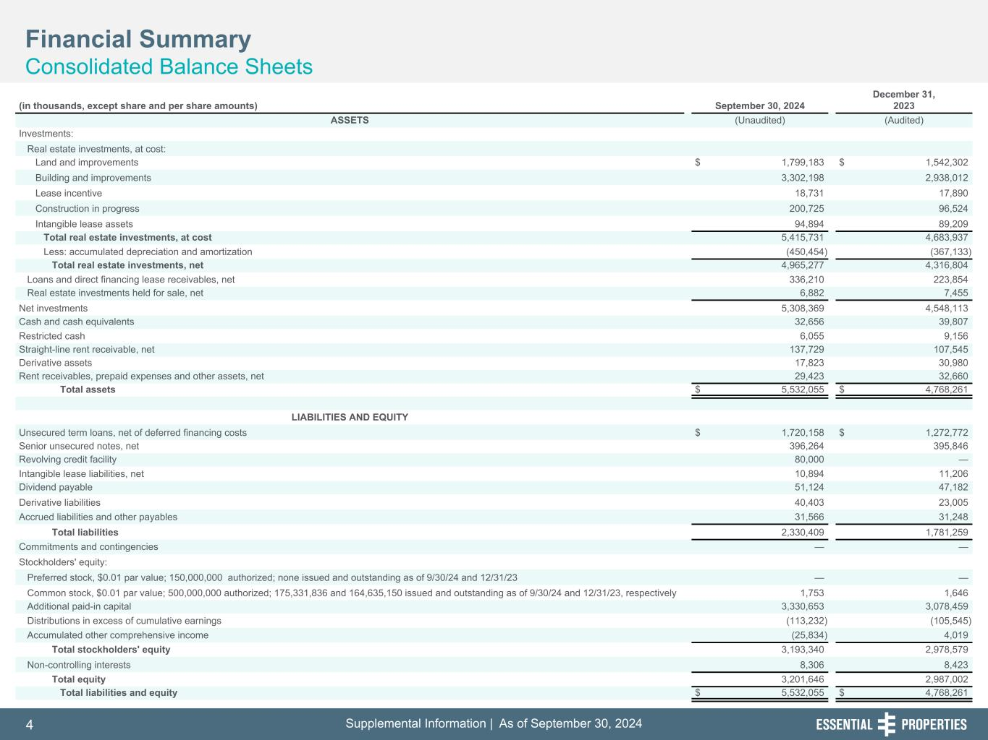
Supplemental Information | As of September 30, 20244 254, 192, 59 75, 108, 127 146, 204, 238 0, 0, 0 38, 169, 224 153, 223, 227 Financial Summary Consolidated Balance Sheets 242, 242, 242 (in thousands, except share and per share amounts) September 30, 2024 December 31, 2023 ASSETS (Unaudited) (Audited) Investments: Real estate investments, at cost: Land and improvements $ 1,799,183 $ 1,542,302 Building and improvements 3,302,198 2,938,012 Lease incentive 18,731 17,890 Construction in progress 200,725 96,524 Intangible lease assets 94,894 89,209 Total real estate investments, at cost 5,415,731 4,683,937 Less: accumulated depreciation and amortization (450,454) (367,133) Total real estate investments, net 4,965,277 4,316,804 Loans and direct financing lease receivables, net 336,210 223,854 Real estate investments held for sale, net 6,882 7,455 Net investments 5,308,369 4,548,113 Cash and cash equivalents 32,656 39,807 Restricted cash 6,055 9,156 Straight-line rent receivable, net 137,729 107,545 Derivative assets 17,823 30,980 Rent receivables, prepaid expenses and other assets, net 29,423 32,660 Total assets $ 5,532,055 $ 4,768,261 LIABILITIES AND EQUITY Unsecured term loans, net of deferred financing costs $ 1,720,158 $ 1,272,772 Senior unsecured notes, net 396,264 395,846 Revolving credit facility 80,000 — Intangible lease liabilities, net 10,894 11,206 Dividend payable 51,124 47,182 Derivative liabilities 40,403 23,005 Accrued liabilities and other payables 31,566 31,248 Total liabilities 2,330,409 1,781,259 Commitments and contingencies — — Stockholders' equity: Preferred stock, $0.01 par value; 150,000,000 authorized; none issued and outstanding as of 9/30/24 and 12/31/23 — — Common stock, $0.01 par value; 500,000,000 authorized; 175,331,836 and 164,635,150 issued and outstanding as of 9/30/24 and 12/31/23, respectively 1,753 1,646 Additional paid-in capital 3,330,653 3,078,459 Distributions in excess of cumulative earnings (113,232) (105,545) Accumulated other comprehensive income (25,834) 4,019 Total stockholders' equity 3,193,340 2,978,579 Non-controlling interests 8,306 8,423 Total equity 3,201,646 2,987,002 Total liabilities and equity $ 5,532,055 $ 4,768,261

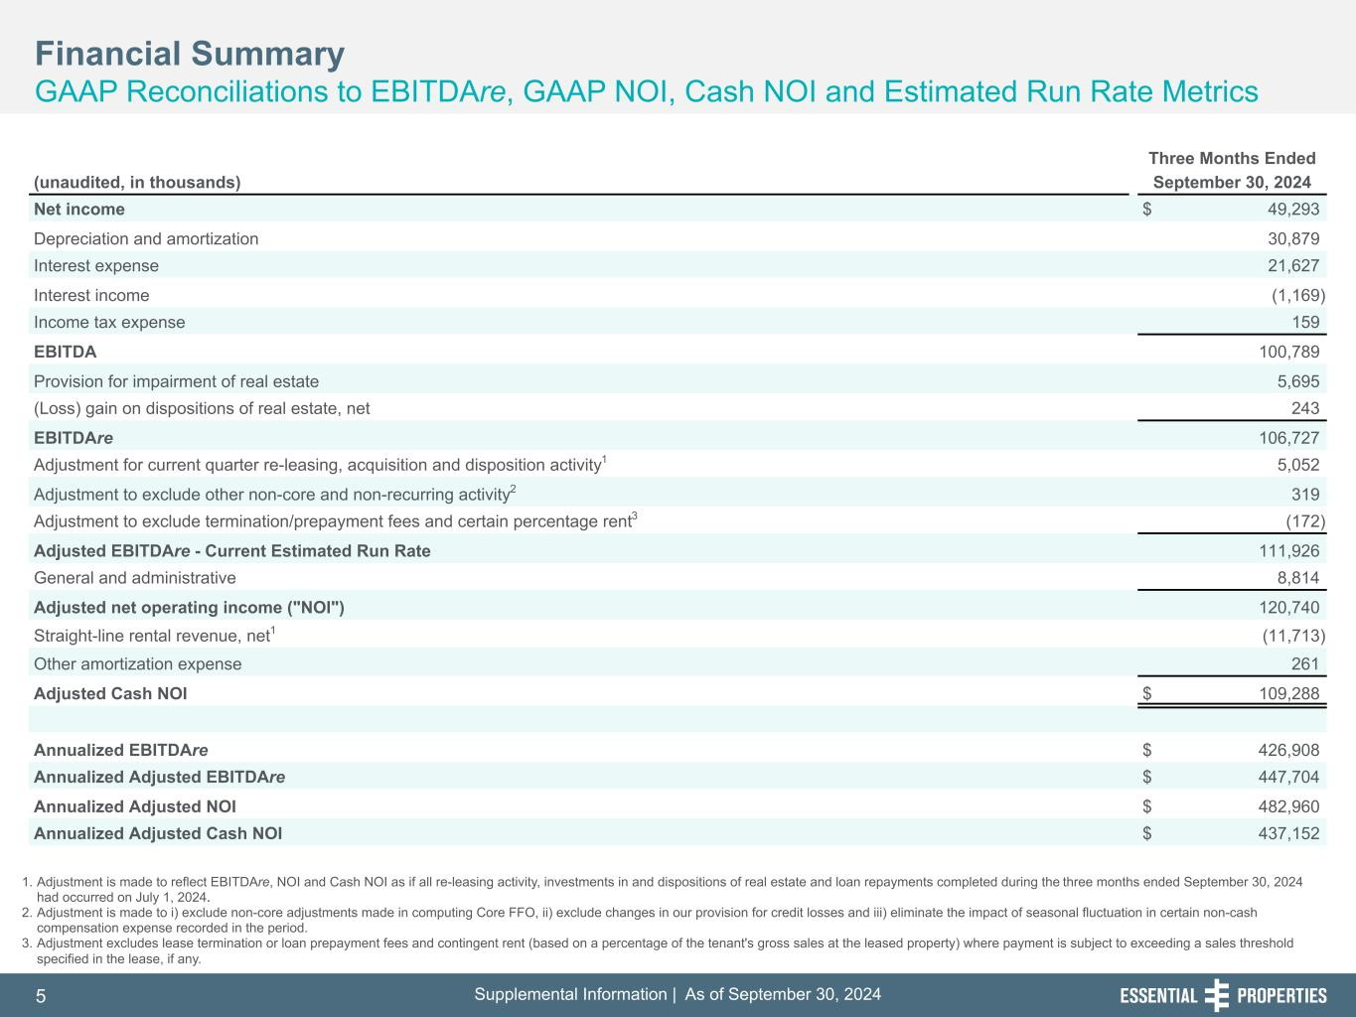
Supplemental Information | As of September 30, 20245 254, 192, 59 75, 108, 127 146, 204, 238 0, 0, 0 38, 169, 224 153, 223, 227 Financial Summary GAAP Reconciliations to EBITDAre, GAAP NOI, Cash NOI and Estimated Run Rate Metrics 242, 242, 242 1. Adjustment is made to reflect EBITDAre, NOI and Cash NOI as if all re-leasing activity, investments in and dispositions of real estate and loan repayments completed during the three months ended September 30, 2024 had occurred on July 1, 2024. 2. Adjustment is made to i) exclude non-core adjustments made in computing Core FFO, ii) exclude changes in our provision for credit losses and iii) eliminate the impact of seasonal fluctuation in certain non-cash compensation expense recorded in the period. 3. Adjustment excludes lease termination or loan prepayment fees and contingent rent (based on a percentage of the tenant's gross sales at the leased property) where payment is subject to exceeding a sales threshold specified in the lease, if any. Three Months Ended (unaudited, in thousands) September 30, 2024 Net income $ 49,293 Depreciation and amortization 30,879 Interest expense 21,627 Interest income (1,169) Income tax expense 159 EBITDA 100,789 Provision for impairment of real estate 5,695 (Loss) gain on dispositions of real estate, net 243 EBITDAre 106,727 Adjustment for current quarter re-leasing, acquisition and disposition activity1 5,052 Adjustment to exclude other non-core and non-recurring activity2 319 Adjustment to exclude termination/prepayment fees and certain percentage rent3 (172) Adjusted EBITDAre - Current Estimated Run Rate 111,926 General and administrative 8,814 Adjusted net operating income ("NOI") 120,740 Straight-line rental revenue, net1 (11,713) Other amortization expense 261 Adjusted Cash NOI $ 109,288 Annualized EBITDAre $ 426,908 Annualized Adjusted EBITDAre $ 447,704 Annualized Adjusted NOI $ 482,960 Annualized Adjusted Cash NOI $ 437,152

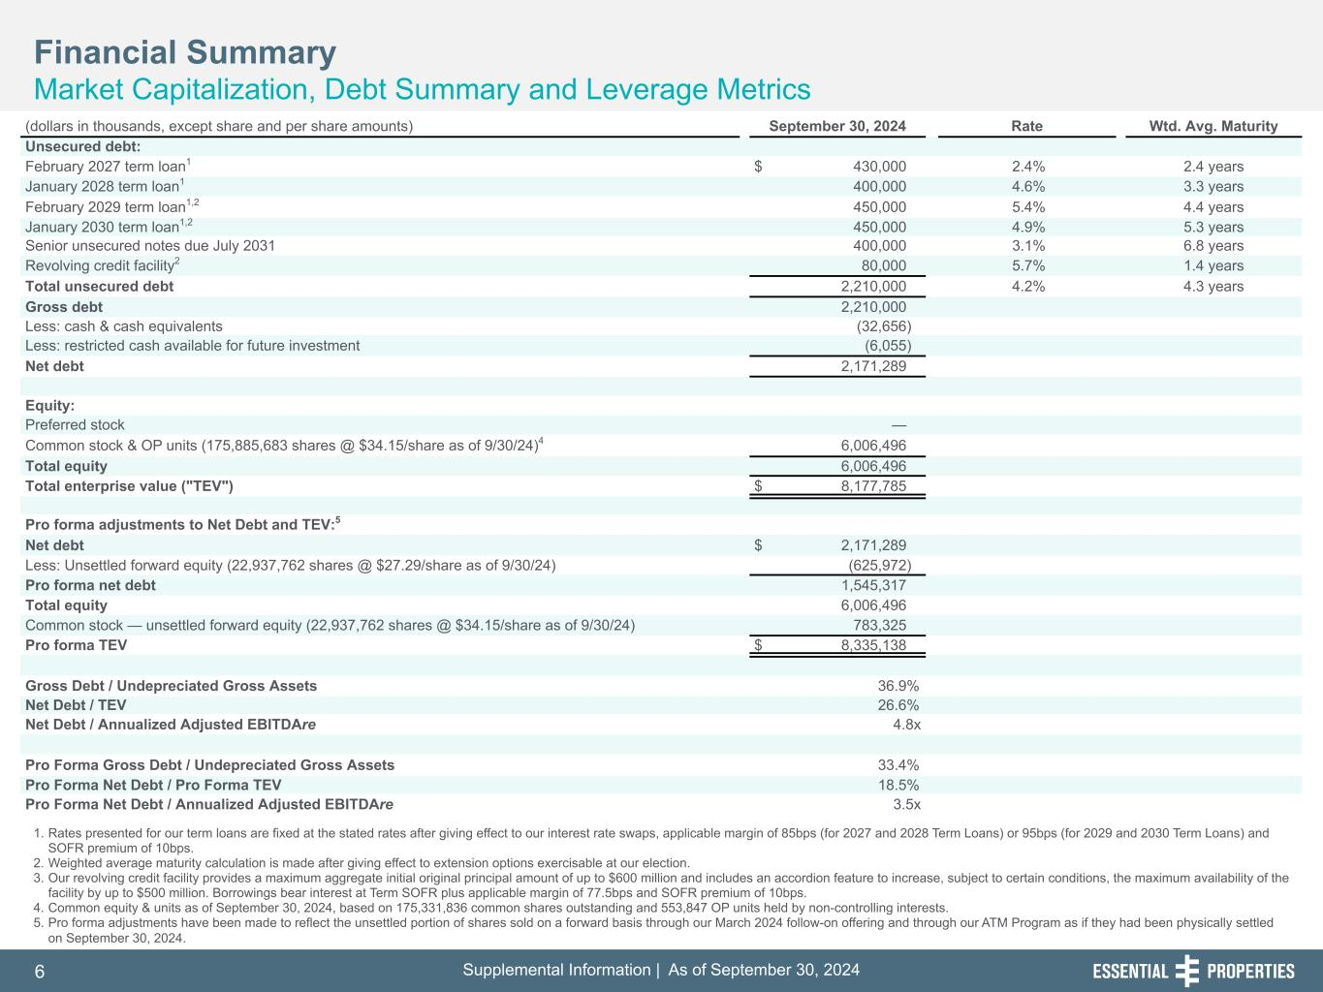
Supplemental Information | As of September 30, 20246 254, 192, 59 75, 108, 127 146, 204, 238 0, 0, 0 38, 169, 224 153, 223, 227 Financial Summary Market Capitalization, Debt Summary and Leverage Metrics 242, 242, 242 1. Rates presented for our term loans are fixed at the stated rates after giving effect to our interest rate swaps, applicable margin of 85bps (for 2027 and 2028 Term Loans) or 95bps (for 2029 and 2030 Term Loans) and SOFR premium of 10bps. 2. Weighted average maturity calculation is made after giving effect to extension options exercisable at our election. 3. Our revolving credit facility provides a maximum aggregate initial original principal amount of up to $600 million and includes an accordion feature to increase, subject to certain conditions, the maximum availability of the facility by up to $500 million. Borrowings bear interest at Term SOFR plus applicable margin of 77.5bps and SOFR premium of 10bps. 4. Common equity & units as of September 30, 2024, based on 175,331,836 common shares outstanding and 553,847 OP units held by non-controlling interests. 5. Pro forma adjustments have been made to reflect the unsettled portion of shares sold on a forward basis through our March 2024 follow-on offering and through our ATM Program as if they had been physically settled on September 30, 2024. (dollars in thousands, except share and per share amounts) September 30, 2024 Rate Wtd. Avg. Maturity Unsecured debt: February 2027 term loan1 $ 430,000 2.4% 2.4 years January 2028 term loan1 400,000 4.6% 3.3 years February 2029 term loan1,2 450,000 5.4% 4.4 years January 2030 term loan1,2 450,000 4.9% 5.3 years Senior unsecured notes due July 2031 400,000 3.1% 6.8 years Revolving credit facility2 80,000 5.7% 1.4 years Total unsecured debt 2,210,000 4.2% 4.3 years Gross debt 2,210,000 Less: cash & cash equivalents (32,656) Less: restricted cash available for future investment (6,055) Net debt 2,171,289 Equity: Preferred stock — Common stock & OP units (175,885,683 shares @ $34.15/share as of 9/30/24)4 6,006,496 Total equity 6,006,496 Total enterprise value ("TEV") $ 8,177,785 Pro forma adjustments to Net Debt and TEV:5 Net debt $ 2,171,289 Less: Unsettled forward equity (22,937,762 shares @ $27.29/share as of 9/30/24) (625,972) Pro forma net debt 1,545,317 Total equity 6,006,496 Common stock — unsettled forward equity (22,937,762 shares @ $34.15/share as of 9/30/24) 783,325 Pro forma TEV $ 8,335,138 Gross Debt / Undepreciated Gross Assets 36.9% Net Debt / TEV 26.6% Net Debt / Annualized Adjusted EBITDAre 4.8x Pro Forma Gross Debt / Undepreciated Gross Assets 33.4% Pro Forma Net Debt / Pro Forma TEV 18.5% Pro Forma Net Debt / Annualized Adjusted EBITDAre 3.5x

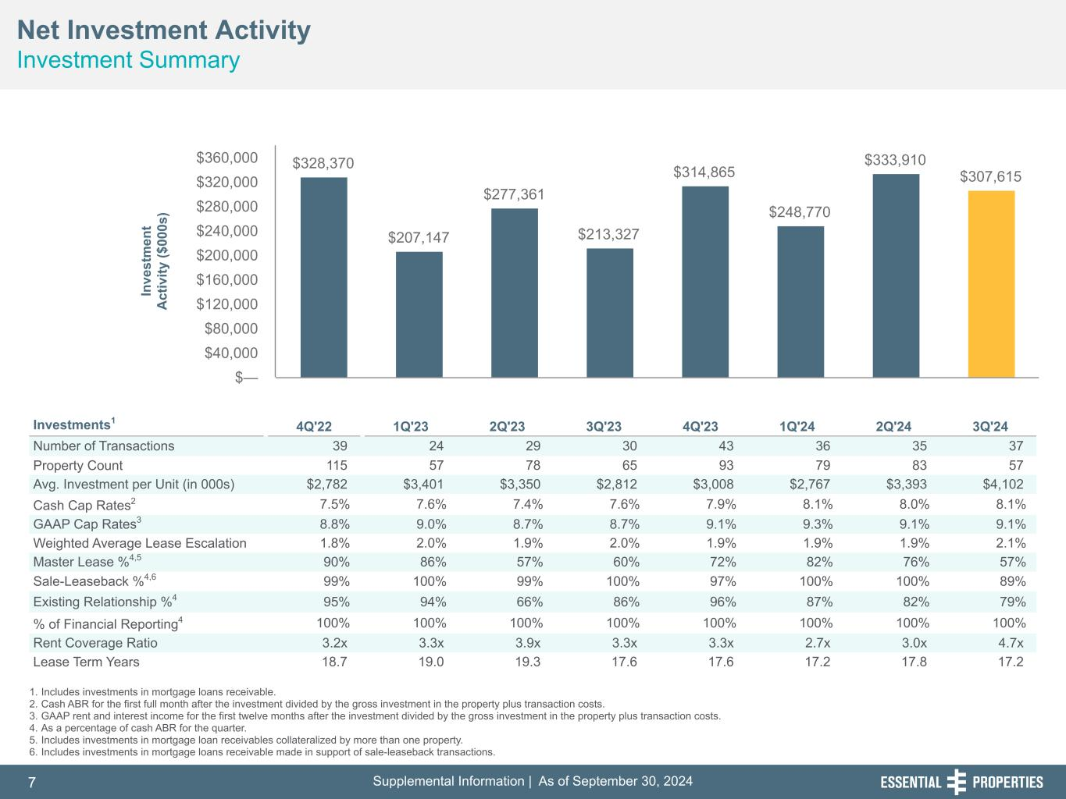
Supplemental Information | As of September 30, 20247 254, 192, 59 75, 108, 127 146, 204, 238 0, 0, 0 38, 169, 224 153, 223, 227 Net Investment Activity Investment Summary 242, 242, 242 1. Includes investments in mortgage loans receivable. 2. Cash ABR for the first full month after the investment divided by the gross investment in the property plus transaction costs. 3. GAAP rent and interest income for the first twelve months after the investment divided by the gross investment in the property plus transaction costs. 4. As a percentage of cash ABR for the quarter. 5. Includes investments in mortgage loan receivables collateralized by more than one property. 6. Includes investments in mortgage loans receivable made in support of sale-leaseback transactions. Investments1 4Q'22 1Q'23 2Q'23 3Q'23 4Q'23 1Q'24 2Q'24 3Q'24 Number of Transactions 39 24 29 30 43 36 35 37 Property Count 115 57 78 65 93 79 83 57 Avg. Investment per Unit (in 000s) $2,782 $3,401 $3,350 $2,812 $3,008 $2,767 $3,393 $4,102 Cash Cap Rates2 7.5 % 7.6 % 7.4 % 7.6 % 7.9 % 8.1 % 8.0 % 8.1 % GAAP Cap Rates3 8.8 % 9.0 % 8.7 % 8.7 % 9.1 % 9.3 % 9.1 % 9.1 % Weighted Average Lease Escalation 1.8 % 1.8 % 2.0 % 1.8 % 1.9 % 1.8 % 2.0 % 1.9 % 1.9 % 1.9 % 2.1 % Master Lease %4,5 90 % 86 % 57 % 60 % 72 % 82 % 76 % 57 % Sale-Leaseback %4,6 99 % 100 % 99 % 100 % 97 % 100 % 100 % 89 % Existing Relationship %4 95 % 94 % 66 % 86 % 96 % 87 % 82 % 79 % % of Financial Reporting4 100 % 100 % 100 % 100 % 100 % 100 % 100 % 100 % Rent Coverage Ratio 3.2x 3.3x 3.9x 3.3x 3.3x 2.7x 3.0x 4.7x Lease Term Years 18.7 19.0 19.3 17.6 17.6 17.2 17.8 17.2 $328,370 $207,147 $277,361 $213,327 $314,865 $248,770 $333,910 $307,615 $— $40,000 $80,000 $120,000 $160,000 $200,000 $240,000 $280,000 $320,000 $360,000 In ve st m en t A ct iv ity ($ 00 0s )

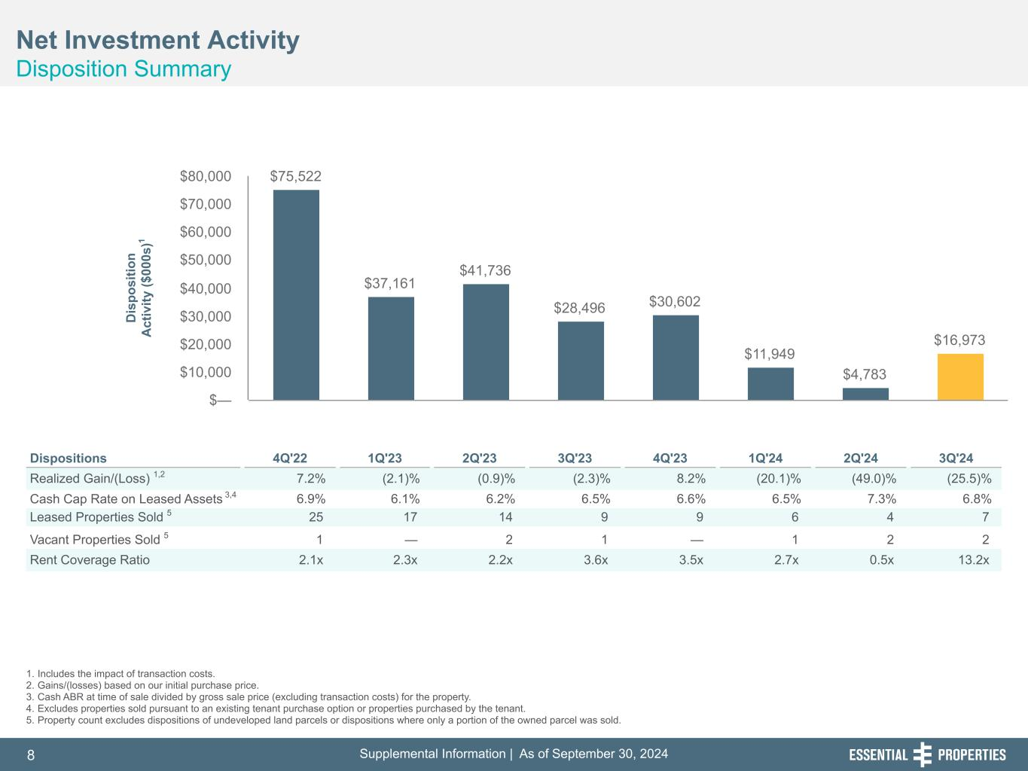
Supplemental Information | As of September 30, 20248 254, 192, 59 75, 108, 127 146, 204, 238 0, 0, 0 38, 169, 224 153, 223, 227 Net Investment Activity Disposition Summary 242, 242, 242 1. Includes the impact of transaction costs. 2. Gains/(losses) based on our initial purchase price. 3. Cash ABR at time of sale divided by gross sale price (excluding transaction costs) for the property. 4. Excludes properties sold pursuant to an existing tenant purchase option or properties purchased by the tenant. 5. Property count excludes dispositions of undeveloped land parcels or dispositions where only a portion of the owned parcel was sold. Dispositions 4Q'22 1Q'23 2Q'23 3Q'23 4Q'23 1Q'24 2Q'24 3Q'24 Realized Gain/(Loss) 1,2 7.2 % (2.1) % (0.9) % (2.3) % 8.2 % (20.1) % (49.0) % (25.5) % Cash Cap Rate on Leased Assets 3,4 6.9 % 6.1 % 6.2 % 6.5 % 6.6 % 6.5 % 7.3 % 6.8 % Leased Properties Sold 5 25 17 14 9 9 6 4 7 Vacant Properties Sold 5 1 — 2 1 — 1 2 2 Rent Coverage Ratio 2.1x 2.3x 2.2x 3.6x 3.5x 2.7x 0.5x 13.2x $75,522 $37,161 $41,736 $28,496 $30,602 $11,949 $4,783 $16,973 $— $10,000 $20,000 $30,000 $40,000 $50,000 $60,000 $70,000 $80,000 D is po si tio n A ct iv ity ($ 00 0s )1

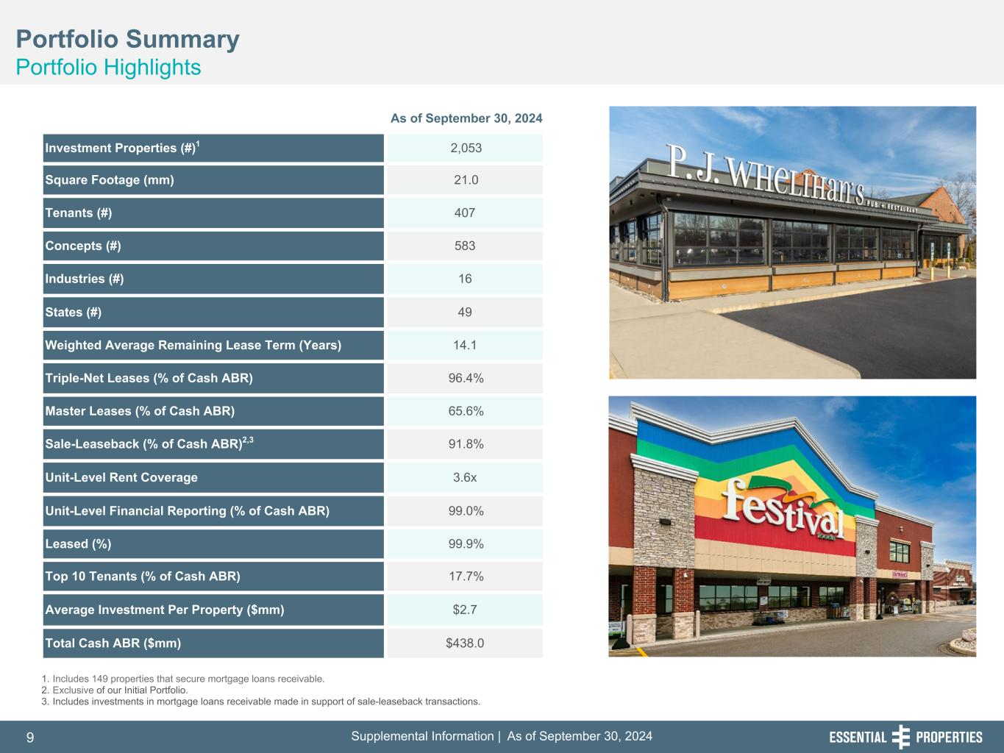
Supplemental Information | As of September 30, 20249 254, 192, 59 75, 108, 127 146, 204, 238 0, 0, 0 38, 169, 224 153, 223, 227 Portfolio Summary Portfolio Highlights 242, 242, 242 1. Includes 149 properties that secure mortgage loans receivable. 2. Exclusive of our Initial Portfolio. 3. Includes investments in mortgage loans receivable made in support of sale-leaseback transactions. As of September 30, 2024 Investment Properties (#)1 2,053 Square Footage (mm) 21.0 Tenants (#) 407 Concepts (#) 583 Industries (#) 16 States (#) 49 Weighted Average Remaining Lease Term (Years) 14.1 Triple-Net Leases (% of Cash ABR) 96.4% Master Leases (% of Cash ABR) 65.6% Sale-Leaseback (% of Cash ABR)2,3 91.8% Unit-Level Rent Coverage 3.6x Unit-Level Financial Reporting (% of Cash ABR) 99.0% Leased (%) 99.9% Top 10 Tenants (% of Cash ABR) 17.7% Average Investment Per Property ($mm) $2.7 Total Cash ABR ($mm) $438.0

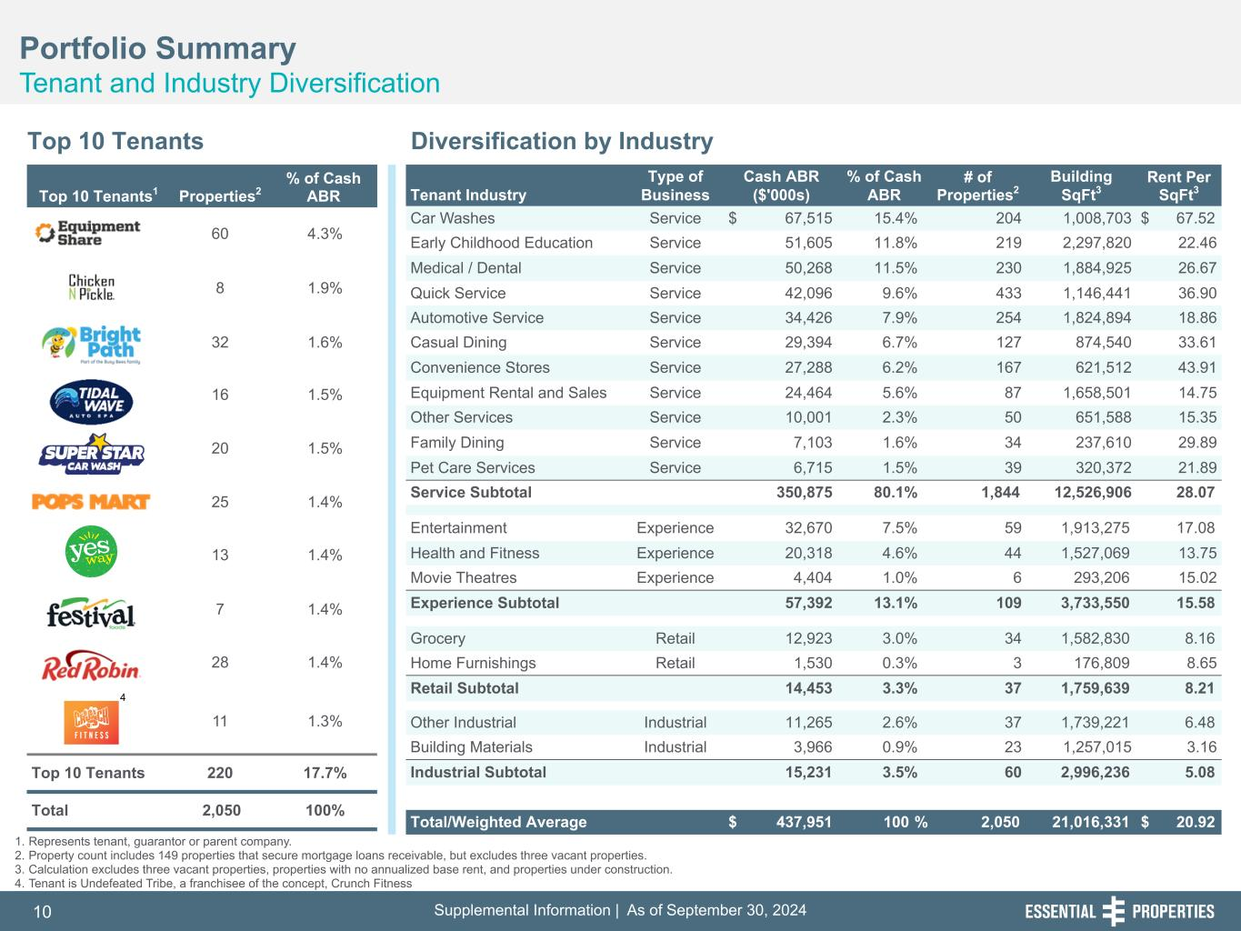
Supplemental Information | As of September 30, 202410 254, 192, 59 75, 108, 127 146, 204, 238 0, 0, 0 38, 169, 224 153, 223, 227 Portfolio Summary Tenant and Industry Diversification 242, 242, 242 Top 10 Tenants Diversification by Industry 1. Represents tenant, guarantor or parent company. 2. Property count includes 149 properties that secure mortgage loans receivable, but excludes three vacant properties. 3. Calculation excludes three vacant properties, properties with no annualized base rent, and properties under construction. 4. Tenant is Undefeated Tribe, a franchisee of the concept, Crunch Fitness Tenant Industry Type of Business Cash ABR ($'000s) % of Cash ABR # of Properties2 Building SqFt3 Rent Per SqFt3 Car Washes Service $ 67,515 15.4 % 204 1,008,703 $ 67.52 Early Childhood Education Service 51,605 11.8 % 219 2,297,820 22.46 Medical / Dental Service 50,268 11.5 % 230 1,884,925 26.67 Quick Service Service 42,096 9.6 % 433 1,146,441 36.90 Automotive Service Service 34,426 7.9 % 254 1,824,894 18.86 Casual Dining Service 29,394 6.7 % 127 874,540 33.61 Convenience Stores Service 27,288 6.2 % 167 621,512 43.91 Equipment Rental and Sales Service 24,464 5.6 % 87 1,658,501 14.75 Other Services Service 10,001 2.3 % 50 651,588 15.35 Family Dining Service 7,103 1.6 % 34 237,610 29.89 Pet Care Services Service 6,715 1.5 % 39 320,372 21.89 Service Subtotal 350,875 80.1 % 1,844 12,526,906 28.07 Entertainment Experience 32,670 7.5 % 59 1,913,275 17.08 Health and Fitness Experience 20,318 4.6 % 44 1,527,069 13.75 Movie Theatres Experience 4,404 1.0 % 6 293,206 15.02 Experience Subtotal 57,392 13.1 % 109 3,733,550 15.58 Grocery Retail 12,923 3.0 % 34 1,582,830 8.16 Home Furnishings Retail 1,530 0.3 % 3 176,809 8.65 Retail Subtotal 14,453 3.3 % 37 1,759,639 8.21 Other Industrial Industrial 11,265 2.6 % 37 1,739,221 6.48 Building Materials Industrial 3,966 0.9 % 23 1,257,015 3.16 Industrial Subtotal 15,231 3.5 % 60 2,996,236 5.08 Total/Weighted Average $ 437,951 100 % 2,050 21,016,331 $ 20.92 Top 10 Tenants1 Properties2 % of Cash ABR 60 4.3% 8 1.9% 32 1.6% 16 1.5% 20 1.5% 25 1.4% 13 1.4% 7 1.4% 28 1.4% 11 1.3% Top 10 Tenants 220 17.7% Total 2,050 100% 4

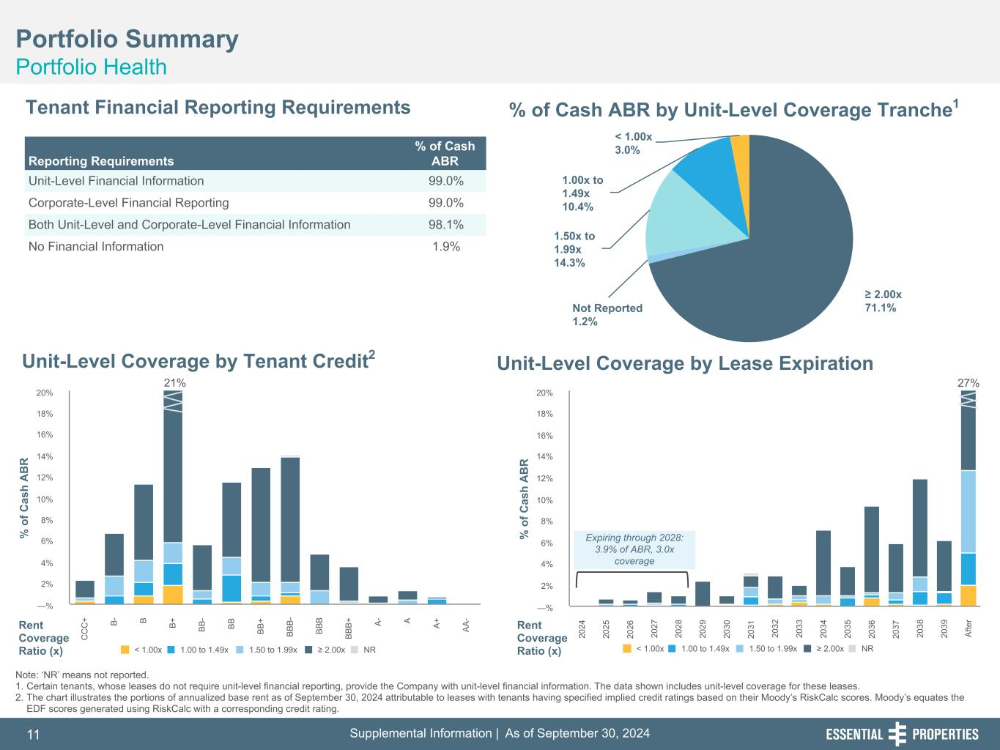
Supplemental Information | As of September 30, 202411 254, 192, 59 75, 108, 127 146, 204, 238 0, 0, 0 38, 169, 224 153, 223, 227 21% % o f C as h A B R < 1.00x 1.00 to 1.49x 1.50 to 1.99x ≥ 2.00x NR 20 24 20 25 20 26 20 27 20 28 20 29 20 30 20 31 20 32 20 33 20 34 20 35 20 36 20 37 20 38 20 39 A fte r —% 2% 4% 6% 8% 10% 12% 14% 16% 18% 20% 27% % o f C as h A B R < 1.00x 1.00 to 1.49x 1.50 to 1.99x ≥ 2.00x NR C C C + B - B B + B B - B B B B + B B B - B B B B B B + A - A A + A A - —% 2% 4% 6% 8% 10% 12% 14% 16% 18% 20% ≥ 2.00x 71.1%Not Reported 1.2% 1.50x to 1.99x 14.3% 1.00x to 1.49x 10.4% < 1.00x 3.0% Portfolio Summary Portfolio Health Tenant Financial Reporting Requirements % of Cash ABR by Unit-Level Coverage Tranche1 Unit-Level Coverage by Lease ExpirationUnit-Level Coverage by Tenant Credit2 Note: ‘NR’ means not reported. 1. Certain tenants, whose leases do not require unit-level financial reporting, provide the Company with unit-level financial information. The data shown includes unit-level coverage for these leases. 2. The chart illustrates the portions of annualized base rent as of September 30, 2024 attributable to leases with tenants having specified implied credit ratings based on their Moody’s RiskCalc scores. Moody’s equates the EDF scores generated using RiskCalc with a corresponding credit rating. Rent Coverage Ratio (x) Reporting Requirements % of Cash ABR Unit-Level Financial Information 99.0% Corporate-Level Financial Reporting 99.0% Both Unit-Level and Corporate-Level Financial Information 98.1% No Financial Information 1.9% Rent Coverage Ratio (x) Expiring through 2028: 3.9% of ABR, 3.0x coverage

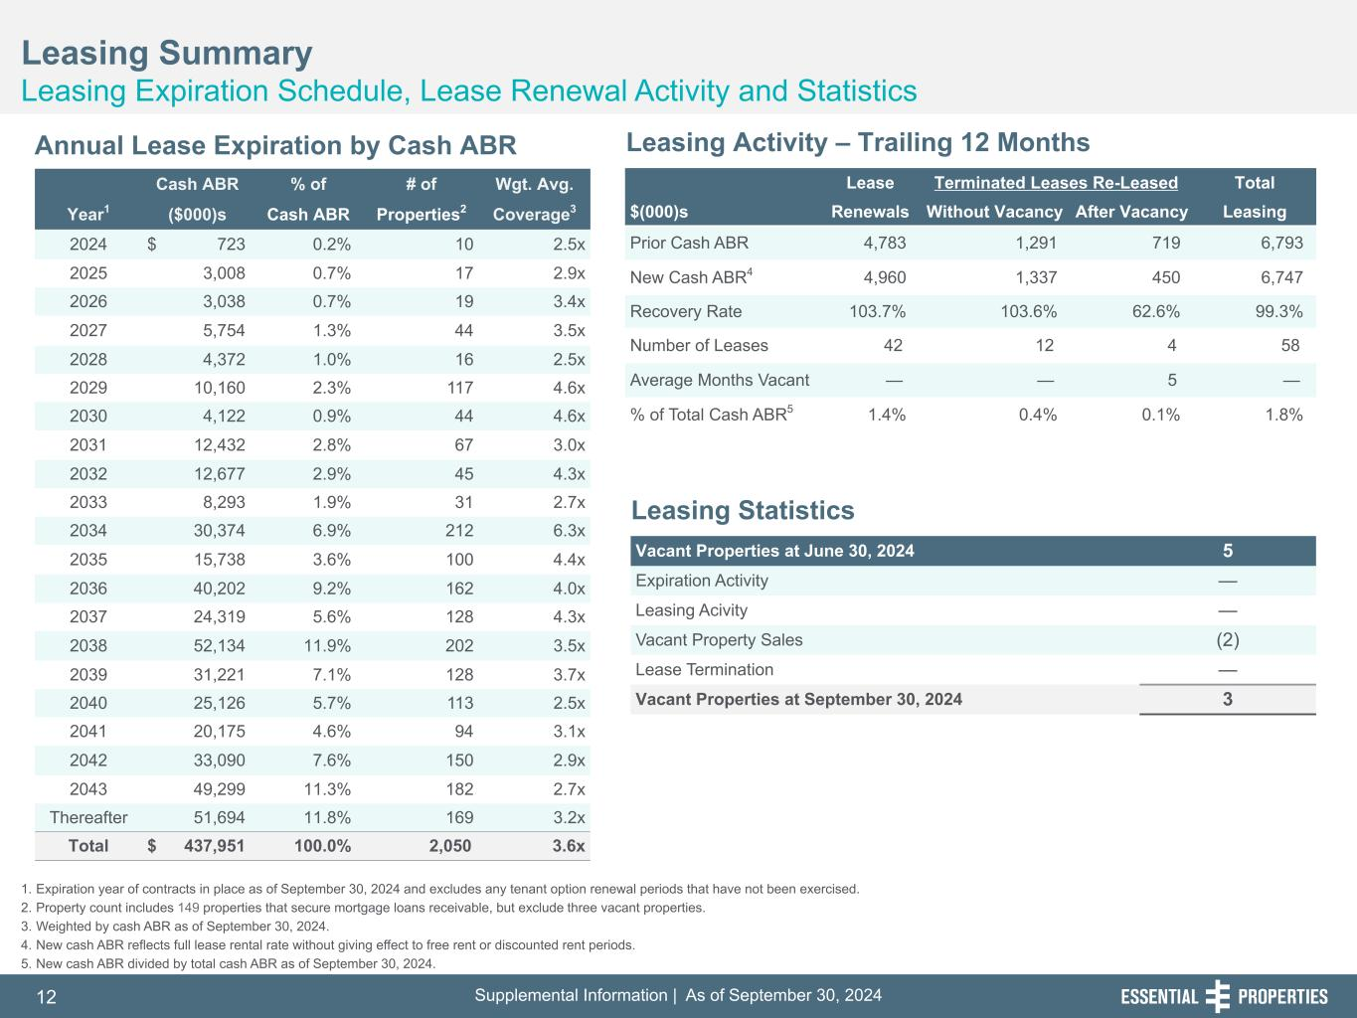
Supplemental Information | As of September 30, 202412 254, 192, 59 75, 108, 127 146, 204, 238 0, 0, 0 38, 169, 224 153, 223, 227 Leasing Summary Leasing Expiration Schedule, Lease Renewal Activity and Statistics 242, 242, 242 1. Expiration year of contracts in place as of September 30, 2024 and excludes any tenant option renewal periods that have not been exercised. 2. Property count includes 149 properties that secure mortgage loans receivable, but exclude three vacant properties. 3. Weighted by cash ABR as of September 30, 2024. 4. New cash ABR reflects full lease rental rate without giving effect to free rent or discounted rent periods. 5. New cash ABR divided by total cash ABR as of September 30, 2024. Annual Lease Expiration by Cash ABR Leasing Activity – Trailing 12 Months Leasing Statistics Lease Terminated Leases Re-Leased Total $(000)s Renewals Without Vacancy After Vacancy Leasing Prior Cash ABR 4,783 1,291 719 6,793 New Cash ABR4 4,960 1,337 450 6,747 Recovery Rate 103.7 % 103.6 % 62.6 % 99.3 % Number of Leases 42 12 4 58 Average Months Vacant — — 5 — % of Total Cash ABR5 1.4 % 0.4 % 0.1 % 1.8 % Vacant Properties at June 30, 2024 5 Expiration Activity — Leasing Acivity — Vacant Property Sales (2) Lease Termination — Vacant Properties at September 30, 2024 3 Cash ABR % of # of Wgt. Avg. Year1 ($000)s Cash ABR Properties2 Coverage3 2024 $ 723 0.2 % 10 2.5x 2025 3,008 0.7 % 17 2.9x 2026 3,038 0.7 % 19 3.4x 2027 5,754 1.3 % 44 3.5x 2028 4,372 1.0 % 16 2.5x 2029 10,160 2.3 % 117 4.6x 2030 4,122 0.9 % 44 4.6x 2031 12,432 2.8 % 67 3.0x 2032 12,677 2.9 % 45 4.3x 2033 8,293 1.9 % 31 2.7x 2034 30,374 6.9 % 212 6.3x 2035 15,738 3.6 % 100 4.4x 2036 40,202 9.2 % 162 4.0x 2037 24,319 5.6 % 128 4.3x 2038 52,134 11.9 % 202 3.5x 2039 31,221 7.1 % 128 3.7x 2040 25,126 5.7 % 113 2.5x 2041 20,175 4.6 % 94 3.1x 2042 33,090 7.6 % 150 2.9x 2043 49,299 11.3 % 182 2.7x Thereafter 51,694 11.8 % 169 3.2x Total $ 437,951 100.0 % 2,050 3.6x

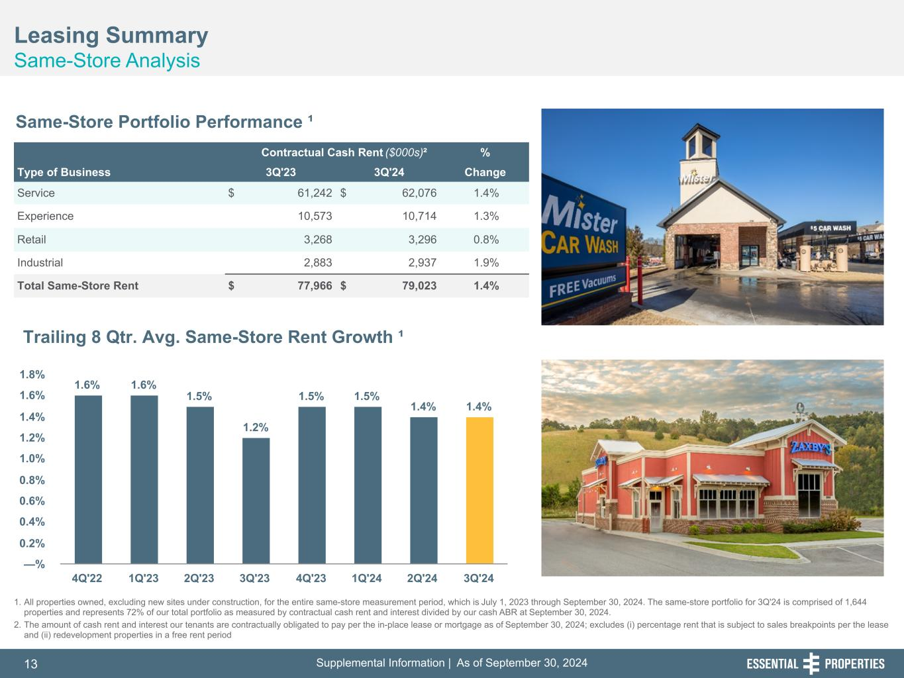
Supplemental Information | As of September 30, 202413 254, 192, 59 75, 108, 127 146, 204, 238 0, 0, 0 38, 169, 224 153, 223, 227 Leasing Summary Same-Store Analysis 242, 242, 242 Same-Store Portfolio Performance ¹ Contractual Cash Rent ($000s)² % Type of Business 3Q'23 3Q'24 Change Service $ 61,242 $ 62,076 1.4% Experience 10,573 10,714 1.3% Retail 3,268 3,296 0.8% Industrial 2,883 2,937 1.9% Total Same-Store Rent $ 77,966 $ 79,023 1.4% 1.6% 1.6% 1.5% 1.2% 1.5% 1.5% 1.4% 1.4% 4Q'22 1Q'23 2Q'23 3Q'23 4Q'23 1Q'24 2Q'24 3Q'24 —% 0.2% 0.4% 0.6% 0.8% 1.0% 1.2% 1.4% 1.6% 1.8% Trailing 8 Qtr. Avg. Same-Store Rent Growth ¹ 1. All properties owned, excluding new sites under construction, for the entire same-store measurement period, which is July 1, 2023 through September 30, 2024. The same-store portfolio for 3Q'24 is comprised of 1,644 properties and represents 72% of our total portfolio as measured by contractual cash rent and interest divided by our cash ABR at September 30, 2024. 2. The amount of cash rent and interest our tenants are contractually obligated to pay per the in-place lease or mortgage as of September 30, 2024; excludes (i) percentage rent that is subject to sales breakpoints per the lease and (ii) redevelopment properties in a free rent period

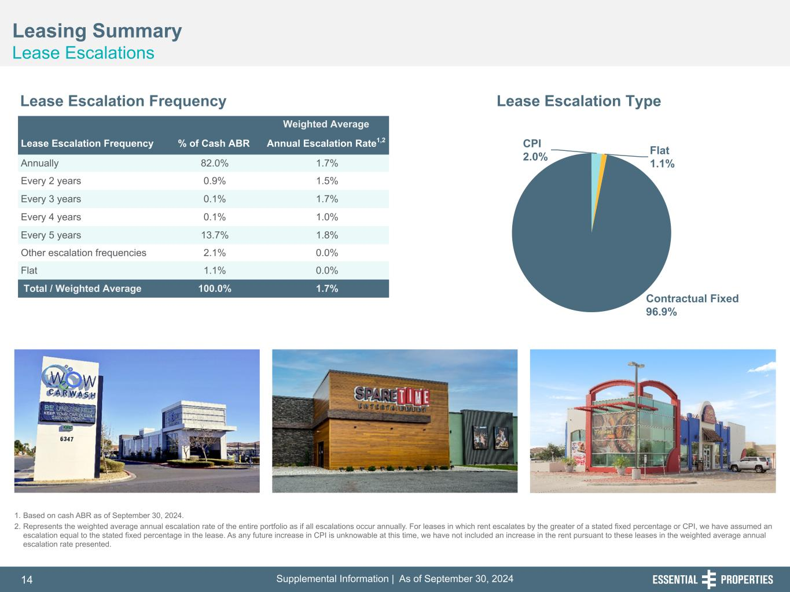
Supplemental Information | As of September 30, 202414 254, 192, 59 75, 108, 127 146, 204, 238 0, 0, 0 38, 169, 224 153, 223, 227 Leasing Summary Lease Escalations 242, 242, 242 1. Based on cash ABR as of September 30, 2024. 2. Represents the weighted average annual escalation rate of the entire portfolio as if all escalations occur annually. For leases in which rent escalates by the greater of a stated fixed percentage or CPI, we have assumed an escalation equal to the stated fixed percentage in the lease. As any future increase in CPI is unknowable at this time, we have not included an increase in the rent pursuant to these leases in the weighted average annual escalation rate presented. Lease Escalation Frequency Lease Escalation Type Weighted Average Lease Escalation Frequency % of Cash ABR Annual Escalation Rate1,2 Annually 82.0% 1.7% Every 2 years 0.9% 1.5% Every 3 years 0.1% 1.7% Every 4 years 0.1% 1.0% Every 5 years 13.7% 1.8% Other escalation frequencies 2.1% 0.0% Flat 1.1% 0.0% Total / Weighted Average 100.0% 1.7% CPI 2.0% Flat 1.1% Contractual Fixed 96.9%

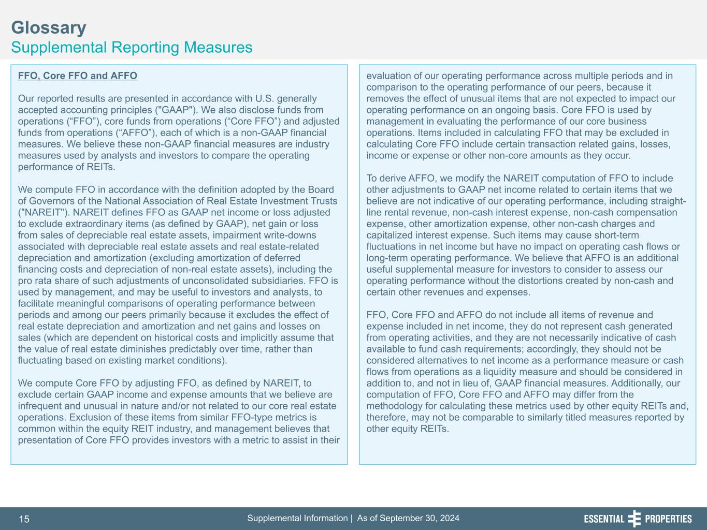
Supplemental Information | As of September 30, 202415 254, 192, 59 75, 108, 127 146, 204, 238 0, 0, 0 38, 169, 224 153, 223, 227 Glossary Supplemental Reporting Measures 242, 242, 242 FFO, Core FFO and AFFO Our reported results are presented in accordance with U.S. generally accepted accounting principles ("GAAP"). We also disclose funds from operations (“FFO”), core funds from operations (“Core FFO”) and adjusted funds from operations (“AFFO”), each of which is a non-GAAP financial measures. We believe these non-GAAP financial measures are industry measures used by analysts and investors to compare the operating performance of REITs. We compute FFO in accordance with the definition adopted by the Board of Governors of the National Association of Real Estate Investment Trusts ("NAREIT"). NAREIT defines FFO as GAAP net income or loss adjusted to exclude extraordinary items (as defined by GAAP), net gain or loss from sales of depreciable real estate assets, impairment write-downs associated with depreciable real estate assets and real estate-related depreciation and amortization (excluding amortization of deferred financing costs and depreciation of non-real estate assets), including the pro rata share of such adjustments of unconsolidated subsidiaries. FFO is used by management, and may be useful to investors and analysts, to facilitate meaningful comparisons of operating performance between periods and among our peers primarily because it excludes the effect of real estate depreciation and amortization and net gains and losses on sales (which are dependent on historical costs and implicitly assume that the value of real estate diminishes predictably over time, rather than fluctuating based on existing market conditions). We compute Core FFO by adjusting FFO, as defined by NAREIT, to exclude certain GAAP income and expense amounts that we believe are infrequent and unusual in nature and/or not related to our core real estate operations. Exclusion of these items from similar FFO-type metrics is common within the equity REIT industry, and management believes that presentation of Core FFO provides investors with a metric to assist in their evaluation of our operating performance across multiple periods and in comparison to the operating performance of our peers, because it removes the effect of unusual items that are not expected to impact our operating performance on an ongoing basis. Core FFO is used by management in evaluating the performance of our core business operations. Items included in calculating FFO that may be excluded in calculating Core FFO include certain transaction related gains, losses, income or expense or other non-core amounts as they occur. To derive AFFO, we modify the NAREIT computation of FFO to include other adjustments to GAAP net income related to certain items that we believe are not indicative of our operating performance, including straight- line rental revenue, non-cash interest expense, non-cash compensation expense, other amortization expense, other non-cash charges and capitalized interest expense. Such items may cause short-term fluctuations in net income but have no impact on operating cash flows or long-term operating performance. We believe that AFFO is an additional useful supplemental measure for investors to consider to assess our operating performance without the distortions created by non-cash and certain other revenues and expenses. FFO, Core FFO and AFFO do not include all items of revenue and expense included in net income, they do not represent cash generated from operating activities, and they are not necessarily indicative of cash available to fund cash requirements; accordingly, they should not be considered alternatives to net income as a performance measure or cash flows from operations as a liquidity measure and should be considered in addition to, and not in lieu of, GAAP financial measures. Additionally, our computation of FFO, Core FFO and AFFO may differ from the methodology for calculating these metrics used by other equity REITs and, therefore, may not be comparable to similarly titled measures reported by other equity REITs.

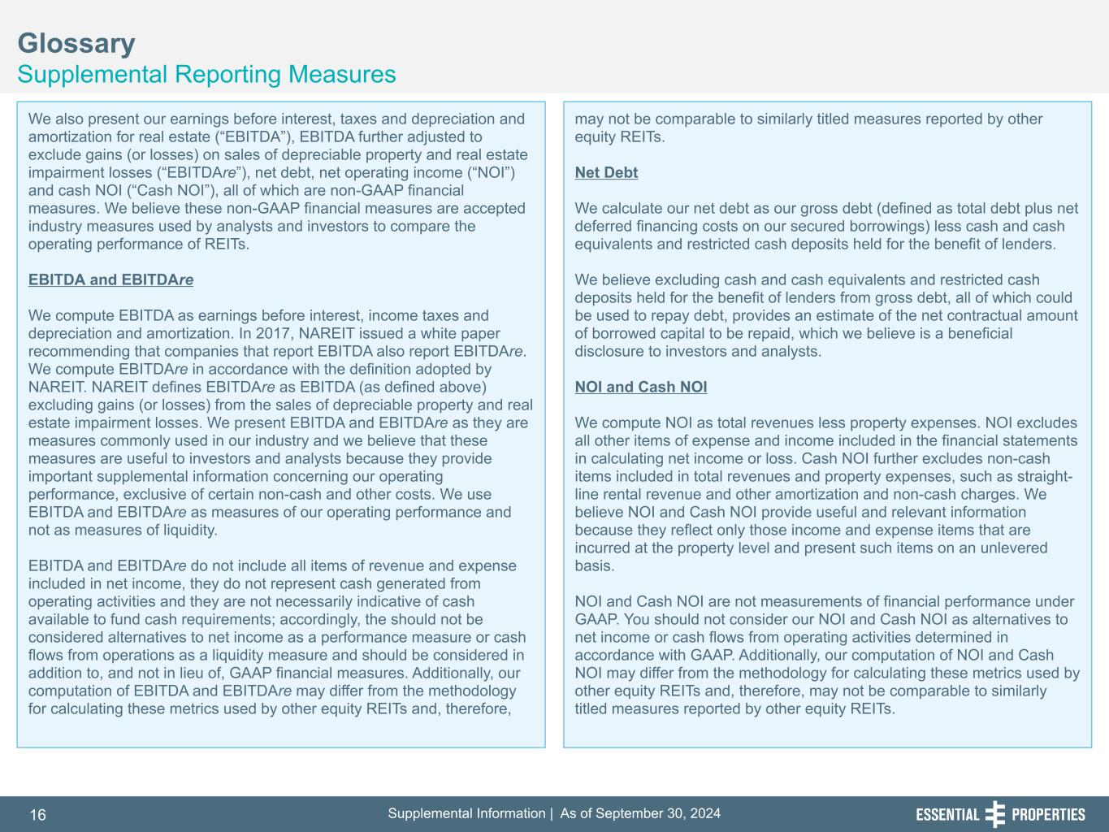
Supplemental Information | As of September 30, 202416 254, 192, 59 75, 108, 127 146, 204, 238 0, 0, 0 38, 169, 224 153, 223, 227 Glossary Supplemental Reporting Measures 242, 242, 242 We also present our earnings before interest, taxes and depreciation and amortization for real estate (“EBITDA”), EBITDA further adjusted to exclude gains (or losses) on sales of depreciable property and real estate impairment losses (“EBITDAre”), net debt, net operating income (“NOI”) and cash NOI (“Cash NOI”), all of which are non-GAAP financial measures. We believe these non-GAAP financial measures are accepted industry measures used by analysts and investors to compare the operating performance of REITs. EBITDA and EBITDAre We compute EBITDA as earnings before interest, income taxes and depreciation and amortization. In 2017, NAREIT issued a white paper recommending that companies that report EBITDA also report EBITDAre. We compute EBITDAre in accordance with the definition adopted by NAREIT. NAREIT defines EBITDAre as EBITDA (as defined above) excluding gains (or losses) from the sales of depreciable property and real estate impairment losses. We present EBITDA and EBITDAre as they are measures commonly used in our industry and we believe that these measures are useful to investors and analysts because they provide important supplemental information concerning our operating performance, exclusive of certain non-cash and other costs. We use EBITDA and EBITDAre as measures of our operating performance and not as measures of liquidity. EBITDA and EBITDAre do not include all items of revenue and expense included in net income, they do not represent cash generated from operating activities and they are not necessarily indicative of cash available to fund cash requirements; accordingly, the should not be considered alternatives to net income as a performance measure or cash flows from operations as a liquidity measure and should be considered in addition to, and not in lieu of, GAAP financial measures. Additionally, our computation of EBITDA and EBITDAre may differ from the methodology for calculating these metrics used by other equity REITs and, therefore, may not be comparable to similarly titled measures reported by other equity REITs. Net Debt We calculate our net debt as our gross debt (defined as total debt plus net deferred financing costs on our secured borrowings) less cash and cash equivalents and restricted cash deposits held for the benefit of lenders. We believe excluding cash and cash equivalents and restricted cash deposits held for the benefit of lenders from gross debt, all of which could be used to repay debt, provides an estimate of the net contractual amount of borrowed capital to be repaid, which we believe is a beneficial disclosure to investors and analysts. NOI and Cash NOI We compute NOI as total revenues less property expenses. NOI excludes all other items of expense and income included in the financial statements in calculating net income or loss. Cash NOI further excludes non-cash items included in total revenues and property expenses, such as straight- line rental revenue and other amortization and non-cash charges. We believe NOI and Cash NOI provide useful and relevant information because they reflect only those income and expense items that are incurred at the property level and present such items on an unlevered basis. NOI and Cash NOI are not measurements of financial performance under GAAP. You should not consider our NOI and Cash NOI as alternatives to net income or cash flows from operating activities determined in accordance with GAAP. Additionally, our computation of NOI and Cash NOI may differ from the methodology for calculating these metrics used by other equity REITs and, therefore, may not be comparable to similarly titled measures reported by other equity REITs.

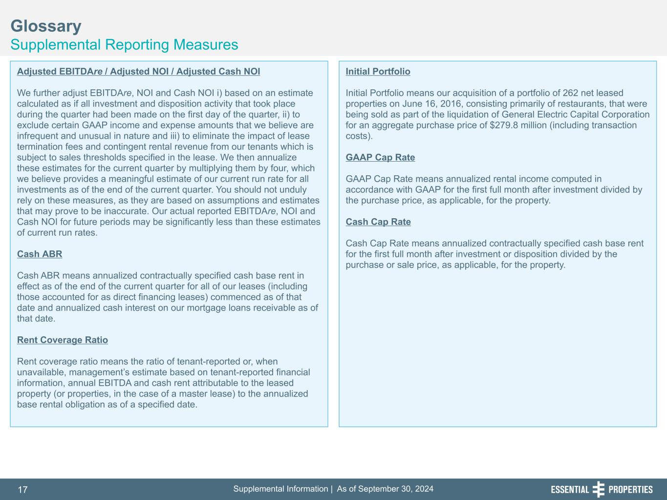
Supplemental Information | As of September 30, 202417 254, 192, 59 75, 108, 127 146, 204, 238 0, 0, 0 38, 169, 224 153, 223, 227 Glossary Supplemental Reporting Measures 242, 242, 242 Adjusted EBITDAre / Adjusted NOI / Adjusted Cash NOI We further adjust EBITDAre, NOI and Cash NOI i) based on an estimate calculated as if all investment and disposition activity that took place during the quarter had been made on the first day of the quarter, ii) to exclude certain GAAP income and expense amounts that we believe are infrequent and unusual in nature and iii) to eliminate the impact of lease termination fees and contingent rental revenue from our tenants which is subject to sales thresholds specified in the lease. We then annualize these estimates for the current quarter by multiplying them by four, which we believe provides a meaningful estimate of our current run rate for all investments as of the end of the current quarter. You should not unduly rely on these measures, as they are based on assumptions and estimates that may prove to be inaccurate. Our actual reported EBITDAre, NOI and Cash NOI for future periods may be significantly less than these estimates of current run rates. Cash ABR Cash ABR means annualized contractually specified cash base rent in effect as of the end of the current quarter for all of our leases (including those accounted for as direct financing leases) commenced as of that date and annualized cash interest on our mortgage loans receivable as of that date. Rent Coverage Ratio Rent coverage ratio means the ratio of tenant-reported or, when unavailable, management’s estimate based on tenant-reported financial information, annual EBITDA and cash rent attributable to the leased property (or properties, in the case of a master lease) to the annualized base rental obligation as of a specified date. Initial Portfolio Initial Portfolio means our acquisition of a portfolio of 262 net leased properties on June 16, 2016, consisting primarily of restaurants, that were being sold as part of the liquidation of General Electric Capital Corporation for an aggregate purchase price of $279.8 million (including transaction costs). GAAP Cap Rate GAAP Cap Rate means annualized rental income computed in accordance with GAAP for the first full month after investment divided by the purchase price, as applicable, for the property. Cash Cap Rate Cash Cap Rate means annualized contractually specified cash base rent for the first full month after investment or disposition divided by the purchase or sale price, as applicable, for the property.

